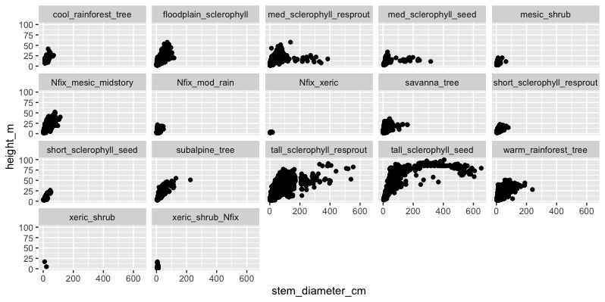

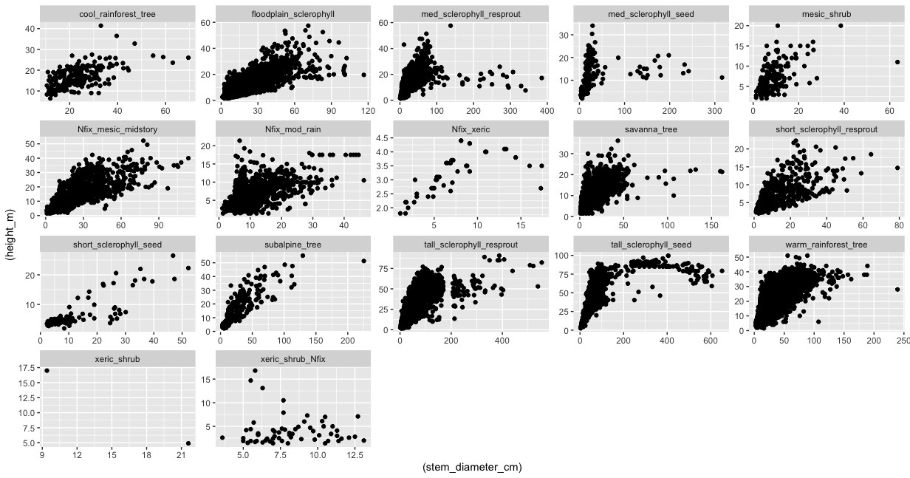

**Figure 1**. Aus-tallo data across PFTs for DBH vs H relationship

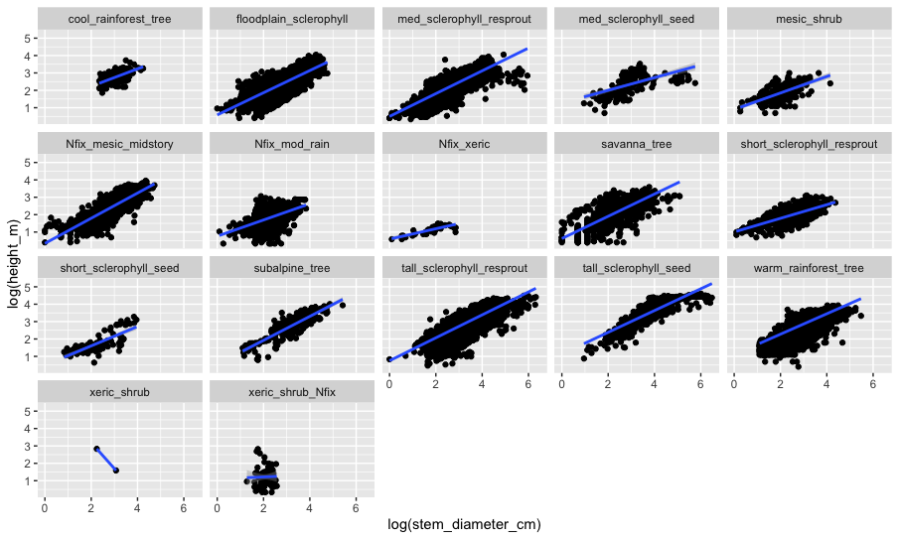

**Figure 2**. Aus-tallo data across PFTs for DBH vs H relationship plotted in a log-log scale with a fitted power function

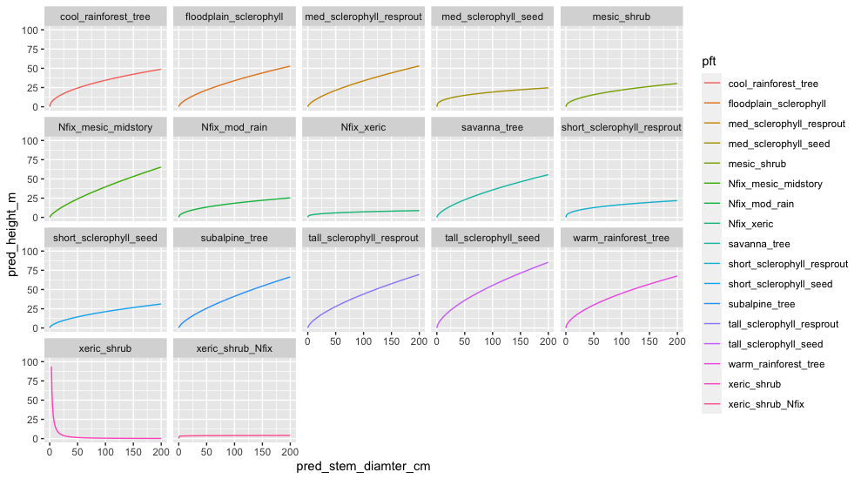

**Figure 3**. Only the power function across PFTs

**Figure 4**. Observed data for the 3 resprouter sclerophyll PFTs form Austallo. It seems like their fitted power function (to derive k_allom2 and 3) will not be that different.

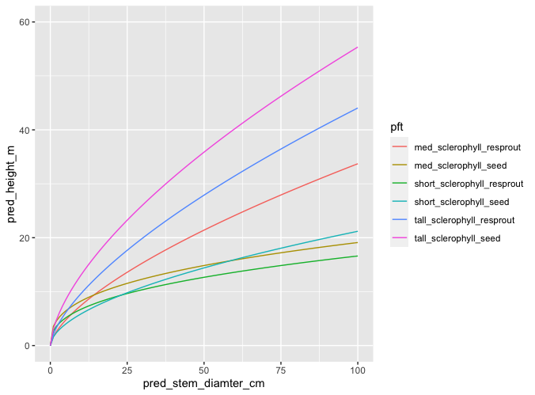

**Figure 5**. The fitted function for the six sclerophyll tree PFTs

* It seems that there is not a lot of difference between the data for the three type of PFTs. A fitted power function here will not be very different across the 3 PFTs.
* Furthermore, the DBH > 200 cm seems out of place.
* There might be some species that their allometric relationships (at least according to this data) do not fit their assigned (top-down) PFT.
* Medium sclerophyll seeders is too low (and too high in low DBH)

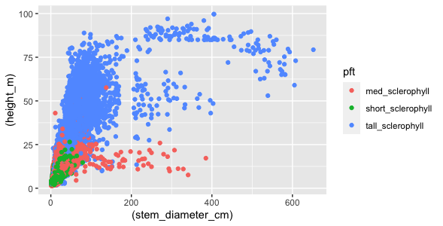

**Figure**. Observed height of tall, medium and short sclerophyll tree PFTs from the Austallo data. Data for Resprouting and reseeding PFTs were combined for each size class to derive the PFTs. The

**Figure**. Predicted height of tall, medium and short sclerophyll tree PFTs according to their allometric relationship that was derived from the Austallo data. Data for Resprouting and reseeding PFTs were combined for each size class to derive the PFTs. These functions seems too low

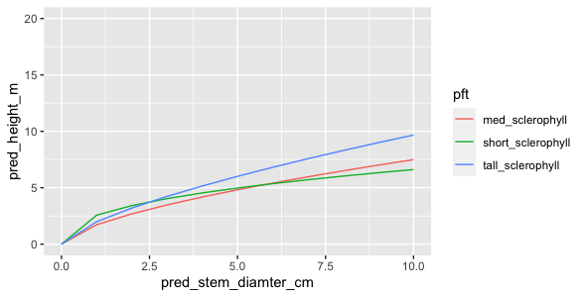

**Figure**. Predicted height of tall, medium and short sclerophyll trees according to their allometric relationship that was derived from the Austallo data, focussed on thin diamters (<10cm). Thinner short trees are taller than taller trees with similar diameter. This can cause a problem with competition in LPJ-GUESS. The figure includes data from 37, 62 and 32 species for the Tall, medium and short sclerophyll trees.

**Too much or too little data?**

Instaed of taking the mean from a lot of data to parameterise K_allom2 and K_allom3, we might need to select generic species for each PFT and use their data.

Across all species in Austallo, the fitted power function (to ) statistics is:

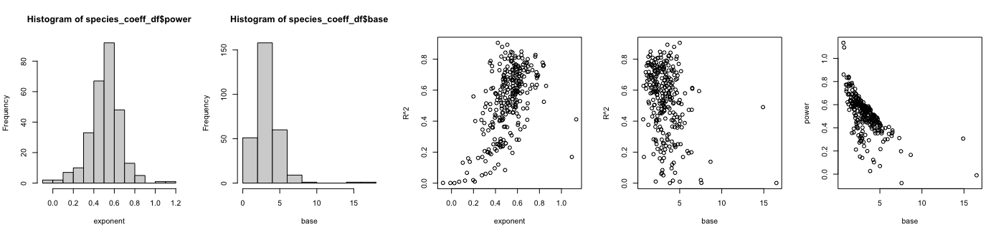

**Figure 6**. Statistics for the exponent (k_allom2) and base(k_allom3) parameters across all the data. Seems like lower exponent has lower R^2.

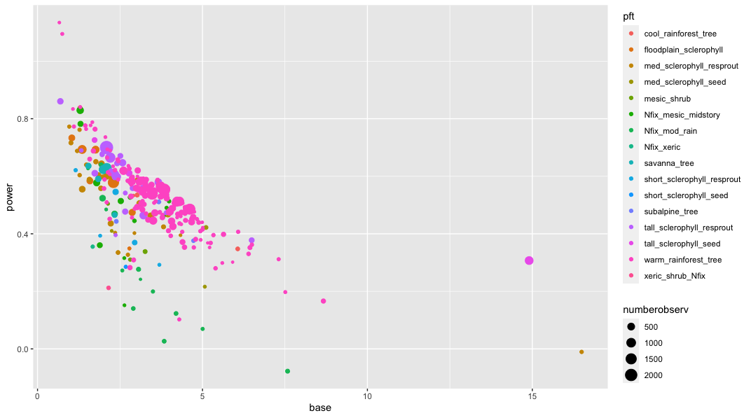

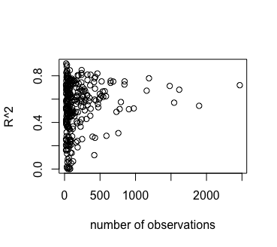

lower R^2 tends to be driven by lower number of observations, but lower number of observations can also result in higher R^2

## DBH>200

* There are a few species that have the DBH > 200cm. This reduces the accuracy of the power function, especially when the stem is thinner (overestimation).
* Here I explore what species are those with DBH data >200cm (AusTallo only).
* **Only 10 species have data for DBH>2 m:**

[1] "Eucalyptus salmonophloia" "Eucalyptus salubris" "Eucalyptus transcontinentalis"

[4] "Eucalyptus dalrympleana" "Eucalyptus andrewsii" "Eucalyptus diversicolor"

[7] "Eucalyptus fastigata" "Eucalyptus globulus" "Eucalyptus jacksonii"

[10] "Eucalyptus microcorys" "Eucalyptus obliqua" "Eucalyptus pilularis"

[13] "Eucalyptus rubida" "Eucalyptus viminalis" "Eucalyptus delegatensis"

[16] "Eucalyptus regnans" "Citronella moorei"

**They are divided across 6 PFTs:**

"med_sclerophyll_resprout" ; "med_sclerophyll_seed" ; "subalpine_tree"; "tall_sclerophyll_resprout"; "tall_sclerophyll_seed" "warm_rainforest_tree"

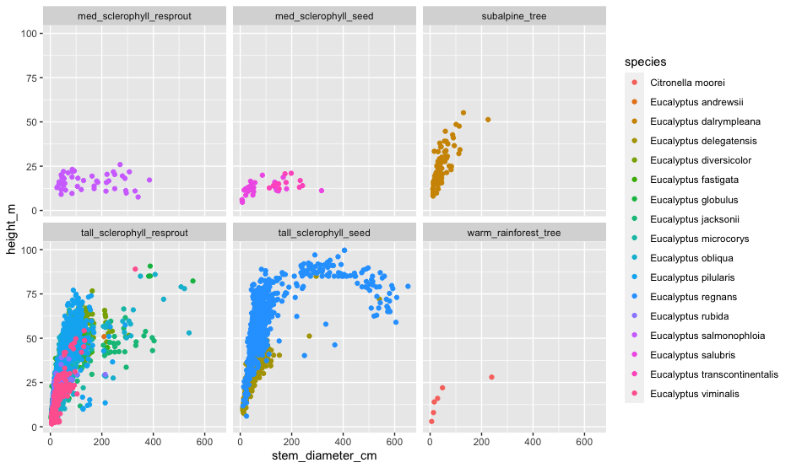

Each species by itself:

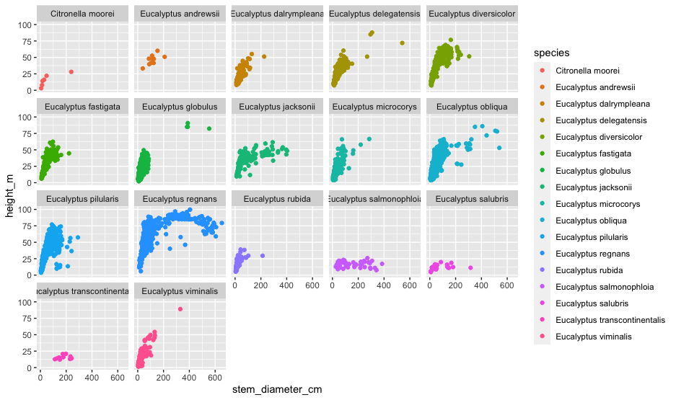

The problem is that the fitted curve (power function) doesn’t always represent the data correctly. For example, in case of E regnans:

When shortening the range (DBH<200)

Note that when DBH (X) is <50cm, the model overestimates height substantially. This is fixed during

It is hard to know how to use this to parameterise PFTs.

Should we make a DBH limit to 200cm beyond which the data is assumed not sure?

Perhaps the addition of more species to each PFT will reduce the line to the correct form?

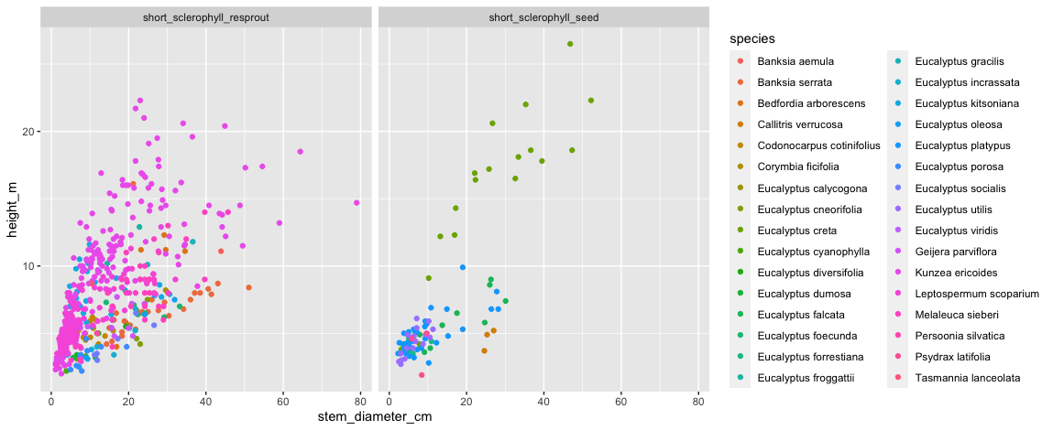

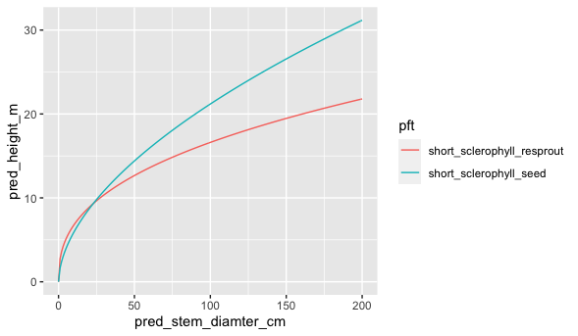

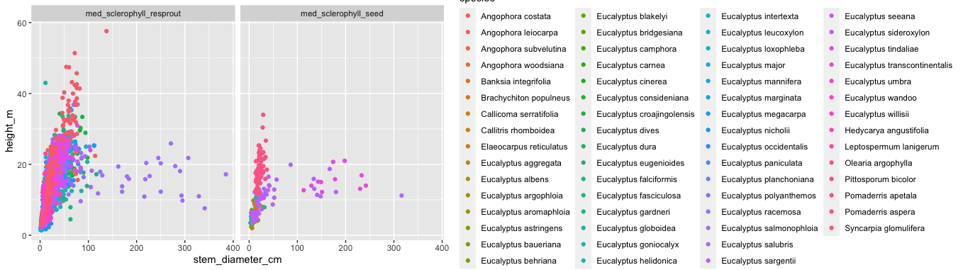

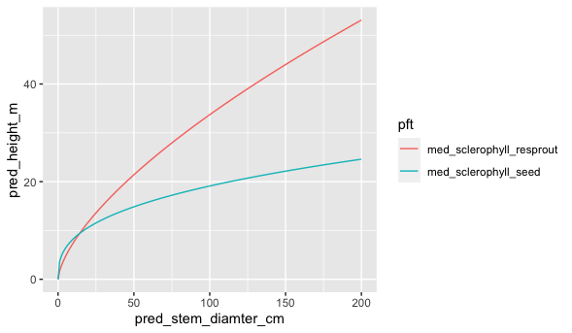

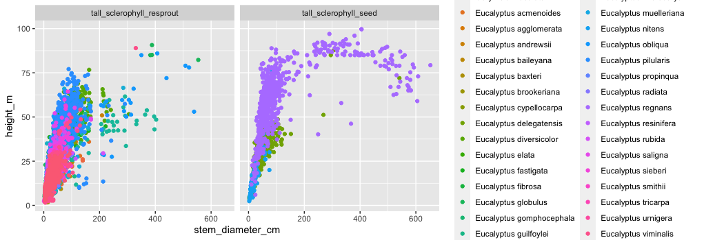

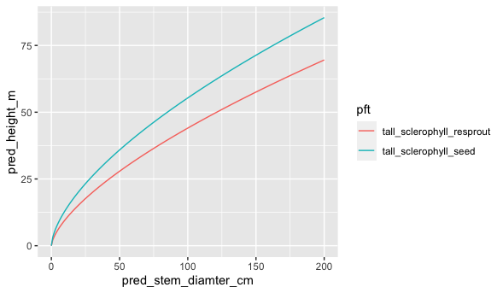

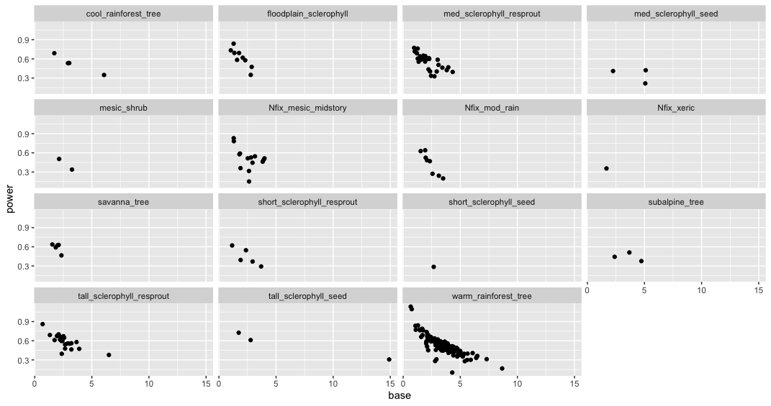

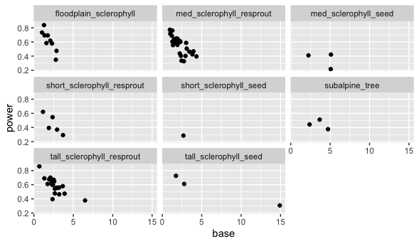

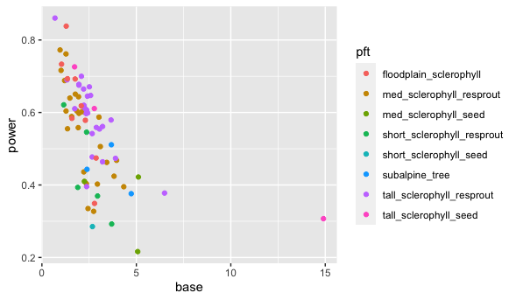

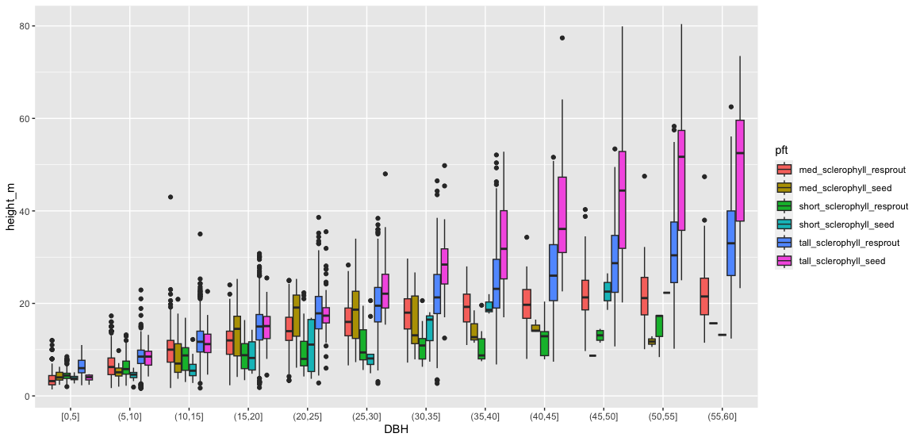

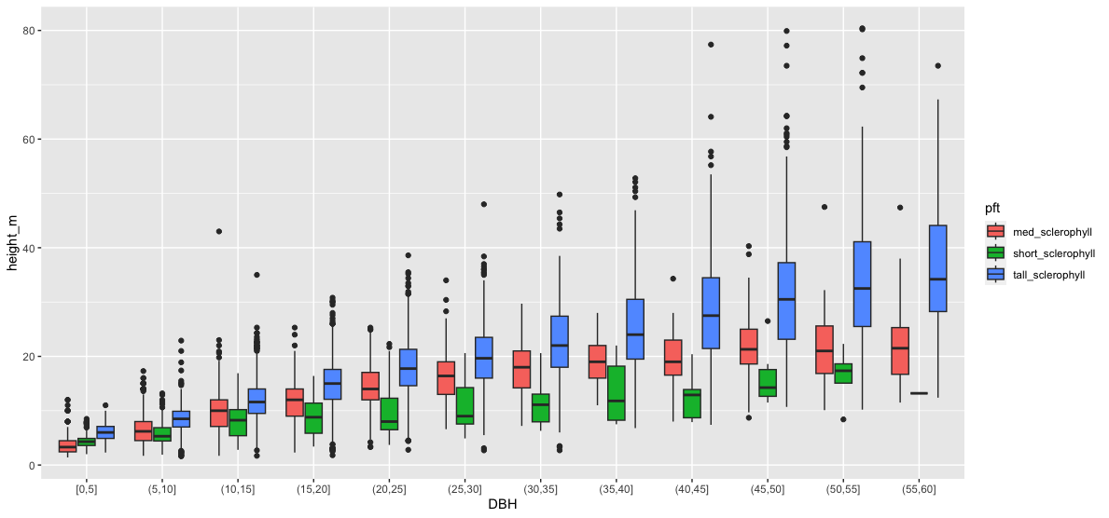

**Euc Only:**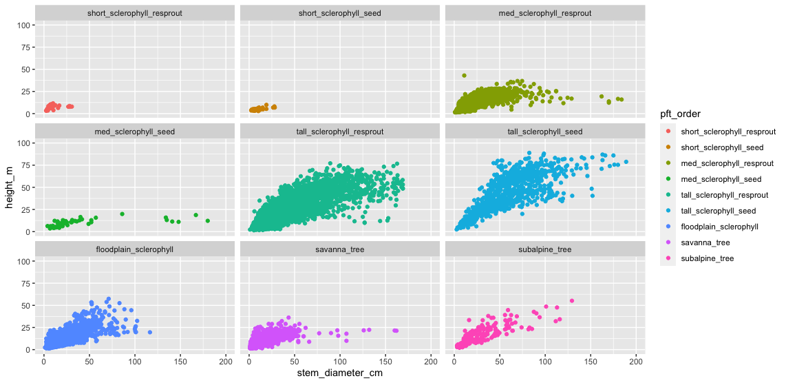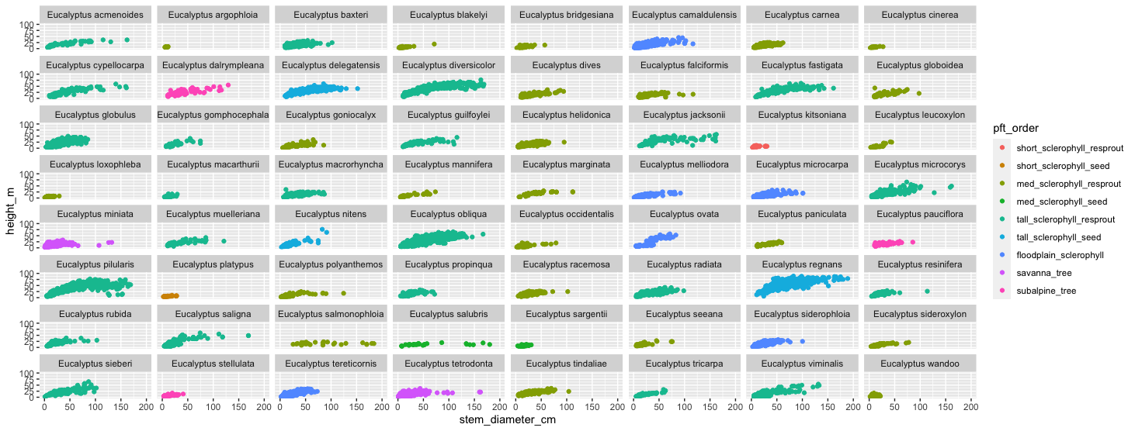

Tall_sclero_resprout only:

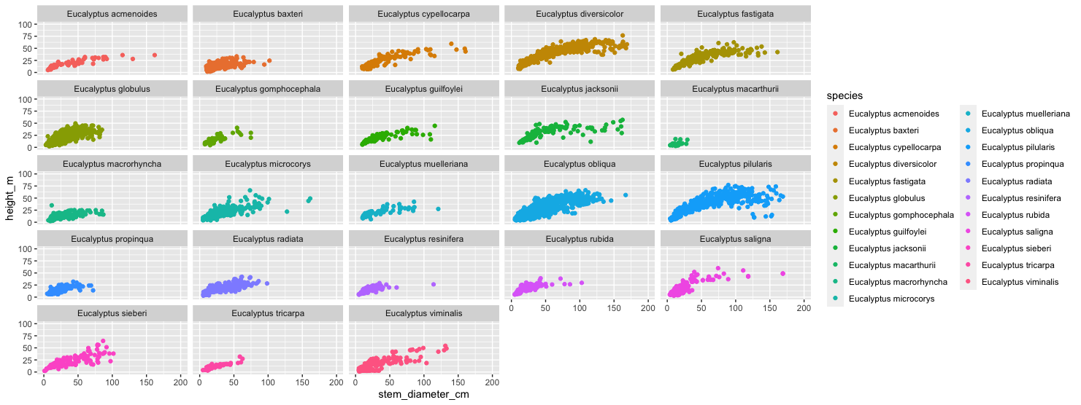

Seems like some species does not belong here.