**LAB 1**

**Problem 1. Building an ER model for a hospital**

**Note: Zoom in to see the ER diagram clearly.**

**1. Finding Entities, key Attributes and related Attributes**

**Entities**: Hospital ,Doctors, Patient, Treatment

**Attribute**:

Hospital: Doctors.

Doctor :

* Key attribute: Doctor code.
* Related attribute: Doctor's name, Date of employment, Specialty.

Patient :

* Key attribute: Patient identification.
* Related attribute: Patient name.

Treatment: Date of treatment, Duration of treatment , Results, Doctor code, Patient identification.

**2. Finding Relationships**

Hospital – Doctors: has

Cardinality: one to many

Patient – Doctor: admit

Cardinality: many to one

Doctor – Patient: treat

Cardinality: one to many

Hospital – Treatment: save

Cardinality: one to many

**3. Finding weak Entities and weak Relationships (if any)**

Weak Entity: Treatment.

Weak Relationship: Treat

**4. Draw an ER model**

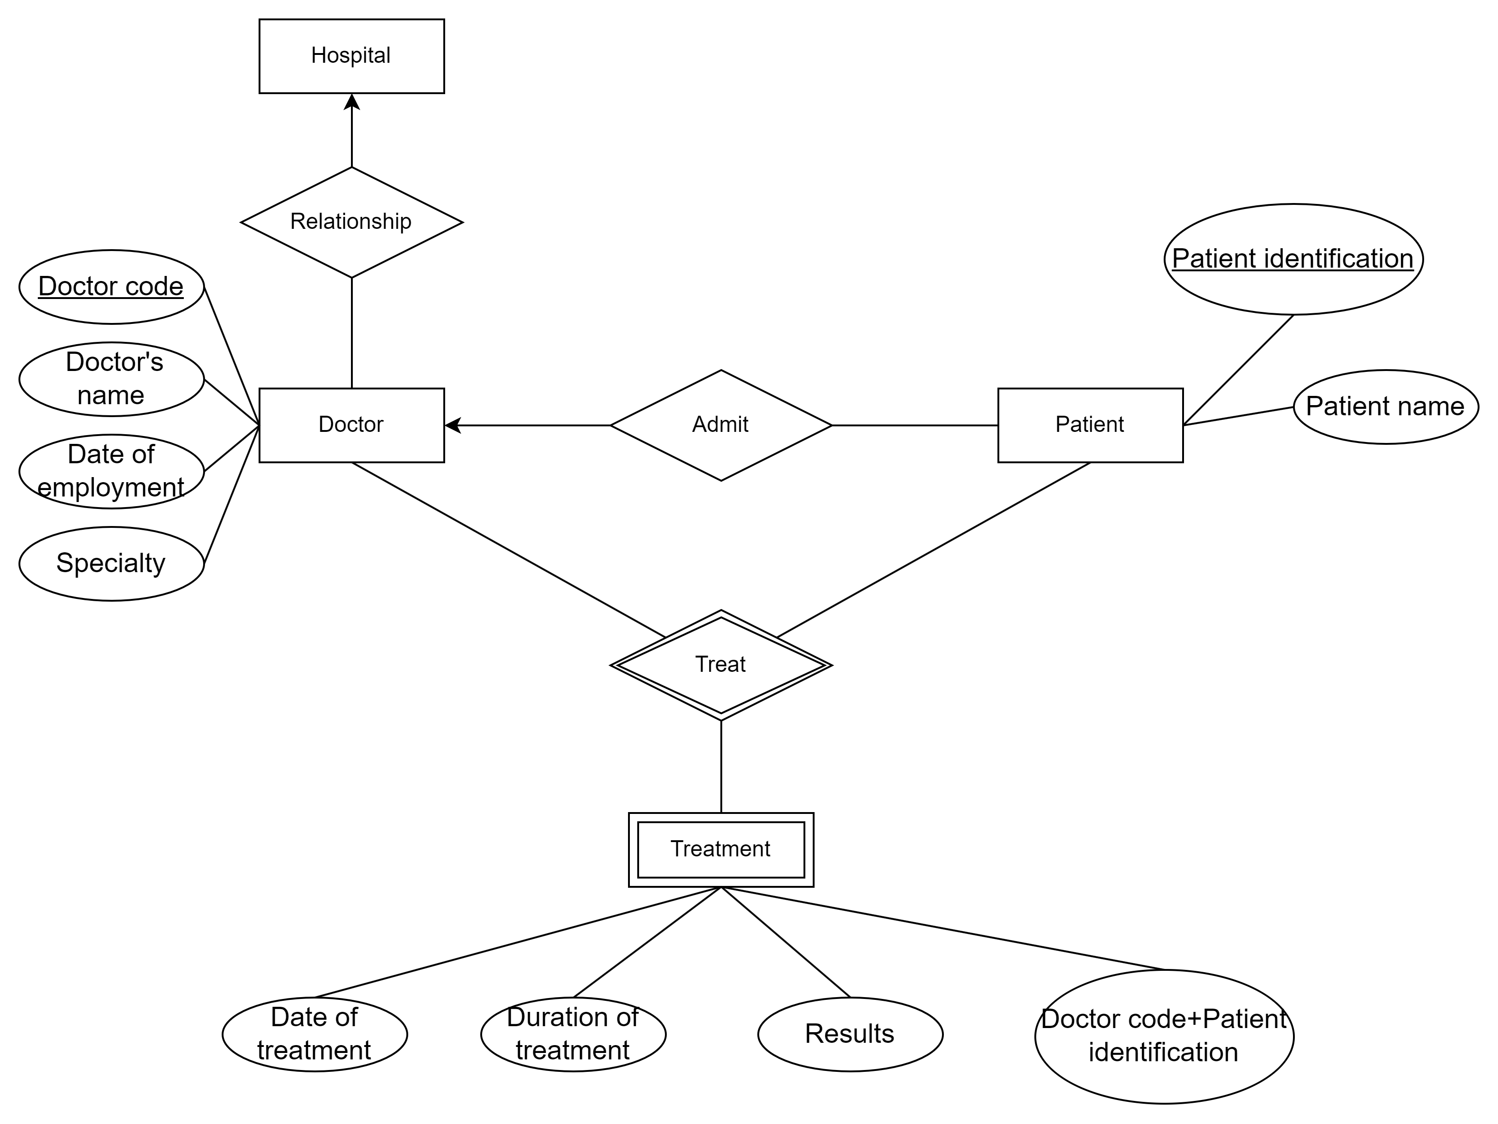

**Problem 2. Building an ER model for a University**

### **1. Finding Entities, Key Attributes, and Related Attributes**

#### Entities:

* Faculty
* Department
* Class
* Student
* Subject
* Course
* Library Card
* Exam
* Graduation Point

#### Attributes:

Faculty:

* Key attribute: Faculty Code
* Related attribute: Faculty Name

Department:

* Key attribute: Department Code
* Related attributes: Department Name, Faculty Code

Class:

* Key attribute: Class Code
* Related attributes: Class Name, Wholesale Number, Department Code

Student:

* Key attribute: Student ID
* Related attributes: Full Name, Date of Birth, Gender, Address, Class Code

Subject:

* Key attribute: Subject Code
* Related attributes: Subject Name, Number of Credits

Course:

* Key attribute: Course ID
* Related attributes: Course Name, Department Code

Library Card:

* Key attribute: Card Number
* Related attributes: Issue Date, Expiration Date, Student ID

Exam:

* Related attributes: Exam Score, Student ID, Subject Code

Graduation Point:

* Related attributes: Graduation Point, Student ID, Course ID

### **2. Finding Relationships**

Faculty - Department:

* Relationship: includes
* Cardinality: One to Many

Department - Class:

* Relationship: consists of
* Cardinality: One to Many

Department - Course:

* Relationship: offers
* Cardinality: One to Many

Class - Student:

* Relationship: enrolls
* Cardinality: One to Many

Student - Subject:

* Relationship: studies
* Cardinality: Many to Many

Student - Library Card:

* Relationship: possesses
* Cardinality: One to One

Student - Exam:

* Relationship: takes
* Cardinality: One to Many

Student - Graduation Point:

* Relationship: earns
* Cardinality: One to One

### **3. Finding Weak Entities and Weak Relationships (if any)**

* Weak Entity: Exam, Graduation Point
* Weak Relationship: takes, earns

**4. Draw an ER model**

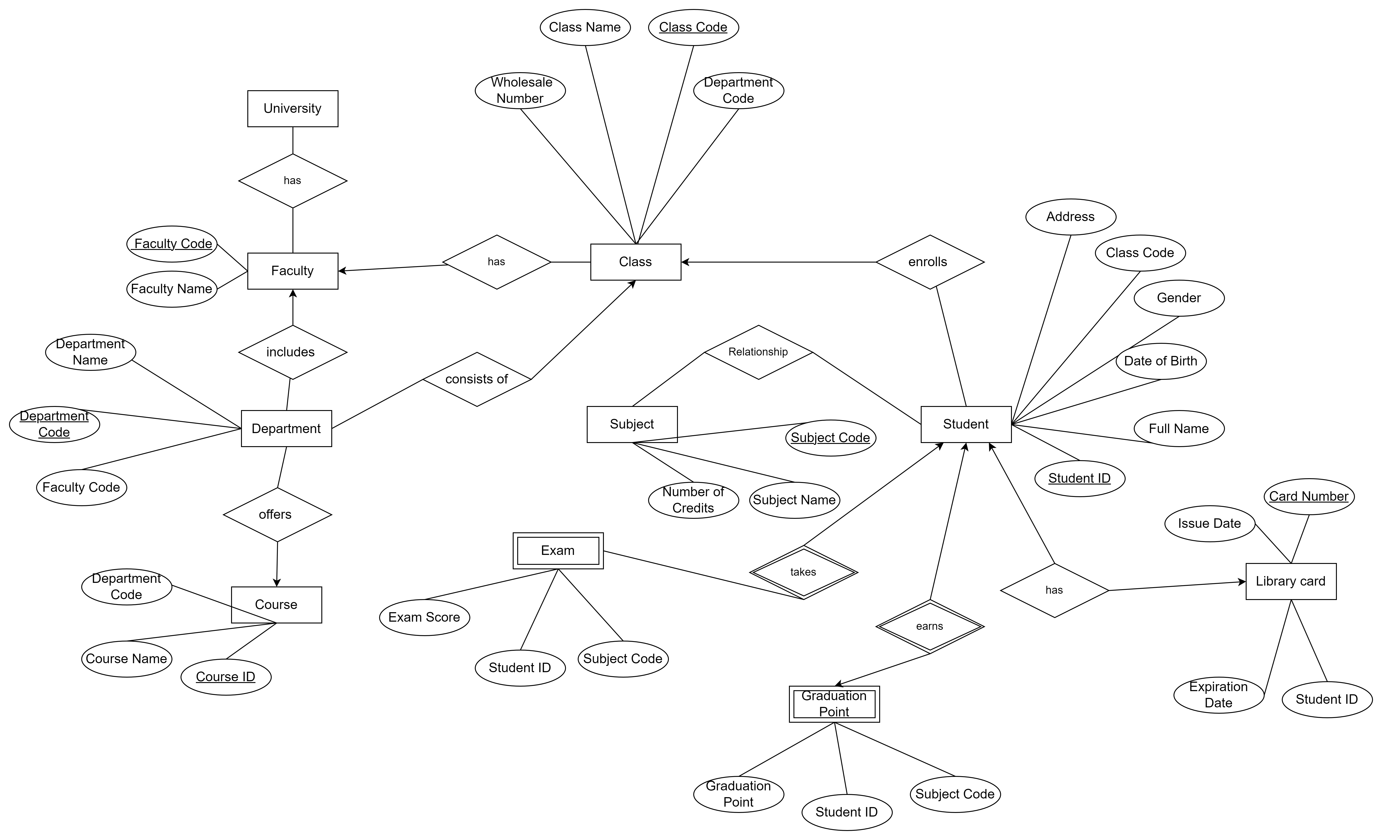

**Problem 3. Building an ER model and relational data model for 1 hotel needs to store information as follows:**

**1. Finding Entities, key Attributes and related Attributes**

Entities: Room, Floor, Guest, Service, Invoice

Attributes:

Room:

* Key attribute: Room code
* Related attributes: Room name, Daily price, Weekly price

Floor:

* Key attribute: Floor code
* Related attribute: Floor name

Guest:

* Key attribute: Identity card number
* Related attributes: Full name, Phone number

Service:

* Key attribute: Service code
* Related attributes: Service name, Amount per use

Invoice:

* Key attribute: Invoice code
* Related attributes: Arrival date, Departure date, Total room amount, Total service amount, Total amount to pay

**2. Finding Relationships Room - Floor: is located on Cardinality: Many to One**

Guest - Room: stays in Cardinality: Many to Many

Room - Service: offers Cardinality: Many to Many

Guest - Invoice: generates Cardinality: One to Many

Invoice - Room: includes Cardinality: Many to One

Invoice - Service: uses (implemented through InvoiceService) Cardinality: Many to Many

Floor - Room: contains Cardinality: One to Many

**3. Finding weak Entities and weak Relationships (if any)**

There are no weak entities or weak relationships in this scenario.

**4. Draw an ER model**

