**LAB 1**

**Problem 1. Building an ER model from Database Schema**

**1. Finding Entities, key Attributes and related Attributes**

**Entities:**

CUSTOMERS

STAFF

PRODUCTS

INVOICE

DETAILOFINVOICE

Attributes for each entity:

**Attributes:**

CUSTOMERS: CUSTOMERID (primary key), FULLNAME, ADDRESS, PHONE, BIRTHDAY,SALE, REGISTRATIONDATE

STAFF: STAFFID (primary key), FULLNAME, DAYOFENTRY, PHONE

PRODUCTS: PRODUCTID (primary key), PRODUCTNAME, UNIT, NATION, PRICE

INVOICE: INVOICEID (primary key), PURCHASEDATE, VALUE

DETAILOFINVOICE: QUANTITY, INVOICEID(FK), PRODUCTID(FK)

**2. Finding Relationships**

CUSTOMERS - INVOICE: has Cardinality: One to Many

STAFF - INVOICE: creates Cardinality: One to Many

PRODUCTS - DETAILOFINVOICE: included Cardinality: One to Many

PRODUCTS - INVOICE: appears in (implemented through DETAILOFINVOICE) Cardinality: Many to Many

**3. Finding weak Entities and weak Relationships (if any)\**

Weak Entity:

DETAILOFINVOICE is a weak entity dependent on INVOICE

Weak Relationship:

contains (between INVOICE and DETAILOFINVOICE)

INVOICE - DETAILOFINVOICE: contains Cardinality: One to Many (Identifying Relationship)

**4. Draw an ER model**

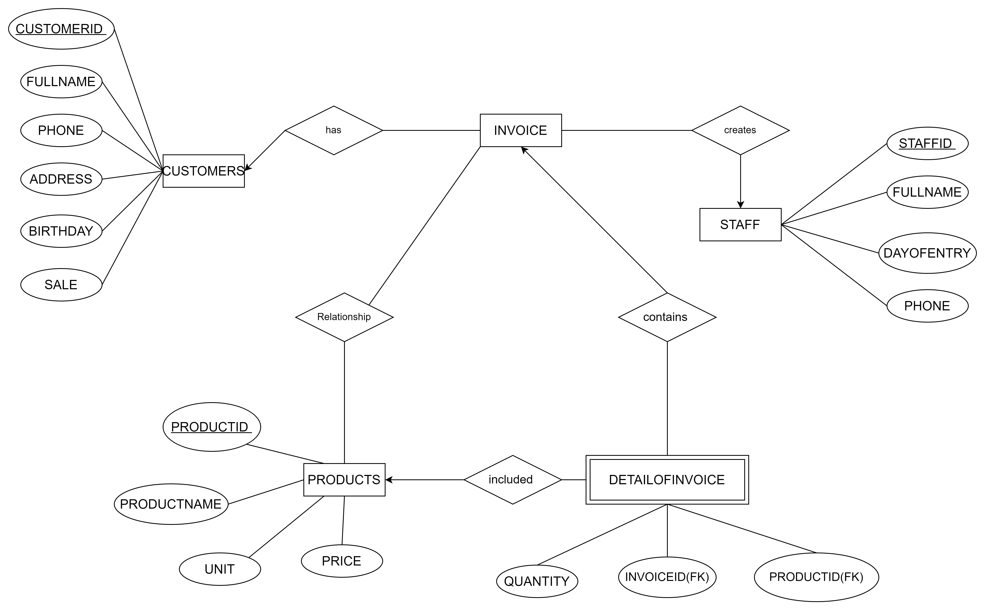

**Problem 2: Draw ER Diagram, then in change to Database Schema**

**1. Finding Entities, Key Attributes and Related Attributes**

**Entities:**

* Employee
* Department
* Project
* Location
* Relative

**Attributes:**

**Employee:**

Key Attribute:

* Employee_Code (unique identifier)

Related Attributes:

* Full_Name (Middle_Name, First_Name)
* Date_of_Birth
* Address
* Gender
* Manager_Code (foreign key referencing Employee.Employee_Code) (Optional)
* Department_Code (foreign key referencing Department.Department_Code)
* Salary (amount)
* Employee_Type (Full-Time, Part-Time)

**Department:**

Key Attribute:

* Department_Code (unique identifier)

Related Attributes:

* Room_Name
* Start_Date_Manager (date the manager starts overseeing the department)
* Location_ID (foreign key referencing Location.Location_ID) OR One-to-Many relationship with Location

**Project:**

Key Attribute:

* Project_Code (unique identifier)

Related Attributes:

* Project_Name
* Location_ID (foreign key referencing Location.Location_ID)

**Location:**

Key Attribute:

* Location_ID (unique identifier) OR Primary Key can be a combination of attributes like (City, Country)

Related Attributes:

* (none in this case)

**Relative:**

Key Attribute:

* Relative_ID (unique identifier) OR Primary Key can be a combination of Employee_Code and Relationship_Type

Related Attributes:

* Employee_Code (foreign key referencing Employee.Employee_Code)
* Relative_Name
* Date_of_Birth
* Relationship_Type

**2. Finding Relationships**

Employee has one (optional) Manager (Employee)

Employee belongs to one Department (Many-to-one)

Department manages many Projects (Many-to-Many)

Department has one or more Locations (One-to-Many) OR Many-to-Many relationship with Location

Employee participates in many Projects (Many-to-Many) implemented through Employee_Project

Employee has many Relatives (One-to-Many)

**3. Finding Weak Entities and Weak Relationships (if any)**

Weak Entity: Relative is a weak entity dependent on Employee.

Weak Relationship: Employee - Relative: has cardinality: One to Many (Identifying Relationship)

**4. Draw an ER model**

