**Lab1-CSE454**

**Tran Le Hien Duc**

**2131200129**

**1. Create a directory “Your name” in “/var/www”**

cd ../../var

sudo mkdir www

sudo mkdir www/hienduc

**2. Create a file firstcode.html in “Your name” directory**

cd www/hienduc

touch firstcode.html

**3. Insert the following texts to firstcode.html (use nano or vi editor)**

nano firstcode.html

**4. Create a directory Project inside “Your name” directory**

sudo mkdir Project

**5. Move the firstcode.html to Project**

sudo mv firstcode.html Project

**6. Rename the firstcode.html to index.html**

cd Project

sudo mv firstcode.html index.html

**7. Create a directory Test inside “Your name” directory**

cd ..

sudo mkdir Test

**8. Create a symbolic link from Project to Test**

cd ..

cd Test

sudo ln -s ../Project

**9. Copy index.html to Test**

sudo cp Project/index.html Test

**10. Edit the content of index.html in Test as below:**

cd Test

sudo nano index.html

**11. Copy all contents of index.html in Test to index.html in Project (use Read File command of nano)**

cd ..

cd Project

sudo nano index.html

In nano press Ctrl+r then fill the path of file (../Test/index.html)

**12. Delete the Test directory**

cd ..

sudo rm -rf Test

**13. Create a new file firstproject.conf in Project and edit with nano Editor**

sudo touch firstproject.conf

sudo nano firstproject.conf

**SSH and OpenSSH**

**Putty**

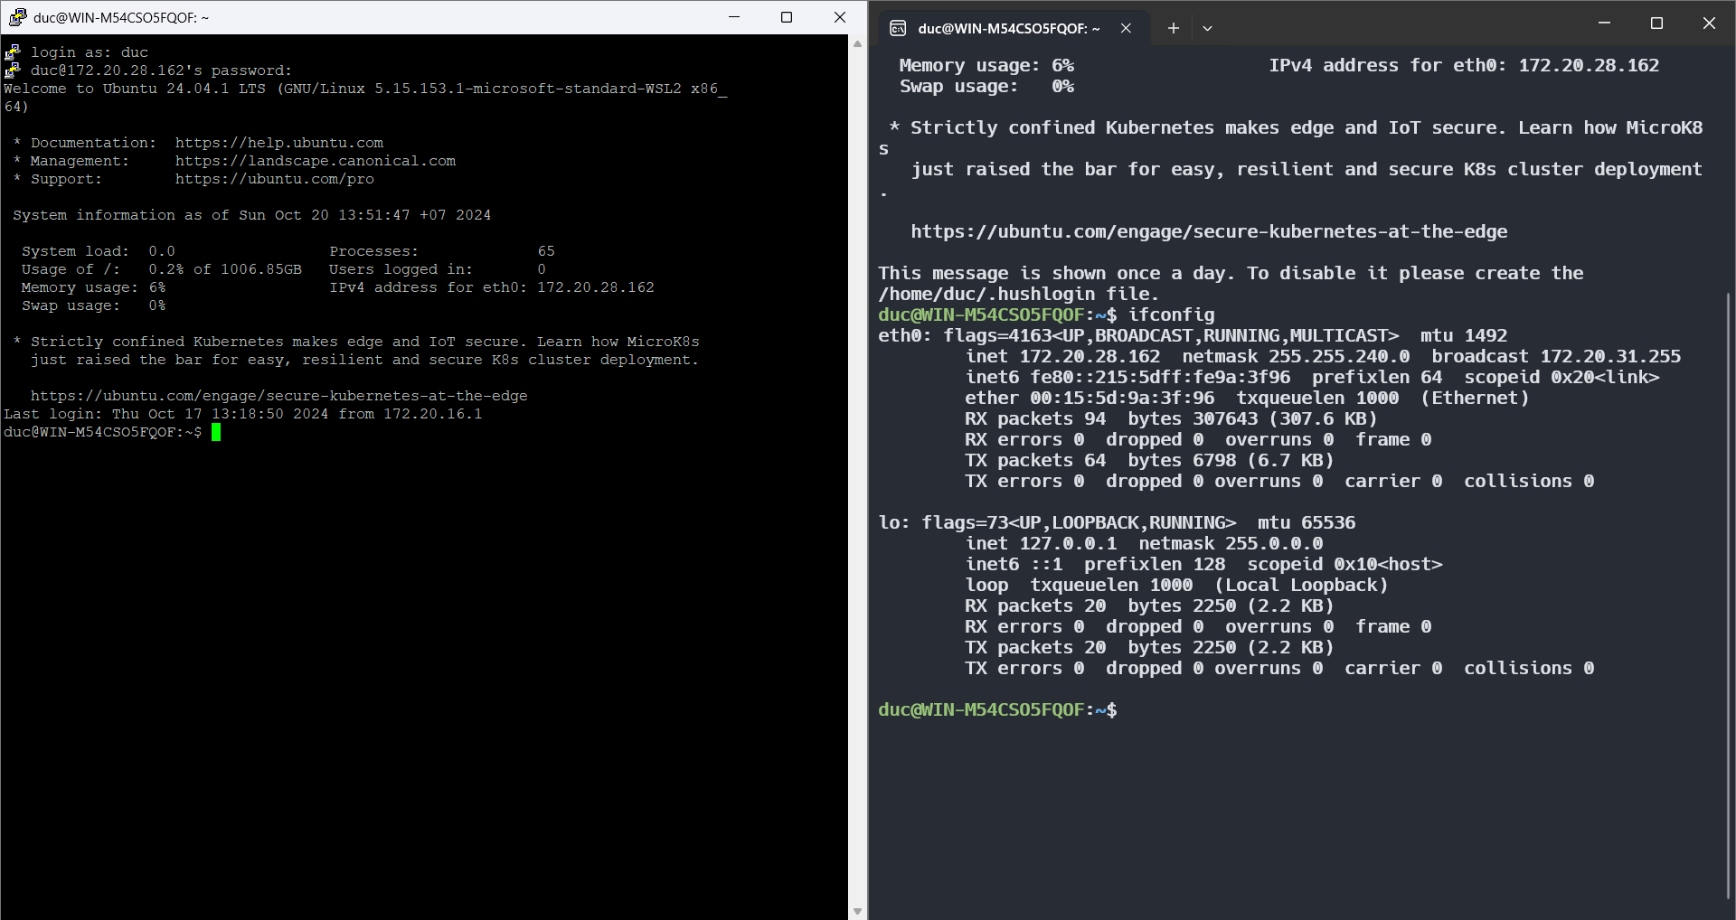

**WinSCP**

