**Lab2-CSE454**

**Tran Le Hien Duc**

**2131200129**

**14. Compress Project by using tar**

sudo tar -czf Project.tar.gz Project

**15. Download WordPress and extract it to Project**

sudo wget <https://wordpress.org/latest.zip>

sudo apt install unzip

sudo unzip latest.zip –d Project

**16. Change ownership of Project and the files inside it to www-data**

sudo chown -R www-data:root Project

**17. Set permissions for Project and the files inside it as the follow:**

**Owner: read, write, execute**

**Group: read and execute**

**Other: read and execute**

sudo chmod 755 Project

**18. Create a file rootFile.txt with the root privilege in Project**

sudo nano Project/rootFile.txt

**19. List files / directories in Project and sort them by owner**

cd Project

ls -l | sort -k3

**20. Write a script to list all files and directories in Project and sort them in Descending Order**

sudo nano listProject.sh

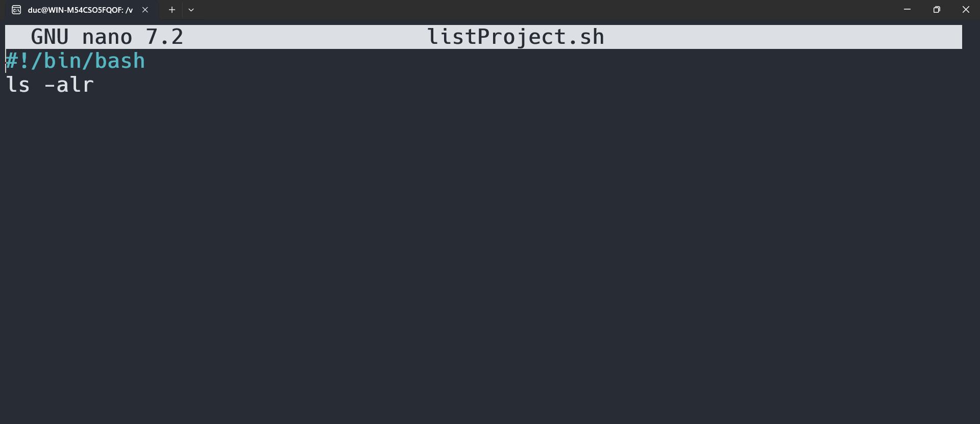

sudo chmod +x listProject.sh

./listProject.sh

**21. Create a script to install services as the following:**

sudo nano installPHP.sh

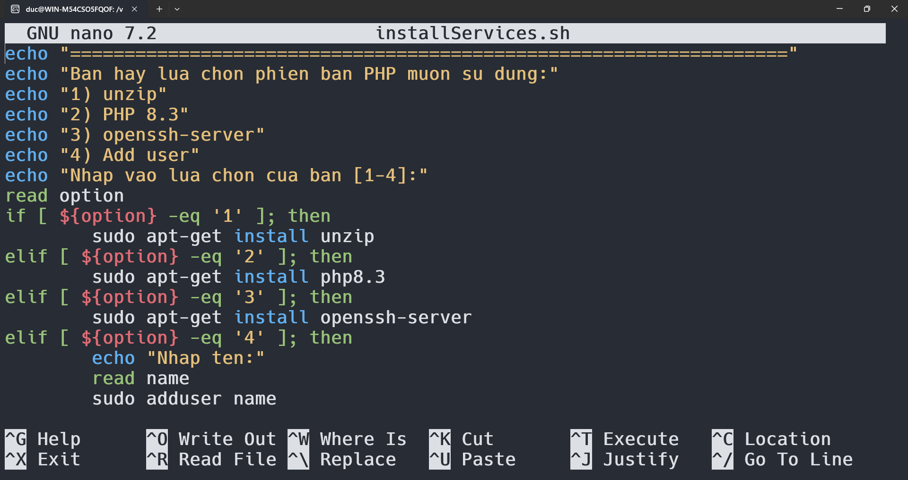

sudo chmod +x installPHP.sh

./listProject.sh

**GitHub**

**1. Create a GitHub account**

**2. Create a new repository**

**Exploring repository settings:**

**▪ Rename Repository name**

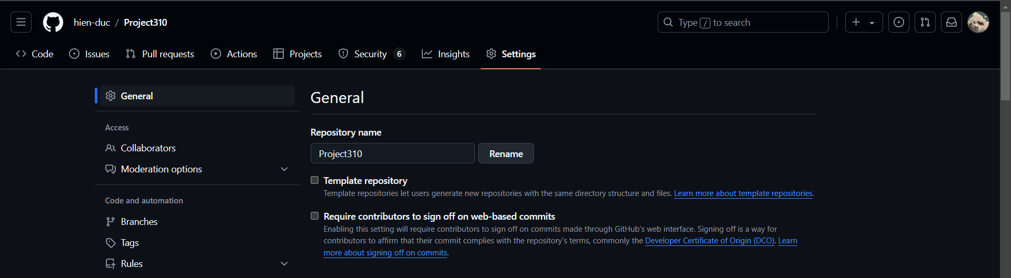

**▪ Turn on/off features: Wiki, Issues**

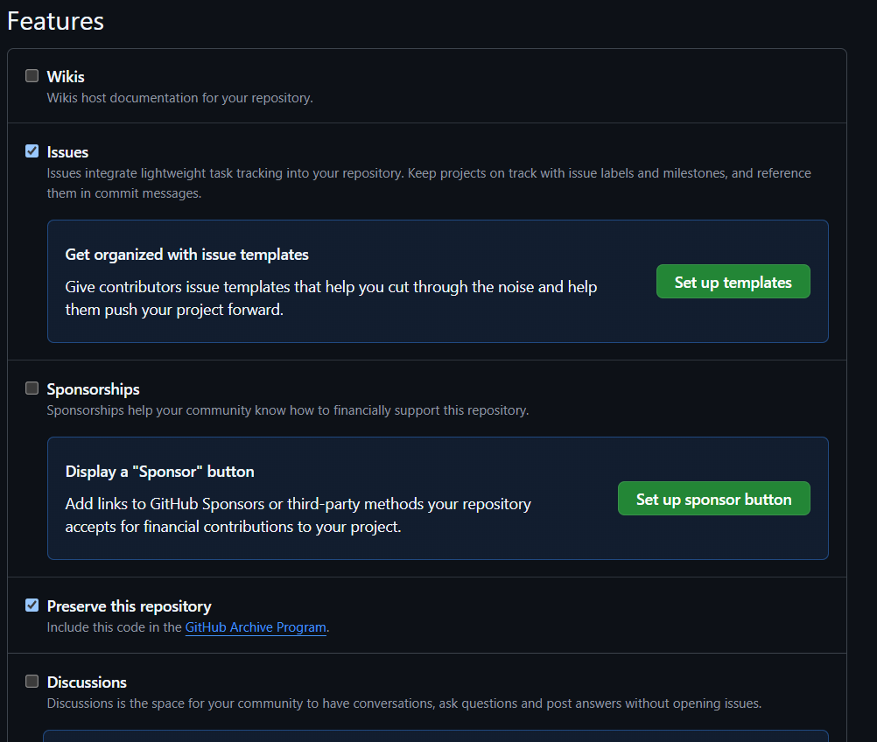

**▪ Change repository visibility**

**▪ Transfer ownership**

**▪ Delete a repository**

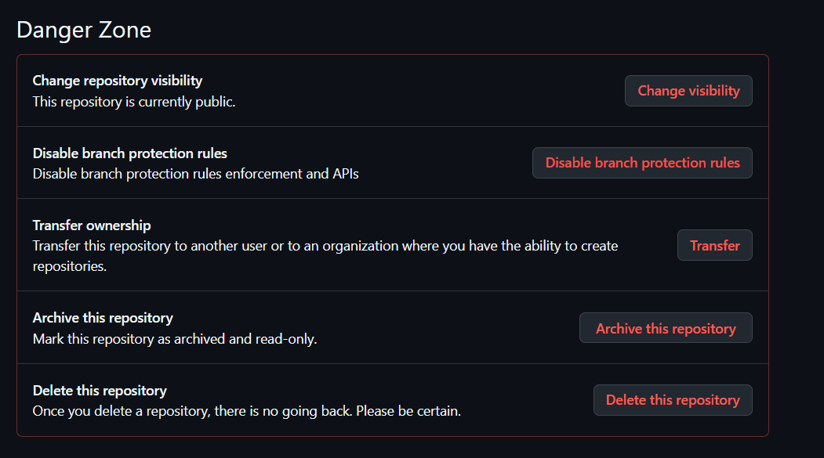

**▪ Add/Delete collaborators**

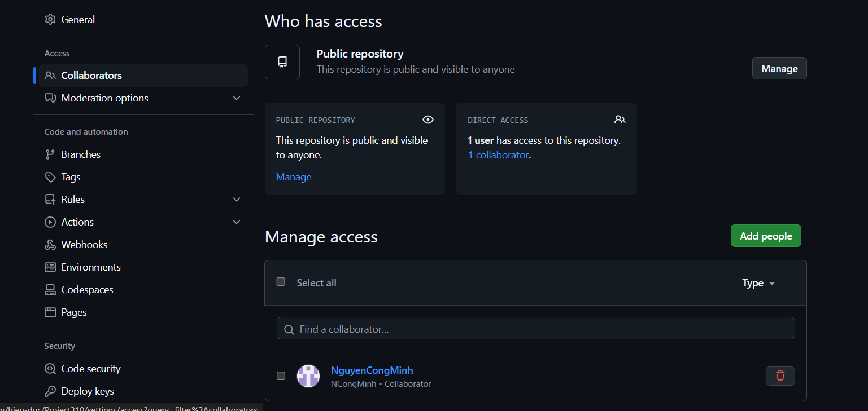

Exploring account settings:

▪ Change username

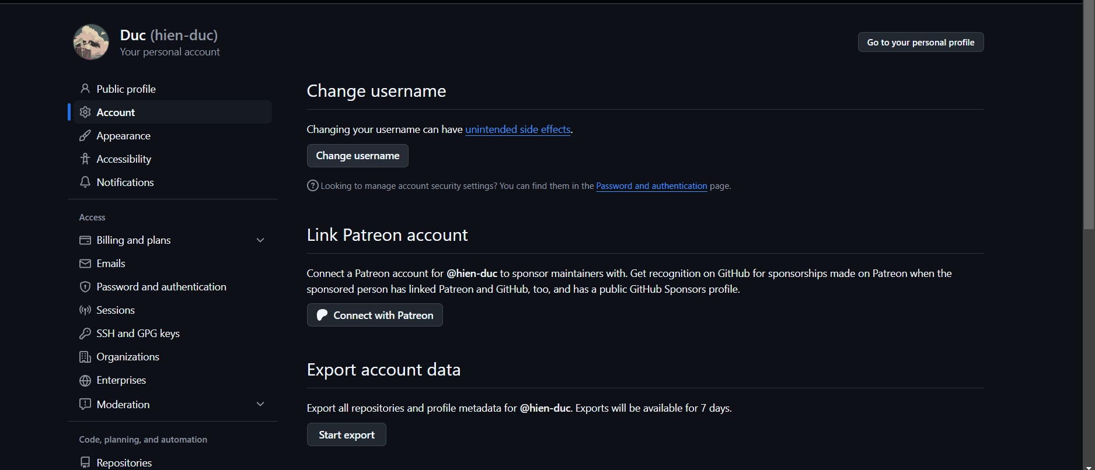

▪ SSH keys

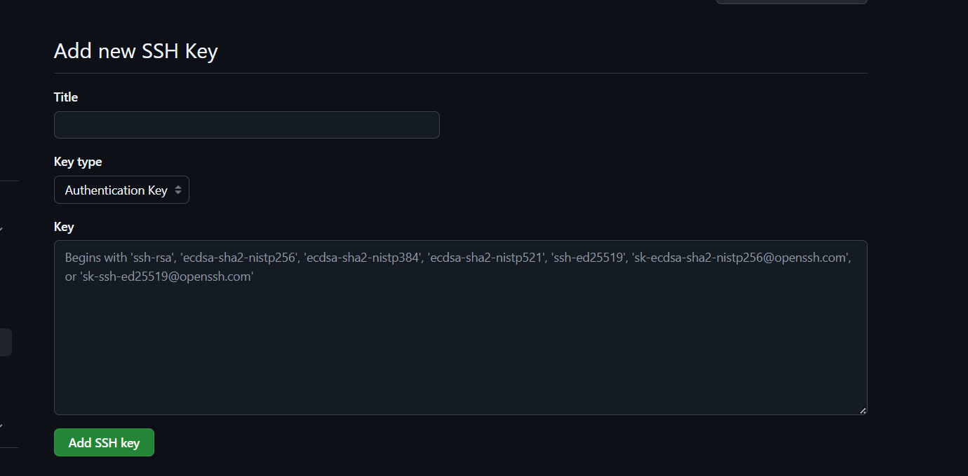

▪ Accept colloaborator invitation

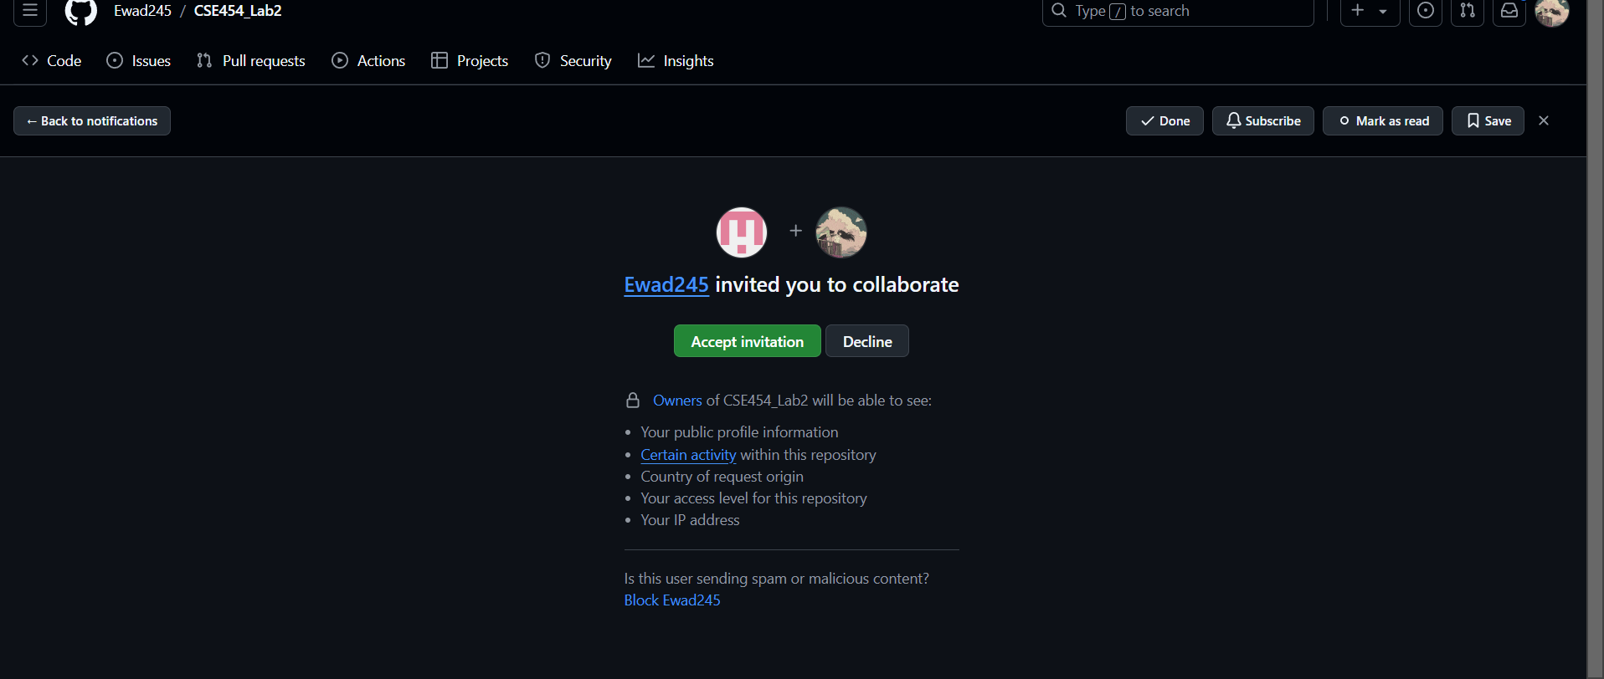

▪ Leave a repository

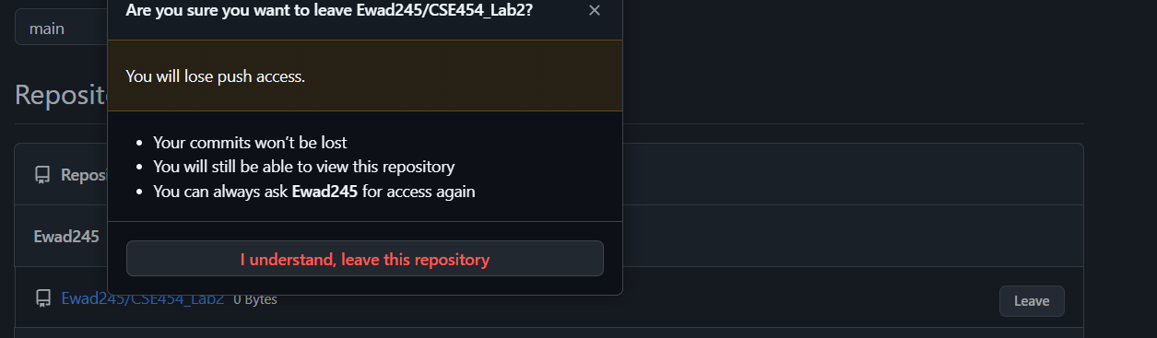

▪ Get Personal access tokens

