**Lab3-CSE454**

**Tran Le Hien Duc**

**2131200129**

**1. Install web server (LAMP)**

**Install Apache (apache2)**

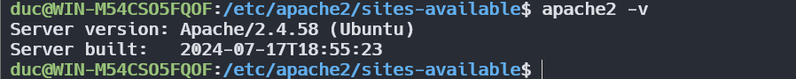

**Install PHP**

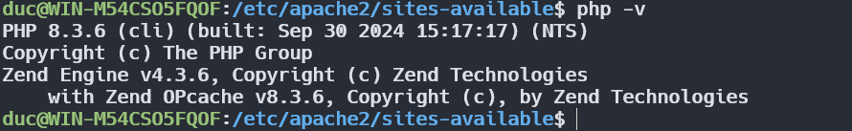

**Install MySQL (mysql-server)**

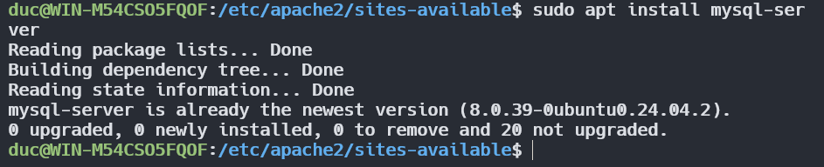

**Config Apache server**

**✓Path: /etc/apache2/mods-enabled/dir.conf**

**✓Modify DirectoryIndex: index.php index.html index.xhtml index.htm**



**Restart the Apache web server (systemctl restart apache2)**



**Assign ownership ($USER:$USER or www-data:www-data) to the your_domain directory**

sudo chown -R www-data:www-data hienduc

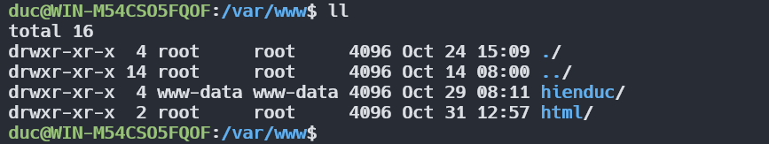

**Assign permissions to the your_domain directory (755 or 744)**

sudo chmod 755 hienduc

**Create an index.html file in the your_domain direactory with any cont**

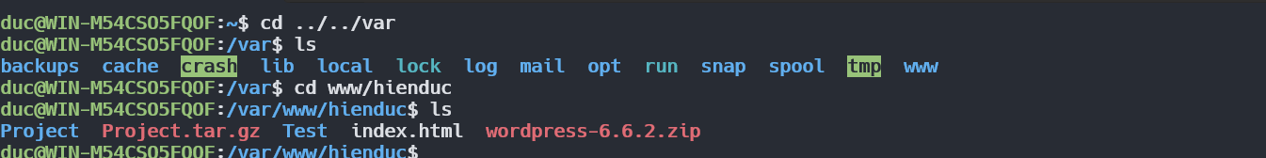

**✓Copy and rename 000-default.conf to your_domain.conf (/etc/apache2/sites-available/) ✓Modify the file:**

**ServerName your_domain**

**ServerAlias www.your_domain**

**DocumentRoot /var/www/your_domain**

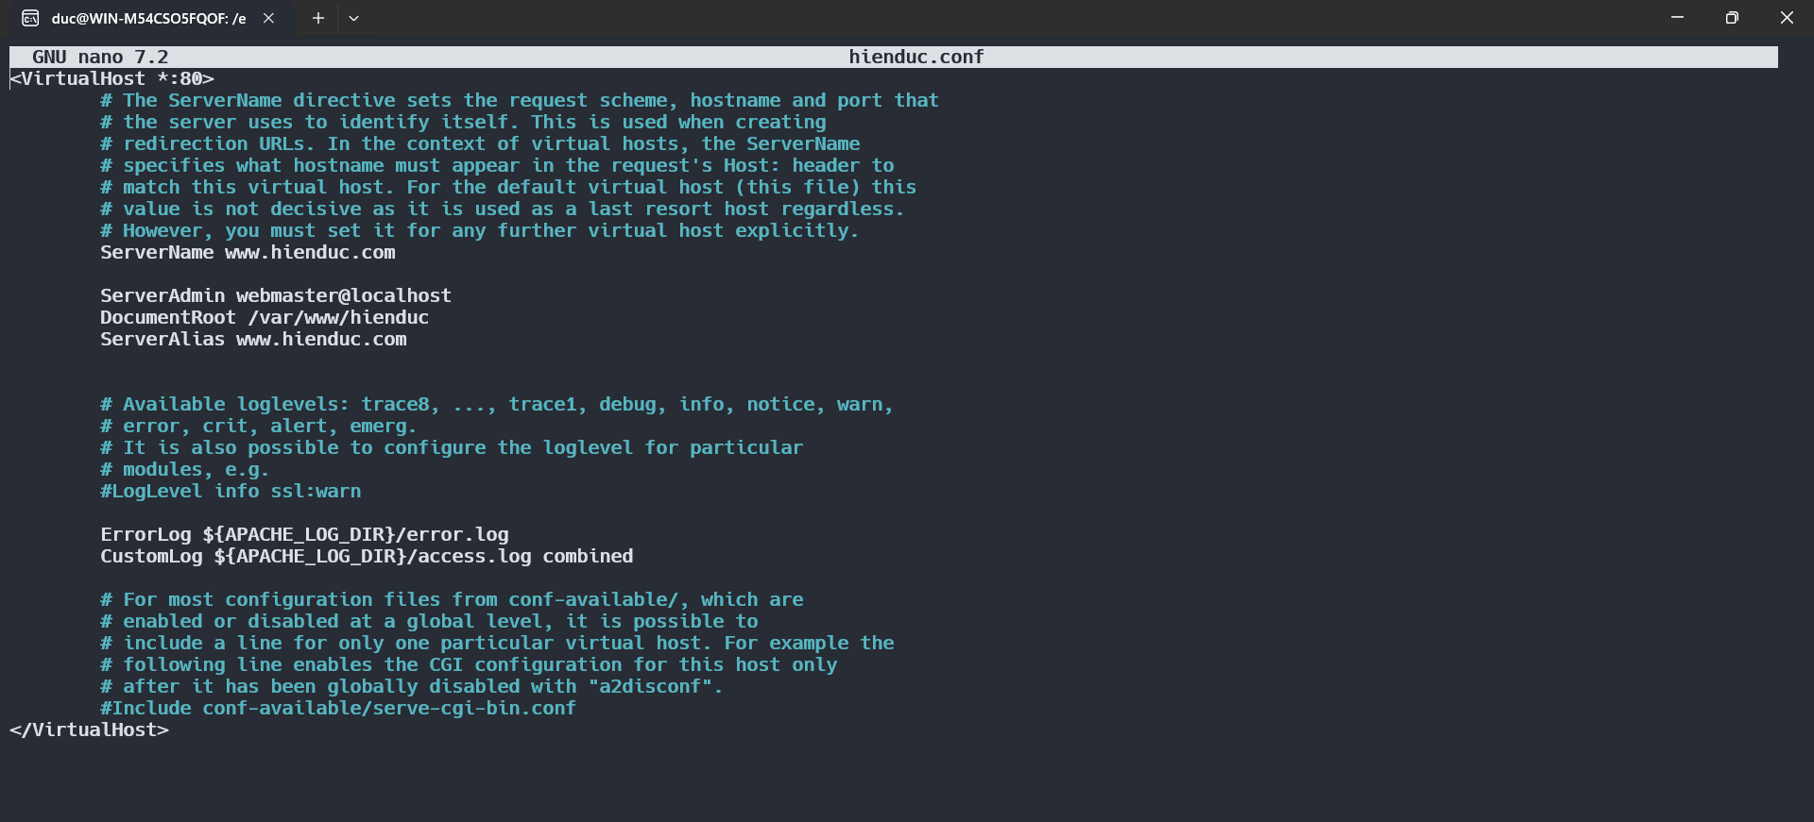

sudo a2ensite hienduc.conf

sudo systemctl reload apache2

**Set up domain name:**

**✓Open hosts file of windows and add the following line: Server_IP your_domain**

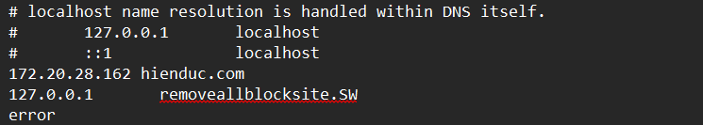

**✓Open a browser and browse url:** [**http://your_domain**](http://your_domain)

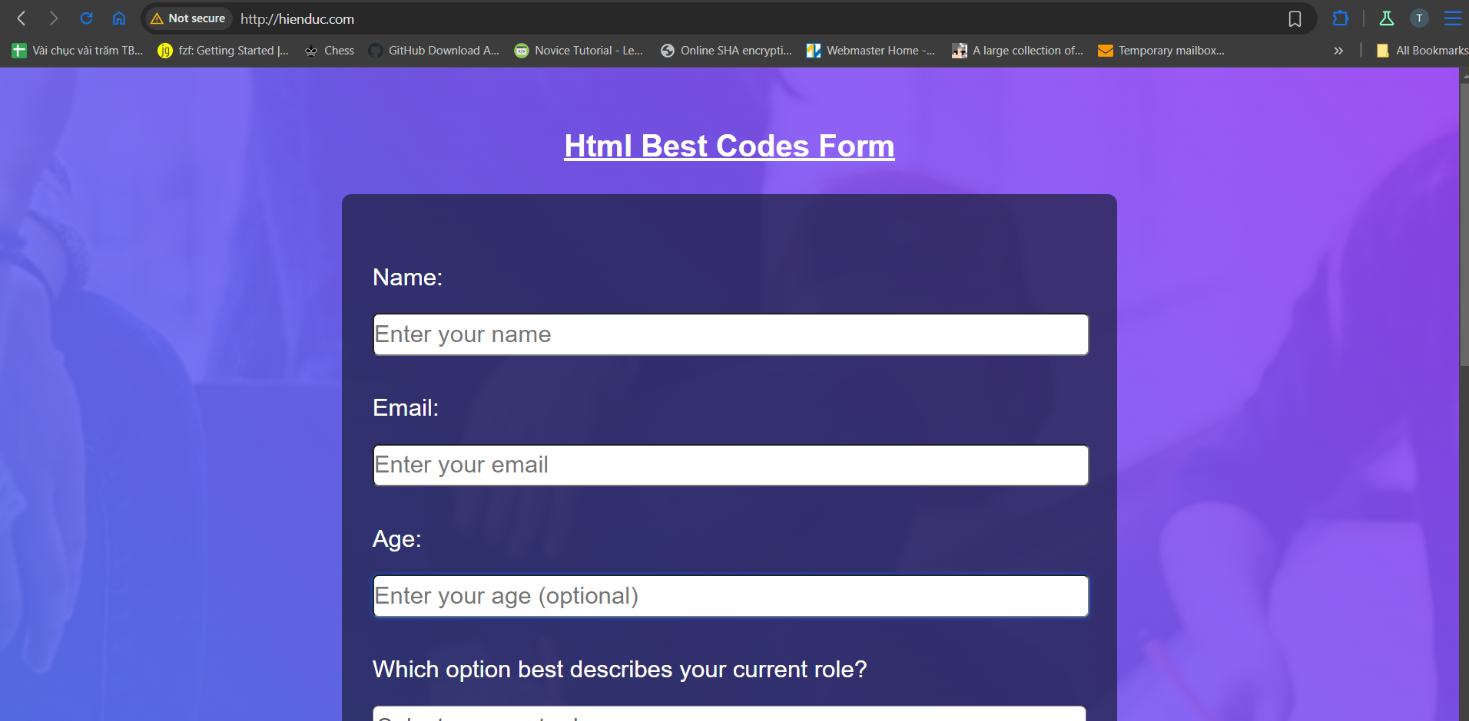

**2. Install web server (LEMP)**

**Install the Nginx (nginx)**



**Install MySQL (mysql-server)**

sudo apt install mysql-server

**Install PHP (php)**

sudo apt install php

**Install the php-fpm module along with an additional helper package, php-mysql, which will allow PHP to communicate with your database backend (php-fpm, php-mysql)**

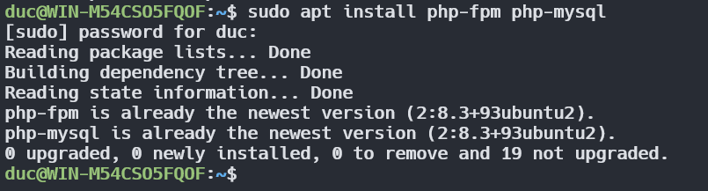

**Configure domain (configure Nginx)**

**Create a new server block configuration file within the /etc/nginx/sites-available/ directory (/etc/nginx/sites-available/example.com)**

**Configure domain**

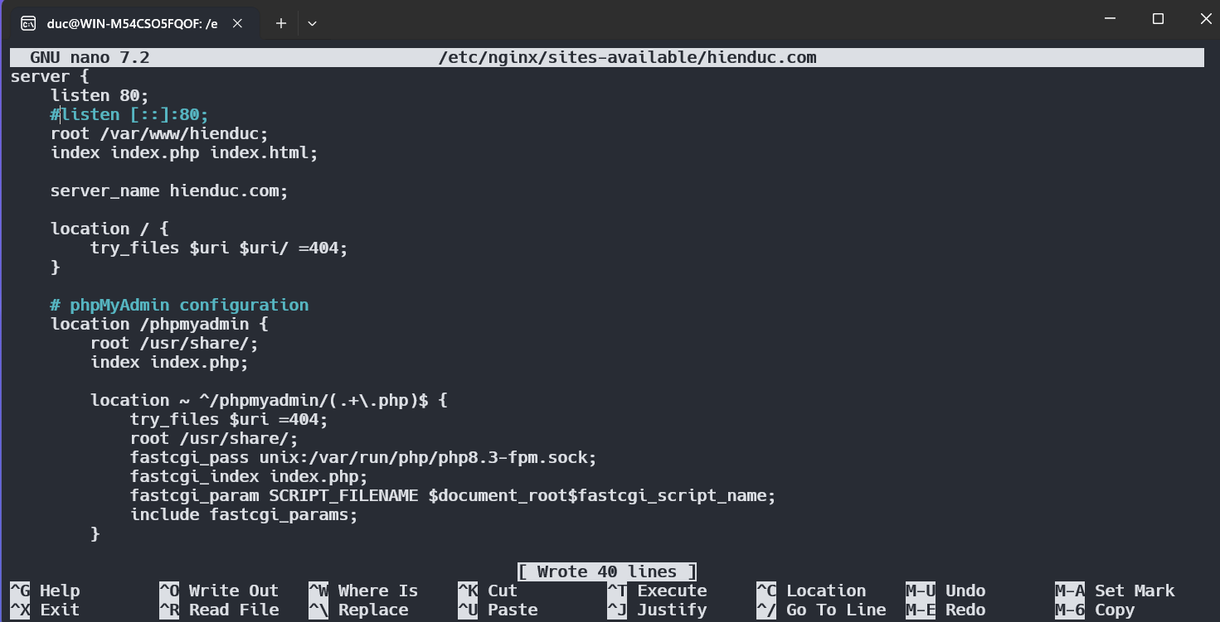

**Enable new server block by creating a symbolic link from new server block configuration file (in the /etc/nginx/sites-available/ directory) to the /etc/nginx/sitesenabled/ directory**

sudo ln -s /etc/nginx/sites-available/hienduc.com /etc/nginx/sites-enabled/

**Test new configuration file for syntax errors (nginx –t)**



**Reload Nginx to make the necessary changes (systemctl reload nginx)**

sudo systemctl reload nginx

**Create a PHP File to Test Configuration**

**✓Create index.php**

**✓Add the line:**

**• Use existing phpMyadmin: Create a soft link form /usr/share/phpmyadmin/ to your_domain directory**

sudo nano /var/www/hienduc/index.php

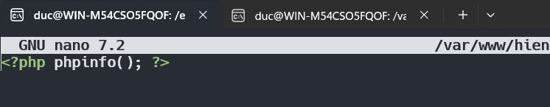

sudo ln -s /usr/share/phpmyadmin/ /var/www/hienduc/phpmyadmin

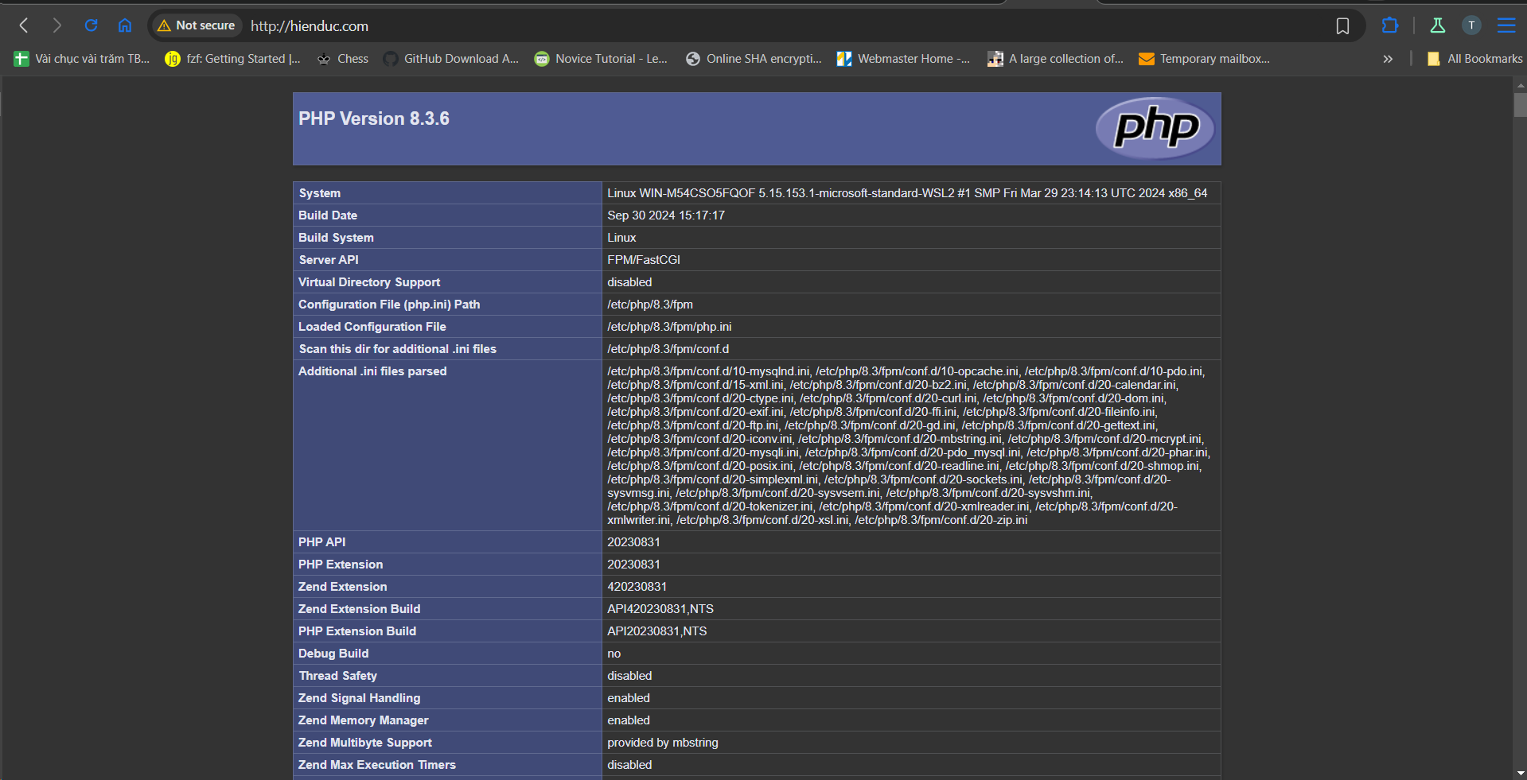

**3. Install and Secure phpMyAdmin**

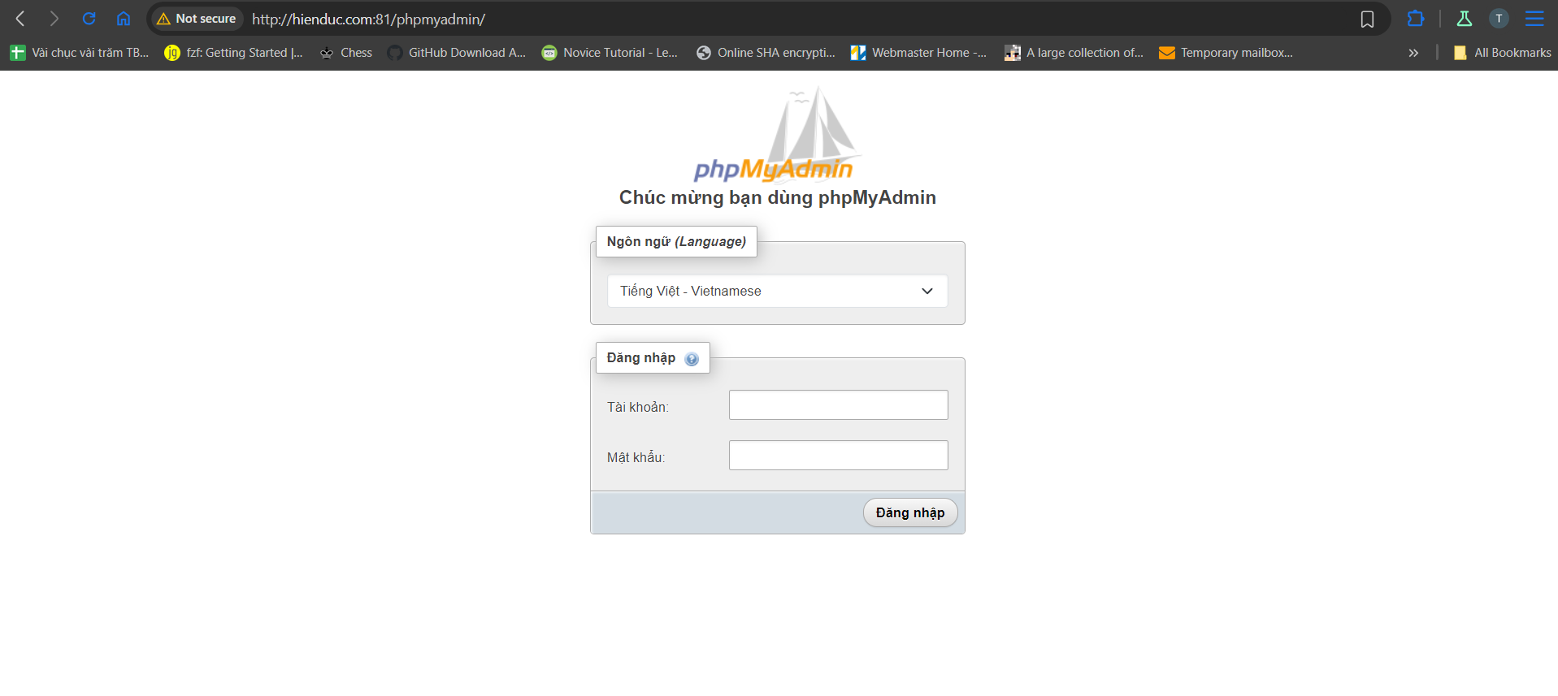

**Install phpMyAdmin (phpmyadmin, php-mbstring, php-zip, php-gd, php-json, php-curl)**

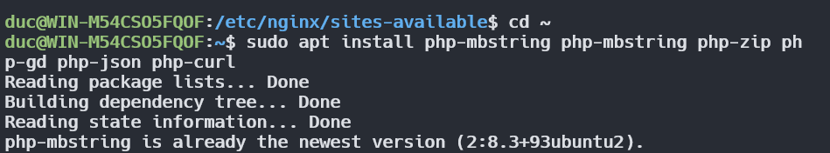

**Enable the mbstring PHP extension (phpenmod mbstring)**

sudo phpenmod mbstring

**Restart Apache for changes (systemctl restart apache2)**

sudo systemctl restart apache2

**Access the web interface by visiting server’s domain name or public IP address followed by /phpmyadmin**

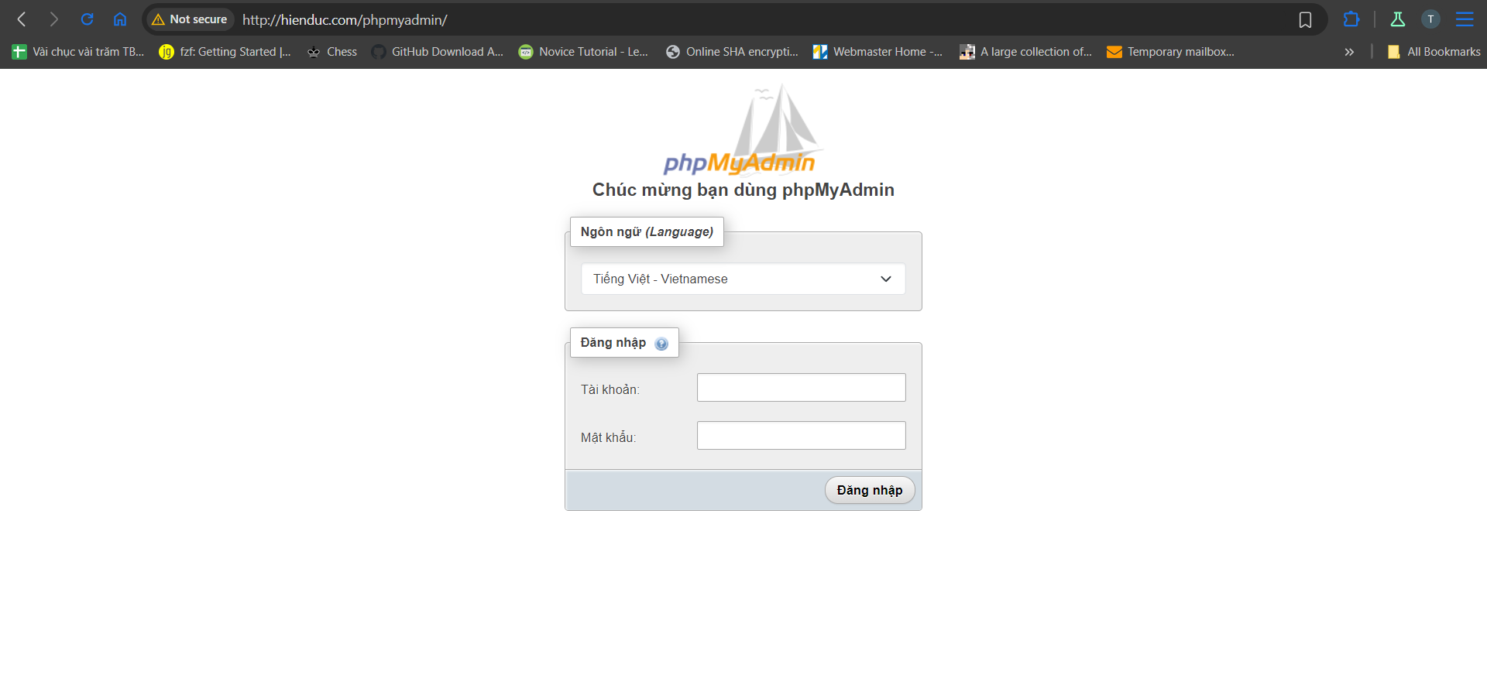

**▪ Manual (For LAMP)**

**• Configuring Password Access for the MySQL Root Account**

**✓Open the MySQL prompt from terminal: sudo mysql**

**✓Change root password**

**✓Create a new user account and grant all privileges**

ALTER USER 'root'@'localhost' IDENTIFIED BY '040503';

CREATE USER 'hienduc'@'localhost' IDENTIFIED BY '040503';

GRANT ALL PRIVILEGES ON *.* TO ‘hienduc’@’localhost’;

FLUSH PRIVILEGES;

