FAMILYHUB PRODUCT SPECIFICATION
Personal Ledger & the “Cá nhân” Tab
What each member keeps to themselves, and how the app keeps that promise.
Your own money book inside a family app. Every member of FamilyHub gets a private ledger — the Cá nhân tab — that the rest of the household cannot see, encrypted under a key only that person holds. Family spending you author flows into it automatically; private spending never leaves it.
Status, 2026-08-29. Live in production. Provisioning, key card unlock, the full tab UI, the family→personal mirror, scope-picked capture, personal budgets (total + per-category), personal incomes, sealed bank-email routing into the personal ledger, and card regeneration are all shipped. This is the first written spec for the feature — reconstructed from the live code and schema, not a forward-looking design.
Audience & layering. Part 1 (Behaviour) is for everyone — product, design, QA, onboarding. Part 2 (Technical Appendix) is for engineers. The Family vs Personal table is the one-glance summary; the five diagrams are the zoom-out views.

Part 1 — Behaviour

1. Summary
- Every user has a personal ledger: their own transactions, incomes and budgets, stored in their own tables and encrypted with a key only they hold. The family cannot open it. FamilyHub (the operator) cannot open it either.
- The person is the root. A family is just a space the person directs money to. A family expense you record shows up in your personal book automatically (the mirror); a private expense stays private forever.
- The ledger is protected by a Personal Key Card — a second key card, separate from the family's. It is shown once, and it is the only way into the data. Lose the card with no unlocked device left, and the data is gone; nobody can recover it, including us. That is the promise working as designed.

2. Why this exists
- Family finance is a subset of each member's personal finance. A person who tracks spending needs the complete picture — what went to the household and what stayed private — in one place that survives anything that happens to the family space.
- Earlier, "personal" was modelled as a special family (internally Model X). It leaked into family metrics and pickers and made recovery depend on shared keys. The current design (Model Y) gives the person their own tables and their own key: personal stats rebuild from the personal key alone.
- Privacy inside the household is the point, not an accident. Money a person spends on themselves — a gift for a partner, a private saving habit — is theirs to share or not. The subtitle on the tab says exactly that: "Sổ riêng của bạn. Gia đình không xem được."

3. What you see — a tour of the tab

3.1 The cash-flow card
The tab opens on a focal card, the same visual system as the family Finance tab, so the two read as siblings:
- "Còn lại tháng này · cá nhân" — income minus spending this month, in red when negative.
- Vào / Ra tiles — tap Vào to open your personal income sheet; tap Ra to jump to the transaction list below.
- A swipeable Day / Week / Month chart compares this period against the previous one. Day view buckets by time of day (Sáng · Trưa · Chiều · Tối), week view runs Mon→Sun against last week, month view compares four weeks against last month. Your last-viewed period is remembered on the device.
- A daily spending guide ("còn tiêu được…") appears once a personal budget exists. It is self-correcting: overspending earlier in the month shrinks what Day and Week say you have left, so a blown month reads as blown everywhere — no false "you're fine today" while the month is failing.
- Four action rows: Ngân sách cá nhân (set or view budget), Xem chi tiêu (category breakdown), Ghi giao dịch (add a transaction), and Khoản thu chi từ email — the bank-email door, with a badge showing how many captured transactions are waiting for review.
- While your authored family expenses are still syncing in, the card says so: "Đang đồng bộ các khoản bạn đã ghi cho gia đình…".

3.2 Các nhóm của tôi — where your money went
A per-space roll-up of this month: one row per family you spent into ("Bạn đã chi cho nhóm tháng này") and, if any, a Riêng tư row — money only you can see ("Chỉ mình bạn thấy").

3.3 Chi theo danh mục — categories against your budget
Spend by category, largest first. With a budget set, a progress bar shows spent vs budget and flips to the danger colour when over ("vượt …"); category bars are then scaled against the budget rather than against each other. Personal budgets support a monthly total and per-category amounts, using the same budget sheet as the family tab, opened in personal scope.

3.4 Giao dịch của bạn — the transaction list
The latest transactions (30 on the tab; the full list opens via Xem chi tiêu). Each row shows the category emoji, note, date — plus a clock time when one is known — and where it went: a family name, or "riêng tư".
Two row types matter:
- Private rows (no space) are yours to edit and delete.
- Mirror rows (a family expense you authored, shown with the family name) are read-only here — you edit them on the family side, and the change flows back into your book automatically.
If some rows cannot be decrypted (wrong card entered at some point, or an interrupted key rotation), the list says so before the rows: "Có N khoản chưa đọc được — chưa tính vào tổng." Unreadable money is excluded from every total and labelled, never silently counted as zero.

4. The Personal Key Card — the one secret
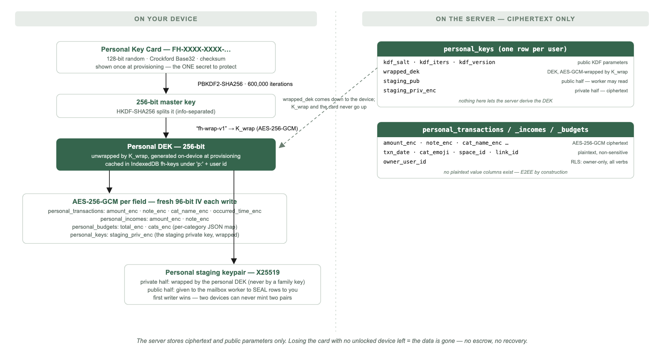
Key hierarchy — what lives on the device, what the server holds
- The first time your personal ledger is prepared, the app mints a Personal Key Card (FH-XXXX-XXXX-…) and shows it once, with save-to-file and copy buttons. This card is distinct from the family's key card, and the sheet says exactly what it is: the key to your personal data — "mất thẻ là mất dữ liệu, không ai khôi phục được (kể cả chúng tôi)."
- On a new device the tab shows "Sổ cá nhân đang khóa" and asks for the card. Typing tolerates dashes, lowercase, and confusable characters (I/L/O/U); a wrong card fails cleanly with "Thẻ không đúng — kiểm tra lại từng nhóm ký tự."
- After that one entry, the device remembers the key — you do not re-enter the card per session.
- See it again: Settings → Mã hóa tài chính → "Xem mã khóa cá nhân" shows the card saved on this device. If this device never saw the card (unlocked before card-caching shipped), it asks you to re-enter it once.
- Lost the card, still have an unlocked device? The same sheet can mint a new card: the app generates a fresh key, re-encrypts every personal row, and only then retires the old card. Interruptions are safe — the old card keeps working until the swap completes, and a re-run picks up where it left off.
- Lost the card and every unlocked device? The data is unrecoverable — by anyone. There is no escrow and no back door; that absence is the guarantee that nobody else can read your book either.

5. Where transactions come from — the four doors

5.1 Typing one in
Ghi giao dịch opens the shared expense sheet pre-scoped to 🔒 Cá nhân. The scope chips (🔒 Cá nhân / 🏡 Gia đình) default to personal — your last choice is remembered — and fall back to family only when the personal ledger isn't unlocked yet. Personal scope trims the form: no member split (a private book has no members), no photos (not wired for personal yet), no bulk-add. The family FAB is hidden on this tab on purpose; the tab has its own quick-add.

5.2 Your family expenses, mirrored automatically
Any realized expense you authored in the active family is copied into your personal book within seconds — labelled with the family name in the list and in Các nhóm của tôi. You never do anything: recording family spending is recording personal spending. Deleting the family copy removes the mirror; editing the family copy refreshes it. The mirror is one-way and read-only on the personal side.

5.3 From your bank's emails
The Khoản thu chi từ email row is the same pipeline the family Finance tab offers (see the bank-email capture spec), opened with the review screen's destination preset to Cá nhân. Each captured row carries its own "Ghi vào đâu?" choice — personal or family — and personal is the default for a connected mailbox. Approved personal rows are written to your private book first; if any of them fails, nothing else proceeds and nothing staged is lost.
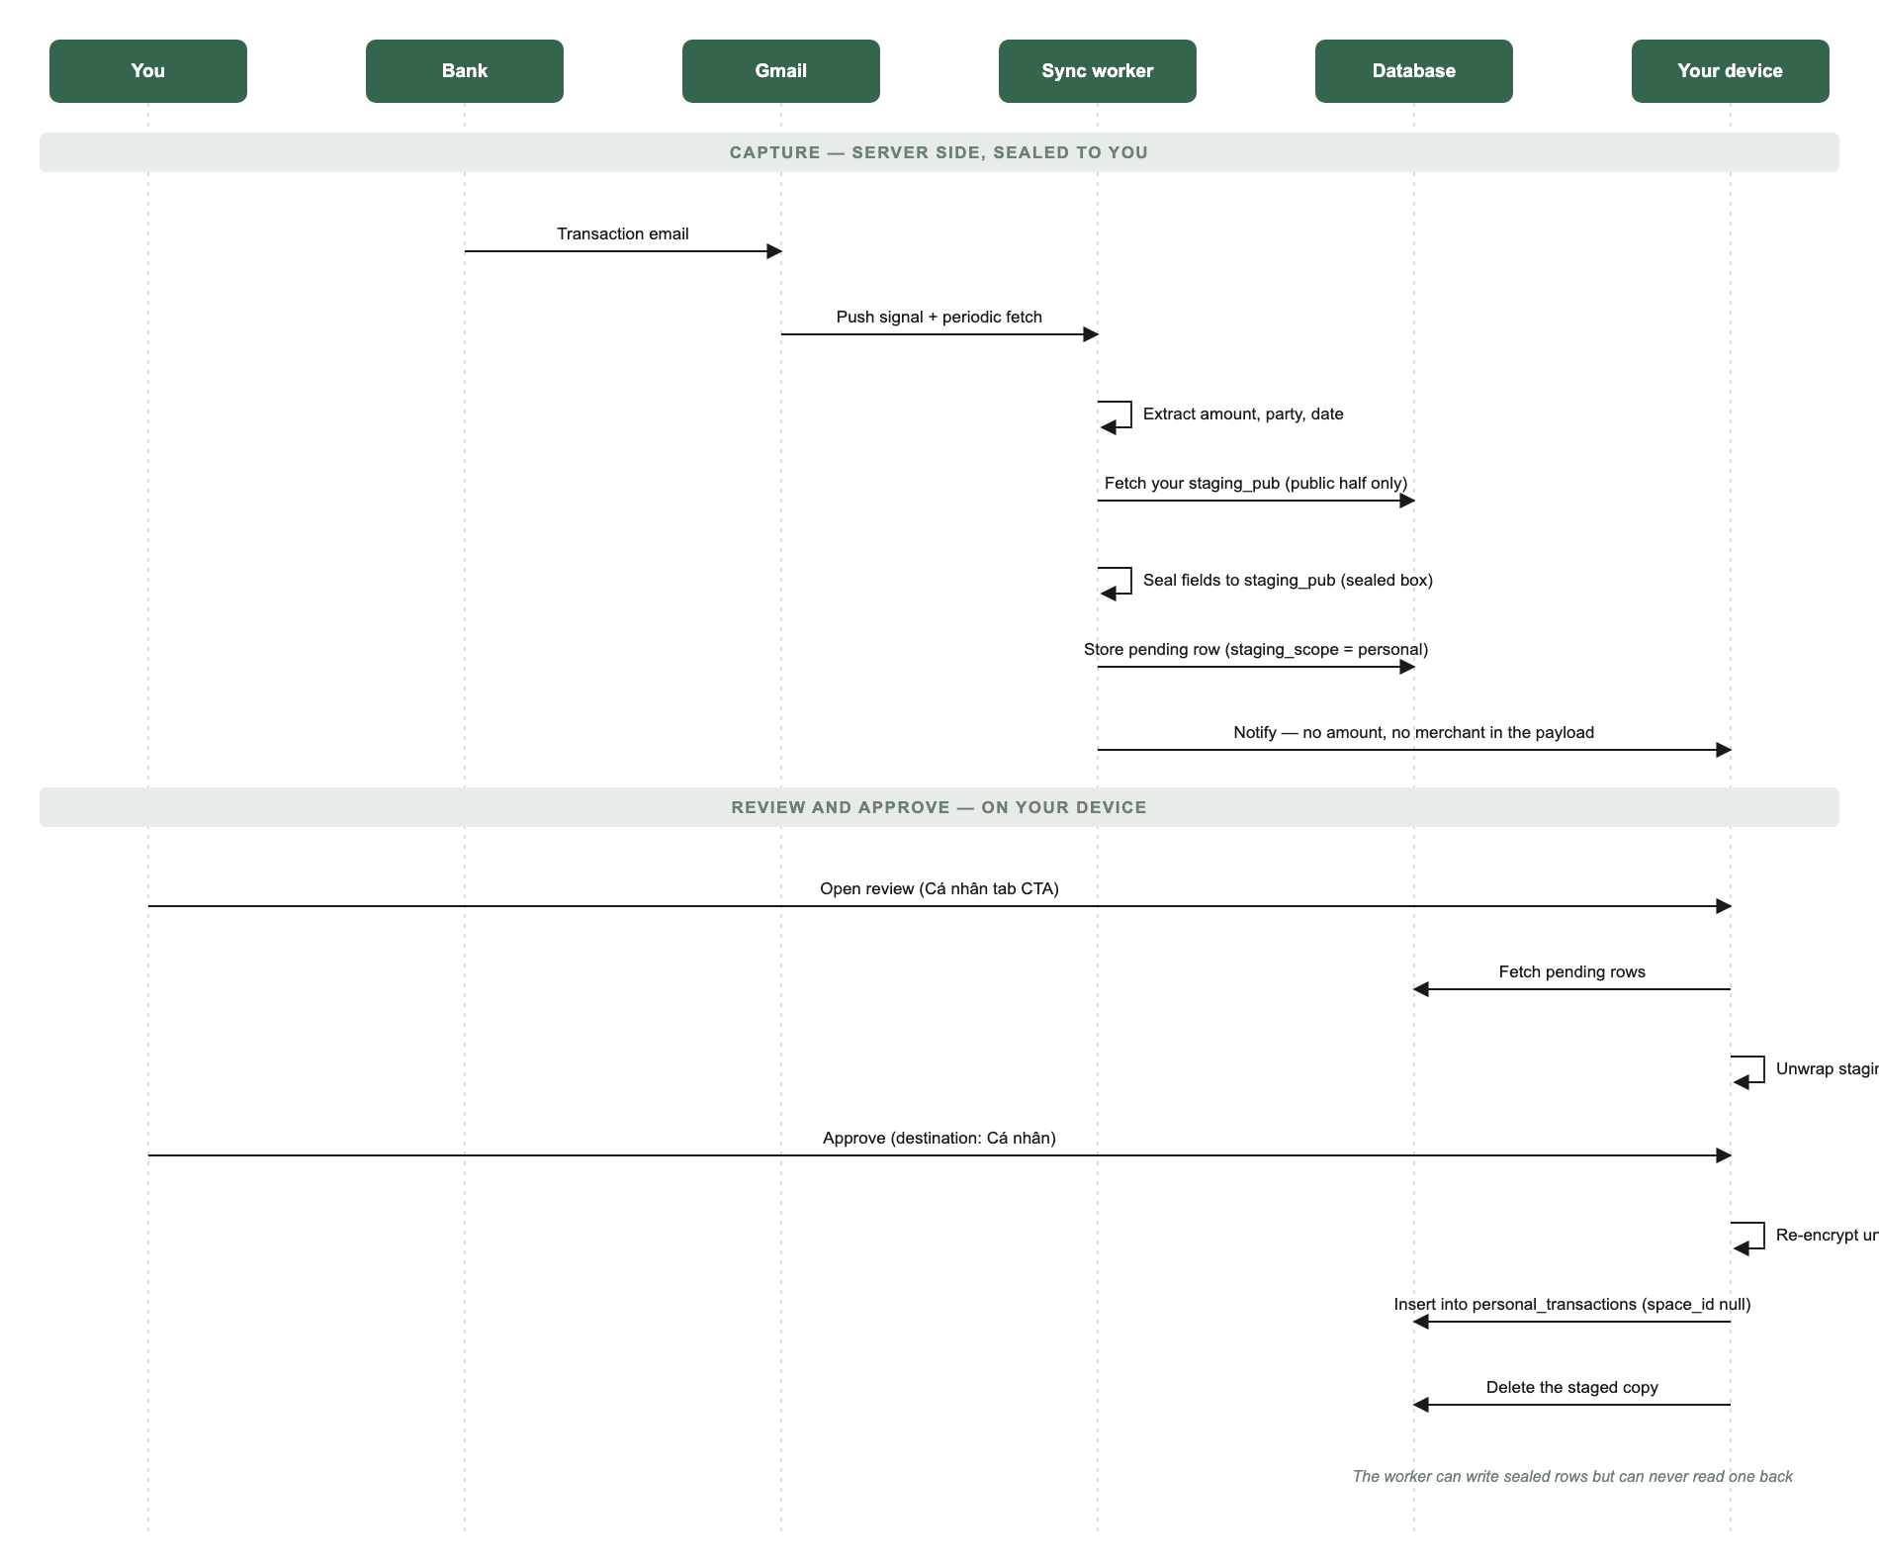
Sealed capture — how a bank email becomes a personal transaction
Captured-but-unreviewed rows are sealed to you personally: the server-side worker that writes them holds only your public sealing key and can never read a row back, and a family member on the same review screen cannot open your rows either.

5.4 Personal income
The Vào tile opens the shared income sheet in personal scope — "Tiền vào của riêng bạn, chỉ mình bạn thấy." Incomes are day-dated amounts with an optional note; add and delete, encrypted like everything else.
Not a door yet: file import (CSV/XLSX) currently writes to the family ledger only. The per-row personal destination exists only for bank-email staged rows.

6. Privacy and trust
- The household cannot see your book. Personal rows live in your own tables, owner-locked at the database level, encrypted under your personal key. A family admin has no more access than a stranger.
- The operator cannot read it either. The tables have no plaintext value columns at all — amounts, notes, category names and times exist only as ciphertext. This is a property of the schema, not a policy: there is nothing stored that could decrypt a row without your card.
- Your personal key is never wrapped by a family key. A "convenient" family-readable copy would quietly hand your private money back to the household — the exact thing this ledger exists to prevent.
- Pending email rows are sealed to you. While a captured transaction waits for review, it is encrypted to your sealing key; the pipeline that wrote it cannot read it back.
- Notifications carry nothing. A "something is waiting" push never includes an amount or a merchant.

7. Family vs Personal at a glance
Aspect | Family ledger | Personal ledger
Who can read it | Every keyed family member | Only you
Key | Family Key Card, shared, socially recoverable | Personal Key Card — yours alone, no escrow
Tables | transactions / incomes + category table | personal_transactions / personal_incomes, own tables
Encryption lifecycle | off → dual → enc migration (legacy families) | Ciphertext-only from birth — no lifecycle
Categories | Family category table | Denormalised name + emoji on each row
Budget | Family monthly + per-category | Personal monthly + per-category (same sheet, own scope)
Photos, reactions, member split | Yes | No (not wired for personal)
Mirror rows | — | Family expenses you authored, read-only copies
Email capture destination | "🏡 Gia đình" chip | "🔒 Cá nhân" chip — the default
If the key is lost | Any keyed member can re-share; social recovery | New card from an unlocked device, else data is gone

8. Safety rules
- Unreadable is never zero. A row that fails to decrypt is counted, labelled, and excluded from totals — the tab tells you it exists instead of silently understating your month.
- Never provision on a read error. A network blip while checking for your key must not mint a fresh card — that would show you a new (wrong) card while your real one scrolls away. Errors show "Thử lại"; only a definitive "no key exists" starts provisioning.
- Mirror rows are machine-owned. The app refuses to edit them on the personal side, and every personal write is additionally filtered to private rows — so the mirror can never be corrupted into disagreeing with the family ledger it reflects.
- Nothing auto-imports. Bank-email rows reach the personal book only through a human tapping Import on the review screen.
- First writer wins for the sealing key. Two devices unlocking at once can never mint two sealing keypairs — the second adopts the first, because a silent overwrite would orphan every row already sealed.

9. Status and current limits
- Live: everything in this Part — provisioning, unlock, the full tab, mirror, scope-picked capture, personal budget (total + categories), personal income, sealed email routing, card regeneration, Settings card viewing.
- Not built yet: transfers between your own accounts (kind='transfer' is schema-ready, unused); publishing a private row out to a family afterwards; friend/trip spaces; photos and reactions on personal rows; automatic categories; full-history view — the ledger decrypts a rolling ~2-month window (this month + last), and older rows, while stored, are not shown.
- The mirror covers the active family only; switching families mirrors that family's rows on its own schedule.
- Personal-tab strings are Vietnamese-only for now (no i18n toggle coverage).

Part 2 — Technical Appendix

10. Architecture in one view
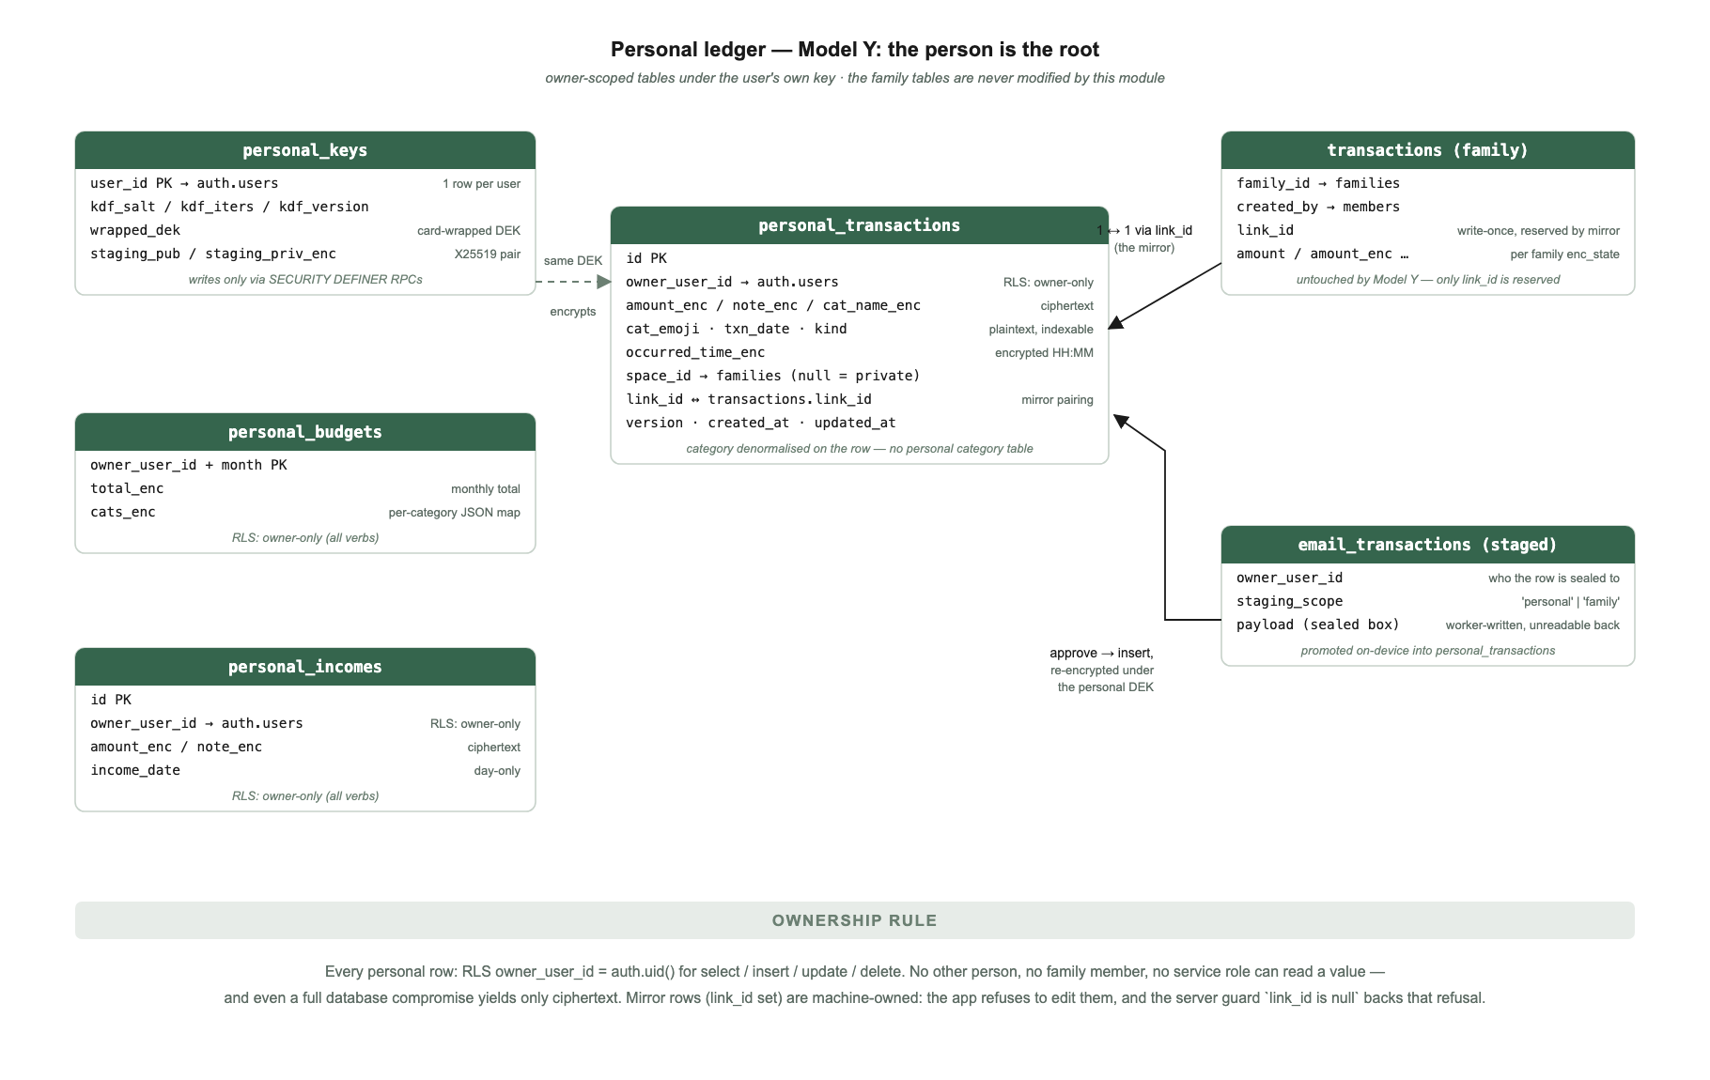
Data model — Model Y, the person is the root
Model Y (the person is the root). Personal data lives in owner-scoped, ciphertext-only tables under a per-user key — not in any family. The family transactions/categories/incomes tables are untouched by this module except for one thing: the mirror reserves link_id on family rows the user authored. There is no off→dual→enc lifecycle and no enc-guard trigger to maintain, because plaintext columns do not exist — E2EE is by construction.
History. Model X (migrations 0076–0077) modelled personal as a families row with type='personal' sharing the family tables; it leaked into family metrics and was reverted. 0079_personal_model_y created the current tables and RPCs; 0080 purged Model-X personal families. Design rationale: docs/features/personal-ledger.md.
Module map.
File | Owns
src/js-data/19-personal.js | State (P), key provisioning/unlock, staging keypair, hydrate, private-row writes, mirror engine, card regeneration
src/js-ui/21-personal.js | Tab rendering, period charts, unlock UI, card intro/view sheets
src/js-ui/10-nav-model.js | go('personal') — lazy boot, hides the family FAB
src/js-data/30-hydrate.js | Calls fhPersonalBoot() once per hydrate (line 416)
src/js-data/20-data-helpers.js | _syncSoon() → fhPersonalMirrorSoon() after every local family write (line 117)
src/js-ui/20-budget.js | Budget sheet in personal scope; Widget A email CTA
src/js-ui/50-sheets-expense-capture.js, 55-expense-photos-writes.js | Scope chips, personal submit/edit/delete
src/js-ui/60-transactions.js | Full list in personal scope; mirror rows read-only
src/js-data/70-goals-income-onboard-ui.js | fhIncome('personal')
src/js-data/72-txn-review.js, 74-autotxn-ui.js, 56-csv-import-ui.js | Staged review: per-row destination, personal seal opening, promotion
src/js-data/66-enc-ui.js | Settings → Mã hóa tài chính → personal card section (lines 118–127)
src/index.html | #v-personal, #t-personal, #sheet-pcard, #sheet-pcode
src/css/40-spending-tabs.css | All pers- / pcard- prefixed styling

11. Schema reference
All four tables: RLS enabled, one policy per table — owner_user_id = auth.uid() (or user_id) for all verbs. No plaintext value columns exist anywhere. *_enc columns are base64(iv‖ct) AES-256-GCM under the personal DEK.

personal_keys — one row per user (0079, extended 0091)
Column | Notes
user_id PK → auth.users, cascade
kdf_salt, kdf_iters, kdf_version | Public KDF parameters
wrapped_dek | DEK wrapped by K_wrap (card-derived)
staging_pub | X25519 public half; service_role may read (column-scoped grant)
staging_priv_enc | X25519 private half, wrapped by the personal DEK

Writes only via SECURITY DEFINER RPCs — there is no insert/update/delete policy at all; the only RLS policy is owner SELECT.

personal_transactions (0079, + occurred_time_enc in 0095)
Column | Notes
id PK
owner_user_id → auth.users | RLS anchor
amount_enc, note_enc, cat_name_enc | Ciphertext
cat_emoji | Plaintext (a content mark, not sensitive)
txn_date (date), kind | Plaintext, indexable; kind ∈ ('expense','transfer')
occurred_time_enc | Encrypted local "HH:MM"; null = day-only
space_id → families, null = private | Which space a master mirrors to
link_id | Pairs with transactions.link_id; null = private row
version, created_at, updated_at | Mirror freshness bookkeeping

Indexes: (owner_user_id, txn_date desc); partial on link_id; partial on space_id. Category is denormalised on the row — there is no personal category table; the tab groups by decrypted name.

personal_incomes (0079)
id PK · owner_user_id · amount_enc · note_enc · income_date · created_at. Index (owner_user_id, income_date desc).

personal_budgets (0083, + cats_enc in 0094)
PK (owner_user_id, month) — month is YYYY-MM-01. total_enc is the encrypted monthly total; cats_enc is an encrypted JSON map { "<category name>": amount }. Upserts write only the columns given, so setting the total leaves the category map untouched.

RPCs (all SECURITY DEFINER, search_path = public, granted to authenticated only)
RPC | Semantics
init_personal_key(salt, iters, version, wrapped_dek) | Insert ON CONFLICT (user_id) DO NOTHING — idempotent; a racing second device never overwrites the first wrap (0079)
rotate_personal_key(...) | Update-or-insert the caller's wrap. Grants nothing new: producing a valid wrap requires holding the raw DEK client-side (0081)
get_personal_staging_key() | Returns {staging_pub, staging_priv_enc}, both null when unprovisioned — the client distinguishes "none yet" from "failed" (0091)
set_personal_staging_key(pub, priv_enc) | First writer wins: updates only WHERE staging_pub IS NULL, then returns the authoritative pair so a racing loser adopts the winner. Never retried with a fresh pair — an overwrite would orphan every box already sealed (0091)

12. Keys and crypto
The construction reuses the family crypto core (src/js-data/15-crypto.js) one level down — see the key-hierarchy diagram in §4.
- Card: 128-bit CSPRNG, Crockford Base32 (I/L/O/U folded on input), CRC-16 checksum group, displayed FH-XXXX-XXXX-…. Parsing accepts any typed/pasted form and fails with length | chars | checksum.
- Derivation: PBKDF2-SHA256, FH_KDF_ITERS_CARD = 600000, then HKDF-SHA256 info-separated into K_auth (unused — the door is Google SSO) and K_wrap (AES-256-GCM, never transmitted).
- DEK: 256-bit, generated on-device at provisioning, wrapped by K_wrap into personal_keys.wrapped_dek. Cached as a CryptoKey in the fh-keys IndexedDB under 'p:' + uid — this is why the card is per-device-once. P.rawKey (exportable raw bytes) exists in memory only, enabling same-session regeneration.
- Card display cache: localStorage['fh-pcard:' + uid] on the owner's device only — powers Settings → "Xem mã khóa cá nhân". Same exposure as the family card cache.
- Field encryption: FHCrypto.encVal/decVal — fresh 96-bit IV per write, base64(iv‖ct).
- Fail-closed decryption. null means "nothing stored"; a sentinel _DEC_FAILED means "stored but unreadable". Only the amount failing takes a row out of totals (_unreadable); an unreadable note or category costs a label, not money. The distinction exists because Number(null) === 0 once folded unreadable rows into monthly totals as 0đ — a wrong key understated spending silently (19-personal.js:40-55).
- Regeneration (fhPersonalRegen): mint new card + DEK; re-encrypt every personal row field-by-field, skipping fields already readable under the new key (resumable after interruption); swap the wrap last via rotate_personal_key — until that succeeds the old card still opens everything. Works from a cold-boot cached DEK (decrypt-capable, raw not exportable).

The personal staging keypair (0091)
Distinct from the DEK, and the distinction is the point: the DEK encrypts what this device writes; the staging pair is what a server-side writer seals to. The mailbox worker holds only staging_pub and can never read back what it writes. The private half is wrapped by the personal DEK and never by a family DEK — a family-wrapped "convenience" copy would make personal money household-readable again. Provisioned lazily after hydrate (fire-and-forget — a missing staging key only delays mail, it must never fail the ledger load), first-writer-wins server-side, with a key-substitution check (fhPersonalStagingVerify) that re-derives the public key from the private half and compares it to the server's copy.

13. Lifecycle — boot, states, hydrate
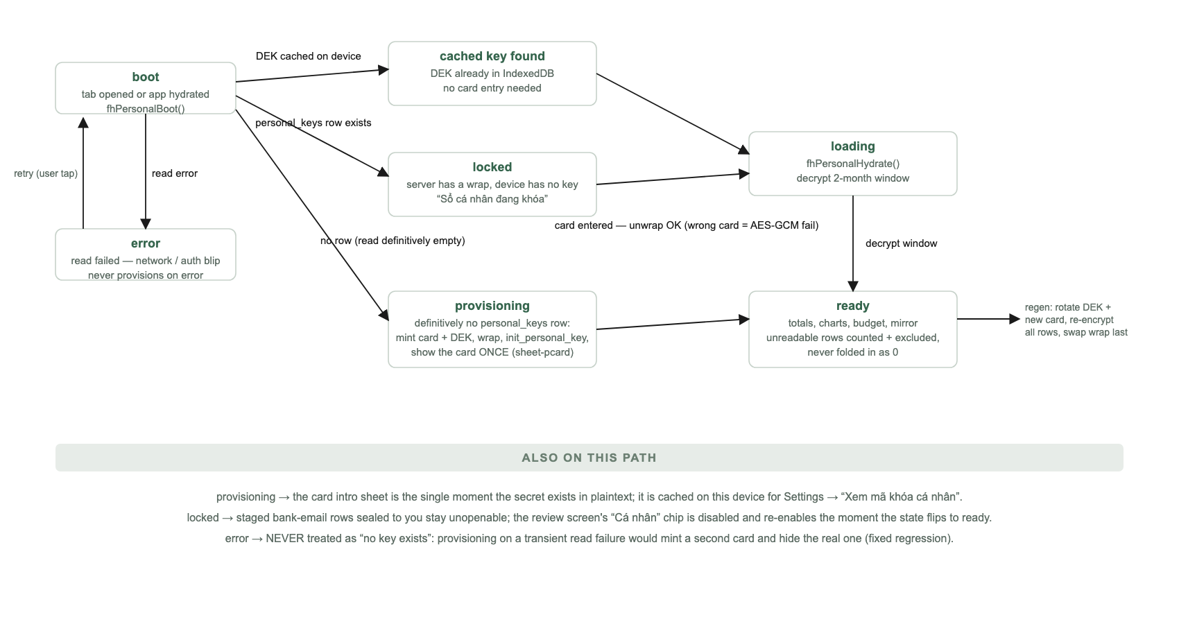
Tab state machine
fhPersonalBoot() runs from hydrate (not awaited) and lazily on first tab open. Order: session uid → IndexedDB key cache hit? → else read personal_keys:
- Read error → error. Never treated as "no key" — provisioning on a transient failure would mint a fresh (mismatched) card every reopen while the server wrap survives (19-personal.js:82-89).
- Row exists → locked (card entry).
- Definitively no row → _provision(): genCard → deriveKeys → genDek → wrap → init_personal_key → cache key + card → card intro sheet.
State changes re-render the tab and the staged-review screen if it is on screen — the review's "Cá nhân" destination chip is disabled while the ledger has no key, and nothing else would re-enable it (19-personal.js:56-71).
fhPersonalHydrate() decrypts a window from the 1st of last month — transactions, incomes, and this month's budget row — into P.txns / P.incomes / P.budget / P.catBudget, counting P.unreadable. Amounts are base units (thousands of VND); fmt() applies the display multiplier.
Rendering (renderPersonal) derives everything from the decrypted month slice with _unreadable rows excluded from every aggregate. Date keys are built locally (_pMonKey, _pDate) — toISOString() is UTC and shifted midnight into the previous month in UTC+7, which once hid the daily guide. The daily guide is self-correcting: remaining month budget ÷ remaining days × period days, with a month-over-month gate — if the month is failing, Day/Week never show a "win". Period choice persists in localStorage['fh-pcfperiod'].

14. The mirror engine
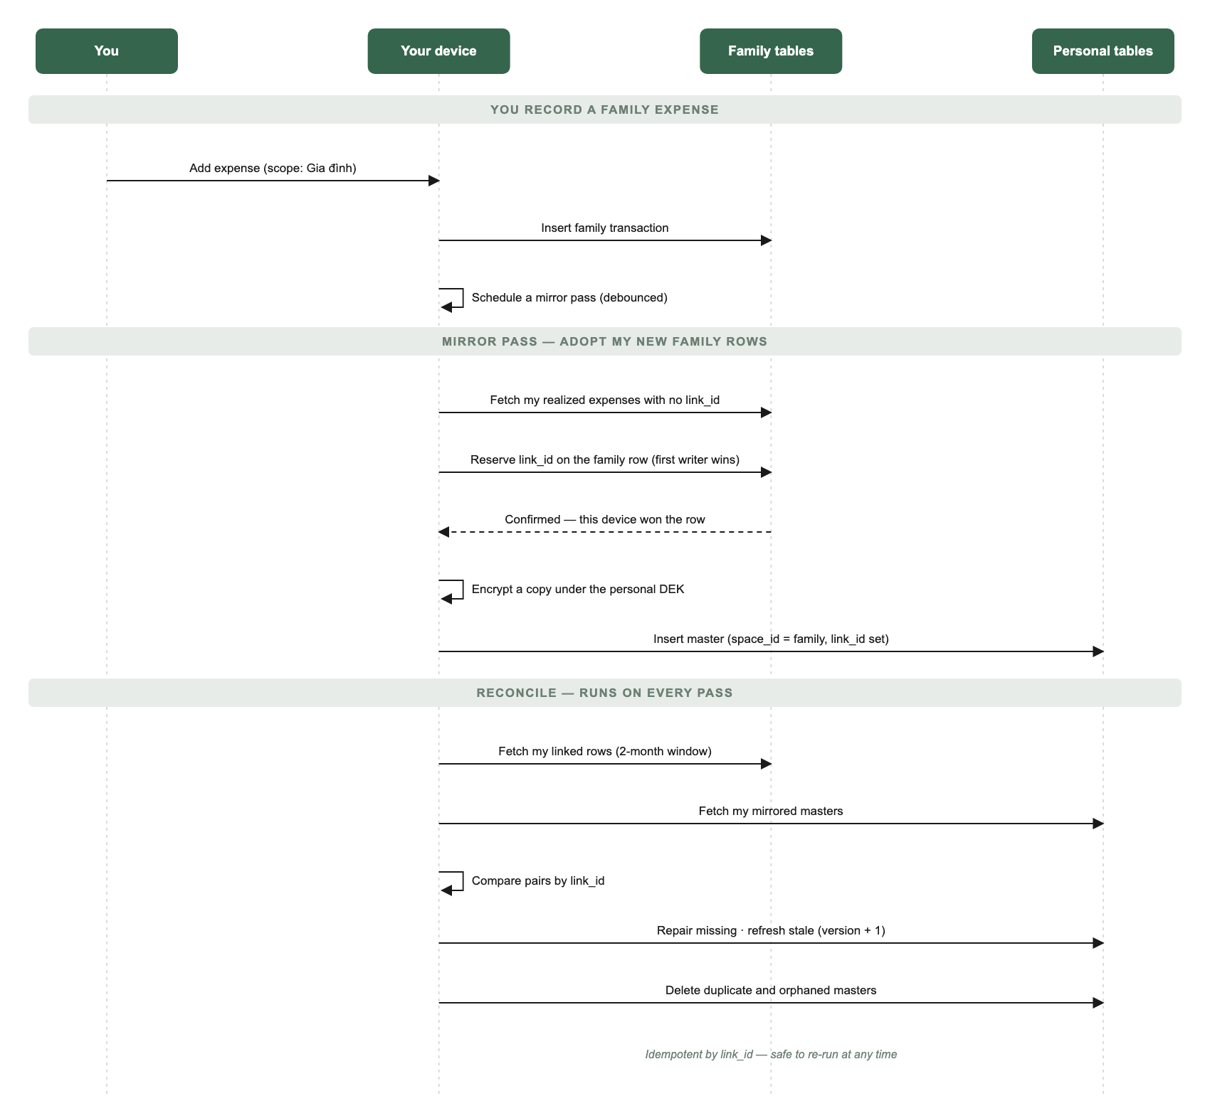
Mirror sequence — family expense to personal master
fhPersonalMirror() (19-personal.js:343-394) maintains the double-entry invariant: my authored, realized family expenses each have exactly one personal master. Masters carry space_id = the family, link_id = the pairing key, and re-encrypted copies of amount/note/category/time under the personal DEK (reading the family side via fhRead, so it works in any family enc_state).
- Adopt: family rows with link_id IS NULL → reserve a fresh link_id on the family row first (UPDATE … WHERE link_id IS NULL … SELECT confirms this writer won), then insert the master. Crash between the two steps is repaired by the next reconcile; the reservation makes adoption race-safe across devices.
- Reconcile: join family rows and masters by link_id over the 2-month window. Missing master → insert. Family updated_at newer and content differs → update master, version + 1. Duplicate masters (same link_id) → keep the oldest, delete the rest. Master whose family row is gone → delete (tombstone).
- Scheduling: debounced 1.5 s after every local family write (_syncSoon), after hydrate/unlock, with bounded retries while the family key or roster isn't ready. Guarded by an in-flight flag; idempotent by link_id, so overlapping passes converge.
- Ownership rule: client edit/delete of personal rows always filters .is('link_id', null) — a mirror row edited locally would just be undone by the next pass, so both the UI and the write predicates refuse. On the family transactions table, a trigger (_fh_link_guard, 0076) makes link_id write-once and version non-decreasing.

15. Sealed staging — the email → personal path
Server-side, personal money only ever lands in email_transactions (the staging table), sealed to the user's staging_pub; the insert into personal_transactions happens on-device after review (diagram in §5.3).
- The worker resolves a grant with default_scope='personal' → requires grant.user_id → fetches staging_pub via a column-scoped service_role grant → seals the payload (X25519 sealed box, owner_user_id bound inside the box) → writes email_transactions with staging_scope='personal' (supabase/functions/_shared/mailbox/{identity,stage,sealed-box}.mjs). A user without a provisioned staging key holds the message (no data loss) until the key exists.
- The review screen branches per row on staging_scope: personal rows open with fhPersonalStagingPrivKey() (requires the personal DEK — the family key "is no help here and must not be tried"), family rows with the family staging key (72-txn-review.js:198-225).
- Promotion (fhPromoteStaged): selected rows split by per-row scope; personal rows are written first via fhPersonalAddIncome (credits) / fhPersonalAddExpense (debits) with space_id = null; any personal failure aborts before family writes and before staged-row deletion.
- Scope gating: a locked personal ledger downgrades a row's effective scope to family and refuses the personal chip with a toast; the remembered default (localStorage['fh-staged-scope']) is never persisted as personal while locked.
- OAuth mailbox connect defaults to personal (74-autotxn-ui.js); a personal-only user (no family) is locked to personal. A URL preset may narrow family→personal, never widen.

16. Shared sheets in personal scope
One flow each, scope-picked — the personal tab retired all its bespoke sheets:
- Expense — openPersonalExpense() = openExpense({scope:'personal'}). Chip default: last choice, else personal when ready, else family. Personal layout drops member-split, photos, bulk-add. Submit requires P.key (toast "Mở khoá sổ cá nhân" otherwise). Edit/delete exist only for private rows (openPersonalTxEdit → fhPersonalUpdateExpense / fhPersonalDeleteExpense).
- Budget — openPersonalBudget() sets budgetScope='personal' on the family budget sheet; personal branch builds its category universe from the ledger's own rows + saved map, has no catch-all "Others" row, and saves via fhPersonalSetBudget(total, cats).
- Transactions list — openTxns('personal') snapshots the ledger into the shared list (_pBuildTxnCtx); title "Chi tiêu cá nhân". No avatars, reactions, or detail screen; private rows tap-to-edit, mirror rows inert.
- Income — fhIncome('personal') lists/adds/deletes against personal_incomes, guarded on state === 'ready'.

17. Failure modes
Scenario | Behaviour
personal_keys read fails (cold-open auth race, network) | error state, "Thử lại". Never provisions — that minted a fresh mismatched card every reopen (fixed regression)
Wrong card entered | parseCard checksum, or AES-GCM unwrap failure — "Thẻ không đúng…". No server round-trip needed to know
Row decrypts to garbage (wrong key epoch, half-finished rotation) | _DEC_FAILED sentinel → _unreadable; excluded from all totals, listed as "Chưa đọc được", banner with count. Re-unlocking with the right card heals
Regen interrupted mid-re-encryption | Old card still valid (wrap swapped last); re-run skips already-migrated fields and completes
Two devices provision the staging pair at once | Server updates only while staging_pub IS NULL; both calls return the winner; loser adopts, never retries with a fresh pair
Mirror crashes between link_id reservation and master insert | Next reconcile pass finds the linked family row with no master and inserts it
Family row edited/deleted after mirroring | Reconcile refreshes (version+1) or tombstones the master within the window
Duplicate masters (historic race) | Self-healed: first kept, rest deleted
Review queue opened before the personal key resolves | Destination chip disabled; _setState re-renders the staged review on unlock so the chip corrects itself without closing the sheet
Staged personal write fails during promotion | Abort before family writes and before deleting staged rows — nothing is lost

18. Security invariants
1. Personal tables are ciphertext-only — no plaintext value columns exist, in any state. E2EE is by construction, with no migration lifecycle. 2. RLS: owner_user_id = auth.uid() for all verbs on all personal tables; personal_keys is select-only + RPC writes; service_role may read only (user_id, staging_pub). 3. The personal DEK is wrapped only by the card-derived K_wrap. Never by a family key. The staging private key is wrapped only by the personal DEK. 4. No escrow, no recovery path that doesn't hold the card or an unlocked device. Operator compromise yields ciphertext + public KDF parameters. 5. init_personal_key is idempotent (DO NOTHING); set_personal_staging_key is first-writer-wins; link_id on family rows is write-once (trigger). 6. Server-side writers touch personal money only as sealed boxes in email_transactions; the sealed box binds owner_user_id; the writer cannot read back. 7. The card plaintext exists in exactly three places, all user-controlled: the intro/view sheet, the owner-device cache, and whatever backup the user saved. 8. Unreadable ciphertext is fail-closed: surfaced and excluded, never coerced to 0.

19. Glossary
Personal ledger. Your private transactions/incomes/budgets under your own key — the Cá nhân tab's data.
Space. A shared container (family today; friend/trip designed) a person directs money to. Personal is not a space.
Master / mirror row. The personal copy of a family expense you authored; space_id = the family, paired 1↔1 by link_id.
Private row. space_id and link_id null — never leaves your book.
Personal Key Card. The 128-bit card that derives the wrap key for your personal DEK. The one secret to protect.
DEK. Data-encryption key; AES-256-GCM key that encrypts every personal field value.
Staging keypair / sealed box. X25519 pair; the worker seals captured bank-email rows to the public half; only your devices hold the private half.
Staged transaction. A captured row in email_transactions waiting for review — not yet in any ledger.
Unreadable row. Stored ciphertext that the current key cannot open; counted and excluded, never zero.
Model X / Model Y. The retired personal-as-a-family design / the current person-is-root design.

20. Related documents
- docs/features/personal-ledger.md — design rationale and locked decisions.
- docs/features/encryption.md, docs/features/key-card-auth.md — the family-side crypto this construction mirrors one level down.
- docs/specs/bank-email-capture-spec.docx — the capture pipeline feeding §5.3.
- docs/specs/transaction-review-spec.md — the review screen where staged rows become ledger rows.
- Migrations: 0079 (Model Y), 0080 (Model X purge), 0081 (rotate), 0083 (budgets), 0091 (staging keypair + scope), 0092–0093 (mailbox scope/backfill), 0094 (category budgets), 0095 (transaction time).

