FAMILYHUB PRODUCT SPECIFICATION
The Family Tab (“Gia đình”) — Shared Family Finance
One place the household reads its money: what’s left, what’s promised, and what everyone thinks about it.
One place the whole household reads its money: what's left this month, what's already promised, what everyone thinks about it — and one place every đồng enters the shared ledger. The tab the app labels Gia đình (internally spending, view #v-spending) is FamilyHub's financial center of gravity: every other money feature is either a widget on this scroll or a door opened from it.
Status, 2026-08-29. Live in production. The cash-flow card with the three-period chart and self-correcting daily guide, budget + categories with the "Others" catch-all, saving goals and the savings pool, the proposal / alignment flow, reactions, the expense capture sheet (bulk natural-language entry, photos, per-row time), file import, bank-email review routing, offline outbox, realtime sync, and family E2EE are all shipped. This is the first written spec for the tab — reconstructed from the live code, schema, and feature docs, not a forward-looking design.
Audience & layering. Part 1 (Behaviour) is for everyone — product, design, QA, onboarding. Part 2 (Technical Appendix) is for engineers. The five diagrams are the zoom-out views; the Family vs Personal table is the one-glance boundary with the sibling personal-ledger spec.

Part 1 — Behaviour

1. Summary
- The Family tab is the household's shared money book: spending, income, budget, savings and goals that every keyed family member can read and write. It answers one question in passing — can we still spend? — and it answers it honestly, counting not just receipts but promises.
- The headline arithmetic is safe to spend = budget − spent − reserved. Reserved is money the family has committed but not yet paid: event set-asides, plus future expenses — and a future expense someone typed in counts only after another member has agreed to it.
- Money enters through many doors — typing (single or bulk), receipt photos, file import, bank email — but every door funnels into one write path, one review vocabulary, and one ledger.
- The social layer is deliberately split in two: reactions (five emoji, free-form, on money already spent) and reviews (the same five emoji re-labelled as consent, on money not yet spent). Only one specific signal — a 🥰 from someone other than the proposer — changes what the money does.
- Everything on the tab is protected by the family's end-to-end encryption once it is turned on: amounts, notes, names, and photos are ciphertext to the database and to FamilyHub the operator. A locked device can look (placeholders), but cannot write.

2. Why this exists
- Budget-vs-actual is the wrong question. A family that has spent 40% of its budget on day 10 is ahead of pace; the same 40% on day 25 is comfortably under. The tab is built around pace and headroom — the run-rate marker, the per-day guide, the week/month comparisons — so "can we spend?" is answered without anyone doing math.
- Committed money must count before it is spent. An event the family is funding, or a couch one partner plans to buy next week, is not free money. If "safe to spend" ignored promises, the number would flatter the family into overspending. The reserve concept exists to make the headline number the real number.
- Shared money needs consent, lightly. A future expense typed by one member should not unilaterally claim family budget. The proposal flow is deliberately not an approval workflow — it is a single "yes, count me in" from any other member, expressed with an emoji the family already uses.
- Logging must be effortless or it stops. Bulk comma entry with Vietnamese amount shorthand ("cafe 50k, chợ 200k"), guessed categories, drafts that survive an accidental swipe, photos, imports, and bank email all exist to keep the ledger alive past week three.

3. What you see — a tour of the tab
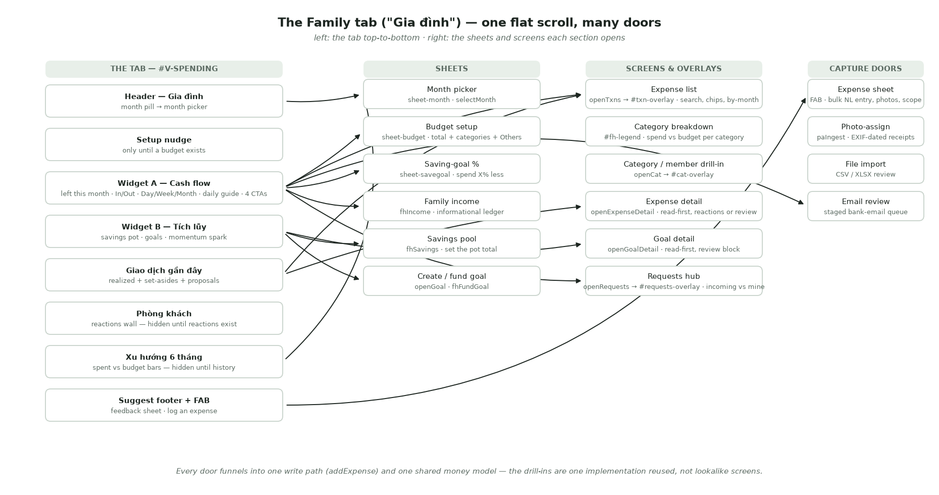
The tab and everything it opens
The tab is one flat scroll — the old overview / breakdown / activity segments are now just scroll anchors. Top to bottom:

3.1 Header and month picker
Title "Gia đình", subtitle "Chi tiêu, thu nhập và tiết kiệm của cả nhà." ("The family's spending, income and savings.") A month pill opens the month picker: one row per month the ledger knows, each with spent trên budget and a verdict — a closed month reads "dưới ngân sách / vượt ngân sách" (under / over budget), the live month "đang diễn ra" (in progress). Picking a month re-renders the whole tab in that month's context.

3.2 First-run nudge
Until a monthly budget exists, a single card sits on top: "Lập ngân sách cho cả nhà" ("Set up your budget") — and removes itself the moment one is saved.

3.3 Widget A — the cash-flow card
The focal card. "Còn lại tháng này" ("Left this month") = income − spent, red when negative. Two tiles: ↑ Thu (tap → the family income sheet) and ↓ Chi (tap → glide to the transaction list).
Below the number, a swipeable chart with three periods on the live month — Day · Week · Month — sharing one bar language: faint bars are the previous comparable period, solid bars are now, and a bar turns warning-colored when it beats its faint twin.
- Day buckets today by buổi — Sáng · Trưa · Chiều · Tối — against yesterday. A transaction's hour comes from when it was logged; unknown hours land in the current buổi.
- Week runs Mon→Sun against the same days last week.
- Month compares four fixed week-buckets against last month's.
- The three views auto-rotate every few seconds when the card is visible (never under reduced motion); any touch pauses them, and a manual pick is remembered on the device. A past month shows the classic week chart plus a week-over-week note ("▼ Giảm … so với cùng kỳ tuần trước") instead of periods.
The daily guide ("Hôm nay còn tiêu được" / "Left to spend today") appears once there is any basis for one, as a tinted tile with a water-level circle. It is self-correcting: the allowance is what's left of the month's budget spread over the days left, sliced to the period — so once the month's budget is blown, Day, Week and Month all read "over" together; a good Tuesday can never say "keep spending" while the month is failing. The allowance is capped by last month's daily pace (the saver of the two signals) and tightened by the family's saving goal. Colour tells the trend: green/yellow/orange headroom under plan; over plan but spending less than the previous period stays orange (improving); over both goes red. Tapping the tile opens the saving-goal sheet: "Tiêu hoang như trước" (0%) or "Tiêu ít hơn 10/15/20/50%", each with an estimated monthly saving; a tap applies instantly, family-wide.
The card ends with up to four full-width action rows: Lập ngân sách (set up budget), Xem chi tiêu (view expenses), Đề xuất chi tiêu (expense proposals — only when some are open, badged with the count), and Khoản thu chi từ email (the bank-email door — always present, badged when captured transactions are waiting for review).

3.4 Widget B — Tích lũy (savings)
The savings card: pot total = money already in goals plus the free pool. A sub-label reads "Cần thêm …" (to go), flips to "… sắp đến hạn" when goals are due within 30 days and short, or "Hoàn tất" when nothing is left to save. Goal rows show emoji, name, saved / target, an "quá hạn" (overdue) tag when past-date and unfunded, and a slim meter. Completed goals fold into one expandable row. When the family saved more this month, a momentum spark says so ("Tháng này để dành thêm …"). The ＋ button creates a goal; the total opens the pool sheet. With no goals yet, the card carries its own CTA: "Tạo mục tiêu đầu tiên."

3.5 Giao dịch gần đây — the activity feed
One card, one timeline. Future money first — event set-asides and future expenses, farthest due date first, each labelled with who proposed it and where it stands ("chờ sếp duyệt" / "sếp duyệt rồi") — then realized spending from today and yesterday only; the full history lives behind "Xem tất cả". The header flips from "Giao dịch gần đây" to "Hoạt động" whenever future rows exist. Rows carry the category emoji (or the receipt photo as the tile), the payer's avatar, note, date + optional clock time, amount, and any reactions. A brand-new family sees a first-run card: "Ghi khoản chi đầu tiên."

3.6 Phòng khách — the reactions wall
"Hoạt động gia đình": a horizontal rail of poster cards, one per reacted-to transaction — the photo (or a gradient), the lead emoji, a deterministic one-liner ("Hân đang xỉu ngang vụ này"), note · amount · age. Hidden entirely until the family has reacted to something. Tapping a card jumps to that expense.

3.7 Xu hướng 6 tháng — the trend
One bar per known month, spent vs a dashed budget line, current and over-budget months styled distinctly. Hidden until some month has real spending ("an all-flat trend reads as broken, not empty"). Tapping a column selects that month everywhere.

3.8 The FAB and the suggest footer
The floating ＋ is the family quick-add: a sheet with Ghi giao dịch, Nhập từ file, Ghi thu nhập, Bỏ ống tiết kiệm, Tạo mục tiêu, plus the Moments group. The footer is a feedback door ("Có ý tưởng hay muốn góp ý? Kể tụi mình nghe nha 💛").

4. The money model — spent, reserved, safe
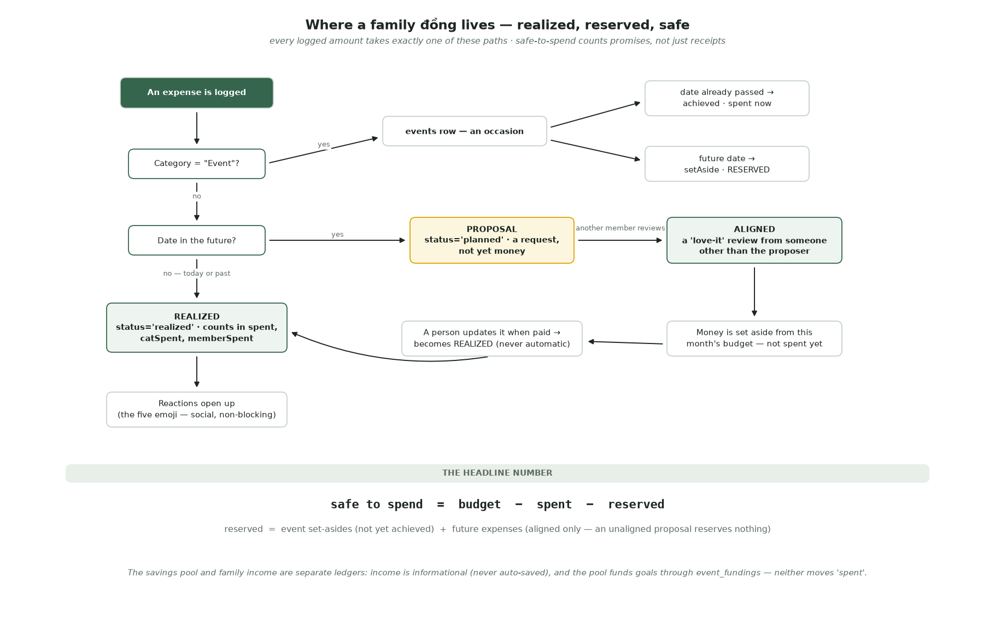
Where a family đồng lives
Every logged amount takes exactly one of three paths:
1. Realized — dated today or earlier. It counts into the month's spent, the category's total, and the payer's total, immediately and optimistically on the device that logged it. 2. A proposal — dated in the future. It is a request, not money: it reserves nothing until some other family member reviews it with 🥰. Once aligned, its amount joins the month's reserve. When the money is actually paid, a person updates the row (moves the date to today) — a proposal never silently becomes spending on its own. 3. An event — the special "Event" category doesn't create a transaction at all; it creates an occasion. Past-dated: achieved, spent now, photos become memories. Future-dated: its amount becomes a set-aside — reserved, not spent.
The headline number the family sees everywhere —
safe to spend = budget − spent − reserved reserved = event set-asides (not yet achieved) + aligned future expenses
Two adjacent ledgers deliberately do not move spent: family income is informational ("ghi riêng, không tự động để dành" — tracked on its own, never auto-saved), and the savings pool funds goals through its own contribution ledger.

5. Where family transactions come from — the doors

5.1 Typing — single or in bulk
The expense sheet opens from the FAB (scoped 🏡 Gia đình / 🔒 Cá nhân — the family side of the chips; the personal side is the sibling spec's story). It behaves like a running list: type "cafe 50k, chợ 200k, đi chơi 800k" and each comma-terminated segment peels into its own card with amount and category already guessed. Amount parsing speaks Vietnamese shorthand — 50k, 1tr2, 2 tỷ, and a bare "45" under VND means 45.000₫. Category guessing is two-axis: language-aware keywords ("gas" is Transport in English, cooking gas → Housing in Vietnamese) resolve to a concept, and the concept then searches the family's own categories by name or emoji — the guesser never invents a category the family doesn't have, and never overwrites a hand-picked one. Each row carries its own optional clock time: a same-day row defaults to now, a back-dated row stays day-only — the app never fabricates a time it doesn't know.
Half-typed batches survive anything: every keystroke mirrors the draft to the device (encrypted, for an encrypted family), an accidental swipe-down keeps it, and reopening restores it with "Đã khôi phục bản nháp chưa lưu." Discarding is a deliberate two-tap.

5.2 Receipt photos
An expense can carry up to 10 photos, which double as memories. Photos are always re-encoded before upload — stripping EXIF and GPS — but the capture date is read from the original file first, because it powers the photo-assign tool: dump up to 20 receipt photos, and the tool groups them by the day they were taken next to that day's expenses. It narrows; it never auto-assigns — the final match is always a human tap. A day with photos but no expense offers to log one, pre-filled with the date and the photos.

5.3 File import (CSV / XLSX)
"Nhập từ file" accepts bank and budgeting-app exports (Vietcombank, MB Bank, Money Lover, Misa; password-protected Excel included). Columns are mapped by heuristics first; only a genuinely ambiguous file sends a masked sample to the mapping model — an encrypted family's real amounts and notes never leave the device readable. Every row lands in a review screen — duplicates flagged, categories guessed from merchants, MCC codes, and the family's own history, with on-device learning of corrections — and nothing writes until the person taps Import. Promotion reuses the exact bulk-expense write path. Import is expense-only for now; income and transfer rows are set aside and say so.

5.4 Bank email
The "Khoản thu chi từ email" row is the bank-email pipeline's family-side door — capture and review are specified in their own documents (bank-email-capture-spec, transaction-review-spec). From this tab's point of view: captured transactions accumulate in a sealed queue, the CTA badge counts them, and the review screen (the same engine as file import) promotes approved rows through the same one write path, with a per-row choice of the family or personal ledger.

5.5 Income
The Thu tile records family income: amount, optional note, day. It is a deliberately separate, informational ledger — the sheet itself says money in is "không tự động để dành" (never auto-saved). Moving money into savings is its own explicit act.

6. The social layer — reactions vs proposals
Both features use the same five emoji — 😱 🤨 😂 🥰 😤 — and they are two different systems, split by time:
- Reactions apply only to money already spent. Long-press any ledger row, pick an emoji, and it appears as an inline chip, on the Phòng khách wall, and as a confetti "arrival" moment on the rest of the family's devices. One reaction per person per transaction; re-reacting replaces; tapping your own again clears it. Reactions never change what a transaction is.
- Reviews apply only to money not yet spent — future expenses, saving goals, future occasions. The same five emoji are re-labelled as decisions ("Đồng ý — chốt luôn" · "Bàn thêm chút nha" · "Chưa hợp lúc này"), and exactly one signal has consequences: a 🥰 from someone other than the proposer aligns the proposal, which is what lets it reserve money. The proposer can never approve their own request — they see a read-only "waiting / aligned" view.
The requests hub (behind Widget A's badged CTA) splits everything into two lanes: "Chờ bạn duyệt" (waiting for you) and "Yêu cầu của bạn" (yours, waiting on others). New requests and decisions arrive as gentle confetti moments, each with its own seen-watermark, and a decision notifies only the person who asked.

7. Budget and categories
The budget sheet holds the monthly total and the category list. Three rules keep it honest:
- "Others" is an invariant, not a category. It always exists, cannot be renamed or removed, and its amount is never typed — it is always total − everything named, floored at zero. Rename or delete any category and the arithmetic self-corrects; money can never fall between categories. If the named categories over-allocate, the sheet says by how much.
- Auto-split never overwrites a human. Entering a monthly total fills untouched categories using best-practice weights (housing .32, groceries .20, transport .15, dining .13, …); any row you've edited by hand is left exactly as it is.
- Renames cascade; deletes archive. Renaming a category rewrites every transaction and every month's totals; deleting one archives it server-side (old transactions keep resolving) — after a two-tap arm-then-confirm.
Each category row on the breakdown shows spend vs budget with an over-budget signal; the drill-in adds pace: "Vượt ngân sách" · "Đang tiêu nhanh hơn dự kiến" · "Thoải mái dưới mức" · "Đúng nhịp".

8. Goals and the savings pool
A goal is money toward a thing ("New laptop", target, optional date); an occasion is a moment. They are separate objects, optionally linked — so a goal can back a trip the family is also planning, and a free picnic never needs a fake target amount.
- The pool is topped up explicitly ("Bỏ ống tiết kiệm" — the sheet sets the total, it doesn't add). Goals are funded from the pool; the client refuses to fund past what the pool holds.
- A goal is done when fully funded — a passed date makes it overdue, never quietly done.
- A new goal is a proposal (it carries its creator), so it enters the same review flow as a future expense.
- Deleting a goal is a full reversal, and the confirm sheet says exactly that: pool-sourced money returns to the pool, budget-sourced money comes back off that month's spend. Nothing is stranded.

9. Months and history
Months are derived, not managed: the first hydrate of a new calendar month simply starts a new bucket, and older months read as closed — no one "closes the books". A closed month keeps its totals and verdict but doesn't itemize transactions ("Các tháng trước chỉ hiển thị tổng"), holds no reserve, and its budget doesn't carry forward — a new month's budget exists when someone saves one. The 6-month trend and the month picker read from the same derived model.

10. Privacy and trust
- Family E2EE, once on, is real and one-way. Amounts, notes, category and member names, goal targets, captions and photo bytes are ciphertext under the family key; the database enforces this with triggers, not policy — a plaintext money write is rejected once encryption is on, and the final enc state is permanent.
- A locked device fails safe. It shows placeholders ("•••", zeros) rather than wrong numbers, blocks every money write with an unlock prompt, and even the offline queue refuses to replay until the key returns.
- Drafts and imports respect the same promise. Expense and import drafts are encrypted on disk for an encrypted family; import samples are masked before any network call; receipt photos are stripped of EXIF/GPS and stored as encrypted objects.
- Notifications carry nothing. Pushes say something happened — never an amount or a merchant.
- What is not hidden: transaction dates (txn_date) and category emoji stay plaintext by design — they drive month math and indexing without exposing values.

11. Family vs Personal at a glance
Aspect | Family tab (this spec) | Cá nhân tab
Who reads it | Every keyed family member | Only you
Key | Family Key Card / passcode, shared, socially recoverable | Personal Key Card, no escrow
Tables | transactions, incomes, saving_goals, … | personal_* twins
Encryption | off → dual → enc lifecycle, DB-enforced | Ciphertext-only from birth
Categories | Family table, "Others" invariant, renames cascade | Denormalised on each row
Social layer | Reactions + proposals/reviews | None
Photos | Yes (encrypted objects) | Not wired yet
Your authored family expenses | Live here | Mirrored in, read-only, via link_id
Offline writes | Outbox with pre-minted ids | Direct writes

12. Safety rules
- Nothing reserves without consent. An unaligned proposal reserves zero.
- Nothing realizes automatically. A planned expense becomes spending only when a person updates it.
- Unreadable is never zero pretending to be fine. A locked or key-less device sees placeholders and a persistent unlock bar, not silently understated totals.
- Edits reverse before they reapply. Changing an expense's amount, category or payer backs the old contribution out of the month's totals before adding the new one — no double counting.
- Deletes are honest. Goal/event deletion names its consequence (money returns to the pool / comes off the month) and requires arm-then-confirm; so do category rows, income rows, drafts, and photo batches.
- Offline writes cannot duplicate. A queued expense carries its future database id; replaying twice is a no-op.
- The guesser never invents. Category guessing maps to the family's own categories or leaves the row unclassified.

13. Status and current limits
- Live: everything in Part 1.
- Structural limits:
- Month buckets are keyed by month name without the year — a ledger longer than 12 months folds e.g. Aug 2025 into Aug 2026. The trend and history features must fix this before multi-year families. - Clock times are stored as bare local HH:MM on the deliberate single-timezone (VN) assumption — upgrade to offset-bearing instants before any non-VN user or source (see docs/features/transaction-time.md, the tripwire). - Offline queueing covers inserts only; offline edits/deletes fail with a toast. Reactions are deliberately not queued.
- Not built / dormant:
- Transfers between accounts: schema-ready (kind, transfer_id), no writer. - USD: render-only fallback for a few legacy families; nothing offers or writes it. - File import of income/transfer rows (deferred rows say so in review). - A dormant render path (renderCatBudget, renderMembers, the old hero ids) writes to DOM ids that no longer exist — safe no-ops, prune candidates; the category breakdown lives in the expense-list overlay now. - The suggest sheet is toast-only (no network write yet).

Part 2 — Technical Appendix

14. Architecture in one view
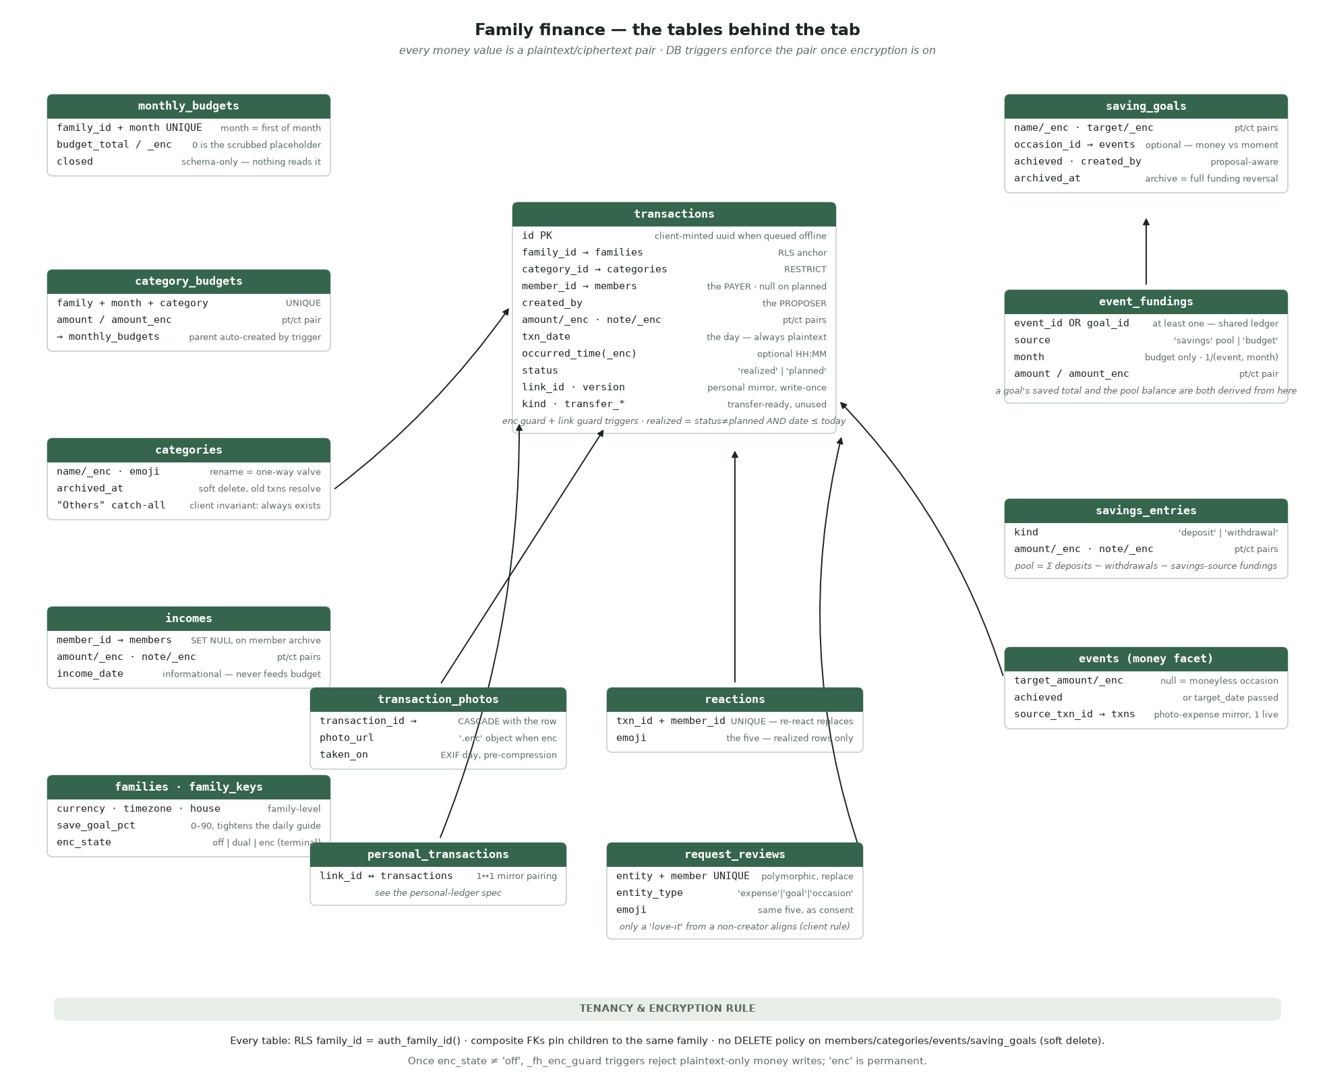
The tables behind the tab
One RPC hydrates everything; one in-memory model renders everything; every write is optimistic-then-persisted; realtime nudges other devices to re-hydrate; encryption sits under all of it as the shape of every read and write. There is no per-feature fetch and no server-side month math the client depends on — an encrypted family's amounts are invisible to SQL, so the client is the calculator.
Module map.
File | Owns
src/js-ui/10-nav-model.js | Tab routing, month model months/M(), reserve math (monthReserved, _entAlignedBy), currency/format, trend
src/js-ui/20-budget.js | renderBudget/renderCashflow fan-out, the three-period chart, daily guide (cfPerDay, fhGuideCompute), budget sheet, "Others" invariant, CTAs
src/js-ui/60-transactions.js | txns ledger, addExpense() (the single write path), tab feed, full list overlay, openCat drill-in
src/js-ui/61-expense-detail.js | Read-first expense detail; reactions block vs review block
src/js-ui/50-sheets-expense-capture.js | Expense sheet: bulk rows, NL parsing, drafts, EXIF, sheet plumbing (openSheet)
src/js-ui/55-expense-photos-writes.js | Photo cap/upload, saveExpenseEdit/deleteExpense (reversal math), photo-assign, submitExpense router
src/js-ui/35-goals.js · 36-goal-detail.js | Tích lũy card, goal create/fund, read-first goal detail
src/js-ui/62-reactions.js · 64-requests.js | Reactions (chip, wall, arrivals) · Requests (hub, review sheet, watermarks)
src/js-data/70-goals-income-onboard-ui.js | Goal/income/savings persistence (fhCreateGoal, fhFundGoal, fhSavings, fhAddFamilyIncome)
src/js-data/30-hydrate.js | loadFamilyData() — snapshot RPC, decrypt-in-place, month/ledger/goal/reaction model build
src/js-data/20-data-helpers.js | DB maps, _syncSoon debounce, _w error surfacing
src/js-data/40-txn-writes-outbox.js | _dbInsertTxn/_dbUpdateTxn/_dbDeleteTxn, photo upload/encrypt, the offline outbox
src/js-data/50-writethrough-realtime.js | Write-through wrappers, budget save, reactions/reviews upserts, realtime channel
src/js-data/15-crypto.js | fhField/fhRead, DEK cache, enc-state machine
src/js-data/68-lock-wall.js · 65-passcode-ui.js | Lock wall, unlock, fhAfterUnlock
src/js-ui/56-csv-import-ui.js · 57-csv-import-review.js | File-import review engine (shared with bank-email staged review)

15. Schema reference
Source of truth: supabase/migrations/0001–0099. Conventions: every table carries family_id; RLS predicate family_id = (SELECT auth_family_id()) (0004, initplan-wrapped 0022); composite FKs (id, family_id) pin children to the tenant; money is numeric(14,2) in the family currency; every protected value is a plaintext/ciphertext pair (X + X_enc, 0030), enforced by _fh_enc_guard triggers (0033) once enc_state ≠ 'off'; soft-deleted tables (members, categories, events, saving_goals) have archived_at and no DELETE policy.

transactions (0001; +0024 created_by, 0030 enc, 0076 link/kind, 0096 time)
Column | Notes
id uuid PK | client-minted when queued offline — the idempotency key
family_id → families | RLS anchor
category_id → categories | composite FK, RESTRICT — categories archive, never orphan
member_id → members | the payer; nullable; CHECK status='planned' OR member_id IS NOT NULL
created_by | the proposer (0024) — a different question from the payer
amount/amount_enc · note/note_enc | pt/ct pairs; presence CHECK one of each pair
txn_date date | the day — always plaintext (month math, windowing)
occurred_time/occurred_time_enc | optional local "HH:MM" (0096); null = day-only. Not yet in the enc-guard pair list or the snapshot
status | enum realized \
plannedlink_id · version | personal-mirror pairing; write-once / monotonic (_fh_link_guard, 0076)
kind · transfer_id · transfer_dir · space_id | transfer plumbing + Model-X remnant — schema-ready, unused

Indexes: (family_id, txn_date), (category_id, family_id), (member_id, family_id), partial on link_id/space_id. Client-side rule: realized = status ≠ 'planned' AND txn_date ≤ today — a planned row never self-realizes.
transaction_photos (0001; taken_on 0018; photo guard 0039): transaction_id composite-FK CASCADE, photo_url (must be null / absolute / %.enc once enc), sort_order, taken_on (EXIF day).

Budget tables (0001; enc 0030/0033)
- monthly_budgets — (family_id, month) unique, month CHECKed to the 1st. budget_total stays NOT NULL through E2EE — 0 is the scrubbed placeholder (readers prefer budget_total_enc). closed boolean exists and is echoed in the snapshot but nothing reads or writes it — month closure is derived client-side.
- category_budgets — (family_id, month, category_id) unique; amount/amount_enc; FK RESTRICT to both parents; BEFORE-INSERT trigger auto-creates the parent monthly_budgets row. Budget writes are plain PostgREST table writes — there is no budget RPC.

categories (0001; enc 0038; roster 0055)
name/name_enc, emoji, color, sort_order, archived_at. The 0038 text guard is a one-way valve: inserts pass (server seeds), but an update that changes name must carry fresh name_enc, and in enc a changed name may not materialize as plaintext. "Others" is a client invariant (CAT_FALLBACK), not a schema object.

incomes (0010; enc 0030)
member_id composite-FK SET NULL (unlike transactions' RESTRICT), amount/_enc, note/_enc, income_date. Informational — nothing joins it to budget math.

Goals & savings (0019 → 0020 → 0021; RPCs 0013/0037; enc 0030/0033)
- saving_goals (0020) — name/_enc, target_amount/_enc, target_date, note/_enc, occasion_id → events (SET NULL; the only goal↔occasion link), achieved, created_by (0024), archived_at.
- event_fundings — the shared contribution ledger: CHECK event_id IS NOT NULL OR goal_id IS NOT NULL (0021); source enum savings \| budget; month required iff budget-sourced (first-of-month); partial unique (event_id, month) WHERE source='budget' — one budget reservation per event per month. A goal's saved and the pool balance are both derived from this table, never stored.
- savings_entries — kind deposit \| withdrawal (sign lives in the enum), amount/_enc, note/_enc, entry_date. Pool = Σ deposits − withdrawals − savings-source fundings, floored at 0. The set_savings RPC (0010) computes the delta in SQL — a pre-E2EE relic blocked by the enc guard for dual/enc families; the client computes the delta instead.
- archive_goal(uuid) (0037) / archive_event(uuid) (0013) — SECURITY DEFINER: delete all the entity's funding rows (full reversal), then soft-archive. Chosen over stranding money in an invisible goal.

Social tables (0023 / 0024)
- reactions — unique (transaction_id, member_id); upsert = replace; composite FKs CASCADE; plaintext emoji. Windowed in the snapshot alongside transactions (0048).
- request_reviews — polymorphic entity_type CHECK ('expense','goal','occasion') + entity_id (no FK) + unique (entity_type, entity_id, member_id). The alignment rule (🥰 from a non-creator) is client-side; the DB stores any emoji. Never windowed. Companion created_by columns landed on transactions, saving_goals, events in the same migration.

Context
families: currency (VND\|USD), timezone (drives family-local "today"), house jsonb, save_goal_pct smallint 0–90 (0070; written via set_family_save_goal, deliberately not E2EE — a percentage, not money). family_keys: enc_state, KDF params, wrapped_dek, staging keypair (0051). events (money facet): target_amount/_enc nullable (0019), achieved (or date-passed via views), source_txn_id → transactions with a one-live-mirror partial unique (0015/0016). email_transactions staging is service-role-only and reaches this ledger exclusively through the client's review + addExpense() path — see the bank-email and review specs.

get_family_snapshot(p_txn_from date) — the one read
SECURITY DEFINER, returns the whole family in one payload: family, enc recipe, key wraps, members, categories (archived included), category/monthly budgets, transactions (windowed by p_txn_from, newest first), events, fundings (always full), savings entries, memories, transaction photos + reactions (windowed with their transactions, 0048), incomes, goals, request reviews (always full). Not in the snapshot: occurred_time, the 0076 columns, save_goal_pct (separate small read), staging keys (separate RPC). A pre-migration server returns missing arrays as empty — hydrate survives.
The pre-E2EE reporting views (v_month_spent, v_savings_balance, …, 0002) still exist but return NULLs for encrypted families — effectively legacy; the client computes everything from decrypted snapshot data.

16. Encryption for family data
The family construction is the one the personal ledger mirrors one level down (full detail: docs/features/encryption.md; keys: docs/features/key-card-auth.md). What the Family tab depends on:
- Key hierarchy: Key Card (600k PBKDF2 iters) or legacy passcode (310k) → HKDF → K_auth (door proof, bcrypt-stored) / K_wrap (device-only) → family DEK → every value b64(iv‖AES-256-GCM ct). The DEK is cached in IndexedDB as a non-extractable CryptoKey.
- States: off → dual → enc, with enc terminal (0035). In dual both twins are written and mismatches are logged loudly; the owner's scrub (scrub_plaintext_amounts) nulls plaintext across all covered tables and flips to enc. Enforcement is trigger-side: a plaintext-only money write is rejected with enc_required.
- The two shapes: fhField(name, value) builds every write (enc → ciphertext-only, throws without the key — fail-closed); fhRead(row, name) resolves every read (decrypt failure → null — renders as 0/"•••", fail-open for display, flagged by the lock bar).
- Write lock: once enc_state ≠ 'off', a keyless device is hard-blocked from every money write (_fhWriteLocked) with an unlock prompt; reads and non-money features stay available ("browse read-only").
- Lock wall: raised after a hydrate detects a needed key; offline-capable unlock (AES unwrap needs no server); fhAfterUnlock flushes the outbox, re-hydrates, and schedules the coverage sweep.
- Photos: encrypted client-side into .enc objects in a public-by-URL bucket — privacy from the key, not the address; EXIF/GPS always stripped by canvas re-encode; a MutationObserver decrypts into memory-only object URLs that die with the key.

17. Lifecycle — boot, hydrate, the month model
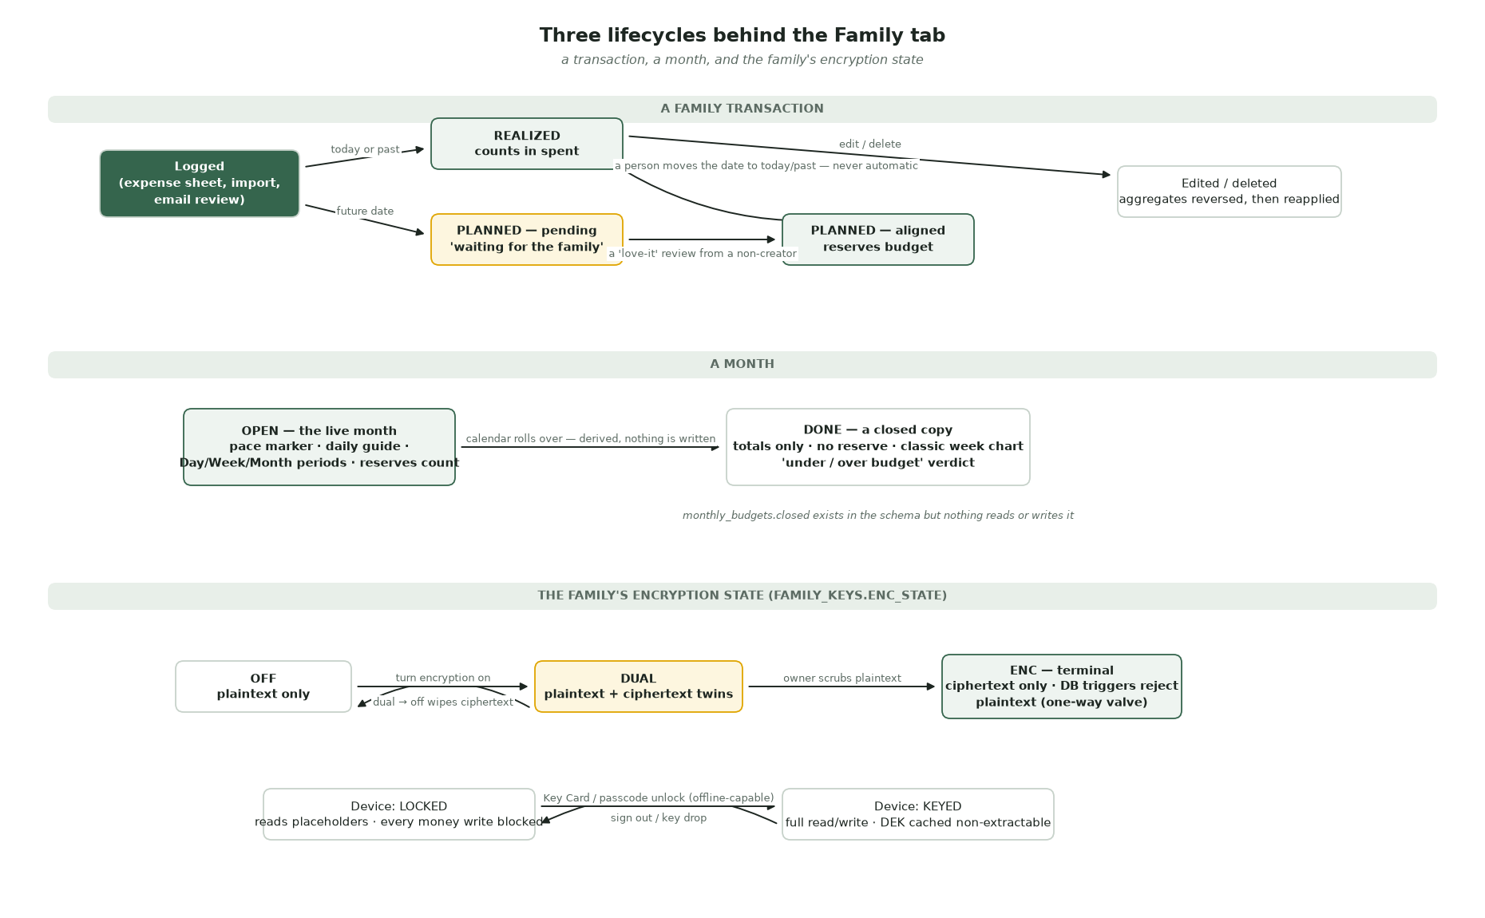
Three lifecycles
Boot. Warm start restores the last snapshot (localStorage for small plaintext; IndexedDB, DEK-encrypted, for enc families — plaintext family data never touches disk) and renders instantly with an "Updating…" chip; then the real hydrate replaces it. window.DB is pre-seeded from the snapshot maps so writes work before the first hydrate lands.
Hydrate (loadFamilyData): one get_family_snapshot RPC (17-query fallback for unmigrated envs), decrypt-in-place via fhRead per field, then build the model: DB.* maps, catOrder/catStyle/catBudget, window.txns (newest-first view rows), months/monthOrder/selMonth, events + goals (+ per-entity funding aggregates), savings, monthIncome, reactions and review maps. Render tail: renderAll → trend/legend/cashflow → subscribe realtime → arrival checks → personal-ledger boot. Every optional tail step is individually try/caught — a consent check must never cost a hydrate.
Windowed refresh (R6). After the first full hydrate, refreshes fetch only the last ~3 months of transactions/photos/reactions and merge onto the held baseline (DB._rawTx); a full pass runs at most every 5 minutes or when an out-of-window row changes. The multi-query fallback is never merged (it returns the full ledger).
The month model. months is keyed by month abbreviation with {label, done, dim, dom, spent, budget, catSpent, memberSpent, _iso}; done is derived (_iso < current month — monthly_budgets.closed is schema-only). Aggregates are recomputed wholesale from realized rows each hydrate and updated incrementally by addExpense/saveExpenseEdit/ deleteExpense in between — the ledger, not the aggregates, is truth. Known constraint: keys collide across years (Aug 2025 = Aug 2026); fix before multi-year history.
Transaction lifecycle. Insert stamps status from the date (planned iff future). Hydrate derives the client's future flag as NOT (status ≠ 'planned' AND date ≤ today). Realization is always a human edit (date moved to today/past → status='realized', clock cleared on future-going edits — "a future proposal has no clock").

18. Write paths
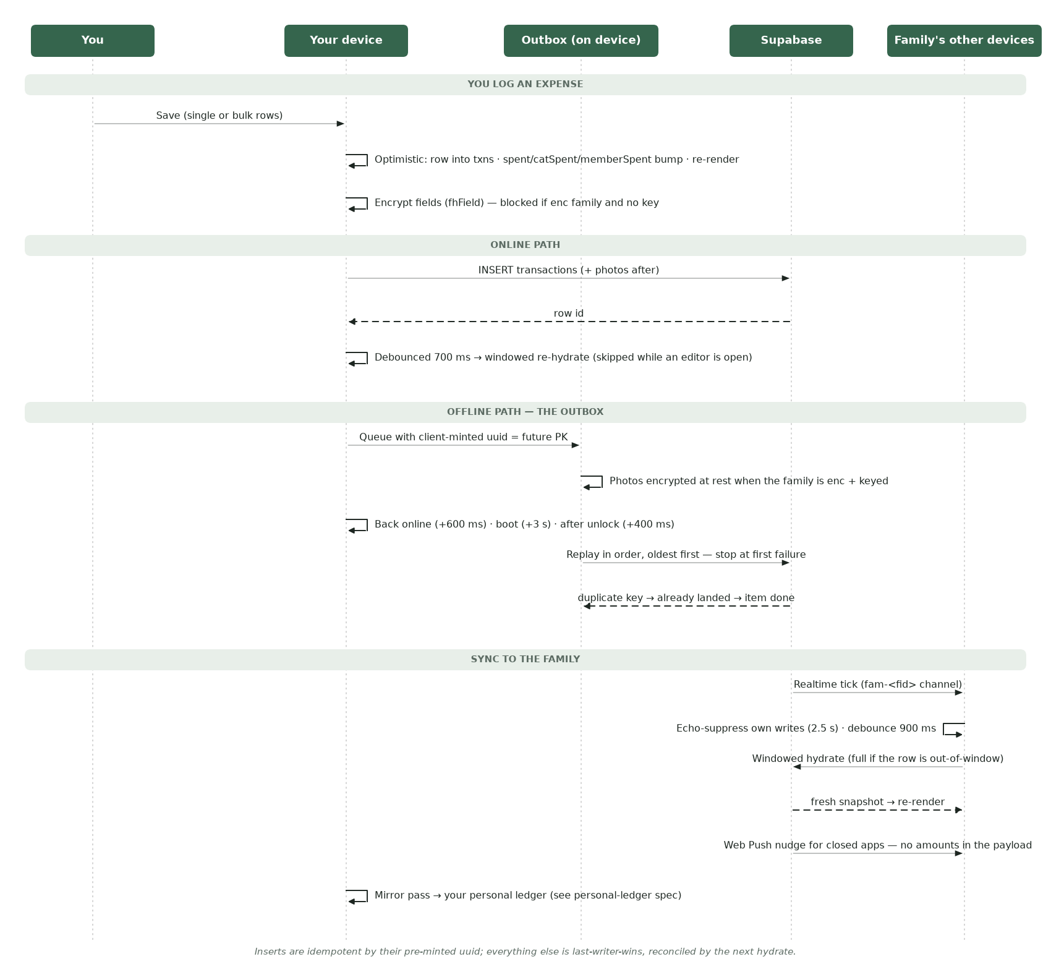
Add expense, offline, and the family sync
addExpense() (60-transactions.js) is the single write path — the sheet, bulk save, file import, and email promotion all funnel into it (bulk under a BULK_SAVING flag that defers the toast/nav tail). Three branches: Event category → events row; future date → proposal (no aggregate touched); else realized → spent/catSpent/memberSpent updated in place, synchronously. Persistence is layered on by the write-through wrapper: diff txns for the new row → _dbInsertTxn → fhField envelope → insert (or outbox) → photo uploads → debounced re-hydrate (700 ms; skipped while an editor is open). A new mirror event waits for the transaction's real id before writing source_txn_id.
Edits and deletes reverse the old contribution before applying the new one, then force a full hydrate (an edit may touch an out-of-window row). Delete archives the linked mirror event via RPC first (FK cascade would strand or RESTRICT), then removes storage files, then the row.
The outbox (inserts + photos only, by design): a queued row's crypto.randomUUID() becomes its eventual primary key, so replay is idempotent — duplicate key means "already landed, item done". Replay is strictly ordered, stops at the first failure, and holds the queue rather than bypass encryption: plaintext rows queued before the key raced away are re-encrypted at flush, and no key → no flush. Triggers: back-online (+600 ms), boot (+3 s), after unlock (+400 ms). The service worker won't auto-update while the outbox is non-empty. Offline edits/deletes and reactions are deliberately not queued.
Other writers. Budget save applies queued renames, archives deletions, upserts monthly_budgets (plaintext budget_total: 0 beside ciphertext — the NOT NULL placeholder) then per-category rows (0 → delete). Goals/income/ savings write via fhField and re-hydrate directly. Reactions and reviews are optimistic local + upsert-on-conflict (replace-not-stack); a reaction on an out-of-window transaction escalates to a full hydrate so the windowed merge can't drop it.
Errors. Every write routes through _w() because supabase-js resolves 4xx instead of throwing; enc_required self-heals via _fhEncRecover (SW-update → rehydrate → unlock prompt); net errors stay silent when the row is already queued.

19. Realtime and push
One channel per family (fam-<fid>), authenticated so RLS-gated postgres_changes deliver. Sixteen finance/social tables watched with a family_id filter plus the families row and family_keys (encryption turned on propagates instantly). A spouse's write arrives as: tick → echo suppression (ticks within 2.5 s of a local write are the device's own echo) → 900 ms debounce → windowed hydrate (full if the changed row is out-of-window; DELETE payloads carry only a PK so they always escalate) — skipped entirely while an expense editor is open. Foreground/focus resumes trigger a throttled hydrate (iOS PWAs resume without reloading). email_transactions is deliberately not watched (sealed rows; refreshed on foreground).
Push is a nudge layer, not a data layer: fhNotify(kind, …) fans out expense_new/expense_bulk/reaction/request_new family-wide, request_response only to the requester, and the daily-guide state push (dgstate) fires only from the device that just logged the expense, only when today's state worsened. Payloads never carry amounts or merchants.

20. Failure modes
Scenario | Behaviour
Expense logged offline | Optimistic row + outbox with pre-minted uuid PK; toast "Đã lưu trên máy, sẽ đồng bộ khi có mạng"; replay on reconnect/boot/unlock; duplicate-key = already landed
Replay hits an error mid-queue | Stop at first failure, keep order, retry on the next trigger — no skipping
Key missing on an enc family | Every money write blocked (fhField throws / _fhWriteLocked toast + unlock prompt); outbox flush holds; reads show placeholders + lock bar
enc_required rejection from the DB | Row queued, _fhEncRecover self-heal (apply waiting SW → rehydrate → unlock prompt)
Two devices write at once | Row-level last-writer-wins; next hydrate reconciles; inserts can't collide (uuid PKs)
Realtime tick for my own write | Echo-suppressed (2.5 s window) — one reload per write, not two
Write/hydrate race with an open editor | _syncSoon and realtime both refuse to hydrate while editingTx is set — the model is replaced wholesale, so an open editor freezes sync
Reaction lands on an out-of-window transaction | Full hydrate forced — a windowed merge would silently drop it
Editing an expense's category/amount/payer | Old contribution reversed, new applied — totals never double-count
Deleting a photographed expense | Mirror event archived via RPC first, storage objects removed, row deleted (photos cascade)
Deleting a goal with money in it | archive_goal deletes funding rows: pool money returns, budget money comes off that month; confirm sheet names this before the tap
Category renamed | Cascades through txns[].cat, every month's catSpent, and the DB (__catRenames); "Others" recomputes; nothing orphans
Category deleted with history | Archived, not deleted; old transactions resolve via DB.catById; unknown/archived category on a row → the catch-all, never someone else's category
CSV/email row can't be categorized | Held in the amber attention section; never auto-imported
Proposal reviewed by its own creator | UI shows read-only FOLLOW view; submitReview defensively bails
Snapshot RPC missing (unmigrated env) | 17-query fallback; newer arrays default empty; never merged as a window
Warm boot before hydrate | Snapshot-seeded DB maps let writes resolve members/categories; enc snapshots are DEK-encrypted at rest

21. Security invariants
1. Every finance table: RLS family_id = auth_family_id(); composite FKs pin children to the tenant; no cross-family read or write path exists. 2. Once enc_state ≠ 'off', plaintext-only money writes are rejected by DB triggers on all covered tables; enc is permanent (one-way valve); scrub refuses while any row is uncovered. 3. fhField is fail-closed (no key → throw); fhRead is fail-open for display only (null → placeholder), never for writes. 4. The outbox never bypasses encryption: flush re-encrypts or halts. 5. Offline inserts are idempotent by pre-minted uuid; link_id is write-once and version monotonic (trigger-enforced) — the personal mirror cannot be corrupted from the family side. 6. Soft-deleted entities (members, categories, events, saving_goals) have no DELETE policy — history stays resolvable forever. 7. Alignment requires an actor other than the creator; the creator's own 🥰 never aligns; the DB unique key makes reviews replace, never stack. 8. Funding reversal RPCs are SECURITY DEFINER and total: no path strands money in an archived goal/event. 9. Photo bytes and drafts are encrypted at rest for enc families; EXIF/GPS is always stripped; push payloads never carry values.

22. Glossary
Realized / planned. The stored status split: money spent vs money proposed. Client-side "future" = planned or future-dated.
Reserve / set-aside. Committed-but-unspent money counted against the month: event budget-fundings + aligned future expenses.
Safe to spend. budget − spent − reserved — the headline number.
Aligned. A proposal that received 🥰 from a non-creator; only then does it reserve. "Others" catch-all. The undeletable category whose budget is always the unallocated remainder — the self-correcting bookkeeping invariant.
Pool. The family savings balance, derived from deposits − withdrawals − savings-source fundings.
Goal vs occasion. Money-toward-a-thing vs a moment; optionally linked by occasion_id.
Outbox. The IndexedDB queue that holds offline transaction inserts under their future primary keys.
Windowed hydrate. A refresh that refetches only recent months and merges onto the held baseline.
Echo suppression. Ignoring realtime ticks caused by this device's own write.
Dual / enc. The two encrypted family states: twins written both ways vs ciphertext-only (terminal).
Mirror row. The personal-ledger copy of a family expense you authored, paired by link_id — the other spec's object.

23. Related documents
- personal-ledger-spec.md — the Cá nhân tab; the mirror's other half.
- bank-email-capture-spec.docx — how bank emails become staged transactions.
- transaction-review-spec.md — the review screen where staged rows (email and file alike) become ledger rows.
- docs/features/ — design rationale per subsystem: budget.md, transactions.md, expense-capture.md, goals.md, social-alignment.md, csv-import.md, transaction-time.md, encryption.md, finance-tab-widgets.md.
- docs/ARCHITECTURE.md — the cross-feature zoom-out (hydrate/write-through pattern, entity-review pattern).
- Key migrations: 0001 (core schema), 0002 (views, legacy), 0010 (income/savings), 0013/0037 (funding-reversal archives), 0015–0021 (mirror events, goal/occasion split), 0022 (snapshot RPC), 0023/0024 (reactions, requests), 0030–0043 (E2EE), 0048 (windowing), 0055 (category roster), 0069/0070 (snapshot, save-goal), 0076/0079 (link/mirror, Model Y), 0096 (transaction time).

