FAMILYHUB PRODUCT SPECIFICATION
Automatic Transaction Capture from Bank Email
Two ways to add spending to your ledger without typing it.
Summary
- FamilyHub can add transactions to your ledger straight from the emails your bank already sends, so you stop entering expenses by hand.
- There are two ways to feed those emails in. You forward them, or you let FamilyHub read them from your mailbox.
- Both end the same way: a short review, one tap to approve, and the transaction is saved and encrypted with your family's key.
Why this exists
- People stop tracking spending because entering it by hand is tedious, and most give up within a few weeks.
- Banks and wallets already send an email for almost every transaction. That email is a complete and timely record you usually ignore.
- If those emails reach FamilyHub, the work of writing a transaction down disappears. You are left with a quick check instead of data entry.
The two methods at a glance
Aspect | Forward your emails | Connect your mailbox
Setup effort | Set a forwarding rule in Gmail, once | Approve access on Google's screen, once
Ongoing effort | None, just review | None, just review
Reads past history | No, starts from now | Yes, up to the last 90 days
Works with | Any bank that emails you | Mailboxes Google hosts (Gmail)
Identity is proven by | A tag in the forwarding address | The access grant itself
Saves to | Family ledger | Personal ledger by default, or family
Availability | Live for a small group | Live, capped until Google review

METHOD A
Forward your bank emails
Turn the bank emails you already receive into ledger entries by forwarding them to FamilyHub.
WHAT YOU DO
- Turn on Connect bank email and receive a personal forwarding address.
- Add a rule in Gmail that forwards bank emails to that address. This is a one-time step.
- From then on, review the transactions that appear. Approve, adjust the category, or dismiss.
HOW IT WORKS
- Forwarded emails arrive in a receiving inbox.
- A background job runs once a minute. For each new email it identifies whose transaction it is, skips anything already captured, and decides whether the email is a real transaction rather than a promotion or a one-time code.
- It reads the amount, the other party, and the date, and flags likely duplicates, such as a bank and a merchant both reporting one purchase.
- It locks the extracted data so the database cannot read it, then stores it as pending.
- You receive a single notification that something is waiting. You open the review screen, check the row, and approve it. Only then does it become a real ledger entry.
STEP-BY-STEP SEQUENCE
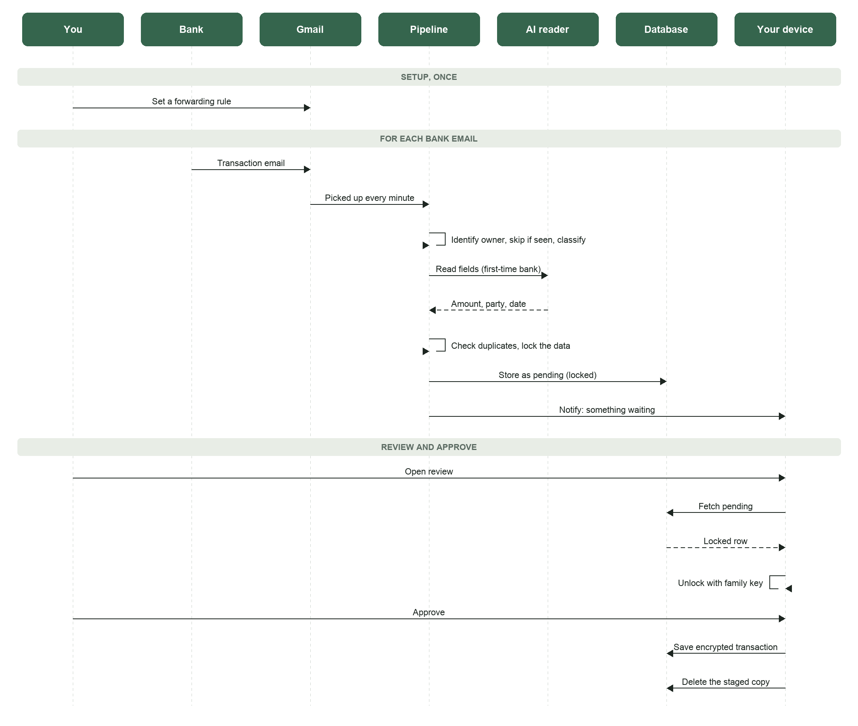
Solid arrow: a request. Dashed arrow: the reply. Looped arrow: the system acting on its own.
PRIVACY AND TRUST
- Approved transactions are encrypted with your family's key. Neither the database nor FamilyHub can read your amounts.
- Be clear about the boundary. While an email is being processed, the background job reads its real contents, and for a bank seen for the first time an extraction service reads it too. You agree to this before it happens. What is protected is the stored record, which is locked the moment it is read.
- Notifications never carry an amount or a merchant name.
SAFETY RULES
- Nothing is added automatically. A person approves every transaction. Automated steps only prepare a row; a human commits it.
- A row that cannot be unlocked is never dropped quietly. It appears as a clear, explained state.
STATUS
- Live for a small allowlist. The full path works: capture, locking, duplicate handling, the review screen, and notifications.
- Not yet in place: a formal consent screen, checks that confirm the sending bank is genuine, and a dedicated email domain in place of the shared inbox used today.
CURRENT LIMITS
- Categories are not filled in for you yet. You choose one per row.
- Moving money between your own accounts can be counted twice, because each account emails its own side of the move.
- It only helps for banks that send email notifications.
METHOD B
Connect your mailbox
Skip forwarding. Grant FamilyHub permission once to read the bank emails in your mailbox, and let transactions arrive on their own, including recent history.
WHAT YOU DO
- Tap Connect email and agree to the consent notice.
- Approve access on Google's own screen.
- Choose where new transactions go by default: your personal ledger, which is the standard choice, or the shared family ledger.
- From then on, review what arrives.
HOW IT WORKS
- After you grant access, FamilyHub can fetch bank emails from your mailbox. It fetches them; it never receives your mail.
- Two things keep it current: an instant signal from Google when new mail arrives, and a backup check every few minutes.
- For each new bank email it does the same core work as forwarding: read the fields, handle duplicates, lock the data, and store it as pending. Then it notifies you to review.
- It fetches mail only from the banks you choose, from a fixed list of senders.
STEP-BY-STEP SEQUENCE
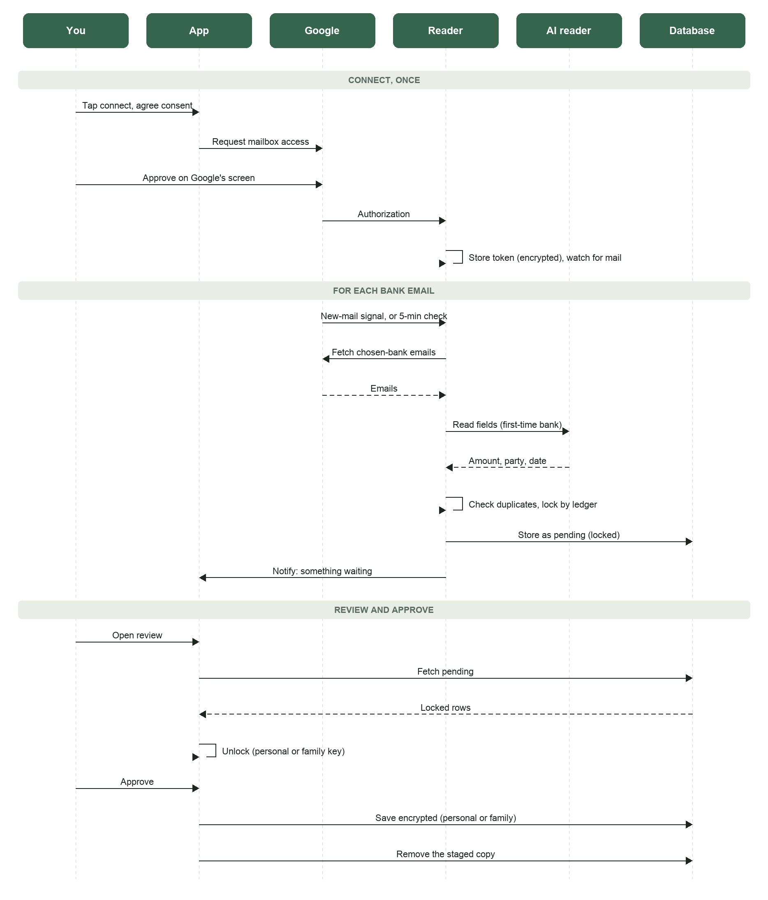
Solid arrow: a request. Dashed arrow: the reply. Looped arrow: the system acting on its own.
PRIVACY AND TRUST
- The same guarantee holds. Stored transactions are locked with your key, and FamilyHub cannot read them.
- The same boundary holds. The reader sees the email while processing it, and a first-time bank goes through an extraction service. Consent covers this.
- One point to be clear about: Google does not offer a bank-emails-only permission. The permission you grant covers your whole mailbox. Our promise to fetch only the senders you choose is a rule we hold ourselves to in code. It is paired with something you can check directly: you can remove access at any time from your Google account.
- Personal is the default on purpose. A personal transaction can later be moved out to the family ledger, but a family transaction cannot be made private again. So the default is the choice you can still undo.
SAFETY RULES
- Nothing is added automatically. A person approves every row.
- The system marks a time window as done only once it finishes cleanly, so it re-reads rather than skips. Skipping would lose a transaction with no way to notice.
STATUS
- Live in production. Around 200 transactions have been captured, with no readable amounts reaching the database.
- Not yet in place: categories filled in for you, connecting a second mailbox (a new one currently replaces the first), and a richer parser from the backend team.
CURRENT LIMITS
- The scaling limit. The mailbox-reading permission is a restricted Google permission. Until Google reviews and approves the app, it is capped at roughly 100 users. Approval depends on Google agreeing that our use fits their allowed categories, and that is not certain, so it is worth testing early.
- The same double-count on transfers between your own accounts, and the same manual category step, as forwarding.
- One mailbox per person for now.
What both methods share
- These are two doors into one pipeline. Once an email has been read and locked, forwarding and mailbox reading behave the same.
- They share one holding area for pending transactions, one review screen, one approval step, and one ledger.
- Because of that, most improvements help both at once. Filling in categories, catching transfers between your own accounts, and better reading of unusual bank formats all land on both methods together.
- Forwarding is the dependable floor: it works with any bank and any mailbox. Mailbox reading is the smoother option: one approval, and it brings in history, but it waits on Google's review to reach everyone.
On the roadmap, not yet built
- Fill in categories automatically from the merchant, so most rows need no edit.
- Record which bank accounts are yours, which lets us catch transfers between your own accounts and route each account to the right ledger.
- Connect more than one mailbox per person, so work mail and personal mail can go to different ledgers.
- Confirm the sending bank is genuine before trusting an email.
- Mark each saved transaction with where it came from, so you can measure how much of the ledger is captured automatically.
Glossary
Ledger. Your running list of transactions in FamilyHub.
Pending transaction. A captured transaction waiting for you to approve before it is saved.
Locking (sealing). Encrypting a transaction so only your family's devices can read it, not the database or FamilyHub.
Family key. The key held on your devices that unlocks your family's data. It never leaves your devices.
Personal ledger. Your own private list, readable only by you, separate from the shared family ledger.
Restricted permission. A Google permission class for reading mailbox contents that requires Google's review before an app can offer it widely.

