FAMILYHUB PRODUCT SPECIFICATION
Effortless Transaction Logging
From a bank's email to the ledger — captured, sealed, reviewed, and filed with one tap.
The umbrella spec for FamilyHub's passive capture feature: a bank emails you about a purchase, and the transaction appears in your ledger after one approving tap — no typing, no CSV export, no bookkeeping. This document covers the whole chain: how emails enter the system (three transports), how they are parsed, how the result is staged so the database cannot read it, how a person reviews it, and how an approved row becomes an encrypted ledger entry.
Status, 2026-08-30. Live in production for allowlisted members, on two transports: forwarding (Apps Script) and OAuth direct read (Edge Functions — the canonical path today). A third implementation, the backend team's Python/GCP pipeline, reads and parses real mail but does not persist yet; it is specified here as pre-live. This is the first end-to-end spec of the feature — reconstructed from the live code, schema and pipeline docs, not a forward-looking design.
Audience & layering. Part 1 (Behaviour) is for everyone — product, design, QA, onboarding. Part 2 (Technical Appendix) is for engineers. The transports table is the one-glance summary; the three diagrams are the zoom-out views.
How this spec relates to its siblings. This is the wide view. Two stages of the chain have their own deep specs and are summarised here: the review screen (transaction-review-spec.md) and the personal-ledger destination (personal-ledger-spec.md). bank-email-capture-spec.docx is the earlier executive-level summary of the same feature; this document supersedes it in depth but not in audience.

Part 1 — Behaviour

1. Summary
- Banks and wallets already email a notification for nearly every transaction. FamilyHub turns that mail into ledger entries: an unattended pipeline reads the email, extracts amount / counterparty / date, and stages the result for review. A person approves each row with one tap; nothing is ever imported automatically.
- There are two ways to feed emails in today — forward them to a personal FamilyHub address, or connect your Gmail once and let FamilyHub fetch bank mail directly. Both end at the same review screen. A third implementation (the backend team's Python pipeline) is built and pre-live.
- Every staged row is sealed: encrypted to a public key before it reaches the database, so neither Supabase nor FamilyHub can read an amount back. Approved rows are then encrypted with the family's key (or your personal key) exactly like a hand-typed expense.
- Each captured row can be filed into the family ledger or your private personal ledger, chosen per row at review. For a connected mailbox, personal is the default.

2. Why this exists
- FamilyHub had two ways money reached the ledger, and both require the user to do something: type an expense, or export and import a CSV. Both are acts of bookkeeping, and bookkeeping is the thing people stop doing in week three.
- Bank notification mail is a complete, timely, structured record of household spending that the user already receives and mostly ignores. If those emails reach us, the work of writing a transaction down disappears; what is left is a quick review whose whole purpose is the one thing a machine cannot supply — what the money was for.
- The design was proposed and prototyped by Trang (Growth) and validated against real forwarded Vietnamese bank emails before the first migration (0025) was written.

3. Who can read what — the trust model
Everything below is easier to hold if you keep the custody chain first. A transaction crosses three domains, and almost every design decision is about what each one is allowed to know.
Domain | Holds | Can read a transaction?
Google — Gmail, Apps Script, Gemini | the raw email; (transport A) the service-role key and DEDUP_FP_KEY | Yes, in transit. The pipeline that parses mail sees plaintext — that is the honest boundary.
Supabase — Postgres, Edge Functions | ciphertext + routing metadata, staging_pub | No. Sealed rows are opaque to the database. The Edge worker sees plaintext in transit (transport B) but stores only ciphertext.
The family / the person — their devices | the family DEK, the personal DEK, the staging private keys | Yes. The only place a staged row becomes readable again.

Two consequences worth internalising:
- Sealing does not hide anything from the pipeline; it hides it from the database. The worker that parses a family's mail can never read the row it wrote — but it read the mail to write it. Consent (§8) covers that leg.
- Keys are deliberately split across companies. DEDUP_FP_KEY lives with the pipeline (Apps Script Properties / Edge secrets), never in Postgres, so a database dump cannot be attacked with it.

4. The journey, end to end
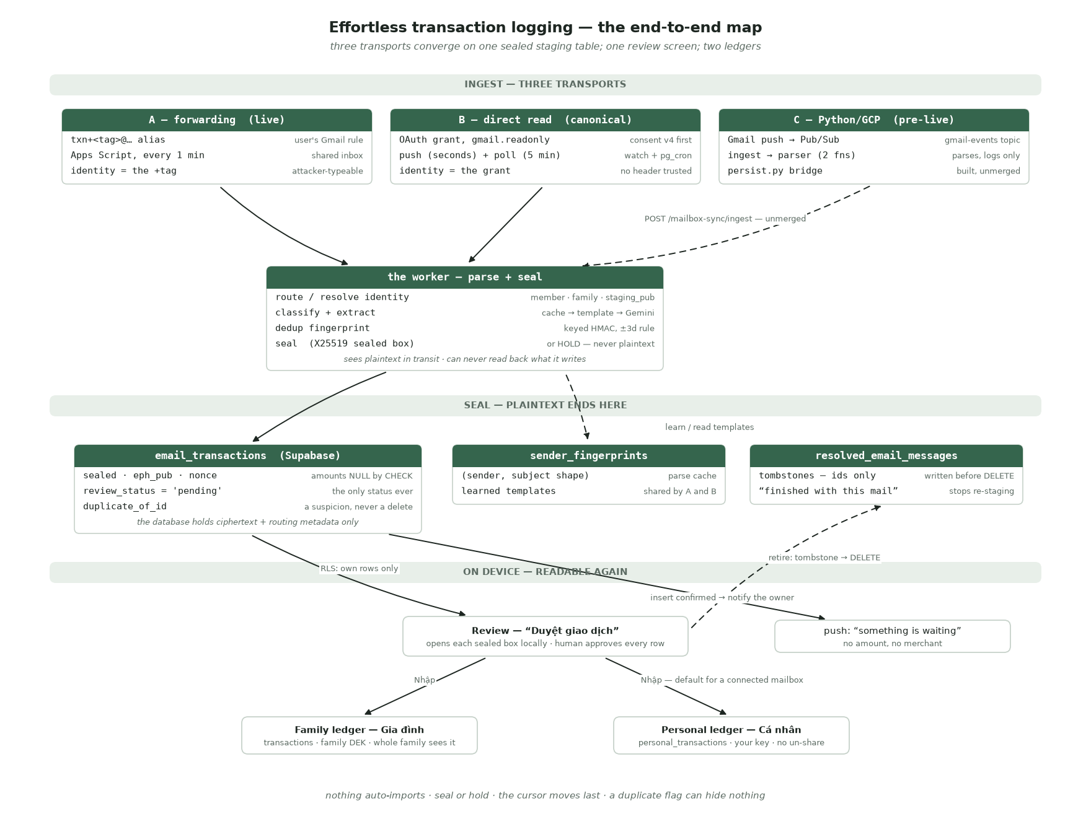
End-to-end map — three transports, one staging table, two ledgers

4.1 Setting up, once
The door is "Khoản thu chi từ email" — on the family Finance tab and on the Cá nhân tab. If nothing is set up yet, a chooser names the two transports:
- Connect Gmail (direct read) — listed first because it is better for almost everyone who can use it: one tap instead of a mail-client filter rule, and it reads history rather than starting from now. Consent is recorded in the app (v4) before Google's own consent screen. At connect you choose two things: where new rows go by default (Cá nhân is the default) and how far back the first read reaches (90 days by default, up to a year).
- Forward your bank email — you receive a personal txn+<tag>@… address and add a Gmail forwarding rule yourself. It stays because it is the only thing that works for a mailbox Google does not host.
Neither is labelled "recommended": the thing that actually decides it is whether the bank writes to a Gmail address, which the person knows and we do not. The connect flow itself is two steps — step 1 only earns the tap and holds no controls; step 2 is the three decisions as one grouped list, every answer pre-filled with a working default.
One mailbox per person, for now. Connecting a second Google account replaces the first — stated on the status screen, because "Đổi" replacing a mailbox is not something anyone would guess.

4.2 Then nothing happens — and that is the point
Capture is passive. Mail arrives, the pipeline reads it (within seconds on Gmail push, within five minutes on the poll for direct read; within a minute for forwarding), extracts the fields, seals them, and stages the row. The user does nothing and sees nothing yet.

4.3 A nudge, not a report
When something is staged, the owning member gets one push: "something is waiting" — never an amount, never a merchant. A burst of five emails is one notification. Only the owner is told; the family is not, because even the fact of a pending transaction is theirs. Tapping it opens the review screen; a badge on the "Khoản thu chi từ email" rows carries the pending count.

4.4 The review — "Duyệt giao dịch"
The human gate. Rows arrive as cards organised by what they need from you: Cần bạn xem (missing category/date/amount), Tụi mình để riêng (possible duplicates, money-in, card payments — decided for you, reversibly), then the ready list grouped by date. Every card can be ticked (import), unticked (keep for later — not a dismissal), or removed with ✕ (gone for good). Inside a card you can fix the description — the field the whole screen exists for — the category (pre-filled by a confidence cascade, §19), the amount, the date and time, who paid, and where it goes:
- 🏡 Gia đình — the shared ledger; the whole family sees it (and a read-only mirror lands in your personal book).
- 🔒 Cá nhân — your private ledger; the family never sees it, and there is no un-share.
Bulk tools appear over any selection (one category, one destination, delete), and a standing per-source route ("MB Bank → Cá nhân") can be set once and remembered. Full behaviour: transaction-review-spec.md.

4.5 Import
Tapping Nhập N writes the ticked rows into their chosen ledgers with the same encryption as hand-typed entries, then retires the staged copies (server-side delete, tombstoned first). Personal rows are written before family rows; any personal failure stops the batch before anything staged is lost. An imported row is indistinguishable from a typed one — same tables, same ciphertext, same budgets and charts.

5. The three transports at a glance
 | A — Forwarding | B — Direct read | C — Python/GCP
Status | Live | Live — canonical | Pre-live (parses, does not persist)
Runs on | Google Apps Script, shared inbox | Supabase Edge Functions + pg_cron | GCP Cloud Functions (Python)
Code root | pipeline/bank-email-pipeline.gs | supabase/functions/_shared/mailbox/*.mjs | earthy/serverless/functions/*
Email enters by | user's forwarding rule → txn+<tag>@… | OAuth grant; we fetch from their mailbox | OAuth grant + Gmail push
Identity is | the +tag in the alias (attacker-typeable, so parsed defensively) | the grant — no header is trusted | the grant (connected_accounts)
Trigger | 1-minute time trigger | Gmail push (seconds) + 5-minute poll | Gmail push over Pub/Sub
Extraction | template cache → Gemini | template cache → label-table → Gemini | regex patterns → Gemini
Writes to | email_transactions (sealed) | email_transactions (sealed) | ends at # TODO: persist; bridge to /ingest unmerged
Setup burden | a filter rule done correctly, an alias not to lose | one tap on Google's screen | (operator-run make connect today)
Works for | any mailbox that can forward | Gmail only | Gmail only

A and B share everything downstream — the staging table, the sender_fingerprints parse cache, the dedup fingerprint key and the review screen. A template learned by one transport is applied by the other.

6. The life of one email
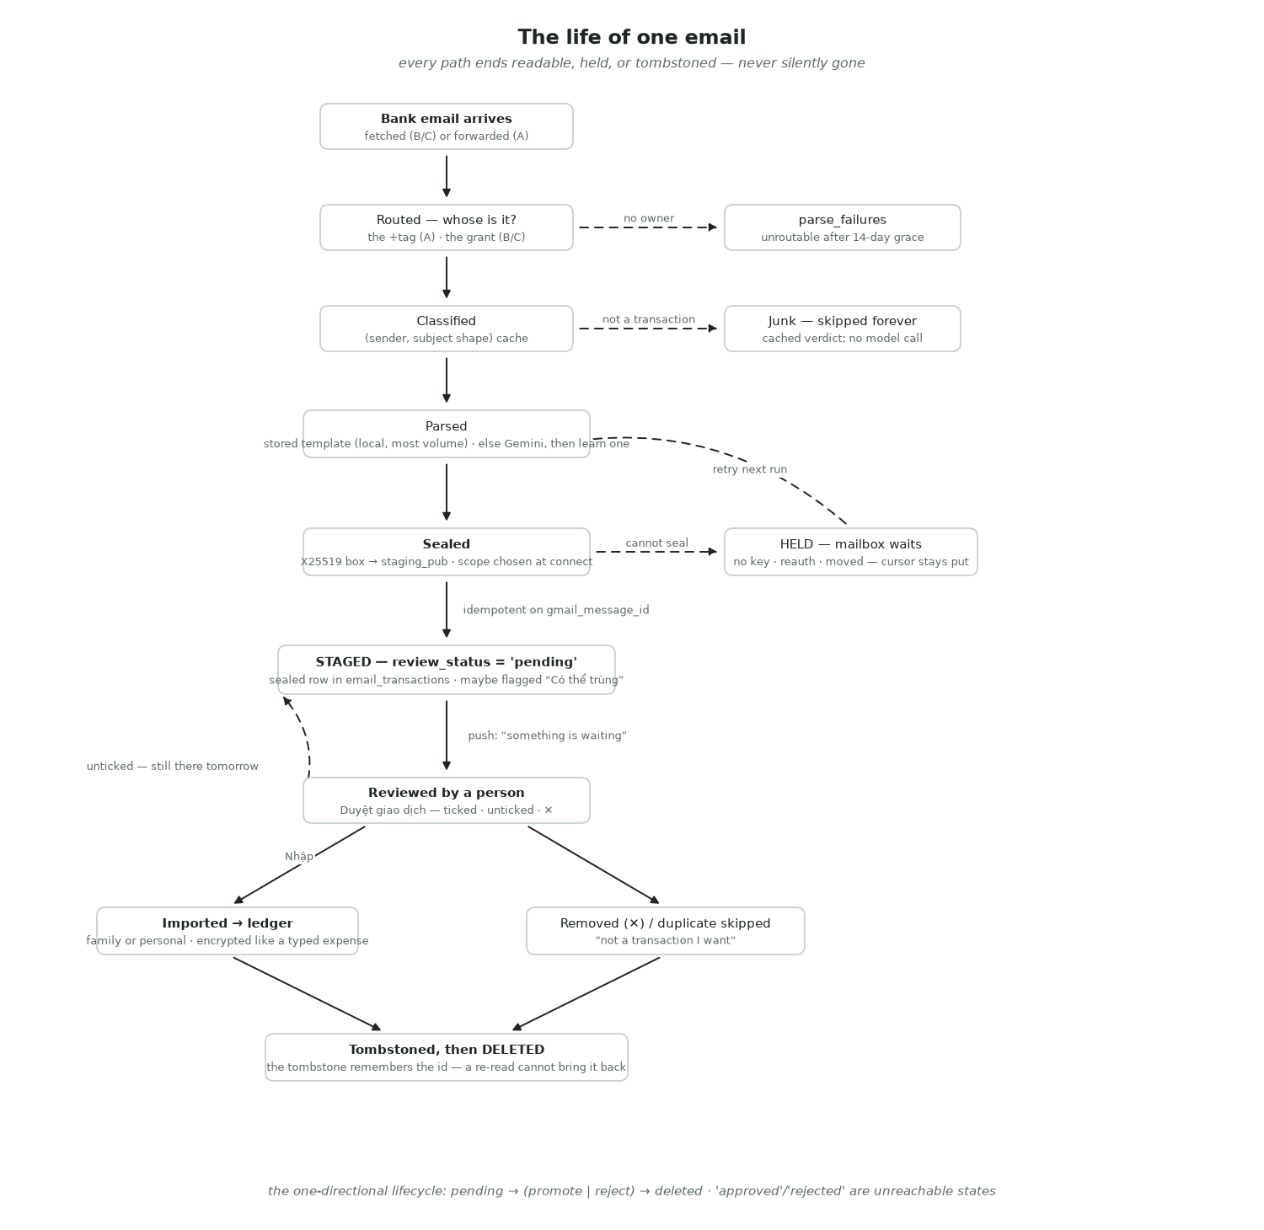
Staged-row state machine — from bank mail to ledger row or tombstone
- 1. Fetched / received. Direct read lists only mail from ~157 known bank and wallet domains; forwarding reads what the user's rule sends.
- 2. Routed. Whose transaction is this? Forwarding parses the +tag; direct read answers from the grant. Unroutable forwarded mail is held 14 days (onboarding may be mid-flight), then recorded as a parse failure.
- 3. Skipped or parsed. A sender cached as non-transactional is skipped forever. A known (sender, subject shape) is parsed locally from a stored template — no model call. Only a first-of-its-kind mail goes to Gemini, and a template is learned from the answer.
- 4. Held, sometimes. If the row cannot be sealed — the family has never minted a staging key, the person has never unlocked their personal ledger, ownership moved since connect — the mail waits. A hold costs one poll and loses nothing; there is no plaintext fallback, ever.
- 5. Sealed and staged. The sensitive fields are encrypted to the family's (or the person's) staging public key and inserted as pending. Likely duplicates are flagged, never dropped.
- 6. Reviewed. Imported → written to a ledger, then the staged row is tombstoned and deleted. Removed → tombstoned and deleted. Unticked → stays pending, still there tomorrow.
- 7. Never re-staged. The tombstone remembers the Gmail message id, so even a re-read of an old window cannot bring a finished transaction back.

7. Duplicates — a suspicion, never a deletion
One purchase can produce two emails: the bank says "debit 200.000đ", the wallet says "receipt 200.000đ". They share no identifier — only an amount. So duplicate detection is a guess, and the system treats its own guesses with suspicion:
- The pipeline flags likely duplicates (duplicate_of_id) but never deletes or hides — flagged rows land in the review screen's "Có thể trùng" bucket with Vẫn nhập / Bỏ qua. This posture was paid for: an earlier version silently filtered flagged rows and a genuine 2.000đ transfer disappeared, notification and all.
- The review screen re-runs detection with better evidence (the decrypted amount, the transaction type the pipeline cannot read on sealed rows, the real ledger) and can overrule a pipeline flag it can prove wrong.
- A missed duplicate costs one tap; a false one hides real money. Every layer is biased accordingly.
- Known gap: moving money between your own accounts still double-counts — two mails, opposite directions, and every rule here matches on sameness (§24).

8. Privacy, consent, and what leaves where
- Consent before collection. Direct read requires the bank_email consent sheet (v4) before Google's screen. The sheet says plainly that a first-time bank's mail is sent to an AI service to be read, amounts and names included. This replaced token masking on 2026-08-25 — v3 consenters agreed to "real values are never sent", so the version bump forces re-affirmation against the new text.
- An AI reads a bank's mail only the first time each mail *format* is seen — and often not even then (most VN bank notices are readable locally, §16.1). After that, a learned template parses every later mail of that format on-device at the server, permanently; a redesign by the bank costs exactly one more model call. Nearly all volume never reaches a model.
- The database can never read a staged row. Amounts, counterparties, references travel only inside a sealed box; the columns are NULL by CHECK constraint.
- Approved rows are end-to-end encrypted under the family or personal key, like every other ledger row. The operator holds ciphertext.
- Notifications carry nothing — no amount, no merchant, asserted by test.
- The raw email body is not stored. Not sealed, not truncated — absent. The user's own mailbox is the better archive, including the property that they can delete it.
- Erasure (PDPL). Withdrawing consent stops OAuth collection immediately (no grace period), disconnects the mailbox, and deletion of stored data follows within 72 hours.

9. Safety rules
- Nothing auto-imports. No scheduled job moves a staged row into any ledger; a person taps Import on every row. Automated writers stage, humans commit — the same trust posture as CSV import.
- Seal or hold — there is no third option. No config flag, no plaintext fallback, no code path from "could not seal" to a readable insert.
- The cursor moves last, and only on a finished window. Every failure here is silent — there is no error page for a transaction that never appeared — so re-reading is normal and skipping is unrecoverable.
- A row that cannot be opened is never silently dropped. Locked devices, stale shells and real tampering all surface as a counted, explained state.
- A duplicate flag is advice, not an action. Nothing a machine guessed can remove a transaction from a human's sight.
- Retirement is local-first. The client remembers what it imported before asking the server to delete, so a failed delete cannot cause a double import.

10. Status and current limits
- Live: both transports; the chooser; two-step connect with per-grant scope and backfill window; sealed staging (family and personal); learned templates; model-supplied category hints; dedup; the review screen with per-row destination; promotion into both ledgers; tombstoned retirement; notifications; watch auto-renewal; beta gate.
- Pre-live: transport C (§15) — parses real Vietnamese bank mail correctly, 445 tests green on the bridge, unmerged.
- Current limits:
- Only banks that send email notifications are captured, and only senders on the domain list are fetched at all (a missing domain fails silently — §21.5). - Internal transfers between your own accounts double-count. - One mailbox per person; a second Google account replaces the first. - Foreign-currency rows stage correctly but the ledger has no currency column; conversion is undecided (§24). - Refresh tokens expire weekly while the Google app is in Testing status — a routine reconnect prompt, not an outage. - Sender authenticity (DKIM) is recorded on every row but not yet enforced.

Part 2 — Technical Appendix

11. Architecture in one view
Three ingest implementations converge on one staging table and one review screen. The module maps:
Transport A — forwarding (Google Apps Script, hand-pasted):
Piece | Owns
pipeline/bank-email-pipeline.gs | The whole run: routing, classification, extraction, sealing, dedup, insert, retention — a single 102 KB file, deployed by paste (§21.3)
Shared Gmail inbox | The corridor forwarded mail lands in; swept after 7 days
mailbox_connections | txn+<tag>@… alias → member

Transport B — direct read (Supabase Edge Functions, Deno):
File | Owns
supabase/functions/mailbox-connect/index.ts | OAuth: /authorize (JWT-verified, returns Google URL as JSON), /callback (state-authenticated, stores the grant, registers the watch)
supabase/functions/mailbox-sync/index.ts | Three routes, all secret-gated: /push (Gmail→Pub/Sub), /ingest (external-reader handoff), bare POST (cron tick)
_shared/mailbox/senders.mjs | Which senders are read at all — the one file standing between "we read bank mail" and "we read everything"
_shared/mailbox/gmail.mjs, mailtext.mjs | Token exchange, messages.list/get, MIME walk, DKIM verdict; HTML → text
_shared/mailbox/extract.mjs, templates.mjs, labeltable.mjs, llm.mjs, memo.mjs | The extraction cascade (§16)
_shared/mailbox/identity.mjs | Grant → {memberId, familyId, stagingPub} and the six holds
_shared/mailbox/sealed-box.mjs, stage.mjs | The seal and the clear/sealed split (§17)
_shared/mailbox/dedup.mjs | dedup_fp + the cross-source rule (§18)
_shared/mailbox/db.mjs | Every read and write, in one place, as service_role
_shared/mailbox/worker.mjs | The run loop — pure, dependencies injected
supabase/migrations/0088 | pg_cron */5 → _mailbox_sync_tick() → net.http_post

Transport C — Python/GCP (earthy/serverless/, pre-live): §15.
Client (shared by all transports):
File | Owns
src/js-data/71-mailbox-ui.js, 73-mailbox-gate.js | Forwarding alias UI; beta gate can_use_mailbox()
src/js-data/74-autotxn-ui.js | Transport chooser, two-step connect, scope + backfill chips, status, disconnect (incl. headless stop for erasure)
src/js-data/75-consent-ui.js | The bank_email consent sheet (v4) — must change in the same commit as llm.mjs
src/js-data/72-txn-review.js | Fetch staged rows, open sealed boxes, orchestrate promote/retire
src/js-ui/57-csv-import-review.js, 56-csv-import-ui.js | The review engine (shared with CSV import): buckets, category cascade, per-row scope, render, promote
src/js-data/18-staging-keys.js, 19-personal.js | Family / personal staging keys, sealed-box open, key-mismatch alarm
src/js-data/40-txn-writes-outbox.js, 50-writethrough-realtime.js | The family ledger write + offline outbox; source stamping
src/js-data/55-push.js | Routes a txn_review push tap into the review screen

12. The shared staging contract

12.1 email_transactions — one table, three writers, one reader
Created in 0025; ~22 columns in three groups. The clear/sealed split is the privacy design in schema form — every clear column has to justify itself:
Stays clear | Why it cannot be sealed
gmail_message_id NOT NULL UNIQUE | the idempotency key, queried before anything is decrypted
member_id (nullable since 0092) | ownership; the RLS policy keys on it
owner_user_id (0092) | ownership for personal-only users, who have no member row
source_provider | dedup compares bank names fuzzily; a hash matches only exactly
occurred_at | dedup queries a date range
dedup_fp | the keyed equality token that replaces the sealed amount (§18)
duplicate_of_id, review_status, staging_scope, txn_source | workflow state and provenance, not content

Sealed (NULL in the row, carried inside the box): amount, currency, direction, counterparty, reference_number, transaction_type, raw_extracted. Envelope: sealed, eph_pub, nonce, enc_v — the email_transactions_sealed_or_plain CHECK (0068) makes the half-sealed state unwritable: all four envelope columns NULL, or all four set and every sensitive column NULL. (0065's first version forgot raw_extracted and transaction_type — the two most content-bearing fields after the amount.)
raw_body is never stored. ~20KB per row that nothing reads back, when the original stays in the user's mailbox. parse_failures stopped storing it too (0068) — a failure row holding a full plaintext email was a side door around everything the sealed table protects.
review_status is only ever 'pending'. The lifecycle is one-directional: pending → (promote | reject) → row physically deleted. 'approved'/'rejected' exist in the CHECK but are unreachable; promoted_transaction_id is a dead column.

12.2 The supporting tables
Table | Role
sender_fingerprints (0025) | The parse cache, keyed (sender_address, subject_template) — not sender alone: one sender can mix transactional and marketing mail. Holds the cached verdict, transaction_type, the learned extraction_regex, human_verified. Shared by transports A and B.
mailbox_connections (0025, 0059) | Forwarding identity: unique forwarding_alias, personal_email, member_id, verified
mailbox_grants (0087, +0089 0092 0093) | The OAuth link: encrypted refresh token, member/family destination, default_scope, backfill_days, sync cursor, watch expiry, needs_reauth. UNIQUE (user_id, provider)
resolved_email_messages (0090, re-keyed 0092) | Tombstones: (owner_user_id, gmail_message_id, member_id) — "this mailbox is finished with this message". No amount, no merchant, no date.
parse_failures (0025) | Triage for unroutable/unreadable mail; plaintext-free since 0068
category_rules, known_provider_domains, mailbox_beta_access | Keyword→category seed; bank-picker seed (largely unused); the beta allowlist (0067)
family_keys.staging_pub / staging_priv_enc (0051) | The family staging keypair — public half readable by the worker, private half wrapped by the family DEK
personal_keys.staging_pub / staging_priv_enc (0091) | The personal staging keypair — private half wrapped by the owner's DEK, never a family key

12.3 Access control
Object | anon | authenticated | service_role
email_transactions | — | SELECT own rows (0058: member_id ∈ my members, or owner since 0092); writes deny-all | full
mailbox_grants | — | SELECT own, column-limited — refresh_token_enc is not grantable to a browser | full
resolved_email_messages | — | SELECT own | SELECT/INSERT/DELETE
resolve_email_transactions(uuid[]) (0060) | — | EXECUTE — SECURITY DEFINER, re-checks ownership, deletes nothing rather than erroring on foreign ids | —
grant_mailbox_access() | — | — | EXECUTE
disconnect_my_mailbox() | — | EXECUTE | —

The 0058 policy is user-based, not auth_family_id()-based — which is what kept a months-long unscoped-dedup bug invisible to clients, and what made the policy survive personal-only containers. Rows with no member_id and no owner are visible to nobody, on purpose.
The worker runs as service_role and bypasses RLS — every scoping filter must be explicit in its queries. That is not theoretical: the dedup query ran for months comparing across members before the member filter was added (§18.2).

12.4 Migration ledger
Cite by filename — the numeric sequence has documented collisions.
File | What it did
0025_bank_email_pipeline | The six additive tables; no existing table altered
0027, 0028, 0029 | Categorisation seed, member routing, mirror-event backfill
0051_family_staging_keys | Family staging keypair + set/get_family_staging_key()
0058_email_transactions_review_access | The SELECT-only client policy
0059 | Forwarding aliases (get_or_create_mailbox_alias)
0060_email_transactions_resolve | Retirement = hard DELETE via SECURITY DEFINER
0065, 0068 | Sealed-or-plain CHECK; hardened + parse_failures plaintext stop
0067_mailbox_beta_gate | Allowlist + can_use_mailbox()
0087_mailbox_direct_read | mailbox_grants, grant_mailbox_access(), disconnect_my_mailbox()
0088_mailbox_sync_schedule | pg_cron tick reading Vault secrets
0089_mailbox_watch | watch_expires_at
0090_resolved_email_messages | Tombstones (after the 2026-08-26 re-staging incident)
0091_personal_staging_key | Personal staging keypair; staging_scope; default_scope
0092_personal_only_mailboxes | Mailbox belongs to a person; family optional; owner_user_id
0093_backfill_window | Per-grant backfill_days (1–365, default 90)
0097–0100 | Backfill fast lane (a once-a-minute cron that services only unfinished backfills); re-backfill on widen; fingerprint-cache hygiene; txn_source provenance
0101_backfill_stall_counter | stalled_runs / first_stalled_at on mailbox_grants — lets a backfill that stopped progressing announce its queue instead of staying silent (§20)
0102_grant_default_scope_read | Adds default_scope to the client's column-level grant — a column added after 0087's explicit grant list was invisible to the app, which read "no scope" as "not set up" and sent a connected user back to setup
0103_one_grant_per_mailbox | Unique on the (fold-normalised) mailbox address itself — one mailbox, one reader, across accounts, not just per account

13. Transport A — forwarding (Apps Script)
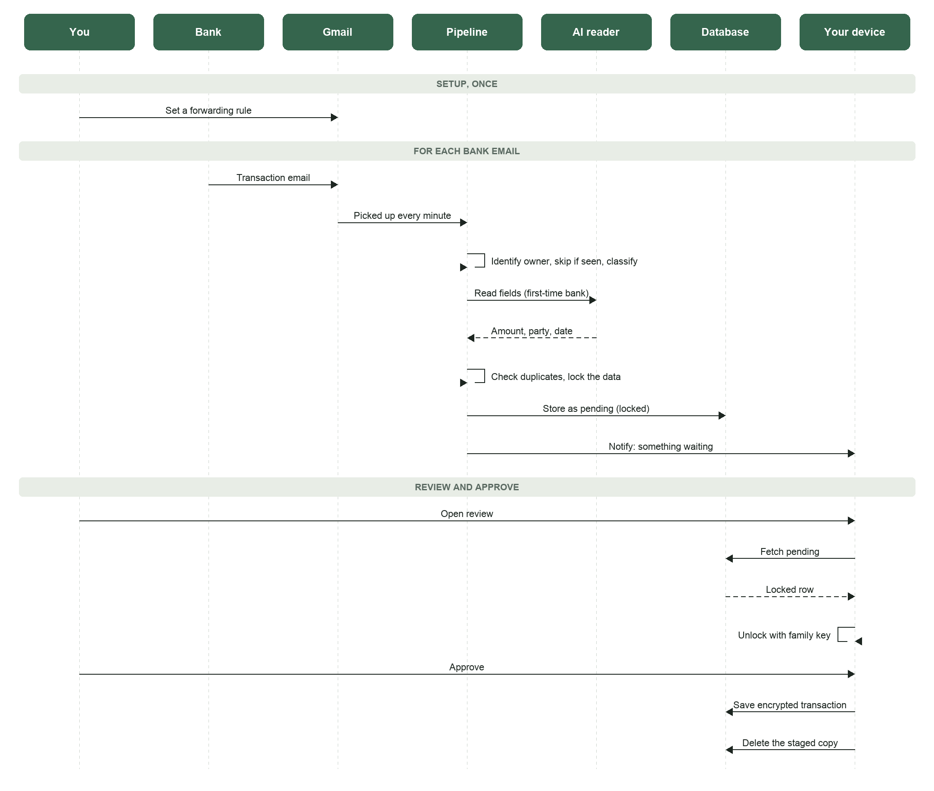
Forwarding sequence
Identity is the +tag, not the To: header. One shared inbox serves all users; To: is attacker-typeable text. resolveMailbox() parses the tag and looks up mailbox_connections; everything else is discarded. Gmail search semantics force the query to carry both to:<alias> terms and a from:<bank domains> newer_than:7d term, because auto-forwarding preserves the original To: header and to:<alias> does not match it.
The run. A time trigger fires every minute holding a script lock (tryLock(0)) — overlap is not theoretical: two concurrent runs are how the DRBG hands two rows the same counter, i.e. keystream reuse. Every run logs v<PIPELINE_VERSION> | N thread(s) — the only reliable answer to "which code is live" (§21.3).
Per message, in order — each step can stop the message, and the stopping behaviour matters as much as the happy path:
# | Step | On failure
1 | Route (+tag → member) | held ROUTING_GRACE_DAYS = 14, then parse_failures + label txn/parse-failed
2 | Idempotency (isAlreadyStaged) | a DB throw is deliberately not caught — "unreachable" must not be read as "not staged"
3 | Classify (cache, else Gemini) | non-transaction → cache the verdict, done
4 | Extract (template, else LLM) | parse_failures
5 | Sender auth (DKIM + forwarder match) | advisory unless SENDER_AUTH_ENFORCE
6–7 | Dedup + fingerprint | flags, never blocks
8 | Seal | null = HOLD: retry next run; no plaintext path exists
9 | Insert | parse_failures
10 | Notify | counted only after a confirmed insert (PostgREST error objects are truthy — a scar)
11 | Relabel txn/processed | —

Budgets: MAX_NEW_CLASSIFICATIONS_PER_RUN = 10, …PER_DAY = 50. Routing runs before extraction so unroutable mail never costs a model call.
Retention. The shared inbox is a corridor, not an archive: processed threads older than 7 days are trashed (≤50 threads per sweep, per-thread try/catch, both ends of the date range bounded so a live thread with one old message survives).

14. Transport B — OAuth direct read (Edge Functions)
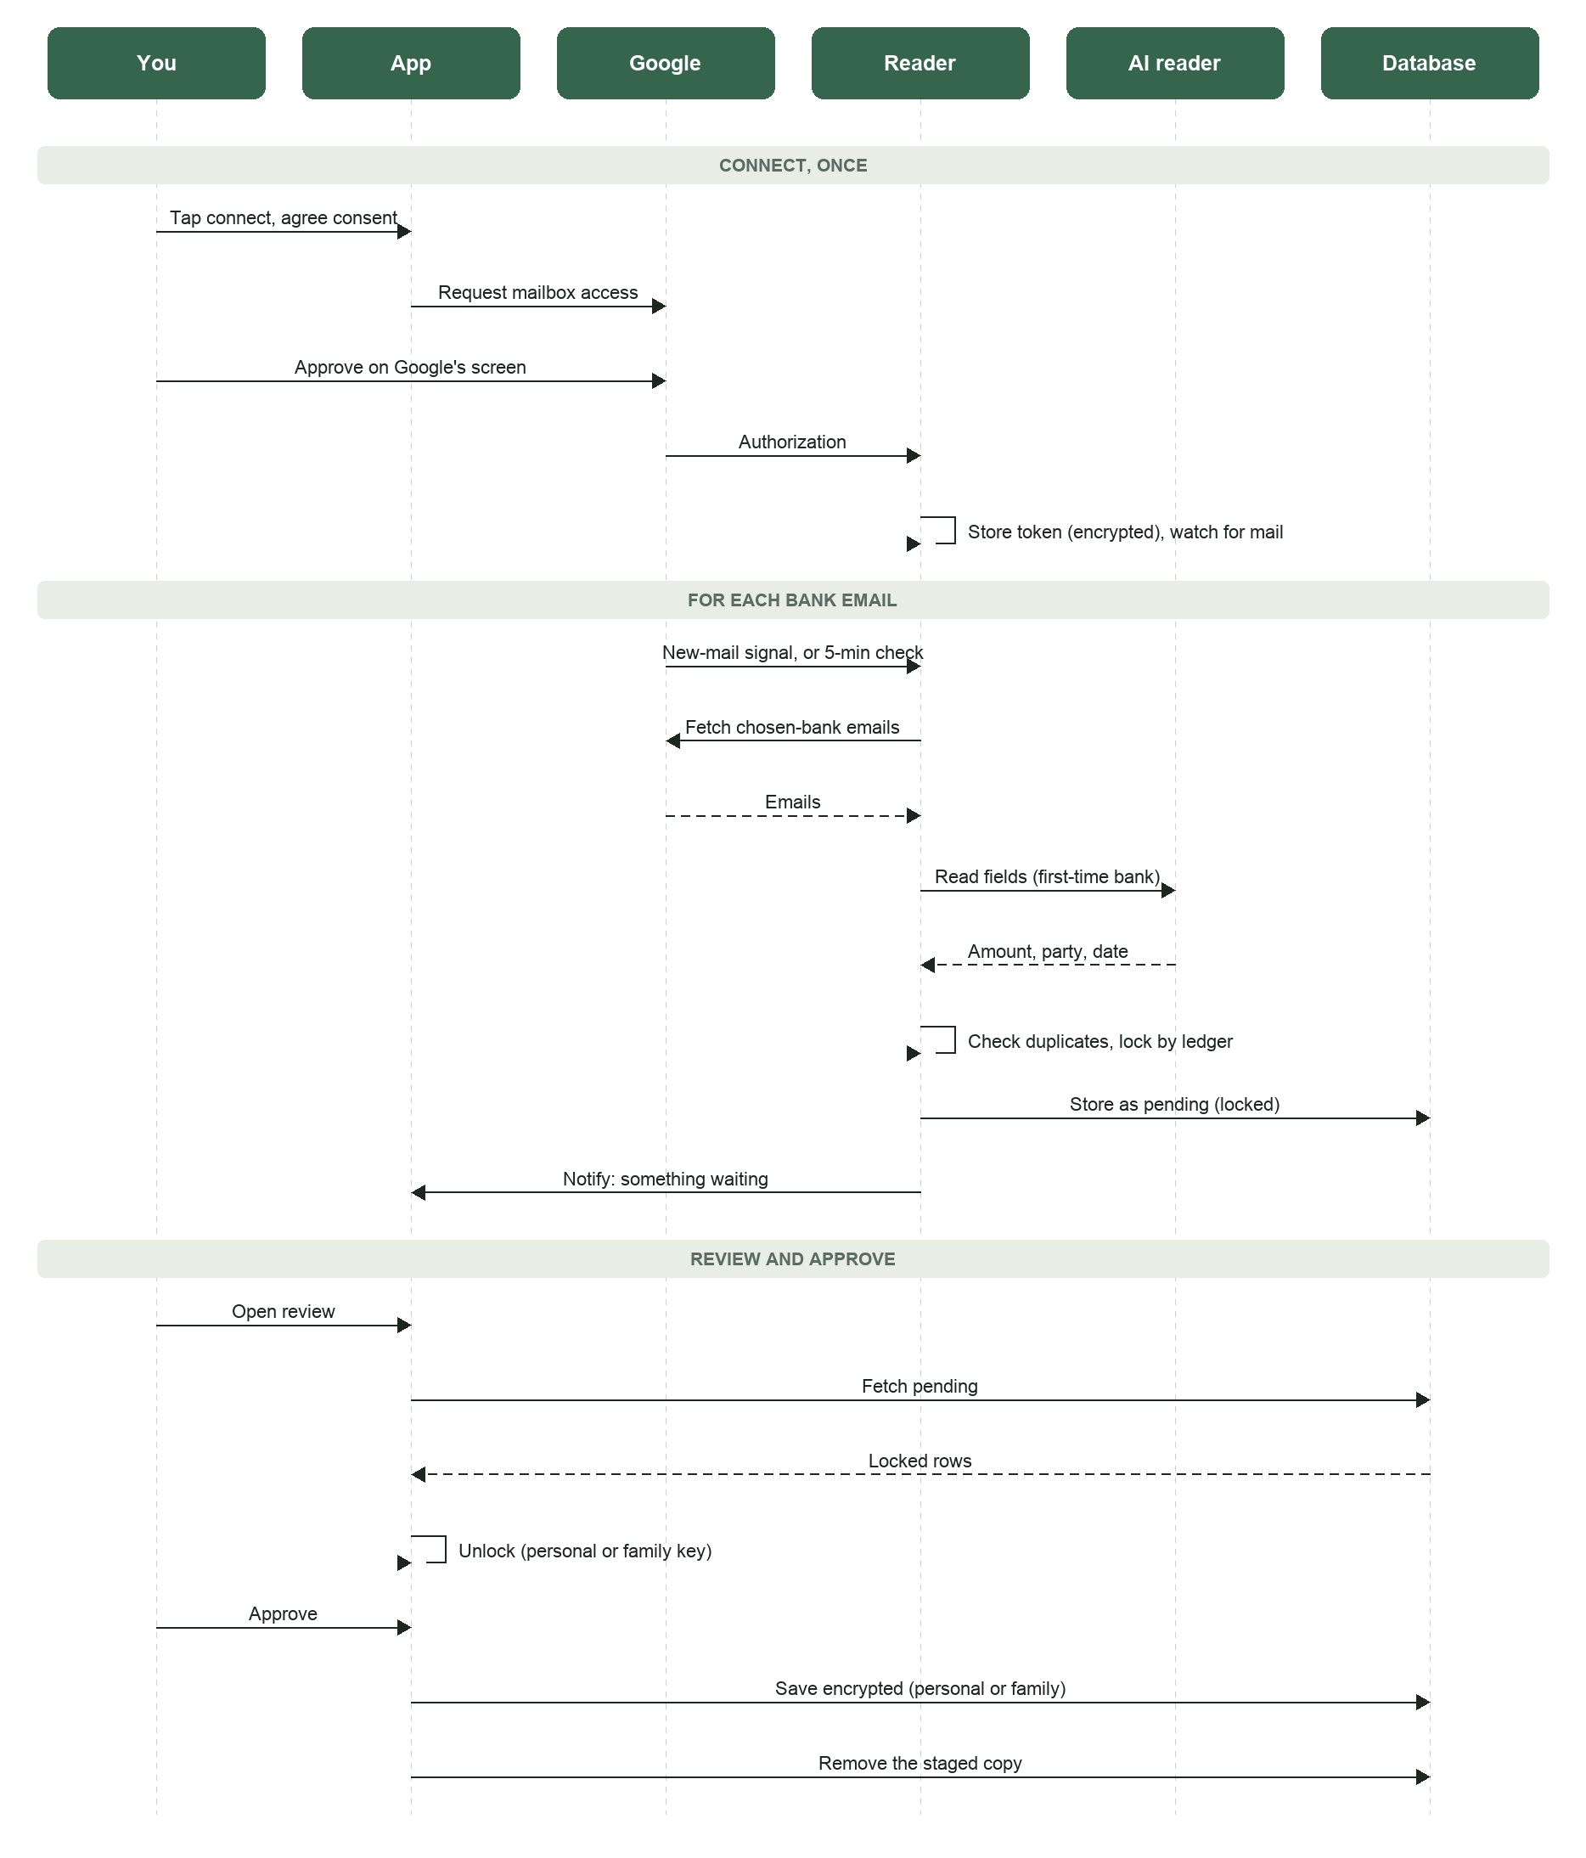
Direct-read sequence

14.1 Connect
/authorize verifies the Supabase JWT, mints an HMAC-signed state (MAILBOX_STATE_SECRET, 15-minute TTL) and returns Google's consent URL as JSON, not a 302 — a cross-origin fetch cannot follow a redirect to Google usefully. /callback runs --no-verify-jwt (a browser returning from Google carries no session) and authenticates by verifying the signed state; it then exchanges the code, encrypts the refresh token (AES-256-GCM, MAILBOX_TOKEN_KEY, v1:<iv>:<ct> in a bytea), and calls grant_mailbox_access().
That RPC is where ownership is decided — the highest-consequence query in the feature:
select m.id, m.family_id from members m join families f on f.id = m.family_id
where m.user_id = p_user_id and m.is_shared = false and m.archived_at is null
and f.type = 'family' and f.archived_at is null
order by m.created_at limit 1;
order by m.created_at is load-bearing: since personal ledgers every user has more than one members row, and an unordered limit 1 is a coin flip that binds a mailbox to the wrong container. Since 0092 only a family-scoped grant requires a member row at all — a personal-only user's grant carries owner_user_id instead. The callback finally registers users.watch() if GMAIL_PUSH_TOPIC is set; best effort — failure costs latency, not transactions.
History note: connect lived on a separate Cloud Run API until 2026-08-25. That API links a Google account to an auth.users row and stages nothing; this one writes mailbox_grants, which carries the member/family a row is sealed to. The erasure path still calls the old API's DELETE so a withdrawn consent also stops the serverless watcher (_atxStopHeadless, 74-autotxn-ui.js).

14.2 Two triggers, one pipeline
Trigger | Path | Latency | Role
Gmail push | Gmail → Pub/Sub → POST /mailbox-sync/push?secret= | seconds | the optimisation
pg_cron | _mailbox_sync_tick() → POST /mailbox-sync | ≤ 5 min | the guarantee

They do identical work and are both needed because they fail differently: a watch lapses after 7 days and Gmail then stops publishing silently — a push-only pipeline looks idle rather than broken. Overlap is harmless (idempotent on gmail_message_id). /push acks anything a retry cannot fix, because Pub/Sub redelivers whatever is not acked and fighting a permanent failure that way is how a topic backs up. The tick also renews watches due within 2 days.

14.3 The run, per mailbox
- 1. Select due grants — needs_reauth = false, oldest first, ≤ MAX_GRANTS_PER_RUN (25).
- 2. Resolve identity → {memberId, familyId, stagingPub}; six states HOLD (§14.5).
- 3. Decrypt the refresh token, exchange for an access token.
- 4. Compute the window (§14.4).
- 5. messages.list — from:(157 domains) newer_than:Nd, deliberately not scoped to the inbox label (auto-filtered bank mail is still a transaction). Caps: LIST_MAX_PER_RUN 500, BACKFILL_LIST_MAX 2000.
- 6. alreadyStaged(ids, …) for the whole window, unioning email_transactions and the tombstones — chunked at 150 ids per request: a 365-day window listed 891 ids, and as a single in.(…) query string (~19KB) Cloudflare refused it with a bare http2 stream error before anything was read — a connect that showed nothing at all, indistinguishable from an empty mailbox (live incident, 2026-08-30).
- 7. Per fresh message (≤ MAX_MESSAGES_PER_GRANT 120; BACKFILL_STAGE_MAX 400 when backfilling; fetches run FETCH_CONCURRENCY = 20 lanes wide — Gmail allows ~50 req/s per user, and a real 90-day backfill spent 65% of its 76 seconds fetching at the old 6): fetch → sender match → DKIM verdict → parse → seal → fingerprint → dedup → insert.
- 8. Advance the cursor — only if nothing held and nothing remains queued.
- 9. Notify (§20 — steady-state runs and backfills announce differently).

14.4 Windowing and the cursor
First connect reads the grant's own backfill_days (default 90, clamped 1–365). After that, windowDays(last_synced_at) = max(POLL_DAYS=2, ceil(days_since)+1) — an outage widens the window instead of skipping it. The 365 ceiling is ours, not Gmail's: Gmail returns newest-first and a staged message still matches the query, so past the list cap the oldest mail is not slow, it is unreachable — hence BACKFILL_LIST_MAX, sized against the busiest observed mailbox (~66 transactions/month ⇒ a year ≈ 800). A run that hits its staging cap reports more and leaves both cursors alone; the next tick continues. A 300-message backfill arrives over a few minutes rather than being truncated and marked done.
Worked timeline. You connect Tuesday 09:00 with the default 90-day backfill: the first run lists newer_than:90d (up to 2000 ids), stages up to 400, reports more if anything remains; runs continue (a dedicated once-a-minute cron, familyhub-mailbox-backfill, fast-lanes unfinished backfills between the 5-minute ticks) until the window is clean, and only then are backfilled_at and last_synced_at written — a real 90-day history (228 messages) lands in ~76 seconds. From then on each tick reads max(2, ceil(days_since_last_sync)+1) days — normally 2. If the worker is down from Friday to Monday, Monday's first tick computes ceil(3)+1 = 4 days: the outage widened the window, nothing was skipped, and alreadyStaged makes the re-read cost one query.

14.5 The six holds
resolveDestination throws MailboxHold for:
Reason | Meaning | Clears when
needs_reauth | Google rejected the refresh token | user reconnects (weekly under Testing status)
no_member | grant carries no destination | ownership restored
member_archived | member archived since connect | —
member_moved | member's family ≠ grant's | ownership settled — sealing to either side would strand the row; the disagreement is the thing to stop on
no_staging_pub | family never minted a staging keypair | any family device unlocks
no_personal_staging_pub | personal grant, owner never unlocked their personal ledger | that person unlocks — no relative can help, which is why it is not folded into the row above

Every hold is a property of the mailbox, not a message, so it stops the whole mailbox; the cursor does not move, so it costs one poll and loses nothing.

14.6 Sender authenticity — what the DKIM verdict actually is
Gmail verifies DKIM before we ever see a message and records the result in the Authentication-Results header, so dkimVerdict (gmail.mjs) reads a verdict rather than doing crypto — taking only the first header value, which is what keeps an attacker-supplied second copy in the body out. The verdict is pass only when both hold:
- dkim=pass in the receiving server's results, and
- alignment: the signing domain and the From: domain match as a suffix on a dot boundary — mail signed by mbbank.com.vn for notify.mbbank.com.vn is aligned; mbbank.com.vn.evil.com is not.
What this does not prove: DKIM proves a domain signed its own mail, not that the domain is really your bank — a lookalike domain signs perfectly for itself. senders.match is what decides the domain is one we believe in; DKIM decides the mail really came from it. Both, or neither is worth much. The verdict matters more under direct read than forwarding: a phishing mail once had to be forwarded to us by the user; now it only has to arrive in their inbox, a much lower bar for an attacker. So the verdict is recorded on every row (_sender_auth, inside the box) and travels to the review screen; enforcement (SENDER_AUTH_ENFORCE, rejecting failures into parse_failures) stays off until observed data earns it, because some banks legitimately sign with an ESP's domain and a check that can reject real transactions must prove itself first. (Transport A's equivalent adds a forwarder match — the mail must have been forwarded by the alias's own personal_email.)

14.7 The grant's lifecycle
One row in mailbox_grants per person, from birth to death:
- Born at /callback: encrypted refresh token, email, the member/family destination (or owner-only), default_scope and backfill_days as chosen on the connect sheet, connected_at. On conflict (reconnect), the token and consent-driven fields update but history_id and backfilled_at are deliberately untouched — overwriting a live cursor skips every message between it and now.
- Weekly death of the token (for now). Google expires refresh tokens after 7 days for external apps in Testing publishing status, and Gmail scopes are never exempt. The first run after expiry gets a rejection from Google → needs_reauth = true → the grant is skipped by every subsequent run (no wasted calls, no held queue confusion) and the app shows a reconnect prompt. Reconnecting replaces the token, clears the flag, and — because the cursor survived — the widened window (§14.4) catches up whatever arrived meanwhile. Routine, not an outage; ends when the OAuth app reaches In-production status (verification + CASA assessment).
- Replaced by a second account. UNIQUE (user_id, provider): connecting another Google account replaces the grant — stated in the UI ("Đổi") because nobody would guess it. And since 0103, one mailbox can only be read by one FamilyHub account (unique on the fold-normalised address itself): a second account connecting the same Gmail is refused rather than silently creating two readers staging every mail twice.
- Disconnect (Settings, arm-then-confirm) → disconnect_my_mailbox() deletes the grant. The registered watch can outlive it by up to 7 days — Gmail keeps ringing a doorbell nobody is behind, which is why /push acks unknown mailboxes.
- Erasure (PDPL) is more than disconnect. Withdrawing bank_email consent must stop collection immediately — there is no grace period for collection-after-withdrawal, even though deletion gets 72 hours. The erasure path therefore also calls the legacy Cloud Run API's DELETE (_atxStopHeadless, where a 404 counts as success — already gone), because a serverless watcher holding its own credentials would otherwise keep reading a mailbox whose owner said stop.

15. Transport C — the Python/GCP pipeline (pre-live)
The backend team's reimplementation, in earthy/serverless/ (a uv workspace, one function per directory, deployed to GCP project fhtest-502915 with make deploy). It reads real mailboxes and parses real Vietnamese bank mail correctly. What it does not do is persist: the parser ends at # TODO: persist.
Shape. The split is drawn where the unit of work changes, mailbox → transaction:
Gmail watch() → [topic: gmail-events]
↓
gmail-transaction-ingest once per notification
history.list → messages.get(format="full") → match sender
↓
[topic: transaction-detected] once per transaction (body travels with it)
↓
transaction-parser strip html → amount/direction/balance
(Gemini `gemini-3.5-flash` for unknown layouts)
- Gmail push carries no content — only {emailAddress, historyId} — so identifying a bank email requires fetching it; there is no cheaper pre-filter stage to split out. Ingest owns the Gmail checkpoint and nothing else; the parser needs no Gmail credentials and can be exercised with a static payload.
- Per-user credentials. A notification names a mailbox; ingest looks up that user's refresh token via the AccountStore seam (shared/accounts.py — Protocol with two methods; swap create_store() for the Postgres-backed store and nothing else changes). Tokens are encrypted at rest; __repr__ is overridden so one cannot reach a log line. historyId advances after the window is handled. Scope is gmail.readonly, asserted by test.
- Token death is a state, not an error. TokenRejected → mark_needs_reauth() + ack (retrying a dead token redelivers until retention runs out). gmail-watch-renew runs daily and renews only watches expiring within 2 days, skipping needs_reauth mailboxes; reports needs_reauth separately from failed.
- The balance is matched separately and skipped by span, not by value, so a transfer that equals the balance still parses. Unknown layouts log INCOMPLETE and ack — a gap to fill, not a transient failure.
What blocks going live:
Thing | Status
persist.py bridge → POST /mailbox-sync/ingest | Built; 445 of their tests green; unmerged on claude/email-reading-integration-ddwqd2 pending backend review. Contract pinned by direct-persist-contract.test.js (real Python build_payload → real sealer → real client opener)
Cloud Scheduler for watch renewal | Not created — today make renew by hand; a lapsed watch fails silently
TEST_SENDERS removal | Anything those accounts send is currently read as a transaction
OAuth verification / CASA assessment | Required past 100 test users for a restricted scope

The /ingest contract — the seam the bridge will cross. When persist.py merges, transport C stops at parsing and hands over; transport B's worker does the half C deliberately does not. The contract (ingest.mjs), pinned by direct-persist-contract.test.js (real Python build_payload → real sealer → real client opener):
- Auth: the shared MAILBOX_SYNC_SECRET. Authenticated means trusted, not correct — everything is re-validated, because a sealed row is one nobody can inspect afterwards to find out what went wrong.
- Payload: {email, gmailMessageId, sourceProvider, senderKind, from?, body?, reading} where reading carries amount (a finite number ≥ 0 — a negative is refused, because direction carries the sign and encoding one fact twice means one encoding is about to be wrong), direction (exactly debit/credit), and optionally currency (default VND), merchant/counterparty, description/memo, balance, type_code, channel, account_tail, reference, category, occurred_at, sender_auth. Field-name translation lives in normaliseReading — neither side's shape is free to move (theirs is pinned by their parser tests, ours by the client opener), so the mapping is one file to look at.
- body is used and never stored — passed only so the memo tidy can detect the account holder's name elsewhere in the mail (a question the memo alone cannot answer); without it, this transport's rows would arrive with no memo_display and the review screen would fall back to raw auto-fill, reintroducing for one transport the bug that field exists to fix.
- Why the seal stays on our side: porting it would create a third byte-compatible sealed-box implementation and a second DEDUP_FP_KEY mint — which is silent: every cross-transport fingerprint stops matching, nothing throws, and the queue quietly holds both halves of every purchase. One implementation, one key, one place plaintext becomes ciphertext.
- Responses are ack decisions (the same contract /push answers): rejected (malformed / no_message_id / no_email / no_amount / bad_direction), ignored (no grant — ordinary, a reader can outlive a disconnect), skipped (already staged or raced the UNIQUE), held, staged (+ duplicate, + senderUnknownToUs). Everything that would fail identically on retry is acked — fighting a permanent failure with redelivery is how a topic backs up.
- The one structural difference from the poll: a hold here cannot heal itself. The poll owns its cursor and re-reads the window; this path owns none — the calling pipeline advances its own history_id past the message. Every hold reason is a mailbox property that will not clear in Pub/Sub-retry time (the commonest — a family that has never unlocked a device — lasts days), so the hold is acked and recorded in parse_failures (ingest_hold:<reason>, ids only). What actually heals it is our own poll, which holds on the same conditions and therefore keeps its window open over the same message. That makes the poll load-bearing here, not belt-and-braces: turn it off and an ingest hold becomes silent data loss.
- Sender naming is reconciled, not enforced. Our registry wins when it recognises the from (so source_provider means the same thing whichever transport wrote the row — the dedup rule matches on it); when it doesn't, the mail is still staged under the caller's label and the divergence is reported (senderUnknownToUs) — their list is wider today, and refusing what they accepted would drop real transactions invisibly to enforce a list.
- Notification is per-row here (no run to summarise), carrying the same nothing the poll's does.
The one-watch rule binds the transports together. Only one Gmail watch() may exist per mailbox — a second call silently replaces the first one's topic, and the loser goes quiet with no error anywhere. Transport B polls precisely so it conflicts with nothing; when transport C owns a mailbox's watch, GMAIL_PUSH_TOPIC must stay unset on the Supabase side (§21.2). When C goes live, it feeds /ingest and B's worker does the sealing — the staging key never leaves the FamilyHub stack, and ownership (member → family → key) stays a FamilyHub concept that connected_accounts alone cannot answer.

16. Extraction — when a mail goes to Gemini, and when it never leaves
This is the heart of "effortless", so it is specified to the decision. readTransaction (extract.mjs) runs once per fresh message and has exactly three outcomes the caller can tell apart: ok (with a parsed extraction), not_a_transaction, or unreadable. A hold is a throw, not an outcome — "the model is rate-limited" and "the model says this is a newsletter" must never collapse into one signal, or the pipeline would either retry a newsletter forever or permanently drop a transaction because a quota reset four minutes later.
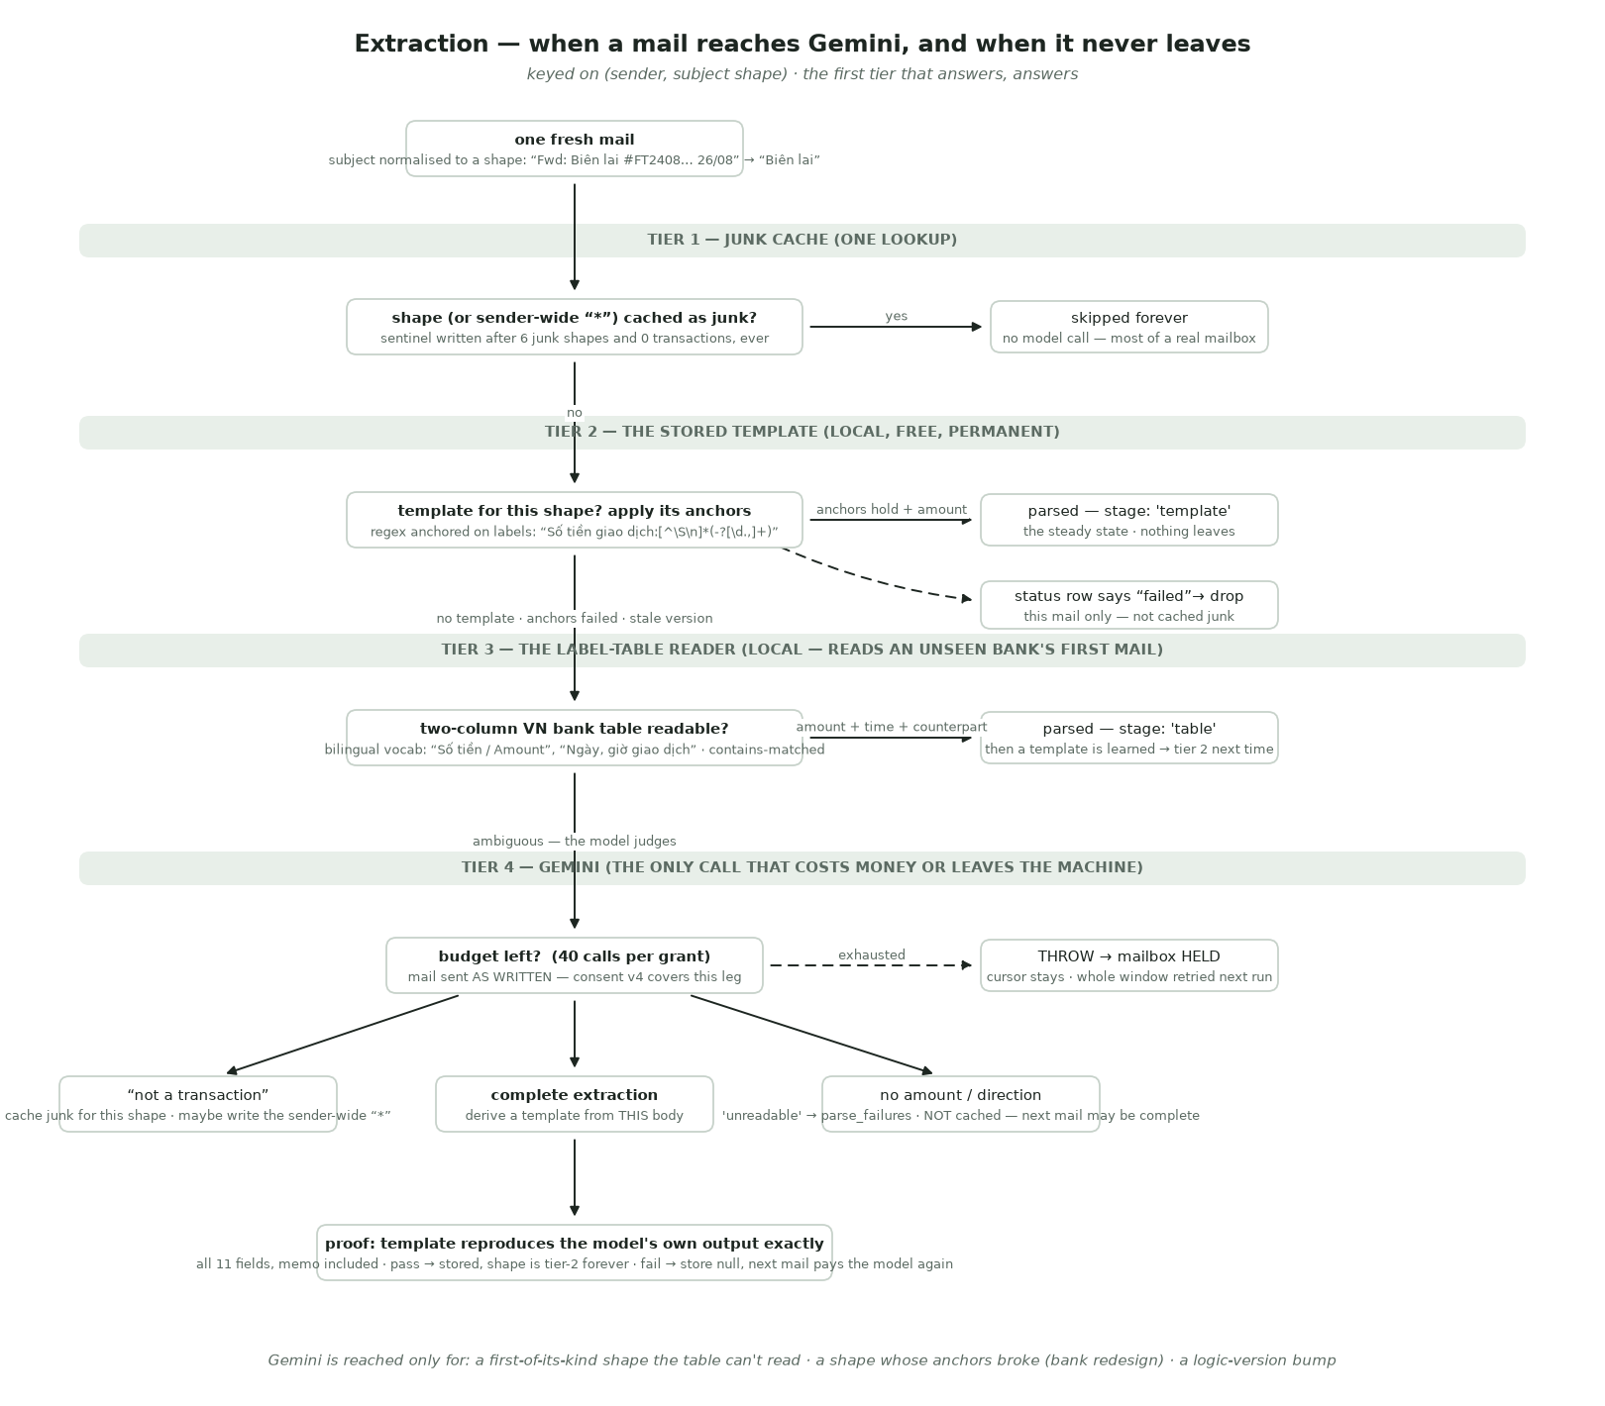
Extraction decision flow — one mail, four tiers, one possible model call

16.1 The decision, step by step
Everything is keyed on (sender_address, subject_template) — the shape of a mail, not the mail. The subject is normalised first (normalizeSubjectTemplate): Fwd:/Re:/Chuyển tiếp: prefixes collapse (a forwarded receipt must land on the bank's own cache row, or every forwarder grows a parallel cache), #refs, runs of 6+ digits, and dates are stripped, whitespace squeezed. So "Fwd: Biên lai chuyển tiền #FT240812… 26/08/2026" and "Biên lai chuyển tiền #FT991103… 29/08/2026" are one cache row: "Biên lai chuyển tiền".
Then, in order — the first tier that answers, answers:
- 1. Junk cache — one lookup, skip forever. If the fingerprint row says is_transaction_source = false, stop. This is most of a real mailbox. Two ways a row got there: this exact shape was judged non-transactional once (tier 4, below), or the sender carries a sender-wide sentinel (`subject_template = '') — written only when a sender has produced SENDER_JUNK_THRESHOLD = 6` distinct junk shapes and zero transactions, ever. The sentinel exists because marketing mail has a new subject every time, so the per-shape cache never repeats and every message would pay a model call to be told the same thing. The txn === 0 guard is the whole safety argument: a sender that has ever* produced one real transaction is never blanketed, however much noise it also sends — banks legitimately mix both on one address. (Six, not two, because a bank's transactional address can open with a run of service notices — login alert, OTP registration, limit change — before its first real transaction.)
- 2. Stored template — local, free, permanent. If the row carries an extraction_regex (a JSON template, §16.2), apply it to the body: - It matches and yields an amount → done, stage: 'template'. No model, nothing leaves the machine. This is the steady state for every bank you've received two mails from. - But the mail's own status row reads "failed" → not_a_transaction for this mail only — several stored templates froze status: 'success' as a static at derivation, so a declined attempt off the same shape would otherwise stage as real spending. Deliberately not cached as junk: the sender is a transaction source; this one mail reports a failure. - The anchors do not hold (usually a structurally different mail from the same sender — the credit variant of a debit notice, or a redesign) → fall through to tier 3/4, and on success the fingerprint row is re-derived and overwritten. A stale template heals itself at the cost of one model call. - Version mismatch or malformed JSON → same fall-through. Every template is stamped with EXTRACTION_LOGIC_VERSION (currently 4); bumping it self-invalidates the whole cache and forces one clean re-derivation per shape, rather than serving answers shaped by logic that no longer exists. (The scar behind this: version 3's templates silently dropped the memo field and still passed their own proof.)
- 3. Label-table reader — local, and it works on a bank's *first* mail. Every VN bank transaction notice observed renders as a two-column label/value table over a small, stable, bilingual vocabulary — "Số tiền / Amount", "Ngày, giờ giao dịch / Trans. Date, Time", "Điểm giao dịch" — where only the values change. readLabelTable parses that structure directly: diacritic-stripped, lowercased, contains-matched labels (VCB writes "Số tiền Transaction Amount" as one cell), with absorber rows sitting above generic ones so "Số tiền khuyến mãi" (a promo figure) can never read as the amount. The confidence gate is the safety argument: it returns null unless the mail yields amount + timestamp + a counterpart, and marketing mail does not carry an amount row and a transaction-timestamp row in table form. On success the template learner runs against its output exactly as it runs against the model's — so a bank this tier reads once graduates to the even cheaper tier-2 path, and the table walk is paid per shape, not per mail.
- 4. Gemini — the only step that costs money or leaves the machine. Before the call, the budget is checked: MAX_MODEL_CALLS_PER_GRANT = 40 — per grant, not one pool shared by the run (the original 10-per-run pool produced exactly what its own comment set out to prevent: with grants running concurrently, the first to reach the model drained it and starved the rest; changed 2026-08-30). Exhaustion throws LlmUnavailable, which HOLDS that mailbox — cursor unmoved, window re-read next run — rather than half-reading a window. Then the outcome branches: - "Not a transaction" → cache the verdict for this exact shape (this is how tier 1 gets populated), then check whether the sender has now earned the blanket sentinel (≥6 junk shapes, 0 transactions). - "A transaction, but no amount or no direction" → unreadable (surfaced in parse_failures), and deliberately not cached: the next mail off this shape may be complete, and caching junk here would blind the pipeline to a whole sender on the strength of one bad mail. - A complete extraction → derive a template from this very body (§16.2). If the derivation survives its proof, store it — every later mail of this shape is tier 2. If it doesn't, store extraction_regex = null: the sender is confirmed as a transaction source, and the next mail simply pays the model again rather than trusting an unproven template.
So, precisely: a mail reaches Gemini only when (a) its (sender, subject shape) has never been resolved before and the label-table reader could not fully read it, (b) a known shape's stored anchors stopped matching (the bank changed its layout, or sent a structural variant), or (c) the template logic version was bumped and every shape re-derives once. Everything else — which is nearly all volume, permanently — is parsed locally, and that fact is half of the consent copy's promise. Production observation: 7 model calls for the first 52 transactions, then 0 (3 templates learned, 3 senders cached as junk).

16.2 What a template actually is
A template is a JSON string stored verbatim in sender_fingerprints.extraction_regex (never parsed-and-restringified on the way through — apply() rejects a non-string by its leading-brace check, and that failure reads exactly like "anchors did not hold", silently sending every mail to the model). It has three parts:
- v — the logic version (4). apply() refuses any other value.
- static — the fields frozen at derivation because they are properties of the shape, not the mail: transaction_type, source_provider, currency, direction, status. Freezing direction is safe only because the anchors protect it: the credit variant of a debit notice is a structurally different mail, fails the anchors, and re-derives — it can never silently inherit direction: 'debit'.
- fields — per-field {re} anchor specs for the values that change per mail: occurred_at (+ a date-transform kind and UTC offset), amount (+ a number-parse mode), and — if present in the derivation mail — counterparty, reference_number, account_masked, memo.
How an anchor is derived. For each value the model extracted, find its raw printed form in the body, then find the stable label text that precedes it — the same-line prefix ("Số tiền giao dịch:") or, failing that, the previous line (VN bank tables often put label and value on adjacent lines). The candidate regex is escape(label) + joiner + valuePattern, and value patterns are tried most general first (([^\n]+) before anything value-specific), because string values — names! — change between emails, and a pattern hard-coding this email's text validates today and fails on every later mail. Amounts are searched in every printed form the number could take — 2.000.000 (VN), 2,000,000 (US), 2000000, with and without decimals — and the winning form fixes the parse mode. Dates try six transforms (d-m-Y H:M, d/m/Y H:M, Y-m-d H:M, then the date-only trio → midnight); the date-only forms exist because VCB and VIB print "Ngày giao dịch: 26/08/2026" with no clock, and without them those banks' templates could never derive — sending every one of their mails to the model forever.
The rules that make a template trustworthy:
- A present-but-unanchorable field fails the whole derivation. If the model read a memo but no anchor can reproduce it, the template is not stored minus-the-memo — that would be the template path silently carrying less than the model path, on the tier that handles most volume forever. (Exactly the v3 scar: first mail from a sender kept its memo, every mail after lost it, silently.)
- The final proof. The finished template is applied back to the very body it came from, and all eleven fields must reproduce the model's output exactly — including memo, including statics. A plausible-looking template that does not actually work would serve wrong figures to every later mail of this sender, on both transports. No proof, no template.
- amount must parse non-zero and occurred_at must transform, or apply() returns null at use time and the mail falls to the model — a template can degrade a mail to the expensive path, never to a wrong answer.
A worked example. MB sends: subject "Thông báo thay đổi số dư tài khoản", body rows "Số tiền giao dịch: -2.000.000 VND", "Thời gian: 26-08-2026 14:32", "Nội dung: NGUYEN THU TRANG chuyen tien".
- 1. First mail ever of this shape: no fingerprint row. The label-table reader recognises "Số tiền" and "Thời gian" rows → parses locally, learns a template — amount anchored as `Số tiền giao dịch:[^\S\n](-?[\d.,]+) with VN parse mode, date as d-m-Y H:M + +07:00, memo anchored under "Nội dung:", statics frozen {direction: debit, currency: VND, provider: MB, …}`. Zero model calls.
- 2. Every later mail of this shape: tier 2 applies the template. Zero cost, nothing leaves the machine, even on the other transport.
- 3. MB's incoming-transfer notice (different subject shape): its own cache row, its own first-mail derivation.
- 4. MB redesigns the email: anchors fail once → one Gemini call → the row is re-derived and overwritten. Self-healing, cost: one call per redesign per shape.

16.3 The model call, exactly
gemini-3.5-flash-lite (DEFAULT_MODEL in llm.mjs, overridable via GEMINI_MODEL), Google Generative Language API, response forced into a closed JSON schema (Gemini's OpenAPI-subset conversion handled at the edge; additionalProperties is a hard 400 there). The system prompt is fixed and does real work — its load-bearing instructions:
- Never guess: null for anything not stated in the mail.
- occurred_at must carry a UTC offset; VN bank mail states none, so the model attaches the sender's local +07:00. Never a bare timestamp.
- memo is copied verbatim, never paraphrased — it is the only field carrying the payer's own words about why the money moved, and the model is explicitly told not to judge whether "NGUYEN VAN A chuyen tien" is meaningful; a human reviews it downstream.
- counterparty copied in full, identifiers included, never shortened.
- flow (income / expense / transfer) is separate from direction (debit / credit) on purpose: direction is a fact the mail states plainly and the template path can read without a model; flow is a judgement about what the movement means (a credit-card bill payment and a wallet top-up are debits that are not spending). Folding them together would make the cheap, reliable field depend on the expensive, fallible one. The prompt also pins the tie-break: when in doubt, answer income/expense — a real expense mislabelled "transfer" vanishes from the ledger; a transfer filed as an expense is merely wrong and visible.
- category is a closed 8-concept vocabulary — Housing, Groceries, Clothing, Shopping, Transport, Dining, Fun, Others — because the family names its own categories in its own language: free text would match none of them while looking like an answer. Null for money coming in (income is not a spending category; guessing one files a salary under Shopping). The review screen resolves the concept against the family's real categories (familyCatForConcept) and never invents one.
- transaction_type ∈ bank_txn / subscription / ecommerce_receipt / p2p_transfer / bill_payment, with p2p defined by a personal counterparty (name, phone, personal account).
The mail goes to the model as written — real amounts, names, account and reference numbers. This reversed a design decision on 2026-08-25: maskForSharing() (shape-preserving fakes swapped back locally) worked and was verified against live Gemini, and was removed deliberately — consent replaced it (v4, §8). A model that cannot read 750.000 cannot use magnitude as evidence, and magnitude is most of how a balance is told from an amount. Two things did not move: repeat senders never reach a model at all (§16.1 is the mechanism), and sealing is untouched. (The CSV-import redactor is a different feature on a different surface and still masks.)
The only "training data" the pipeline collects: when the model succeeds on a mail the table tier could not read, the unrecognised label texts (bank boilerplate — no values, no amounts, nothing personal) are logged so the table vocabulary grows from real misses.

16.4 The tidy layer — after any tier, before sealing
_tidy() runs on every successful extraction regardless of tier:
- memo_display alongside memo, never over it. tidyMemo strips bank auto-fill ("NGUYEN THU TRANG chuyen tien") by removing the account holder's own name and generic banking verbs; a structured memo ("MB.5153-…NAP TIEN DIEN THOAI…") splits into a human part and a type_code. memo_display === '' is a verdict ("this memo says nothing"), not a missing value — the client must not resurrect the rejected memo with || (§19). Keeping both means a misjudged heuristic stays recoverable by the reviewer.
- account_masked is re-masked defensively — stored templates predate the masking rule and capture whatever the mail printed, which for MB is the full account number sitting one row below the masked one.
- source_provider leaves canonical (canonProviderName) from every tier — template statics included, which heals names frozen at derivation without touching the stored template.
Sender lists (senders.mjs): ~157 bank + wallet domains, matched on the sender domain with dot-boundary suffix rules (mail.momo.vn matches momo.vn; momo.vn.evil.com does not), promo-token exclusions in the query. canonicalProvider folds accents and strips banking noise words longest-first so "MB Bank" / "MBBank" / "MB" are one bank.

17. Sealed staging — the writer that cannot read
The pipeline is an unattended script; it cannot hold the family's DEK (nobody is there to unlock it). FamilyHub's promise is that nobody but the family can read their money. The sealed-box design resolves those two facts.

17.1 Keypairs
- Family (0051): an X25519 pair minted on a family device. staging_pub stored clear (it only locks); staging_priv_enc wrapped by the family DEK, only ever opened on a device.
- Personal (0091): the same construction one level down — personal_keys.staging_pub / staging_priv_enc, the private half wrapped by the owner's personal DEK and never by a family key (a family-readable copy would hand private money back to the household). Minted lazily on unlock; first-writer-wins server-side (set_personal_staging_key updates only WHERE staging_pub IS NULL and returns the authoritative pair, so a racing device adopts the winner — an overwrite would orphan every box already sealed).

17.2 The seal
buildStagedRow (stage.mjs) is the boundary — plaintext before it, ciphertext and routing metadata after. Wire format v1:
sealed = base64( nacl.box(payloadUtf8, nonce, staging_pub, eph_priv) )
eph_pub 32 B · nonce 24 B · enc_v = 1
Ephemeral-static X25519 + XSalsa20-Poly1305; the ephemeral secret is zeroed immediately, so the only remaining route to the shared secret runs through the staging private key, which never leaves a device. Byte-compatible across transports A and B (direct-sealed-box.test.js pins parity).
Identity is bound inside the box. The payload carries gmail_message_id plus family_id (family scope) or owner_user_id (personal scope) — different payload keys on purpose, so a payload sealed in one scope can never satisfy the other's check. On open the client compares against values from its own session, never from the server-sent row — a mismatch raises staging_identity_mismatch. Ciphertext moved onto another row or another family is detected rather than silently decrypted onto the wrong transaction.
Seal-or-hold is absolute. Missing library, no staging_pub, pin mismatch, any throw — all hold the message for the next run. There is no code path from "could not seal" to a plaintext insert.

17.3 Scope is decided before anything is read
A box cannot be re-sealed, so "which key" must be answered before the mail is parsed — deciding at review would mean the plaintext had already touched a key the person did not choose. mailbox_grants.default_scope records the answer (chosen at connect; personal is the default); email_transactions.staging_scope records which key actually sealed each row, because the client holds two private keys and a sealed box gives no hint which fits — guessing would turn a wrong key into a silent "unreadable" instead of a clear one.
The asymmetry is the whole argument for the default: a personal-sealed row can still be promoted outward to the family at review (opened with the personal key, re-encrypted under the family DEK); a family-sealed row cannot be pulled back, because the household has already been able to open it. Over-sealing is recoverable; under-sealing is not.

17.4 Opening, and the key-mismatch alarm
fhStagingOpenRow (18-staging-keys.js) opens each box locally (nacl.box.open), verifying Poly1305 integrity and the identity binding. Any failure surfaces the row as unreadable — counted and explained, never skipped.
A malicious operator could swap the server-stored keypair. Defence: on every unlock the client re-derives the public key from its unwrapped private half and compares with the server's copy (fhStagingVerifyServerKey; personal: fhPersonalStagingVerify). A mismatch latches a per-family alarm (localStorage) that freezes approval of staged rows family-wide — every device runs the same verify at its own unlock, so the freeze spreads with no server push. The family ledger itself stays usable (different key). Only a later verify passing clears the latch; a network blip is not treated as tampering.
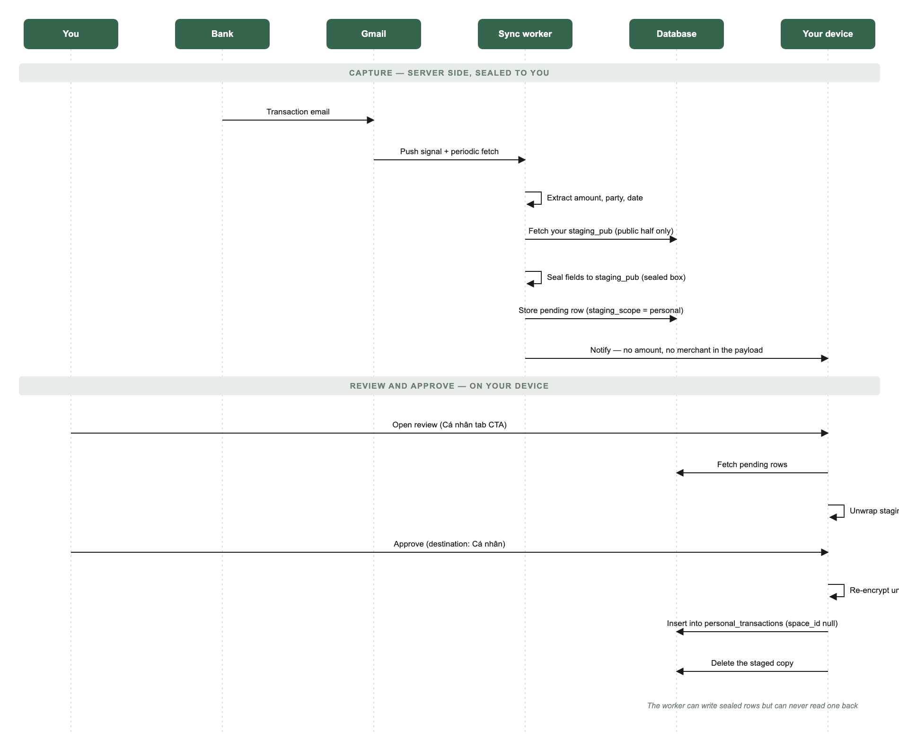
Sealed capture into the personal ledger

17.5 One staged row, concretely
The §16.2 MB debit ("−2.000.000 VND, 26-08-2026 14:32, NGUYEN THU TRANG chuyen tien"), as it actually lands in email_transactions for a family-scoped grant:
In the clear | Value | There because
gmail_message_id | 18b9f2… | idempotency, queried before any decrypt
member_id, owner_user_id | the grant's | RLS / routing
source_provider | MB Bank (canonical) | fuzzy dedup needs the name
occurred_at | 2026-08-26T14:32:00+07:00 | dedup queries a date range
dedup_fp | `HMAC(key, "v1\ | 2000000\ | debit\ | VND")` | the equality token standing in for the sealed amount
staging_scope | family | tells the client which private key to try — a sealed box gives no hint
review_status | pending | the only value ever written
sealed / eph_pub / nonce / enc_v | the envelope | all four or none (CHECK)
amount, currency, direction, counterparty, reference_number, transaction_type, raw_extracted | NULL | enforced NULL by the same CHECK

Inside the box (abridged): the ledger fields the reviewer needs — amount: 2000000, currency, direction, counterparty — plus the whole raw_extracted blob (memo and memo_display, type_code, channel, account_masked, category_hint, flow, _transport, _sender_auth) and the identity binding: family_id + gmail_message_id (for a personal row: owner_user_id instead, under a different payload key, so a box sealed in one scope can never satisfy the other scope's check). The seal happens before the fingerprint is computed and before anything is logged, keeping the window where the function holds both a readable amount and a writable row as short as possible.
The flow field is reconciled, not trusted. direction is a fact the mail states and a template can read with no model; flow (income/expense/transfer) is a judgement only the model makes. Where they disagree, direction wins and the judgement is discarded — a credit can only be income or transfer, a debit only expense or transfer. Where the model said nothing (every template-parsed row — most volume), flow is derived from direction rather than left null, so the client never guesses. The one case that fallback gets wrong — an untagged internal transfer reads as income or expense — is the failure the prompt is told to prefer, because a transfer filed as an expense is wrong but visible, while a real expense filed as a transfer vanishes from the ledger.
On open, the client checks three things, in order: the Poly1305 tag (any tamper → unreadable), the scope identity (its own session's family_id or user id against the one in the box — never the server-sent row's, or a lying server could satisfy both sides), and the gmail_message_id match (ciphertext moved onto another row is caught here). Any failure → the row surfaces counted as unreadable, never silently skipped.

18. Dedup and idempotency
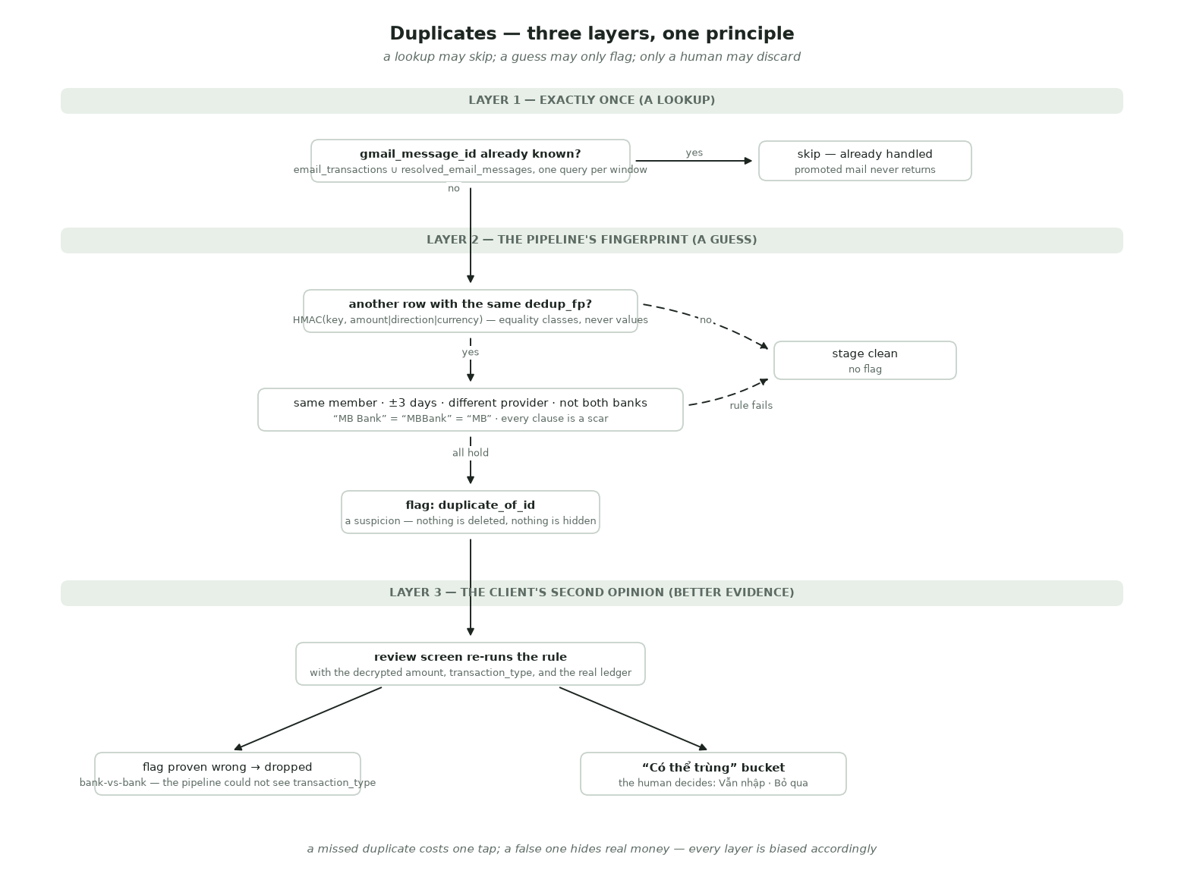
Duplicate decision tree — pipeline guess, client verdict

18.1 Exactly-once: two tables, one question
The question is "have we finished with this message?" — not "is it in email_transactions?", because promotion deletes the staged row.
- gmail_message_id is NOT NULL UNIQUE; alreadyStaged() is asked once per window before anything is fetched, unioning email_transactions and resolved_email_messages. A DB-unreachable throw is deliberately not caught — concluding "not staged" would double-insert.
- resolved_email_messages (0090) exists because of a production incident (2026-08-26): clearing backfilled_at to widen a 15-day backfill to 90 days re-staged 42 transactions already promoted into the ledger. The tombstone stores only ids — recorded before the delete, so a failed insert rolls back and keeps the row; losing the row while failing to record it is the one ordering that cannot be recovered from.
- The client's own retired-set guard cannot cover this: it remembers staged row UUIDs, and a re-staged message is a new row with a new UUID.

18.2 Cross-source dedup — the most-revised part of the pipeline
dedup_fp = base64(HMAC-SHA256(DEDUP_FP_KEY, 'v1|amount|direction|currency')). Keyed, not a plain hash: VND amounts are low-entropy and an unkeyed hash is a dictionary away from readable — what it still leaks, on record, is equality classes, never values. Provider is deliberately excluded from the fingerprint (a hash matches only exactly; bank names need fuzzy matching), which is also why source_provider and occurred_at stay clear columns.
The rule:
same member ∧ same fingerprint ∧ within ±3 days
∧ different canonical provider ∧ not both banks
Every clause was added because its absence caused a real failure:
Clause | Because
canonical provider | "MB Bank"/"MBBank"/"MB" compared as strings → two genuine MB transfers looked cross-source and one was deleted
fingerprint instead of amount | sealing makes amount NULL, so amount=eq.X matches nothing — forever, silently
same member | the query runs as service_role (bypasses RLS) and carried no member filter — every row compared against every member, for months
not both banks | two banks each see only their own account; an MB debit and a VCB debit are two pieces of money, however equal
currency | the bare number compared 200 USD equal to 200 VND

One exception: same provider at the byte-identical instant is a duplicate — that is one email read by both transports; two real transfers never share an exact timestamp.
Worked examples — what gets flagged and what does not:
The two emails | Flagged? | Which clause decides
MB says "debit 200.000đ", MoMo says "receipt 200.000đ", same day | Yes | different canonical providers, one swipe seen from two sides — the case the rule exists for
Two MB transfers of 200.000đ, same afternoon | No | same canonical provider — each bank sees only its own account, so two same-bank debits are two pieces of money
MB debit 200.000đ + VCB debit 200.000đ | No | not both banks — two banks, two accounts, two real debits
A $200 charge and a 200.000đ transfer | No | currency is inside the fingerprint — the bare numbers never meet
The same MB mail staged by forwarding and direct read | Yes (collapsed) | same provider at the byte-identical instant — one email, two transports

DEDUP_FP_KEY is COPIED between transports, never regenerated. Two mints give two key spaces: every cross-transport fingerprint stops matching, nothing throws, and the symptom is a queue quietly holding both halves of every purchase. direct-dedup.test.js pins the format; only a human can ensure the key.
The result sets duplicate_of_id. Nothing is deleted (§7).

18.3 The client's second opinion
The review screen re-runs the rule (csvStagedCrossSourceDup) with strictly more evidence: the decrypted amount, the unsealed provider, transaction_type — which the pipeline cannot read on sealed rows — and the real ledger to compare against (same amount within 3 days of an existing transaction; in-batch same description+amount+day+minute). Where it can prove a pipeline flag wrong (bank-vs-bank), it drops the flag rather than passing the tap to a person. Two independent implementations disagreeing is a free correctness signal — it is how the currency bug was found.

19. Review — how rows land in buckets, and what Nhập actually does
(Screen anatomy and every verb: transaction-review-spec.md. This section specifies the decisions — why a row is where it is, and the exact import sequence.)

19.1 From sealed row to review candidate
- One entry point, two doors. fhEmailTxnCta(preset) checks both transports in parallel; either one set up opens the queue, neither opens the chooser. The Cá nhân entry pre-scopes new rows to personal.
- The review screen is the CSV import engine in csvStagedMode — each decrypted staged row is shaped into a 5-column synthetic CSV row (occurred_at, description, signed amount, counterparty, category hint), so the category cascade, bulk tools and duplicate buckets apply for free. Fetch is 1000 rows (TXN_REVIEW_PAGE), with an exact-count follow-up when the page is full — the old silent cap that hid the oldest rows is the bug this fixes.
- The description is chosen by transaction kind, because "Chi cho gì?" asks what the money was for: the tidied memo when it says anything (memo_display — and an empty one is a verdict that must not be resurrected with ||); else, for a card purchase, the counterparty (the merchant is what was bought); else, for a p2p transfer, deliberately blank — "LE VAN HOANG - 0912…" answers who, not what for, and a pre-filled wrong answer gets accepted rather than corrected.
- The sign encodes direction: credits arrive positive, debits negative, and the engine's sign-convention resolver reads the dominant sign as spending — which routes credits into the money-in holdback below.

19.2 The bucket decision, in order
- 1. Richest-copy merge (staged rows only, before anything else). One payment can reach the queue twice — both transports live, a bank that notifies twice, a hand-forward on top of a rule. Copies are keyed on amount + the exact second (occurred_at instant — the same identity the pipeline's fingerprint uses; wording can diverge between copies, an instant cannot). The most informative copy survives — scored by real description (longer wins), then category, counterparty, time, reference — never "first one wins", because arrival order is an accident. Merged copies are not shown as duplicates ("same amount to the second" is one payment by construction; asking would be a question with no second answer) but they are counted in the header and retired on import. Day-only rows never merge — two honest same-amount purchases would collapse.
- 2. Deferral — "Tụi mình để riêng" / the quiet money-in line. A row is held out of the import if any of: it is money in (a credit, or spending-file wording like "lương/CK đến/hoàn tiền/salary/refund"); it is a credit-card repayment (matched by wording — "thanh toán thẻ tín dụng", "trả nợ thẻ", … — or flow: transfer): money leaving the account that is not consumption, because the purchases it covers live on the card's own statement and importing both counts the month twice; it is missing its date or amount (nothing to file); or the whole batch's signs are ambiguous. Every held row keeps a one-tap way back in ("It's spending, import it").
- 3. Duplicate suspicion — "Có thể trùng". Three layers, most concrete last (§18.3): in-batch (same description-or-counterparty + amount + day — plus the minute for rows that carry a time, because two same-day topups to the same person are how people actually move money; 44 of them once sat parked as "duplicates"); against the real ledger (same amount within 3 days); cross-source (bank vs non-bank, judged on the sealed transaction_type the pipeline couldn't read). A row with no description and no counterparty is simply not deduped — the placeholder text made two unrelated transfers "identical" once.
- 4. Merchant groups — one tap, many rows. Rows that only lack a category, sharing a merchant, collapse to a single card ("Highlands · 3 items"); picking once resolves the group.
- 5. Ready list — everything else, grouped by date. A row whose category came from the fallback or a pattern guess would import as-is but still renders up in "Cần bạn xem" — confidence decides where a row shows, never whether it imports.

19.3 The category cascade
Highest confidence first — the first tier that answers, answers, and every tier resolves to a category the family actually has, never an invented one: pipeline category_hint (the 8-concept vocabulary, resolved via familyCatForConcept — live, despite older docs saying "ignored") → history (the note or the counterparty of a transaction a human already categorised — counterparty too, because renaming a row on import used to make its category unfindable forever) → on-device learned corrections (keyed merchant + amount band, because "… chuyen tien" covers a 35k coffee and a 7M rent, and a lesson at one size must not relabel the other) → MCC (a card statement's "5411" is the network stating the merchant's line of business; only the leading code is read) → merchant/brand match ("a brand is specific evidence; a keyword is a guess about vocabulary, and 'COFFEE HOUSE' filed under Housing is what happens when the guess goes first") → keyword — with transfer phrasing stripped first, because deburred "chuyển tiền cho X" matches "chợ" and once filed every p2p transfer under groceries → spending pattern (same small payee ≥3× → dining; same large round recurring amount → rent) → catch-all fallback. Concretely: a Highlands charge with category_hint: Dining lands pre-filled on the family's "Ăn uống"; a bare "NGUYEN THU TRANG chuyen tien" with no hint and no history falls to the catch-all and renders up in "Cần bạn xem" so it gets a glance. A guess is never final; only an explicit human pick is learned from (and "quên đi" unlearns a bad lesson).

19.4 Nhập N — the import transaction, step by step
fhPromoteStaged runs five steps whose order is the safety design:
- 1. Compute the finished set first, by exclusion: everything readable minus everything still parked in a bucket. (The ✕ handlers splice candidates out of review state, so a rule built from "what was removed" couldn't see them; and merged richer-copy twins are in no bucket, so exclusion correctly counts them finished.) If the review state is unreadable, retire nothing rather than guess.
- 2. Split the ticked rows by per-row destination (csvRowScope, §5-layer resolution — row's own choice → standing per-source route → remembered default).
- 3. Write personal rows first — fhPersonalAddExpense per debit, fhPersonalAddIncome per credit. Any personal failure aborts the whole batch before family writes and before any retirement: a half-done batch that already deleted its staged rows has nothing to retry from.
- 4. Write family rows — csvPromote: commit review-invented categories into catOrder, pre-resolve each distinct category id once, serially (without this, 59 rows raced to CREATE the same category and the batch failed), then submitBulk → addExpense() per row — the encryption-correct path, never submitExpense() (which reads the scope chip live from the DOM and would silently file bank transactions into the personal ledger — one function call of separation).
- 5. Retire — record ids in the local retired set (fh-staged-retired:<memberId>) first, then resolve_email_transactions (tombstone → DELETE). Local-first because duplicating a transaction is recoverable and losing one is not.
What fails how:
Failure | Result
A personal write fails (incl. offline — personal is online-only) | Batch aborts at step 3: no family writes, nothing retired, nothing lost
A family write while offline | Falls into the durable IndexedDB outbox — succeeds later
The server delete in step 5 fails | Rows already written; local retired set keeps them out of this device's queue; toast "Đã lưu, nhưng chưa xoá được bản nháp trên máy chủ" — the double-import guard is the local record, not the server delete
App dies between steps 4 and 5 | Ledger has the rows; staged rows survive server-side; this device's local set has them only if step 5 started — worst case the queue re-shows them and the ledger-duplicate check (§18.3) flags them on re-review

19.5 An amount's journey — every hop of "2.000.000đ"
The single most bug-prone value in the pipeline, traced end to end:
Hop | Value | Rule
The email | "2.000.000 VND" | VN formatting: dot = thousands separator
Extraction (any tier) | 2000000 | raw number, no separators, no symbol; sign never encoded here — direction carries it
Sealed payload + fingerprint | 2000000 + VND | currency travels with the amount everywhere — into the HMAC, the box, and the reviewer's hands (200 USD once read as 200.000đ without it)
Review candidate | "-2000000" | sign prepended from direction (debit → negative)
Review display | 2.000.000đ | display units
Family ledger write | 2000 | ÷1000 to base units inside addExpense (parseAmtBase) — callers pass display units
Personal ledger write | 2000 | ÷1000 explicitly at the call site (csvBaseAmt) — the personal writers take base units directly
At rest | amount_enc | AES-256-GCM ciphertext of the base amount, under the family / personal DEK

The two bolded rows are the standing hazard: same result, two conversion sites (curMult() = 1000 for VND). Passing a candidate's raw amount to the personal writer once stored 1000× too much; a refactor that changes one site must change both — flagged in §24 as worth unifying.

19.6 Retirement bookkeeping
The local retired set is pruned against what the server actually returns (so it cannot grow unbounded), and both entry badges read one global fhStagedCount — the total pending for this member, not per-scope.

20. Notifications
One push per staging run per mailbox on the steady-state poll path, one per row on /ingest; counted only after confirmed inserts; a forwarding burst is one notification. A backfill announces differently: a first read notifies once, on completion, not once per chunk — a 90-day history arriving in runs must not buzz per run. That opened a hole the stall counter (0101) closes: "completion" means nothing held and nothing queued, so a mailbox carrying even one permanently unreadable message never completes and would never notify — a full queue and silence. Past STALL_NOTIFY_AFTER = 12 stalled runs the completion notice is sent anyway, carrying the exact pending count, edge-triggered on the streak crossing, never level-checked — the level form (>=) fired on the crossing run and every run after, and with the minute fast lane that was sixty notices an hour (live incident, 2026-08-30; the notice built to stop ten buzzes an hour sent six times as many). Stalling deliberately does not set backfilled_at: the threshold changes who gets told, never what gets read — stragglers keep being retried. Only the owning member is told. The payload carries no amount and no merchant — asserted by review-notify.test.js, because it travels through a third-party push service that must not learn what the sealed row says. Path: worker → push-send Edge Function (kind txn_review, service-role entrance) → push_subscriptions → 55-push.js routes the tap into the review screen. A failed notification never fails a run.
"When will it appear?" — the latency budget, bank-send to reviewable:
Path | Staged within | Notified | Notes
Direct read, push healthy | seconds | end of that run | the optimisation
Direct read, poll only | ≤ 5 min | end of that run | the guarantee; also the ceiling while a lapsed watch waits for renewal
Forwarding | ≈ 1–2 min | end of that run | 1-min trigger + Gmail forwarding delay
/ingest (transport C, future) | seconds | per row | push-driven end to end
First connect (90-day backfill) | minutes | per completed run | more-chunked at 150 rows per tick; backfilled history is deliberately not push-notified as a flood — each run sends one notice
Badge (fhStagedCount) | on app open / CTA render | — | global count, not per-scope

21. Operations and runbook

21.1 The shared singletons
There is exactly one of each of these, shared by every branch and both humans; a git branch protects none of them:
Singleton | Rule
The live Supabase DB + applied migration numbers | announce numbers in AGENT_SYNC.md before writing, again when applying
Edge Functions (mailbox-connect, mailbox-sync, push-send) | a redeploy replaces whatever the other session deployed — say so
The Apps Script | paste only from origin/main; bump PIPELINE_VERSION
Script Properties / Edge secrets / Vault | announce before changing; no diff, no history
The Gmail watch per mailbox | last watch() caller wins, silently — leave GMAIL_PUSH_TOPIC unset when another pipeline owns the watch

21.2 Secrets and configuration
Edge Function secrets (supabase secrets set):
Secret | Purpose
MAILBOX_TOKEN_KEY | AES-256-GCM key for refresh tokens
MAILBOX_STATE_SECRET | HMAC key for OAuth state
MAILBOX_SYNC_SECRET | gate for /, /push, /ingest; must equal Vault's mailbox_sync_secret (a mismatch = every tick 403s, invisibly)
DEDUP_FP_KEY | copied from Apps Script Properties, never generated
GOOGLE_OAUTH_CLIENT_ID/_SECRET/_REDIRECT_URI | the OAuth client; redirect matched byte-for-byte
GEMINI_API_KEY, GEMINI_MODEL | extraction fallback; key unset ⇒ unlearned templates unreadable
APP_ORIGIN | callback bounce target
GMAIL_PUSH_TOPIC | unset ⇒ poll-only, which is fully functional; set ⇒ we register watches
SENDER_AUTH_ENFORCE | true ⇒ reject on DKIM failure (off; verdicts recorded first)

Vault (out of band, never committed): mailbox_sync_url, mailbox_sync_secret — _mailbox_sync_tick() no-ops silently until both exist.
Apps Script Properties (transport A): SUPABASE_URL, SUPABASE_SERVICE_ROLE_KEY (bypasses RLS), SEALED_STAGING_ENABLED, DEDUP_FP_KEY (self-mints on first use — correct only while it is the sole implementation), SENDER_AUTH_ENFORCE, INBOX_RETENTION_DAYS, GEMINI_API_KEY, ANTHROPIC_API_KEY (dormant, §24). Caches in Script Properties outlive code changes — version the cache key.

21.3 Deploying each transport
- A: hand-paste pipeline/bank-email-pipeline.gs into the Apps Script editor, from origin/main only. No CI, no review gate. The run log's PIPELINE_VERSION line is the only proof a paste took — twice, a "bug" was old code still running. (clasp would delete this class of problem; not done.)
- B: supabase functions deploy mailbox-sync --no-verify-jwt and mailbox-connect --no-verify-jwt (cron and Google's browser return cannot present a user JWT). Push topic setup: create the Pub/Sub topic, grant gmail-api-push@system.gserviceaccount.com roles/pubsub.publisher on the topic, create the push subscription with the secret in the URL (a push subscription cannot set headers), then set GMAIL_PUSH_TOPIC. Full sequence: docs/features/direct-mailbox-read.md §Going live.
- C: make deploy FN=<name> from earthy/serverless/ (uv-generated requirements.txt, shared modules vendored by make sync-shared); make connect / make renew per mailbox today.

21.4 Reading a run
Smoke test: curl -X POST …/functions/v1/mailbox-sync -H "x-sync-secret: …" → {"polled":1,"modelCalls":1,"results":[…]}. Per-mailbox statuses:
status | means | do
ok | window finished | nothing
more | staged its share, more queued | nothing; next tick continues
held + reason | §14.5 | usually nothing; it heals
needs_reauth | token rejected | app prompts; weekly in Testing status
token_unreadable | MAILBOX_TOKEN_KEY changed / row corrupt | user reconnects
error | unexpected; cursor did not move | read detail
ignored (push) | no grant / malformed envelope; acked | nothing

The tick also reports watches: {renewed, failed, needsReauth} — renewed nonzero on every tick means expiries are not being stored (check milliseconds vs seconds).
Extraction telemetry — is the cascade actually saving money? Every read bumps a tally by outcome: junk_cache (tier 1 hit), template (tier 2), table (tier 3), llm (tier 4 success), llm_junk (tier 4 said newsletter), failed_status (a declined attempt dropped), unreadable. A healthy steady state is template + table + junk_cache dwarfing llm; llm climbing on a known sender means anchors are breaking (a bank redesign) — check sender_fingerprints for that sender before suspecting the model. parse_failures triage: unroutable_after_grace rows are forwarding-identity problems; ingest_hold:<reason> rows are transport-C holds the poll should be healing (§15); plaintext is never stored there, so triage works from message ids and reasons only. The table tier also logs unrecognised label texts (logMissLabels) — the queue of vocabulary to add so unseen banks parse locally on first contact.

21.5 Failure modes
The characteristic failure of this feature is silence — nearly every fault returns "no transactions", which is also what an empty mailbox looks like.
Symptom | Likely cause | Where to look
Queue empty, no error | held: no staging key, no family | run status / Executions log holding
Transactions stop appearing | watch lapsed and poll not running | watch_expires_at past; cron history
Every tick 403s | function secret ≠ vault secret | compare; nothing surfaces in-app
Duplicates from both transports | DEDUP_FP_KEY regenerated | fingerprints stop matching; no error
Mail from a bank never appears | domain absent from senders.mjs | never fetched — cannot appear as skipped
History stops at an arbitrary date | window exceeded the list cap | run summary fetched at cap ⇒ raise BACKFILL_LIST_MAX, not the window
Rows in DB, none in the app | member_id/owner null (unroutable) | parse_failures; visible to nobody by design
Queue reads as locked | sealed to a different family than active | staging alarm; 18-staging-keys.js
Already-promoted mail returns | pre-0090 behaviour | fixed; tombstones
Weekly reconnect prompts | 7-day tokens under Testing status | expected; needs_reauth
A notification per minute | stall notice evaluated as a level, not an edge (fixed 2026-08-30) | push-send invocations/hour in logs; stalled_runs on the grant
read_tally.junk_cache exploding (tens of thousands/day) | a backfill window whose tail is all junk re-reads it every fast-lane minute — junk is cached but never remembered as done (§24) | read_tally; backfilled_at stuck null with a stall streak cycling
Nothing since a "fix" (transport A) | the paste did not save | Executions log version string
Notifications stop | push-send not redeployed / no subscription | Edge function logs

RLS denials return empty, not an error — when adding a gate here, make it log.

22. Testing
node tools/run-tests.js discovers every `pipeline/.test.js and tools/.test.js` and exits 1 on empty discovery — a green tick over zero tests once hid the loss of four suites. Tests extract real functions from source by name, so a rename breaks loudly. Highlights:
Suite | Proves
direct-flow.test.js | the whole path: connect → read → parse → seal → save → the real client opener reads the amount back (fake Google/Gemini, real crypto, real bank mail)
direct-own-mailbox | every Gmail call is users/me under that grant's token; read-only scope
direct-sealed-box, sealing | envelope parity across transports + identity binding (53 assertions on the .gs side)
direct-dedup, dedup-provider, staged-instant-dedup | fingerprint parity byte-for-byte; canonicalisation; member scope
direct-resolved-messages | a promoted message stays gone; throws rather than failing open
direct-personal-scope | two real keypairs: a personal row opens with the person's key and fails with the family's
direct-backfill-window | window clamps; a backfill lists deeper than a poll
direct-persist-contract | real Python build_payload → real sealer → real client opener (the transport-C bridge)
direct-ingest | /ingest validation, holds, at-least-once tolerance
email-transport-chooser | the entry point sees both transports; step 1 of connect holds no controls
review-notify | no notification copy variant can carry money
client suites | dup-advisory, review-bucketing, staged-retire, bulk-promote, merchant-memory, mailbox-gate, autotxn-connect/return

Transport C: test_*.py per function plus the parser suites (445 green on the bridge branch).

23. Security invariants
- 1. Sealed rows are opaque to the database. Sensitive columns are NULL by CHECK when the envelope is present; there is no half-sealed state and no plaintext insert path.
- 2. The writer cannot read back. Workers hold only staging_pub; private halves are wrapped by the family DEK / owner's personal DEK and opened only on devices.
- 3. The seal binds identity inside the ciphertext — gmail_message_id plus family_id or owner_user_id under different payload keys — and the client verifies against its own session, so relocated ciphertext and cross-scope substitution are detected at open time.
- 4. Key substitution is detected: clients re-derive the public key from the private half on every unlock and freeze staged approval family-wide on mismatch.
- 5. The personal staging key is never family-wrapped; personal-sealed rows can be promoted outward, never pulled back (over-sealing is recoverable, under-sealing is not).
- 6. Nothing auto-imports; every ledger write passes a human tap and the encryption-correct addExpense() path.
- 7. RLS scopes reads to the owner; writes are deny-all; retirement is a SECURITY DEFINER that re-checks ownership and deletes nothing on foreign ids rather than erroring (no id-probing oracle).
- 8. dedup_fp is keyed (HMAC), leaking equality classes, never values; the key never lives beside the ciphertext it classifies.
- 9. Refresh tokens are encrypted at rest and unreachable from a browser by column-level grant; the read scope is gmail.readonly, asserted by test; restraint of what is fetched lives in one reviewable file (senders.mjs).
- 10. A duplicate flag can hide nothing; a failed decryption surfaces as a counted, explained state, never a silent skip or a zero.

24. Open questions
- A junk-tailed backfill can never finish (open as of 2026-08-30, live on a real grant). Only staged rows and tombstones are remembered as done; junk-cached and failed-status mail is processed cheaply but re-listed and re-fetched every run, so a window whose remainder is all junk never reaches "nothing queued", backfilled_at never sets, the minute fast lane re-chews it forever (observed: ~40k junk-cache reads in a day for a ~900-id window), and the stall notice recurs on every streak re-crossing. Fix direction: the completion condition must count processed-but-not-staged mail as handled — either in the run's own bookkeeping or as remembered handled ids — plus backoff on the fast lane.
- Internal transfers double-count. Two mails, opposite directions, one movement of money — every dedup rule matches on sameness. Designed but unbuilt: pair the legs client-side (the masked account number is sealed, so the pipeline cannot do it), emit one kind='transfer'. Blocking detail: nothing records which bank accounts are yours — the same gap that blocks account_masked routing, so the two would pay for it together.
- account_masked is the strongest routing signal not yet used. Most households split by account, not merchant — "anything on the …4412 card is mine" is one rule where merchant rules would be dozens. Staged on every row already.
- Auto-routing one mailbox to both ledgers is a rule engine away, not a crypto change: destination is already per-row at review, and personal-by-default sealing makes any automation survivable.
- Currency / FX at promotion. email_transactions.currency is per-row (a real USD sample exists); transactions has no currency column. Conversion point undecided.
- Should dedup_fp retire? The client runs the same rule with strictly more evidence. Against: two independent implementations disagreeing is a free correctness signal. Not a decision to take in the change that builds its replacement.
- Could Claude Haiku return as the extractor? The Apps Script carries a complete, dormant classifyAndExtractViaHaiku() path (and an ANTHROPIC_API_KEY property) alongside the live Gemini one. Kept as a candidate future extractor / fallback; no decision recorded.
- Provider naming is split — the model's label wins over the sender table's, producing "MBBank" and "MB" for one bank; canonicalProvider absorbs it at dedup but the review screen shows the raw string.
- A second mailbox per person. UNIQUE (user_id, provider) makes a second Google account replace the first. Widening to (user_id, provider, email) is most of the work — the worker already resolves each grant independently.
- Metadata is not sealed, and metadata is information. Row counts and occurred_at are readable with database access — how many transactions in May, an unusually busy Tuesday; not what was bought. A deliberate trade (dedup queries a date range), recorded so it stays deliberate.

25. Glossary
Staged transaction. A captured row in email_transactions waiting for review — not yet in any ledger.
Sealed box. The X25519 + XSalsa20-Poly1305 envelope a staged row's sensitive fields travel in; sealed to a public key the writer cannot open.
Staging keypair. The X25519 pair (family or personal) staged rows are sealed to; private half wrapped by the respective DEK.
Staging scope. Which keypair sealed a row (family | personal), decided at connect, recorded per row.
Transport. An independent implementation of email ingest: A (forwarding), B (direct read), C (Python/GCP, pre-live).
The grant. A row in mailbox_grants: the OAuth link, its encrypted refresh token, its destination and its cursor.
Hold. A mailbox-level condition that stops a run before staging, losing nothing — the cursor does not move.
The window. The newer_than:Nd slice of mailbox history a run reads; widened after outages, bounded by list caps.
Tombstone. A row in resolved_email_messages: "this mailbox is finished with this Gmail message" — ids only.
Fingerprint (dedup_fp). Keyed HMAC of amount|direction|currency; the equality token that lets sealed rows be compared without being read.
Template. A learned extraction regex in sender_fingerprints that parses a repeat sender with no model call.
Promotion / retirement. Writing an approved staged row into a ledger / tombstoning-then-deleting the staged copy.
Category concept. One of the 8 closed vocabulary values the extractor may emit; resolved to a real family category at review, never invented.

26. Related documents
- docs/specs/transaction-review-spec.md — deep spec of the review screen.
- docs/specs/personal-ledger-spec.md — deep spec of the personal destination, keys and mirror.
- docs/specs/bank-email-capture-spec.docx — the executive-level summary this document supersedes in depth.
- docs/features/bank-email-pipeline.md — transport A, full feature doc.
- docs/features/direct-mailbox-read.md — transport B, full feature doc (including the go-live sequence).
- pipeline/SEALED-STAGING-DESIGN.md — the sealed-box construction and its recorded consequences.
- pipeline/OAUTH-DIRECT-READ.md, pipeline/FORWARDING-HANDOFF.md, pipeline/README.md — decision records and operator guides.
- earthy/serverless/README.md — transport C's own documentation.
- docs/features/encryption.md, docs/features/key-card-auth.md — the DEK and card machinery sealing builds on.
- docs/features/csv-import.md — the sibling staging path and the shared review engine.
- docs/PDPL-COMPLIANCE.md — consent and erasure obligations.
- AGENT_SYNC.md — cross-session ground rules and live claims.

