
aptech computer education
eProject Document
Project Name:
Group 1
Group Member | - Nguyen Tien Hien  - Vo Khanh Duy  - Trao An Tien
Instructor | Mr. Nguyen Tran Nhat Kha
Batch | 155+158
Semester | 3

- Danang, Vietnam, 09/2021 -

Contents
1. Acknowledgements 3
2. Introduction 3
3. Problem Definition 3
3.1. Problem Abstraction 3
3.2. Boundaries of the System 4
3.3. Development Environment 4
4. Requirements and Business Flow 5
4.1. Activity Diagram 5
4.2. Use Case Diagram 7
4.3. Use Case Specification 12
5. Design 28
5.1. Flow chart 29
5.2. Class Diagram 32
5.3. Sequence Diagram (Optional) 34
5.4. Entity Relationship Diagram 37
5.5. Database Design 38
5.6. Algorithms (optional) 42
5.7. Others (optional) 42
6. System Prototype 43
Intro page 43
Admin 47
6. Management and Project Planning 54
6.1. Task Sheet 54
7. Checklists 57
7.1. Check List of Validation 57
7.2. Submission Checklist 57
8. Coding Convention 57
Appendix 59

Acknowledgements

We would like to sincerely acknowledge the kindness of all the people who have given moral support and helped us make a successful project.
We wish to express our deep gratitude to the eProject Team at the Head Office, who guided and helped us. Particular thanks to Mr. Nguyen Tran Nhat Kha who suggested the "debugging is parallelizable" formulation, helped us develop the analysis proceeding from it and debugged code. We also would like to express our great gratitude to all the student members of our center
Although we have made many attempts, because of the limited time, the practice could not be able to avoid the mistakes and omissions. We hope that the Project Team at the Head Office will consider and evaluate our project. And finally, we would like to offer many thanks to all our friends for their valuable suggestions and constructive feedbacks

Introduction

The Project is to be developed where the user is allowed to register their mobile number on the site and they will be allowed to send the message to any mobile. on defining, optimizing, and aligning their client’s business and IT strategies. It also provide option for activating the service for the joke, current affairs, sports, news in your mobile, this would be paid service where user has to pay through credit card.

Problem Definition

Problem Abstraction

As the Internet and the web being the growth engines of the new millennium, the management had decided to maintain the details of their message, their services and payment details. So they want an online application to be introduced into their system through which they can keep track of the services they provide, their clients, and the their SMS.

So they had approached us in order to help them by creating a web application for them meeting their requirements.

Boundaries of the System
1. The details of the SMS and services offered are to be maintained.
2. The different department details are to be maintained. The different departments that Excell-on has is as follows
Administration
Employee
3. The details of the employees are to be maintained based on the designation and the services (like out-bound, in-bound, etc.)
4. The details of the charges levied for each service are to be maintained.
5. The details of the clients are to be maintained.
6. The details of the products and services that their clients offer are to be maintained.
7. Based on the charges levied for a service, the total charges for the clients are to be calculated based on the services that the client prefers.
8. The details of the payments as received by the client are to be maintained.

Development Environment
 | Server | Client
Hardware | * Ram 512 MB or higher  * CPU 2.0 GHz or higher  * HDD 80 GB or higher  * Internet | * Ram 128 Mb or higher  * CPU 266 MHZ or higher  * Internet
Software | * Windows Server 2016 or later  * SQL Server 2016 or later  * IIS 7 or later | * Internet Explorer  * Firefox  * Chrome  * Safari

Development tools
- Microsoft Windows 10 or higher
- Microsoft Visual Studio 2019 or higher
- Microsoft SQL Server 2016 Standard Edition or higher
- Net Framework 4.0 or higher

Requirements

User Requirements

Use Case Diagram

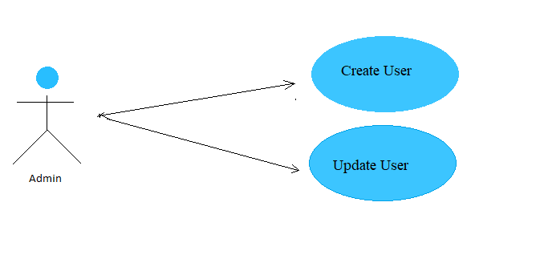
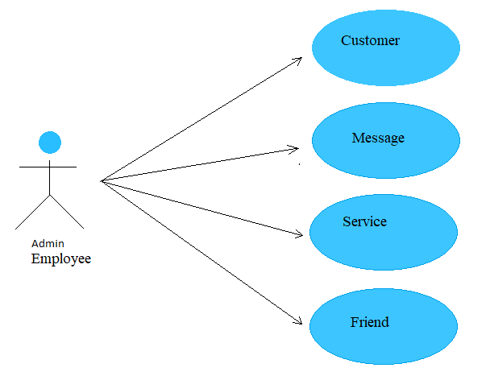

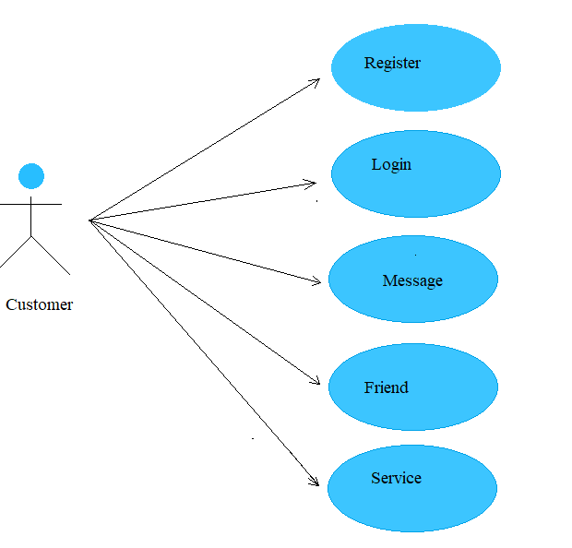

Use Case Specification

USE CASE SPECIFICATION

Use-case No. | UC001 | Use-case Version | 1.0
Use-case Name | Add new Level Services
Actor: Admin, Employee
Summary: Add new Level Services
Goal: Create new Level Services
Triggers
Preconditions:
Employee must login to the system
Main Success Scenario:
1. Employee enters information of the Level Services
2. Employee create new the Level Services
3. Update into the database

USE CASE SPECIFICATION

Use-case No. | UC002 | Use-case Version | 1.0
Use-case Name | Update new Level Services
Actor: Admin, Employee
Summary: Edit new Level Services
Goal: Update new Level Services
Triggers
Preconditions:
Employee must login to the system
Main Success Scenario:
1. Employee enters information of the Level Services
2. Employee create new the Level Services
3. Update into the database

USE CASE SPECIFICATION

Use-case No. | UC003 | Use-case Version | 1.0
Use-case Name | Add new Service
Actor:
Actor: Admin, Employee
Summary: Add new Service
Goal: Create new Service
Triggers
Preconditions:
Employee must login to the system
Post Conditions:
Main Success Scenario:
1. Employee enters information of theServices
2. Employee create new the Services
3. Update into the database

USE CASE SPECIFICATION

Use-case No. | UC004 | Use-case Version | 1.0
Use-case Name | Update Service
Actor:
Actor: Admin, Employee
Summary: Update new Service
Goal: Edit new Service
Triggers
Preconditions:
Employee must login to the system
Post Conditions:
Main Success Scenario:
1. Employee enters information of the Services
2. Employee new the Services
3. Update into the database

USE CASE SPECIFICATION

Use-case No. | UC004 | Use-case Version | 1.0
Use-case Name | Add new User
Actor:
Actor: Admin
Summary: Add new User
Goal: Create new User
Triggers
Preconditions:
Admin must login to the system
Post Conditions:
Main Success Scenario:
1. Admin enters information of User
2. Admin create new the User
3. Update into the database

USE CASE SPECIFICATION

Use-case No. | UC005 | Use-case Version | 1.0
Use-case Name | Update User
Actor:
Actor: Admin
Summary: Update new User
Goal: Edit User
Triggers
Preconditions:
Admin must login to the system
Post Conditions:
Main Success Scenario:
1. Admin enters information of the Services
2. Admin edit the Services
3. Update into the database

USE CASE SPECIFICATION

Use-case No. | UC006 | Use-case Version | 1.0
Use-case Name | Register Customer
Actor: Customer
Summary: Add Customer
Goal: Create User
Triggers
Post Conditions:
Main Success Scenario:
1. Customer create new the Customer
2. Customer enter information the Customer
3. Update into the database

USE CASE SPECIFICATION

Use-case No. | UC006 | Use-case Version | 1.0
Use-case Name | Customer Add Friend
Actor: Customer
Summary: Add Friend
Goal: Create Friend
Triggers
Preconditions:
Customer must login to the system
Post Conditions:
Main Success Scenario:
1. Customer search new Friends
2. Customer add friends
3. Update into the database

USE CASE SPECIFICATION

Use-case No. | UC006 | Use-case Version | 1.0
Use-case Name | Customer Receive Friend
Actor: Customer
Summary: Add Friend
Goal: Create Friend
Triggers
Preconditions:
Customer must login to the system
Post Conditions:
Main Success Scenario:
1. Customer confirm or delete friends
3. Update into the database

USE CASE SPECIFICATION

Use-case No. | UC006 | Use-case Version | 1.0
Use-case Name | Customer Send Message
Actor: Customer
Summary: Add Message
Goal: Create Message
Triggers
Preconditions:
Customer must login to the system
Post Conditions:
Main Success Scenario:
1. Customer choice Customer Receive or phone number receive
2. Customer enter content SMS
3. SMS send phone number receive
4. Update into the database

USE CASE SPECIFICATION

Use-case No. | UC006 | Use-case Version | 1.0
Use-case Name | Customer Active Service
Actor: Customer
Summary: Add Message
Goal: Create Message
Triggers
Preconditions:
Customer must login to the system
Post Conditions:
Main Success Scenario:
1. Customer choice Service
2. Customer Register Service
3. Customer payment with bank
4. Update into the database

have separate functions and the method inherits from the basic class (the class parents in the package Business)

DataAccess: As a class, including the method of installation process connected database, to define the method of connection (connected by any type), called the method of connecting functions and the method of static models for use in the classroom in different packages.
Business: including Class with the equivalent method, the function set () and get (). The void () also declared here. Each one-class equivalent to a table in the database. Each Class this will be the basic classes, class interface for the class by installation it.

Flow chart
Add new record
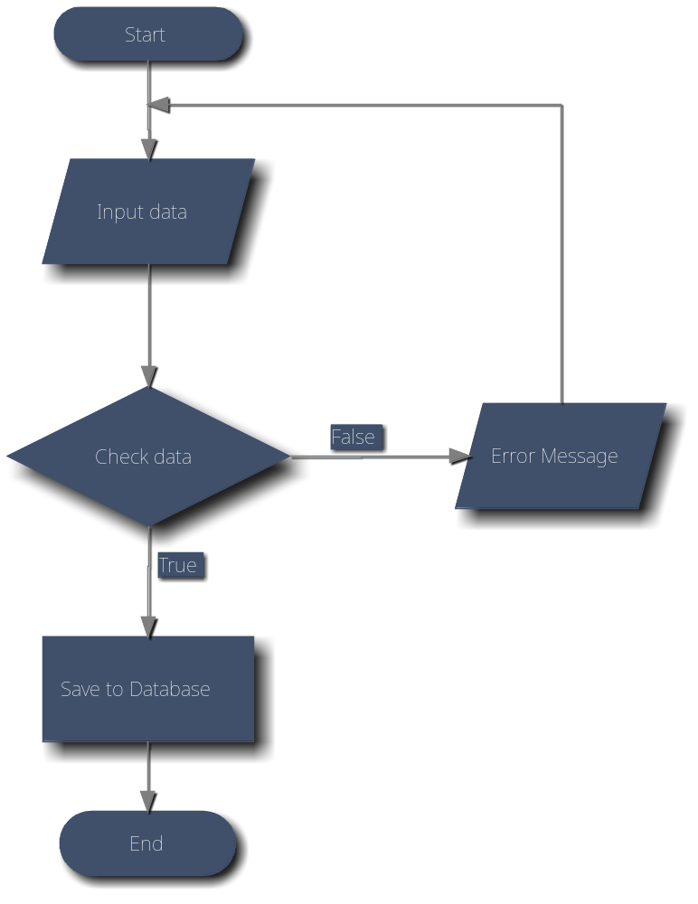
Edit record
Search information
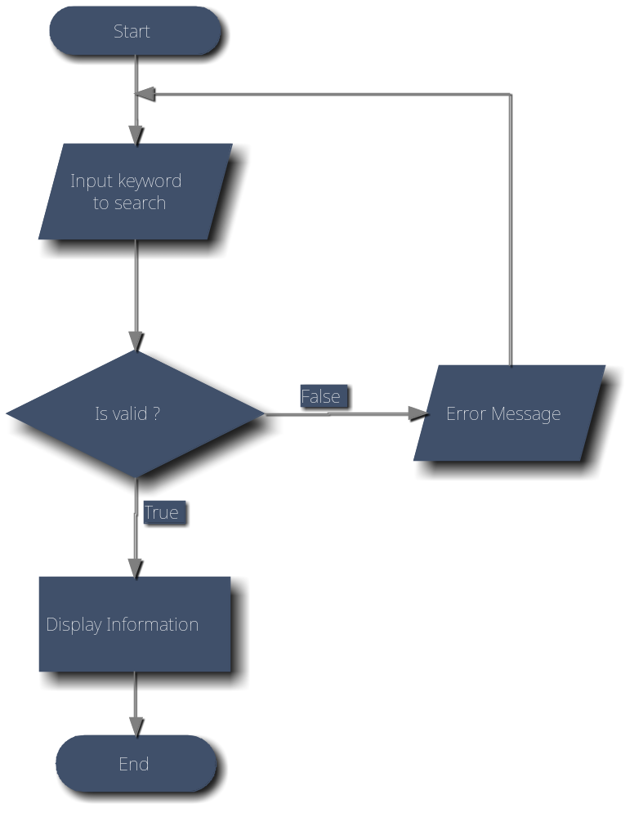
Delete record
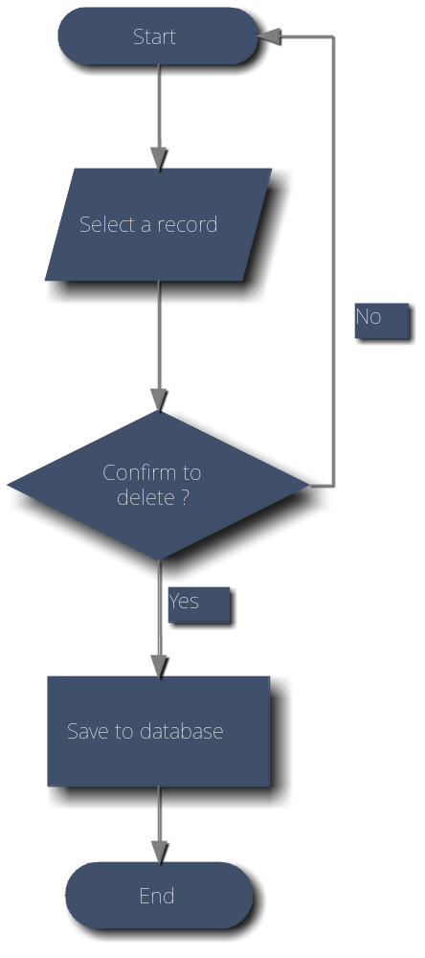

Entity Relationship Diagram

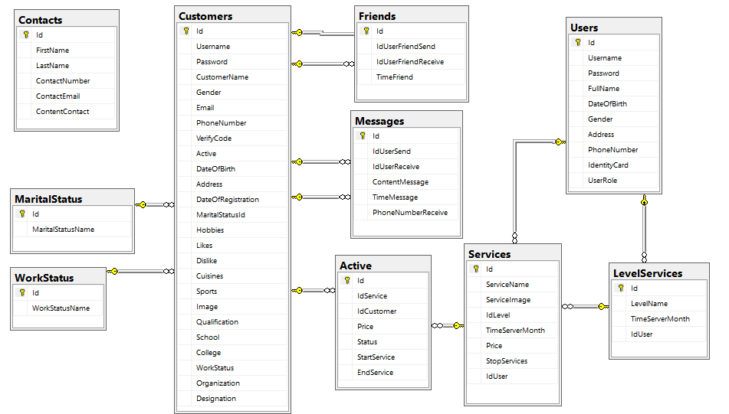

Database Design

-Users
Table : Users
Field Name | Data Type | Key | Description
Id | int | PK | Stores of the id
Username | nvarchar(100) |  | Stores role Username
Password | nvarchar(100) |  | Stores password
FullName | nvarchar(100) |  | Stores the Full Name of User
DateOfBirth | datetime |  | Stores Date of birth of Employee
Gender | bit |  | Store Gender of Employee. Male:1, Female:0
Address | nvarchar(100) |  | Stores Address of Employee
PhoneNumber | nvarchar(10) |  | Stores Phone Number of Employee
IdentityCard | nvarchar(10) |  | Stores Identity Card of Employee
UserRole | nvarchar(10) |  | Stores User Role of Employee
SpeedSMSAPI | nvarchar(100) |  | Stores SpeedSMSAPI of Employee
deviceID | nvarchar(100) |  | Stores deviceID of Employee
- MaritalStatus
Table : MaritalStatus
Field Name | Data Type | Key | Description
Id | int | PK | Stores of the id
MaritalStatusName | varchar(10) |  | Stores the Marital Status Name
- WorkStatus
Table : WorkStatus
Field Name | Data Type | Key | Description
Id | int | PK | Stores of the id
WorkStatusName | varchar(15) |  | Stores the Work Status Name

-Customers
Table : Customer
Field Name | Data Type | Key | Description
Id | int | PK | Stores Id of Customer
Username | nvarchar(100) |  | Stores Username of Customer
Password | nvarchar(100) |  | Stores Password of Customer
CustomerName | nvarchar(100) |  | Stores Name of Customer
Gender | bit |  | Store Gender of Customer. Male:1, Female:0
Email | nvarchar(100) |  | Stores Email of Customer
PhoneNumber | nvarchar(10) |  | Stores Phone of Customer
VerifyCode | nvarchar(5) |  | Stores Verify Code of Customer
Active | bit |  | Status Active of Customer
DateOfBirth | datetime |  | Stores Birthday of Customer
Address | nvarchar(100) |  | Stores Address of Customer
DateOfRegistration | datetime |  | Stores time Customer Registration
MaritalStatusId | int | FK | Id of MaritalStatus
WorkStatus | int | FK | Id of WorkStatus
Hobbies | nvarchar(100) |  | Stores Hobbies of Customer
Likes | nvarchar(100) |  | Stores Likes of Customer
Dislike | nvarchar(100) |  | Stores Dislike of Customer
Cuisines | nvarchar(100) |  | Stores Cuisines of Customer
Sports | nvarchar(100) |  | Stores Dislike of Customer
Image | nvarchar(100) |  | Stores link Image of Customer
Qualification | nvarchar(100) |  | Stores Qualification of Customer
School | nvarchar(100) |  | Stores School of Customer
College | nvarchar(100) |  | Stores College of Customer
Organization | nvarchar(100) |  | Stores Organization of Customer
Designation | nvarchar(100) |  | Stores Designation of Customer
-Messages
Table: Messages
Field Name | Data Type | Key | Description
Id | int | PK | Stores Id of Messages
IdUserSend | int | FK | Id of Customer Send
IdUserReceive | int | FK | Id of Customer Receive
ContentMessage | nvarchar(MAX) |  | Stores Content of Message
TimeMessage | datetime |  | Stores Time of Message
PhoneNumberReceive | nvarchar(10) |  | Phone Number of Customer Receive if Phone Number not exist in database
- Friends
Table: Friends
Field Name | Data Type | Key | Description
Id | int | PK | Stores Id of Friends
IdUserSend | int | FK | Id of Customer Send
IdUserReceive | int | FK | Id of Customer Receive
TimeMessage | datetime |  | Stores Time of Message

- LevelServices
Table : LevelServices
Field Name | Data Type | Key | Description
Id | int | PK | Stores of the id LevelServices
LevelName | nvarchar(50) |  | Name of Level Services
TimeServerMonth | int |  | Service usage time in months
IdUser | int | FK | Id of Employee last create or update Level Services
-Services
Table : Services
Field Name | Data Type | Key | Description
Id | int | PK | Stores of the id Services
ServiceName | nvarchar(50) |  | Name of Services
ServiceImage | nvarchar(100) |  | Stores link Image of Services
IdLevel | int | FK | Id of Level Services
Price | money |  | Price of Services
StopServices | bit |  | Is the service discontinued?
IdUser | int | FK | Id of Employee last create or update Services
-Active
Table : Active
Field Name | Data Type | Key | Description
Id | int | PK | Stores of the id Active
IdService | int | FK | Id of Services
IdCustomer | int | FK | Id of Customers
Price | money |  | Price of Services when customers active
Status | Bit |  | Is the service still available to customers?
StartService | Datetime |  | Service start time
EndService | Datetime |  | Service end time
-Contacts
Table : Contacts
Field Name | Data Type | Key | Description
Id | int | PK | Stores of the id Contacts
FirstName | nvarchar(50) |  | First Name of Contact
LastName | nvarchar(50) |  | Last Name of Contact
ContactNumber | nvarchar(10) |  | Phone Number of Contact
ContactEmail | nvarchar(100) |  | Email of Contact
ContentContact | nvarchar(Max) |  | Content of Contact

Class Diagram

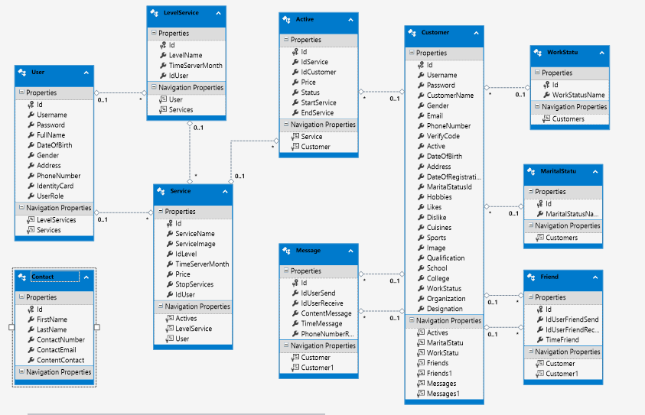

Algorithms (optional)
<Provide the detailed description about algorithms used in the system. You can use Flow Chart or Activity Diagram to represent algorithms. Focus on the important and complex algorithms>

Others (optional)
<Any design concerns or diagrams can be put here>

System Prototype

Intro page

Home 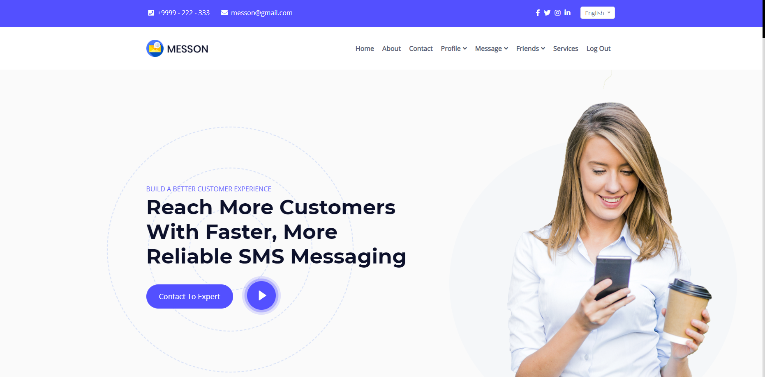
Contact 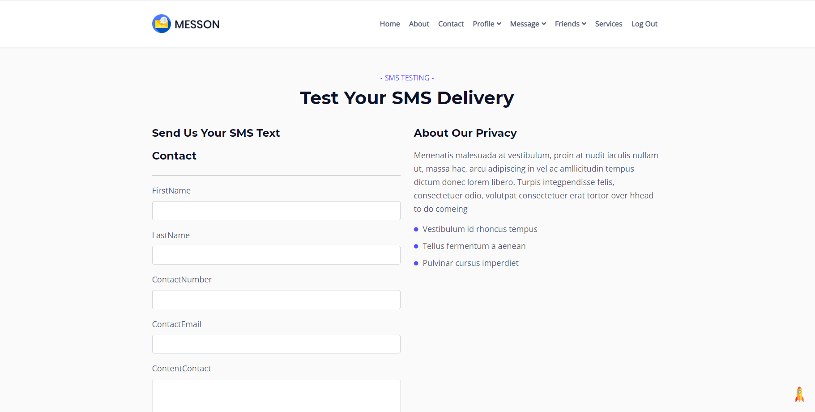
Service
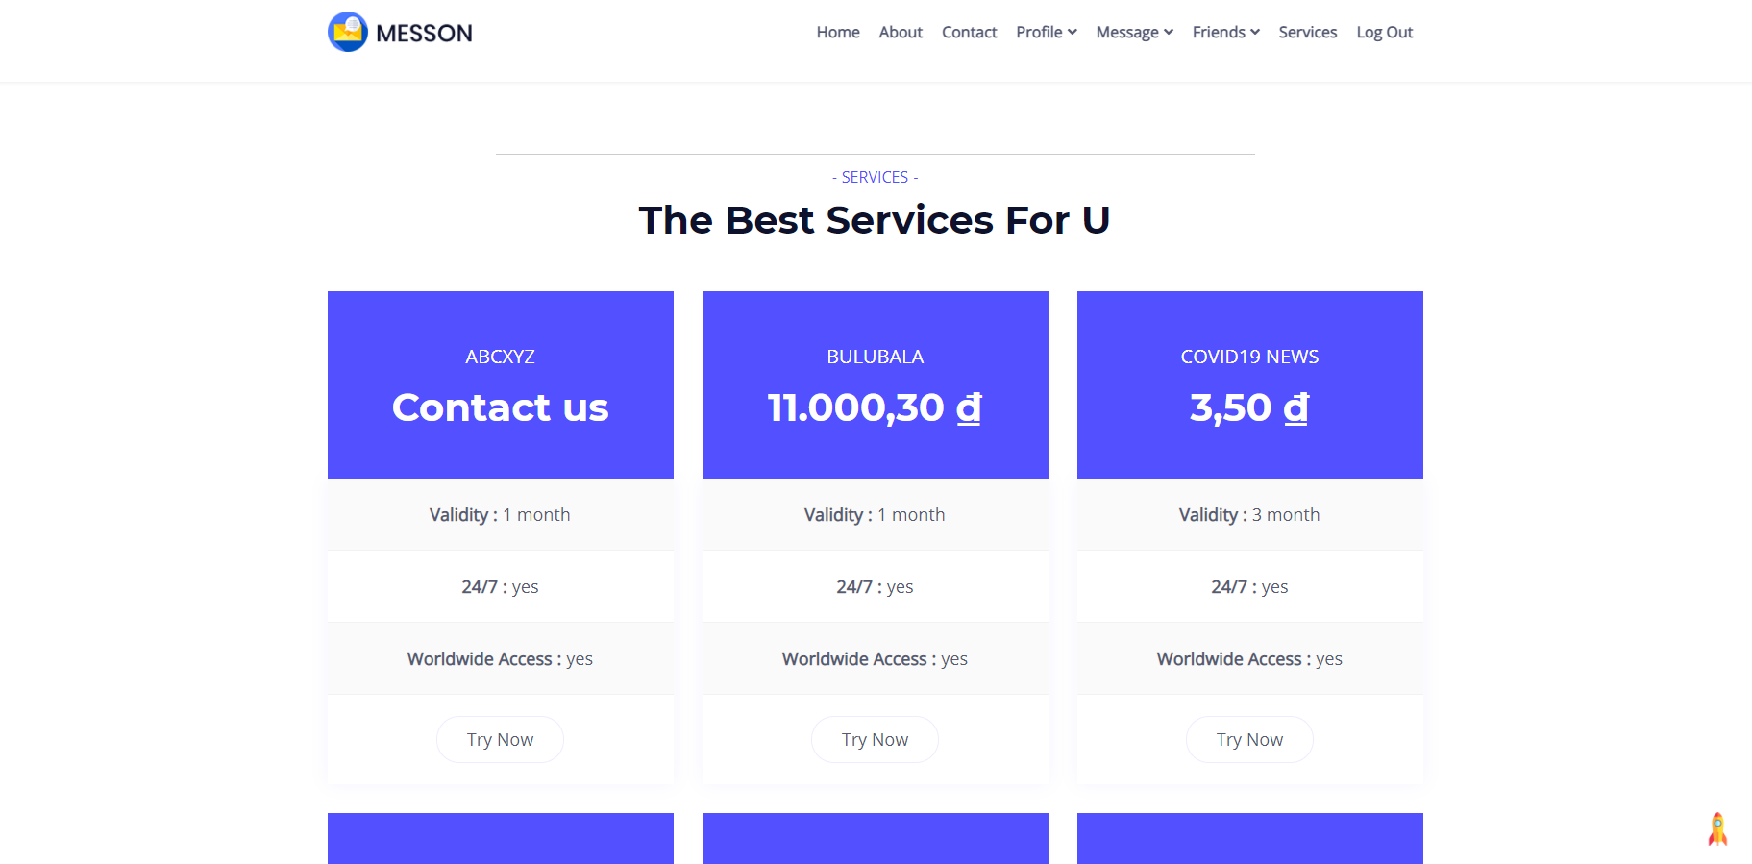
Customer Login
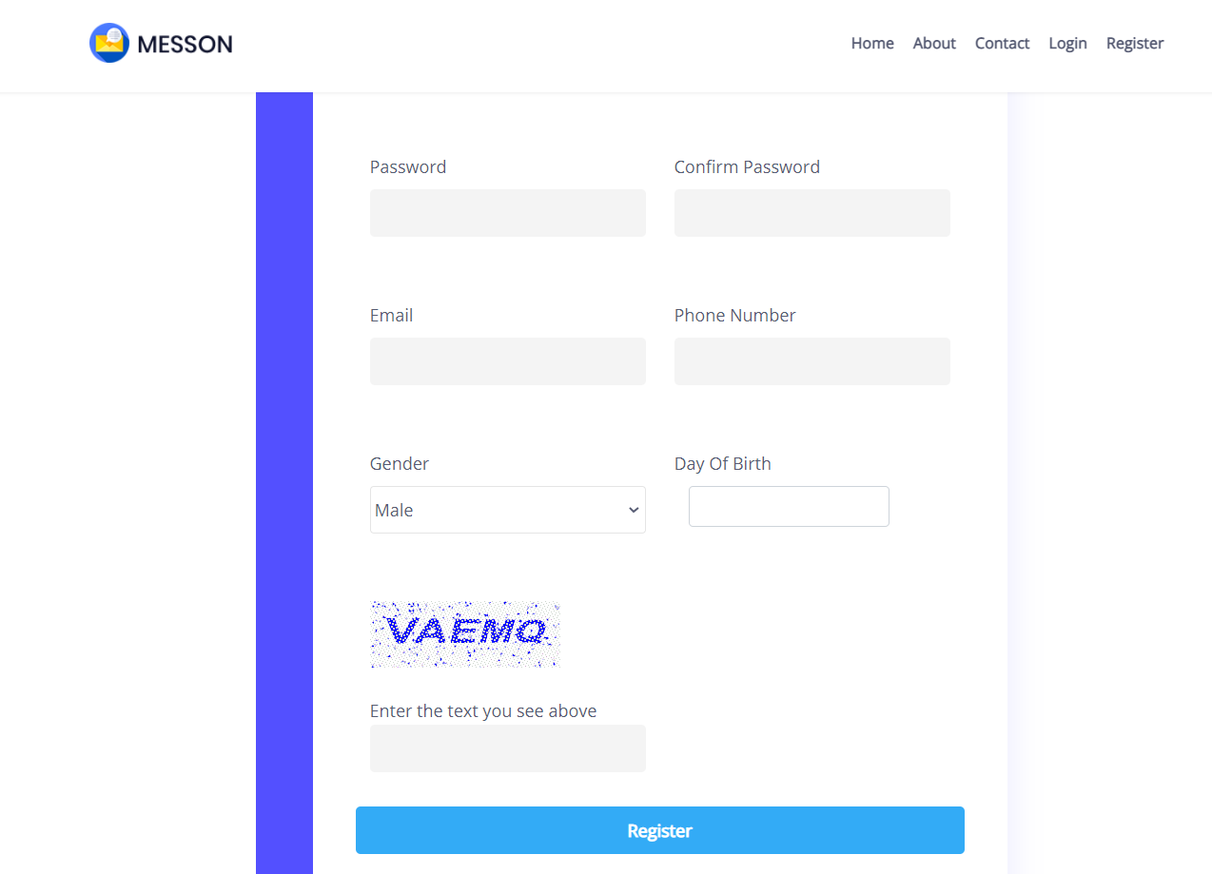
User Login
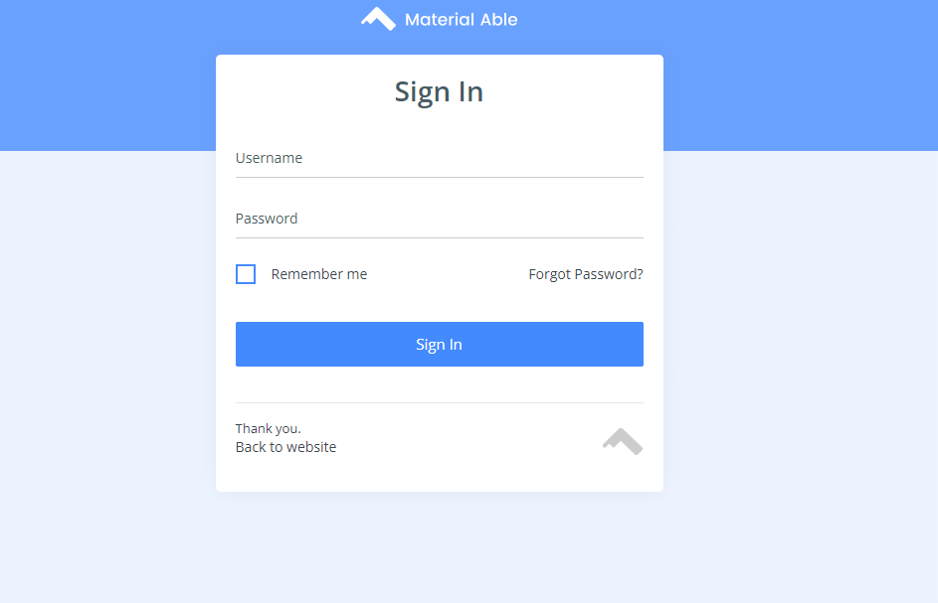

Dashboard
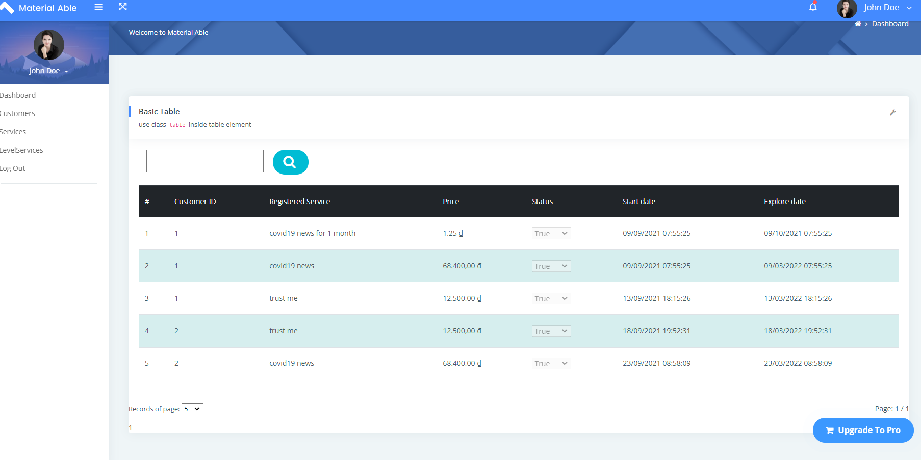
Employees
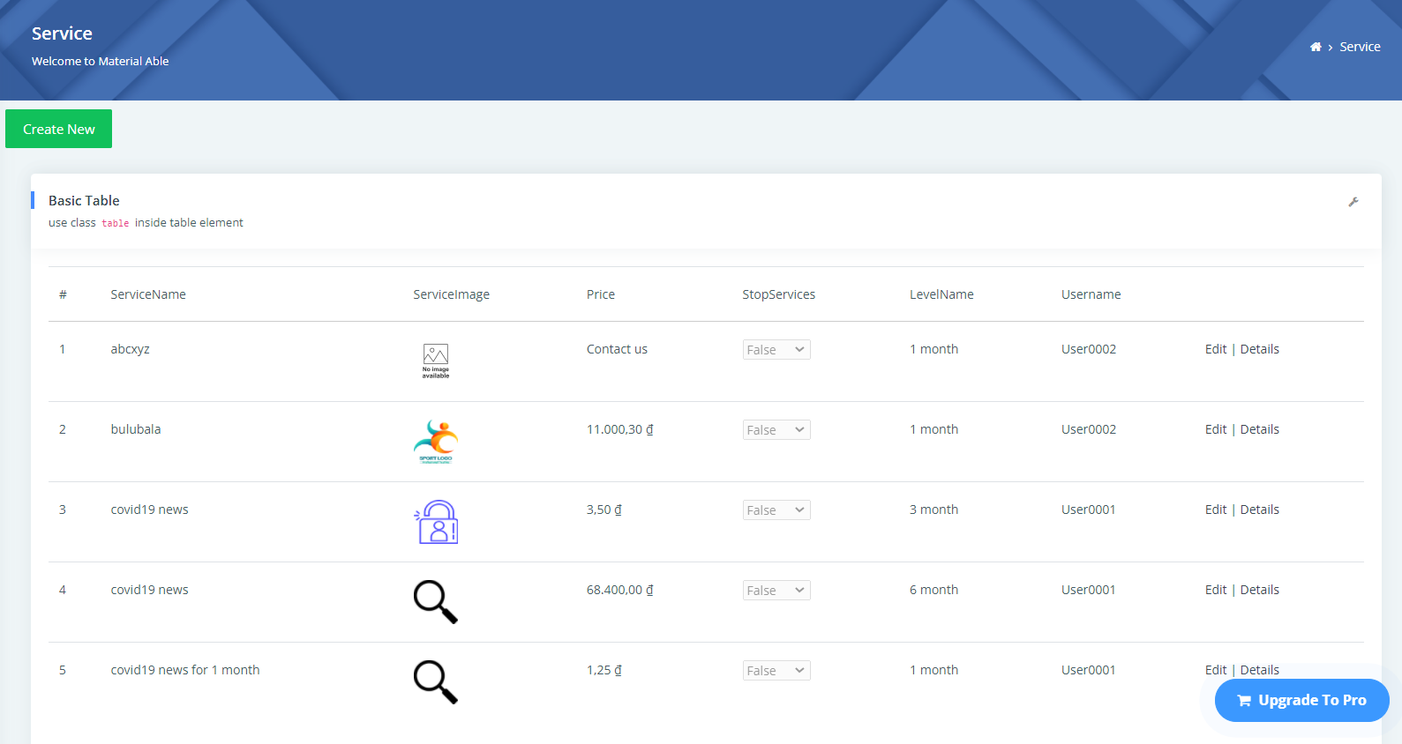

Management and Project Planning

Task Sheet

Sr.No | Task | Team Members Names
Dashboard
1 | Database Design | Nguyen Tien Hien
2 | Create, Update, Change Password, Reset Password, RoleUser | Nguyen Tien Hien
3 | Login User | Nguyen Tien Hien
4 | Manager Customer | Nguyen Tien Hien
4 | Create,Update Level Service and Service | Vo Khanh Duy
Customer
1 | Function SMS Moblie | Vo Khanh Duy  Nguyen Tien Hien
2 | Register, Login. Verify,Change Password , UpdateProfile, Profile Page of Customer | Nguyen Tien Hien
3 | Friend, Add Friend of Customer | Trao An Tien
4 | Send, Receive Message of Customer | Trao An Tien
5 | Customer Register and Payment Service | Vo Khanh Duy
6 | Contact Us | Trao An Tien

Checklists

Check List of Validation

Option | Validated
Can admin login to the application ? | Yes
Has the hardware and software been correctly chosen ? | Yes
Does the application’s functionality resolve the user problem,and satisfy their needs | Yes
Do all the options present in the application display the correct result ? | Yes

Submission Checklist

Sr.No | Particulars | Yes | No | N/A | Comments
1 | Are the users table to login the application after validation is performed on the username and password ? | Yes
2 | Are the administrator able to modify the user information after getting created ? | Yes
3 | Can the user to edit employee’s details after getting added ? | Yes
4 | Are the user able to find a product’s wherever they wants ? | Yes |  |  | Search functionality is very useful.
5 | Is the application user-friendly ? | Yes |  |  | Windows GUI is familiar with everyone

---------------------------------Thank You ---------------------------------------

