INTERNATIONAL PROGRAMMERSTRAINING CENTER
SOFTECH APTECH





PROJECT:
School System Management

Professor: Mr. Nguyen Duc Thao
Members: Nguyen Tien Hien
Nguyen Tran Huy
Nguyen Dang Thanh Dat
Group :
Batch : 153-154

DaNang, 02nd July 2020

Table of Contents

- Acknowledgements
- Defination of Problems
- Abstract Problem
- Proposed System
- Boundaries of the System
- Hardware and Software Required
III. Technical
- Tools Used
- Languages Used
IV. Requirement Specification
- Critical Use Case Specification
- Use Case Diagram
- Enity Relationship Diagram
- Table
- GUI Design

I. ACKNOWLEDGEMENTS

First, we’d like to thank the teacher who helped us make the project successful, Mr. Nguyen Duc Thao. He willingly recommended us what need to do and shared his expertise experience for our project.

II. DEFINITION OF THE PROBLEMS:

1. Abstract problem
Student Management is a software that helps schools and teachers reduce working time but still bring high efficiency. A student management software includes:, Employee Management, Student Management, Class Management, Score System. My team decided to make a Student Management software.

2. Proposed system
The Student Manager will store all necessary information and data that can be obtained easily. Student Management can manage grades / tuition / add, edit, delete staff, students, subjects, and grades.

3. Boundaries of the system
The Admin can manage all functions of the system.
The manager can manage the functions: staff, student, position, activity class, section class , subject, and class.

4. Hardware and software required
4.1. Minimum requirements
- A minimum computer system that will help you access all the tools in courses is Pentium 200 CPU or higher capacity
- RAM 256 MB or more
- Netbeans 8.0.2
- SQLSERVER 2014
- Jdk 1.6.0_13

4.2. Request for proposal
- CPU: Pentium 4
- 512 MB RAM or higher
- Netbeans 6.5.1
- SQL Server 2014
- Jdk 1.6.0_13

III. TECHNICAL:
- Tools used: NetBeans IDE, SQL Server.
- Languages used: Java, SQL.

IV. REQUIREMENT SPECIFICATION:
- Critical Use Case Specification:

Use-case No. | UC01 | Use-case Version | 1.0
Use-case Name | Login
Purpose:
Allowing the users log into the management system, create and/or delete account.
Input:
Users will enter the “Username”, “Password” and push “Login” button to login or “Exit” in order not to login the system.
Output:
A notification appear if users didn’t enter “Username” and/or “Password” or they entered “Username” and/or “Password” wrong.

Use-case No. | UC02 | Use-case Version | 1.0
Use-case Name | Main
Purpose:
Display Menubar for users to select.
Input:
Users will select a Menubar and operate on it.

Use-case No. | UC03 | Use-case Version | 1.0
Use-case Name | Position Management
Purpose:
Allow users to add, delete, edit the position (admin, manager, teacher or cashier).

Input:
Users will add positions by pushing “Add” button and entering the required fields.
Users will edit information of positions by choosing the row they want to edit, pushing “Edit” button and entering the required fields.
Users will delete position by choosing the row they want to remove and pushing “Delete” button.

Output:
When users click “Add”,”Edit”, or “Delete” button, system will notify the users add/edit/delete successfull or not.

Use-case No. | UC04 | Use-case Version | 1.0
Use-case Name | Staff Management
Purpose:
Allow users to add, delete, edit information of staff (admin, manager, teacher or cashier).

Input:
Users will add information of staff by pushing “Add” button and entering the required fields.
Users will edit information of staff by choosing the row they want to edit, pushing “Edit” button and entering the required fields.
Users will delete information of staff by choosing the row they want to remove and pushing “Delete” button.

Output:
When users click “Add”,”Edit”, or “Delete” button, system will notify the users add/edit/delete successfull or not.

Use-case No. | UC05 | Use-case Version | 1.0
Use-case Name | Subject Management
Purpose:
Allow users to add, delete, edit information of Subject.

Input:
Users will add information of Subject by pushing “Add” button and entering the required fields.
Users will edit information of Subject by choosing the row they want to edit, pushing “Edit” button and entering the required fields.
Users will delete information of Subject by choosing the row they want to remove and pushing “Delete” button.

Output:
When users click “Add”,”Edit”, or “Delete” button, system will notify the users add/edit/delete successfull or not.

Use-case No. | UC06 | Use-case Version | 1.0
Use-case Name | Student Management
Purpose:
Allow users to add, delete, edit information of student.

Input:
Users will add information of student by pushing “Add” button and entering the required fields.
Users will edit information of student by choosing the row they want to edit, pushing “Edit” button and entering the required fields.
Users will delete information of student by choosing the row they want to remove and pushing “Delete” button.

Output:
When users click “Add”,”Edit”, or “Delete” button, system will notify the users add/edit/delete successfull or not.

Use-case No. | UC07 | Use-case Version | 1.0
Use-case Name | Class Management
Purpose:
Allow users to add, delete, edit information of class.

Input:
Users will add information of class by pushing “Add” button and entering the required fields.
Users will edit information of class by choosing the row they want to edit, pushing “Edit” button and entering the required fields.
Users will delete information of class by choosing the row they want to remove and pushing “Delete” button.

Output:
When users click “Add”,”Edit”, or “Delete” button, system will notify the users add/edit/delete successfull or not.

Use-case No. | UC08 | Use-case Version | 1.0
Use-case Name | Class Meeting Management
Purpose:

Allows users to add, delete, edit information of class meeting.
Input:
Users will add information of class meeting by pushing “Add” button and entering the required fields.
Users will edit information of class meeting by choosing the row they want to edit, pushing “Edit” button and entering the required fields.
Users will delete information of class meeting by choosing the row they want to remove and pushing “Delete” button.

Output:
When users click “Add”,”Edit”, or “Delete” button, system will notify the users add/edit/delete successfull or not.

Use-case No. | UC09 | Use-case Version | 1.0
Use-case Name | Class Arrangement
Purpose:
Allow users to add student to a class, or remove student from a class.

Input:
Users will select a class meeting from combobox to display student list from that class.
Users will add a student to a class by choosing a row of “Student not in class” table and pushing “Add” button.
User will remove a student from a class by choosing a row of “Student had class” table and pushing “Remove” button.

Output:
When users “Add” or “Remove” a student, system will notify the users add/remove successfull or not.

Use-case No. | UC10 | Use-case Version | 1.0
Use-case Name | Input Score Management
Purpose:
Allow users to edit student’s score.
Input:
User will select a class in combobox and select a student from that class, pushing “Add/Edit” button to add or edit scores from that student.
Output:
When users edit score, system will notify the users edit successfull or not.

Use-case No. | UC11 | Use-case Version | 1.0
Use-case Name | Tuition Fee Management
Purpose:
Allow users to add, remove student that pay fee or not.

Input:
Users will remove student that paid fee by choosing a row of unpaid fee student table and push “Pay” button.

Output:
When users “Remove” a student, system will notify the users remove successfull or not.

Use-case No. | UC12 | Use-case Version | 1.0
Use-case Name | Change Password
Purpose:
Allow users change password.
Input:
Users will change password by entering the required fields and pushing “Change Password” button.
Output:
System will notify the user that has changed successfully or not.

- Use Case Diagram:
Score
Management


Change
Password
Student
Management
Teacher

Class
Management


Change
Password
Cashier
Tuition Fee
Management

Change
Password

Score
Management


Student
Management
Score
Management
Manager

Tuition Fee
Management

Class
Arrangement
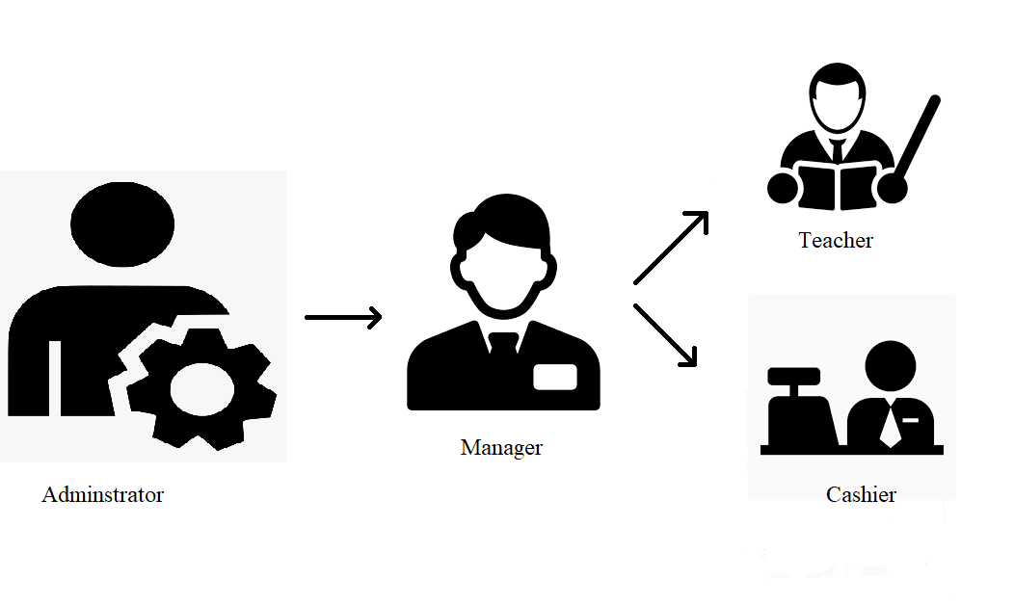
- Enity Relationship Diagram:
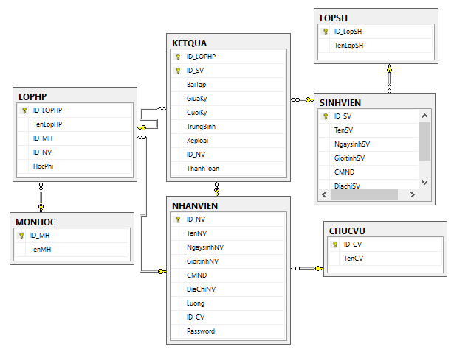

- Tables:
- Table SinhVien:
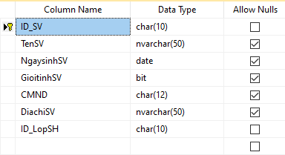

- Table NhanVien:
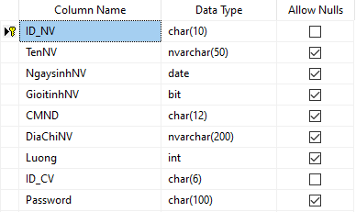

- Table ChucVu:
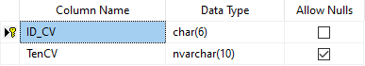

- Table MonHoc:
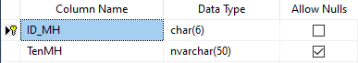

- Table LopHP:
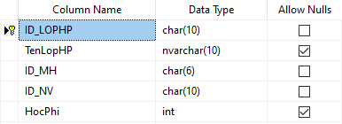

- Table LopSH:
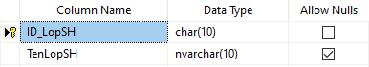

- Table KetQua:
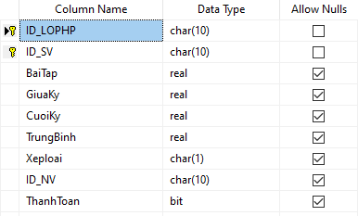

- GUI Design:
  - Login Form
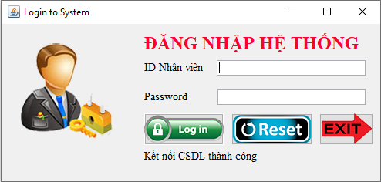
  - Main Form
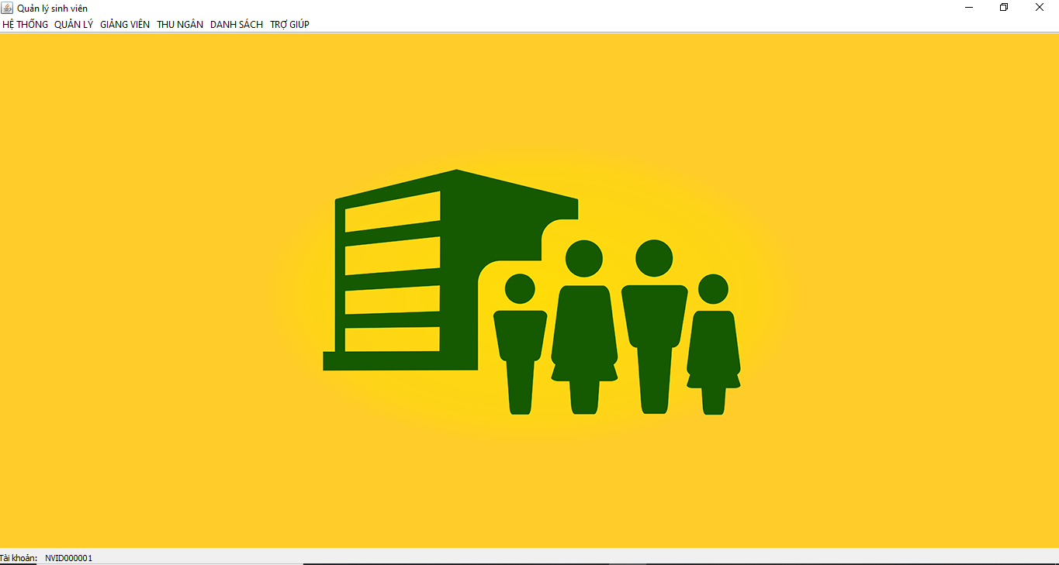
  - Change Password

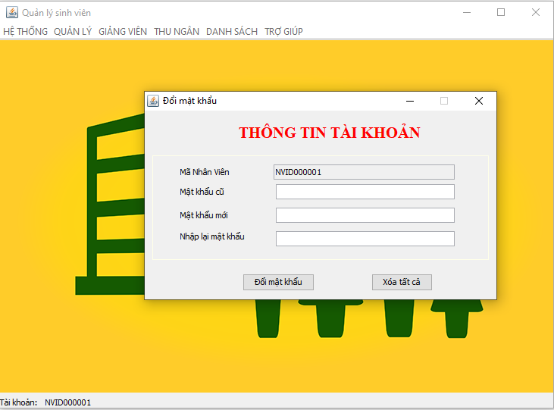
  - Student Management
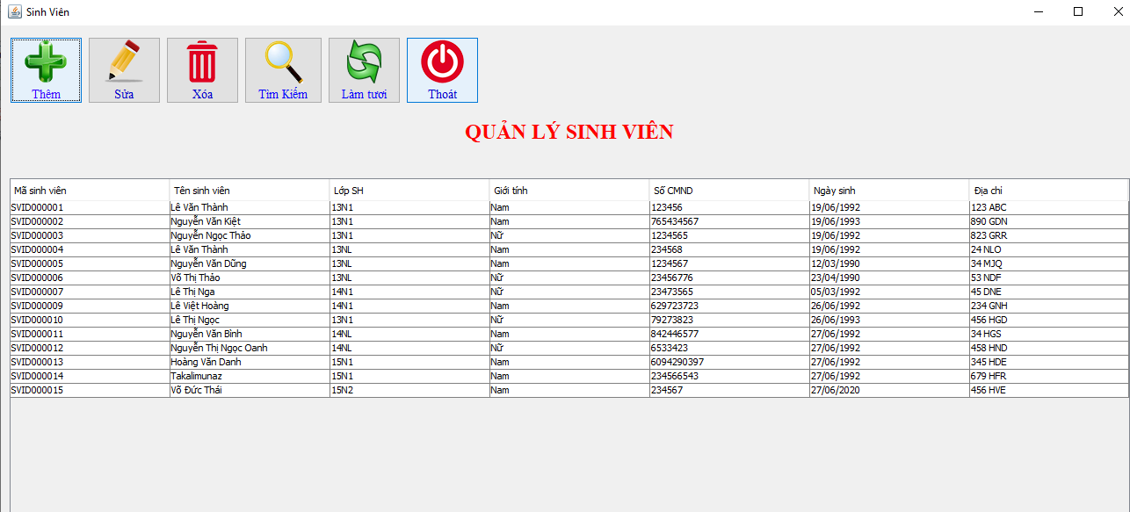
  - Staff Management
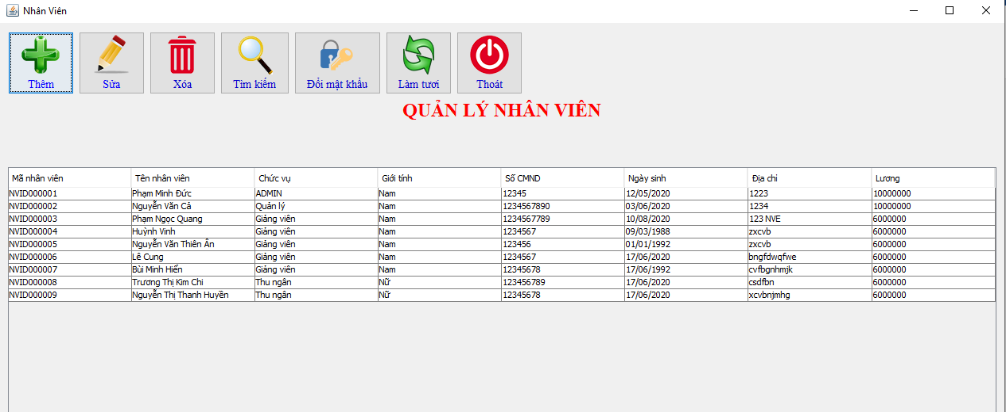
  - Position Management
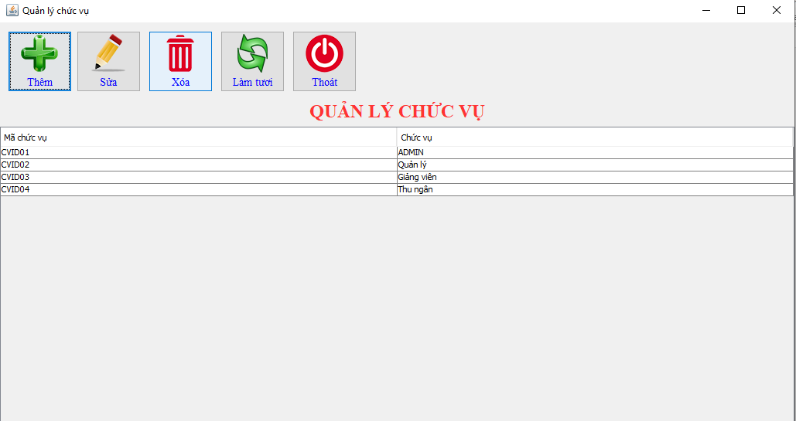
  - Class Management
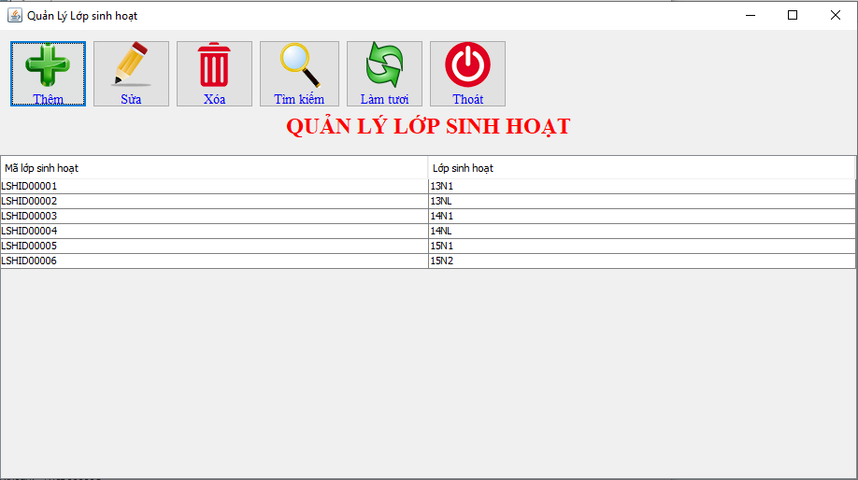
  - Section Class Management
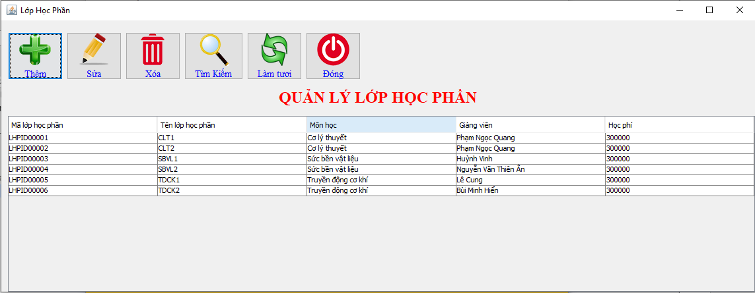
  - Subject Management
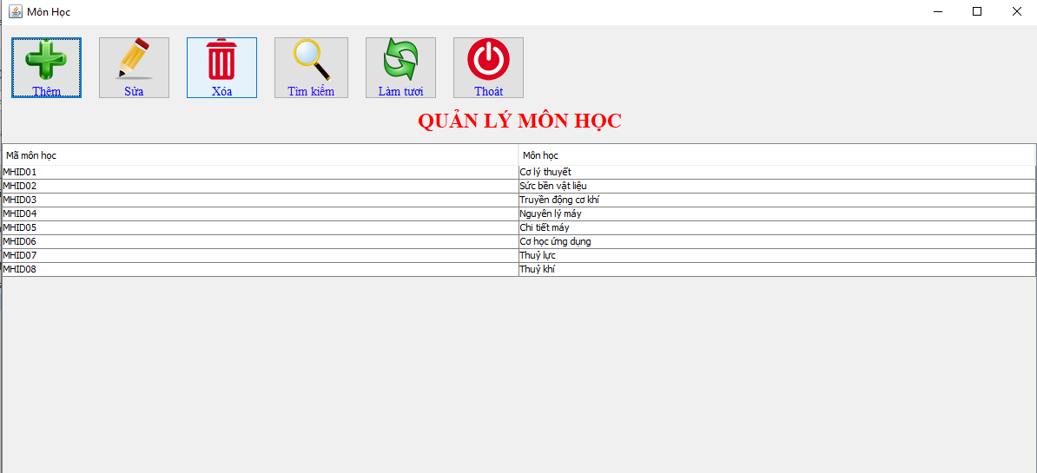
5.10. Class Arrangement
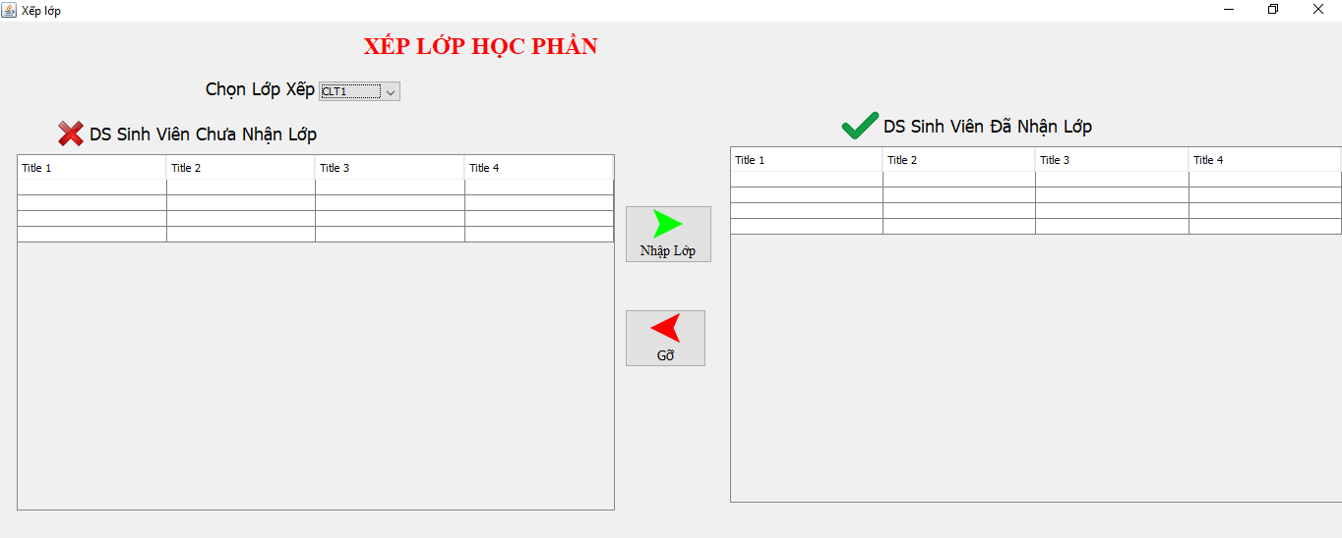
5.11. Input Score
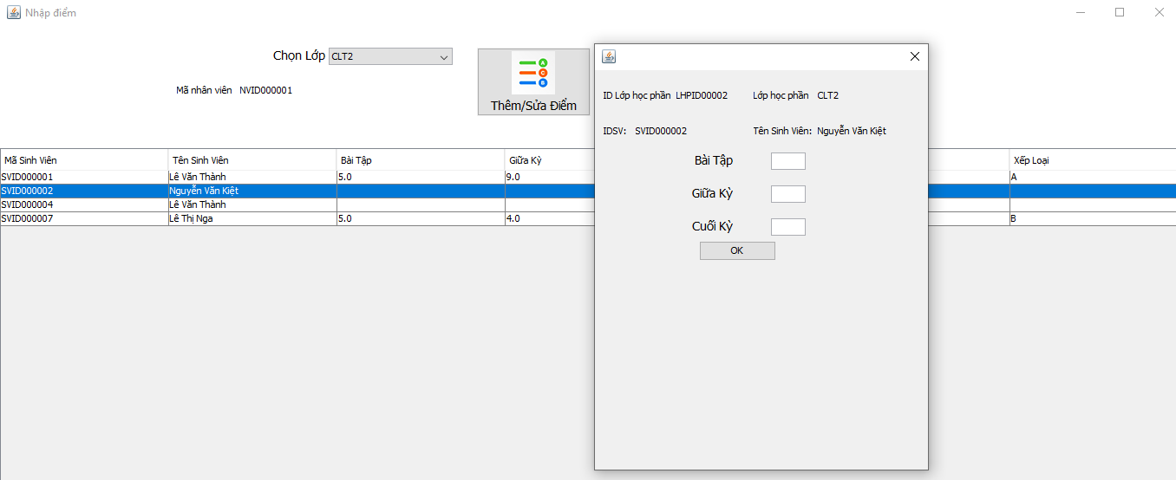
5.12. Tuition Fee Management
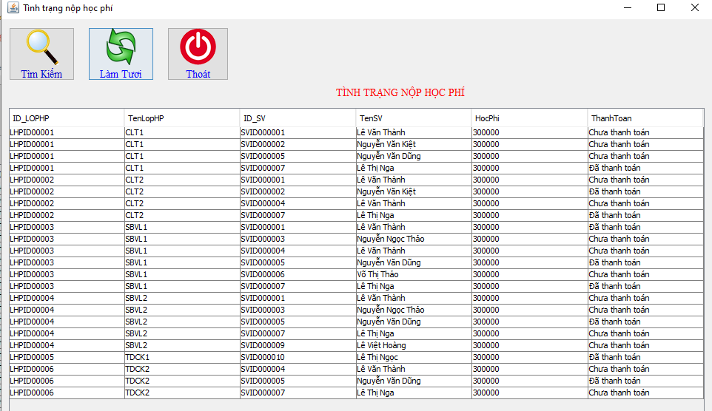
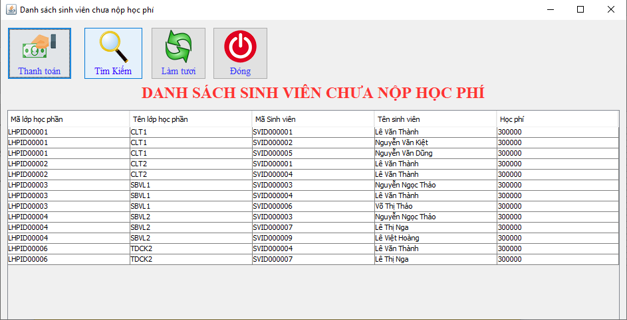
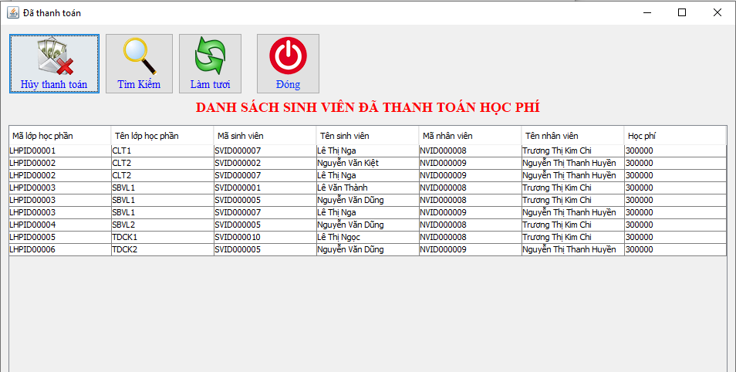
5.13. List
5.13.1. Staff List
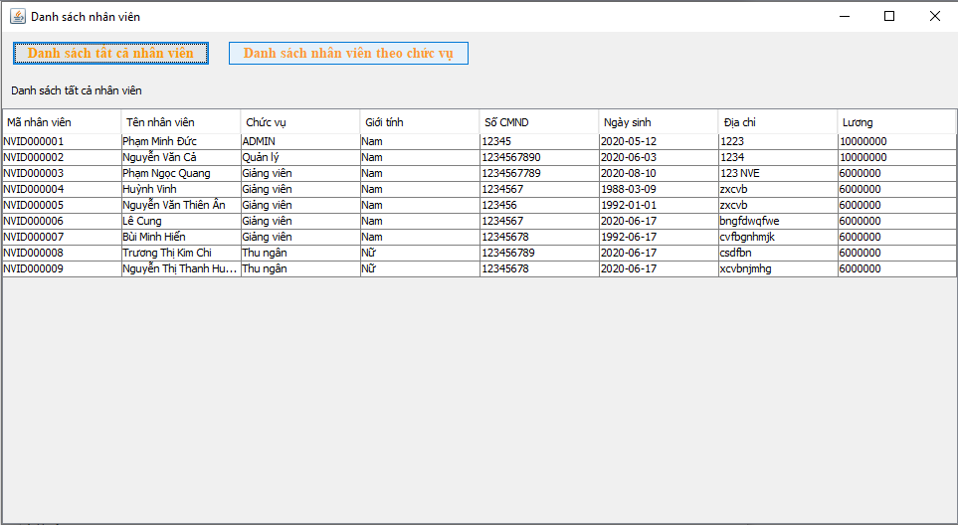
    - Student List
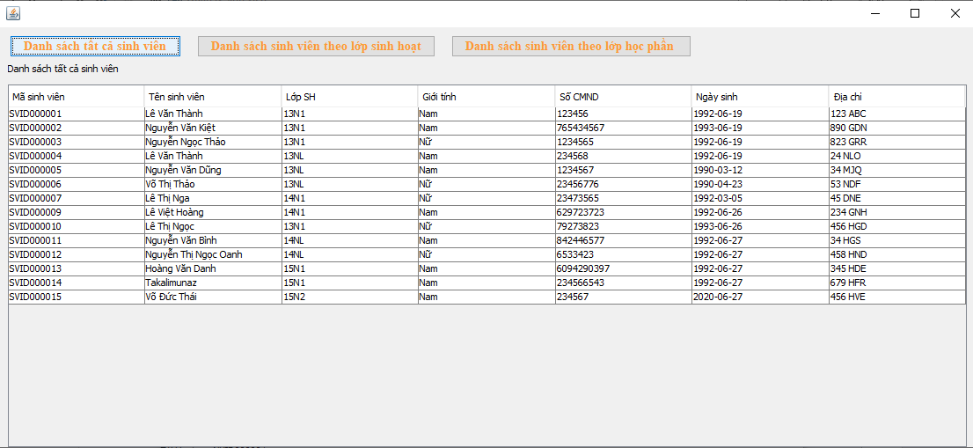
    - Class List
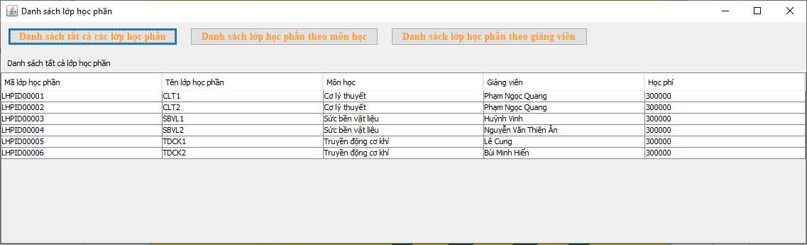
    - Student’s Score List
