
aptech computer education
eProject Document
Project Name:
Group 1
Group Member | - Nguyen Tien Hien  - Vo Khanh Duy  - Nguyen Dang Thanh Dat
Instructor | Mr. Nguyen Ngoc Anh
Batch | 159+160
Semester | 4

- Danang, Vietnam, 09/2021 -

Contents
1. Acknowledgements 3
2. Introduction 3
3. Problem Definition 3
3.1. Problem Abstraction 3
3.2. Boundaries of the System 4
3.3. Development Environment 4
4. Requirements and Business Flow 5
4.1. Activity Diagram 5
4.2. Use Case Diagram 7
4.3. Use Case Specification 12
5. Design 28
5.1. Flow chart 29
5.2. Class Diagram 32
5.3. Sequence Diagram (Optional) 34
5.4. Entity Relationship Diagram 37
5.5. Database Design 38
5.6. Algorithms (optional) 42
5.7. Others (optional) 42
6. System Prototype 43
Intro page 43
Admin 47
6. Management and Project Planning 54
6.1. Task Sheet 54
7. Checklists 57
7.1. Check List of Validation 57
7.2. Submission Checklist 57
8. Coding Convention 57
Appendix 59

Acknowledgements

We would like to sincerely acknowledge the kindness of all the people who have given moral support and helped us make a successful project.
We wish to express our deep gratitude to the eProject Team at the Head Office, who guided and helped us. Particular thanks to Mr. Nguyen Ngoc Anh a who suggested the "debugging is parallelizable" formulation, helped us develop the a who suggested the "debugging is parallelizable" formulation, helped us develop the analysis proceeding from it and debugged code. We also would like to express our great gratitude to all the student members of our center
analysis proceeding from it and debugged code. We also would like to express our great gratitude to all the student members of our center
Although we have made many attempts, because of the limited time, the practice could not be able to avoid the mistakes and omissions. We hope that the Project Team at the Head Office will consider and evaluate our project. And finally, we would like to offer many thanks to all our friends for their valuable suggestions and constructive feedbacks

Introduction
Our client is a retail dealer for the shoes and sells at his shop Shop Shoes.
Because of no automation in the system, the orders placed get delayed, due to which the customer dissatisfaction happens. Also in this competitive world where the number of publications and the dealers are increasing, it becomes difficult to retain the customers.

Problem Definition
Through a web browser the customers can search for a product, later can add to the shopping cart and finally purchase using a payment method of his choice. The user can login using his account details or new customers can set up an account very quickly. They should give the details of their name, email address, contact number and address. The user can also give feedbacks by posting comments through the system provided by the application.

Problem Abstraction
A customer can, create, sign in to his account, place items into a shopping cart and purchase using his credit card details or other payment method. A customer can also track his / her order status by entering the order code received by email.
Online Payment (Note : This payment is through the Credit Card, and the order will be dispatched only after the payment is being processed by the respective bank).
This application is developed using Java Spring boot programming language and SQL Server

Boundaries of the System
1. Development Environment
 | Server | Client
Hardware | * Ram 512 MB or higher  * CPU 2.0 GHz or higher  * HDD 80 GB or higher  * Internet | * Ram 128 Mb or higher  * CPU 266 MHZ or higher  * Internet
Software | * Windows Server 2016 or later  * SQL Server 2016 or later  * IIS 7 or later | * Internet Explorer  * Firefox  * Chrome  * Safari

Development tools
- Microsoft Windows 10 or higher
- Spring Tool Suite4
- Microsoft SQL Server 2019 Standard Edition or higher
- Net Framework 4.0 or higher

Requirements

User Requirements

Use Case Diagram

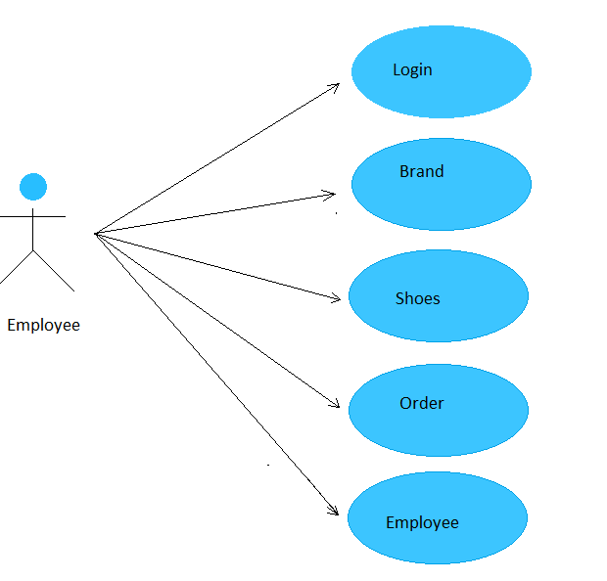

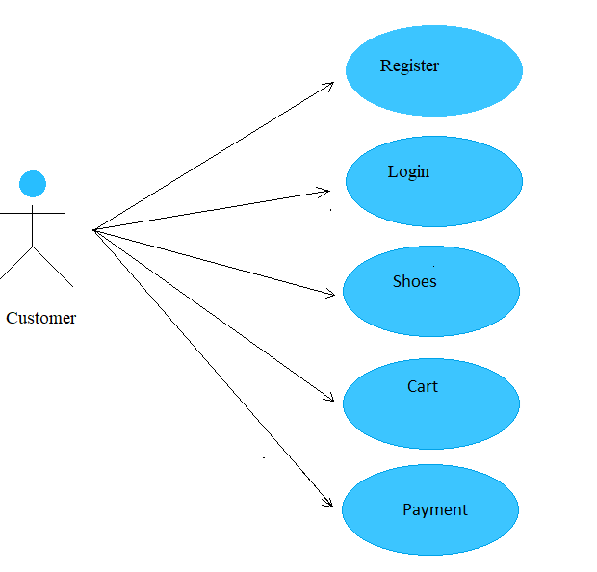

Use Case Specification

USE CASE SPECIFICATION

Use-case No. | UC001 | Use-case Version | 1.0
Use-case Name | Add new Brand
Actor:
Employee
Summary: Add new Brand
Goal: Create new brand by service
Triggers
Preconditions:
Employee must login to the system
Post Conditions:
After company create, redirect to create order service page
Main Success Scenario:
1. Employee enters information of the brand
2. Employee create new the brand
3. System determines the validity of the information
4. System confirm action
5. Employee agrees the company
6. Update into the database

USE CASE SPECIFICATION

Use-case No. | UC002 | Use-case Version | 1.0
Use-case Name | Update Brand information
Actor:
Employee
Summary:
Update the Brand
Goal:
Edit brand information
Triggers
Preconditions:
Employee must login to the system
Post Conditions:
Employee can update company information
Main Success Scenario:
1. Employee login
2. Employee select company
3. Edit information that he want to change
4. System determines the validity of the information
5. System confirm action
6. Update into the database

USE CASE SPECIFICATION

Use-case No. | UC003 | Use-case Version | 1.0
Use-case Name | Add new Shoes size
Actor:
Employee
Summary: Add new ShoesSize
Goal: Create new Shoes Size
Triggers
Preconditions:
Employee must login to the system
Post Conditions:
Main Success Scenario:
1. Employee enters information of the dealer
2. Employee create new the dealer
3. System determines the validity of the information
4. System confirm action
5. Employee agrees the dealer
6. Update into the database

USE CASE SPECIFICATION

Use-case No. | UC004 | Use-case Version | 1.0
Use-case Name | Update Shoes size information
Actor:
Employee
Summary:
Update the Shoes size
Goal:
Edit dealer information
Triggers
Preconditions:
Employee must login to the system
Post Conditions:
Employee can update dealer information
Main Success Scenario:
1. Employee login
2. Employee select dealer
3. Edit information that he want to change
4. System determines the validity of the information
5. System confirm action
6. Update into the database

USE CASE SPECIFICATION

Use-case No. | UC005 | Use-case Version | 1.0
Use-case Name | Delete Shoes size
Actor:
Employee
Summary:
Delete Dealer
Goal:
Remove dealer on the system
Triggers
Preconditions:
Employee must login to the system
Post Conditions:
After remove the dealer, system will remove record on database
Main Success Scenario:
1. Employee login
2. Employee select his dealer
3. Edit information that he want to change
4. System determines the validity of the information
5. System confirm action
6. Admin agrees the dealer
7. Update into the database

USE CASE SPECIFICATION

Use-case No. | UC006 | Use-case Version | 1.0
Use-case Name | Add new Shoes Type
Actor:
Employee
Summary: Add new Shoes Type
Goal: Create new Shoes Type
Triggers
Preconditions:
Employee must login to the system
Post Conditions:
Main Success Scenario:
1. Employee enters information of the Shoes Type
2. Employee create new the Shoes Type
3. System determines the validity of the information
4. System confirm action
5. Employee agrees the department
6. Update into the database

USE CASE SPECIFICATION

Use-case No. | UC007 | Use-case Version | 1.0
Use-case Name | Update shoes Type
Actor:
Employee
Summary:
Update the department
Goal:
Edit department information
Triggers
Preconditions:
Employee must login to the system
Post Conditions:
Employee can update shoes type
Main Success Scenario:
1. Employee login
2. Employee select shoes type
3. Edit information that he want to change
4. System determines the validity of the information
5. System confirm action
6. Update into the database

USE CASE SPECIFICATION

Use-case No. | UC008 | Use-case Version | 1.0
Use-case Name | Delete shoes type
Actor:
Employee
Summary:
Delete department
Goal:
Remove department on the system
Triggers
Preconditions:
Employee must login to the system
Post Conditions:
After remove the department, system will remove record on database
Main Success Scenario:
1. Employee login
2. Employee select his department
3. Edit information that he want to change
4. System determines the validity of the information
5. System confirm action
6. Admin agrees the department
7. Update into the database

USE CASE SPECIFICATION

Use-case No. | UC009 | Use-case Version | 1.0
Use-case Name | Add new Employee
Actor: Admin
Summary: Add new Employee
Goal: Create new employee of excel company
Triggers
Preconditions:
Admin must login to the system
Post Conditions:
Main Success Scenario:
1. Admin enters information of the employee
2. Admin create new the employee
3. System determines the validity of the information
4. System confirm action
5. Admin agrees the employee
6. Update into the database

USE CASE SPECIFICATION

Use-case No. | UC010 | Use-case Version | 1.0
Use-case Name | Update employee information
Actor:
Admin
Summary:
Update the employee
Goal:
Edit employee information
confirm action
6. Update into the database
Alternative Scenario:
Exceptions:
Relationships: Department Manager
Business Rules:

USE CASE SPECIFICATION

Use-case No. | UC011 | Use-case Version | 1.0
Use-case Name | Delete employee
Actor:
Admin
Summary:
Delete employee
Goal:
Remove employee on the system

USE CASE SPECIFICATION

Use-case No. | UC0012 | Use-case Version | 1.0
Use-case Name | Add new Shoes
Actor: Employee
Summary: Add new shoes
Goal: Create new shoes of excel company
Triggers
Preconditions:
Employee must login to the system
Post Conditions:
Main Success Scenario:
1. Employee enters information of the shoes
2. Employee create new the shoes
3. System determines the validity of the information
4. System confirm action
5. Employee agrees the shoes
6. Update into the database

USE CASE SPECIFICATION

Use-case No. | UC013 | Use-case Version | 1.0
Use-case Name | Update shoes information
Actor:
Employee Summary:
Update the shoes
Goal:
Edit shoes information
Triggers
Preconditions:
Employee must login to the system
Post Conditions:
Employee can update product information
Main Success Scenario:
1. Employee login
2. Employee select product
3. Edit information that he want to change
4. System determines the validity of the information
5. System confirm action
6. Update into the database

USE CASE SPECIFICATION

Use-case No. | UC014 | Use-case Version | 1.0
Use-case Name | Delete shoes
Actor:
Employee
Summary:
Delete shoes
Goal:
Remove shoes on the system
Triggers
Preconditions:
Employee must login to the system
Post Conditions:
After remove the shoes, system will remove record on database
Main Success Scenario:
1. Employee login
2. Employee select his product
3. Edit information that he want to change
4. System determines the validity of the information
5. System confirm action
6. Employee agrees the product
7. Update into the database

USE CASE SPECIFICATION

Use-case No. | UC014 | Use-case Version | 1.0
Use-case Name | Update Orders
Actor:
Employee
Summary:
Delete shoes
Goal:
Remove shoes on the system
Triggers
Preconditions:
Employee must login to the system
Post Conditions:
After remove the shoes, system will remove record on database
Main Success Scenario:
1. Employee login
2. Employee select his product
3. Edit information that he want to change
4. System determines the validity of the information
5. System confirm action
6. Employee agrees the product
7. Update into the database

USE CASE SPECIFICATION

Use-case No. | UC006 | Use-case Version | 1.0
Use-case Name | Register Customer
Actor: Customer
Summary: Register Customer
Goal: Create User
Triggers
Post Conditions:
Main Success Scenario:
1. Customer create register
2. Customer enter information the Customer
3. Update into the database

USE CASE SPECIFICATION

Use-case No. | UC006 | Use-case Version | 1.0
Use-case Name | Customer Check out
Actor: Customer
Summary: Check out
Goal: Add Shoes in Cart
Triggers
Preconditions:
Customer must login to the system
Post Conditions:
Main Success Scenario:
1. Customer Check out
2. Customer Pay with payment
3. Update into database

have separate functions and the method inherits from the basic class (the class parents in the package Business)

DataAccess: As a class, including the method of installation process connected database, to define the method of connection (connected by any type), called the method of connecting functions and the method of static models for use in the classroom in different packages.
Business: including Class with the equivalent method, the function set () and get (). The void () also declared here. Each one-class equivalent to a table in the database. Each Class this will be the basic classes, class interface for the class by installation it.

Flow chart
Add new record
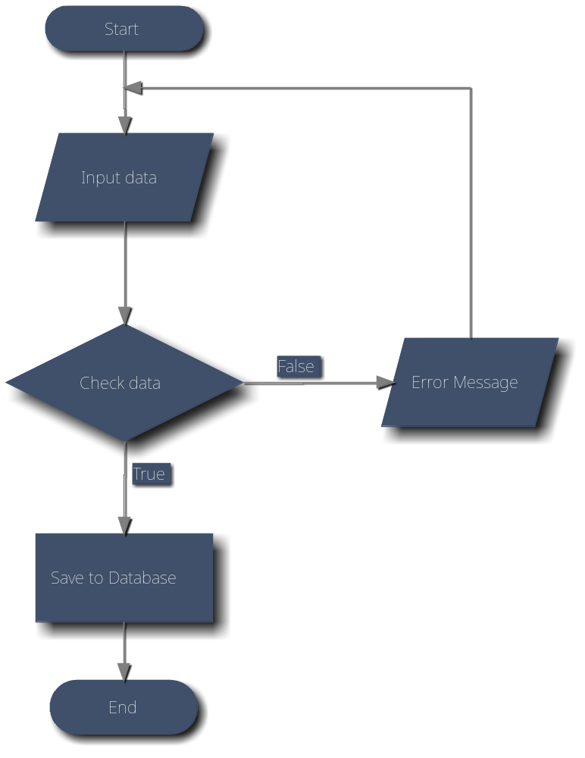
Edit record
Search information
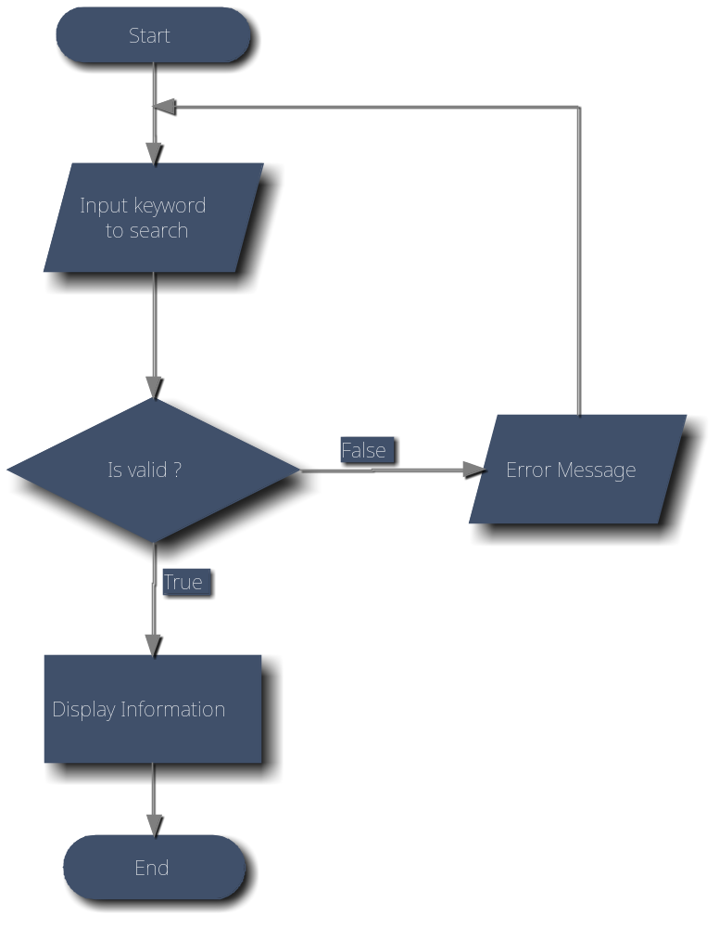
Delete record
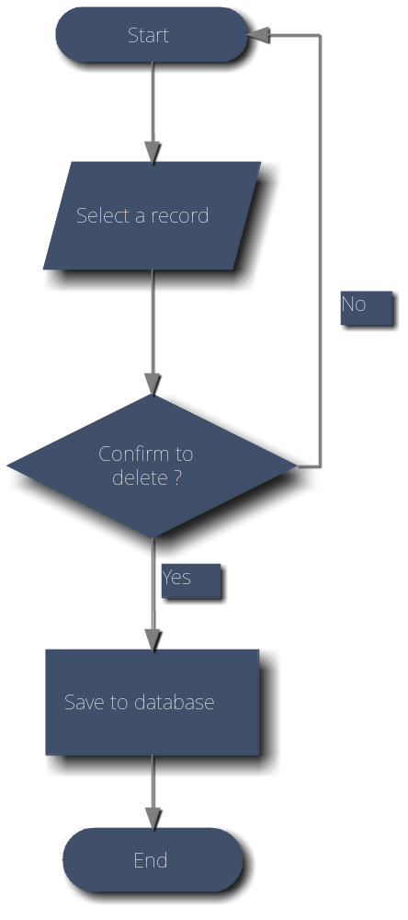

Entity Relationship Diagram

Database Design

-Employee
Table : Users
Field Name | Data Type | Key | Description
EmployeeId | int | PK | Stores of the id
Username | nvarchar(100) |  | Stores role Username
Password | nvarchar(100) |  | Stores password
FullName | nvarchar(100) |  | Stores the Full Name of User
DateOfBirth | datetime |  | Stores Date of birth of Employee
Gender | bit |  | Store Gender of Employee. Male:1, Female:0
Address | nvarchar(100) |  | Stores Address of Employee
Phone | nvarchar(10) |  | Stores Phone Number of Employee
IdentityCard | nvarchar(10) |  | Stores Identity Card of Employee
Role | nvarchar(10) |  | Stores User Role of Employee
Email | nvarchar(100) |  | Stores Email of Employee
IsDelete | Boolean |  | Comfirm Employee is delete
Status | String |  | Stores status of Employee Working or Retired

-Customers
Table : Customer
Field Name | Data Type | Key | Description
CustomerId | int | PK | Stores Id of Customer
Username | nvarchar(100) |  | Stores Username of Customer
Password | nvarchar(100) |  | Stores Password of Customer
CustomerName | nvarchar(100) |  | Stores Name of Customer
Gender | bit |  | Store Gender of Customer. Male:1, Female:0
Email | nvarchar(100) |  | Stores Email of Customer
Phone | nvarchar(10) |  | Stores Phone of Customer
DateOfBirth | datetime |  | Stores Birthday of Customer
Address | nvarchar(100) |  | Stores Address of Customer
RegisterDate | datetime |  | Stores time Customer Registration
Status | nvarchar(15) |  | Id of WorkStatus
-Brand
Table: Brand
Field Name | Data Type | Key | Description
BrandId | int | PK | Stores Id of Brand
Address | nvarchar(100) |  | Stores Address of Brand
Email | nvarchar(100) |  | Stores Email of Brand
Phone | nvarchar(12) |  | Stores Phone of Brand
Description | nvarchar(100) |  | Description of Brand
IsDelete | Boolean |  | Comfirm Brand is delete
- Shoes Size
Table: Shoes Size
Field Name | Data Type | Key | Description
ShoesSizeId | int | PK | Stores Id of Size
sizeNumber | double |  | Stores Size Number
centimeter | double | FK | Stores Size Number centimet unit

-ShoesType
Table : ShoesType
Field Name | Data Type | Key | Description
ShoeTypeId | int | PK | Stores of the id shoesTypes
Shoes_type_name | nvarchar(50) |  | Name of ShoesType
image | nvarchar(100) |  | Stores link Image of ShoesType
Gender | bit |  | Store Gender of Shoes Type. Male:1, Female:0
BrandId | int | FK | Id of Brand
UnitPrice | double |  | Price of Shoes Type
Status | nvarchar(15) |  | ShoesType Status
BestSeller | Bit |  | Is the Shoes Type Best Seller?
Description | nvarchar(100) |  | Description of Shoes Type
-Shoes
Table : Shoes
Field Name | Data Type | Key | Description
ShoesId | int | PK | Stores of the id shoes
createdDate | Date |  | Date created Shoes
updatedDate | Date |  | Date update Shoes
IsDelete | Boolean |  | Comfirm Shoes is delete
Quantity | int |  | Quantity of Shoes
Status | nvarchar(15) |  | Shoes Status
EmployeeId | int | FK | Id of Employee create or update
shoesSize | int | FK | Id of shoes size
Id | int | FK | Id of Brand

-Orders
Table : Orders
Field Name | Data Type | Key | Description
OrderId | int | PK | Stores of the id Order
GrandTotal | double |  | Stores of Grand Total
IdCustomer | int | FK | Id of Customers
Price | money |  | Price of Services when customers active
Status | Bit |  | Status Order
orderDate | Date |  | Stores of Order Date
shipDate | Date |  | Stores of shipment Date

-OrderDetails
Table : OrderDetails
Field Name | Data Type | Key | Description
OrderDetailId | int | PK | Stores of the id OrderDetail
Quantity | Int |  | Quantity of Shoes
Unit Price | Int |  | Price of 1 unit shoes
OrderId | int | FK | Stores of the id Order
ShoesId | int | FK | Stores of the id shoes

-Shipment
Table : OrderDetails
Field Name | Data Type | Key | Description
ShipmentId | int | PK | Stores of the id Shipment
AddessLine | nvarchar(100) |  | Address of shipment
ShipmentName | vvarchar(100) |  | Shipment of shipment
Phone | nvarchar(12) |  | Stores Phone of shipment
Province | nvarchar(100) |  | Stores Province of shipment

-Contacts
Table : Contacts
Field Name | Data Type | Key | Description
Id | int | PK | Stores of the id Contacts
FirstName | nvarchar(50) |  | First Name of Contact
LastName | nvarchar(50) |  | Last Name of Contact
ContactNumber | nvarchar(10) |  | Phone Number of Contact
ContactEmail | nvarchar(100) |  | Email of Contact
ContentContact | nvarchar(Max) |  | Content of Contact

Class Diagram

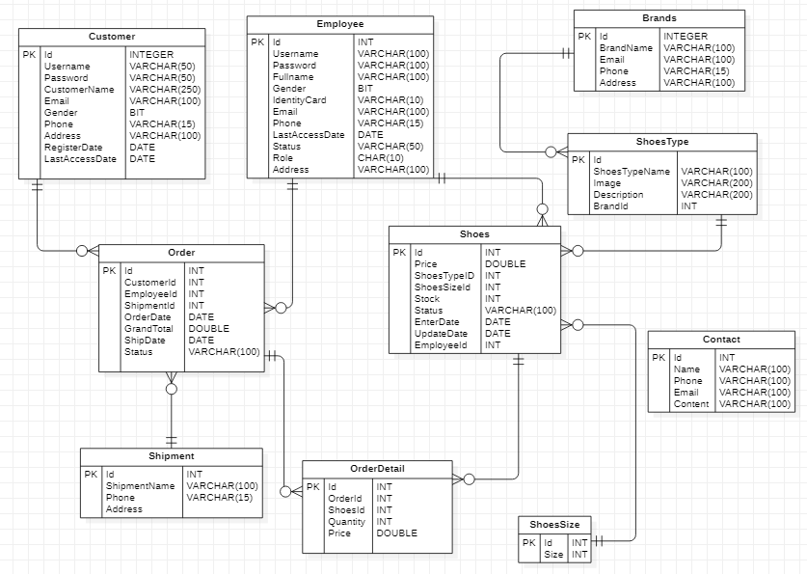

Algorithms (optional)
<Provide the detailed description about algorithms used in the system. You can use Flow Chart or Activity Diagram to represent algorithms. Focus on the important and complex algorithms>

Others (optional)
<Any design concerns or diagrams can be put here>

System Prototype

Intro page

Home
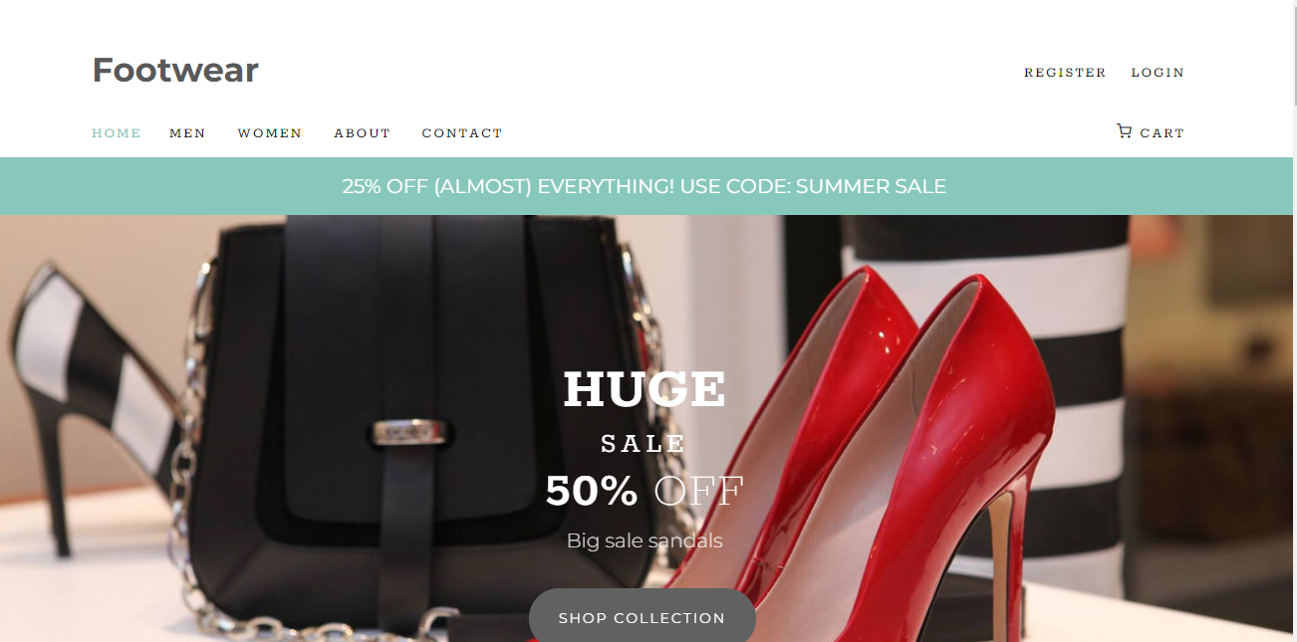
Cart
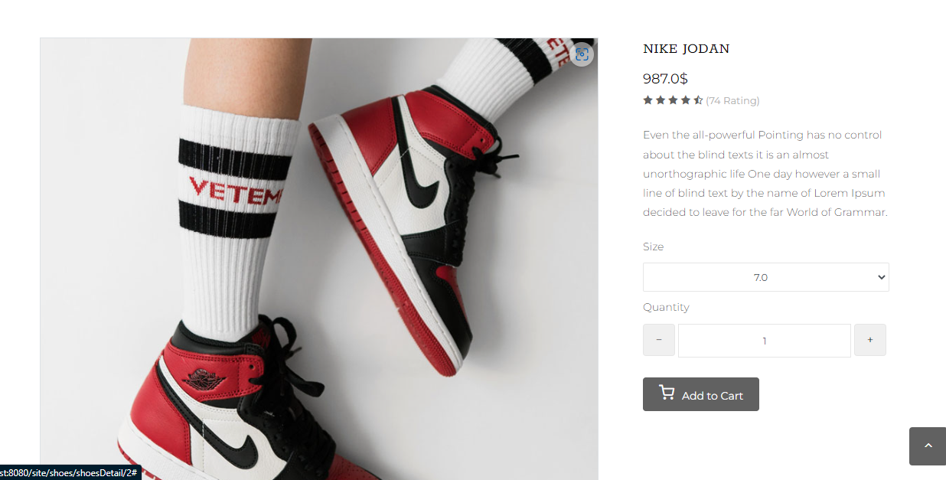

Employee Login

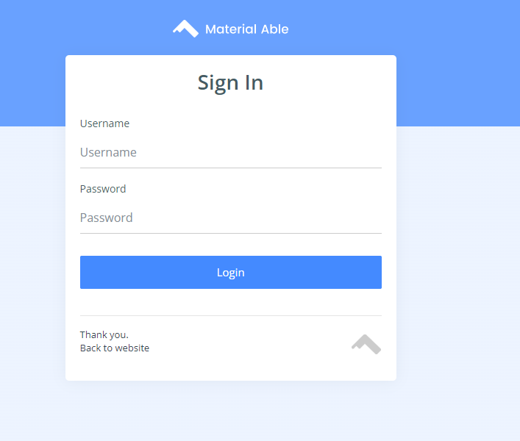
Dashboard
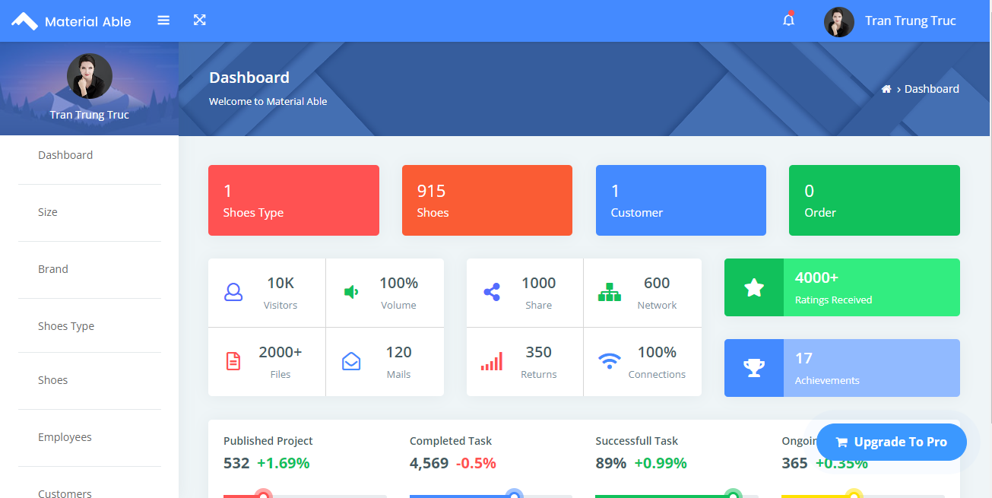
Add New Shoes Type

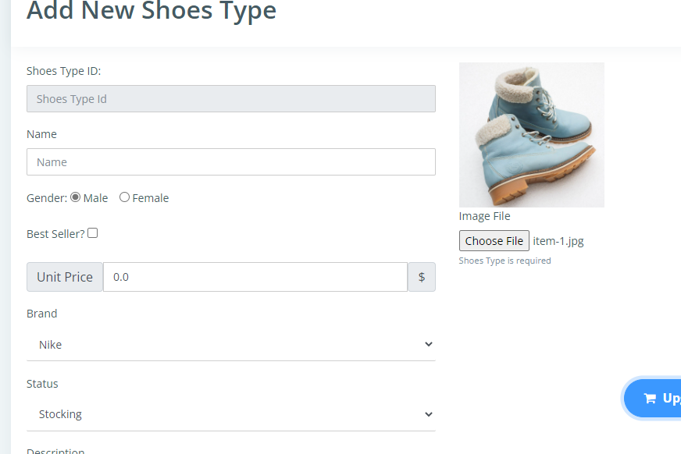

Change Password
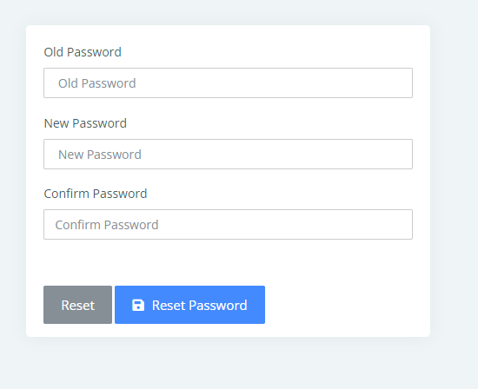

Management and Project Planning

Task Sheet

Sr.No | Task | Team Members Names
 | Database Design | Nguyen Tien Hien  Vo Khanh Duy  Nguyen Dang Thanh Dat
Admin
1 | Create, Update,
2 | Add, Update, List, Search Shoes Size | Nguyen Dang Thanh Dat
3 | Add, Update, List, Search Brand | Nguyen Dang Thanh Dat
4 | Add, Update, List, Search ShoesType | Nguyen Dang Thanh Dat
5 | Add, Update, List, Search Shoes | Nguyen Tien Hien
6 | Add, Update, List,Login Search Emloyee | Nguyen Tien Hien
7 | Search Emloyee, Shipment | Nguyen Tien Hien
8 | Change Password, Reset Password | Nguyen Tien Hien
9 | Update Order | Nguyen Tien Hien
Customer
1 | Register, Login | Vo Khanh Duy
2 | Home | Vo Khanh Duy
3 | Cart | Vo Khanh Duy
4 | Check out | Vo Khanh Duy
5 | Payment Service with Payment | Vo Khanh Duy

Checklists

Check List of Validation

Option | Validated
Can admin login to the application ? | Yes
Has the hardware and software been correctly chosen ? | Yes
Does the application’s functionality resolve the user problem,and satisfy their needs | Yes
Do all the options present in the application display the correct result ? | Yes

Submission Checklist

Sr.No | Particulars | Yes | No | N/A | Comments
1 | Are the users table to login the application after validation is performed on the username and password ? | Yes
2 | Are the administrator able to modify the user information after getting created ? | Yes
3 | Can the user to edit employee’s details after getting added ? | Yes
4 | Are the user able to find a product’s wherever they wants ? | Yes |  |  | Search functionality is very useful.
5 | Is the application user-friendly ? | Yes |  |  | Windows GUI is familiar with everyone

---------------------------------Thank You ---------------------------------------

