Install the Windows Subsystem for Linux

Run the command **wsl --install** in PowerShell

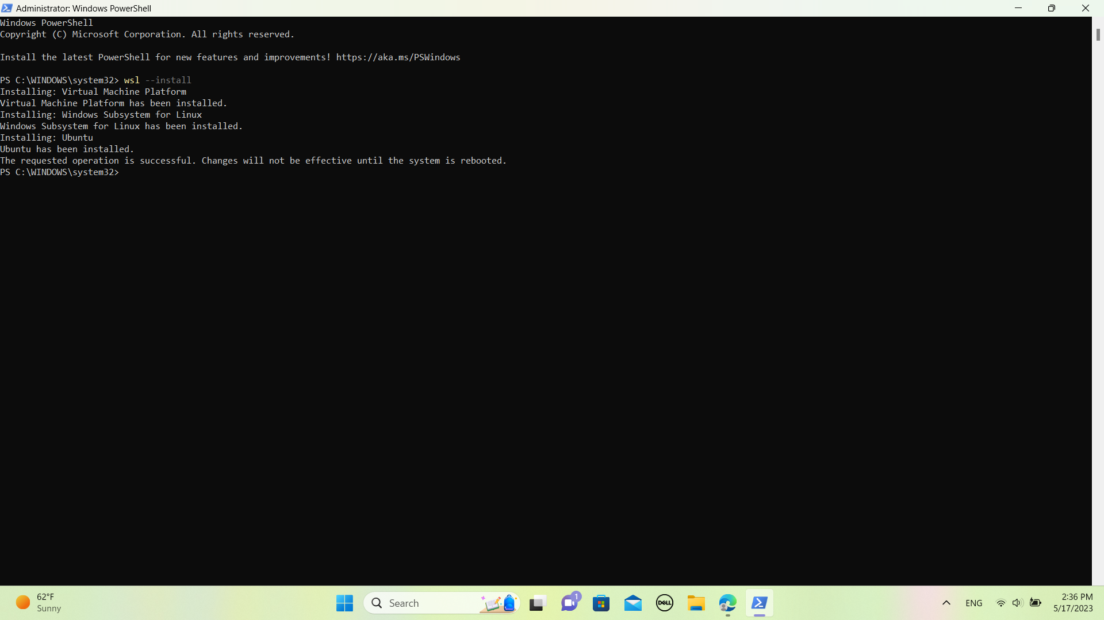

Reboot

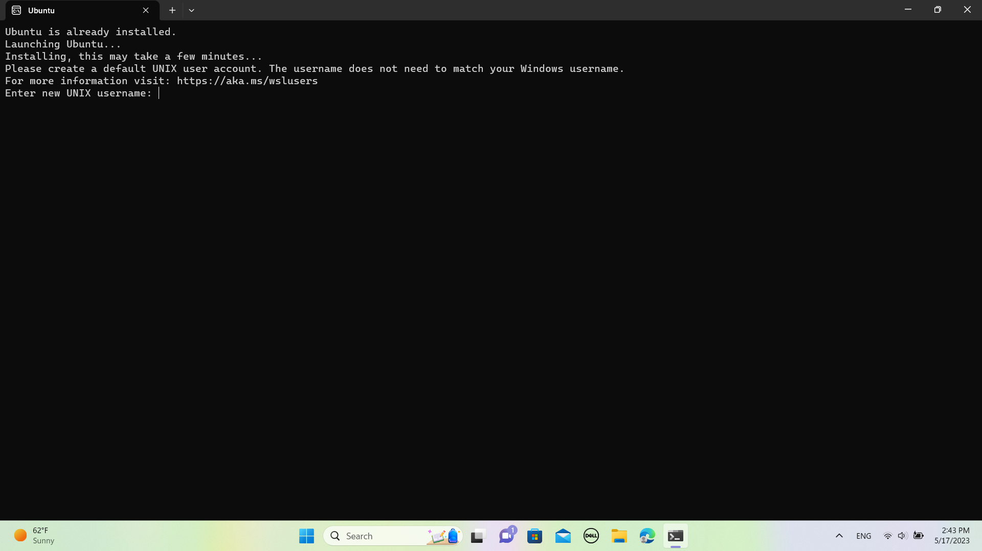



Installing Ansible

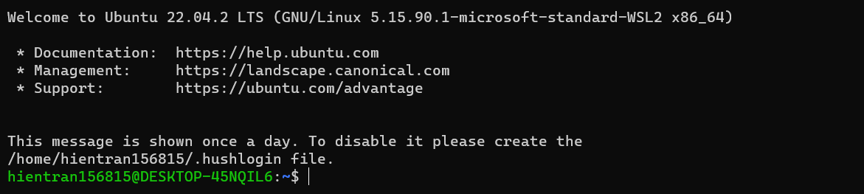

Run the command

**sudo apt-get update**

Install all the relevant dependencies

**sudo apt-get install python3 python3-pip git libffi-dev libssl-dev -y**

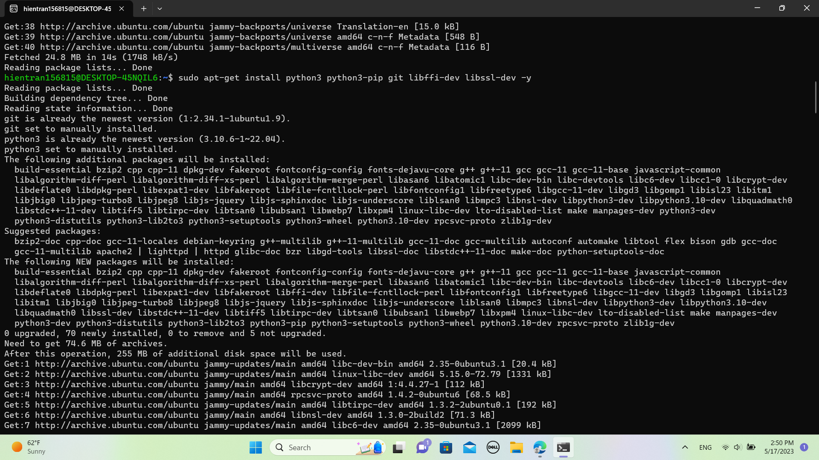

Python’s pip3 can be used to install Ansible

**pip3 install ansible**

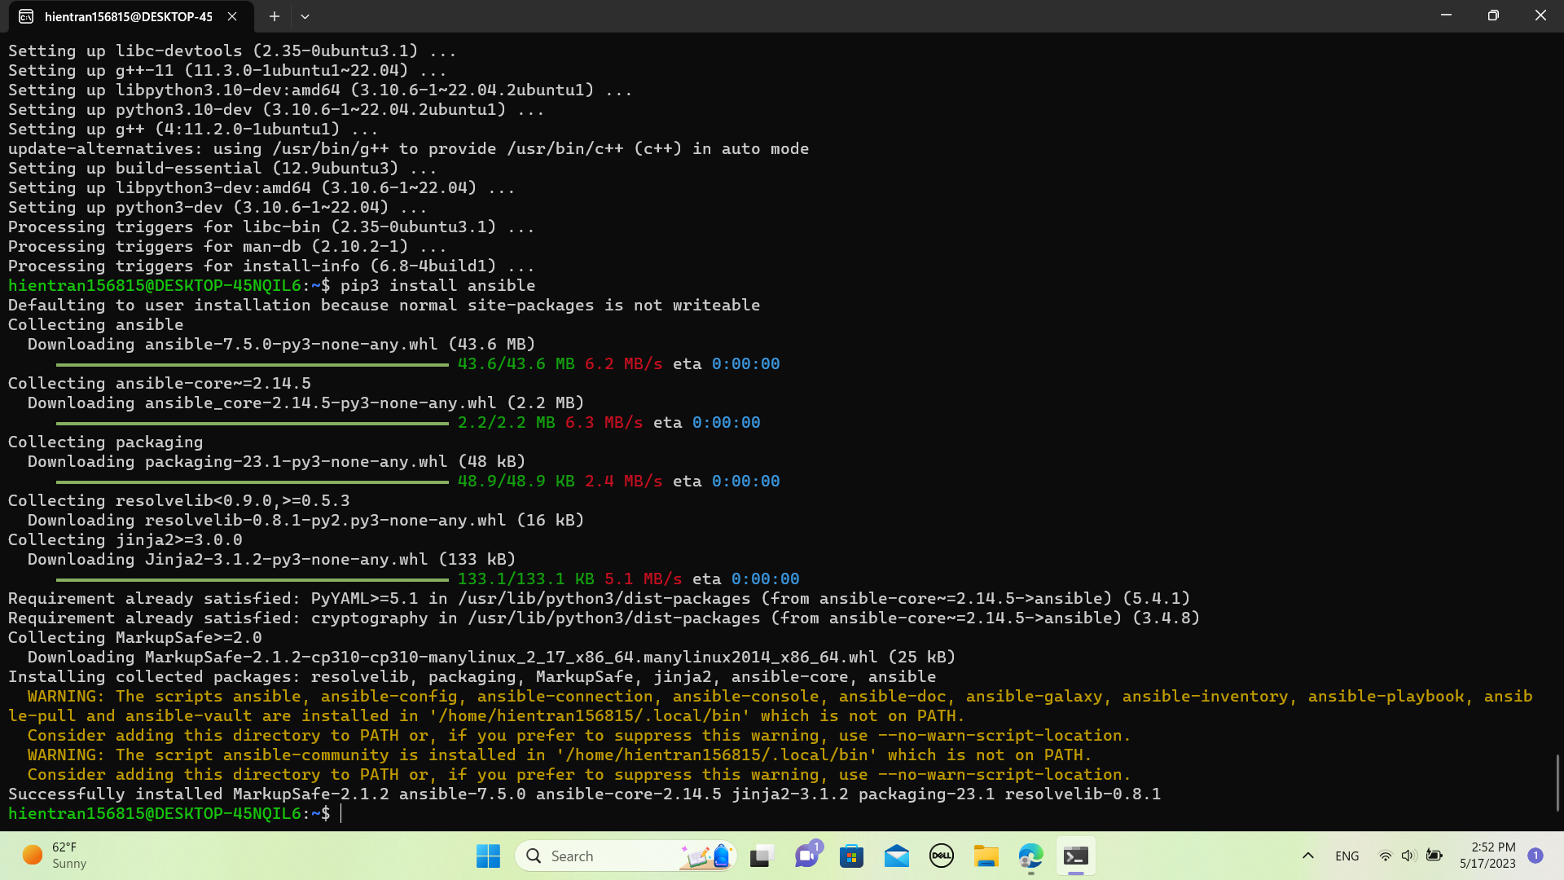

Encounter an error when trying to check if ansible is installed using command

**ansible --version**

So, run command

**sudo apt install ansible**

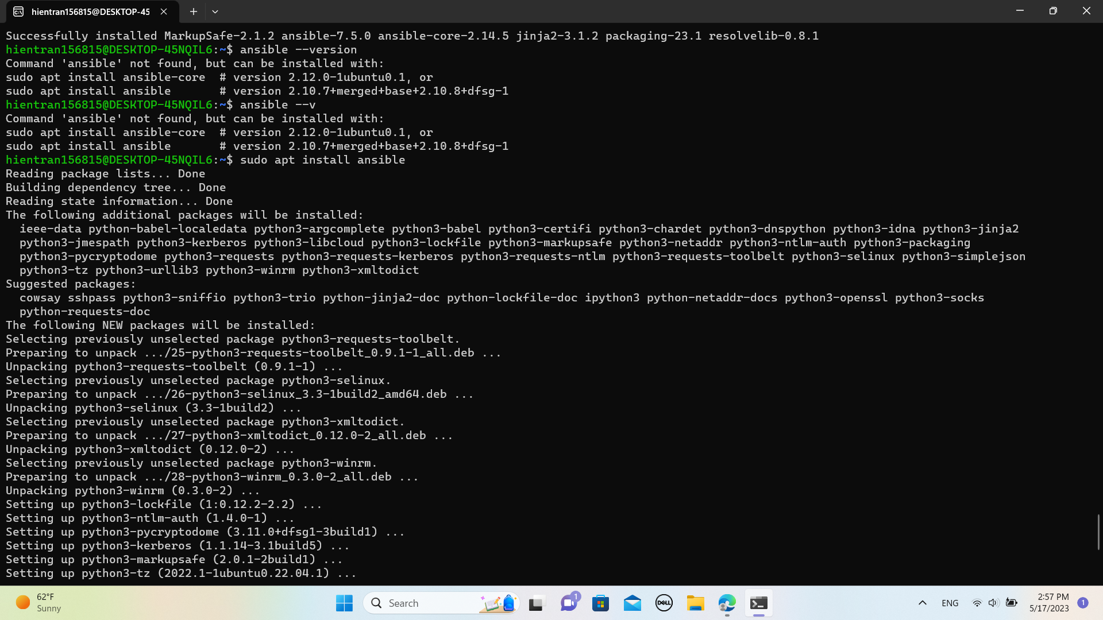

Now it works

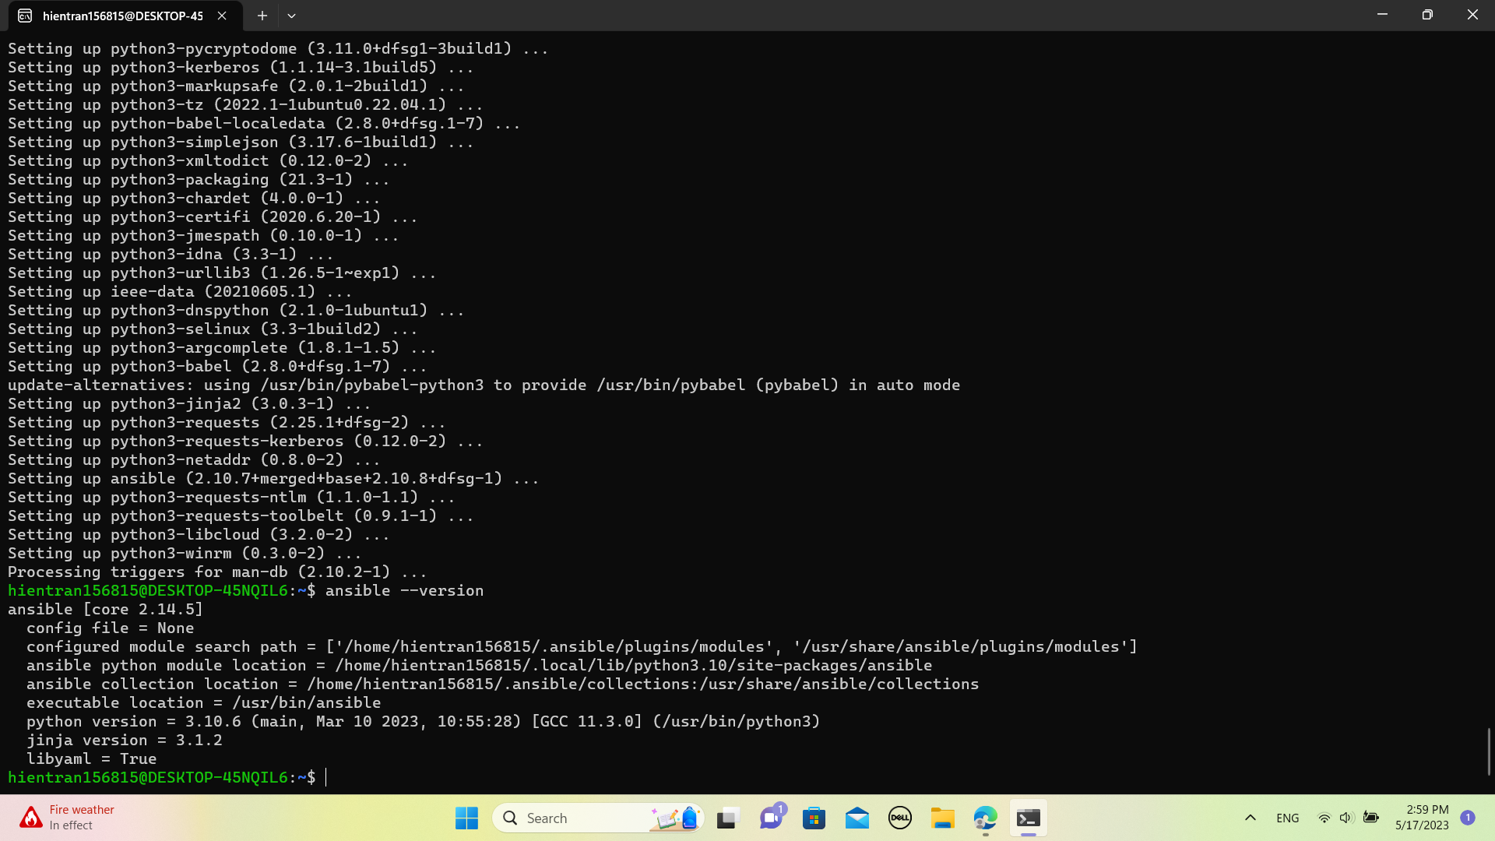

**Ansible Support for SSH**

Ansible uses SSH to communicate with other environments

**sudo apt-get install openssh-server -y**

Generate ssh key to allow secure communication between servers

**ssh-keygen -t rsa**

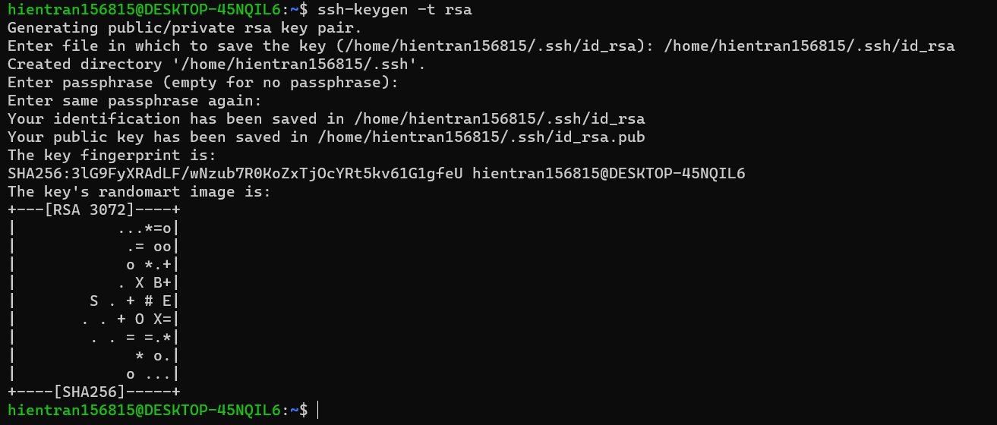

Check the key in the directory

**ls -l .ssh**

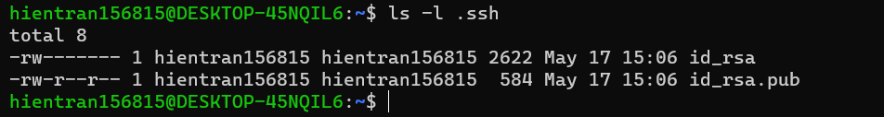

Copy keys to your working environment

**ssh-copy-id localhost**

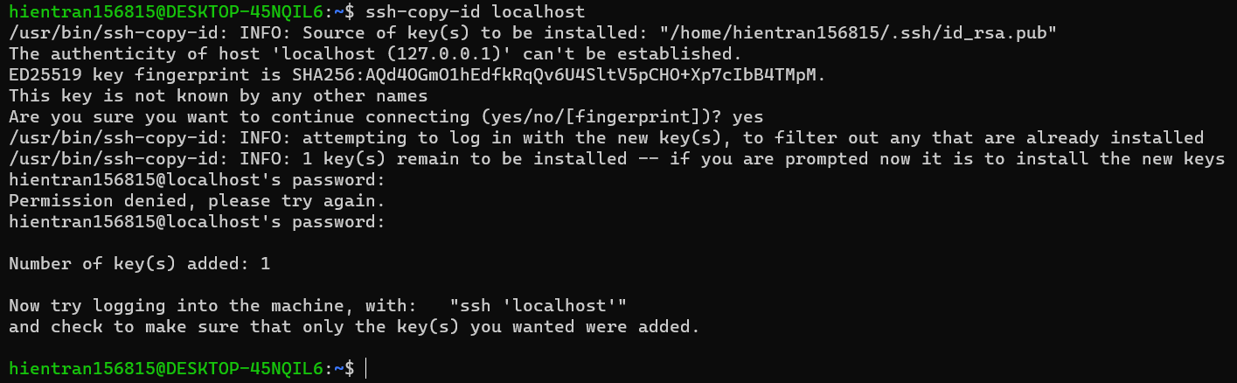

Logging into the machine

**ssh localhost**

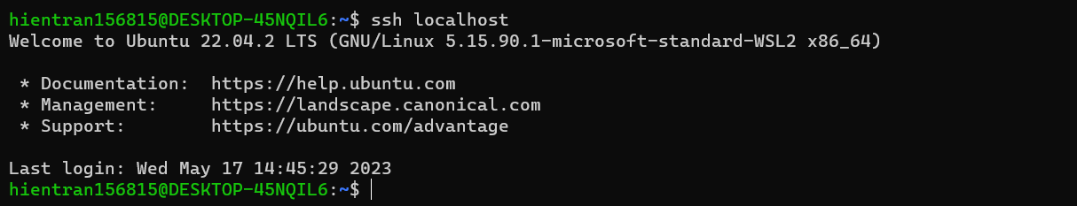

Now you can login to your environment without the need to input your username and password as SSH will use the newly created keys

Run your 1st Ansible command

**ansible all -i "localhost," -m shell -a 'echo Ansible is fun'**

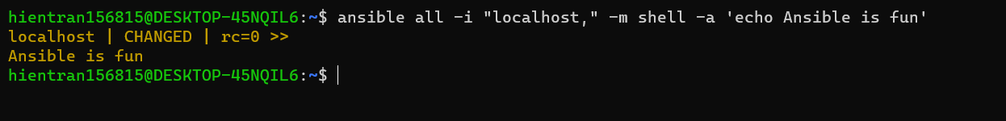

→ Run across all the inventory

→ Make a list of inventory with -i option

→ -m to specify a module we use. Eg shell module to run a shell command

→ -a to provide arguments to the shell module. Eg running an echo command to print the output ‘Ansible is fun’

Run over multiple systems

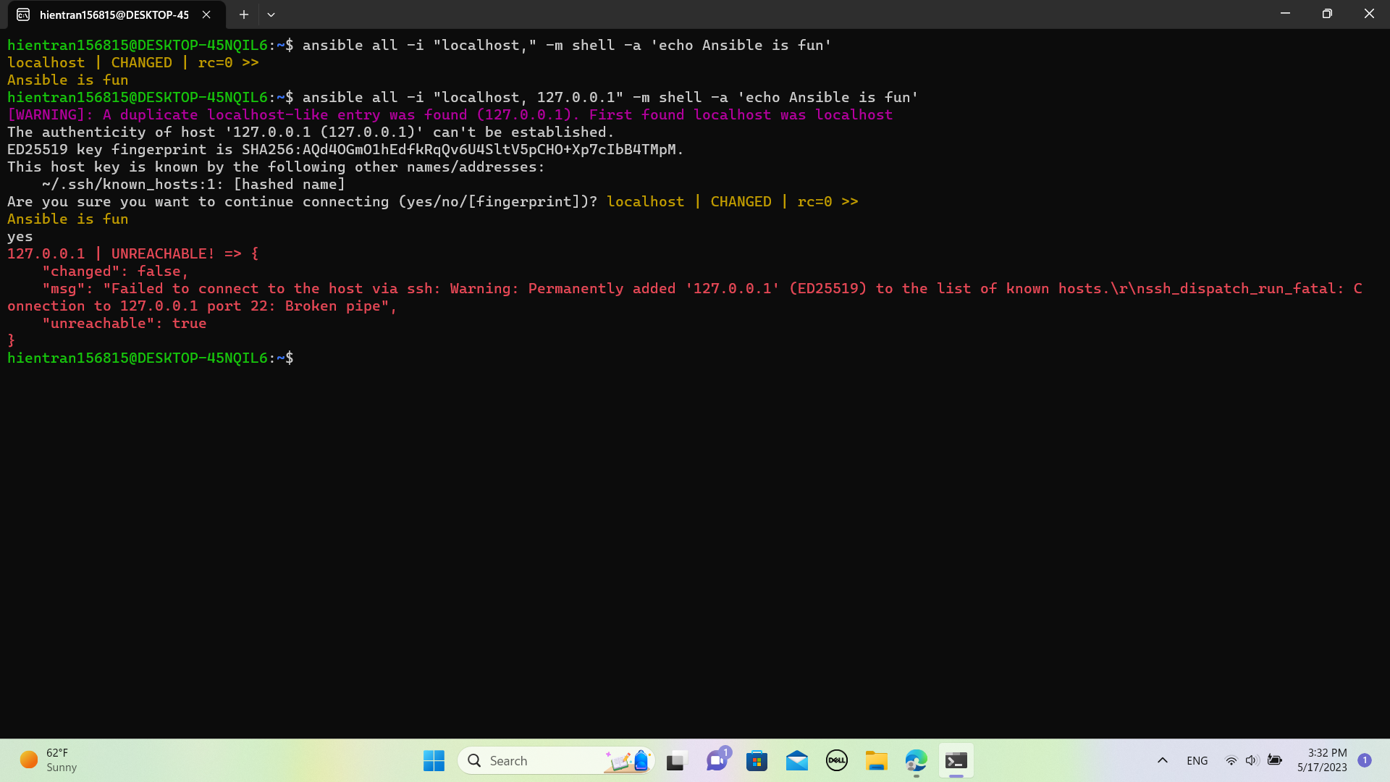

Ansible Playbooks

Create a new file

**touch test.yml**

Edit the file

**vi test.yml**

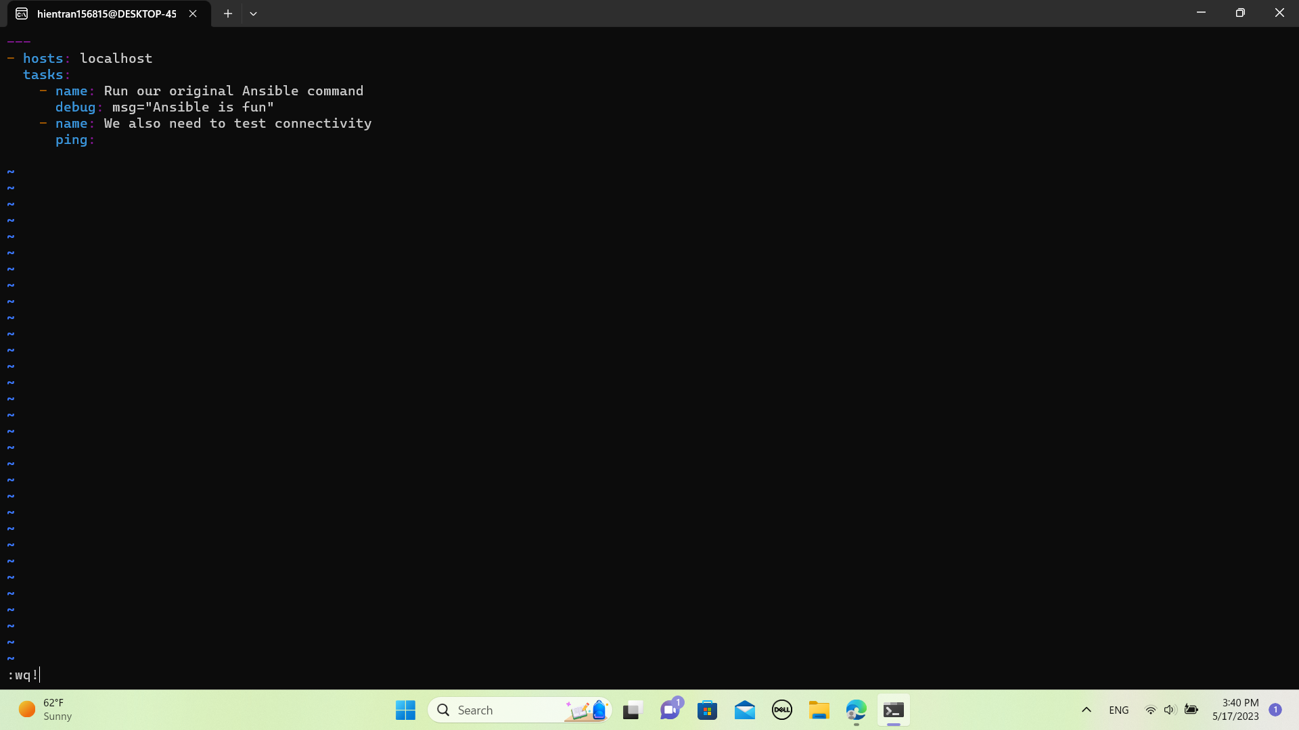

Run the playbook

**ansible-playbook test.yml -i "localhost,"**

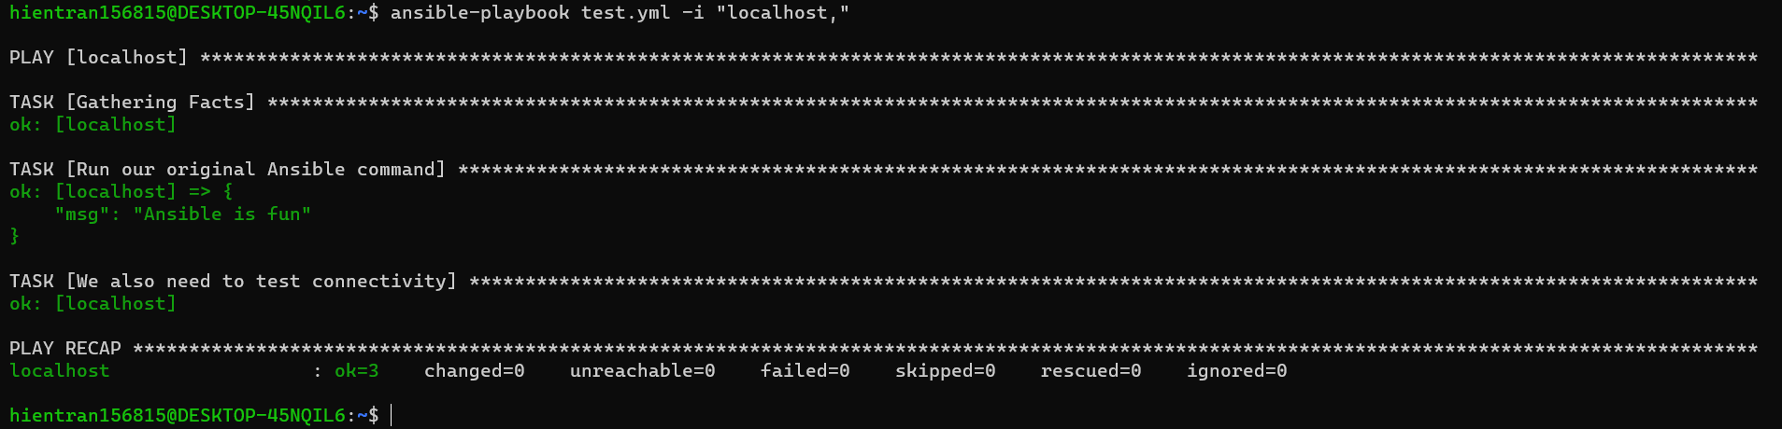

Ansible Configuration and Inventory Files

Set up the Inventory of hosts

**touch hosts**

**via hosts**



**ansible all -i hosts -m shell -a 'echo Ansible is fun'**



**Ansible Modules**

Run the ping module

**ansible mylaptop -i hosts -m ping**



**ansible mylaptop -i hosts -m setup**

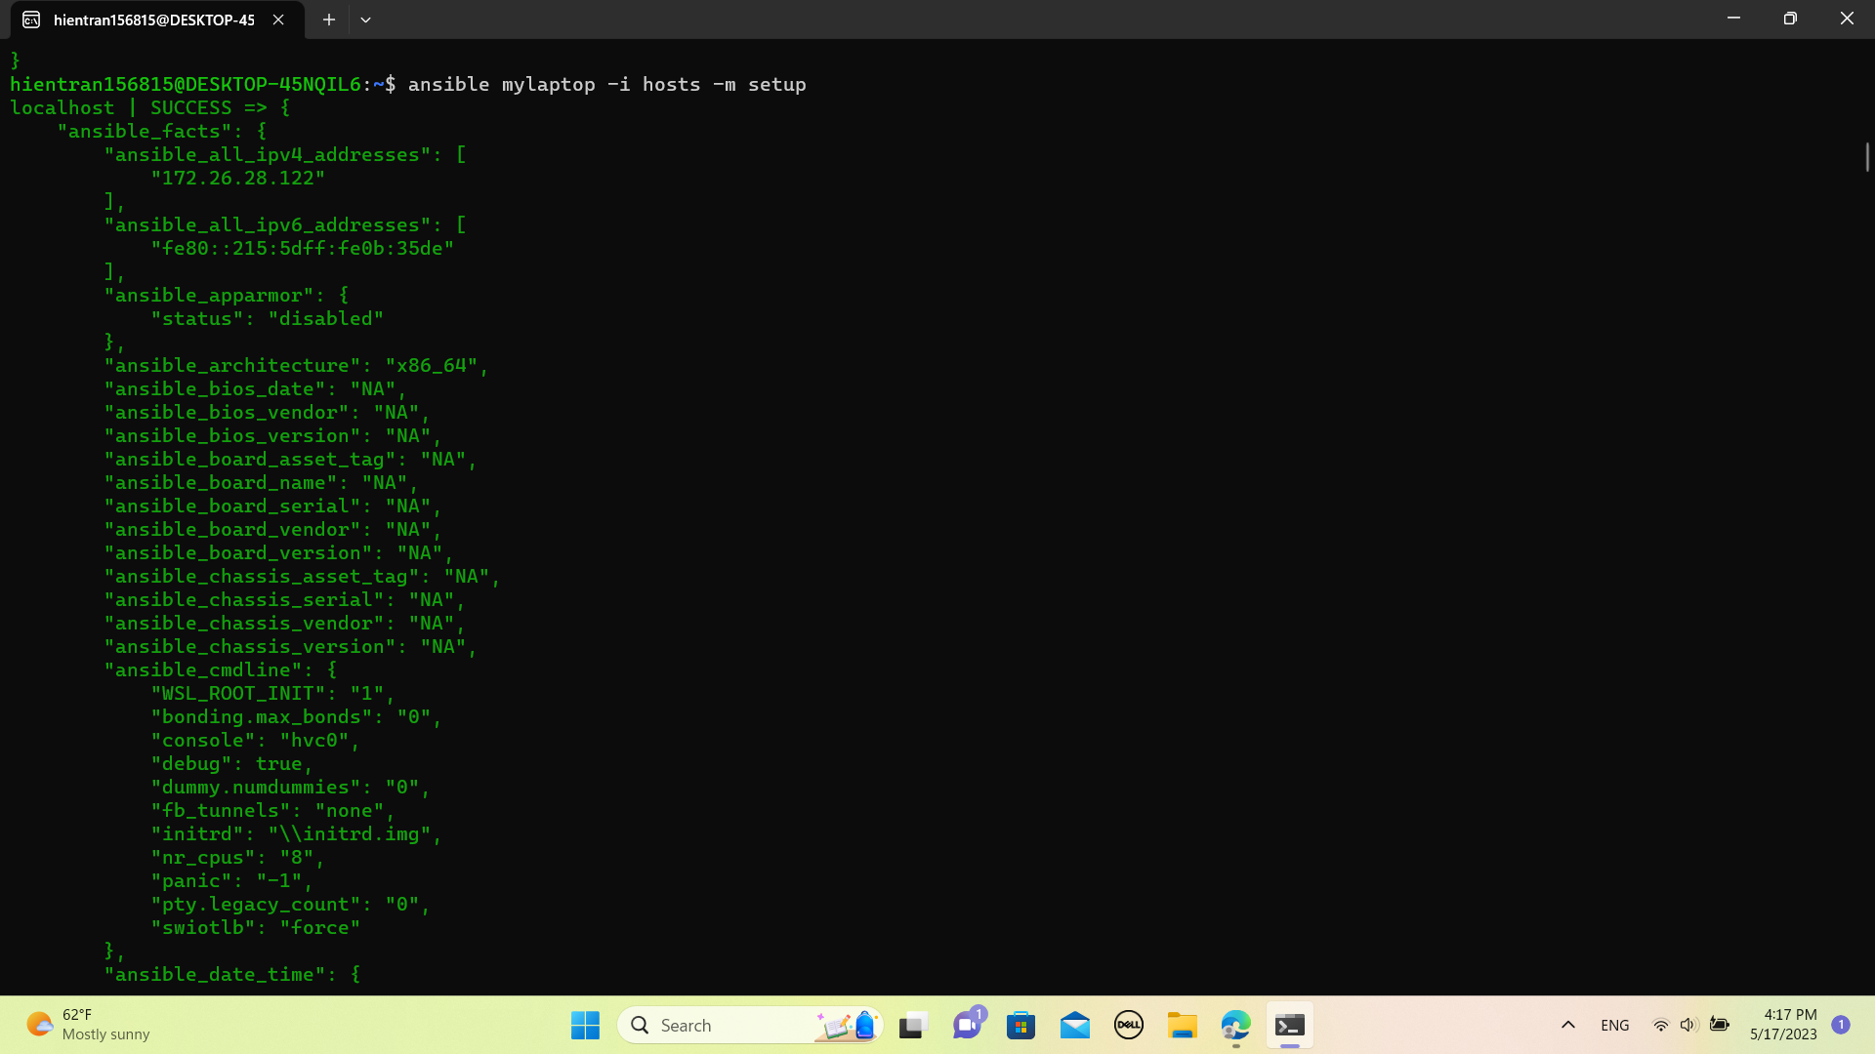

**Shell**

**ansible mylaptop -i hosts -m shell -a "ls -l /tmp/"**

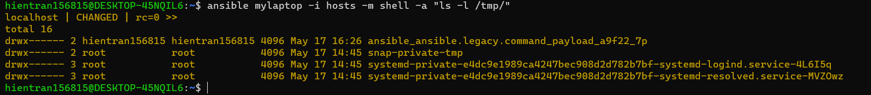

**Apt (or Yum)**

**ansible mylaptop -i hosts -m apt -a "name=apache2 state=present"**

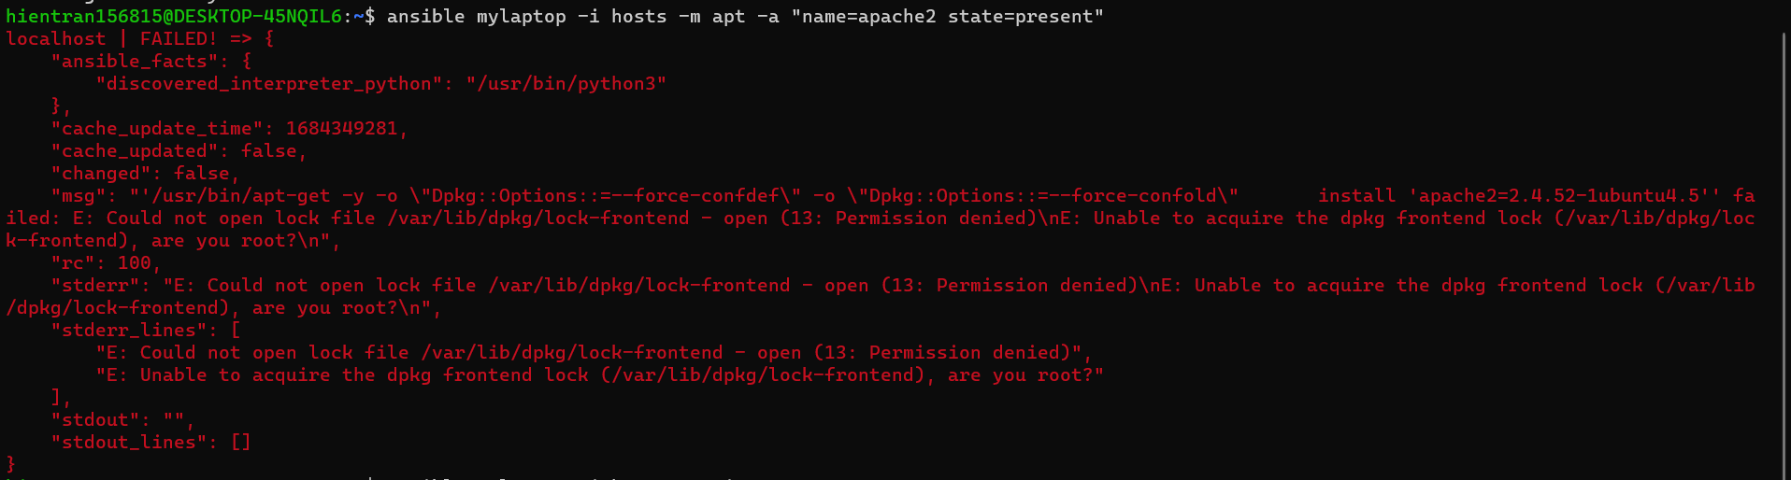

TROUBLESHOOT

ansible mylaptop -i hosts -m apt -a "name=apache2 state=present" --become --ask-become-pass

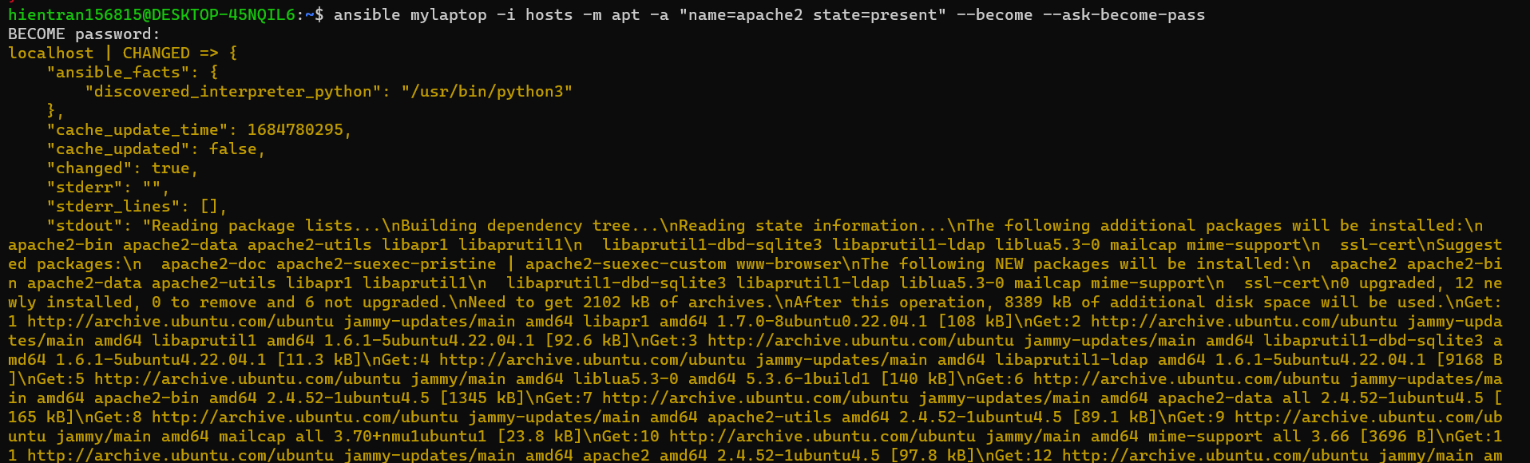

**Package**

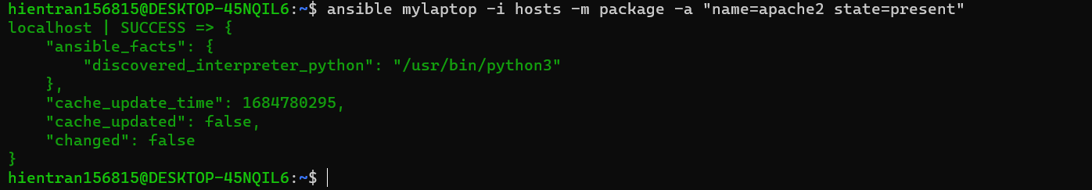

**Service**

**ansible mylaptop -i hosts -m service -a "name=apache2 state=started"**

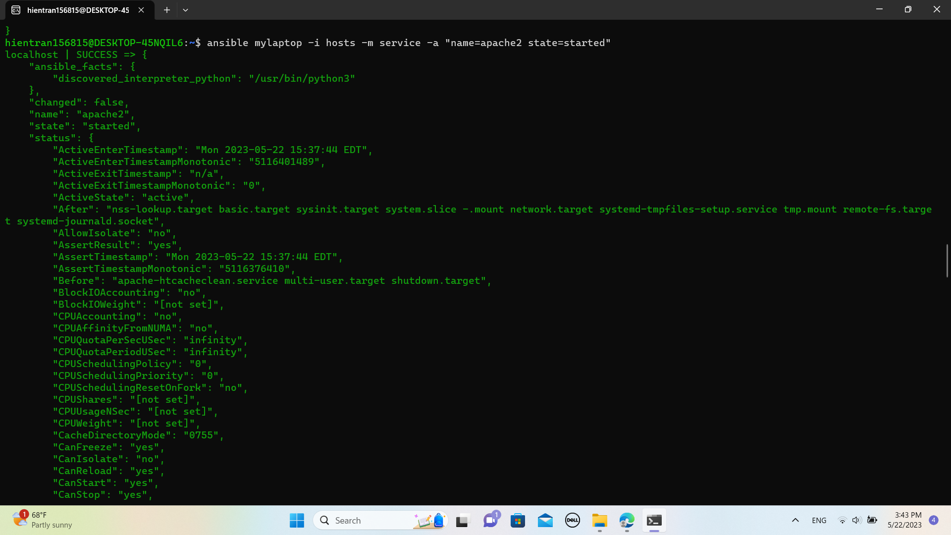

**ansible mylaptop -i hosts -m get_url -a "url=http://localhost dest=/tmp/"**

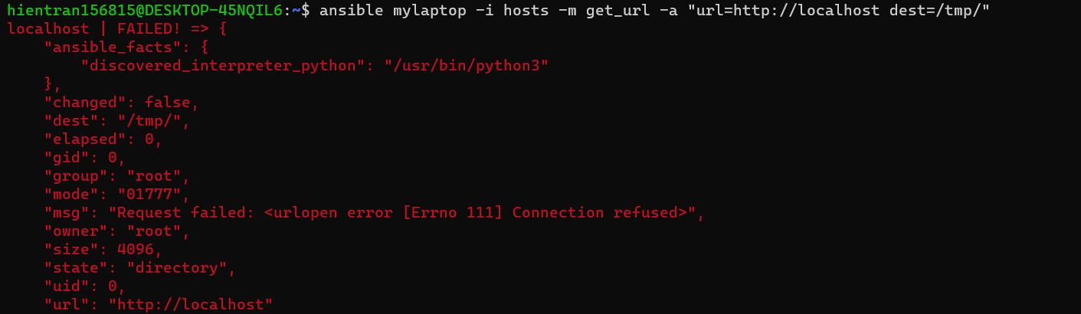



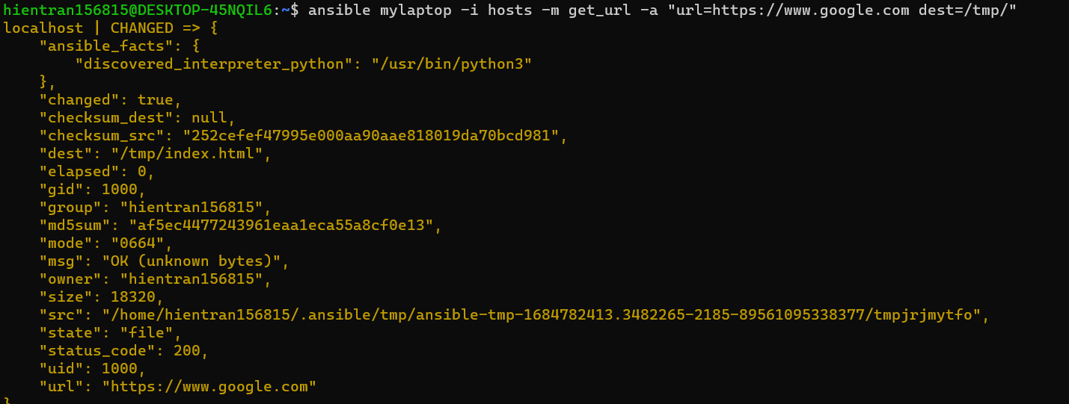

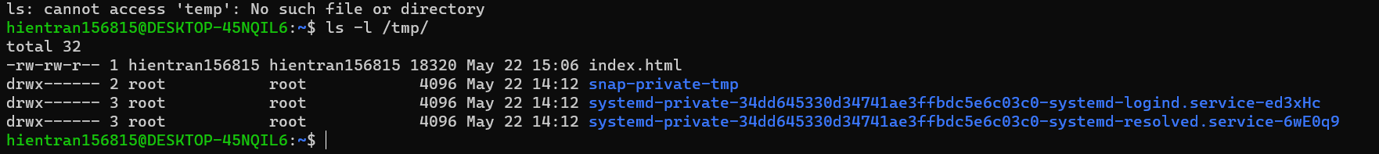

**ansible mylaptop -i hosts -m file -a "path=/tmp/another_test owner=root group=root state=directory"**

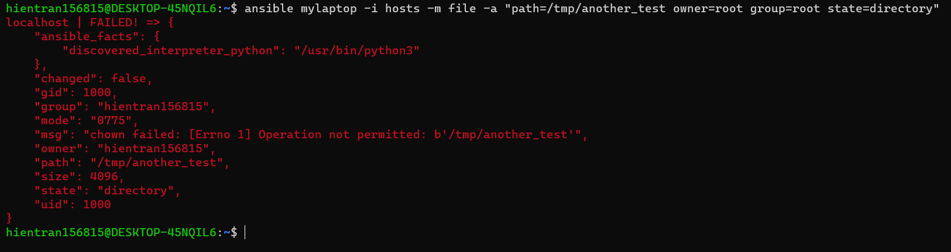

**TROUBLESHOOT**

**ansible mylaptop -i hosts -m file -a "path=/tmp/another_test owner=root group=root state=directory" --become --ask-become-pass**

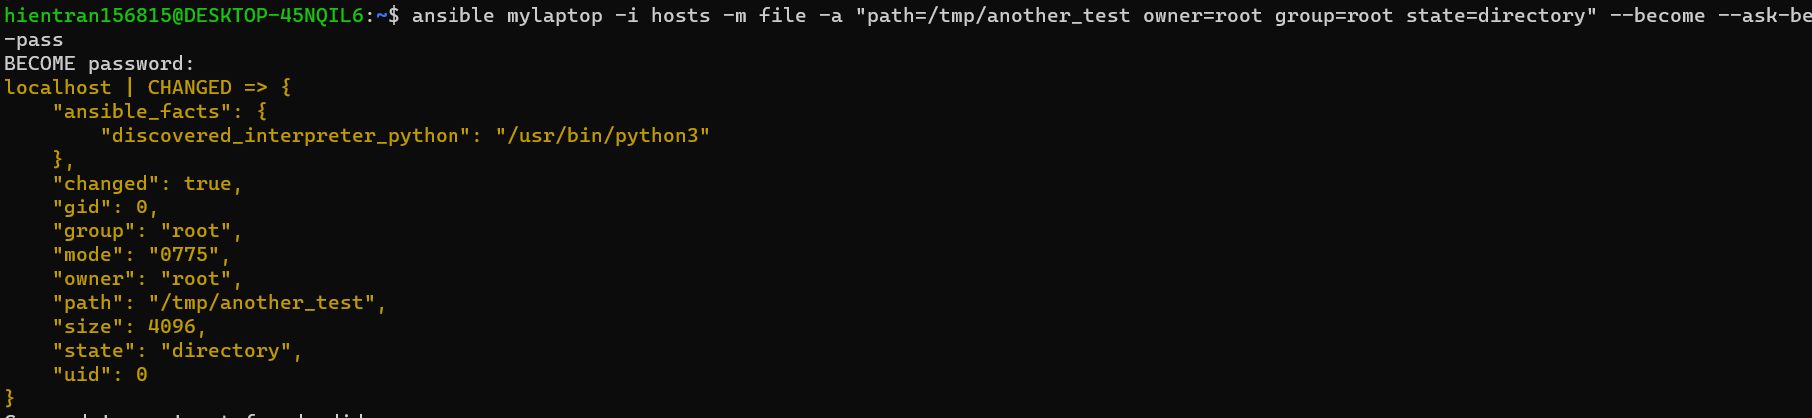

**User**

**ansible mylaptop -i hosts -m user -a "name=jsmith comment='Jane Smith' state=present" --become --ask-become-pass**

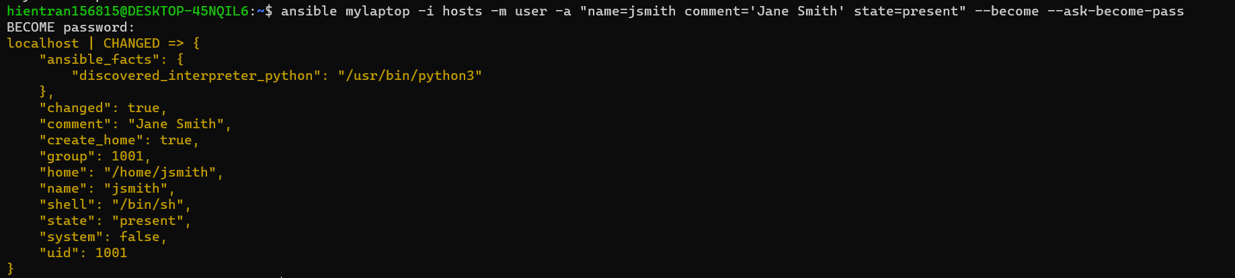

**Check for user**

**cat /etc/passwd | grep jsmith**



**Find**

**ansible mylaptop -i hosts -m find -a "path=/var/log/ age=1w file_type=directory"**

