Project 2 Screenshots

Initial deployment

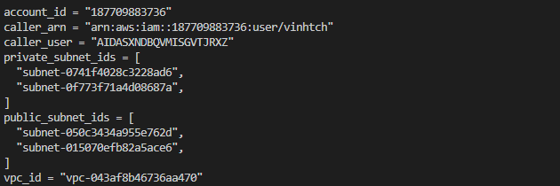

Edited

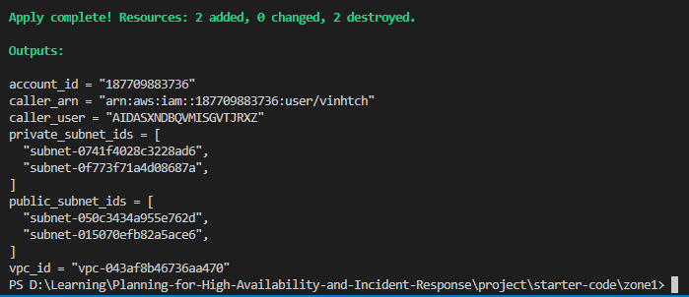

Resources

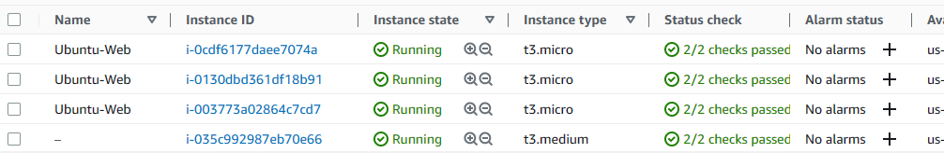

Dashboard

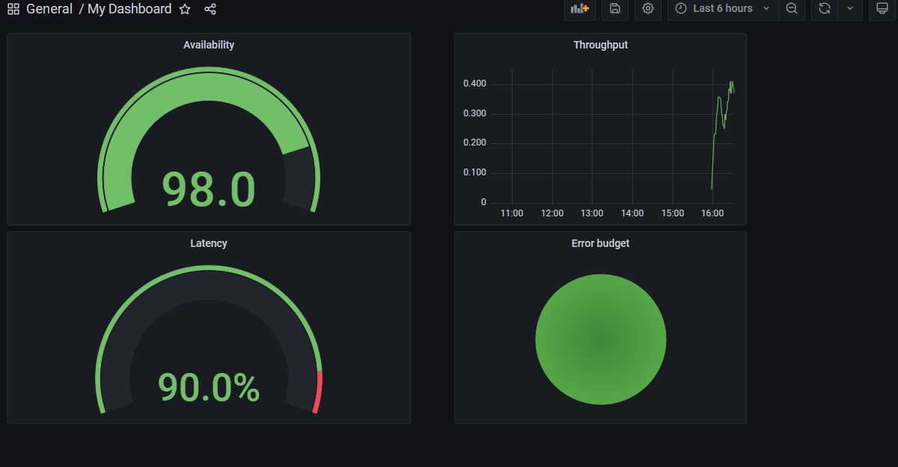

Zone 2 latest deployment after fixing the instance limit

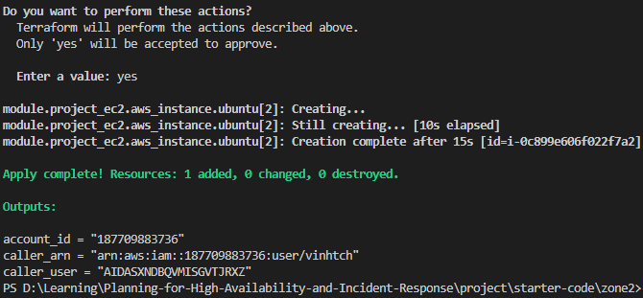

Reduced instance in order to run successfully

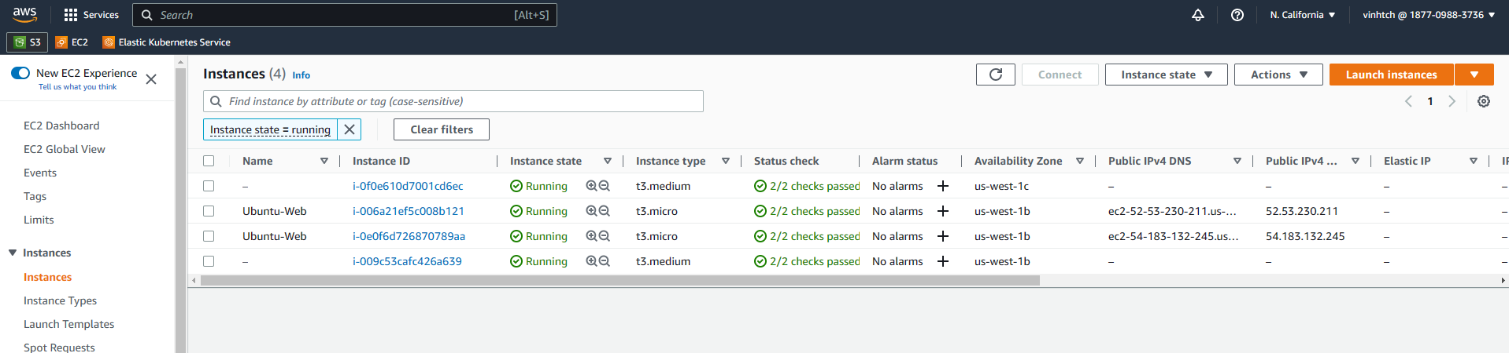

RDS

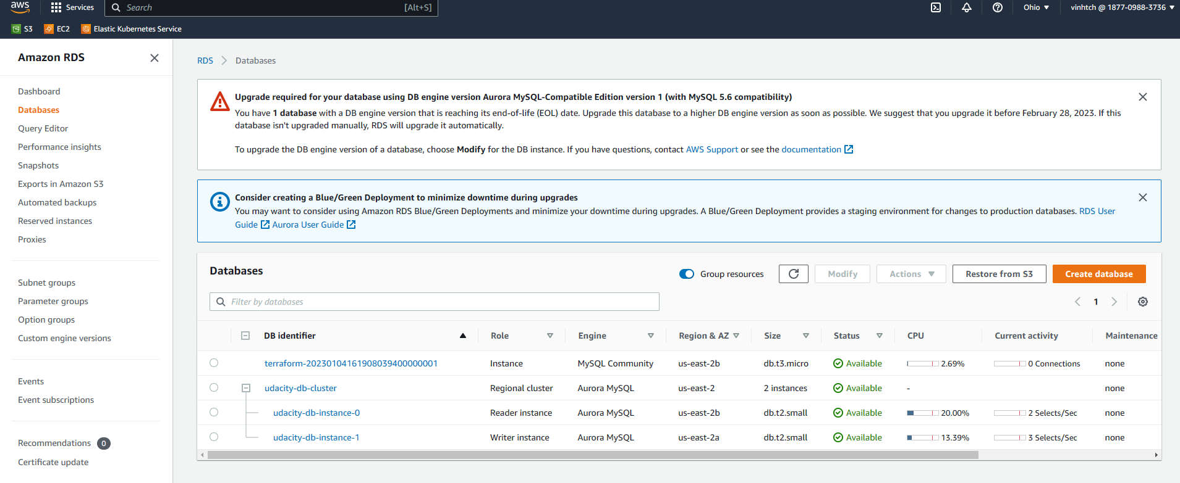

Review #3: DESTROY UPDATED

Zone 1

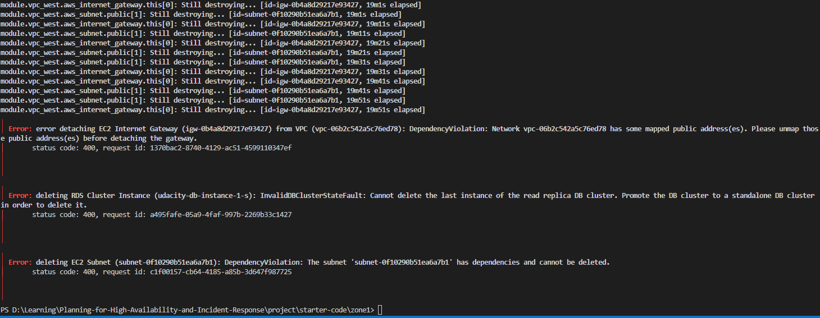  
VPC cannot be deleted

IGW being used

Subnet being used

RDS Cluster cannot be deleted

Cannot delete last instance of read replica DB Cluster

The order was not right, it is the Stack, treated as FILO, hence destroy zone 2 first, after zone1 re-apply

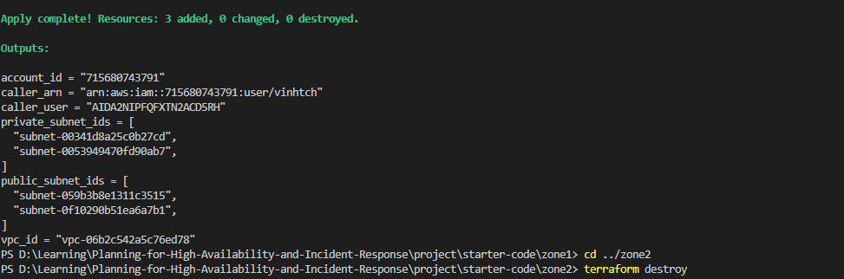

Zone2 destroyed

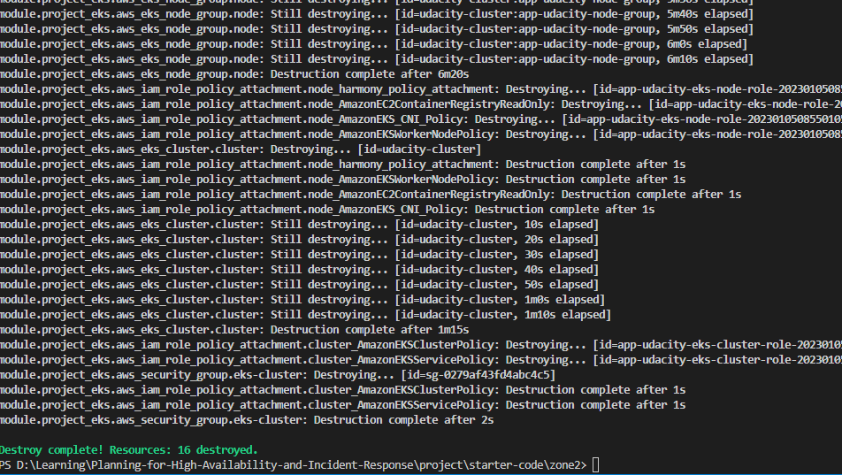

Zone 1 1st destroy attemp

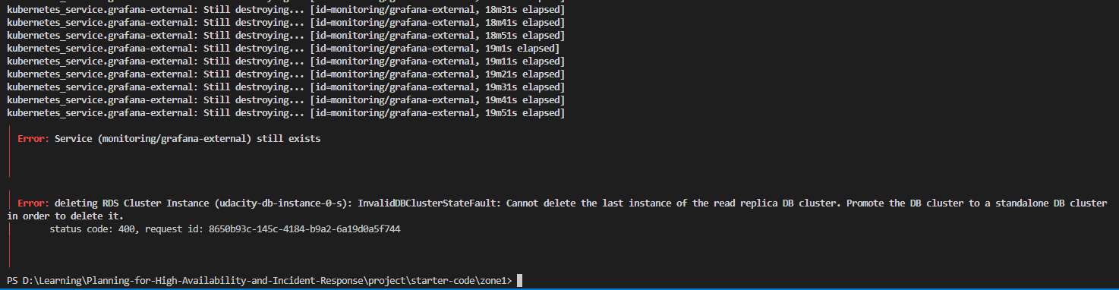

Retry delete EKS cluster **manually** then remove terraform state (it stuck for hours, no point keep continuing destroy via terraform)

*terraform state rm kubernetes_service.grafana-external*

RDS replica needs to be promoted before destruction

Rerun Zone1 destroy:

