**Restaurant POS 2.0**

<https://www.youtube.com/watch?v=5Ul_rUuoUZE>

Point of sale (POS) or point of purchase is the time and place where a retail transaction is completed. At the point of sale, the merchant calculates the amount owed by the customer, indicates that amount, may prepare an invoice for the customer, and indicates the options for the customer to make payment. In restaurant business, POS systems often include table reservation, ordering food, alerts, billing, credit card processing and customer management. Even before the COVID-19 crisis, POS systems had gained traction across the industry. During the coronavirus pandemic, restaurants face greater peril than ever. Such systems are expected to increase business intelligence, reduce wasted effort and opportunity to scale to a large business. Moreover, the systems should support take-away options Our customers have multiple restaurants and have a need to develop a responsive web-based POS system that implement the current business flow as described in Figure 1. (The current POS terminal can be replaced in this web-based solution)

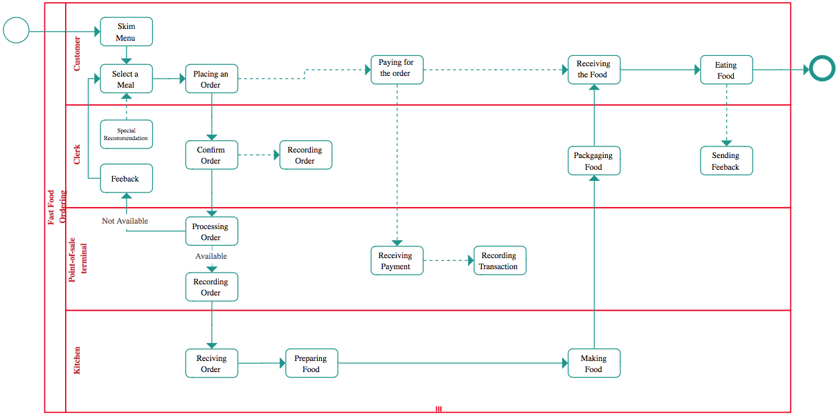

Figure 1: Customer-drawing workflow

The restaurant owners express several special demands for the new system:

* The system should allow non-direct contact between Clerks and Customers
* The system should be implemented using Web technology and QR code, so customers will not have to install apps
* The system should be usable from a mobile device, a tablet device or a normal computer/ laptop
* The system should be extendable to use in multiple restaurants in the future
* The current transactions is about 300 orders per day.

The restaurant owners have also ordered a designer to make designs of tablet-version of some pages, as shown below:

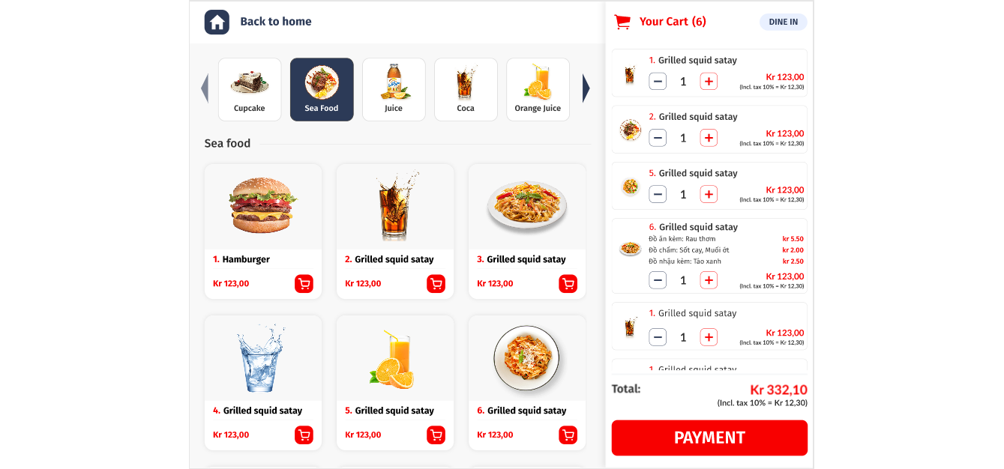

Figure 2: The menu screen for take-away or dine-in customers

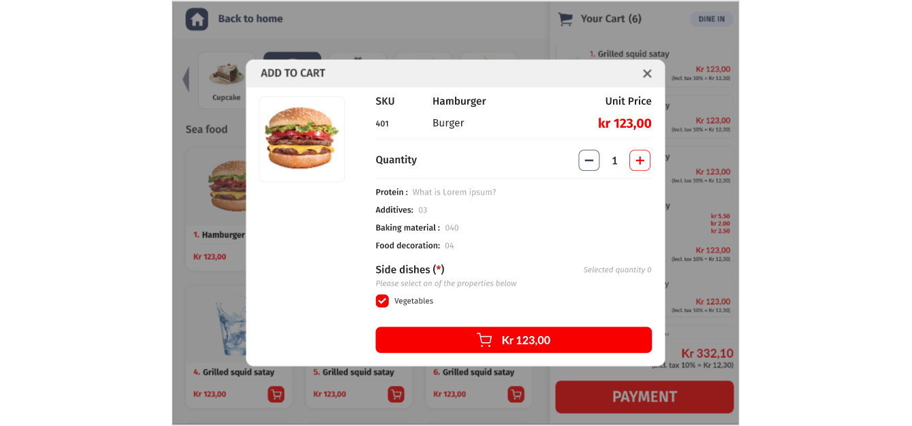

Figure 3: The detail item screen when clicking to select an item in Figure 2. When changing the Quantity or click on the shopping button, returning to the Menu screen and update the sum-up Your Cart in the right hand side.

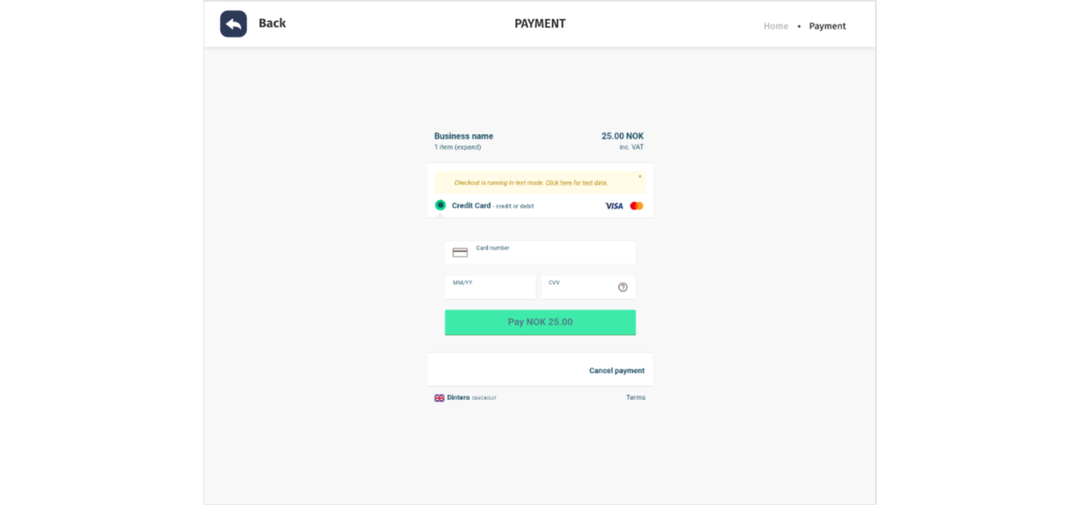

Figure 4: The payment page when clicking on the button Payment in Figure 2

The capstone project for the course consists of five tasks. The tasks should be delivered one after another. The prior tasks need to be done in order to work with the next ones.

**Task 1: Requirement elicitation**

The team needs to perform the following tasks:

* Task 1.1. Identify the context of this project. Who are relevant stakeholders? What are expected to be done? What are the scope of the project?
* Task 1.2. Describe all functional and non-functional requirements of the desired system. Draw a use-case diagram for the whole system
* Task 1.3. Choose one specific feature, i.e. food ordering, table reservation, customer management. Draw its use-case diagram and describe the use-case using a table format

**Task 2: System modelling**

The team needs to perform the following tasks:

* Task 2.1. Draw an activity diagram to capture **Major (not all)** functional requirements of the desired system
* Task 2.2. Draw a sequence diagram for use-case in Task 1.3.
* Task 2.3. Draw a class diagram

**Task 3: Architecture design**

The team needs to perform the following tasks:

* Task 3.1. Describe an architectural approach you will use to implement the desired system
* Task 3.2. Draw an implementation diagram for **Major (not all)** functional requirements

**Task 4: Implementation – Sprint 1**

The team needs to perform the following tasks:

* Task 4.1. Setting up. The team creates an online repository (github, bitbucket, etc) for version control.
* Task 4.2. Adding documents, materials and folders for Requirement, System modelling and Architectural design. Use the selected version control system to report the changes to these files/ folders
* Task 4.3. Implement a Minimum Viable Product (MVP) for the **menu screen in Figure 2** and demonstrate the result. MVP means that do the least to be able to demonstrate. That means at this stage, no need for a database to store all menu items, customers, etc. Data can be hard coded in code files.
  + Figure 2 may contain these functions that listed as below:
    - List all food’s information
    - Filter foods by category
    - View cart
  + However, students can focus on
    - List all food’s information
    - Filter foods by category

**Task 5: Implementation – Sprint 2**

* The team needs to implement the MVP for screen showing in Figure 2 and Figure 3.
* Demonstrate the whole project from Task 1 to Task 5.