

Requirement & Design Specification
Student Football Tournament Management System (SFTMS)
Version: 1.0

Group X
HE151219 – Võ Phan Hoàng Tùng (34%)
HE186191 – Phan Quang Hiệp (33%)
HE172394 – Hoàng Ngọc Tỉnh (33%)

Table of content
Table of content 2
I. Overview 4
1. User Requirements 4
1.1 Actors 4
1.2 Use Cases 5
2. Overall Functionalities 7
2.1 Screens Flow (API Flow) 7
2.2 Screen Descriptions (API Descriptions) 8
2.3 Screen Authorization (API Authorization) 10
2.4 Database Design 12
2.5 Business Rules 14
II. Design Specifications 15
1. User logs in with the designated account 15
1.1. Web Service 15
1.2. Processing & Validation 15
2. Team Manager registers an account 15
2.1. Web Service 15
2.2. Processing & Validation 16
3. Admin creates a tournament 16
3.1. Web Service 16
3.2. Processing & Validation 17
4. Team Manager registers a team into a tournament 17
4.1. Web Service 17
4.2. Processing & Validation 18
5. Team Manager adds a player to the team 18
5.1. Web Service 18
5.2. Processing & Validation 19
6. Admin approves or rejects a team 19
6.1. Web Service 19
6.2. Processing & Validation 19
7. Admin generates the round-robin schedule 20
7.1. Web Service 20
7.2. Processing & Validation 20
8. Team Manager submits the starting lineup 21
8.1. Web Service 21
8.2. Processing & Validation 22
9. Referee starts or finishes a match 22
9.1. Web Service 22
9.2. Processing & Validation 22
10. Referee records a goal 23
10.1. Web Service 23
10.2. Processing & Validation 23
11. Referee records a card 24
11.1. Web Service 24
11.2. Processing & Validation 24
12. Referee records a substitution 24
12.1. Web Service 24
12.2. Processing & Validation 25
13. Guest views the detail of a finished match 25
13.1. Web Service 25
13.2. Processing & Validation 26
14. Guest views the league table 27
14.1. Web Service 27
14.2. Processing & Validation 27
15. Guest views the top scorers 28
15.1. Web Service 28
15.2. Processing & Validation 28

I. Overview
The Student Football Tournament Management System (SFTMS) is a RESTful Web API that supports the organizing committee of a university or faculty in running a 7-a-side student football tournament. The system manages accounts, tournaments, teams, players, venues, the match schedule, starting lineups, match events (goals, cards, substitutions), standings, top scorers and player suspensions.
The tournament is played as a single-table round-robin league (in the style of the English Premier League or La Liga): there are no groups, every team plays every other team once or twice (home and away), and the team at the top of the table at the end of the season is the champion. A match lasts 60 minutes (two halves of 30 minutes with a 10-minute break).
The project is developed with ASP.NET Core Web API (.NET 8), Entity Framework Core (Code First and Migrations) and Microsoft SQL Server. Authentication uses JWT Bearer tokens, and all endpoints are documented and tested with Swagger/OpenAPI. As an end-of-term assignment, the scope is limited to the back-end API and the database; a front-end, Docker, message queues and cloud deployment are out of scope.

1. User Requirements

1.1 Actors
# | Actor | Description
1 | Admin | Member of the organizing committee. Has full management of the system: user accounts (creates Referee accounts, locks/unlocks accounts), tournaments, team approval, venues, match schedule, referee assignment and correction of match results.
2 | Team Manager | Captain or manager of a team. Registers an account, registers the team into a tournament, manages the team's player list and submits the starting lineup before each match.
3 | Referee | Official assigned to a match. Starts and finishes the match and records match events: goals, yellow/red cards and substitutions.
4 | Guest | Any user without logging in. Views tournaments, teams, players, the schedule, match details, standings, top scorers and suspended players.

1.2 Use Cases

a. Diagram(s)
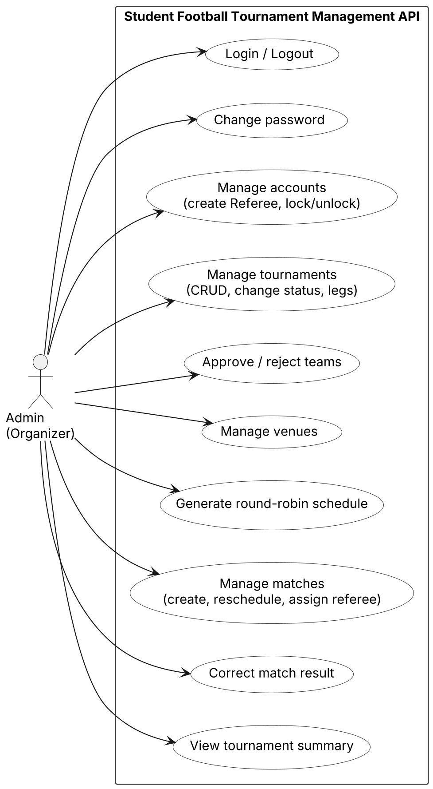
Figure 1. Use case diagram – Admin
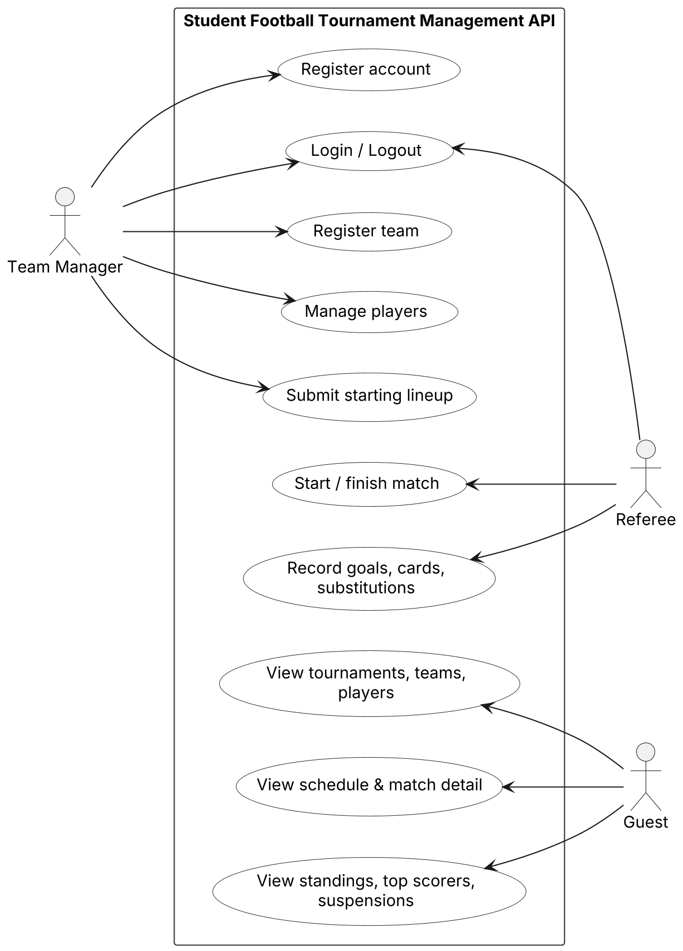
Figure 2. Use case diagram – Team Manager, Referee and Guest

b. Descriptions
ID | Feature | Use Case | Use Case Description
01 | Admin | Login / Logout | Log in with username and password to receive a JWT token.
02 | Admin | Manage Accounts | Create Referee accounts, view the account list, lock or unlock accounts.
03 | Admin | Manage Tournaments | Add, edit, delete, view tournaments; set the number of legs (1 or 2); change status Draft → Registration → Ongoing → Finished.
04 | Admin | Approve Teams | Approve or reject teams registered for a tournament.
05 | Admin | Manage Venues | Add, edit, delete, view 7-a-side pitches.
06 | Admin | Generate Schedule | Automatically generate the round-robin schedule for the whole tournament, divided into rounds, swapping home/away in the second leg.
07 | Admin | Manage Matches | Create a match manually, reschedule, change venue, assign a referee, postpone or cancel a match.
08 | Admin | Correct Match Result | Edit the result of a finished match after a complaint; the change is logged.
09 | Admin | View Tournament Summary | View number of matches, goals and average goals per match.
10 | Team Manager | Register Account | Create a Team Manager account.
11 | Team Manager | Register Team | Register a team (name, faculty, logo, kit colour) into a tournament.
12 | Team Manager | Manage Players | Add, edit, delete players of own team (student code, name, shirt number, position).
13 | Team Manager | Submit Lineup | Submit the starting lineup (7 players incl. 1 goalkeeper) and substitutes before kick-off.
14 | Referee | Start / Finish Match | Change match status Scheduled → InProgress → Finished.
15 | Referee | Record Match Events | Record goals (scorer, minute, own goal), yellow/red cards and substitutions.
16 | Guest | View Tournaments & Teams | View tournaments, teams, players and player statistics.
17 | Guest | View Schedule & Match Detail | View the schedule by round, team or date; view a finished match with lineups, goals, cards and substitutions.
18 | Guest | View Standings & Statistics | View the league table, top scorers and suspended players.

2. Overall Functionalities

2.1 Screens Flow (API Flow)
Because the system is a Web API without a user interface, the screen flow is presented as the main flow of API calls through the life cycle of a tournament, grouped by actor.
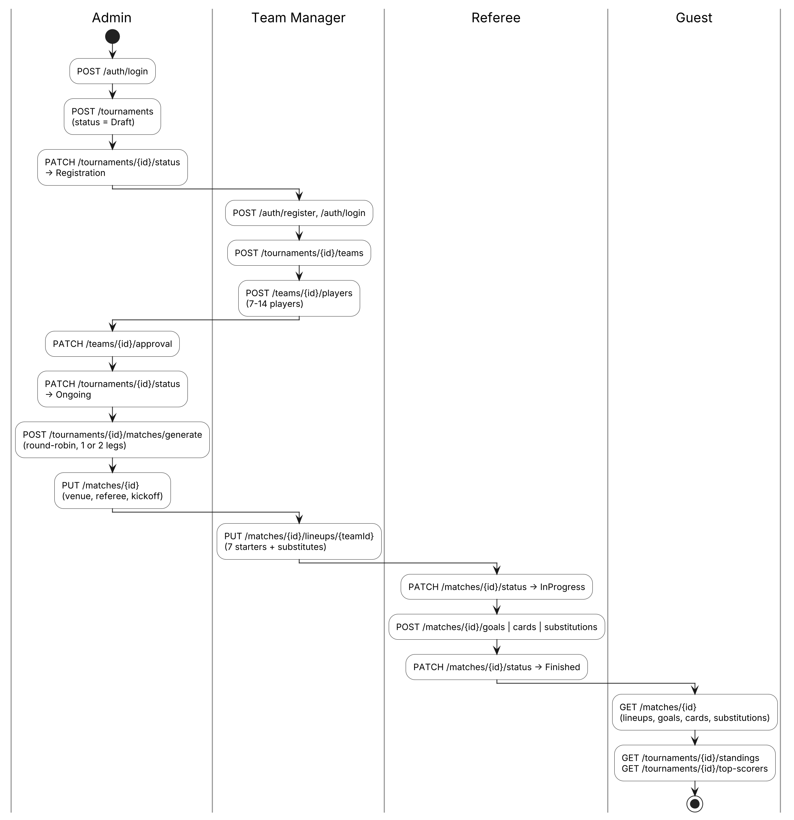
Figure 3. Main API flow of a tournament

2.2 Screen Descriptions (API Descriptions)
All endpoints use the prefix /api, return JSON in the unified format { success, message, data } and support paging on list endpoints with ?page=&pageSize=&search=&sortBy= (default 10, maximum 50).
# | Feature | Method | Endpoint | Description
1 | Authentication | POST | /api/auth/register | Register a Team Manager account
2 | Authentication | POST | /api/auth/login | Log in and receive a JWT token
3 | Authentication | GET | /api/auth/me | Get the current user's profile
4 | Authentication | PUT | /api/auth/change-password | Change password
5 | Account Management | GET, POST | /api/users | List accounts / create a Referee account
6 | Account Management | PATCH | /api/users/{id}/status | Lock or unlock an account
7 | Tournament Management | GET | /api/tournaments | List tournaments (filter, paging)
8 | Tournament Management | GET | /api/tournaments/{id} | Tournament detail
9 | Tournament Management | POST, PUT, DELETE | /api/tournaments/{id?} | Create / update / delete a tournament (incl. number of legs)
10 | Tournament Management | PATCH | /api/tournaments/{id}/status | Change tournament status
11 | Tournament Management | GET | /api/tournaments/{id}/summary | Tournament summary statistics
12 | Team Management | GET | /api/tournaments/{id}/teams | List teams of a tournament
13 | Team Management | POST | /api/tournaments/{id}/teams | Register a team
14 | Team Management | GET, PUT | /api/teams/{id} | Team detail / update team
15 | Team Management | PATCH | /api/teams/{id}/approval | Approve or reject a team
16 | Player Management | GET, POST | /api/teams/{id}/players | List players / add a player
17 | Player Management | PUT, DELETE | /api/players/{id} | Update / delete a player
18 | Player Management | GET | /api/players?search= | Search players by name, student code, team
19 | Player Management | GET | /api/players/{id}/stats | Player statistics (goals, cards, matches)
20 | Venue & Referee | GET, POST, PUT, DELETE | /api/venues/{id?} | Manage venues
21 | Venue & Referee | GET | /api/referees | List referees
22 | Schedule Management | GET | /api/matches?tournamentId=&round=&teamId=&date= | Schedule with filters
23 | Schedule Management | POST | /api/matches | Create a match manually
24 | Schedule Management | POST | /api/tournaments/{id}/matches/generate | Generate the round-robin schedule
25 | Schedule Management | PUT | /api/matches/{id} | Reschedule, change venue, assign referee
26 | Lineup | GET | /api/matches/{id}/lineups | View lineups of both teams
27 | Lineup | PUT | /api/matches/{id}/lineups/{teamId} | Submit / update a team's lineup
28 | Match Result | PATCH | /api/matches/{id}/status | Start, finish, postpone or cancel a match
29 | Match Result | POST, DELETE | /api/matches/{id}/goals | Record / remove a goal
30 | Match Result | POST, DELETE | /api/matches/{id}/cards | Record / remove a card
31 | Match Result | POST, DELETE | /api/matches/{id}/substitutions | Record / remove a substitution
32 | Match Result | PUT | /api/matches/{id}/result | Correct the result of a finished match
33 | Match Result | GET | /api/matches/{id} | Match detail: score, starting lineups, goals, cards, substitutions
34 | Statistics | GET | /api/tournaments/{id}/standings | League table
35 | Statistics | GET | /api/tournaments/{id}/top-scorers?top=10 | Top scorers
36 | Statistics | GET | /api/tournaments/{id}/suspensions | Suspended players

2.3 Screen Authorization (API Authorization)
Authorization is implemented with JWT role claims and [Authorize(Roles = "...")] attributes. Ownership rules (own team, assigned match) are checked in the service layer.
# | API Group | Admin | Referee | Team Manager | Guest
1 | Login / Register / Change password | X | X | X | Register, Login
2 | Account Management | X
3 | View tournaments, teams, players | X | X | X | X
4 | Create / update / delete tournament, change status | X
5 | Register team, update own team |  |  | X
6 | Approve / reject team | X
7 | Add / update / delete players of own team |  |  | X
8 | Manage venues, view referees | X
9 | View schedule, match detail, lineups | X | X | X | X
10 | Create match, generate schedule, reschedule | X
11 | Submit lineup of own team |  |  | X
12 | Start / finish match, record goals, cards, substitutions |  | Assigned match
13 | Postpone / cancel match, correct result | X
14 | View standings, top scorers, suspensions | X | X | X | X
15 | Tournament summary | X

2.4 Database Design

a. Database Schema
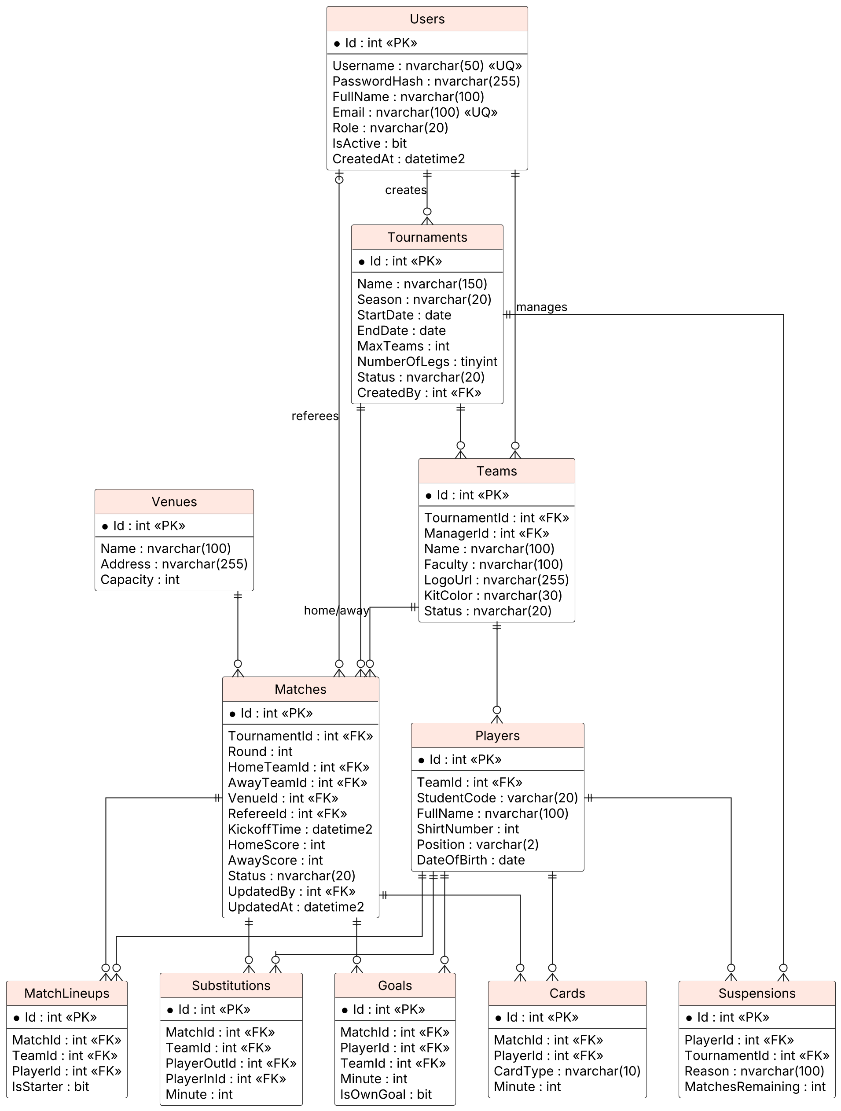
Figure 4. Entity relationship diagram (SQL Server)

b. Table Descriptions
No | Table | Description | Keys & Constraints
01 | Users | Stores user accounts with fields Id, Username, PasswordHash, FullName, Email, Role, IsActive, CreatedAt. Role ∈ {Admin, Referee, TeamManager}. | Primary key: Id. Unique: Username, Email.
02 | Tournaments | Stores tournaments with fields Name, Season, StartDate, EndDate, MaxTeams, NumberOfLegs (1 or 2), Status (Draft, Registration, Ongoing, Finished), CreatedBy. | Primary key: Id. Foreign key: CreatedBy → Users. Check: EndDate ≥ StartDate.
03 | Teams | Stores teams registered for a tournament with fields Name, Faculty, LogoUrl, KitColor, Status (Pending, Approved, Rejected). There is no group table because the tournament has a single league table. | Primary key: Id. Foreign keys: TournamentId → Tournaments, ManagerId → Users. Unique: (TournamentId, Name).
04 | Players | Stores players of a team with fields StudentCode, FullName, ShirtNumber, Position (GK, DF, MF, FW), DateOfBirth. A team has 7–14 players. | Primary key: Id. Foreign key: TeamId → Teams. Unique: (TeamId, ShirtNumber).
05 | Venues | Stores 7-a-side pitches with fields Name, Address, Capacity. | Primary key: Id.
06 | Matches | Stores matches with fields Round, KickoffTime, HomeScore, AwayScore, Status (Scheduled, InProgress, Finished, Postponed, Cancelled), UpdatedBy, UpdatedAt. | Primary key: Id. Foreign keys: TournamentId, HomeTeamId, AwayTeamId, VenueId, RefereeId, UpdatedBy. Check: HomeTeamId ≠ AwayTeamId.
07 | MatchLineups | Stores the lineup each team submits for a match; IsStarter = 1 for the 7 starting players, 0 for substitutes. The lineup is locked when the match starts. | Primary key: Id. Foreign keys: MatchId, TeamId, PlayerId. Unique: (MatchId, PlayerId).
08 | Substitutions | Stores substitutions with fields PlayerOutId, PlayerInId, Minute (1–60). | Primary key: Id. Foreign keys: MatchId, TeamId, PlayerOutId, PlayerInId → Players.
09 | Goals | Stores goals with fields PlayerId, TeamId (team credited with the goal), Minute (1–60), IsOwnGoal. | Primary key: Id. Foreign keys: MatchId, PlayerId, TeamId.
10 | Cards | Stores cards with fields PlayerId, CardType (Yellow, Red), Minute (1–60). | Primary key: Id. Foreign keys: MatchId, PlayerId.
11 | Suspensions | Stores suspensions generated automatically when a match finishes, with fields Reason and MatchesRemaining. | Primary key: Id. Foreign keys: PlayerId, TournamentId.
Conventions: primary keys are INT IDENTITY; date-times are stored as DATETIME2 in UTC; the league table is not stored but computed from finished matches through the view vw_Standings. Indexes are created on all foreign keys and on Players.StudentCode and Matches.KickoffTime.

2.5 Business Rules
ID | Business Rule
BR01 | A team has from 7 to 14 players; a team with fewer than 7 players cannot be approved.
BR02 | A student (student code) can belong to only one team in the same tournament.
BR03 | Shirt numbers are unique within a team.
BR04 | Teams can be registered and player lists edited only while the tournament is in Registration status.
BR05 | The number of approved teams cannot exceed the tournament's MaxTeams.
BR06 | The two teams of a match must be different and belong to the same tournament.
BR07 | A venue cannot host two overlapping matches (each match takes 60 minutes plus a 10-minute break).
BR08 | A team cannot play two matches on the same day.
BR09 | A referee can update only the matches assigned to him/her, and only while the match is InProgress.
BR10 | The scorer / carded player must belong to one of the two teams. Minute is from 1 to 60.
BR11 | The match score must equal the number of recorded goals (including own goals).
BR12 | Points: win 3, draw 1, loss 0. A draw stands; there is no extra time or penalty shoot-out.
BR13 | Ranking order: Points → Goal difference → Goals scored → Head-to-head result.
BR14 | Two yellow cards in a match = one red card. A red card means a 1-match suspension; 3 accumulated yellow cards mean a 1-match suspension.
BR15 | Only Admin can edit a Finished match; every change records who edited it and when.
BR16 | Match status: Scheduled → InProgress → Finished, or Scheduled → Postponed / Cancelled.
BR17 | Single-table round-robin: every team plays every other team. With 2 legs each pair meets twice with home/away swapped, giving 2×(n−1) rounds for n teams. The team on top of the table at the end is champion.
BR18 | A match has two halves of 30 minutes with a 10-minute half-time break (maximum 60 minutes of play).
BR19 | A starting lineup has exactly 7 players including exactly 1 goalkeeper; the remaining registered players (maximum 7) are substitutes. Suspended players cannot be included.
BR20 | Lineups must be submitted before kick-off; a match can start only when both teams have a lineup. When the match becomes InProgress the lineup is locked and never edited, even after substitutions.
BR21 | Substitution: the player going off must be on the pitch, the player coming on must be an unused substitute; a substituted player cannot return; a sent-off player cannot be replaced.
BR22 | A goal can be credited only to a player who is on the pitch at that minute (starting lineup plus substitutions).

II. Design Specifications

1. User logs in with the designated account

1.1. Web Service
Provide endpoint with following information:
- Endpoint
URL | /api/auth/login
Method | POST
Authorization | Anonymous
Body | JSON: username, password
- Request body example:
{
"username": "admin",
"password": "Admin@123"
}
- Response:
Status Code | Content
OK - 200 | JSON with accessToken, expiresIn and user information (id, fullName, role)
BadRequest - 400 | Username or password is empty
Unauthorized - 401 | Wrong username or password
Forbidden - 403 | Account is locked (IsActive = false)
- Response example (OK - 200):
{
"success": true,
"message": "Login successful",
"data": {
"accessToken": "eyJhbGciOiJIUzI1NiIsInR5cCI6IkpXVCJ9...",
"expiresIn": 3600,
"user": {
"id": 1,
"fullName": "Tournament Admin",
"role": "Admin"
}
}
}

1.2. Processing & Validation
- Find the user by Username; verify the password against PasswordHash using BCrypt.
- Reject locked accounts (IsActive = false).
- Generate a JWT containing the claims sub (user id), name and role; the token expires after 60 minutes.
- The client sends the token in the header Authorization: Bearer <token> for protected endpoints.

2. Team Manager registers an account

2.1. Web Service
Provide endpoint with following information:
- Endpoint
URL | /api/auth/register
Method | POST
Authorization | Anonymous
Body | JSON: username, password, fullName, email
- Request body example:
{
"username": "manager_cntt",
"password": "Manager@123",
"fullName": "Nguyen Van A",
"email": "anv@fpt.edu.vn"
}
- Response:
Status Code | Content
Created - 201 | JSON of the created account (without password)
BadRequest - 400 | Invalid data (missing field, invalid email, weak password)
Conflict - 409 | Username or email already exists
- Response example (Created - 201):
{
"success": true,
"message": "Account created",
"data": {
"id": 12,
"username": "manager_cntt",
"fullName": "Nguyen Van A",
"email": "anv@fpt.edu.vn",
"role": "TeamManager"
}
}

2.2. Processing & Validation
- The role is always set to TeamManager; Admin and Referee accounts cannot be self-registered.
- Password must be at least 8 characters; it is hashed with BCrypt before saving.
- Username and Email must be unique.

3. Admin creates a tournament

3.1. Web Service
Provide endpoint with following information:
- Endpoint
URL | /api/tournaments
Method | POST
Authorization | Bearer token – role Admin
Body | JSON: name, season, startDate, endDate, maxTeams, numberOfLegs
- Request body example:
{
"name": "FPTU Student Football Cup 2026",
"season": "Fall 2026",
"startDate": "2026-11-01",
"endDate": "2026-12-20",
"maxTeams": 8,
"numberOfLegs": 2
}
- Response:
Status Code | Content
Created - 201 | JSON of the created tournament with status Draft
BadRequest - 400 | Invalid data (EndDate < StartDate, numberOfLegs not 1 or 2, maxTeams < 2)
Unauthorized - 401 | Missing or invalid token
Forbidden - 403 | User is not Admin
- Response example (Created - 201):
{
"success": true,
"data": {
"id": 1,
"name": "FPTU Student Football Cup 2026",
"season": "Fall 2026",
"startDate": "2026-11-01",
"endDate": "2026-12-20",
"maxTeams": 8,
"numberOfLegs": 2,
"status": "Draft"
}
}

3.2. Processing & Validation
- A new tournament always starts in Draft status.
- Status changes through PATCH /api/tournaments/{id}/status in the order Draft → Registration → Ongoing → Finished (BR04).
- A tournament can be deleted only while in Draft status.

4. Team Manager registers a team into a tournament

4.1. Web Service
Provide endpoint with following information:
- Endpoint
URL | /api/tournaments/{id}/teams
Method | POST
Authorization | Bearer token – role TeamManager
Body | JSON: name, faculty, logoUrl, kitColor
- Request body example:
{
"name": "CNTT FC",
"faculty": "Information Technology",
"logoUrl": "https://example.com/logo/cntt.png",
"kitColor": "Orange"
}
- Response:
Status Code | Content
Created - 201 | JSON of the team with status Pending
BadRequest - 400 | Invalid data
NotFound - 404 | Tournament does not exist
Conflict - 409 | Tournament is not in Registration status, or team name already exists
- Response example (Created - 201):
{
"success": true,
"data": {
"id": 3,
"tournamentId": 1,
"name": "CNTT FC",
"faculty": "Information Technology",
"managerId": 12,
"status": "Pending"
}
}

4.2. Processing & Validation
- ManagerId is taken from the JWT of the current user.
- Allowed only when the tournament is in Registration status (BR04).
- Team name is unique within a tournament.

5. Team Manager adds a player to the team

5.1. Web Service
Provide endpoint with following information:
- Endpoint
URL | /api/teams/{id}/players
Method | POST
Authorization | Bearer token – role TeamManager (own team)
Body | JSON: studentCode, fullName, shirtNumber, position, dateOfBirth
- Request body example:
{
"studentCode": "HE190123",
"fullName": "Tran Van B",
"shirtNumber": 10,
"position": "FW",
"dateOfBirth": "2004-05-20"
}
- Response:
Status Code | Content
Created - 201 | JSON of the created player
BadRequest - 400 | Invalid data (position not in GK, DF, MF, FW)
Forbidden - 403 | The team is not managed by the current user
Conflict - 409 | Team already has 14 players, duplicate shirt number, or the student is already in another team of the tournament
- Response example (Created - 201):
{
"success": true,
"data": {
"id": 25,
"teamId": 3,
"studentCode": "HE190123",
"fullName": "Tran Van B",
"shirtNumber": 10,
"position": "FW"
}
}

5.2. Processing & Validation
- Maximum 14 players per team (BR01).
- Shirt number unique within the team (BR03); student code unique within the tournament (BR02).
- Allowed only while the tournament is in Registration status (BR04).

6. Admin approves or rejects a team

6.1. Web Service
Provide endpoint with following information:
- Endpoint
URL | /api/teams/{id}/approval
Method | PATCH
Authorization | Bearer token – role Admin
Body | JSON: approved (bool), reason
- Request body example:
{
"approved": true,
"reason": null
}
- Response:
Status Code | Content
OK - 200 | JSON of the team with the new status
NotFound - 404 | Team does not exist
Conflict - 409 | Team has fewer than 7 players, or the tournament already has MaxTeams approved teams
- Response example (OK - 200):
{
"success": true,
"data": {
"id": 3,
"name": "CNTT FC",
"status": "Approved"
}
}

6.2. Processing & Validation
- A team can be approved only with 7–14 players (BR01).
- The number of approved teams cannot exceed MaxTeams (BR05).
- A rejected team keeps its data but is excluded from the schedule.

7. Admin generates the round-robin schedule

7.1. Web Service
Provide endpoint with following information:
- Endpoint
URL | /api/tournaments/{id}/matches/generate
Method | POST
Authorization | Bearer token – role Admin
Body | JSON: firstKickoff, daysBetweenRounds, kickoffTimes[], venueIds[]
- Request body example:
{
"firstKickoff": "2026-11-07",
"daysBetweenRounds": 7,
"kickoffTimes": [
"08:00",
"09:10",
"10:20",
"11:30"
],
"venueIds": [
1,
2
]
}
- Response:
Status Code | Content
Created - 201 | JSON with the number of rounds and the list of generated matches
BadRequest - 400 | Invalid parameters
Conflict - 409 | Tournament is not Ongoing, fewer than 2 approved teams, or the schedule already exists
- Response example (Created - 201):
{
"success": true,
"data": {
"totalRounds": 14,
"totalMatches": 56,
"matches": [
{
"id": 1,
"round": 1,
"homeTeam": "CNTT FC",
"awayTeam": "Kinh te FC",
"venue": "Pitch A",
"kickoffTime": "2026-11-07T08:00:00"
}
]
}
}

7.2. Processing & Validation
- Uses the circle method on all approved teams; if the number of teams is odd, a 'bye' is added.
- One leg: n−1 rounds; two legs: 2×(n−1) rounds, the second leg repeats the first with home/away swapped (BR17).
- Matches in a round are assigned to the given kick-off slots and venues, respecting a 70-minute slot per match (BR07) and one match per team per day (BR08).
- All generated matches are saved in one transaction with status Scheduled.

8. Team Manager submits the starting lineup

8.1. Web Service
Provide endpoint with following information:
- Endpoint
URL | /api/matches/{id}/lineups/{teamId}
Method | PUT
Authorization | Bearer token – role TeamManager (own team)
Body | JSON: starters[] (7 player ids), substitutes[] (player ids)
- Request body example:
{
"starters": [
21,
22,
23,
24,
25,
26,
27
],
"substitutes": [
28,
29,
30
]
}
- Response:
Status Code | Content
OK - 200 | JSON of the saved lineup
BadRequest - 400 | Not exactly 7 starters, not exactly 1 goalkeeper, or a player not in the team
Forbidden - 403 | The team is not managed by the current user
Conflict - 409 | Match already started, or a suspended player is included
- Response example (OK - 200):
{
"success": true,
"data": {
"matchId": 12,
"teamId": 3,
"starters": [
{
"playerId": 21,
"shirtNumber": 1,
"fullName": "Le Van C",
"position": "GK"
}
],
"substitutes": [
{
"playerId": 28,
"shirtNumber": 12,
"fullName": "Pham Van D",
"position": "MF"
}
]
}
}

8.2. Processing & Validation
- Exactly 7 starters including exactly 1 goalkeeper; the rest are substitutes (BR19).
- Players must belong to the team and must not be suspended.
- The PUT replaces the previous lineup in MatchLineups; it is allowed only while the match is Scheduled. Once the match is InProgress the lineup is locked (BR20).

9. Referee starts or finishes a match

9.1. Web Service
Provide endpoint with following information:
- Endpoint
URL | /api/matches/{id}/status
Method | PATCH
Authorization | Bearer token – role Referee (assigned) / Admin
Body | JSON: status (InProgress, Finished, Postponed, Cancelled)
- Request body example:
{
"status": "Finished"
}
- Response:
Status Code | Content
OK - 200 | JSON of the match with the new status and final score
Forbidden - 403 | Referee is not assigned to this match
Conflict - 409 | Invalid status transition, or a lineup is missing when starting the match
- Response example (OK - 200):
{
"success": true,
"data": {
"id": 12,
"status": "Finished",
"homeScore": 2,
"awayScore": 1
}
}

9.2. Processing & Validation
- Valid transitions: Scheduled → InProgress → Finished; Scheduled → Postponed / Cancelled (Admin only) (BR16).
- Starting requires both lineups (BR20).
- Finishing runs in one transaction: recalculates the score from goals (BR11), creates suspensions for red cards and every 3 accumulated yellow cards, and decreases MatchesRemaining of existing suspensions of both teams (BR14).

10. Referee records a goal

10.1. Web Service
Provide endpoint with following information:
- Endpoint
URL | /api/matches/{id}/goals
Method | POST
Authorization | Bearer token – role Referee (assigned)
Body | JSON: playerId, minute, isOwnGoal
- Request body example:
{
"playerId": 25,
"minute": 12,
"isOwnGoal": false
}
- Response:
Status Code | Content
Created - 201 | JSON of the goal and the updated score
BadRequest - 400 | Minute not in 1–60
Conflict - 409 | Match is not InProgress, or the player is not on the pitch at that minute
- Response example (Created - 201):
{
"success": true,
"data": {
"goalId": 40,
"matchId": 12,
"playerId": 25,
"teamId": 3,
"minute": 12,
"isOwnGoal": false,
"homeScore": 1,
"awayScore": 0
}
}

10.2. Processing & Validation
- The player must be on the pitch at that minute, computed from the starting lineup and substitutions (BR22).
- TeamId is the team credited with the goal: the player's team, or the opponent if it is an own goal.
- HomeScore / AwayScore are updated immediately so the score always equals the number of goals (BR11).
- DELETE /api/matches/{id}/goals/{goalId} removes a goal recorded by mistake.

11. Referee records a card

11.1. Web Service
Provide endpoint with following information:
- Endpoint
URL | /api/matches/{id}/cards
Method | POST
Authorization | Bearer token – role Referee (assigned)
Body | JSON: playerId, cardType (Yellow, Red), minute
- Request body example:
{
"playerId": 31,
"cardType": "Yellow",
"minute": 25
}
- Response:
Status Code | Content
Created - 201 | JSON of the card; if it is the player's second yellow, a red card is added
BadRequest - 400 | Invalid card type or minute
Conflict - 409 | Match is not InProgress, or the player has already been sent off
- Response example (Created - 201):
{
"success": true,
"data": {
"cardId": 7,
"matchId": 12,
"playerId": 31,
"cardType": "Yellow",
"minute": 25,
"sentOff": false
}
}

11.2. Processing & Validation
- The player must belong to one of the two teams of the match (BR10).
- A second yellow card in the same match automatically creates a red card (BR14).
- Suspensions are generated when the match is finished, not when the card is recorded.

12. Referee records a substitution

12.1. Web Service
Provide endpoint with following information:
- Endpoint
URL | /api/matches/{id}/substitutions
Method | POST
Authorization | Bearer token – role Referee (assigned)
Body | JSON: teamId, playerOutId, playerInId, minute
- Request body example:
{
"teamId": 3,
"playerOutId": 26,
"playerInId": 28,
"minute": 40
}
- Response:
Status Code | Content
Created - 201 | JSON of the substitution
BadRequest - 400 | Minute not in 1–60, or playerOutId = playerInId
Conflict - 409 | Player out is not on the pitch, player in is not an unused substitute, or the player out has been sent off
- Response example (Created - 201):
{
"success": true,
"data": {
"id": 9,
"matchId": 12,
"teamId": 3,
"playerOut": "Nguyen Van E",
"playerIn": "Pham Van D",
"minute": 40
}
}

12.2. Processing & Validation
- Substitutions are stored only in the Substitutions table; the starting lineup in MatchLineups is never changed (BR20).
- A substituted player cannot come back; a sent-off player cannot be replaced (BR21).

13. Guest views the detail of a finished match

13.1. Web Service
Provide endpoint with following information:
- Endpoint
URL | /api/matches/{id}
Method | GET
Authorization | Anonymous
Body | None
- Response:
Status Code | Content
OK - 200 | JSON of the match: score, venue, referee, starting lineups of both teams and the timeline of goals, cards and substitutions
NotFound - 404 | Match does not exist
- Response example (OK - 200):
{
"success": true,
"data": {
"id": 12,
"round": 3,
"status": "Finished",
"kickoffTime": "2026-11-07T08:00:00",
"venue": "Pitch A",
"referee": "Hoang Van R",
"homeTeam": {
"id": 3,
"name": "CNTT FC",
"score": 2,
"startingLineup": [
{
"playerId": 21,
"shirtNumber": 1,
"name": "Le Van C",
"position": "GK"
}
],
"substitutes": [
{
"playerId": 28,
"shirtNumber": 12,
"name": "Pham Van D"
}
]
},
"awayTeam": {
"id": 4,
"name": "Kinh te FC",
"score": 1,
"startingLineup": [],
"substitutes": []
},
"events": [
{
"minute": 12,
"type": "Goal",
"teamId": 3,
"player": "Tran Van B",
"isOwnGoal": false
},
{
"minute": 25,
"type": "YellowCard",
"teamId": 4,
"player": "Vu Van F"
},
{
"minute": 40,
"type": "Substitution",
"teamId": 3,
"playerOut": "Nguyen Van E",
"playerIn": "Pham Van D"
}
]
}
}

13.2. Processing & Validation
- startingLineup is read from MatchLineups where IsStarter = 1 and does not change after substitutions.
- events merges Goals, Cards and Substitutions and is sorted by minute.
- Data is loaded with EF Core Include/Select projection into a DTO in a single query.

14. Guest views the league table

14.1. Web Service
Provide endpoint with following information:
- Endpoint
URL | /api/tournaments/{id}/standings
Method | GET
Authorization | Anonymous
Body | None
- Response:
Status Code | Content
OK - 200 | JSON array of the table rows ordered by rank
NotFound - 404 | Tournament does not exist
- Response example (OK - 200):
{
"success": true,
"data": [
{
"rank": 1,
"teamId": 3,
"team": "CNTT FC",
"played": 5,
"won": 4,
"drawn": 1,
"lost": 0,
"goalsFor": 14,
"goalsAgainst": 4,
"goalDifference": 10,
"points": 13
},
{
"rank": 2,
"teamId": 4,
"team": "Kinh te FC",
"played": 5,
"won": 3,
"drawn": 1,
"lost": 1,
"goalsFor": 9,
"goalsAgainst": 6,
"goalDifference": 3,
"points": 10
}
]
}

14.2. Processing & Validation
- The table is computed from Finished matches only (view vw_Standings); it is not stored.
- Points: win 3, draw 1, loss 0 (BR12).
- Ranking: points → goal difference → goals scored → head-to-head (BR13).
- All approved teams appear, including teams that have not played yet.

15. Guest views the top scorers

15.1. Web Service
Provide endpoint with following information:
- Endpoint
URL | /api/tournaments/{id}/top-scorers?top=10
Method | GET
Authorization | Anonymous
Body | None
- Response:
Status Code | Content
OK - 200 | JSON array of players ordered by number of goals
NotFound - 404 | Tournament does not exist
- Response example (OK - 200):
{
"success": true,
"data": [
{
"rank": 1,
"playerId": 25,
"player": "Tran Van B",
"team": "CNTT FC",
"goals": 7
},
{
"rank": 2,
"playerId": 44,
"player": "Do Van G",
"team": "Kinh te FC",
"goals": 5
}
]
}

15.2. Processing & Validation
- Counts Goals where IsOwnGoal = false in Finished matches of the tournament.
- Players with equal goals are ordered by fewer matches played, then by name.
- Parameter top defaults to 10, maximum 50.

