**BLUETOOTH FW FOR SMART SPEAKER DEVICE**

1. **Requirements**

The device SDK runs on Raspberry Pi, Beaglebone. It requires C++11 or later.

1. **Dependencies**

* This is list of requirement and dependencies for the Device SDK for C++.

Building with Bluetooth is optional and is currently limited to Raspberry Pi and Beaglebone. `A2DP-SINK`,`A2DP-SOURCE`, `AVRCPTarget` and `AVRCPController` profiles are supported.

If you choose to build with Bluetooth, these libraries and modules, and their dependencies, must be installed:

|  |  |
| --- | --- |
| **Library** | **Minimum version** |
| SBC Library | 1.3 |
| Bluez5 | 5.37 or earlier |
| Libpulse-dev. Only require if enabling Cmake variable : BLUETOOTH_BLUEZ_PULSEAUDIOINITIALIZER | 8.0 |
| **Module** | **Minimum version** |
| Pulseaudio | 12.2 or earlier |
| Pulseaudio Bluetooth |
| Cmake | 3.7 |

1. **Setup Environment on Debian Image**

Download the latest firmware for your Beaglebone as website: <https://beagleboard.org/latest-images>

In case of document, the version is [Debian 9.5 2018-10-07 4GB SD IoT](https://debian.beagleboard.org/images/bone-debian-9.5-iot-armhf-2018-10-07-4gb.img.xz)

1. **Pulseaudio**

* Installing:

*sudo apt-get update*

*sudo apt-get install pulseaudio pulseaudio-module-bluetooth*

* Automatically change sound Input Output device:

Add the following line into our **“/etc/pulse/default.pa”**

*load-module module-switch-on-connect*

1. **BlueZ 5**

* Install Dependencies:

*sudo apt-get update*

*sudo apt-get install -y libusb-dev libdbus-1-dev libglib2.0-dev libudev-dev libical-dev libreadline-dev*

* Download, Compile and Install:

*wget* [*http://www.kernel.org/pub/linux/bluetooth/bluez-5.48.tar.xz*](http://www.kernel.org/pub/linux/bluetooth/bluez-5.48.tar.xz)

*tar xvf bluez-5.48.tar.xz*

*cd bluez-5.48*

*./configure --prefix=/usr --mandir=/usr/share/man --sysconfdir=/etc --localstatedir=/var --enable-experimental*

*make*

*sudo make install*

1. **Cmake**

*sudo apt-get install cmake*

1. **SBC**

*sudo apt-get install libsbc-dev*

1. **Build and run the example**

* Install libsoc just for testing:
* Git clone libsoc from git repository:

*git clone* [*https://github.com/jackmitch/libsoc.git*](https://github.com/jackmitch/libsoc.git)

* Enter the libsoc.git directory:

*cd libsoc*

* Run autoreconf to generate the libsoc configure scripts

*autoreconf -i*

* Configure the libsoc library with the required features

*./configure --enable-debug --enable-board=beaglebone_black --with-board-configs*

* Compile and Install

*make && sudo make install*

* Git clone source code from git repository:

*git clone* [*https://github.com/olli-ai/omni-device-sdk.git*](https://github.com/olli-ai/omni-device-sdk.git)

* Go to direction of example

*cd omni-device-sdk/BluetoothDevice/BlueZ/test/Discoverable*

* Create folder for building

*mkdir build && cd build*

* Use Cmake to generate Makefiles

*cmake ..*

* Compile the code using make

*make*

* Run the example as 2 cases

Start the pulseaudio with command:

*pulseaudio --start*

In discoverable Mode:

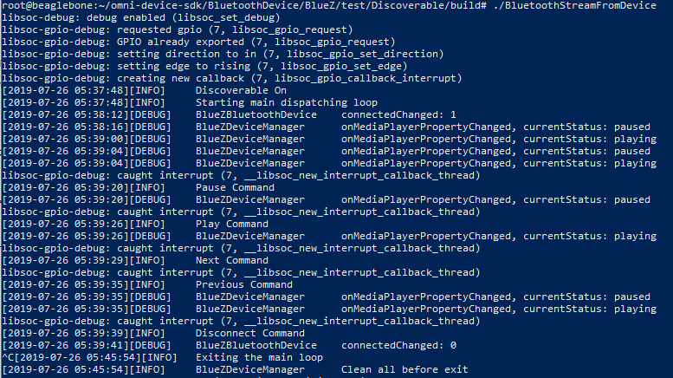

And Pairing Mode:

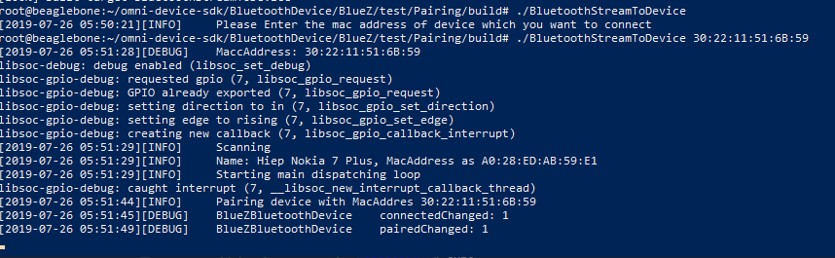

1. **Issue**

If Pulseaudio can not auto switch on new Audio Output Device. Please follow instructions below:

* Now let’s check that A2DP streaming is working. We start by checking that PulseAudio is listing the Bluetooth sound card:

*pacmd list-cards*

* The Bluetooth card will be index #1, you can also see the supported profiles (a2dp, hsp, off…). Set A2DP as active profile:

*pacmd set-card-profile bluez_card.xx_xx_xx_xx_xx_xx a2dp_sink*

* Set the Bluetooth device as output audio:

*pacmd set-default-sink bluez_sink.xx_xx_xx_xx_xx_xx.a2dp_sink*

1. **API**

getHostController

getDiscoveredDevices

1. **HostController:**

An interface to represent the HostControllerInterface on the local system.

This is responsible for Scanning and Discovery.

* **getMac**(): @return the MAC address of the adapter.
* **getFriendlyname**(): @return the friendly name of the adapter.
* **isDiscoverable**(): @return the device is current discoverable by other devices. If right, return True. Otherwise, False.
* **enterDiscoverableMode**(): Set the adapter to become discoverable.

@return True if the operation was successful. Otherwise, False.

* **exitDiscoverableMode**(): Set the adapter become non-discoverable.

@return True if the operation was successful. Otherwise, False.

* **isScanning**(): Getter for the scanning state of the device. This must wait until any priority startScan and StopScan methods have finished.

@return the device is currently scanning for other device. If right, return True. Otherwise, False.

* **startScan**(): Set the adapter to start scanning

@return True if the operation was successful. Otherwise, False.

* **stopScan**(): Set the adapter to stop scanning.

@return True if the operation was successful. Otherwise, False.

1. **BluetoothDeviceInterface:**

* **getMac**(): return the MAC address of the Bluetooth Device.
* **getFriendlyName**(): return the friendly name of the Bluetooth Device.
* **getDeviceState**(): return the DeviceState of the current device. Like: FOUND, UNPAIRED, PAIRED, IDLE, DISCOVERED, CONNECTED.
* **isPaired**(): Getter for the paired state of the device. This should return the state after any pending state changes have been resolved.

@return if the device is paired, return True. Otherwise, False.

* **pair**(): Initiate a pair with this device.

@return if the pairing was successful, return True. Otherwise, False.

* **unpair**(): Initiate an unpair with this device.

@return if the unpairing was successful, return True. Otherwise, False.

* **isConnected**(): Getter for the paired state of the device. This should return the state after any pending state changes have been resolved.

@return if the device is paired, return True. Otherwise, False.

* **connect**(): Initiate a connect with this device.

@return if the connecting was successful, return True. Otherwise, False.

* **disconnect**(): Initiate an disconect with this device.

@return if the disconnecting was successful, return True. Otherwise, False

* **getAVRCPTarget**(): Audio/Video Remote Control Profile
  + **play**(): sends a play command to device supporting the AVRCPTarget.

@return a Boolean indicating the success of the function.

* + **pause**(): sends a pause command to device supporting the AVRCPTarget.

@return a Boolean indicating the success of the function.

* + **next**(): sends a next command to device supporting the AVRCPTarget.

@return a Boolean indicating the success of the function.

* + **previous**(): sends a previous command to device supporting the AVRCPTarget.

@return a Boolean indicating the success of the function.