

Learning Language Social Network
Software Requirement Specification

Project Code: PLSN-GEP
Document Code: DLSN – v2.2
Team Members:
- Vũ Huy Quân
- Dương Quang Hải
- Huỳnh Hữu Nhân
- Nguyễn Hoàng Hiệp

Record of change

*A - Added M - Modified D - Deleted
Effective Date | Changed Items | A*  M, D | Change Description | New Version
20/03/2015 | Initial | A | Add project over view | 1.0
21/03/2015 | Introduction | A | Add Overview, Scope and Purpose | 1.1
22/03/2015 | Overall Description, Introduction | A | Add “Definitions, Acronyms and Abbreviations” for Introduction; and add the “Overall Description” | 1.2
23/03/2015 | Functional Requirements | A | Add “The Actors Table” with diagrams; and add “The use-cases table” | 1.4
24/03/2015 | Functional Requirements “The use-cases table” | M | Divide requirements into logical group | 1.5
25/03/2015 | Functional Requirements | A | Add Functional Requirements for The Documents | 2.0
26/03/2015 | Non-functional Requirements | A | Add non-functional requirements | 2.1
27/03/2015 | Support Information | M | Add appendices for “Support Information” | 2.2

SIGNATURE PAGE
ORIGINATOR:
- Name: Vũ Huy Quân
- Date: 25/03/2015
- Position: Project Manager

REVIEWERS:
- Dương Quang Hải
- Nguyễn Hoàng Hiệp
- Huỳnh Hữu Nhân
APPROVAL:
- Name: Nguyễn Huy Hùng
- Date: 30/03/2015
- Position: Chairman of GEP company
TABLE OF CONTENTS

1 Introduction 6
1.1 Purpose 6
1.2 Scope 6
1.3 Definitions, Acronyms and Abbreviations 6
1.4 References 7
1.5 Overview 7
2 Overall Description 8
3 FUNCTIONAL Requirements 10
3.1 The actors 10
3.2 The use cases 10
3.3 Use Cases Diagram 12
3.3.1 Function Requirement One 12
3.3.2 Function Requirement Two 15
3.3.3 Function Requirement Three 17
3.3.4 Function Requirement Four 19
3.3.5 Function Requirement Five 23
3.3.6 Function Requirement Six 28
4 NON-FUNCTIONAL Requirements 32
4.1 Usability 32
4.2 Reliability 32
4.3 Performance 32
4.4 Supportability 32
4.5 Design Constraints 33
4.6 On-line User Documentation and Help System Requirements 33
4.7 Purchased Components 33
4.8 Interfaces 33
4.9 Licensing Requirements 33
4.10 Legal, Copyright, and Other Notices 33
4.11 Applicable Standards 33
5 Supporting Information 34

Introduction
This section describes the overview of this SRS document. It also gives an overview and some definitions and abbreviations of the document.

Purpose
- The purpose of this document is to give a detailed description of the requirements for the “Learning Language Social Network” (LLSN) software. It will illustrate the purpose and complete declaration for the development of system. It will also explain system constraints. This document is primarily intended to be proposed to a customer for its approval and a reference for developing the first version of the system for the development team.

Scope
- LLSN is a social network for language learning. This network would overcome the disadvantages of other current websites by providing the ability to interact with teachers and the lessons; it gives users the ability to interact with each other.
- LLSN is a web application; the users have to have l that can connect to The Internet to communicate with the application.
- This version of LLSN currently has not supported well on small devices like mobile, but it will be responsive well for these devices in the future.
- The students can access the application resources, take courses or discuss topics in forums. The teachers can create and update courses. Finally, the administrators manage the system and keep the information accurate.

Definitions, Acronyms and Abbreviations
Term | Definition
OS | Operating System
LLSN | Learning Language Social Network
User | Someone who interact with the web application like: taking courses and access learning tools
Teacher | Someone who have the ability to create courses
Administrator | People who manage the system
CMS | Content management system
PC | Personal Computer
Web platform | An open community of developers building resources for a better web, regardless of brand, browser, or platform.

References
[1] IEEE Software Engineering Standards Committee, “IEEE Std 830-1998, IEEE Recommended Practice for Software Requirements Specifications”, October 20, 1998.
[2] “srs_example_2010_group2.pdf” – An example of SRS document.

Overview
- This document includes five chapters
- Chapter two gives the overview of the whole system
- Chapter three gives specific requirements, which the webpage is expected to deliver. Functional requirements are given by various use cases.
- Chapter four gives non-functional requirements some performance requirements and design constraints are also given. Finally, describe to supporting information about system.
- Chapter five gives support information about the system

Overall Description
- This section will give the overview of the whole system including the perspective of the system, product functions and some user characteristics.
- Product perspective:
- The main feature of the product is to let user access the rich learning resources of website. Moreover, users can commend and ask questions via forum. All the comment, questions and learning resources will be stored in the database.
- The system will be online 24/7, the system will be able to response the users within 30 second.
- The students can only get the data for resources, but administrators and teachers can modify, update or insert into the database. In forum feature, everyone have the right to modify database of the forum
- Product functions:
- Users can login and access to online resources for free
- Users have the opportunity to study with best teachers from GEP
- Students and teachers can discuss through forum
- Bringing easy to use interfaces to users
- Having the ability to support a huge amount of users
- User characteristics:
- There are four types of users that can interact with the system. Each type of users have their own role and different use of the system
- The guests users can only search and view overview information of courses
- The students can search course, enrol courses, access the learning resources and discuss in forum
- The teacher user can create new courses and update learning resources
- The administrators roles are managing the data of the whole system and keep it correct
- Constraints:
- The system will strongly support web platform on any kind of PC and OS (Windows, Linux and Mac)
- This version will be responsive to run well on browsers of as many mobile devices as possible
- This version still not support purchased courses created from teacher, currently all courses are free
- The server is running on “Microsoft Server 2008”. It can handle for about 10000 users
- Assumptions and dependencies:
    - To access the resources and features from the system, users are assumed have devices that can connect to the Internet; these devices must have one of these browsers:
      - Internet Explorer
      - Chrome
      - Safari
      - Opera
      - Firefox
    - More over users are assumed to have at least one email address to receive and validate confirmation email sent form The Training Department

FUNCTIONAL Requirements

The actors
# | Main functions | Guests | Logged-in Users | Teachers | Administrators
1 | Register New Account | x
2 | Log-in/ Log-out | x | x | x | x
3 | Search courses | x | x | x | x
4 | Enroll courses |  | x
5 | Discuss in a forum |  | x | x | x
6 | Do tests |  | x
7 | Create/Update courses |  |  | x
8 | View student learning progress |  |  | x
9 | Invite students to enroll in courses |  |  | x
10 | Remove students from courses |  |  | x | x
11 | Add/Update/Delete users |  |  |  | x
12 | Ban users |  |  |  | x

The use cases
System Functions | Main Use Cases | Use Case #
Functional Requirement One
 | Register new account | UC_001.1
 | Login an account | UC_001.2
 | Logout an account | UC_001.3
Functional Requirement Two
 | Create new topic in forum | UC_002.1
 | Comment on a topic | UC_002.2
Functional Requirement Three
 | Search courses base on title | UC_003.1
 | Search courses base on category | UC_003.2
 | Search courses base on name of teacher | UC_003.3
Functional Requirement Four
 | Enroll courses | UC_004.1
 | Give feedback for teachers | UC_004.2
 | Do writing or reading tests | UC_004.3
 | Do speaking tests | UC_004.4
Functional Requirement Five
 | Create courses | UC_005.1
 | Remove courses | UC_005.2
 | Update courses | UC_005.3
 | Remove students from courses | UC_005.4
 | View students learning process | UC_005.5
 | Invite students to enroll in courses | UC_005.6
Functional Requirement Six
 | Add users | UC_006.1
 | Delete users | UC_006.2
 | Update users | UC_006.3
 | Ban users | UC_006.4

Use Cases Diagram
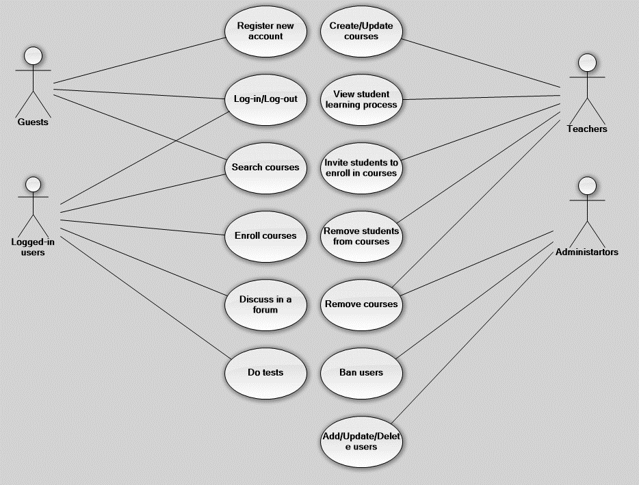

3.3.1 Function Requirement One
3.3.1.1 Create New Account
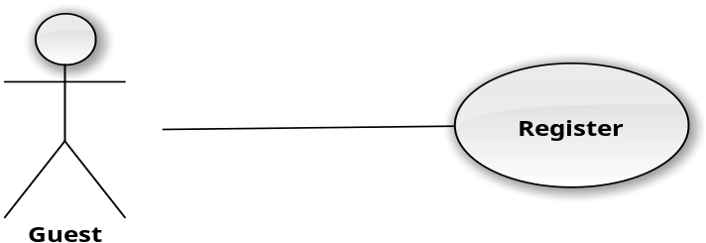

User Case ID | UC_001.1
Name | Create a new account
Goal | A new account is created
Actors | Guest
Pre-conditions | N/A
Post-conditions | New account has been create, confirmed email has been sent
Main Flow | 1. Guest visits homepage  2. Teacher visits personal page  3. Click on “Create New Course” button  4. Input details of new course  5. Click on “Save” button
Exception | 1. Email is already registered  2. Password is too low  3. Not input full name

3.3.1.2 Login
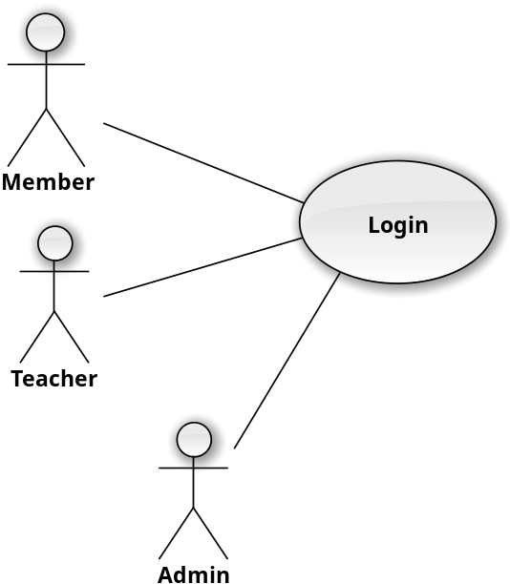
User Case ID | UC_001.2
Name | Login an account
Goal | Login to enter the system and become member, teacher or admin
Actors | Member, teacher, admin
Pre-conditions | Enter Username and password.  Username and password already existed or has registered.
Post-conditions | Success: The message is show “Login Success!” and back to website.  Fail: + The message is show “Wrong Username or password” if don’t have username password the same in DB.  + The message is show “Please enter Username and Password” if Username or password is empty.
Main Flow | - People enter user name and password on the font login.  - Click on the “Login” button.
Exception | Don’t input user name or password.  Password or username is wrong.

3.3.1.3 Logout
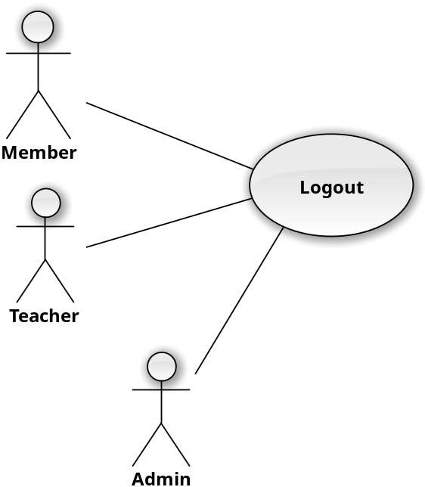
User Case ID | UC_001.3
Name | Logout an account
Goal | Logout from system.
Actors | Member, teacher, admin
Pre-conditions | Have been logged in.
Post-conditions | Success: Logout to system and become guest.  Fail: N/A
Main Flow | People click on “Logout” button
Exception | N/A

3.3.2 Function Requirement Two
3.3.2.1 Create New Topic
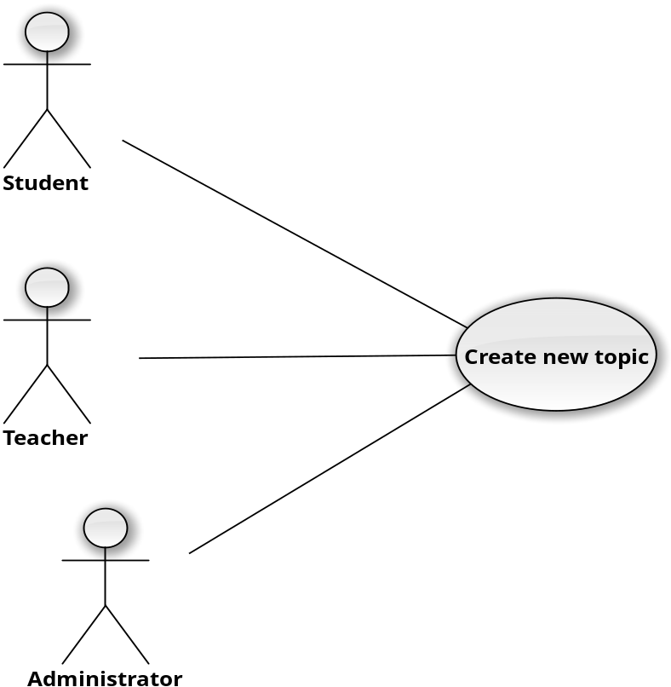

User Case ID | UC_002.1
Name | Create new topic
Goal | Create new topic in forum
Actors | Member, teacher, admin
Pre-conditions | Have been logged in.
Post-conditions | Success: Logout to system and become guest.
Main Flow | 1. Users go to forum  2. Users click button “Create new topic”  3. Users choose category and fill in description of the topic  4. Users click “Ok” button
Exception | 1. User did not choose category  2. User did not fill in all required information

3.3.2.2 Comment on topic
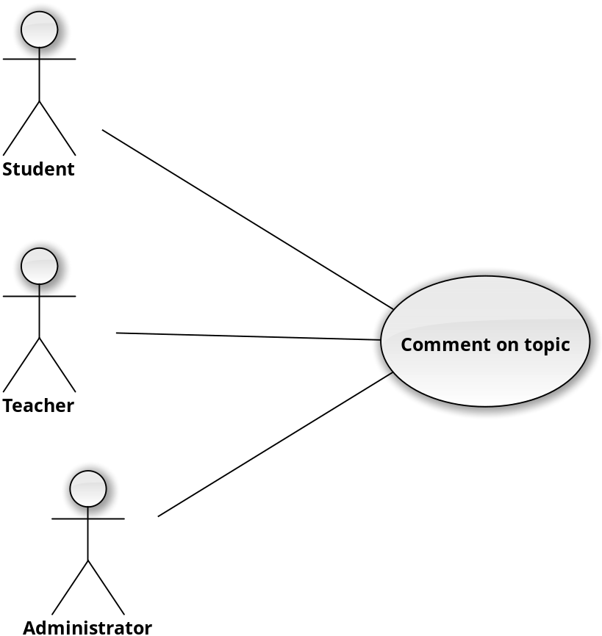

User Case ID | UC_002.2
Name | Comment on topin
Goal | Give comment on topic
Actors | Member, teacher, admin
Pre-conditions | Have been logged in.
Post-conditions | Success: Logout to system and become guest.
Main Flow | 1. Users go to forum  2. Users click on any topic  3. Users click on “Comment” button  4. Users fill in all required information  5. Users click “Ok” button
Exception | The content of comment is empty

3.3.3 Function Requirement Three
3.3.3.1 Search Courses Base On Title
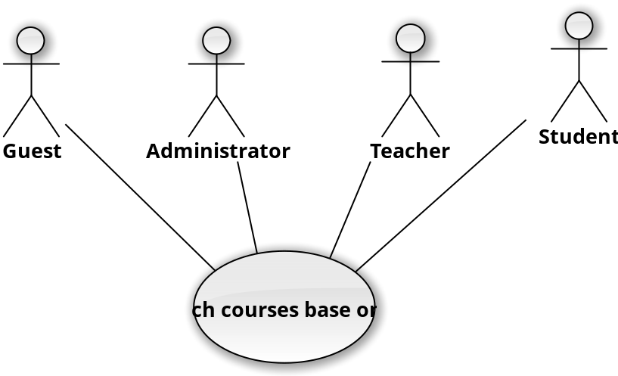
User Case ID | UC_003.1
Name | Search courses base on title
Goal | Get all courses (from the current list that user have searched) base on title
Actors | Guest, Administrator, Teacher, Student
Pre-conditions | Keyword
Post-conditions | Base on current list of courses that user has, return a new list of courses that have name match title of that courses
Main Flow | 1. Users access the web application via browser  2. From the home page users click on the “All courses” button, the website then bring them to the page that show all available courses  3. From the combo box below the search bar, users choose “Title” element  4. User input the keyword into the search bar; server will give a list of hints right below the search bar to help user easier to find courses
Exception | N/A

3.3.3.2 Search Courses Base On Category
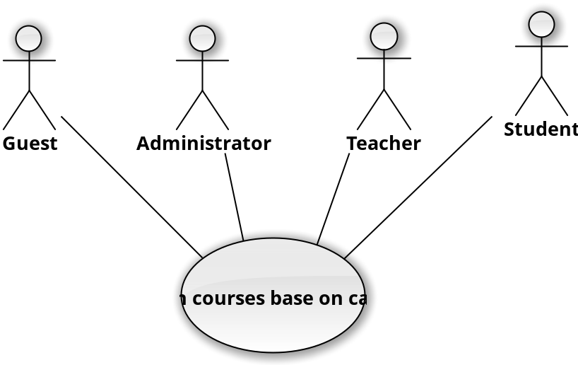
User Case ID | UC_003.2
Name | Search courses base on category
Goal | Get all courses (from the current list that user have searched) base on category
Actors | Guest, Administrator, Teacher, Student
Pre-conditions | N/A
Post-conditions | Return a list of courses that have the category users have chosen
Main Flow | 1. Users access the web application via browser  2. From the home page users click on the “All courses” button, the website then bring them to the page that show all available courses  3. From left panel of the web page, there is a list of available categories; each on have an checkbox. Users click to choose some categories
Exception | N/A

3.3.3.3 Search Courses Base On Name Of Teachers
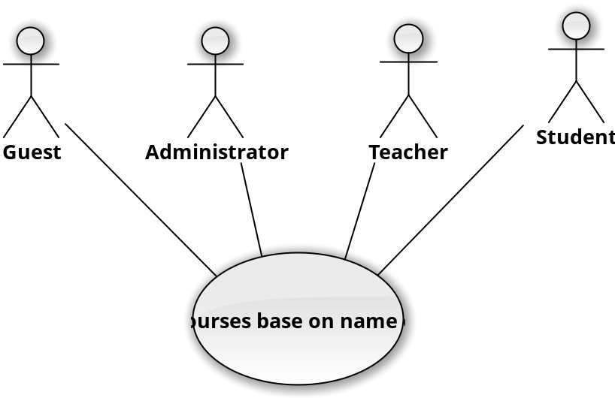
User Case ID | UC_003.3
Name | Search courses base on name of teacher
Goal | Get all courses (from the current list that user have searched) base on teacher name
Actors | Guest, Administrator, Teacher, Student
Pre-conditions | Keyword
Post-conditions | Base on current list of courses that user has, return a new list of courses that have name match title of that courses
Main Flow | 1. Users access the web application via browser  2. From the home page users click on the “All courses” button, the website then bring them to the page that show all available courses  3. From the combo box below the search bar, users choose “Teacher” element  4. User input the keyword on to the search bar; server will give a list of hints right below the search bar to help user easier to find courses
Exception | N/A

3.3.4 Function Requirement Four
3.3.4.1 Enroll Courses

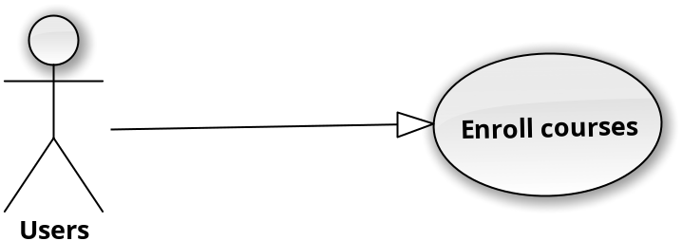
User Case ID | UC_004.1
Name | Enroll courses
Goal | Enroll the courses want to learn.
Actors | User
Pre-conditions | User has a code to enroll that subject.
Post-conditions | Learn that subject
Main Flow | 1.Login  2.Select the subject, which want to learn.  3.Enter code to enroll.  4.Press to confirm.
Exception | N/A

3.3.4.2 Give Feedback To Teachers
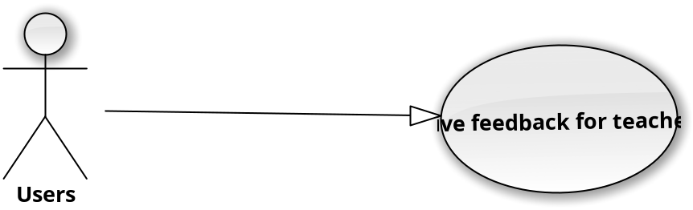
User Case ID | UC_004.2
Name | Give feedback for teachers
Goal | To know that student think about the level of teacher.
Actors | User
Pre-conditions | Student who learn that courses.
Post-conditions | Feedback what you think about who teach you.
Main Flow | 1.Login  2. Press the feedback  3.Write the feedback.  4.Press the confirm.
Exception | N/A

3.3.4.3 Do Writing Or Reading Test
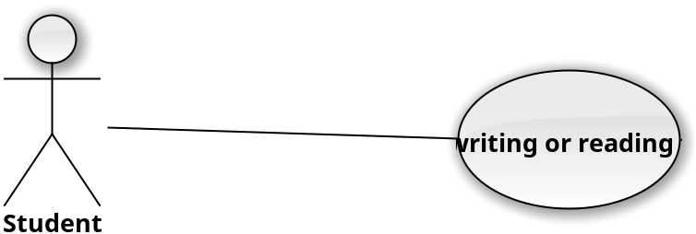
User Case ID | UC_004.3
Name | Do writing or reading tests
Goal | Students can do online writing and reading test
Actors | Student
Pre-conditions | Student has login and enroll the correct course
Post-conditions | Students can do and submit test
Main Flow | 1. Student accesses the web application via browser and logins successfully  2. From the home page students click go to the personal profile by click his/her name on the upper right corner of the website  3. From the dash board shown, student chooses one of current courses  4. From the course dash board, student clicks the the test section  5. Student chooses one of the writing or reading test and start doing  6. Student click “Submit” button when he/she finishes
Exception | 1. The courses have been closed  2. The test was overdue

3.3.4.4 Do Speaking Test
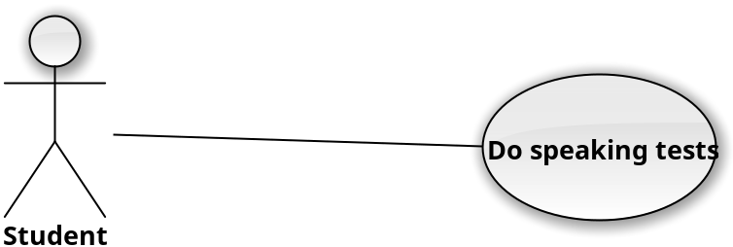
User Case ID | UC_004.4
Name | Do speaking tests
Goal | Students can do online speaking test
Actors | Student
Pre-conditions | Student has login and enroll the correct course
Post-conditions | Students can do and submit test
Main Flow | 1. Student accesses the web application via browser and logins successfully  2. From the home page students click go to the personal profile by click his/her name on the upper right corner of the website  3. From the dash board shown, student chooses one of current courses  4. From the course dash board, student clicks the test section  5. Student chooses one of the speaking test  6. If the test is kind of multichoice-test, the audio will be play automatically after 3 to 5 minutes  7. If the test is a communication test directly with teachers, students must first check the input output device like camera and microphone to make sure they work well before the test  8. Student can complete and submit the test using “Submit” button
Exception | 1. The courses have been closed  2. The test was overdue  3. Teacher is not available  4. Student has problem with input and output devices

3.3.5 Function Requirement Five
3.3.5.1 Create Courses
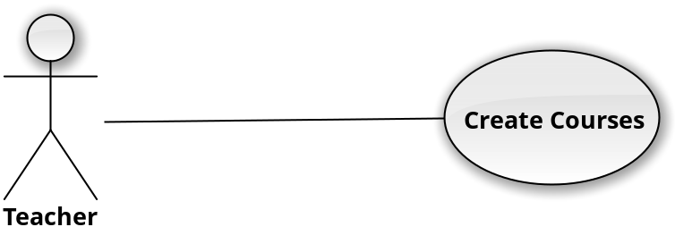
User Case ID | UC_005.1
Name | Create Courses
Goal | A new course is created
Actors | Teachers
Pre-conditions | User must log-in with role “Teacher”
Post-conditions | New course is created for teacher.
Main Flow | 1. Teacher visits home page  2. Teacher visits personal page  3. Click on “Create New Course” button  4. Input details of new course  5. Click on “Save” button
Exception | - “Course Name” is duplicated.  - Category was not filled in.

3.3.5.2 Remove Courses
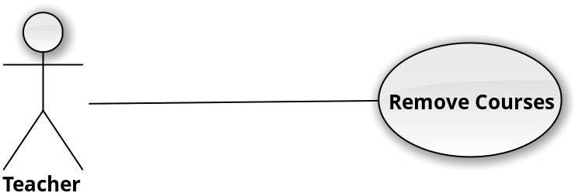
User Case ID | UC_005.2
Name | Remove Courses
Goal | A course is removed
Actors | Teachers
Pre-conditions | User must log-in with role “Teacher”
Post-conditions | Teacher removes a course.
Main Flow | 1. Teacher visits home page  2. Teacher visits personal page  3. Find course  3. Enter course  4. Click on “Remove this course” button  5. A confirm message is shown  6. “Yes” button is clicked -> course is removed. “No” button is clicked -> return course page
Exception | - Course not found

3.3.5.3 Update Courses
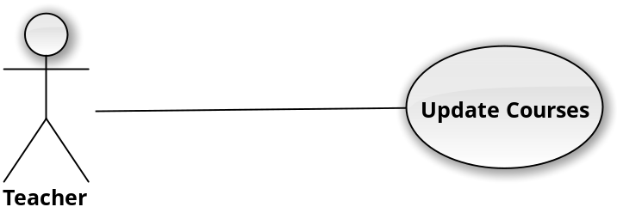
User Case ID | UC_005.3
Name | Update Course
Goal | A course is updated
Actors | Teachers
Pre-conditions | User must log-in with role “Teacher”
Post-conditions | Teacher updates a course.
Main Flow | 1. Teacher visits home page  2. Teacher visits personal page  3. Find course  4. Enter course  5. Click on “Update” button  6. Update new details  7. A confirm message is shown  8. “Yes” button is clicked -> course is updated. “No” button is clicked -> return course page
Exception | - Course not found  - Category was not filled in  - Course’s details are duplicated

3.3.5.4 Remove Students From Courses
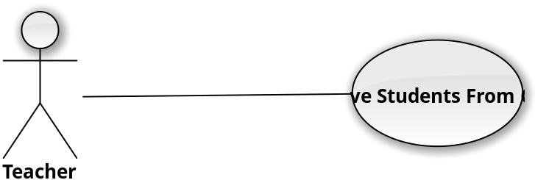
User Case ID | UC_005.4
Name | Remove Students From Course
Goal | A Student is removed from course
Actors | Teachers
Pre-conditions | User must log-in with role “Teacher”
Post-conditions | Teacher removes a course.
Main Flow | 1. Teacher visits home page  2. Teacher visits personal page  3. Find course  4. Enter course  5. Click on “View Student List” button  5. Find Student’s Name  4. Click on “Remove” button  5. A confirm message is shown  6. “Yes” button is clicked -> A Student is updated. “No” button is clicked -> return course page
Exception | - Course not found  - Student’s Name not found

3.3.5.5 View Student Learning Progress
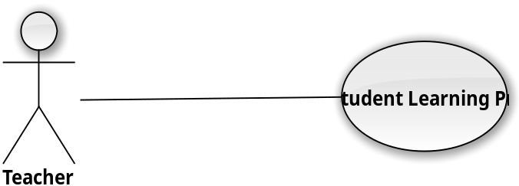
User Case ID | UC_005.5
Name | View Student Learning Progress
Goal | Want to view student learning progress
Actors | Teachers
Pre-conditions | User must log-in with role “Teacher”
Post-conditions | View Student learning progress
Main Flow | 1. Teacher visits home page  2. Teacher visits personal page  3. Enter course  4. Click on “View Student List” button  5. Student learning progress is shown

3.3.5.6 Invite Students To Enroll in Courses
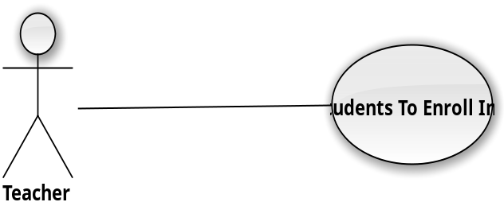
User Case ID | UC_005.6
Name | Invite Students To Enroll In Courses
Goal | Want to invite students to enroll in courses
Actors | Teachers
Pre-conditions | User must log-in with role “Teacher”
Post-conditions | Students enroll in courses
Main Flow | 1. Teacher visits home page  2. Find course  3. Enter course  4. Find Student’s Name  5. Click on “Invite to enroll this course” button
Exception | - Course not found  - Student’s Name not found  - Student has already enrolled course

3.3.6 Function Requirement Six
3.3.6.1 Add Users
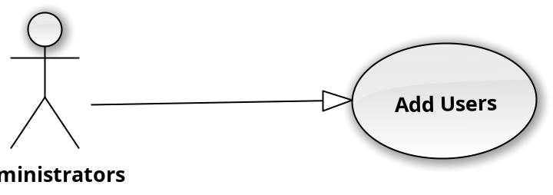

User Case ID | UC_006.1
Name | Add users
Goal | Want to add the users
Actors | Administrators
Pre-conditions | Have a code in the user’s email and use the code to approve
Post-conditions | User become member of social network
Main Flow | 1. Go to manage member  2. Accept the user’s request.
Exception | N/A

3.3.6.2 Delete Users
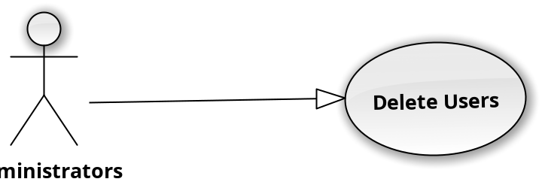
User Case ID | UC_006.2
Name | Delete users
Goal | Delete user from social network
Actors | Administrators
Pre-conditions | User’s account isn’t used.
Post-conditions | Remove account from account list
Main Flow | 1. Go to manage member.  2. Search the user’s name.  3. Select the user.  4. Select the deleted.  5. Select the confirm to delete.
Exception | 3.if you selected the user want to remove, when you select that user the user’s information need to show, avoid removing wrong member.

3.3.6.3 Update Users
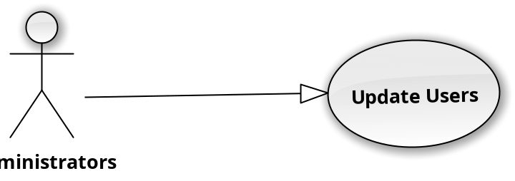
User Case ID | UC_006.3
Name | Update user
Goal | Update the information of member
Actors | Administrators
Pre-conditions | User’s information need to be changed
Post-conditions | User’s information will be changed
Main Flow | 1. Go to manage member  2. Search the user’s name.  3. Select the user.  4. Select edit.  5. Edit the information.  6. Select Confirm to update the information.
Exception | 6. The information won’t change if don’t press the confirm.

3.3.6.4 Ban Users
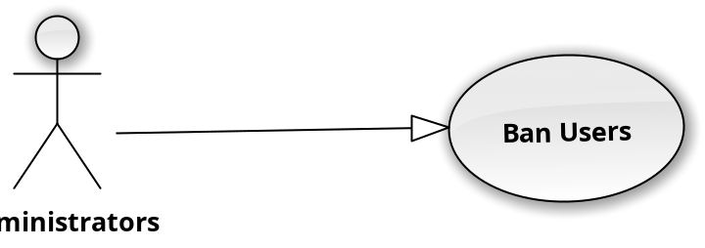
User Case ID | UC_006.4
Name | Ban User
Goal | Ban User who don’t allow learn some subject or forum
Actors | Administrators
Pre-conditions | Violation of the rules set out by the administrator or amount people report ban that user.
Post-conditions
Main Flow | 1. Go to manage member  2. Search the user’s name.  3. Select the user.  4. Select ban.  5. Select the subject that users don’t allow enroll.  6. Select Confirm to update.
Exception | N/A

NON-FUNCTIONAL Requirements
- This sections describes non-functional requirements of the application

Usability
- Easy to use: the system must be easy to use and understand. We have to make sure that the user can used all functions of system after 1 day training without any mistake.
- Conformity: the icon, picture, button must be clear and avoid confusion as least as possible.

Reliability
- Availability: 24 hours per day.
- Mean Time Between Failures (MTBF): more than 6 months.
- Mean Time To Repair (MTTR): less than 24 hours.
- Accuracy: 100% of data output.
- Maximum Bugs: maximum of 3 bugs per thousand lines of code (3bugs/KLOC).

Performance
- Response time: between 100 – 500 milliseconds per transaction.
- Throughput: at least 1 transaction per second at rush hour.
- Degradation mode: if the system has been degraded in some manner, it is also able to work at least 50% of normal capacity.
- Resource utilization:
  - Memory: 2 GB.
  - Disk: 1 TB.
  - Network: can work effective with a 1 MB/second line.

Supportability
- One year technical support via telephone (in business day).
- Online support via main website of FPT Software Company.

Design Constraints
- The client-side of the application will be implemented using CSS, HTML and PHP language
- The database system using here is MySQL
- The server-slide and backend will be implemented using J2EE Teachnology

On-line User Documentation and Help System Requirements
- Help System are include inside each function the software.

Purchased Components
- Project is to create a social networking site for learning languages online, and there is currently no charge for the course, but the future will be.

Interfaces
- Not supported yet.

Licensing Requirements
- This system is under customer possession. After delivered it, the software company cannot sell it to any other companies and the customer has full right to the system.
- This system can be shared licensed to some related company.

Legal, Copyright, and Other Notices
- If any requirement mentioned above is not satisfied, the customer can decline to receive the whole system.
- This software will keep track of everything required by copyright licensing agencies in USA.

Applicable Standards
- Works well under American publication delivery standards.
- He system must meet standards for usability, interoperability and internationalization of USA.

Supporting Information
Appendices
- Database is a structured set of data held in a computer, especially one that is accessible in various way.
- The Internet is a global system of interconnected computer networks that use the standard Internet protocol suite (TCP/IP) to link several billion devices worldwide.
- CMS is a computer application that allows publishing, editing and modifying content, organizing, deleting as well as maintenance from a central interface. Such systems of content management provide procedures to manage workflow in a collaborative environment.
- Social Network is a dedicated website or other application that enables users to communicate with each other by posting information, comments, messages, images, etc.

