

Learning Language Social Network
Software Requirement Specification

Project Code: PLSN-GEP
Document Code: DLSN – v2.0
Team Members:
- Vũ Huy Quân
- Dương Quang Hải
- Huỳnh Hữu Nhân
- Nguyễn Hoàng Hiệp

Record of change
*A - Added M - Modified D – Deleted
Effective Date | Changed Items | A*  M, D | Change Description | New Version
30/03/2015 | Signature page | A | Add description for signature page | 1.1
30/03/2015 | Introduction | A | Add all contents for introduction | 1.1
30/03/2015 | System Architecture | A | Add diagram design for the whole system | 1.1
31/03/2015 | Diagrams | A | Add sequence diagrams | 1.2
31/03/2015 | Diagrams | A | Add activity diagrams | 1.2
01/04/2015 | Packages | A | Add packages and class diagrams | 1.3
01/04/2015 | Consideration | A | Add other considerations | 2.0
01/04/2015 | Appendix | A | Add some knowledge for appendix | 2.0

SIGNATURE PAGE
ORIGINATOR:
- Name: Vũ Huy Quân
- Date: 25/03/2015
- Position: Project Manager

REVIEWERS:
- Dương Quang Hải
- Nguyễn Hoàng Hiệp
- Huỳnh Hữu Nhân

APPROVAL:
- Name: Nguyễn Huy Hùng
- Date: 30/03/2015
- Position: Chairman of GEP company

TABLE OF CONTENTS
1 Introduction 6
1.1 Purpose 6
1.2 Definitions, Acronyms and Abbreviations 6
1.3 References 7
1.4 Overview 7
2 SYSTEM Architecture 8
2.1 Web Architecture 8
2.2 CMS page Architecture 9
2.3 Search Feature 10
2.4 Create Course 10
2.5 Create Topic 11
2.6 Design Pattern 11
2.7 Class Diagram 12
3 Diagrams 13
3.1 Sequence Diagrams 13
3.1.1 Create new topic 13
3.1.2 Comment on topic 14
3.1.3 Create new course 14
3.1.4 Remove course 15
3.1.5 Remove student from course 15
3.1.6 Update course 16
3.1.7 Add user 16
3.1.8 Delete user 17
3.1.9 Update user 17
3.1.10 Create new account 18
3.2 Activity Diagrams 18
3.2.1 Login 18
3.2.2 Logout 18
3.2.3 Search course base on title 19
3.2.4 Search course base on category 19
3.2.5 Search course base on teacher name 19
3.2.6 Enroll course 19
3.2.7 Give feedback for teachers 19
3.2.8 Do writing or reading test 20
3.2.9 Do speaking test 20
3.2.10 View student learning process 20
3.2.11 Invite students to enroll in course 20
3.2.12 Ban users 20
4 Packages 21
4.1 com.gep.user package 21
4.1.1 Class diagram 21
4.1.2 User Manager class 22
4.1.3 Teacher Manager class 23
4.1.4 Student Manager class 24
4.1.5 User class 25
4.1.6 Teacher class 25
4.1.7 Student class 26
4.1.8 Guest class 27
4.1.9 Admin class 27
4.2 com.gep.forum package 29
4.2.1 Class diagram 29
4.2.2 Topic class 29
4.2.3 Comment class 30
4.2.4 Topic Manager class 30
4.3 com.gep.course package 31
4.3.1 Class diagram 31
4.3.2 Course class 32
4.3.3 Test class 32
4.3.4 Course Manager class 33
5 Other considerations 34
6 Appendix 35

Introduction

Purpose
- This design document includes all necessary contents about the whole system design for the web application
- It includes all classes and their methods and attributes. It also include class diagrams to demonstrate the classes will be used
- Design pattern and System Architecture are also demonstrated using graph
- All user case will be described using sequence and activities diagram
- Developer and tester will base on the details of this design to implement appropriate classes and unit tests
- This design still not considers how the application will adapt to mobile devices, and be responsive

Definitions, Acronyms and Abbreviations
Term | Definition
OS | Operating System
LLSN | Learning Language Social Network
User | Someone who interact with the web application like: taking courses and access learning tools
Teacher | Someone who have the ability to create courses
Administrator | People who manage the system
Guest | People who just can visit the web page
CMS | Content management system
PC | Personal Computer
MVC | Model – View – Controller Architecture
UI | User interface
Web platform | An open community of developers building resources for a better web, regardless of brand, browser, or platform.

References
[1] IEEE Software Engineering Standards Committee, “IEEE Std 830-1998, IEEE Recommended Practice for Software Requirements Specifications”, October 20, 1998.
[2] “srs_example_2010_group2.pdf” – An example of SRS document.

Overview
- This document contains System Architecture, Diagrams, Packages, Other Consideration and Appendix.
- System Architecture: include diagrams and design to specify how the system work
- Packages: contain class diagrams help designers and developers have the details view about the whole classes of the system
- Other Consideration: This section provides a description of other design elements that were considered as alternatives in selection process for the above class design
- Appendix: provide extra information and technology that designers and developers need to know to read the documents

SYSTEM Architecture

Web Architecture
the system will use MVC architecture to communicate with users. The reason why using this model: the system have to server a large amount of users, using MVC architecture help the system quicky response to the interaction from users.
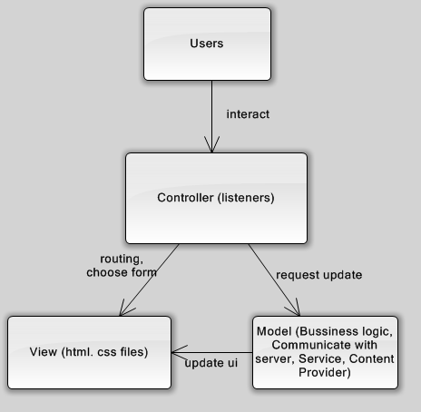

CMS page Architecture
The managing system (CMS page) will also using MVC architecture to help administrators quickly update or make sure the corrections of all data within the system.
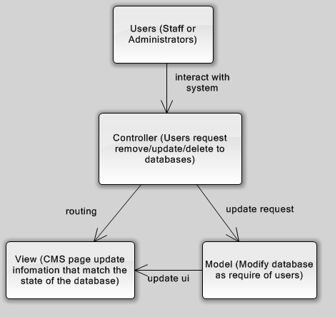

Search Feature
Search engine will use the architecture “Pipe and Filter” to generate output of each search input.
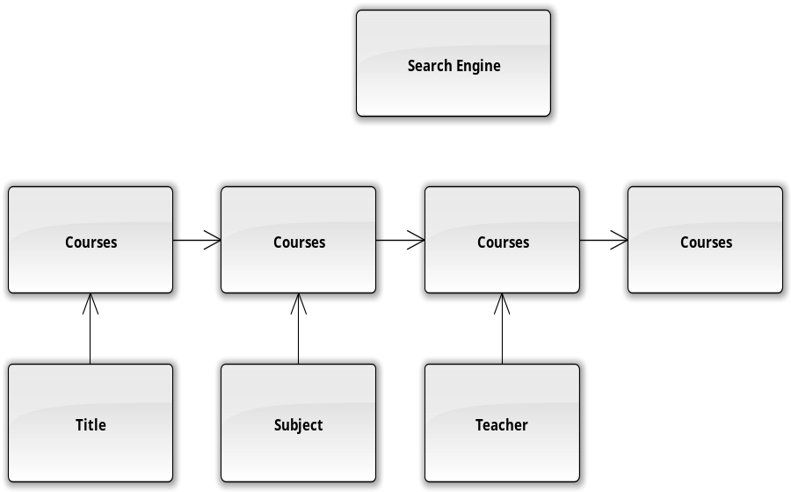

Create Course
Teacher will have to sequential input necessary information before creating a course, this design using “Pipe and Filter” Architecture.
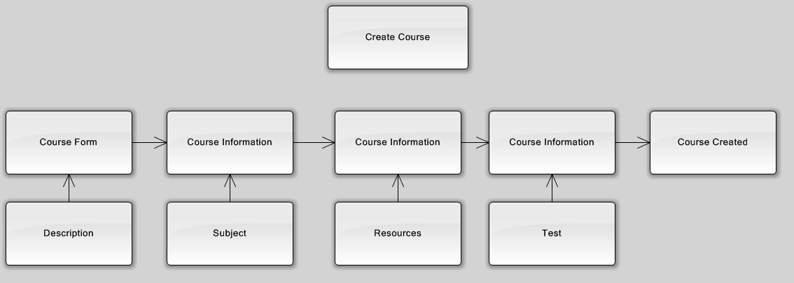

Create Topic
Create a new topic also require some input flow information. This flow using “Pipe and Filter” Architecture.
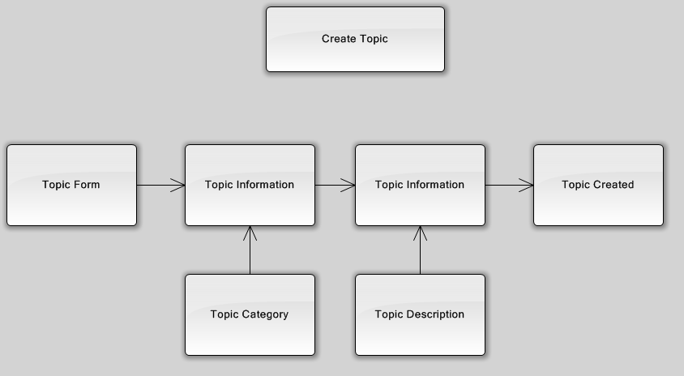

Design Pattern
a) Singleton: the users have the ability to report problem or give feedback to a partiular teacher. So that using Singleton Design Pattern to create single instance that help users can access and give report and feedback everywhere within the whole system.
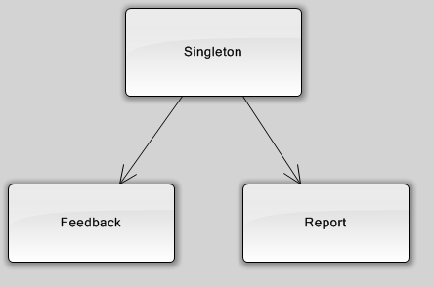

b) Observer: the system need to update data about learning resources for student, if there is change in database, the system should notify the change to user. Using Observer Design Pattern will solve the problem
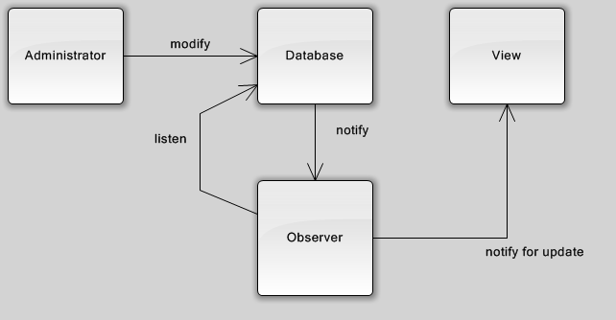

Class Diagram
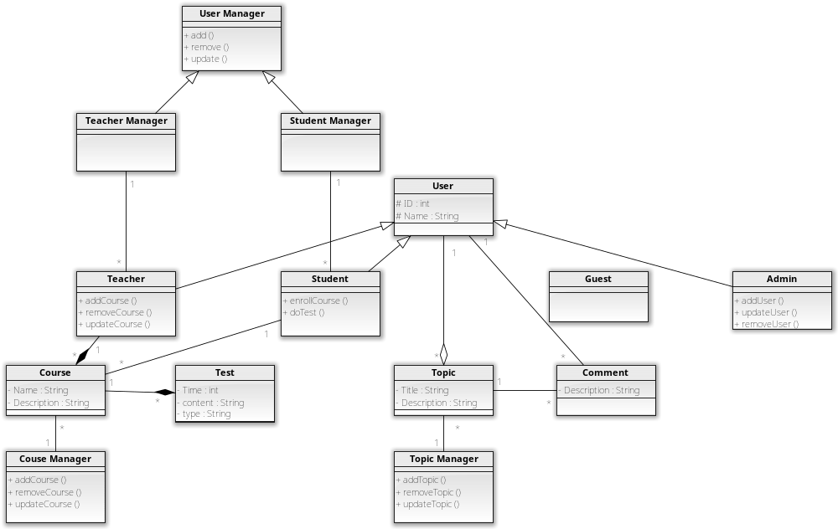

Diagrams

Sequence Diagrams

Create new topic
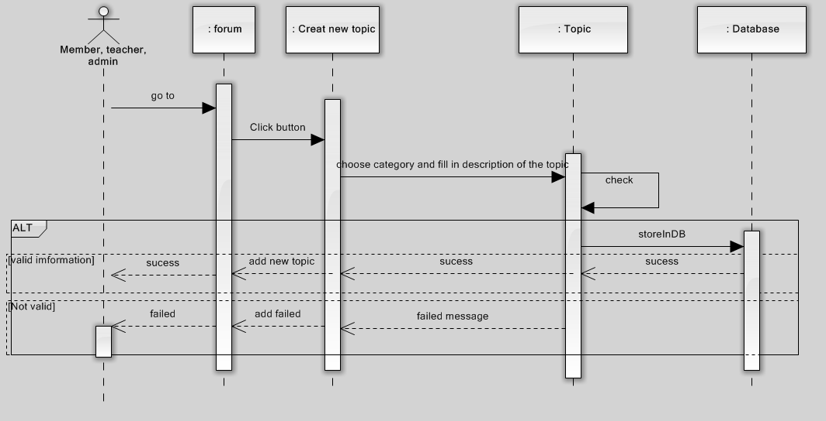

Comment on topic
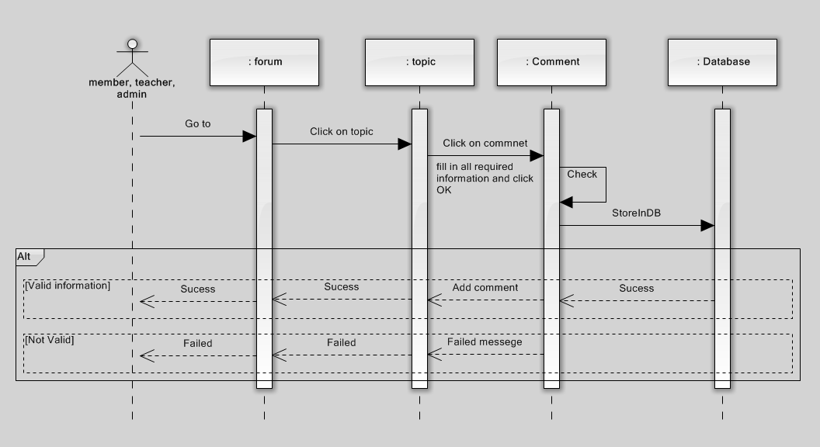

Create new course
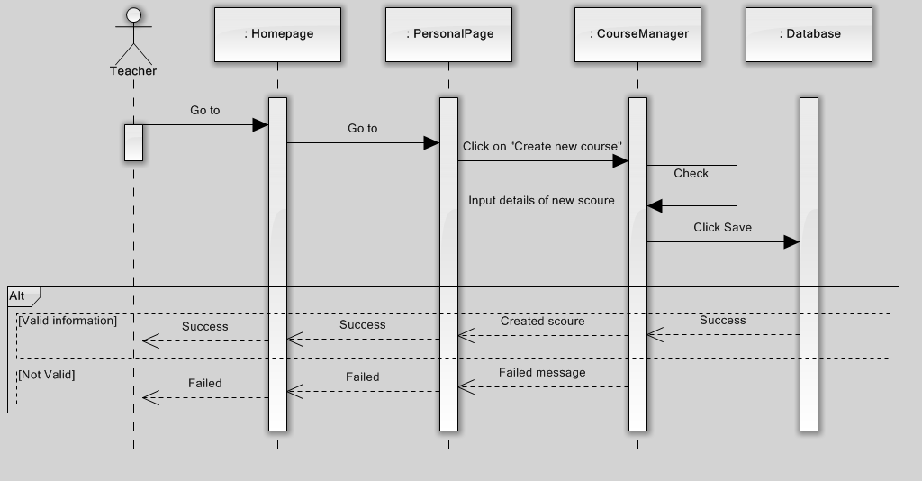

Remove course
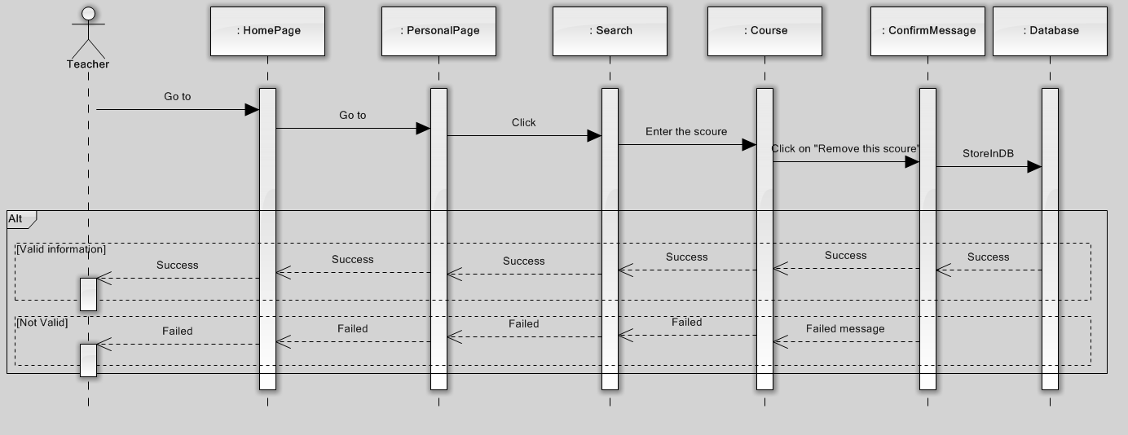

Remove student from course
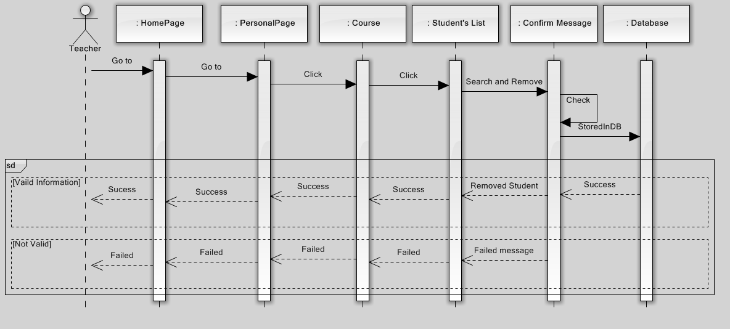

Update course
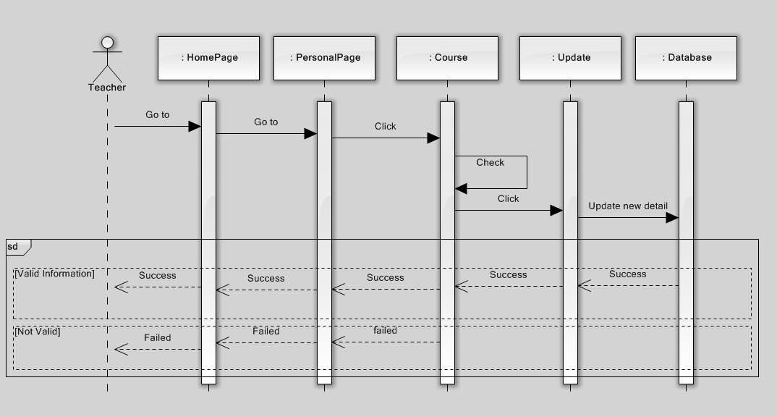

Add user
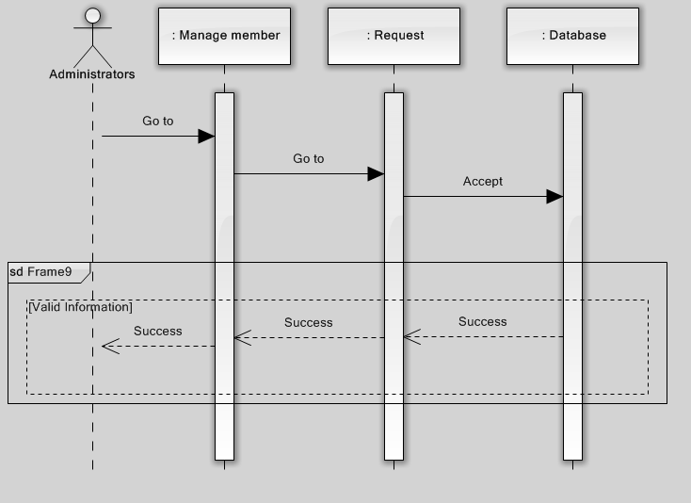

Delete user
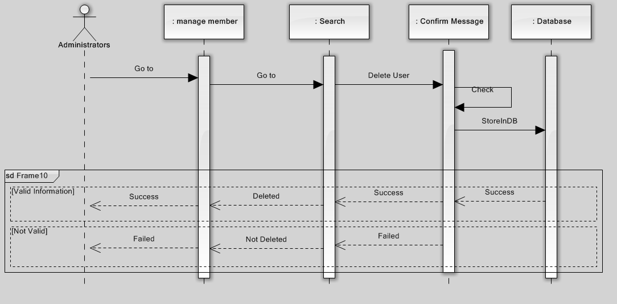

Update user
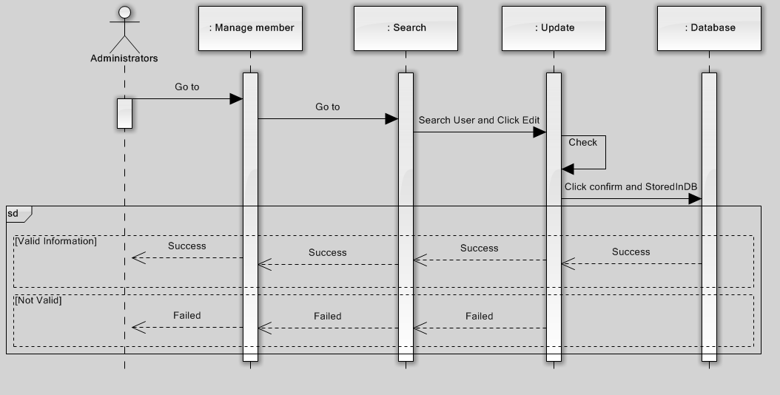

Create new account
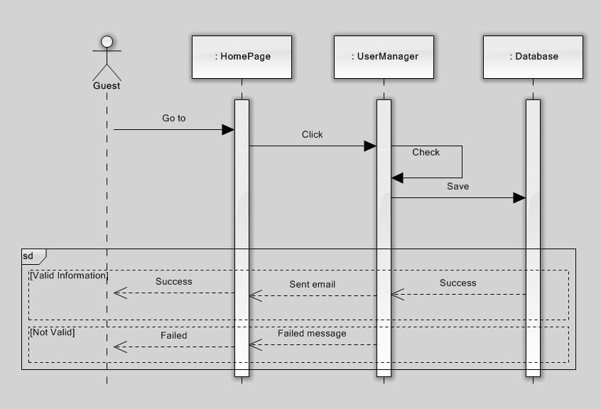

Activity Diagrams

Login
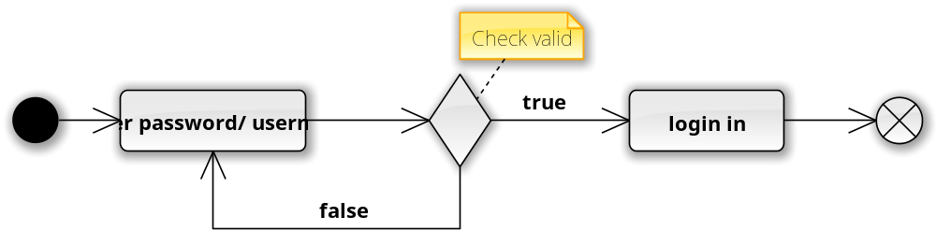

Logout
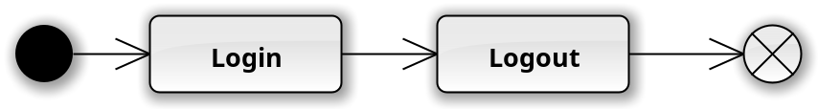

Search course base on title

Search course base on category

Search course base on teacher name

Enroll course
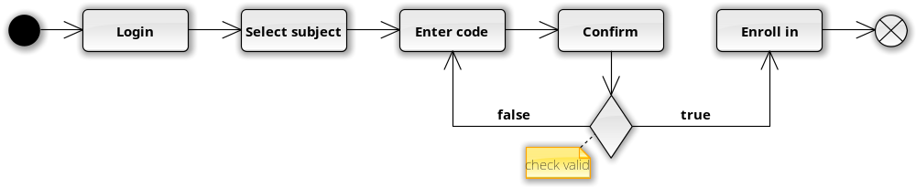

Give feedback for teachers

Do writing or reading test
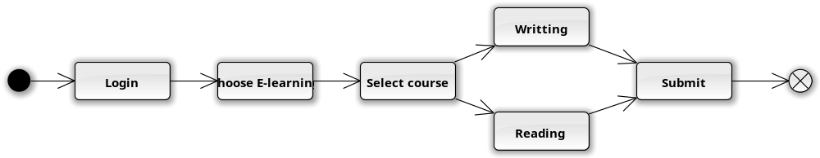

Do speaking test

View student learning process

Invite students to enroll in course

Ban users

Packages
No | Package | Language | Description
01 | com.gep.user | Java | This package includes user manager class and user class with different role.
02 | com.gep.forum | Java | This package has 3 classes Topic Manager and Comment
03 | com.gep.couse | Java | This package has 3 classes Course Test and Course Manager

com.gep.user package

Class diagram
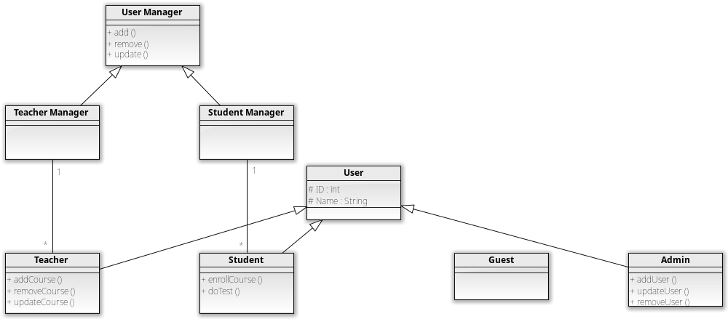
No | Class Name | Description
01 | User Manager | This class will manage Teacher Manager class and Student Manager class (add, remove, update)
02 | Teacher Manager | This class will manage Teacher class
03 | Student Manager | This class will manage Student class
04 | User | N/A
05 | Teacher | This class is a User with role “Teacher”
06 | Student | This class is a User with role “Student”
07 | Guest | This class is a User with role “Guest”
08 | Admin | This class is a User with role “Admin”

User Manager class

Attributes
No | Attribute | Type | Description
01 | N/A | N/A | N/A

Methods
No | Method | Description
01 | add() | Add
02 | remove() | Remove
03 | update() | Update

add() method

Parameters & return
No | Parameter | Type | Description
01 | N/A | N/A | N/A

remove() method

Parameters & return
No | Parameter | Type | Description
01 | N/A | N/A | N/A

update() method

Parameters & return
No | Parameter | Type | Description
01 | N/A | N/A | N/A

Teacher Manager class

Attributes
No | Attribute | Type | Description
01 | N/A | N/A | N/A

Methods
No | Method | Description
01 | addTeacher() | Add a teacher
02 | removeTeacher() | Remove a teacher
03 | updateTeacher() | Update a teacher

addTeacher() method

Parameters & return
No | Parameter | Type | Description
01 | Teacher | Teacher | This parameter will be added as role “teacher”

removeTeacher() method

Parameters & return
No | Parameter | Type | Description
01 | Teacher | Teacher | This parameter will be removed as role “teacher”

updateTeacher() method

Parameters & return
No | Parameter | Type | Description
01 | Teacher | Teacher | This parameter will be updated as role “teacher”

Student Manager class

Attributes
No | Attribute | Type | Description
01 | N/A | N/A | N/A

Methods
No | Method | Description
01 | addStudent() | Add a student
02 | removeStudent() | Remove a student
03 | updateStudent() | Update a student

addStudent() method

Parameters & return
No | Parameter | Type | Description
01 | Student | Student | This parameter will be added as role “student”

removeStudent() method

Parameters & return
No | Parameter | Type | Description
01 | Student | Student | This parameter will be removed as role “student”

updateStudent() method

Parameters & return
No | Parameter | Type | Description
01 | Student | Student | This parameter will be updated as role “student”

User class

Attributes
No | Attribute | Type | Description
01 | ID | int | ID of users
02 | Name | String | Name if users

Methods
No | Method | Description
01 | N/A | N/A

Parameters & return
No | Parameter | Type | Description
01 | N/A | N/A | N/A

Teacher class

Attributes
No | Attribute | Type | Description
01 | ID | int | ID of user “teacher”
02 | Name | String | Name of user “teacher”

Methods
No | Method | Description
01 | addCourse() | Add a course
02 | removeCourse() | Remove a course
03 | UpdateCourse() | Update a course

addCourse() method

Parameters & return
No | Parameter | Type | Description
01 | Course | Course | This parameter will be added

removeCourse() method

Parameters & return
No | Parameter | Type | Description
01 | Course | Course | This parameter will be removed

updateCourse() method

Parameters & return
No | Parameter | Type | Description
01 | Course | Course | This parameter will be updated

Student class

Attributes
No | Attribute | Type | Description
01 | ID | int | ID of user “Student”
02 | Name | String | Name of user “Student”

Methods
No | Method | Description
01 | enrollCourse() | Students enroll the course
02 | doTest() | Students do test

enrollCourse() method

Parameters & return
No | Parameter | Type | Description
01 | Course | Course | This parameter is the course that student will enroll

doTest() method

Parameters & return
No | Parameter | Type | Description
01 | Test | Test | This parameter is Tests for students

Guest class

Attributes
No | Attribute | Type | Description
01 | N/A | N/A | N/A

Methods
No | Method | Description
01 | N/A | N/A

Admin class

Attributes
No | Attribute | Type | Description
01 | ID | int | ID of user “admin”
02 | Name | String | Name of user “admin”

Methods
No | Method | Description
01 | addUser() | Add a user
02 | removeUser() | Remove a user
03 | updateUser() | Update a user

addUser() method

Parameters & return
No | Parameter | Type | Description
01 | User | User | This parameter will be added as “user” by admin

removeUser() method

Parameters & return
No | Parameter | Type | Description
01 | User | User | This parameter will be removed as “user” by admin

updateUser() method

Parameters & return
No | Parameter | Type | Description
01 | User | User | This parameter will be updated as “user” by admin

com.gep.forum package

Class diagram
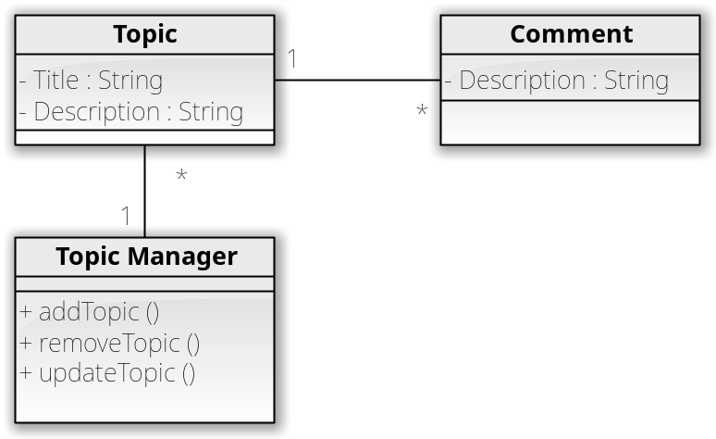

No | Class Name | Description
01 | Topic | Topics of a forum
02 | Comment | Comments for a topic
03 | Topic Manager | Add, Remove, Update topic

Topic class

Attributes
No | Attribute | Type | Description
01 | Title | String | Title of a topic
02 | Description | String | Description of topic

Methods
No | Method | Description
01 | N/A | N/A

Parameters & return
No | Parameter | Type | Description
01 | N/A | N/A | N/A

Comment class

Attributes
No | Attribute | Type | Description
01 | Description | String | Description of comment

Methods
No | Method | Description
01 | N/A | N/A

Parameters & return
No | Parameter | Type | Description
01 | N/A | N/A | N/A

Topic Manager class

Attributes
No | Attribute | Type | Description
01 | N/A | N/A | N/A

Methods
No | Method | Description
01 | addTopic() | Add a topic
02 | removeTopic() | Remove a topic
03 | updateTopic() | Update a topic

addTopic() method

Parameters & return
No | Parameter | Type | Description
01 | Topic | Topic | This parameter will be added as a “Topic”

removeTopic() method

Parameters & return
No | Parameter | Type | Description
01 | Topic | Topic | This parameter will be removed as a “Topic”

updateTopic() method

Parameters & return
No | Parameter | Type | Description
01 | Topic | Topic | This parameter will be updated as a “Topic”

com.gep.course package

Class diagram
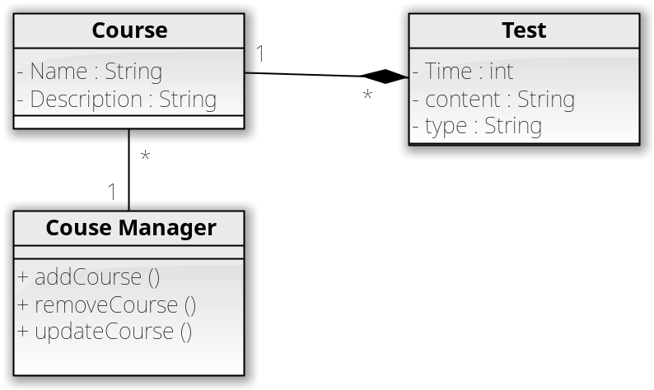
No | Class Name | Description
01 | Couse | Information of Courses
02 | Test | Tests of course
03 | Couse Manager | Add, Remove, Update a course

Course class

Attributes
No | Attribute | Type | Description
01 | Name | String | Name of course
02 | Description | String | Description of course

Methods
No | Method | Description
01 | N/A | N/A

Parameters & return
No | Parameter | Type | Description
01 | N/A | N/A | N/A

Test class

Attributes
No | Attribute | Type | Description
01 | Time | int | Time Start and End of a Test
02 | Content | String | Content of tests
03 | Type | String | Type of tests

Methods
No | Method | Description
01 | N/A | N/A

Parameters & return
No | Parameter | Type | Description
01 | N/A | N/A | N/A

Course Manager class

Attributes
No | Attribute | Type | Description
01 | N/A | N/A | N/A

Methods
No | Method | Description
01 | addCourse() | Add a course
02 | removeCourse() | Remove a course
03 | updateCourse() | Update a course

addCourse() method

Parameters & return
No | Parameter | Type | Description
01 | Course | Course | This parameter will be added as “Course”

removeCourse() method

Parameters & return
No | Parameter | Type | Description
01 | Course | Course | This parameter will be removed as “Course”

updateCourse() method

Parameters & return
No | Parameter | Type | Description
01 | Course | Course | This parameter will be updated as “Course”

Other considerations
There is another way to divide the packages:
1) com.gep.manager package contains all manager classes like “StudentManager, TeacherManager”
2) com.gep.user package contains all user classes
3) com.gep.forum package contains all classes related to forum
4) com.gep.course package contains all classes related to course
Using this design help developers easier to manage the classes. For example, if developer want to find classes associated with manager they can open package com.gep.manager. But if a developer is developing “Courses Feature”, they have to open com.gep.manager package instead of the current com.gep.course package.
Moreover, it may have a package like com.gep.helper to contain all helper static classes like “UiUtils class” contains all method and UI elements that can help developers quickly solve their problem, or “Constant class” contains all constant variables using through out the system.

Appendix
- Database is a structured set of data held in a computer, especially one that is accessible in various way
- CMS is a computer application that allows publishing, editing and modifying content, organizing, deleting as well as maintenance from a central interface. Such systems of content management provide procedures to manage workflow in a collaborative environment
- MVC is software architecture for implementing user interfaces. It divides a given software application into three interconnected parts, so as to separate internal representations of information from the ways that information is presented to or accepted from the user
- Pipe Filter Architecture is a mechanism of a flow of data where the output of this operation will be the input of the next one
- Observer is a design pattern that there is an object called “Observer”. Its mission is to listen for the states of data. When there is data modification, the observer will be notify and help other classes update their states
- Singleton is a design pattern that there is an object called “Monitor”. This object will handle the job of creating new objects like Thread, to make sure the users do not create so much object that harm the performances of the system. Moreover, the singleton object make other classes easy to call it from anywhere via static method

