T1110-003 Lab Report
HiepTD16
January 5, 2026

Table Of Content
1. Summary
2. Identify the initial details of the attack.
3. Deeper Investigation
4. Investigation Timeline and Conclusion
5. IOC

1. Summary
An attacker performed a password spraying/brute-force attack targeting the RDP service in a CYBERDEFENDERS environment (lab T1110-003) by sending a series of failed logon requests to multiple accounts to search for valid credentials without triggering account lockout mechanisms too early. The attack lasted approximately 05:48, and the attacker compromised 6 accounts. After that, the system successfully logged in (a logon success event was recorded) and the user returned to access it after 11 minutes, indicating a repeat access attempt aimed at maintaining access privileges. This incident increases the risk of unauthorized access, particularly the risk of privilege escalation and lateral movement within the network, if measures such as account lockout, enhanced.
2. Identify the initial details of the attack.
First use the querry:
index="t1110-003"
| spath
| fieldsummary
| search field="*ip*"
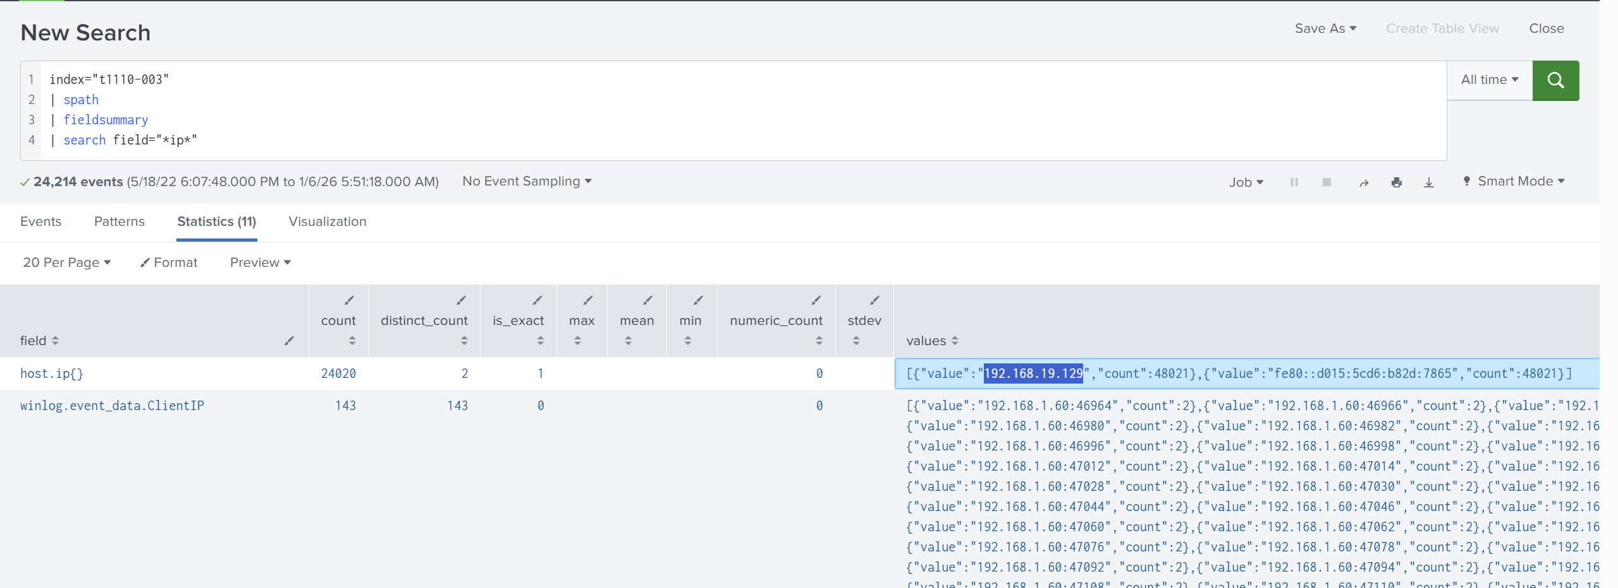
We can conclude that the victim (host) IP is: 192.168.19.129
Next, we need to determine the latest account which logs into the system. I search for “windows event logs cheat sheet” and access the link: https://www.scribd.com/document/659681382/Windows-Event-Log-Cheat-Sheet to support for the investigation
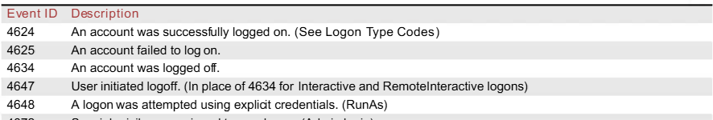
I search for successfully logged on event ID
Use querry: index="t1110-003" 4624
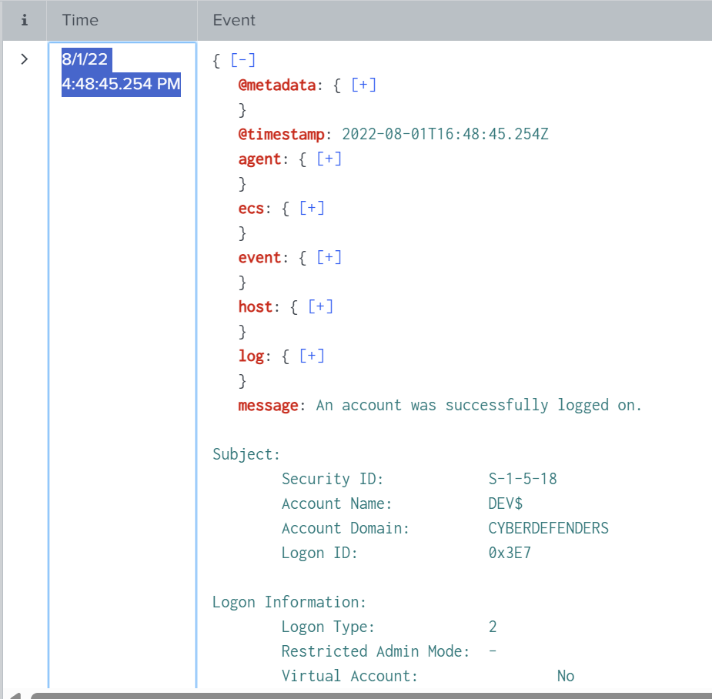
Splunk shows a list of 4624 events and displayed the list in chronological order from the newest to the oldest event. As we can see the lastest logged on was happening on 8/1/22 4:48:45.254 PM
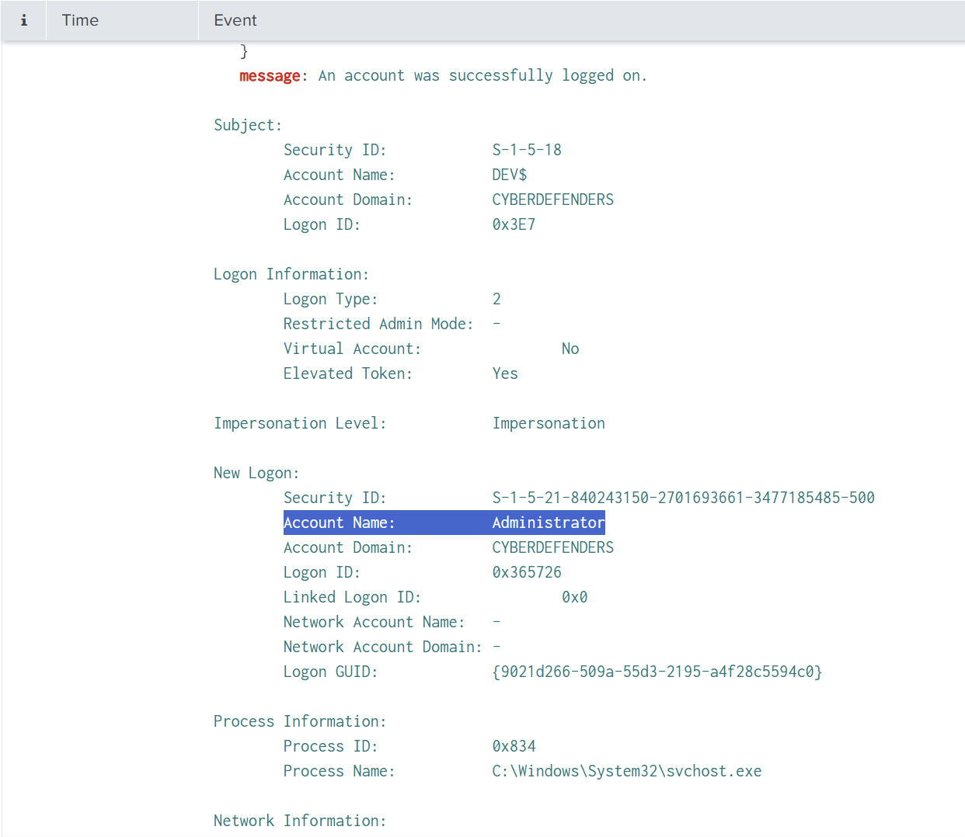
And finanlly determine that the latest loggond account was Administrator with Logon ID: 0x365726
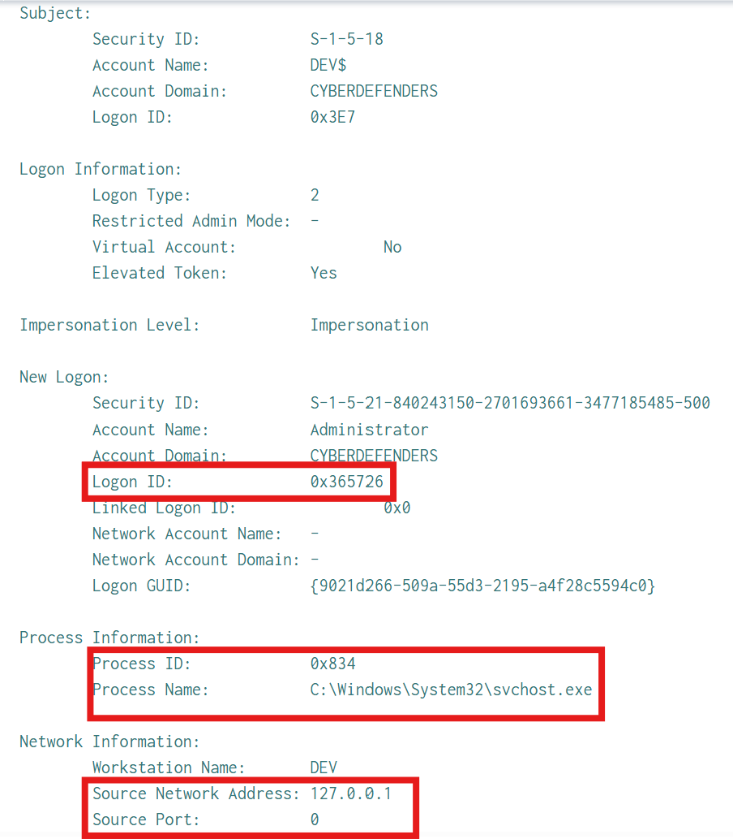
Process which created logon session: C:\Windows\System32\svchost.exe
A very important point to note: LogonType=2 + 127.0.0.1 → this event is local/interactive, unlike external RDP => No remote login attempts detected.

Beacause the attacker tried 1 or a small list of passwords and tried to log on to the system through many accounts so it must have a few fails logon, so I tried to find Logon Type of a failure logged on
Use the querry: index="t1110-003" 4625
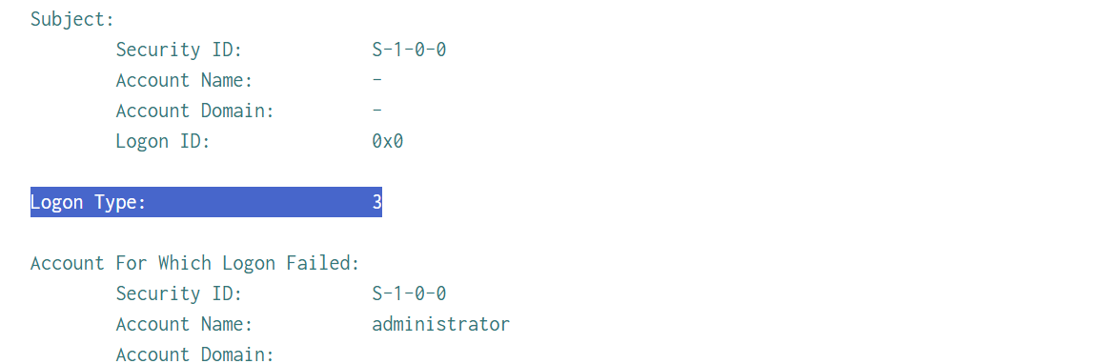
The Logon Type was: 3. The login failures mostly occurred with LogonType=3 (Network), indicating that the password cracking operation was performed remotely over the network rather than through on-site interaction.
Focus on the lastest failure logged on event
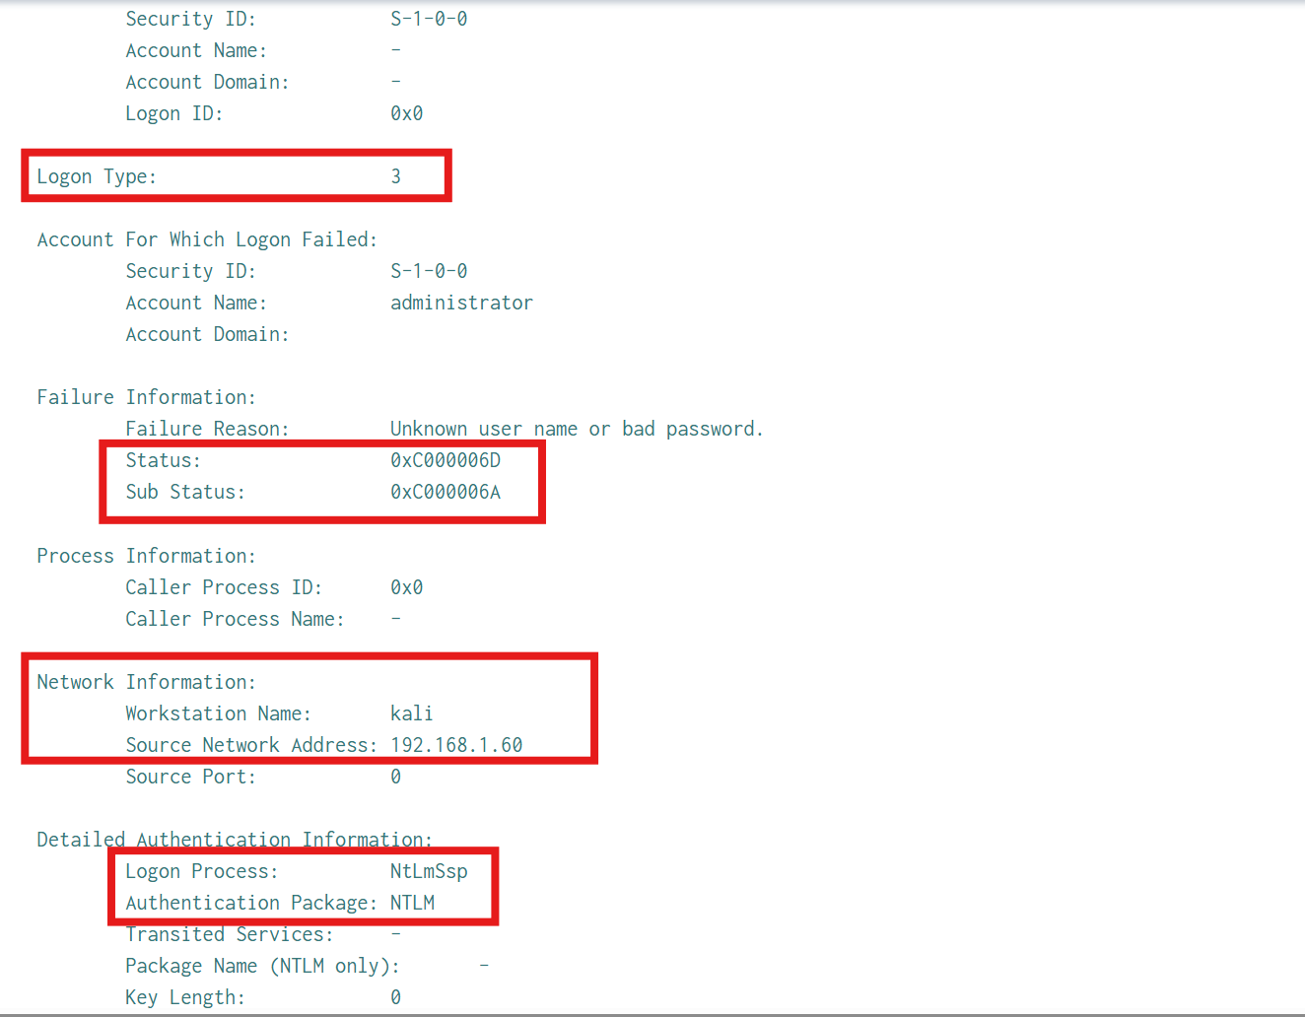
- Lastest failing target account:
+ Account Name: administrator

+ Account Domain: (blank) → commonly occurs when authentication fails before resolving the domain/user (or local account context) completely.
- Attack Source:
+ Workstation Name: kali
+ Source Network Address: 192.168.1.60
+ Source Port: 0
- Authentication Mechanism/Related Protocol
+ Logon Process: NTLM
+ Authentication Package: NTLM
=> It shows that these failures are following the NTLM branch, commonly found in “Windows network authentication” scenarios (SMB/NTLM-based authentication, or a service that accepts NTLM).
Used to differentiate from Kerberos/Negotiate.
- Reason for Failure
+ Failure Reason: Unknown username or bad password.
+ Status: 0xC000006D
+ Sub Status: 0xC000006A
0xC000006A usually corresponds to a “bad password”, a sign of password spraying.

Compilation of data from fail logon:
+ TargetUsername:
index="t1110-003" 4625
| spath
| search winlog.event_data.LogonType=3
| stats count as attempts by winlog.event_data.TargetUserName
| sort 0 – attempts
This querry: Filter failed logon attempts with LogonType = 3 (network logon), Count the number of attempts for each username in winlog.event_data.TargetUserName, Sort in descending order to see which account was tried the most.
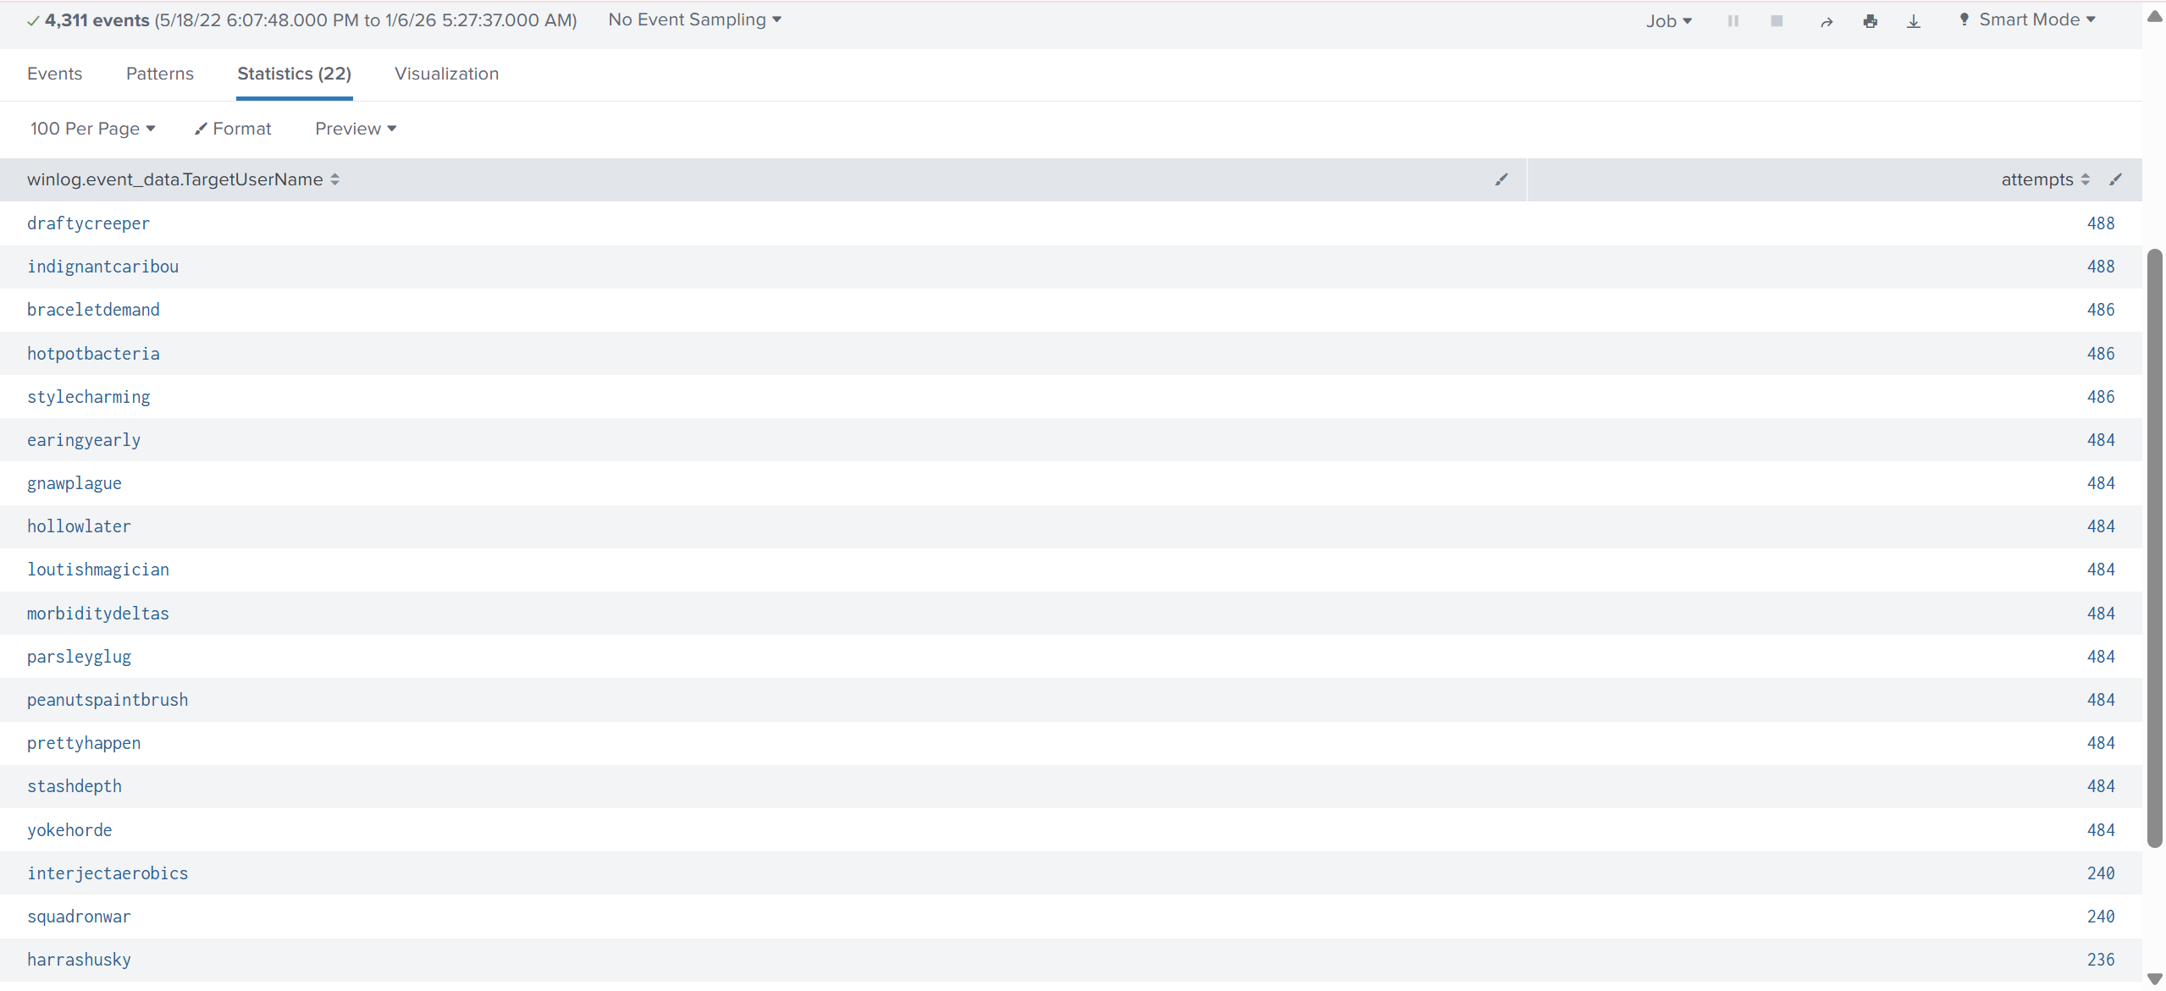
The table lists 22 accounts that were attempted (left column), along with the number of failed attempts (right column).
Many accounts have a very high and consistent number of attempts (e.g., ~484–488 attempts).
→ This is a typical sign of password spraying/brute-force attacks on a user list: the attacker repeatedly attempts on multiple accounts, with the number of attempts on each account being almost equal.

Next, I determine the attacerk’s IP address
Use the querry:
index="t1110-003" 4625
| spath
| search winlog.event_data.LogonType=3
| stats count as attempts values(winlog.event_data.WorkstationName) as workstations by winlog.event_data.IpAddress
| sort 0 – attempts
This querry: Filter LogonType = 3 (failed network logon), Count the number of failures for each source IP (winlog.event_data.IpAddress) and list the corresponding WorkstationName.
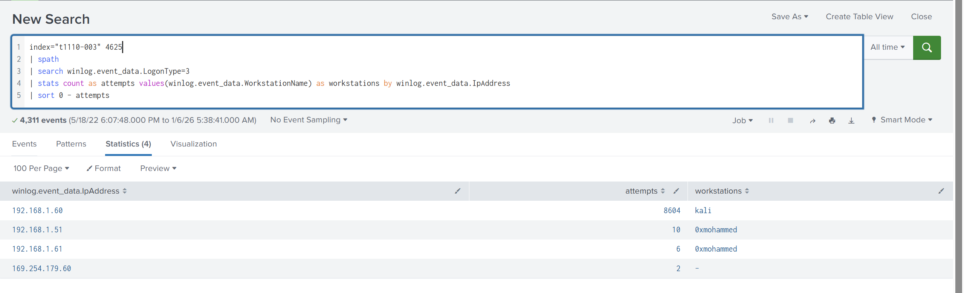
192.168.1.60 /workstation = kali / 8604 attempts → This is almost certainly the primary source of the attack (numerous attempts, typical spraying).
192.168.1.51 and 192.168.1.61 /workstation = 0xmohammed / 10 and 6 attempts → There is a small number of failed logons from other machines: possibly noise/experimental activity, or a secondary but inconspicuous source.

To dertermine the type of attack I use querry to:
Filter failures with source IP = 192.168.1.60 (attacker).
Group and count failures based on 3 criteria:
+ LogonType
+ LogonProcessName
+ AuthenticationPackageName
“index="t1110-003" 4625
| spath
| search winlog.event_data.IpAddress="192.168.1.60"
| stats count as attempts
by winlog.event_data.LogonType
winlog.event_data.LogonProcessName
winlog.event_data.AuthenticationPackageName
| sort 0 – attempts”
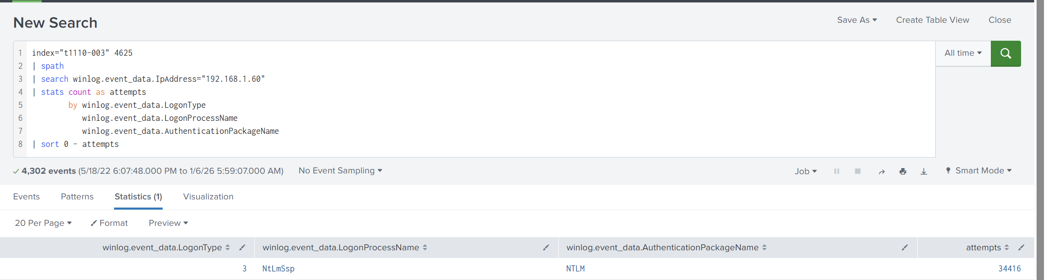
The failed logons from 192.168.1.60 were all LogonType 3 and used NTLM (NtLmSsp), indicating that the attacker performed password spraying over the NTLM network authentication channel with a total of 34,416 attempts.
In the results: LogonType=3, LogonProcess=NtLmSsp, AuthenticationPackage=NTLM, which means:
+ This is a network login attempt.
+ And that attempt follows the NTLM authentication branch (not Kerberos).
3. Deeper Investigation
To go furthur in this investigation I dertemine how long the attack lasts.
Use querry:
index="t1110-003" 4625
| spath
| search winlog.event_data.IpAddress="192.168.1.60"
| stats min(_time) as start max(_time) as end count as attempts
| eval duration_sec=end-start
| eval duration=tostring(duration_sec,"duration")
| table start end duration attempts
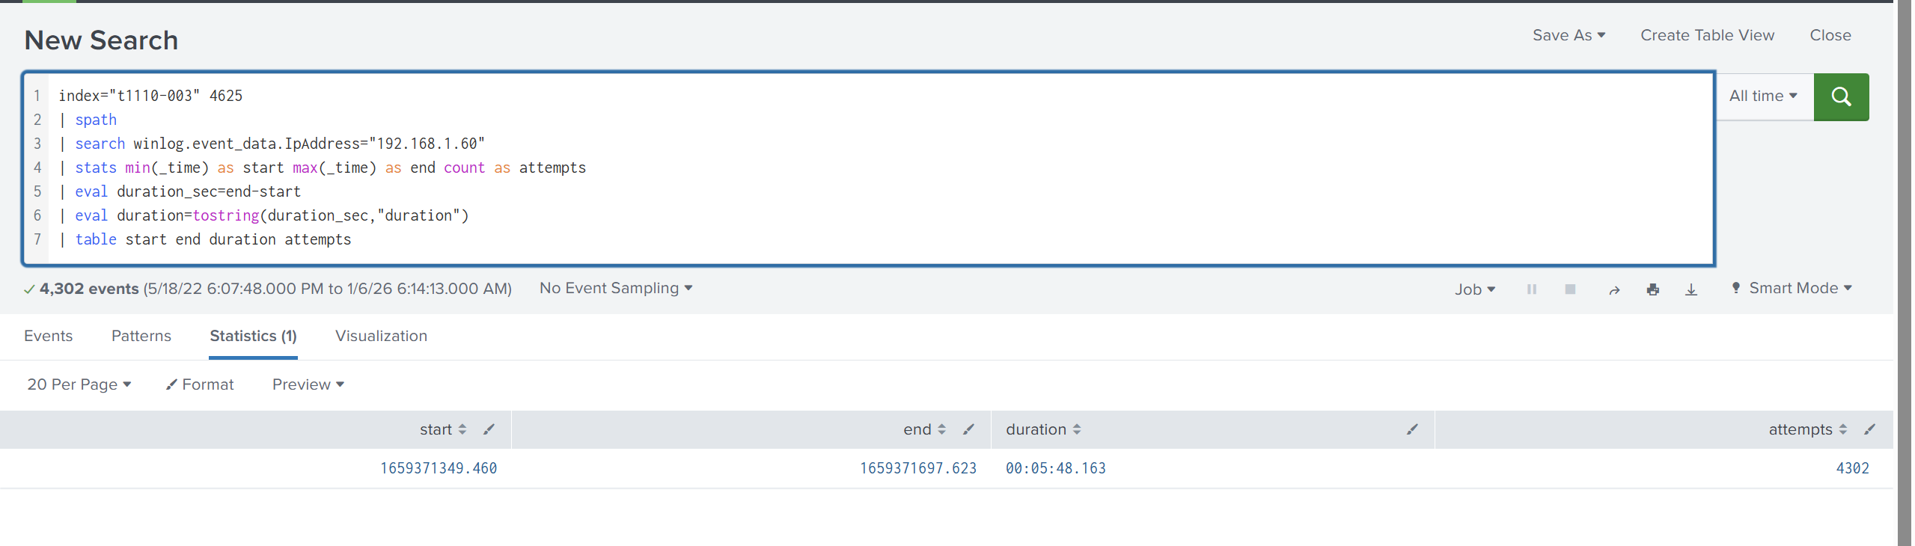
The brute-force/password spraying activity observed in log 4625 from IP 192.168.1.60 lasted approximately 5 minutes and 48 seconds (from the first attempt to the last attempt).
Use querry:
index="t1110-003" 4625
| spath
| search winlog.event_data.IpAddress="192.168.1.60" winlog.event_data.LogonType=3
| stats min(_time) as start max(_time) as end count as attempts
| eval duration_min=(end-start)/60
| eval avg_attempts_per_min=round(attempts/duration_min,2)
| table start end attempts duration_min avg_attempts_per_min
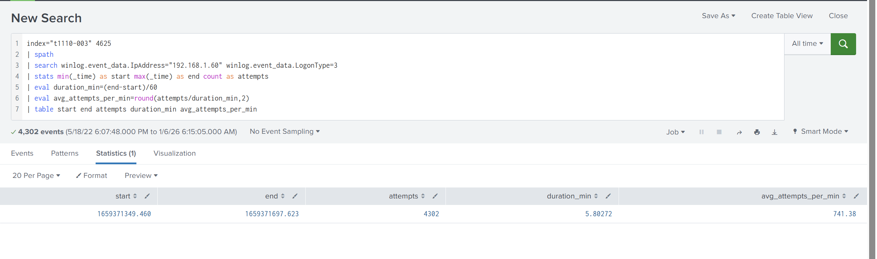
The source 192.168.1.60 performed 4,302 failed network logons (4625, LogonType=3) in approximately 5.8 minutes(5:48), with an average rate of approximately 741 attempts/minute, demonstrating highly automated brute-force/password spraying behavior.

Use the querry:
index="t1110-003" (4624 OR 4625)
| spath
| search winlog.event_data.IpAddress="192.168.1.60"
| stats count as events by winlog.event_data.LogonType
| sort 0 - events
I used queries to try to identify the protocol the attacker used to launch the Bruceforce attack. I filtered both successful and failed logon events to determine the logon type of the filtered events.
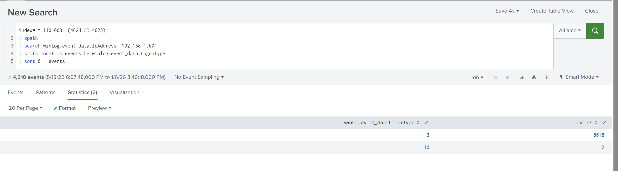
The results show:
LogonType = 3: 8618 events
→ This is Network logon. Given the context you previously demonstrated (NTLM/NTLM), this is typically a Windows network authentication type (most commonly SMB/NTLM or services that accept NTLM).
LogonType = 10: 2 events
→ This is RemoteInteractive — a very typical fingerprint of RDP/Terminal Services.
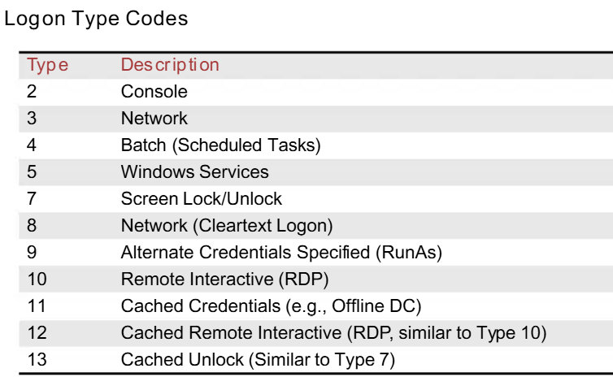
The source 192.168.1.60 generated most of the type 3 (network) logon events with NTLM, indicating brute-force behavior over the NTLM network authentication channel; there were also a few types 10 logons suggesting an RDP attempt/session.
Check 2 type 10 event logs
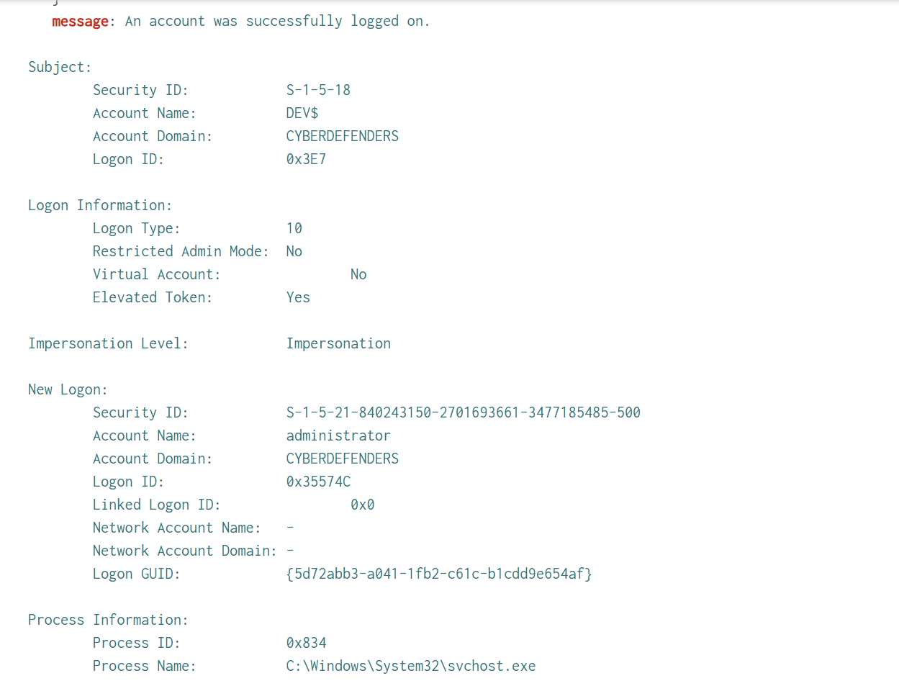
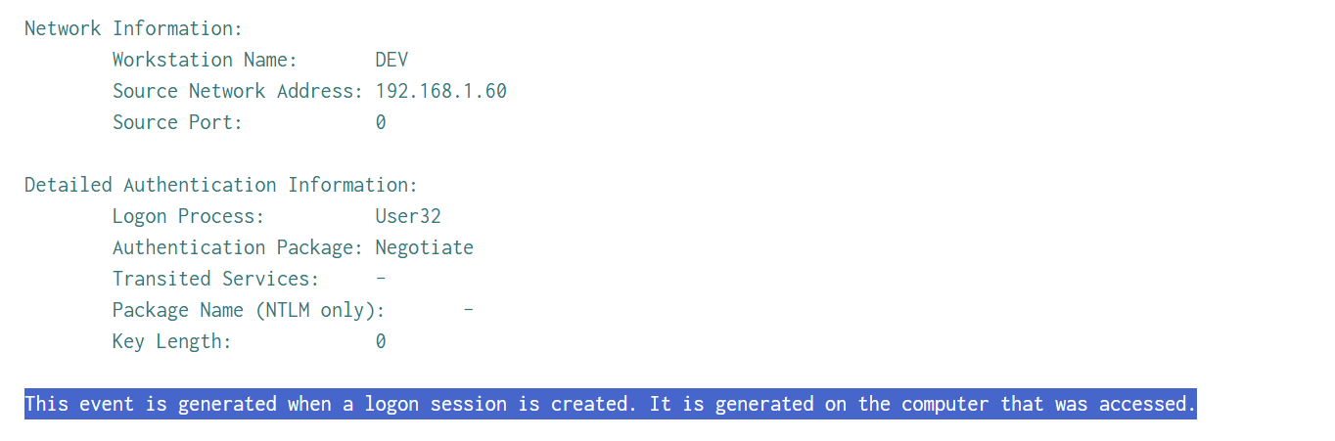
From IP 192.168.1.60, a successful remote login to the Administrator account on the DEV machine was achieved with elevated privileges, and now we have the login ID/GUID to reverse all activity after accessing the machine.

The attacker had successfully logged on administrator account which meant there might be other accounts which were hacked
Use the querry:
index="t1110-003" 4624
| spath
| search winlog.event_data.IpAddress="192.168.1.60"
| stats dc(winlog.event_data.TargetUserName) as unique_users values(winlog.event_data.TargetUserName) as users
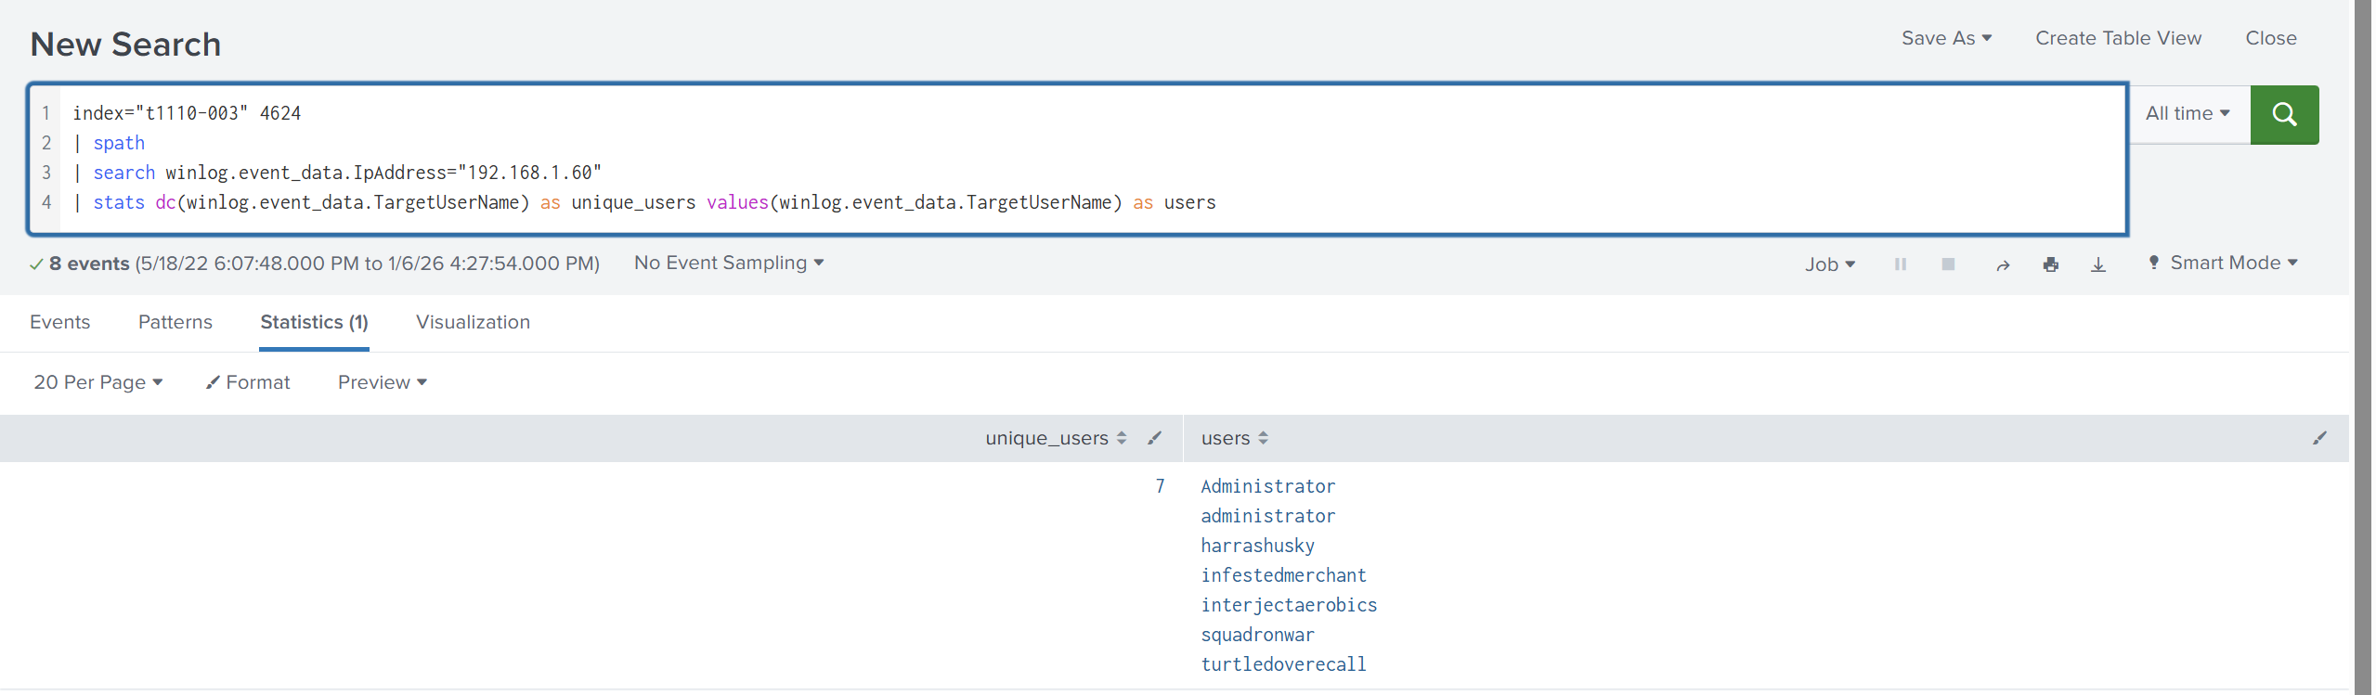
As we can see, these are the accounts which the attackers have successfully logged on
Next, I use the querry:
index="t1110-003" 4624
| spath
| search winlog.event_data.IpAddress="192.168.1.60"
| stats min(_time) as first_seen max(_time) as last_seen count as success_count values(winlog.event_data.LogonType) as logon_types by winlog.event_data.TargetUserName
| convert ctime(first_seen) ctime(last_seen)
| sort 0 first_seen
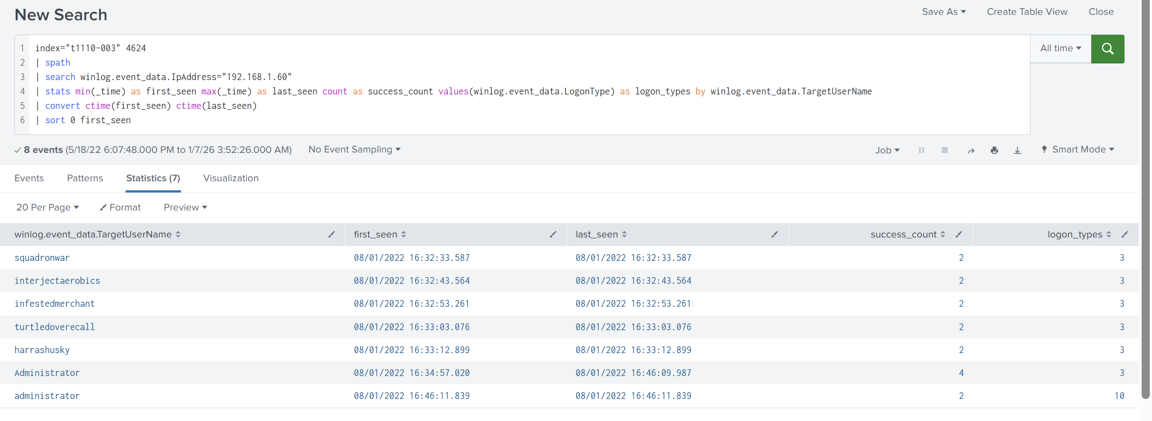
Initial phase (16:32–16:33): Many accounts were successfully "network logonized" (Type 3) very quickly, a strong indication of successful brute force/spraying on multiple users.
As we can see the attacker logged into the machine again with Adminitrator account after 11 minites since the first successful logged on.
Continue the investigation, I focused on 2 user Administrtor and administrator, Windows is generally not case-sensitive, but the logs may still show both styles due to different parsers/fields, so I confirm through SID
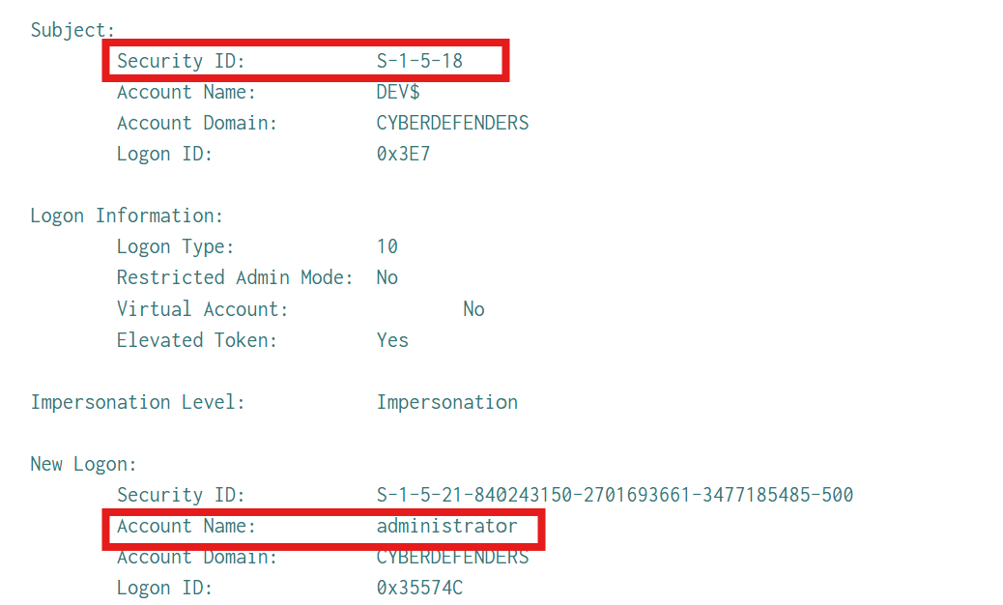
I confirm that these 2 Administrator accounts are the same one as they SID. Next, I determine the administrator account privilege, see what attackers could been done after successfully logged on to the system
I use querry to retrieve all administrator event 4672s and compile a list of privileges that Windows assigns to its logon session.
index="t1110-003" 4672
| spath
| search winlog.event_data.SubjectUserName="administrator"
| stats values(winlog.event_data.PrivilegeList) as privileges
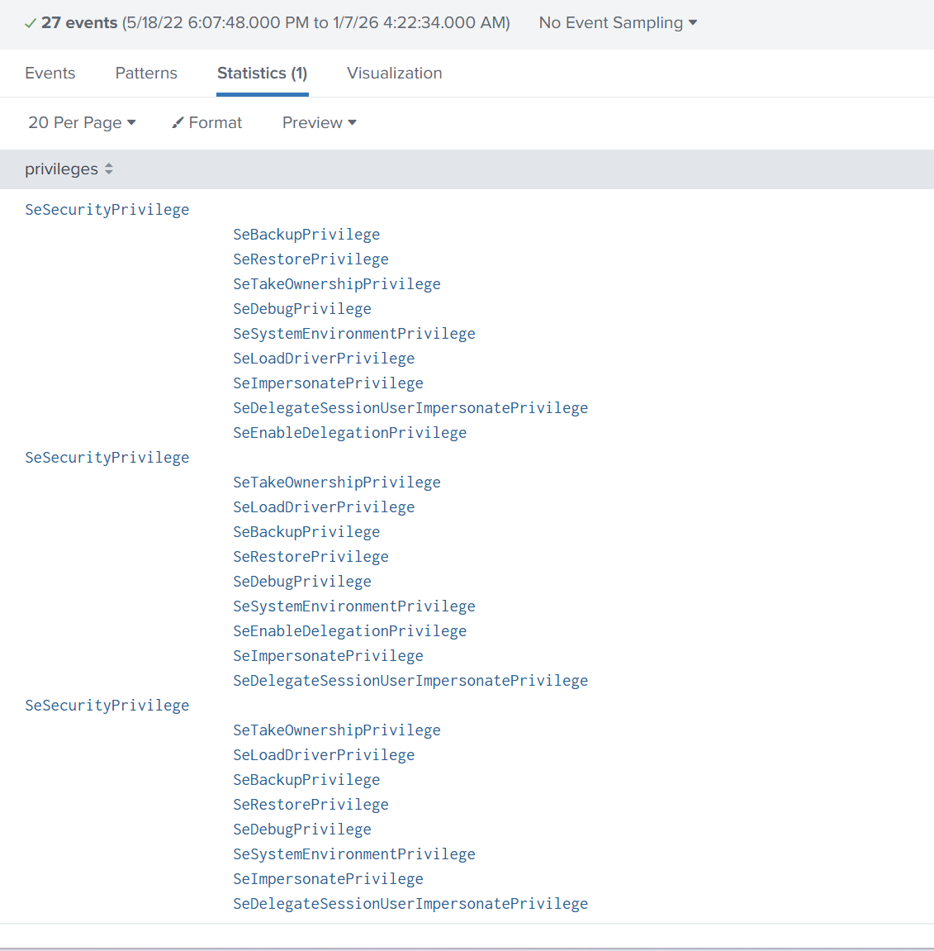

I investigated what action the attackers did after logged into an administrator account. I click on each event and determine its logon ID.
Use the querry:
index="t1110-003" "0x35574C"
and I found 3 events
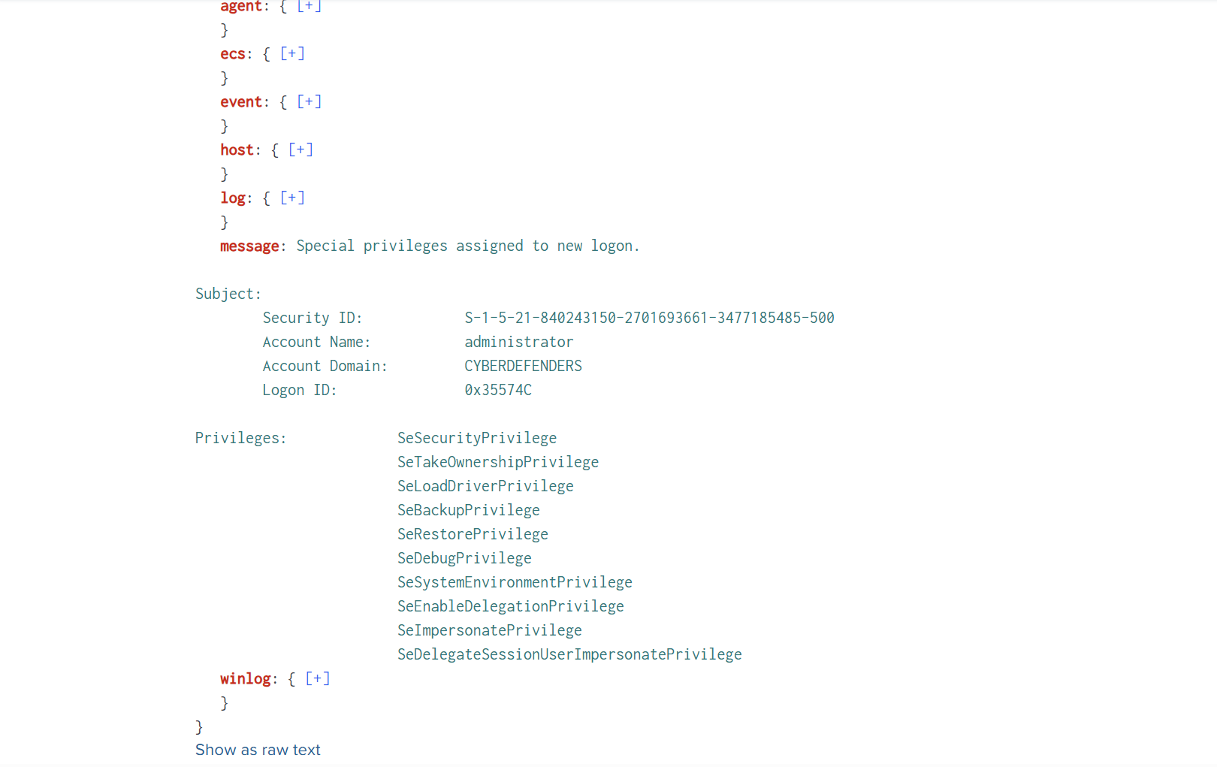
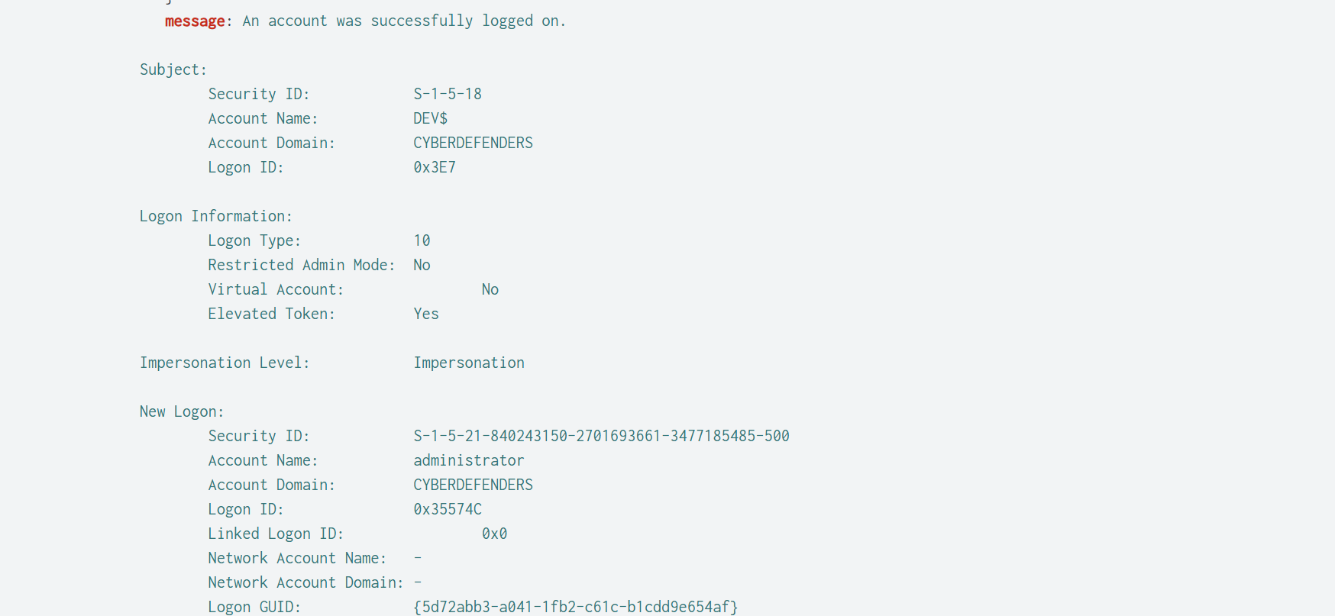
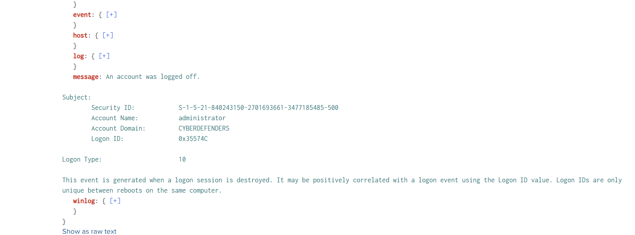
The attacker (192.168.1.60) created a login RDP (LogonType 10) into the administrator account, granted high privileges (4672), and then logged out very quickly (4634).
4. Investigation Timeline and Conclusion
1 - Initiation of failed logon bursts (spraying/bruteforce):
The attack source 192.168.1.60 began generating a large number of failed logon attempts (4625 – LogonType=3 (Network)). This burst was measured to have 4,302 attempts.
2 - Early "successes" occurred on many users during the burst:
Between 16:32 and 16:33, many accounts successfully logged on 4624 – Type 3 very quickly (indicating accurate credential predictions on many users while the attack continued).
3 - Burst End & Attack Speed:
Burst 4625 lasted approximately 5 minutes and 48 seconds, averaging 741 attempts/minute ⇒ highly automated behavior (tool brute-force/spraying).
4 - Success with privileged account (Administrator):
After Type 3 successes, the attacker has successful access to the Administrator account, and you observe the "return after 11 minutes" behavior (re-access/persistence at the behavioral level).
5 - Appearance of RDP/RemoteInteractive (LogonType=10):
LogonType=10 (RemoteInteractive) is present from the same attack source ⇒ typical fingerprint of RDP/Terminal Services.
6 - Very short admin session (logon ID for pivoting):
With LogonId=0x35574C, you have pivoted to the event sequence and concluded: the attacker RDPed to the administrator account (Type 10), was granted high privileges (4672), and then logged out very quickly (4634).
Conclusion
This is Password Spraying/Brute-force (T1110.003) from 192.168.1.60 targeting remote login, clearly demonstrated by a burst of 4625 LogonType=3 with an intensity of approximately 741 attempts/minute for approximately 5:48.
The attacker had successful logons (4624) on multiple accounts during the burst, and eventually gained Administrator access, followed by a LogonType=10 (RDP/RemoteInteractive) — sufficient evidence to conclude the target was bruteforce/spraying for remote login (RDP).
5. IOC
Network / Host IOCs
- Attacker Source IP (primary): 192.168.1.60
- Attacker WorkstationName: kali
- Other low-volume sources (noise/secondary): 192.168.1.51, 192.168.1.61 (WorkstationName: 0xmohammed)
- Victim/Target host IP (identified): 192.168.19.129
Authentication / Protocol IOCs
- Key Event IDs: 4625 (failed logon), 4624 (successful logon), 4672 (special privileges assigned), 4634 (logoff)
- Primary LogonType: 3 (Network) — consistent with password spraying/brute-force over the network
- RDP evidence: LogonType=10 (RemoteInteractive) observed from the same attacker source
- LogonProcess / AuthPackage: NtLmSsp + NTLM (NTLM-based network authentication)
- Failure status/substatus: 0xC000006D and 0xC000006A (bad password) — consistent with spraying/brute-force activity
Account / Session IOCs
- Privileged account accessed: Administrator/administrator (case differs but same SID, as verified)
- Notable pivot LogonId: 0x35574C (4624 → 4672 → 4634 sequence; very short admin session)
- “Latest local/interactive” LogonId recorded: 0x365726

