Prerequire:

* Terraform CLI
* Aws CLI (configured with default profile)
* Create keys, S3 bucket, and dynamo db – (LockID(String) primary/hash key) for terraform backend (store state files)

Clone repo at: [hieptran228/sd4871_infrastructure (github.com)](https://github.com/hieptran228/sd4871_infrastructure)

1. Bootstrap

Run:

cd bootstrap

terraform init

terraform plan

terraform apply -auto-approve

Result:

1. Create AWS network

cd network

terraform init

terraform plan

terraform apply -auto-approve

Result:

* VPC create multiple subnets in different regions

1. Create AWS EC2 (for Jenkins, docker build, sonarqube, agrocd)

cd ec2

terraform init

terraform plan

terraform apply -auto-approve

Result:

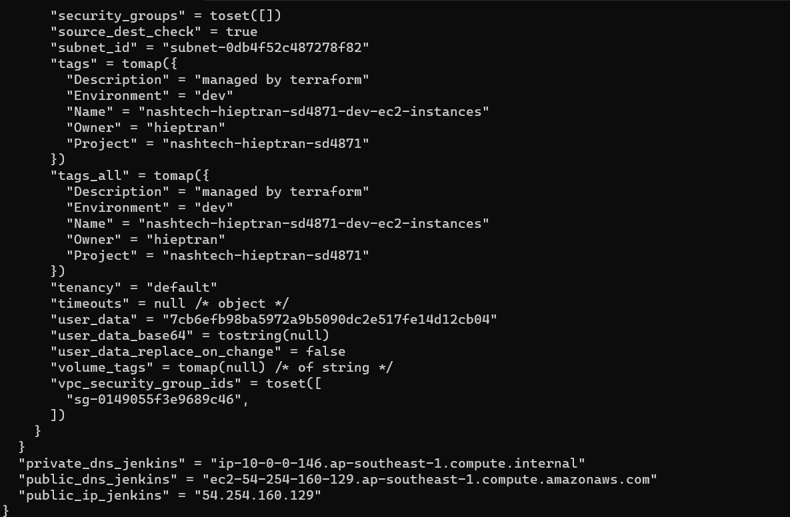

1. Create AWS ECR

cd ecr

terraform init

terraform plan

terraform apply -auto-approve

Output

1. Create AWS EKS cluster

cd eks

terraform init

terraform plan

terraform apply -auto-approve

Output

