przykĹ‚ady_do_mgr.R

Sebastian

Tue Mar 27 17:07:25 2018

wzrost <- c(161, 184, 148, 196, 138, 166, 189, 173, 162, 171)  
waga <- c(63, 81, 56, 91, 57, 67, 76, 72, 62, 68)  
ludzie <- as.data.frame(cbind(wzrost, waga))  
summary(ludzie)

## wzrost waga   
## Min. :138.0 Min. :56.00   
## 1st Qu.:161.2 1st Qu.:62.25   
## Median :168.5 Median :67.50   
## Mean :168.8 Mean :69.30   
## 3rd Qu.:181.2 3rd Qu.:75.00   
## Max. :196.0 Max. :91.00

model <- lm(waga~wzrost, data= ludzie)  
summary(model)

##   
## Call:  
## lm(formula = waga ~ wzrost, data = ludzie)  
##   
## Residuals:  
## Min 1Q Median 3Q Max   
## -4.9602 -2.3768 -0.9886 2.2634 5.9992   
##   
## Coefficients:  
## Estimate Std. Error t value Pr(>|t|)   
## (Intercept) -28.13749 12.33889 -2.280 0.052 .   
## wzrost 0.57724 0.07273 7.937 4.62e-05 ***  
## ---  
## Signif. codes: 0 '***' 0.001 '**' 0.01 '*' 0.05 '.' 0.1 ' ' 1  
##   
## Residual standard error: 3.915 on 8 degrees of freedom  
## Multiple R-squared: 0.8873, Adjusted R-squared: 0.8732   
## F-statistic: 62.99 on 1 and 8 DF, p-value: 4.623e-05

plot(waga,wzrost,col = "blue",main = "model regresji wzrostu i wagi",  
 abline(lm(wzrost~waga)),cex = 1.3,pch = 16,xlab = "Waga w Kg",ylab = "wzrost w cm")

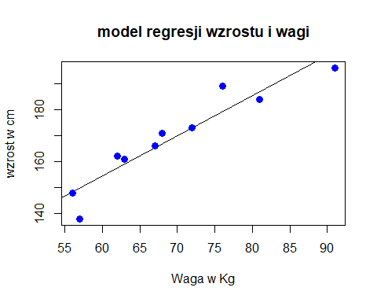

par(mfrow=c(1, 2))  
plot(density(wzrost), main="Wykres gęstości- wzrost", ylab="Częstotliwość", xlab="wzrost")  
polygon(density(wzrost), col="blue")  
plot(density(waga), main="Wykres gęstości- waga", ylab="Częstotliwość", xlab="waga")  
polygon(density(waga), col="red")

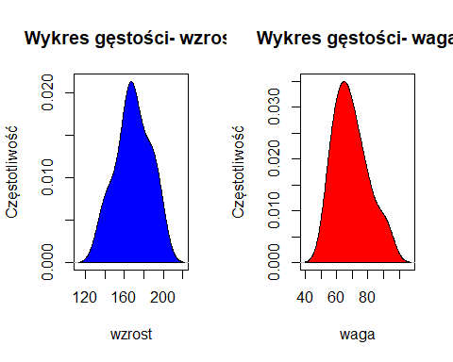

par(mfrow=c(1, 2)) # divide graph area in 2 columns  
boxplot(wzrost, data= ludzie, main="wzrost") # box plot for 'speed'  
boxplot(waga, data= ludzie, main= "waga")

