OPENGL画茶壶并旋转

实验目的：opengl的函数功能，使用opengl库函数对3D图像的坐标位置进行定位，使用相关函数进行旋转。设置输入输出语句，配合scanf人机交互，由用户对旋转轴和角度进行指定。填充图定位在固定点，旋转线框图来进行对照。

实验代码：

#include<glut.h>

#include<stdio.h>

GLsizeiwinWidth = 500,winHeight = 500;

charsixel;

floatthera=0;

float x=0,y=0,z=0;

voidinit(void){

glClearColor(1.0,1.0,1.0,0.0);

}

voiddisplayWirePolyhedra(float x,floaty,floatz,floatthera){

glClear(GL_COLOR_BUFFER_BIT);

glColor3f(0.0,0.0,1.0);

gluLookAt(5.0,5.0,5.0,0.0,0.0,0.0,0.0,1.0,0.0);

glScalef(1.0,1.0,1.0);

glTranslatef(1.0,2.0,0.0);//下一个图形坐标

glutSolidTeapot(1.5);

//glutWireTeapot(1.5);//放大倍数

glScalef(1.0,1.0,1.0);//缩放比

glTranslatef(-1.0,-5.0,0.0);//下一个图形坐标

glRotatef(thera,x,y,z);

glutWireTeapot(1.5);

//glutSolidTeapot(2.0);

glFlush();

}

void display(){

displayWirePolyhedra(x,y,z,thera);

}

voidwinReshapeFcn(GLintnewWidth,GLintnewHeight){

glViewport(0,0,newWidth,newHeight);

glMatrixMode(GL_PROJECTION);

glFrustum(-1.0,1.0,-1.0,1.0,2.0,20.0);

glMatrixMode(GL_MODELVIEW);

glClear(GL_COLOR_BUFFER_BIT);

}

void main(intargc,char** argv){

glutInit(&argc,argv);

glutInitDisplayMode(GLUT_SINGLE|GLUT_RGB);

glutInitWindowPosition(100,100);

glutInitWindowSize(winWidth,winHeight);

glutCreateWindow(" ");

init();

printf("请选择绕拿一个轴旋转x,y,z \n");

scanf("%c",&sixel);

getchar();

if(sixel=='x'){

x=1.0;

y=0.0;

z=0.0;

printf("请输入旋转的角度\n");

scanf("%f",&thera);

}else if(sixel=='y'){

x=0.0;

y=1.0;

z=0.0;

printf("请输入旋转的角度\n");

scanf("%f",&thera);

}else if(sixel=='z'){

x=0.0;

y=0.0;

z=1.0;

printf("请输入旋转的角度\n");

scanf("%f",&thera);

}else{

printf("输入有误\n");

}

glutDisplayFunc(display);

glutReshapeFunc(winReshapeFcn);

glutMainLoop();

}

实验结果

1. 绕x轴旋转30度

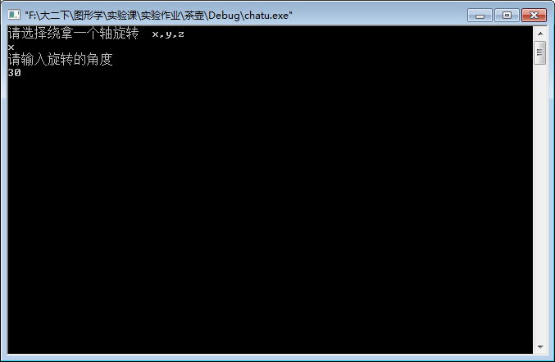

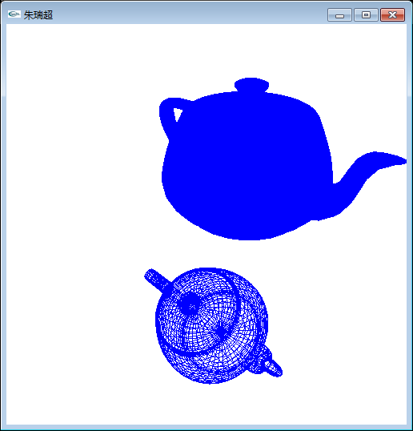

2.绕y轴旋转90度

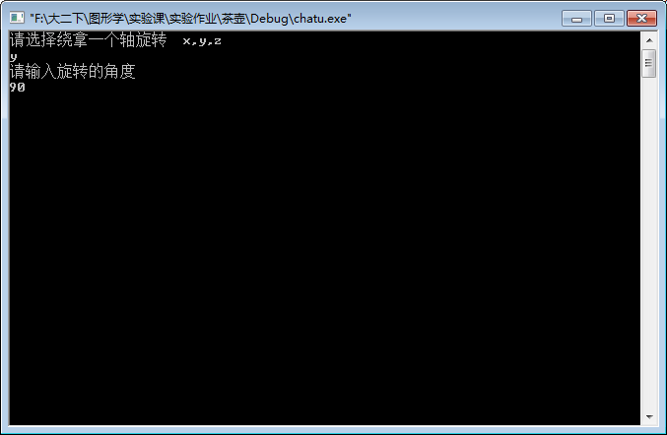

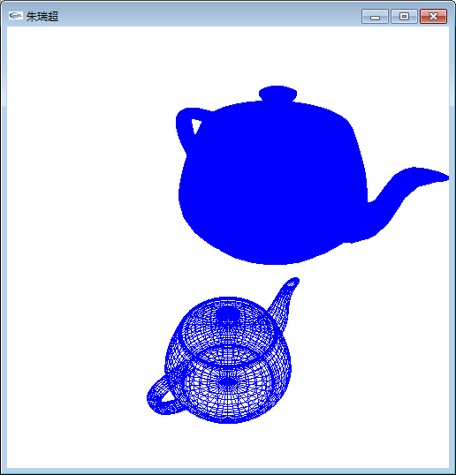

3.绕Z轴旋转180度

