1. 2.12节 第2题：

**Waterfall:**

Benefits：

simple,familiar to most developers,easy to understand

easy to associate measures,milestoees,and deliverables with the differeat stages.

Drawbacks:

does not reflect how software is really developed

not applicable for many types of development

does not reflect the back-and-forth,iterative nature of problem solving

**V model:**

Benefits:

bener spells role of types of tesing

involves the user in testing

Drawbacks:

exnensive testing may not always be cou-effective

some of the same drawbacks as waterfall

**Prototyping:**

Benefits:

peomoees understanding of peoblem before trying to implement solution

roduces risk and uncertainty

imvolves user in evaluating interface

Drarwbacks:

in systems where the problem is well understood or where the user interface is simple and straightforward,the extra time spent in prototyping is not warranted protoryping can use up a lot of resources,especially if the prototype fails completely and must be serapped.

**Operational specification:**

Benetits：

allows user and developer to resolve requirements uncertainty early on

Drawbacks:

upfront investment may not be warranted if problem is well understood

**Transformational:**

Benefits:

eliminates large steps of the process,thus reducing cost and opportunity for error.

provides automatic documentation

Drawbacks:

needs a very precise formal specification

**Incremental or iterative development:**

Benefits:

reduces time to when customer receives some product

customer training can begin early

creates markets for new functionality

frequent releases allow problems to be fixed quickly

expertise can be applied to different releases

Drawbacks:

customer may not be satisfied with an incomplete product or with frequent changes to system.

product may never be "complete".

problem may not be easily decomposable

changes may have to be made to completed parts in order to work with new parts.

**Spiral:**

Benefits:

monitors and controls risks throughout process

easily incorporates protoryping

Drawbacks:

a lot of overhead.

第四章4.19节 第1题：

1. Developers,customers,and users all bear some responsibility for the situation,as they all had input into the requirements of the system.However,the developers (or the development organization)should probably bear most of the responsibility because they,as software professionals,should have the expertise to ensure that the requirements are complete.

第四章4.19节 第3题：

3.In an early meeting with your customer, the customer lists the following “requirements” for a system he wants you to build:

(a) The client daemon must be invisible to the user (b)The system should provide automatic verification of corrupted links or outdated data

(c) An internal naming convention should ensure that records are unique (d) Communication between the database and servers should be encrypted

 (e) Relationships may exist between title groups [a type of record in the database]

(f)Files should be organizable into groups of file dependencies

(g) The system must interface with an Oracle database

(h) The system must handle 50,000 users concurrently

Classify each of the above as a functional requirement, a quality requirement, a design constraint, or a process constraint. Which of the above might be premature design decisions? Re express each of these decisions as a requirement that the design decision was meant to achieve.

1. The client daemon must be invisible to the user.

**Design constraint.**

1. The system should provide automatic verification of corrupted links or outdated data.

**Functional requirement.**

1. An internal naming convention should ensure that records are unique.

**Functional requirement.**

1. Communication between the database and servers should be encrypted.

**Functional requirement.**

1. Relationships may exist between title groups [a type of record in the database].

**Design constraint.**

1. Files should be organizable into groups of file dependencies.

**Functional requirement**

1. The system must interface with an Oracle database.

**Design constraint**

(h) The system must handle 50,000 users concurrently.

**Quality requirement.**

(a) and (c) refer to design constructs. These requirements could be better expressed by eliminating reference to these constructs:

a) User should believe that he is interacting with a centralized system

c) All records must be unique

第四章4.19节 第11题：

1. Some factors to consider in this decision are

Who will be building the prototype?If they have a good understanding of the requirements,then they could write the requirements after the prototype has been evaluated.Otherwise,they will need some guidance or documentation,and a draft of the requirements should be written by someone else so that the prototype builders can use them.

How tight are the schedule and budget?If the requirements are written before the

prototype is developed,they will likely have to be substantially modified after

the prototype is evaluated.

How much is known about the requirements before the prototype is evaluated?If

little is understood about the requirements,then it does not make sense to try to write

them down.They will be clarified through the evaluation of the prototype(s)with the

customer.

第五章5.18节 第11题：

11. For each of the systems described below, sketch an appropriate software

architecture and explain how you would assign key functionalities to the design’s components.

(a) a system of automated banking machines, acting as distributed kiosks that bank

customers can use to deposit and withdraw cash from their accounts (b) a news feeder that notifies each user of news bulletins on topics in which the user has

(c)image-processing software that allows users to apply various operations to modify

their pictures (e.g.，rotation, color tinting, cropping)

(d) a weather forecasting application that analyzes tens of thousands of data elements collected from various sensors; the sensors periodically transmit new data values

(a) Repositories. The central data store (bank server) contains information about all accounts in the bank. Each machine is a data accessor, capable of retrieving account information for a given account and withdrawing or depositing cash into that account.

(b) Publish-Subscribe. Every user can subscribe the news they needed, and when the news are published, users who subscribed the news will get a notice.

(c) Pipe-and-Filter. Each operation corresponds to a filter that outputs the user input image as target data. The filters could be combined to process the images.

(d) Cilent-Server. Every sensor is a client, they generate data and send it to the central server.

第六章6.16节 第1题：

1.Answers to this question may vary,since some details for the specific scenarios will befilled in by the reader.The number of distinct use cases is also subjective,as long as theuse cases in combination describe all of the car wash functionality specified.

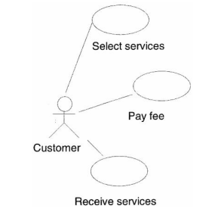One solution is as follows:

The "seleet services"scenario begins when the customer drives his car up to the

control panel.The system displays on the control panel is listing of the different

levels of service available and the price for each.The customer initiates a

transaction by pushing a button on the control panel corresponding to a particular

service.The system then prompts the customer to indicate (by pushing a button on

the control panel)the type of car he or she is driving (eg.compact,midsize.

minivan,truck),or to cancel.if the customer selects "cancel",the system resets and

the customer can select a different service,if desired.

The "pay fee"scenario begins when the customer has finished selecting the services

The system then computes the fee and displays the amount on the control paneL If

the customer does nothing.then after a short period of time the system resets itself

Otherwise,the customer inserts money into the money reader.which is responsible

for reporting to the system the value of the money just entered.[Note that because the car wash is to be an automated system,we assume the existence of an external system for accepting customer payment.The system compares the value of the money just entered to the fee remaining to be paid.If the amount just entered is greater,then the system instructs the money reader to return the proper amount of change:otherwise,the system calculates the remaining fee and instructs the money reader to display this amount on the control panel When the fee has been completely

paid the system is ready to dispense services.

The "receive services"scenario begins when the customer has completely paid the

fee.If the car wash is currently busy,the control panel indicates that the customer.

第六章6.16节 第22题：

1. Consider a simplified OO design, shown in Figure 6.47, for a banking system. Accounts can be created at the bank, and money can be deposited and withdrawn from the account. An account is accessed by its account number. Use the Decorator design pattern to add two new banking features to the design:

(a) Overdraft protection: allows the customer to withdraw money when the account balance is zero; the total amount that can be withdrawn in this feature is a predefined

credit limit.

(b) Transaction fee: charges the customer a fixed fee for each deposit and withdrawal

transaction.

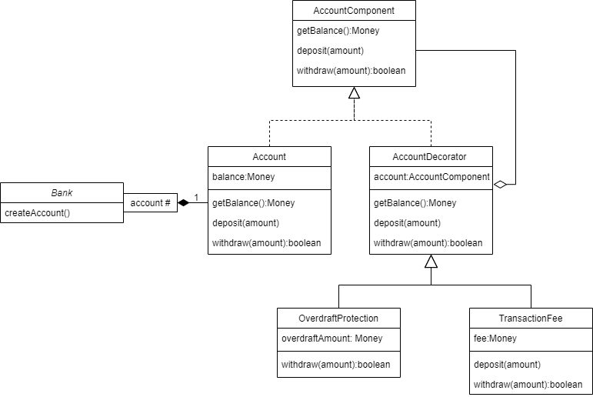

第六章6.16节 第23题：

1. A bank must report to the government’s tax institution all transactions (deposits and withdrawals) that exceed $10,000. Building on the initial design of the banking system from question 22, use the Observer design pattern to construct a class that monitors all Account transactions.

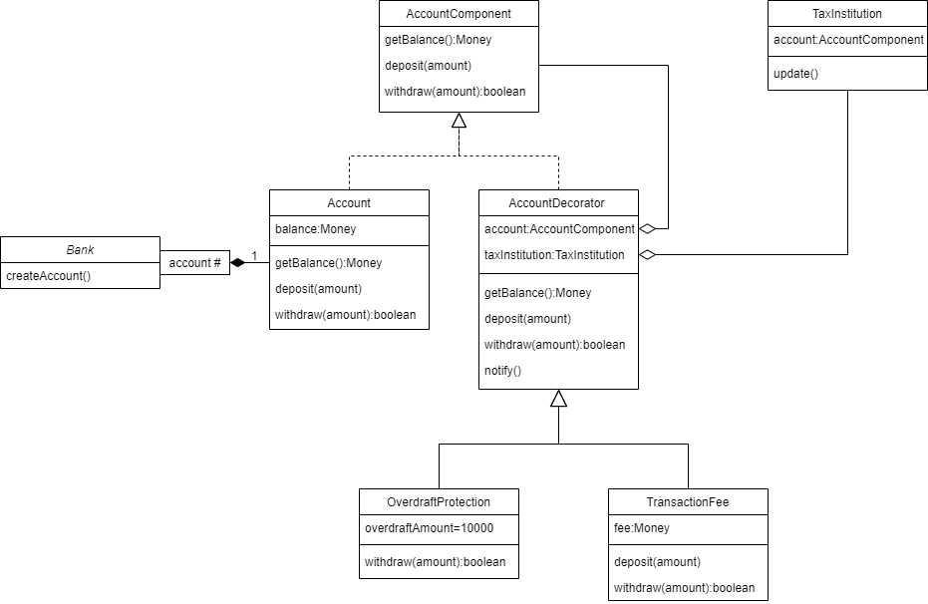

第六章8.16节 第4题：

4. Suppose a program contains N decision points, cach of which has two branches.

How many test cases are needed to perform path testing on such a program? If there

are M choices at each decision point, how many test cases are needed for path testing. Can the program’s structure reduce this number? Give an example to support your answer.

If there are N decision points and each decision points has 2 branches, then the total number of possible paths to pass all the decision points is 2^N.So the total number of the test cases is 2^N.

If each decision points have M choices, then total number of paths to pass all decision points is M^N;

The effect of reducing the number of paths can be achieved by nested branches. For example, the following four branches have a total of 2^4=16 paths

if(a<0)and(b<0)then...

if(a<0)and(b>=0)then...

if(a>0)and(b<0)then...

if(a>0)and(b>=0)then...

The above program is equivalent to the following program, but the latter has only four paths, only four test cases are needed

if(a<0)then

if((b<0) then...

Else....

else

if((b<0) then...

Else...