**Bài tập lí thuyết**

**Bài 1:**

Đếm các bậc của đỉnh:

|  |  |  |  |  |  |  |  |
| --- | --- | --- | --- | --- | --- | --- | --- |
|  | Đỉnh a | Đỉnh b | Đỉnh c | Đỉnh d | Đỉnh e | Đỉnh f | Đỉnh g |
| 5.1 | 3 | 4 | 4 | 4 | 2 | 5 | 2 |
| 5.2 | 5 | 4 | 4 | 5 | 2 | 6 |  |
| 5.3 | 5 | 6 | 4 | 4 | 4 | 3 |  |
| 5.6 | 3 | 2 | 1 | 1 | 1 | 1 |  |

**Bài 2:**

Ma trận kề của 5.1:

|  |  |  |  |  |  |  |  |
| --- | --- | --- | --- | --- | --- | --- | --- |
| 5.1 | A | B | C | D | E | F | G |
| A | 0 | 1 | 1 | 1 |  |  |  |
| B | 1 | 0 |  |  | 1 | 1 |  |
| C | 1 |  | 0 |  |  | 1 |  |
| D | 1 |  |  | 0 |  | 1 | 1 |
| E |  | 1 |  |  | 0 |  |  |

Đếm các bậc của đỉnh:

|  |  |  |  |  |  |  |  |
| --- | --- | --- | --- | --- | --- | --- | --- |
|  | Đỉnh a | Đỉnh b | Đỉnh c | Đỉnh d | Đỉnh e | Đỉnh f | Đỉnh g |
| 5.1 | 3 | 4 | 4 | 4 | 2 | 5 | 2 |
| 5.2 | 5 | 4 | 4 | 5 | 2 | 6 |  |
| 5.3 | 5 | 6 | 4 | 4 | 4 | 3 |  |
| 5.6 | 3 | 2 | 1 | 1 | 1 | 1 |  |

Bài 2:

Ma trận kề của 5.1:

|  |  |  |  |  |  |  |  |
| --- | --- | --- | --- | --- | --- | --- | --- |
| 5.1 | A | B | C | D | E | F | G |
| A | 0 | 1 | 1 | 1 |  |  |  |
| B | 1 | 0 |  |  | 1 | 1 |  |
| C | 1 |  | 0 |  |  | 1 |  |
| D | 1 |  |  | 0 |  | 1 | 1 |
| E |  | 1 |  |  | 0 |  |  |
| F |  | 1 | 1 | 1 |  | 0 |  |
| G |  |  |  | 1 |  |  | 0 |

Ma trận kề của 5.6:

|  |  |  |  |  |  |  |
| --- | --- | --- | --- | --- | --- | --- |
| 5.6 | A | B | C | D | E | F |
| A | 0 | 1 | 1 | 1 |  |  |
| B | 1 | 0 | 1 |  | 1 |  |
| C |  |  | 0 | 1 | 1 |  |
| D |  |  |  | 0 | 1 |  |
| E |  |  |  |  | 0 | 1 |
| F |  | 1 |  |  |  | 0 |

Ma trận kề của ví dụ 5.7:

|  |  |  |  |  |  |  |  |
| --- | --- | --- | --- | --- | --- | --- | --- |
| F |  | 1 | 1 | 1 |  | 0 |  |
| G |  |  |  | 1 |  |  | 0 |

Ma trận kề của 5.6:

|  |  |  |  |  |  |  |
| --- | --- | --- | --- | --- | --- | --- |
| 5.6 | A | B | C | D | E | F |
| A | 0 | 1 | 1 | 1 |  |  |
| B | 1 | 0 | 1 |  | 1 |  |
| C |  |  | 0 | 1 | 1 |  |
| D |  |  |  | 0 | 1 |  |
| E |  |  |  |  | 0 | 1 |
| F |  | 1 |  |  |  | 0 |

Ma trận kề của ví dụ 5.7:

|  |  |  |  |  |  |  |
| --- | --- | --- | --- | --- | --- | --- |
| 5.7 | A | B | C | D | E | F |
| A | 0 | 110 | 90 | 100 |  |  |
| B | 110 | 0 | 50 |  | 55 | 80 |
| C | 90 | 50 | 0 | 40 | 80 |  |
| D | 100 |  | 40 | 0 | 60 |  |
| E |  | 55 | 80 | 60 | 0 | 70 |
| F |  | 80 |  |  | 70 | 0 |

Ma trận kề của ví dụ 5.11:

|  |  |  |  |  |  |  |  |  |  |  |  |  |  |  |
| --- | --- | --- | --- | --- | --- | --- | --- | --- | --- | --- | --- | --- | --- | --- |
| 5.11 | 1 | 2 | 3 | 4 | 5 | 6 | 7 | 8 | 9 | 10 | 11 | 12 | 13 | 14 |
| 1 | 0 | 1 | 1 | 1 |  |  |  |  |  |  |  |  |  |  |
| 2 | 1 | 0 |  |  |  |  | 1 |  |  |  |  |  |  |  |
| 3 | 1 |  | 0 |  |  | 1 |  |  |  |  |  |  |  |  |
| 4 | 1 |  |  | 0 | 1 |  |  |  |  |  |  |  |  |  |
| 5 |  |  |  | 1 | 0 |  |  |  |  | 1 | 1 |  |  |  |

Ma trận kề của ví dụ 5.11:

|  |  |  |  |  |  |  |  |  |  |  |  |  |  |  |
| --- | --- | --- | --- | --- | --- | --- | --- | --- | --- | --- | --- | --- | --- | --- |
| 5.11 | 1 | 2 | 3 | 4 | 5 | 6 | 7 | 8 | 9 | 10 | 11 | 12 | 13 | 14 |
| 1 | 0 | 1 | 1 | 1 |  |  |  |  |  |  |  |  |  |  |
| 2 | 1 | 0 |  |  |  |  | 1 |  |  |  |  |  |  |  |
| 3 | 1 |  | 0 |  |  | 1 |  |  |  |  |  |  |  |  |
| 4 | 1 |  |  | 0 | 1 |  |  |  |  |  |  |  |  |  |
| 5 |  |  |  | 1 | 0 |  |  |  |  | 1 | 1 |  |  |  |
| 6 |  |  | 1 |  |  | 0 |  |  |  |  |  |  |  |  |
| 7 |  | 1 |  |  |  |  | 0 | 1 | 1 |  |  |  |  |  |
| 8 |  |  |  |  |  |  | 1 | 0 |  |  |  |  | 1 | 1 |
| 9 |  |  |  |  |  |  | 1 |  | 0 |  |  |  |  |  |
| 10 |  |  |  |  | 1 |  |  |  |  | 0 |  | 1 |  |  |
| 11 |  |  |  |  | 1 |  |  |  |  |  | 0 |  |  |  |
| 12 |  |  |  |  |  |  |  |  |  | 1 |  | 0 |  |  |
| 13 |  |  |  |  |  |  |  | 1 |  |  |  |  | 0 |  |
| 14 |  |  |  |  |  |  |  | 1 |  |  |  |  |  | 0 |

**Bài 3**: Hình 5.1 , hình 5.8:

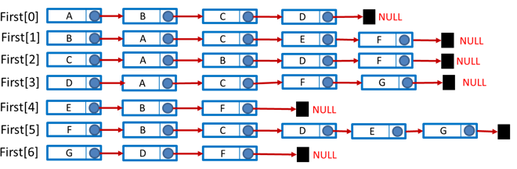

Hình 5.7:

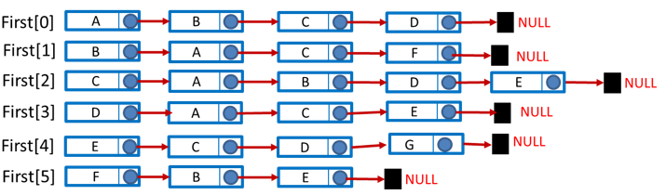

Hình 5.11:

