Họ Tên: Nguyễn Thị Thu Thanh

MSSV: 1654050100

NHÓM 7 – IT82

CHƯƠNG 5: ĐỒ THỊ

**BÀI TẬP LÝ THUYẾT**

**Bài 1: Thực hiện đếm bậc các đỉnh tại ví dụ 5.1, 5.2, 5.3, 5.6**

* Ví dụ 5.1:
* Det (A) = 3
* Det (B) = 4
* Det (C) = 4
* Det (D) = 4
* Det (E) = 2
* Det (F) = 5
* Det (G) = 2
* Ví dụ 5.2:
* Det (A) = 5
* Det (B) = 4
* Det (C) = 4
* Det (D) = 6
* Det (E) = 2
* Det (F) = 7
* Det (G) = 2
* Ví dụ 5.3:
* Det (A) = 5
* Det (B) = 6
* Det (C) = 4
* Det (D) = 4
* Det (E) = 4
* Det (F) = 3
* Ví dụ 5.6:

|  |  |  |
| --- | --- | --- |
| Đỉnh | INPUT | INPUT |
| A | 0 | 3 |
| B | 2 | 2 |
| C | 2 | 2 |
| D | 2 | 1 |
| E | 3 | 1 |
| F | 1 | 1 |
| Tổng: | 10 | 10 |

**Bài 2: Cho biết ma trận kề của đồ thị tại ví dụ 5.1, 5.6, 5.7, 5.11**

* Ví dụ 5.1:

|  |  |  |  |  |  |  |  |
| --- | --- | --- | --- | --- | --- | --- | --- |
|  | **A** | **B** | **C** | **D** | **E** | **F** | **G** |
| **A** |  | 1 | 1 | 1 |  |  |  |
| **B** | 1 |  | 1 |  | 1 | 1 |  |
| **C** | 1 | 1 |  | 1 |  | 1 |  |
| **D** | 1 |  | 1 |  |  |  | 1 |
| **E** |  | 1 |  |  |  | 1 |  |
| **F** |  | 1 | 1 |  | 1 |  | 1 |
| **G** |  |  |  | 1 |  | 1 |  |

* Ví dụ 5.2:

|  |  |  |  |  |  |  |  |
| --- | --- | --- | --- | --- | --- | --- | --- |
|  | **A** | **B** | **C** | **D** | **E** | **F** | **G** |
| **A** | 1 | 1 | 1 | 1 |  |  |  |
| **B** | 1 |  | 1 |  | 1 | 1 |  |
| **C** | 1 | 1 |  | 1 |  | 1 |  |
| **D** | 1 |  | 1 | 1 |  |  | 1 |
| **E** |  | 1 |  |  |  | 1 |  |
| **F** |  | 1 | 1 |  | 1 | 1 | 1 |
| **G** |  |  |  | 1 |  | 1 |  |

* Ví dụ 5.3:

|  |  |  |  |  |  |  |
| --- | --- | --- | --- | --- | --- | --- |
|  | **A** | **B** | **C** | **D** | **E** | **F** |
| **A** |  | 1 | 1 | 1 |  |  |
| **B** | 1 |  | 1 |  | 1 | 1 |
| **C** | 1 | 1 |  |  | 1 |  |
| **D** | 1 |  |  |  | 1 |  |
| **E** |  | 1 |  | 1 |  | 1 |
| **F** |  | 1 |  |  | 1 |  |

* Ví dụ 5.6:

|  |  |  |  |  |  |  |
| --- | --- | --- | --- | --- | --- | --- |
|  | **A** | **B** | **C** | **D** | **E** | **F** |
| **A** |  | 1 | 1 | 1 |  |  |
| **B** |  |  | 1 |  | 1 |  |
| **C** |  |  |  | 1 | 1 |  |
| **D** |  |  |  |  | 1 |  |
| **E** |  |  |  |  |  | 1 |
| **F** |  | 1 |  |  |  |  |

* Ví dụ 5.7:

|  |  |  |  |  |  |  |
| --- | --- | --- | --- | --- | --- | --- |
|  | **A** | **B** | **C** | **D** | **E** | **F** |
| **A** |  | 110 | 90 | 100 |  |  |
| **B** | 110 |  | 50 |  |  | 80 |
| **C** | 90 | 50 |  | 40 | 80 |  |
| **D** | 100 |  | 40 |  | 60 |  |
| **E** |  |  | 80 | 60 |  | 70 |
| **F** |  | 80 |  |  | 70 |  |

* Ví dụ 5.11:

|  |  |  |  |  |  |  |  |  |  |  |  |  |  |  |
| --- | --- | --- | --- | --- | --- | --- | --- | --- | --- | --- | --- | --- | --- | --- |
|  | **1** | **2** | **3** | **4** | **5** | **6** | **7** | **8** | **9** | **10** | **11** | **12** | **13** | **14** |
| **1** |  | 1 | 1 | 1 |  |  |  |  |  |  |  |  |  |  |
| **2** | 1 |  |  |  |  |  | 1 |  |  |  |  |  |  |  |
| **3** | 1 |  |  |  |  | 1 |  |  |  |  |  |  |  |  |
| **4** | 1 |  |  |  | 1 |  |  |  |  |  |  |  |  |  |
| **5** |  |  |  | 1 |  |  |  |  |  | 1 | 1 |  |  |  |
| **6** |  |  | 1 |  |  |  |  |  |  |  |  |  |  |  |
| **7** |  | 1 |  |  |  |  |  | 1 | 1 |  |  |  |  |  |
| **8** |  |  |  |  |  |  | 1 |  |  |  |  |  | 1 | 1 |
| **9** |  |  |  |  |  |  | 1 |  |  |  |  |  |  |  |
| **10** |  |  |  |  | 1 |  |  |  |  |  |  | 1 |  |  |
| **11** |  |  |  |  | 1 |  |  |  |  |  |  |  |  |  |
| **12** |  |  |  |  |  |  |  |  |  | 1 |  |  |  |  |
| **13** |  |  |  |  |  |  |  | 1 |  |  |  |  |  |  |
| **14** |  |  |  |  |  |  |  | 1 |  |  |  |  |  |  |

**Bài 3: Cho biết danh sách kề của đồ thị tại ví dụ 5.1, 5.7, 5.8, 5.11**

* **Ví dụ: 5.1, 5.8:**

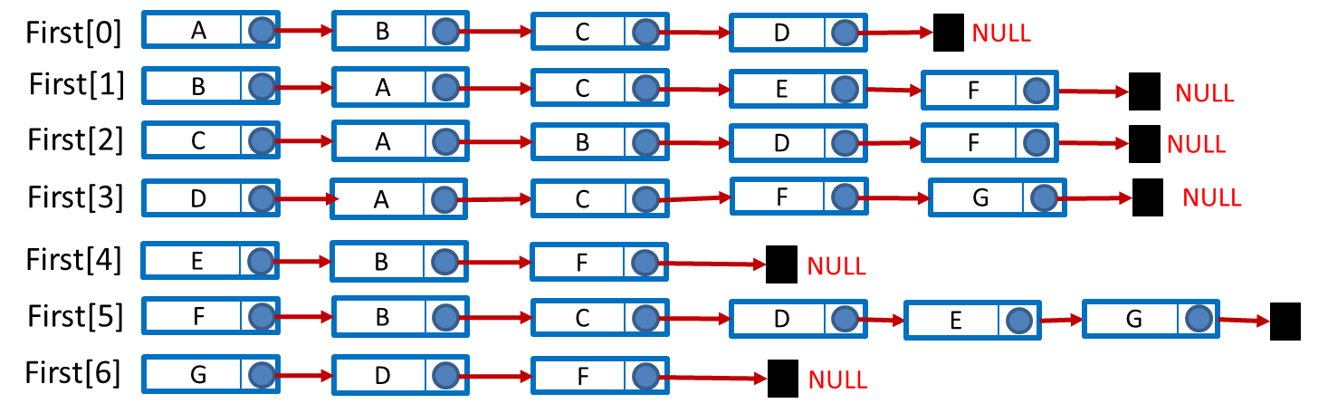

* **Ví dụ: 5.7:**

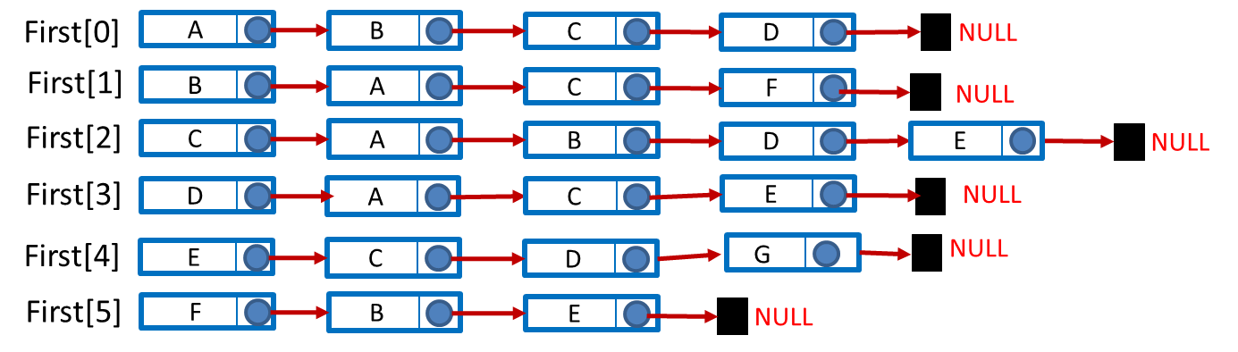

* **Ví dụ: 5.11:**

