**CHƯƠNG 5 – BTLT**

*Họ và tên: Nguyễn Văn Thanh Thiên*

*MSSV:1654050106*

*Nhóm: 8*

**Bài 1: Thực hiện đếm bậc các đỉnh tại ví dụ 5.1, 5.2, 5.3, 5.6**

* Ví dụ 5.1:
* Det (A) = 3
* Det (B) = 4
* Det (C) = 4
* Det (D) = 4
* Det (E) = 2
* Det (F) = 5
* Det (G) = 2
* Ví dụ 5.2:
* Det (A) = 5
* Det (B) = 4
* Det (C) = 4
* Det (D) = 6
* Det (E) = 2
* Det (F) = 7
* Det (G) = 2
* Ví dụ 5.3:
* Det (A) = 5
* Det (B) = 6
* Det (C) = 4
* Det (D) = 4
* Det (E) = 4
* Det (F) = 3
* Ví dụ 5.6:

|  |  |  |
| --- | --- | --- |
| Đỉnh | VÀO (+) | RA (-) |
| A | 0 | 3 |
| B | 2 | 2 |
| C | 2 | 2 |
| D | 2 | 1 |
| E | 3 | 1 |
| F | 1 | 1 |
| Tổng: | 10 | 10 |

**Bài 2: Cho biết ma trận kề của đồ thị tại ví dụ 5.1, 5.6, 5.7, 5.11**

* Ví dụ 5.1:

|  |  |  |  |  |  |  |  |
| --- | --- | --- | --- | --- | --- | --- | --- |
|  | A | B | C | D | E | F | G |
| A |  | 1 | 1 | 1 |  |  |  |
| B | 1 |  | 1 |  | 1 | 1 |  |
| C | 1 | 1 |  | 1 |  | 1 |  |
| D | 1 |  | 1 |  |  |  | 1 |
| E |  | 1 |  |  |  | 1 |  |
| F |  | 1 | 1 |  | 1 |  | 1 |
| G |  |  |  | 1 |  | 1 |  |

* Ví dụ 5.2:

|  |  |  |  |  |  |  |  |
| --- | --- | --- | --- | --- | --- | --- | --- |
|  | A | B | C | D | E | F | G |
| A | 1 | 1 | 1 | 1 |  |  |  |
| B | 1 |  | 1 |  | 1 | 1 |  |
| C | 1 | 1 |  | 1 |  | 1 |  |
| D | 1 |  | 1 | 1 |  |  | 1 |
| E |  | 1 |  |  |  | 1 |  |
| F |  | 1 | 1 |  | 1 | 1 | 1 |
| G |  |  |  | 1 |  | 1 |  |

* Ví dụ 5.3:

|  |  |  |  |  |  |  |
| --- | --- | --- | --- | --- | --- | --- |
|  | A | B | C | D | E | F |
| A |  | 1 | 1 | 1 |  |  |
| B | 1 |  | 1 |  | 1 | 1 |
| C | 1 | 1 |  |  | 1 |  |
| D | 1 |  |  |  | 1 |  |
| E |  | 1 |  | 1 |  | 1 |
| F |  | 1 |  |  | 1 |  |

* Ví dụ 5.6:

|  |  |  |  |  |  |  |
| --- | --- | --- | --- | --- | --- | --- |
|  | A | B | C | D | E | F |
| A |  | 1 | 1 | 1 |  |  |
| B |  |  | 1 |  | 1 |  |
| C |  |  |  | 1 | 1 |  |
| D |  |  |  |  | 1 |  |
| E |  |  |  |  |  | 1 |
| F |  | 1 |  |  |  |  |

* Ví dụ 5.7:

|  |  |  |  |  |  |  |
| --- | --- | --- | --- | --- | --- | --- |
|  | A | B | C | D | E | F |
| A |  | 110 | 90 | 100 |  |  |
| B | 110 |  | 50 |  |  | 80 |
| C | 90 | 50 |  | 40 | 80 |  |
| D | 100 |  | 40 |  | 60 |  |
| E |  |  | 80 | 60 |  | 70 |
| F |  | 80 |  |  | 70 |  |

* Ví dụ 5.11:

|  |  |  |  |  |  |  |  |  |  |  |  |  |  |  |
| --- | --- | --- | --- | --- | --- | --- | --- | --- | --- | --- | --- | --- | --- | --- |
|  | 1 | 2 | 3 | 4 | 5 | 6 | 7 | 8 | 9 | 10 | 11 | 12 | 13 | 14 |
| 1 |  | 1 | 1 | 1 |  |  |  |  |  |  |  |  |  |  |
| 2 | 1 |  |  |  |  |  | 1 |  |  |  |  |  |  |  |
| 3 | 1 |  |  |  |  | 1 |  |  |  |  |  |  |  |  |
| 4 | 1 |  |  |  | 1 |  |  |  |  |  |  |  |  |  |
| 5 |  |  |  | 1 |  |  |  |  |  | 1 | 1 |  |  |  |
| 6 |  |  | 1 |  |  |  |  |  |  |  |  |  |  |  |
| 7 |  | 1 |  |  |  |  |  | 1 | 1 |  |  |  |  |  |
| 8 |  |  |  |  |  |  | 1 |  |  |  |  |  | 1 | 1 |
| 9 |  |  |  |  |  |  | 1 |  |  |  |  |  |  |  |
| 10 |  |  |  |  | 1 |  |  |  |  |  |  | 1 |  |  |
| 11 |  |  |  |  | 1 |  |  |  |  |  |  |  |  |  |
| 12 |  |  |  |  |  |  |  |  |  | 1 |  |  |  |  |
| 13 |  |  |  |  |  |  |  | 1 |  |  |  |  |  |  |
| 14 |  |  |  |  |  |  |  | 1 |  |  |  |  |  |  |

**Bài 3: Cho biết danh sách kề của đồ thị tại ví dụ 5.1, 5.7, 5.8, 5.11**

* **Ví dụ: 5.1, 5.8:**

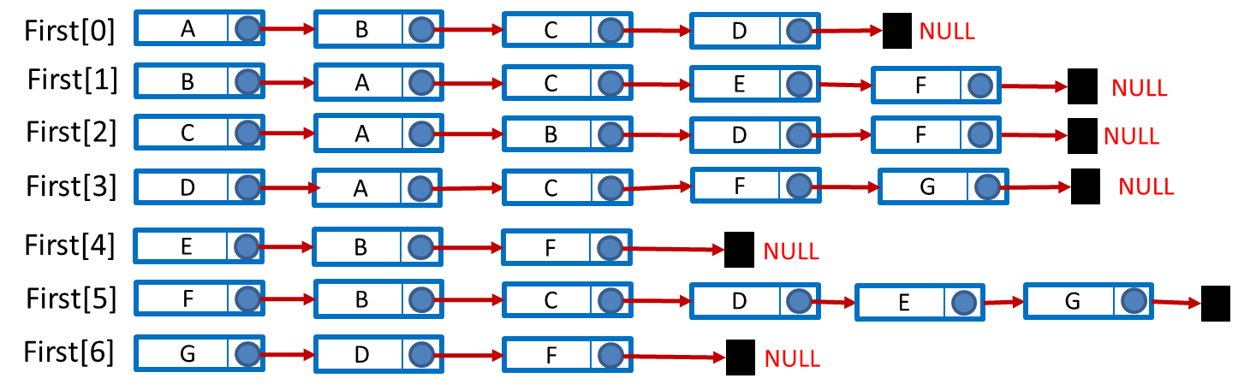

* **Ví dụ: 5.7:**

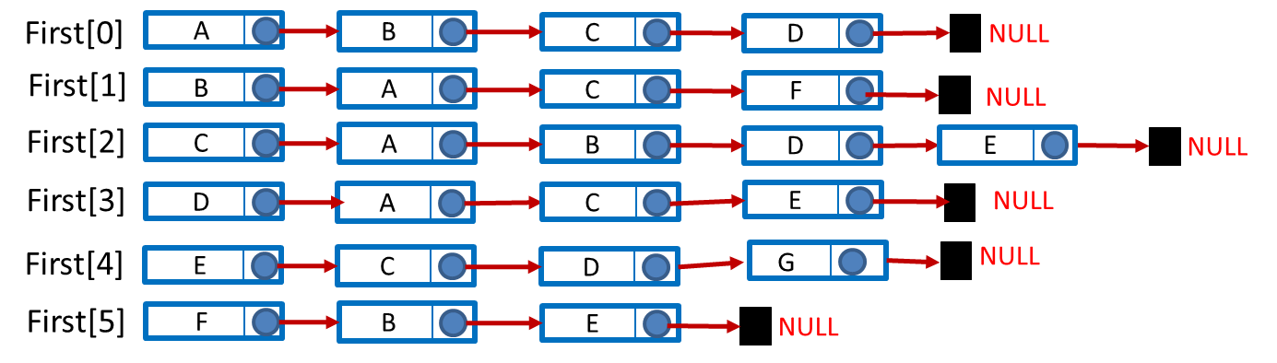

* **Ví dụ: 5.11:**

