**5G NR OVERVIEW**

Author: Vũ Công Hoàn

1. **5G NR System Overview**

* RAN (radio access network): responsible for all radio-related functionality. Like: scheduling, radio-resource handling, retransmission protocols, coding, various mutil-antena schemes. (provides the connection between the end user and the network)
* CN (core network): responsible for function not related to the radio access. Like: authentication, charging functionality, setup end to end connection. ( is the backbone of the telecommunications network. Provides the backbone for the entire network, enabling connectivity to other network).
  1. **The 5G Core Network**
* Service-based architecture:
  + Service and functionality provide by core network.
  + 5g network functionality to become more granular and decoupled. It becomes independently with other function.
* Support for network slicing:
  + Create multiple logical networks on a common hardware.
  + Each network slice can be configured to meet the requirements of various applications
* Control plane/user plane split:
  + They are independently about the capacity of the two.
  + User-plane: the process of sending and receiving user data, which are the main signal for communication.
  + User plane is gateway between the RAN and external internet.
  + User plane responsibilities include: packet routing and forwarding, packet inspection, QoS handling, packet filtering and traffic measurements.
  + Control-plane: a series of control process that are exchanged to establish communication and authentication.
  + Control plane include:
    - Session management function (SMF): IP address allocation for the device (user equipment (UE)), control of policy enforcement and general session management.
    - Access and mobility management function (AMF): control signal between core network and device, security user data, idle-state mobility and authentication.
  + Policy control function (PCF): responsible for policy rules
  + Unified data management (UDM) responsible for authentication credentials and access authorization.
  + Network exposure function (NEF)
  + NR repository function (NRF)
  + Authentication server function (AUSF)
  + Network slice selection function (NSSF)
  + Unified data repository (UDR)
  + Application function (AF)

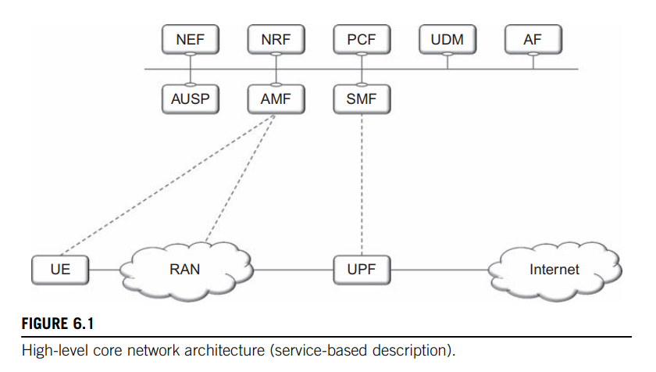

* 1. **The Radio-Access Network (RAN)**

Radio-access network (RAN): can have two types of nodes connected to the 5G core network.

* gNB, serving NR devices
* ng-eNB, serving LTE devices
* A radio-access network consisting of both ng-eNB and gNB is known as an NG-RAN.
* gNB or eNG is responsible for all radio-related function in one or more cells.
* gNB is a logical node and not a physical implementation.
* gNB connected to 5G core network by NG interface
* One gNB can be connected to multiple UPF/AMF for the purpose of load sharing and redundancy.
* gNB connected to other gNB by Xn interface.
* gNB can have two part :
  + A central unit (CU): support RRC, PDCP, SDPA protocols
  + One or more distributed units (DU): support RLC, MAC, PHY protocols.
* CU connected to DU by F1 interface
* DU connected to UE by Uu interface

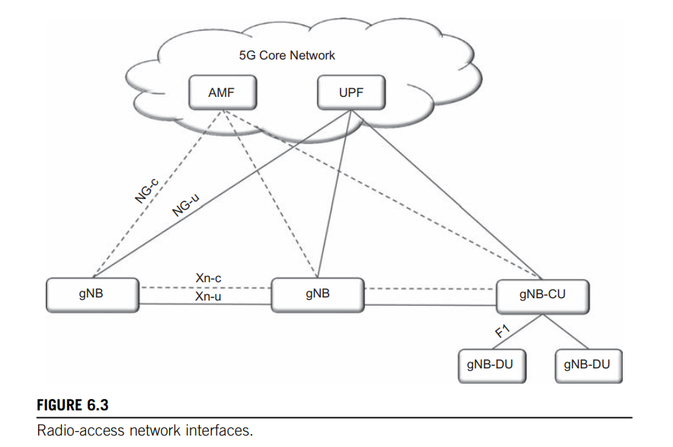

1. **5G NR Protocols Overview**

## **2.1. Radio Protocol Architecture**

* Non-access-stratum (NAS) used to manage the establishment of communication sessions and for maintaining continuous with UE as it moves.
* UE connected to AMF (core network) by NAS protocol.
* UE connected to gNB by RRC, SDAP, PDCP, RLC, MAC, PHY protocols.

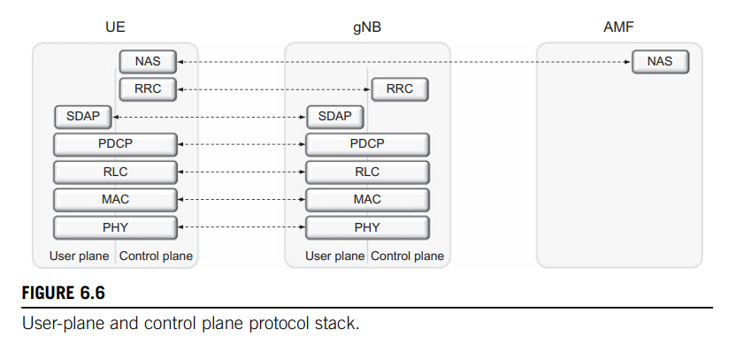

## **2.2. User-Plane Protocols**

* **Service Data Application Protocol (SDAP)** 
  + Is responsible for QoS handling. In particular, SDAP will map a specific QoS Flow within a PDU Session to a corresponding Data Radio Bearer.
  + SDAP will mark the transmitted packets, ensuring that the packet receives the correct
* **Packet Data Convergence Protocol (PDCP)** 
  + performs IP header compression, ciphering, and integrity protection.
  + handles retransmissions, in-sequence delivery, and duplicate removal in the case of handover.
  + For dual connectivity with split bearers, PDCP can provide routing and duplication.
  + There is one PDCP entity per radio bearer configured for a device.
* **Radio-Link Control (RLC)**
* is responsible for segmentation and retransmission handling.
* The RLC provides services to the PDCP in the form of RLC channels
* **Medium-Access Control (MAC)**
  + handles multiplexing of logical channels, hybrid-ARQ retransmissions
  + scheduling and scheduling-related functions
* **Physical Layer (PHY)** 
  + handles coding/decoding, modulation/demodulation, multi-antenna mapping, and other typical physical-layer functions

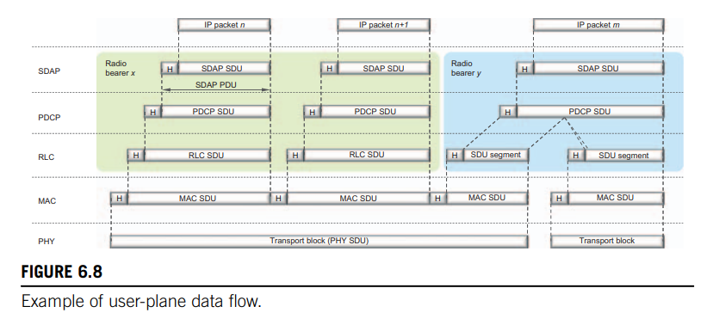

### **2.1.1. Service Data Adaptation Protocol (SDAP)**

* mapping between QoS and data radio bearer
* marking Qos identifier
* gNB connect EPC (NSA), SDAP is not used.

### **2.2.2. Packet-data convergence protocol (PDCP)**

* performs IP header compression to reduce the number of bits to transmit.
* header-compression is based on ROHC.
* ciphering to protect against eavesdropping
* at the receiver, corresponding deciphering and decompression operations.
* handles retransmissions, in-sequence delivery, and duplicate removal in the case of handover.
* PDCP is in charge of distributing the data between the MCG and the SCG

### **2.2.3. Radio-Link Control (RLC)**

* segmentation of RLC SDUs from the PDCP into suitably sized RLC PDUs
* handles retransmissions of incorrect received PDUs.
* Removal of duplicate PDUs.
* 3 modes:
  + Transparent mode:
    - RLC Header Added : No
    - Buffering: Buffering done only at Transmission
    - Functionality: No Segmentation and No Reassembly
    - Feedback Mechanism (ARQ): No feedback (No ACK/NACK for RLC PDU)
  + Unacknowledged mode:
    - RLC Header Added : Yes
    - Buffering: Buffering done both at Transmission and Reception
    - Functionality: Segmentation done at TX and Reassembly at RX side
    - Feedback Mechanism (ARQ): No feedback (No ACK/NACK for RLC PDU)
  + Acknowledged mode:
    - RLC Header Added : Yes
    - Buffering: Buffering done both at Transmission and Reception
    - Functionality: Segmentation done at TX and Reassembly at RX side
    - Feedback Mechanism (ARQ): Feedback mechanism is there (ACK/NACK for RLC PDU)

### **2.2.4. Medium-Access Control (MAC)**

**2.2.4.1. Logical Channels and Transport Channels**

**Logical-channel includes:**

The MAC provides services to the RLC in the form of logical channels

* Control channel: used for transmission of control and configuration information necessary for operating an NR system
* Traffic channel: used for the user data
* Broadcast Control Channel (BCCH): transmission of system info from the network to all devices in cell.
* Paging Control Channel (PCCH): paging of devices whose location on a cell level is not known to the network. The paging message need to be transmitted in multiple cells
* Common Control Channel (CCCH): transmission of control information in conjunction with random access
* Dedicated Control Channel (DCCH): transmission of control information to/from a device. Use for configuration of a device.
* Dedicated Traffic Channel (DTCH): transmission of user data to/ from a device

**Transport-channel includes:**

From the physical layer, the MAC layer uses services in the form of transport channels.

Data on a transport channel are organized into transport blocks.

In each Transmission Time Interval (TTI), at most one transport block of dynamic size is transmitted over the radio interface to/from a device.

* Broadcast Channel (BCH): has a fixed transport format, provided by the specifications. It is used for transmission of parts of the BCCH system information
* Paging Channel (PCH): is used for transmission of paging information from the PCCH logical channel
* Downlink Shared Channel (DL-SCH):
  + is the main transport channel used for transmission of downlink data
  + It supports key NR features such as dynamic rate adaptation and channel-dependent scheduling in the time and frequency domains, hybrid ARQ with soft combining, and spatial multiplexing.
  + transmission of the parts of the BCCH system information not mapped to the BCH
* Uplink Shared Channel (UL-SCH): the uplink transport channel used for transmission of uplink data
* Random-Access Channel (RACH): it does not carry transport blocks

Part of the MAC functionality is multiplexing of different logical channels and mapping of the logical channels to the appropriate transport channels

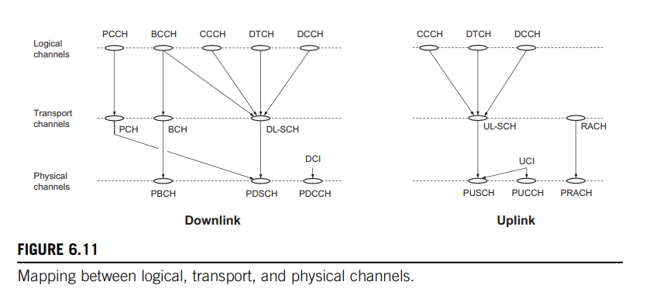

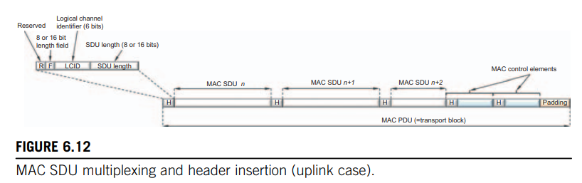 **2.2.4.2. Scheduling**

* controls the assignment of uplink and downlink resources
* dynamic scheduling
* the gNB takes a scheduling decision. Once per slot, and sends scheduling information to the selected set of devices.
* the actual data transmission isn’t restricted to start or end at the slot boundaries
* Uplink and downlink scheduling are separated
* The downlink scheduler:
  + controlling which device(s) to transmit to
  + the set of resource blocks for DL-SCH.
  + Transport-format selection (selection of transport-block size, modulation scheme, and antenna mapping)
  + logical-channel multiplexing for downlink transmissions are controlled by the gNB
  + channel-state information (CSI) support downlink. It report channel quality.
* The uplink scheduler:
  + control which devices are to transmit on their respective UL-SCH.
  + uplink scheduling decision does not explicitly schedule a certain logical channel
  + the device is responsible for selecting from radio bearer(s)

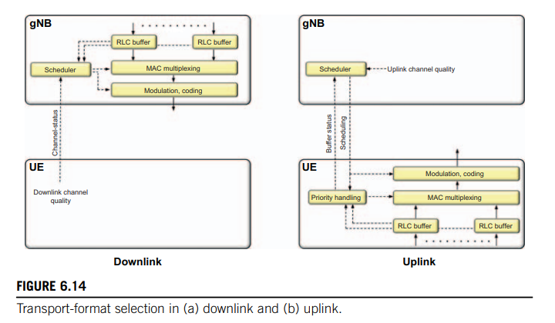

**2.2.4.3. Hybrid ARQ with Soft Combining**

* provides robustness against transmission errors.
* is part of the MAC layer
* Hybrid ARQ is not applicable for all types of traffic (broadcast transmission).
* hybrid ARQ is only supported for the DL-SCH and the UL-SCH
* when receive of a transport block 🡪 decode and send ack bit to the transmitter.
* An asynchronous hybrid-ARQ protocol is used for both downlink and uplink
* Up to 16 hybrid-ARQ processes are supported.

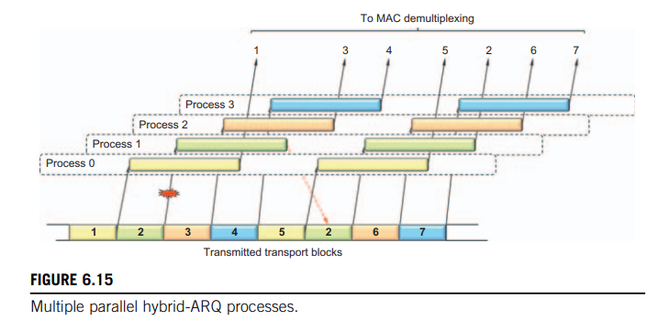

### **2.2.5. Physical Layer (PHY)**

* The physical layer is responsible for coding, physical-layer hybrid-ARQ processing, modulation, multi-antenna processing, and mapping of the signal to the appropriate physical time-frequency resources
* mapping of transport channels to physical channels
* provides services to the MAC layer in the form of transport channels
* A physical channel corresponds to the set of timefrequency resources
* each transport channel is mapped to a corresponding physical channel
* Physical Downlink Shared Channel (PDSCH): the main physical channel used for unicast data transmission.
* Physical Broadcast Channel (PBCH): carries part of the system information, required by the device to access the network.
* Physical Downlink Control Channel (PDCCH): is used for downlink control information, mainly scheduling decisions, required for reception of PDSCH, and for scheduling grants enabling transmission on the PUSCH
* Physical Uplink Shared Channel (PUSCH): There is at most one PUSCH per uplink component carrier per device.
* Physical Uplink Control Channel (PUCCH): send hybrid-ARQ, support downlink channel-dependent scheduling, and requesting resources to transmit uplink data.
* Physical Random-Access Channel (PRACH): is used for random access.

## **2.3. Control-Plane Protocols**

* responsible for connection setup, mobility, and security.
* NAS connect AMF and UE. It includes authentication, security, and different idlemode procedures. responsible for assigning an IP address to a device.
* Radio Resource Control (RRC): responsible for handling the RAN related control-plane procedures. Includes:
  + Broadcast of system information necessary
  + Transmission of paging messages originating from the MME to notify the device about incoming connection requests.
  + Connection management, including setting up bearers and mobility
  + Mobility functions such as cell (re)selection.
  + Measurement configuration and reporting.
  + Handling of device capabilities

### **2.3.1. RRC State Machine**

* three RRC states, RRC_IDLE, RRC_ACTIVE, and RRC_INACTIVE

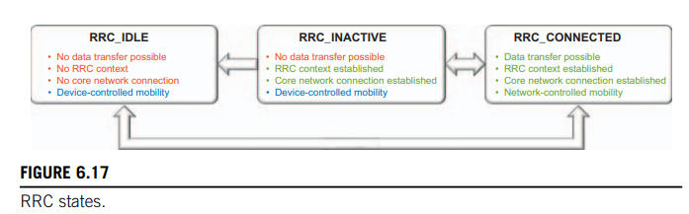

* RRC_IDLE: No data transfer may take place as the device sleeps most of the time to reduce battery consumption
  + Broadcast of System Information
  + Cell re-selection mobility
  + DRX for CN paging configured by NAS
* RRC_CONNECTED: for communication between the device and the radio-access network are known to both entities
  + The connected state is intended for data transfer to/from the device, but can be configured (DRX)
  + Mobility is managed by the radio-access network.
  + 5GC - NG-RAN connection is established for UE
  + The UE AS context is stored in NG-RAN and UE
  + NG-RAN knows the cell which the UE belongs to
  + Transfer of unicast data to/from the UE
  + Network controlled mobility including measurements
* RRC_INACTIVE: can be seen as a mix of the idle and connected states.
  + Broadcast of system information
  + Cell re-selection mobility
  + Paging is initiated by NG-RAN
  + RAN based notification area is managed by NG-RAN
  + DRX for RAN paging configured by NG-RAN
  + The UE AS context is stored in NG-RAN and the UE
  + NG-RAN knows the RNA which the UE belongs to
* For the idle and inactive states, mobility is handled by the device through cell reselection,
* while for the connected mode, mobility is handled by the radio-access network based on measurements

### **2.3.2. Idle-State and Inactive-State Mobility**

**2.3.2.1. Tracking the Device**

* devices are only tracked on a cell-group level
  + The network only receives new information about the device location if the device moves into a cell outside of the current cell group
  + broadcast over all cells within the cell group.

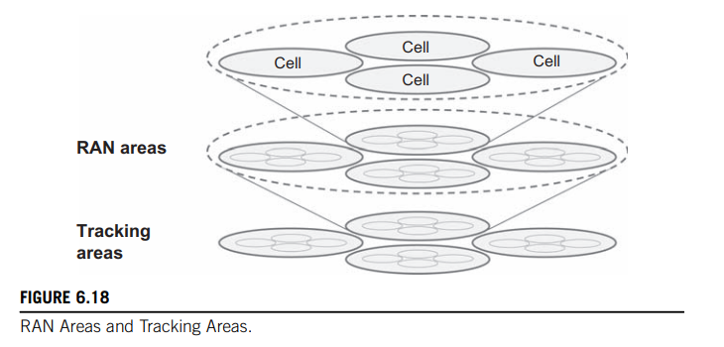

* + RAN Area Identifier (RAI)
  + Tracking Area Identifier (TAI).
  + When a device enters a cell( be not assigned by UE)🡪update NAS.

**2.3.2.2. Paging Message Transmission**

* paging messages are provided by means of ordinary scheduled PDSCH transmissions
* a device is only supposed to wake up to monitor for paging messages.
* Paging messages are indicated by a specific PI-RNTI carried within the DCI
* Then the device demodulates and decodes the corresponding PDSCH to extract the paging message(s)

### **2.3.3. Connected-State Mobility**

* to ensure that this connectivity is retained without any interruption or noticeable degradation as the device moves within the network.
* the device continuously searches for new cells both on the current carrier frequency and on different carrier frequencies
* the device does not make any decisions of its own when it comes to handover to a different cell
* the device reports the result of the measurements to the network