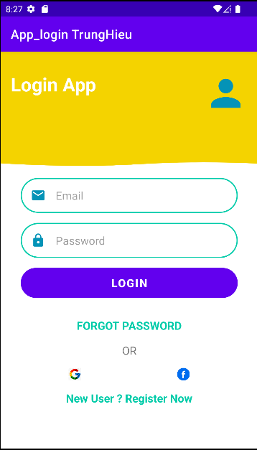





Link video

https://drive.google.com/file/d/1sLXnI3Q8-KoDG4ZE43L_wi_MAsuOwfMB/view?usp=sharing

