6. Middleware

1. What is middleware

All of function between incoming request (from client) and response (server) named middeleware

Have next method to direct to next middleware and then router middelware, end with response

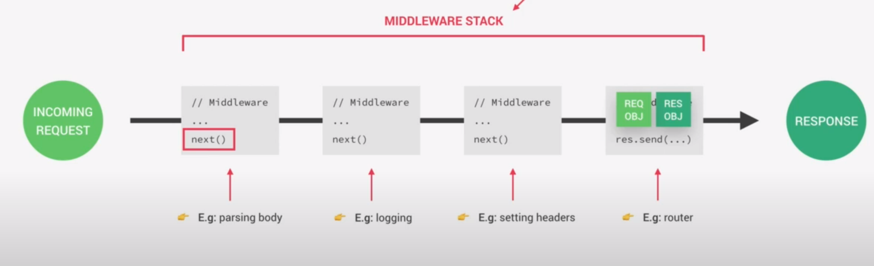

2. Create middleware to see request of the response

Get date, change to ISO string

2.1 ISO:

international organization for standardization. It is an independent, non-governmental international organization that develops and publishes internaltional standards across various industries and sector

ISO standards are designed to provide guidelines, specifications, and best practices to ensure quality, safety, and efficiency in products, services, and systems. These standards are developed through a consensus-based approach involving experts from different countries and industries, aiming to establish globally recognized benchmarks.

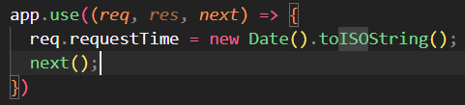

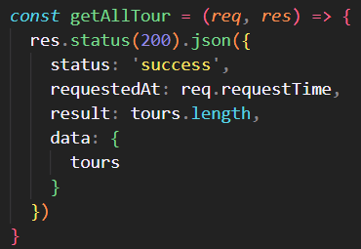

3. Using 3rd party middleware: morgan

Visit morgan github to see detail implementation code

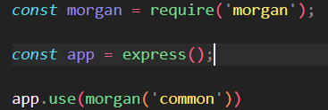

This middleware allow us to see request data in the log console

3.1 Differentiate regular dependency and dev dependency

Regular Dependencies:

Regular dependencies, also known as production dependencies, are the packages or libraries that are required for the application or software to run correctly in a production environment. These dependencies include the essential components and functionality needed for the application to function as intended.

Development Dependencies (Dev Dependencies):

Development dependencies, as the name implies, are the packages or libraries that are needed during the development process but are not required for the actual runtime of the application. They include tools, libraries, and testing frameworks that assist with development, debugging, testing, building, or documentation generation.

3.2 about express

Express like a package contain all library

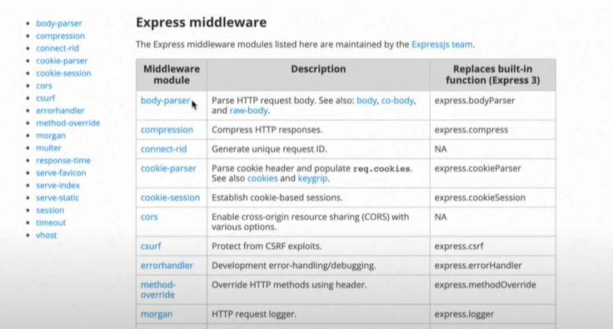

4. Implementing user route

It look the same with tours route



5. Classify user route and tours route

Create router for the tour in the nodejs ?

Express call to Router function, this one also call tour router middelware

We separate to two parent route tour and user insight contain more route

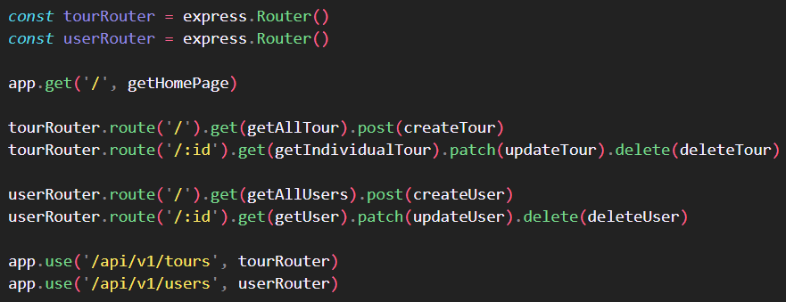

6.Refactor code to get better structure – MVC model

Split route:

Create folder route contain user route and tour route

userRoute contain route for some function



And is used in app



Use it as a middleware:

app.use('/api/v1/tours', tourRouter)

Split controller:

Contain all function related to get, create, delete

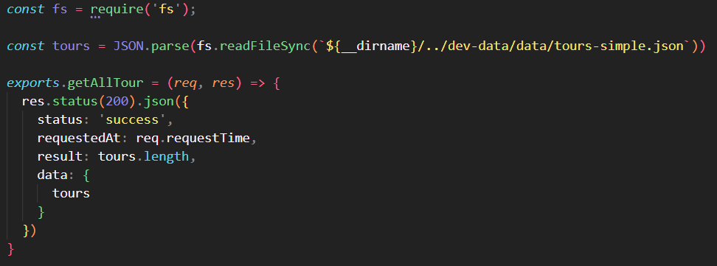

Split server:

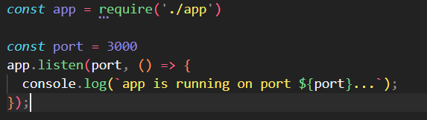

7. Create param middleware

When the route contain param, this middleware will work by using param function, second param take a call back function: req, res, next, val

Add middleware to check whether id is valid

In the tour route



In the tour controller

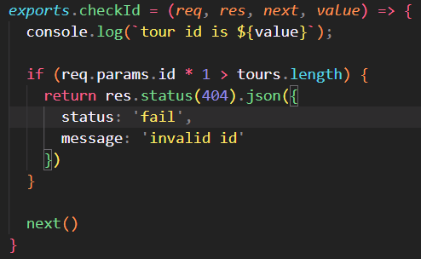

It mean that when check if have a param in the route, this middleware will be triggered and call to the middleware checkid to validate that id

Remember to contain next function and return key

So this middleware also call a pipeline or stack of a middleware

8. Chainning multiple middleware function for the same route

Add middleware to check body of the request post to the route is valid, add middleware to the first param of the post

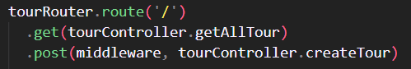

Add function check like this:

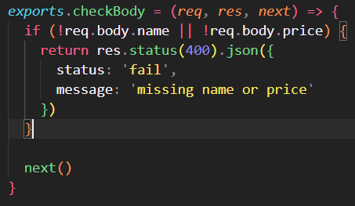

9. Serving static file – with express

Public file that we cannot access from browser, but we have to access through express

The browser will compare all of route, if don’t have the same route in the backend, it keep continue to find file in the public folder to the route



10. Environment variable

Nodejs, express can run in different environment – production or development, we will use diff db

Express defaul set environment to development

Check we are currently dev or prod

Check all of the variable built-in



Custom environment variable



Install library to read variable from environment and save to nodejs environment variable: using dotenv lib

In the app, import dotenv, config environment file in the directory

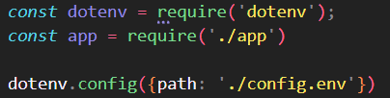

In the log, it already import like this:

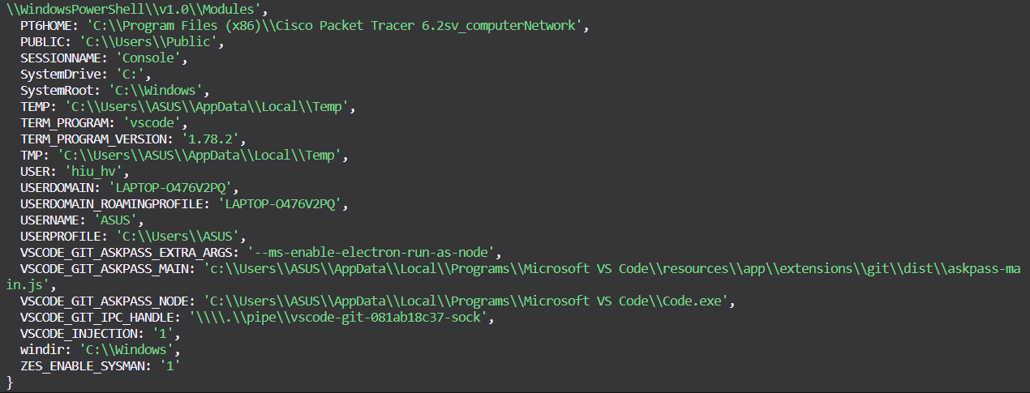

Check if we are on development mode, log if have request to the server

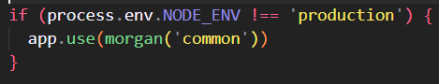

Must be config environment to the node before config the app

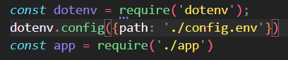

Add npm start for production mode

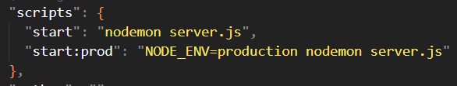

Check will not get the logger