Wireshark Lab:

Getting Started

v

8

.0

Supplement to

*Computer Networking: A Top*

*-*

*Down*

*Approach,*

*8*

*th*

*ed.*

*,*

J.F. Kurose and K.W. Ross

*“Tell me and I forget. Show me and I remember. Involve me*

*and I understand.”*

Chinese proverb

©

2005

-

20

20

, J.F Kurose and K.W. Ross, All Rights Reserved



Student Name : Nguyễn Hữu Hiếu

Student ID : 2013149

# What to hand in

The goal of this first lab was primarily to introduce you to Wireshark. The following questions will demonstrate that you’ve been able to get Wireshark up and running, and have explored some of its capabilities. Answer the following questions, based on your Wireshark experimentation:

1. List 3 different protocols that appear in the protocol column in the unfiltered packet-listing window in step 7 above.

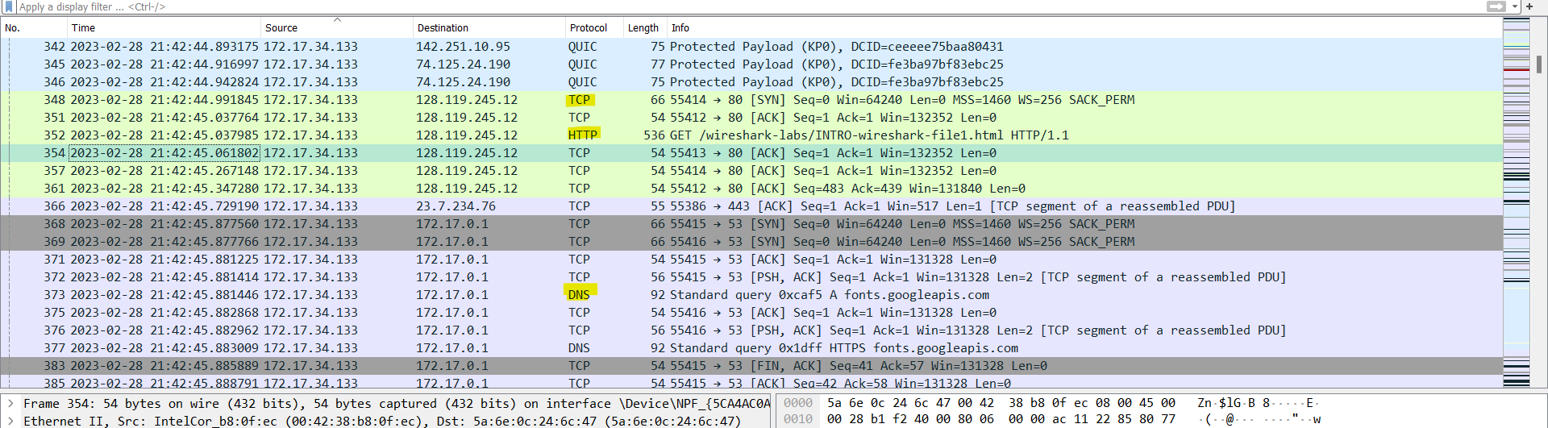

3 different protocols:

1. DNS
2. TCP
3. HTTP
4. How long did it take from when the HTTP GET message was sent until the HTTP OK reply was received

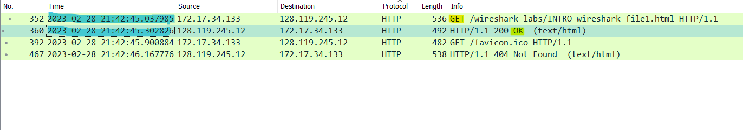

The arrival time of HTTP GET message is : Feb 28, 2023 21:42:45.037985000 SE Asia Standard Time

The arrival time of HTTP OK message is : Feb 28, 2023 21:42:45.302826000 SE Asia Standard Time

So it’s take close to 0.3s

1. What is the Internet address of the gaia.cs.umass.edu (also known as www.net.cs.umass.edu)? What is the Internet address of your computer?

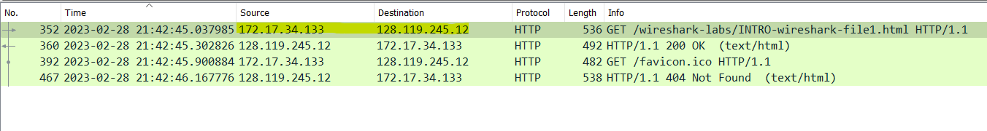

The internet address of the gaia.cs.umass.edu (Source Address) is 172.17.34.133

My internet address of my computer (Destination Address) is 128.119.245.12

1. Print the two HTTP messages (GET and OK) referred to in question 2 above. To do so, select *Print* from the Wireshark *File* command menu, and select the “*Selected Packet Only”* and *“Print as displayed”* radial buttons, and then click OK.

HTTP GET:

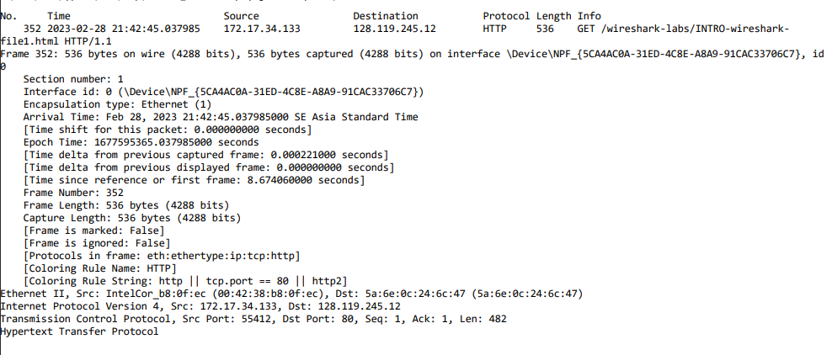

HTTP OK:

