Skymap Global Pte Ltd
Weekly internship report

Intern’s fullname : Nong Minh Hieu
Report period : 26th September - 3rd October
Supervisor : Mr. Le Hai Ha & Kai Hwa Hoo

Table of content

Section | Content | Page
A | Disclaimer | 2
B | Reports Contents | 2
I. | Introduction | 2
II. | Using Qgis to label road’s centerline | 2
III. | Using Qgis to label road’s centerline | 5
IV. | Using Qgis to label road’s centerline | 6
V. | Remaining uncompleted tasks | 8

A. Disclaimer.
This report template is used to help supervisor track and monitor the learning progress of the intern at the designated company/organization. This report template shall not be kept, recorded or used for any formal reasons.

B. Report contents.
I. Introduction.
This report is a summarization on the progress of the aforementioned intern on “Using Qgis to label sattelite image for training RoadNet” task. This report shall cover briefly on what the intern has learnt, what other tasks are remained and self reflection.

II. Using Qgis to label road’s centerline.
To extract road centerline, segmentation and edge from satellite image, the following steps are to be taken :
- Load the satellite image.
- Use “QuickOSM” Qgis plugin to download road dataset (centerlines).
- Buffer the road centerlines to achieve the segmentation.
- From the buffered layer, use vector preprocessing tool “Polygon to lines” to extract the edge.
To load satellite image into Qgis, since SAS.planet is not available in Linux, “Quick Map Services” plugin in Qgis is used as an alternative to load the whole world map into Qgis.
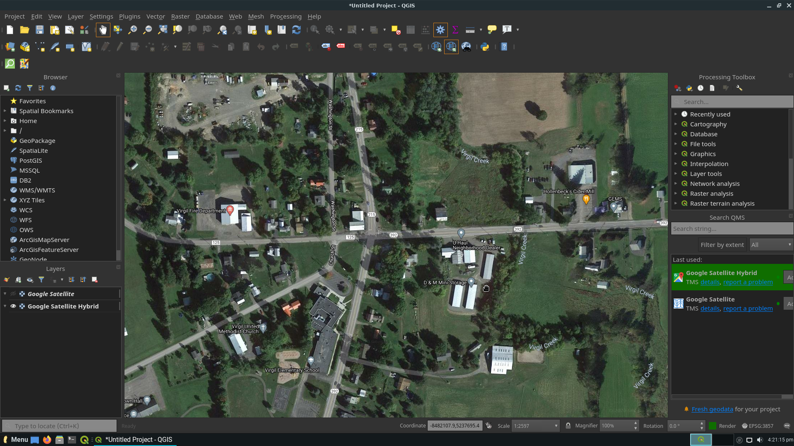
After the world map is loaded, zoom in a location of choice to extract the raw image then clip the image according to the map extent :
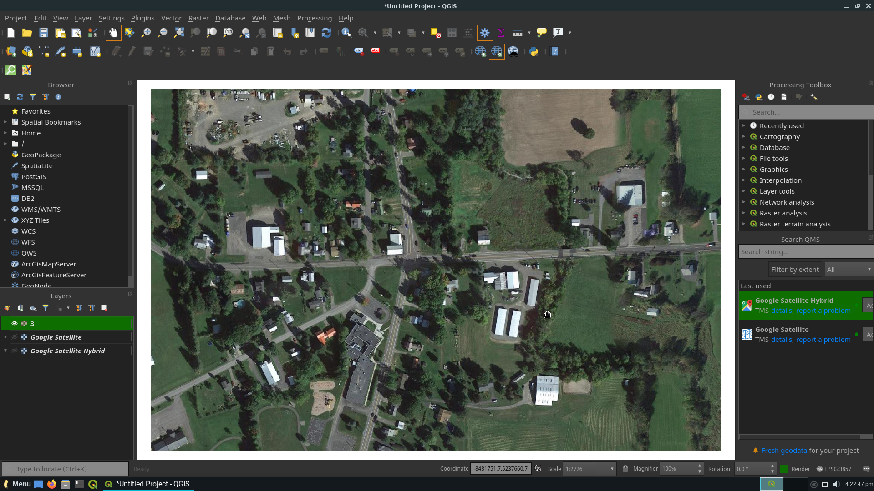
Use “QuickOSM” to query (download) road data within the map extent from the API. The data will be returned as vector layers (highway, route, railway, ...). Then, merge all these vector layers to get the complete road map of the location.

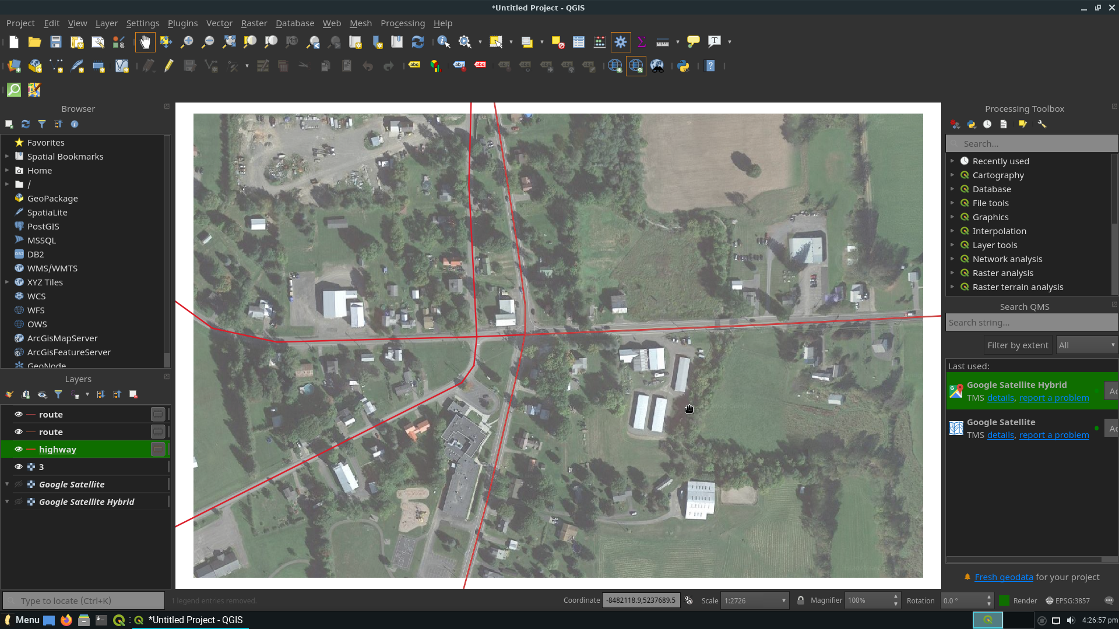
From here, clip the road map according to the sattelite image extent using the vector preprocessing tool “Clip by layer extent”:
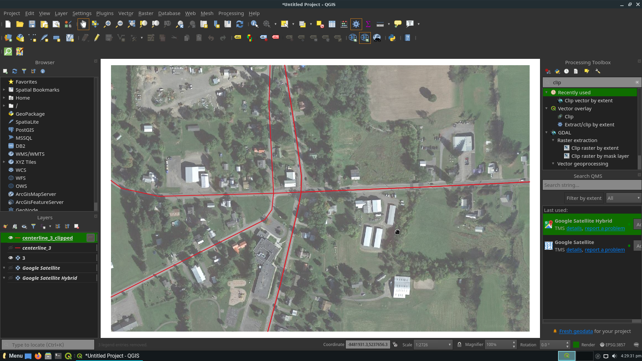

III. Using Qgis to label road’s segment.
From the complete centerline map derived from “QuickOSM”, buffer the centerlines to extract the segmenation of road using “Buffer” preprocessing tool:

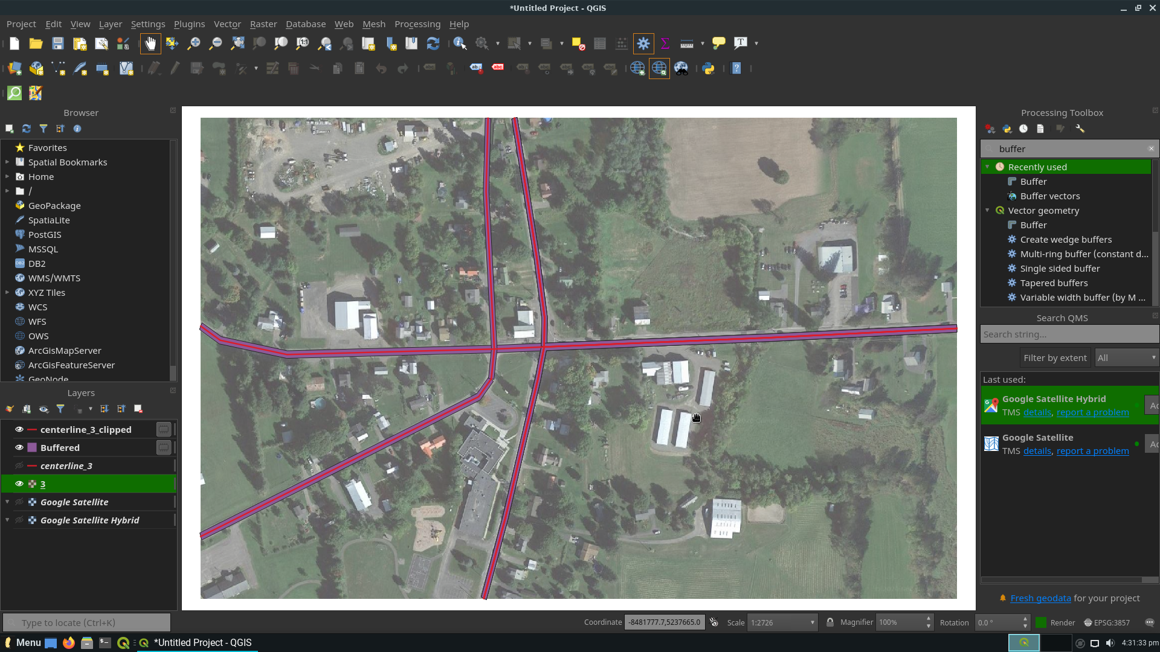
However, the buffered layer is returned as a list of separate polygons. Therefore, it is neccessary to merge all the polygons to produce a complete segmenation map :
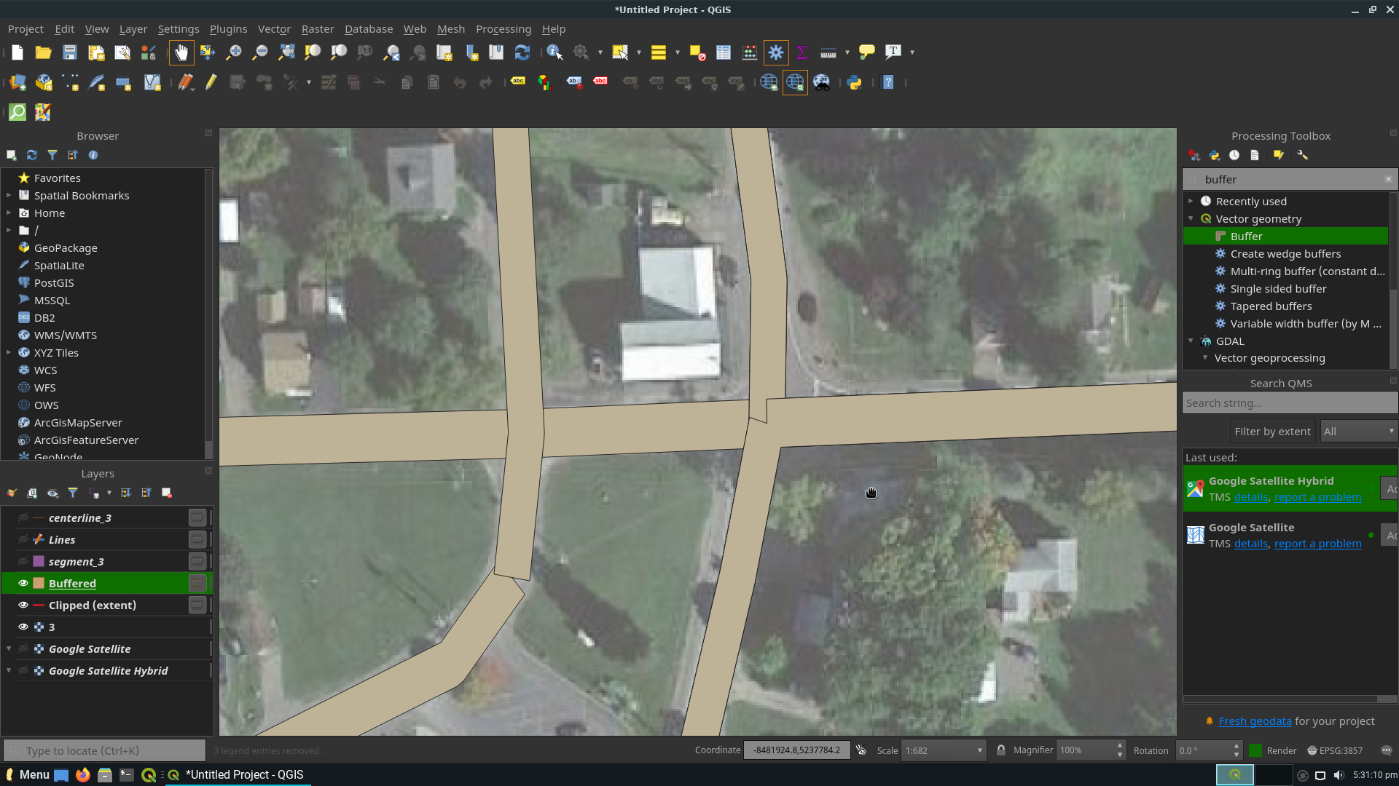
(Before merging buffered layer)
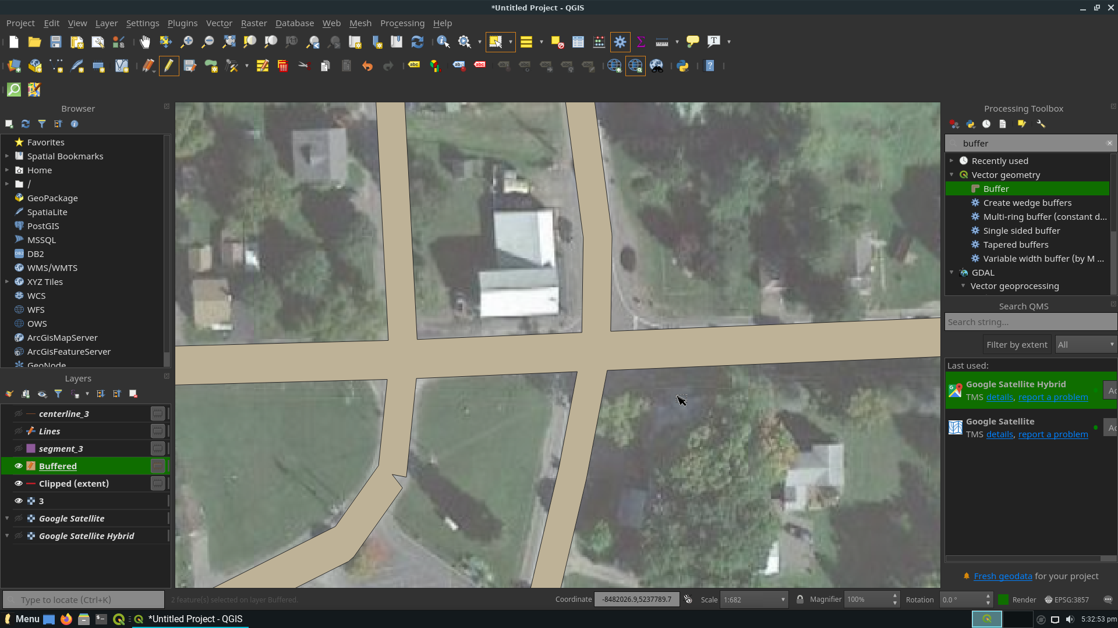
(After mergin the polygons to produce complete segmentation)

IV. Using Qgis to label road’s edge.
From the complete segmentation derived before, the edge can be extracted easily using “Polygon to lines” preprocessing tools.
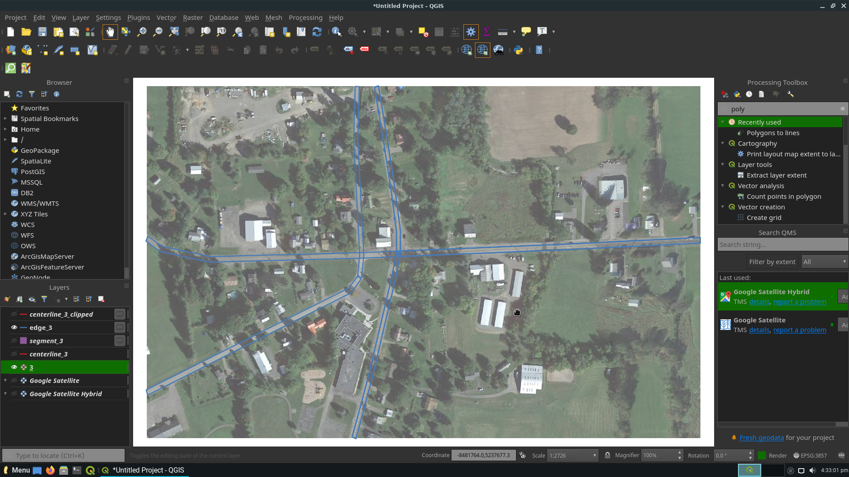
However, there are still several overlapping lines. Toggle edit the edge layer and delete the abundant lines and we have the final result :
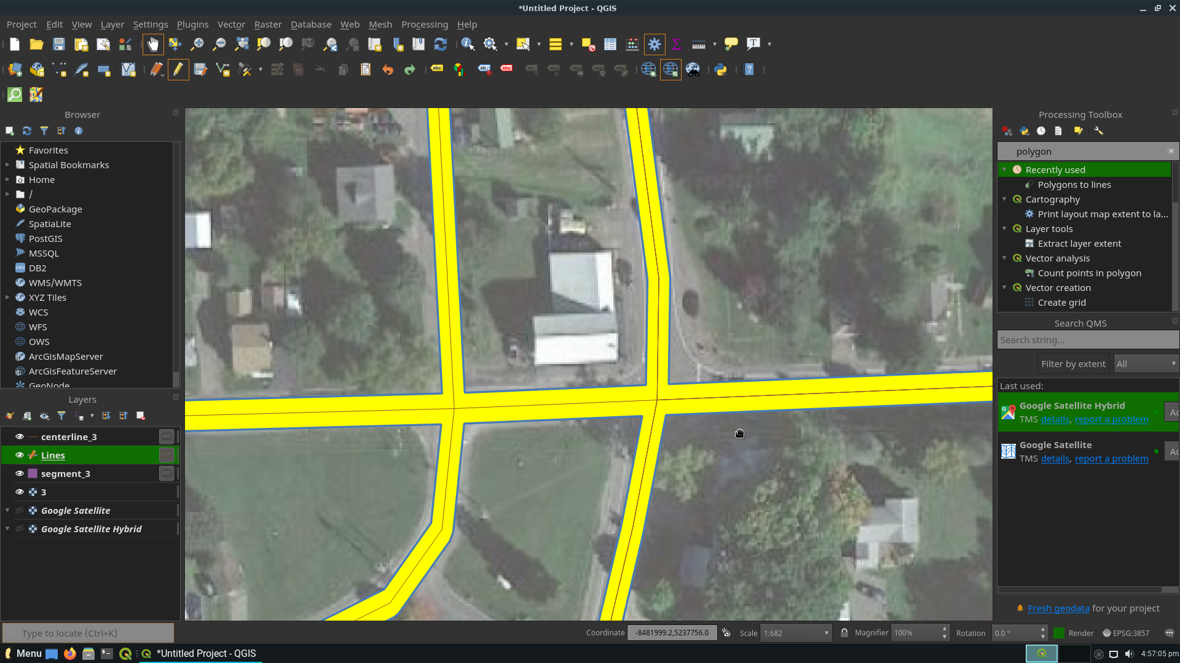
Finally, we can extract each layer individually (in GeoJSON) and start training RoadNet by adding the self-labeled dataset to the Ottawa dataset.

V. Remaining uncompleted tasks.
- Convert the GeoJSON files of segmenation, edge and centerline into tiff images.
- Start training RoadNet with data labeled from Qgis.

