HANOI UNIVERSITY OF SCIENCE AND TECHNOLOGY
School of Information and Communications Technology

Software Requirement Specification
Version 1.2

AIMS – An Internet Media Store
Subject: ITSS Software Development

Group 23
Bùi Trung Hiếu – 20235932
Nguyễn Trần Bình – 20235899
Trần Trung Nghĩa – 20235983
Nguyễn Hữu Tuấn Tú – 20236005
Nguyễn Tuấn Khanh - 20235952

Hanoi, <March, 2026>
Table of contents

1. Introduction 2
1.1. Objective 2
1.2. Scope 2
1.3. Glossary 2
1.4. References 4
2. Overall Description 5
2.1. Survey 5
2.2. Overall requirements 6
2.3. Business process 6
3. Detailed Requirements 14
3.1. Use case “Place order” 14
3.2. Use case “Pay order by VietQR” 19
3.3. Use case “Pay Order By Credit Card” 24
3.4. CUD Product 27
3.5. Use case 5 40
4. Supplementary specification 46
4.1. Functionality 46
4.2. Usability 46
4.3. Reliability 46
4.4. Performance 47
4.5. Supportability 47
4.6. Other requirements 47

Introduction

Objective
- The AIMS’s SRS defines the e-commerce software’s functional and non-functional requirements and acts as a guiding document.
- The purpose of this Software Requirements Specification is to provide a comprehensive, structured reference that defines what software must do, ensuring alignment between stakeholders, developers, and testers

Scope
- The AIMS is an e-commerce software that runs 24/7, and it is easy for new users to use. It can serve up to 1,000 customers simultaneously without significantly reducing performance and can operate continuously for 300 hours without failure. If something goes wrong, the software can get back to normal within 1 hour. The maximum response time of the software is 2 seconds under normal conditions or 5 seconds during peak hours.
- This software helps with online shopping, making it simple for users and businesses. It manages sales and customer needs. Its goal is to stay fast, dependable, and user-friendly, keeping customers happy and businesses running smoothly.

Glossary
No | Term | Explanation | Example | Note
1 | VAT (Value-Added Tax) | A consumption tax placed on a product. In AIMS, the original value and current price of products are recorded without a 10% VAT. | The total product price including VAT is calculated and displayed on the invoice before payment. | Shipping fees are not subject to tax.
2 | Sandbox | A testing environment used by developers to simulate operations without affecting a live system or processing real transactions. | PayPal Sandbox , VietQR Sandbox. | Used in this project for demonstration purposes only.
3 | Administrator | A system role with privileges to manage user accounts. They can create, view, update, delete, block, unblock users, reset passwords, and assign roles. | An IT admin resetting a forgotten password for a product manager. | Requires login to access corresponding features.
4 | Product Manager | A system role responsible for inventory and order management. They can add, view, edit, or delete products, manually adjust stock, and review pending orders. | A manager manually reducing stock due to damaged items. | Requires login to access corresponding features.
5 | Pending Processing State | The status of an order immediately after a successful payment but before it is reviewed by a product manager. | An order paid via VietQR waiting for a manager to approve it for shipping. | Customers can choose to cancel the order while it is in this state.
6 | VietQR | A standardized QR code payment method used in Vietnam. It allows customers to scan a generated code to complete their transaction. | Scanning the default QR code displayed on the checkout screen to pay. | Integrated for demonstration via the VietQR Test Callback API.
7 | Deactivated Status | A product status indicating that an item is no longer available for sale. This occurs when a product manager attempts to delete a product that still has stock greater than zero. | A manager tries to delete a book with 5 copies left; the system marks it as "deactivated" instead. | Prevents deletion of items that still physically exist in the inventory.
8 | Endpoint | A specific URL within an API used to execute a specific function or access a resource. | POST /v2/payments/captures/{capture_id}/refund. | Used in the PayPal REST API integration to issue refunds.
9 | ISSN | International Standard Serial Number, an optional identifier used to record detailed information specifically for newspaper products. | Entering an ISSN when adding a new newspaper to the catalog. | Part of the product metadata required for specific media types.

References

Overall Description

Survey
AIMS is an online media store system that supports both customer shopping activities and internal management operations. The system allows customers to search for products, view product details, add products to the cart, manage the cart, place orders, make payments, and track order information. At the same time, the system also provides management functions for Product Manager and Administrator to ensure that products, orders, and user accounts are handled effectively.
There are three main actors in the system. The first actor is Customer, who uses AIMS to browse and purchase media products such as books, CDs, DVDs, or LP records. The second actor is Product Manager, who is responsible for managing product information and checking customer orders. The third actor is Administrator, who manages user accounts and controls access permissions in the system.
Besides the main actors, AIMS also interacts with external services during the payment process. In this system, VietQR supports QR-based payment, while Paypal Sandbox is used for credit card payment simulation. These external services help the system complete payment-related functions in a more practical way.
In general, AIMS is designed as an integrated system that supports the full process of online shopping and store management. Customers can interact with the store conveniently, while managers and administrators can perform their tasks through dedicated system functions.

Overall requirements
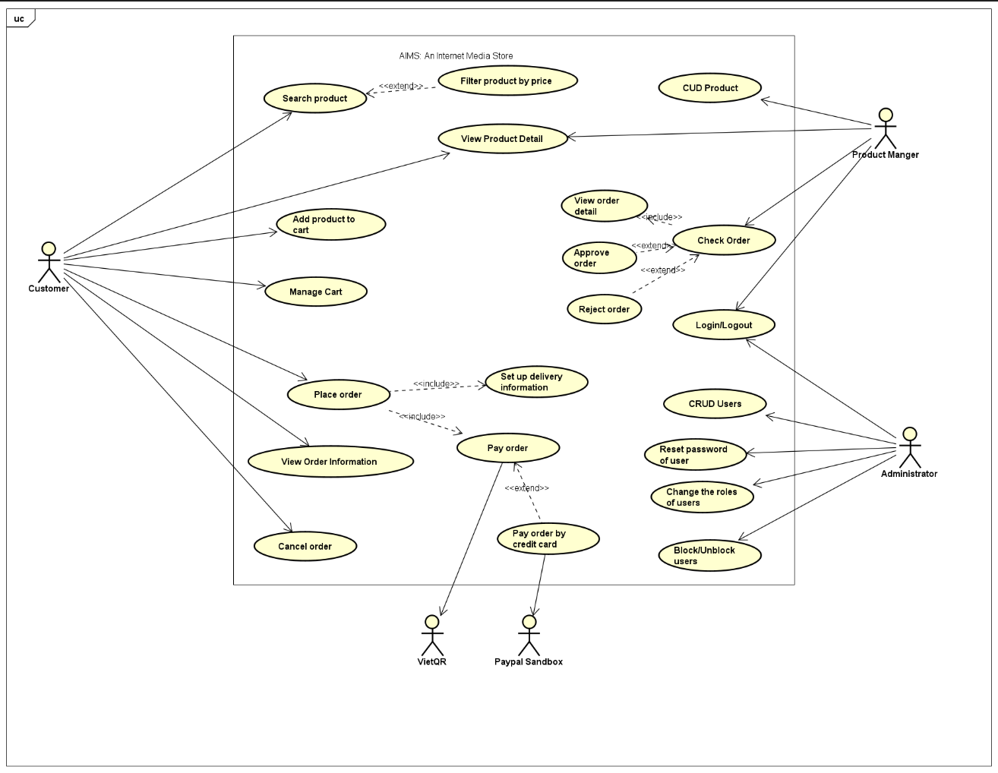

Business process
    - Activity Diagram “Place Order”
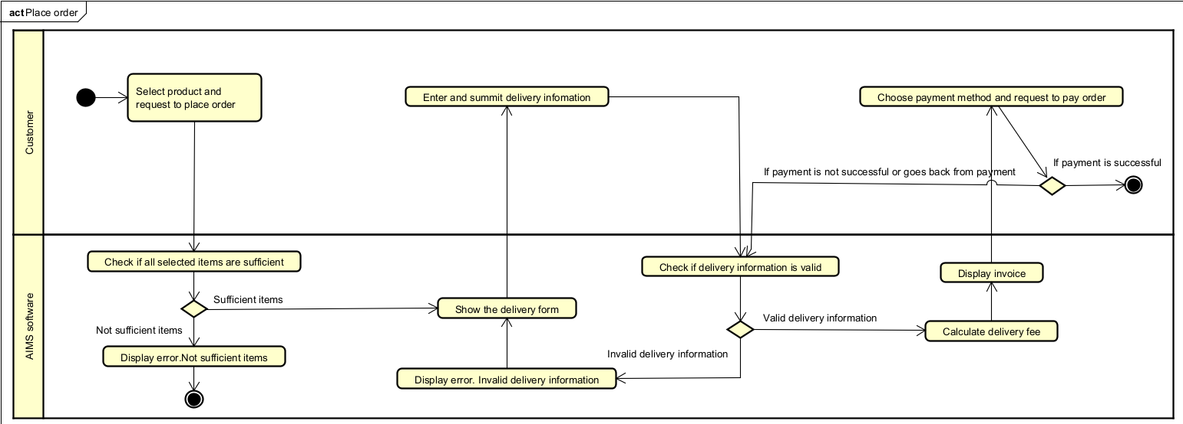
    - Activity Diagram “Pay Order (VietQR)
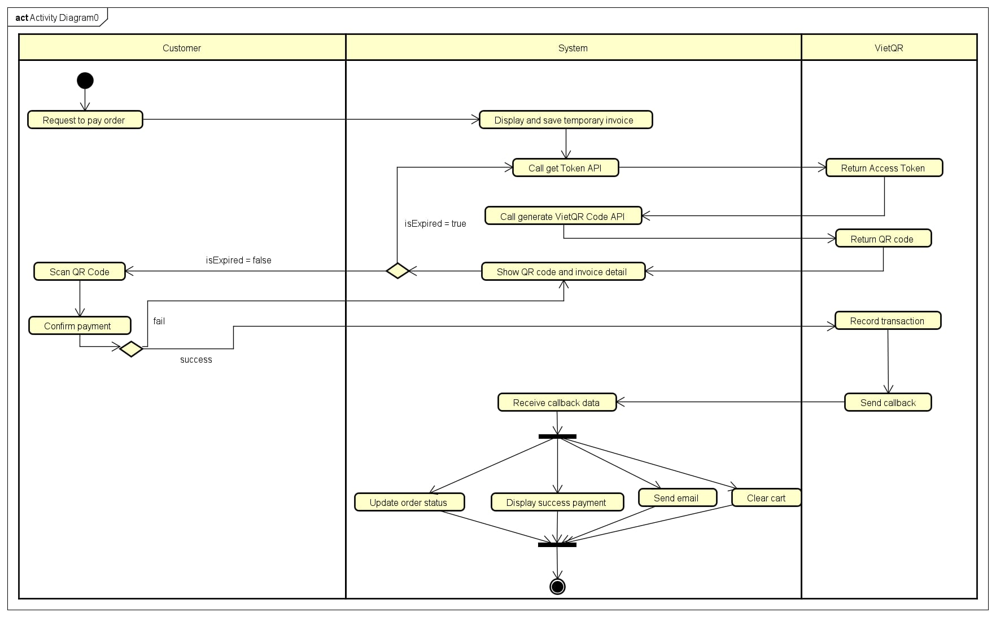
    - Activity Diagram “Pay Order by Credit Card”
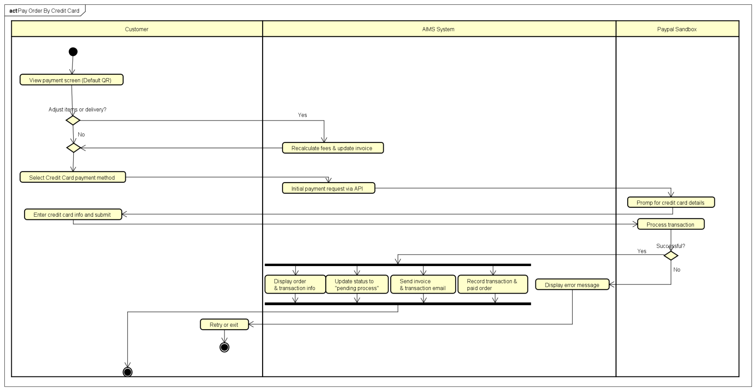
    - Activity Diagram “CUD Product”
ADD PRODUCT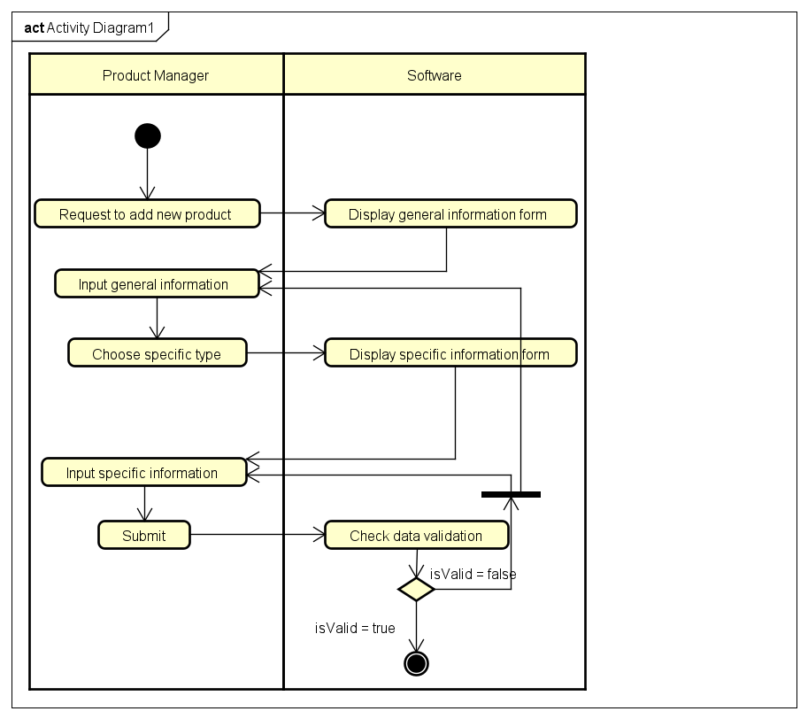
ADJUST QUANTITY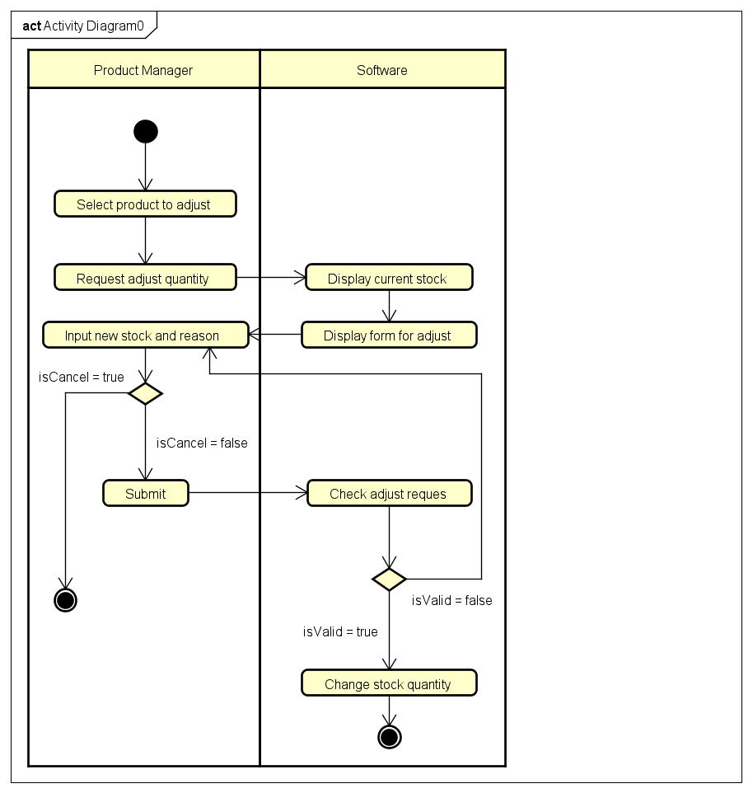
CUD PRODUCT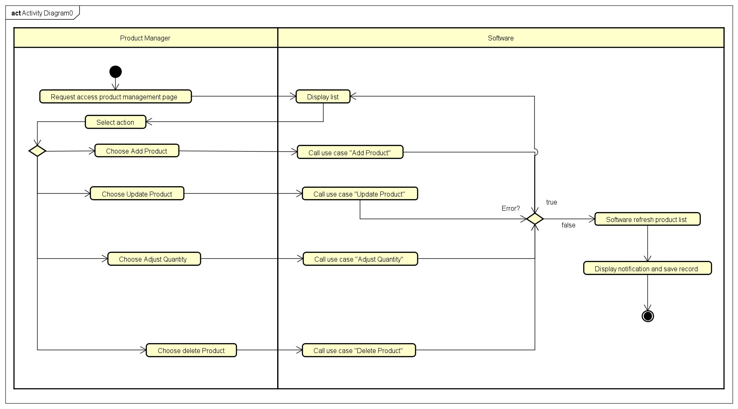
DELETE PRODUCT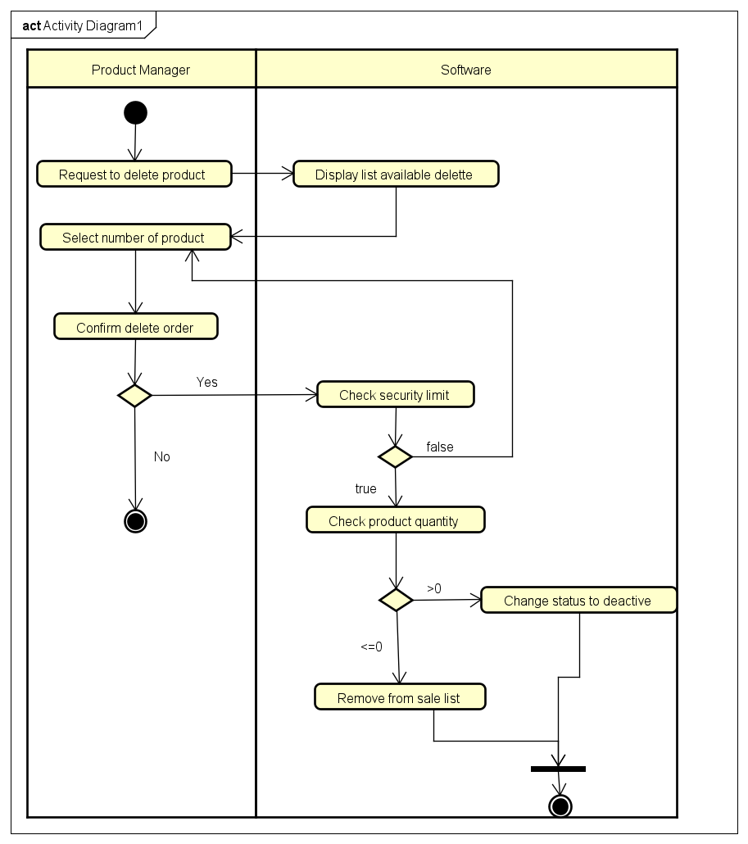
UPDATE PRODUCT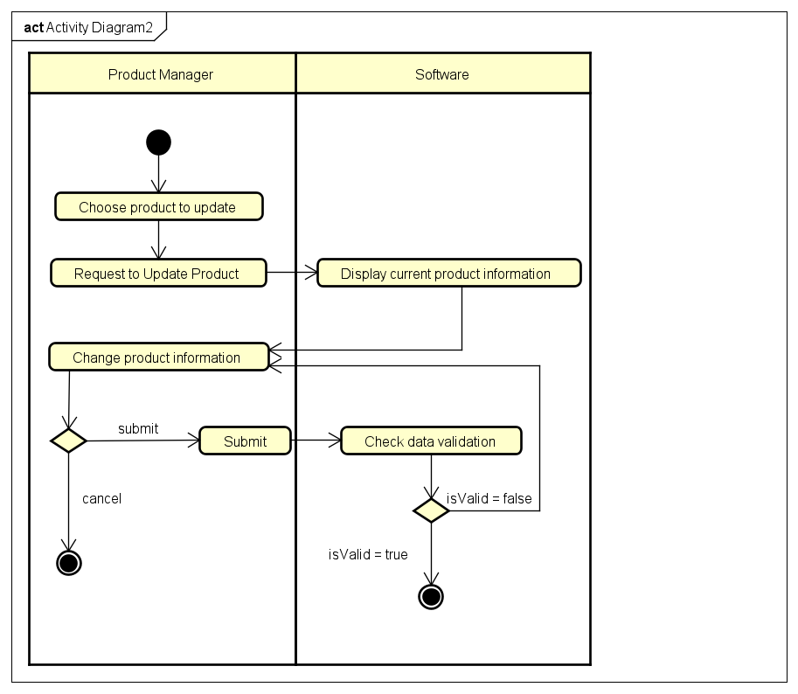
    - Activity Diagram “View Product Detail”
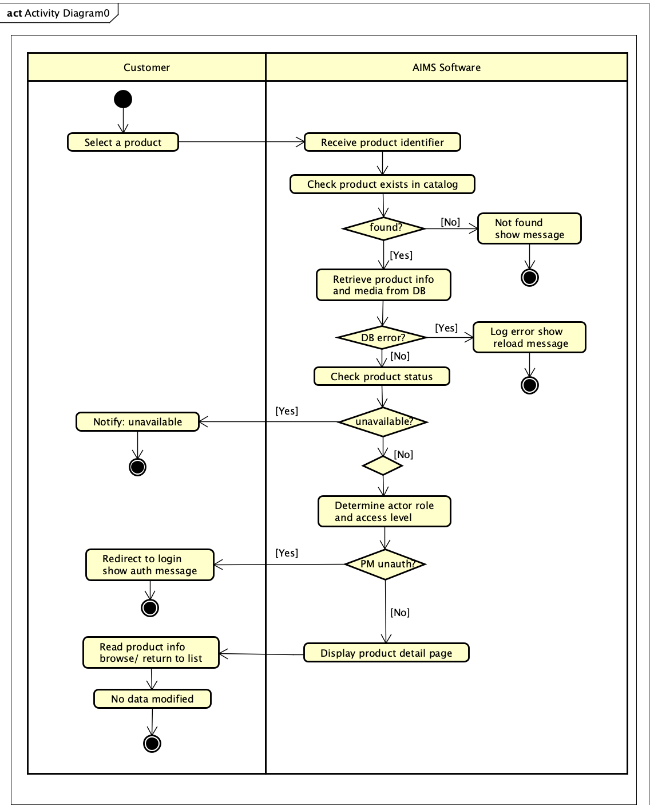

Detailed Requirements

Use case “Place order”

Use Case “Place order”
1. Use case code
UC231
2. Brief Description
The use case “Place order” describes the interaction between customers and AIMS software
3. Actors
3.1 Customer
3.2 AIMS software
4. Preconditions
- The available stock is sufficient to fulfill the customer’s demand.
- There is at least one item in the cart.
5. Basic Flow of Events
1. Customer requests to place an order
2. The AIMS software checks the availability of products in the cart
3. AIMS software displays the form of delivery information with order information
4. Customer enters and submits delivery information (see Table 1)
5. AIMS software checks if the delivery information is valid
6. AIMS software calculates the shipping fee
7. AIMS software displays invoice screen (see Table 2)
8. Customer asks to pay order
9. AIMS software calls the UC “Pay order”
10. AIMS software updates the invoice status
11. AIMS software saves a new order with an invoice
12. AIMS software makes the cart empty
13. The AIMS software sends an email about the successful order notification and information to the customer
14. The AIMS software displays the successful order information and the transaction information (see Table 3)
6. Alternative flows
Table N-Alternative flows of events for UC Place order
No | Location | Condition | Action | Resume location
1. | At Step 3 | If the products are not available | The AIMS software notifies that the products in the cart are not available and stay at the use case “View cart” | Use case ends
2. | At Step 5 | If the delivery info is invalid | AIMS software notifies that the delivery info is invalid (blank or wrong format) | At Step 3
3. | At Step 8 | If the order payment is not successful or goes back from the payment | AIMS software notifies that the order payment is not successful | At Step 5
7. Input data
Table 1-Input data of delivery information
No | Data fields | Description | Mandatory | Valid condition | Example
1. | Receiver Name |  | Yes |  | Bui Trung Hieu
2. | Phone number |  | Yes | - 10 digits  -May contains separator “.” or space or “-” in the middle of the phone number(one separator type) | 0981413168  0981 413 167  0988-097-136  0987-676-767
3. | Province | Choose from a list | Yes |  | Hanoi
4. | Address |  | Yes |  | No. 1 Dai Co Viet road, Bach Mai Ward, Hai Ba Trung District
5. | Shipping instructions |  | No
8. Output data
Table 2-Output data of invoice screen
No | Data fields | Description | Display format | Example
1. | Title | Title of a media product |  | DVD Phim Sieu Nhan
2. | Price | Price of corresponding media product | - Comma for thousands separator  - Positive integer  - Right alignment | 234,000
3. | Quantity | Quantity of the corresponding media | - Positive integer  - Right alignment | 3
4. | Amount | Total money of the corresponding media | - Comma for thousands separator  - Positive integer  - Right alignment | 702,000
5. | Subtotal before VAT | Total price of products in the cart before VAT | - Comma for thousands separator  - Positive integer  - Right alignment | 1,234,000
6. | Subtotal | Total price of all products in the cart with VAT | - Comma for thousands separator  - Positive integer  - Right alignment | 1,357,400
7. | Shipping fee |  | - Comma for thousands separator  - Positive integer  - Right alignment | 35,000
8. | Total | Sum of subtotal and shipping fee |  | 1,392,400
Table 3-Output data of general information of order and transaction info
No | Data fields | Description | Display format | Example
1. | Customer name |  |  | Bui Trung Hieu
2. | Phone number |  |  | 0936363636
3. | Province |  |  | Hanoi
4. | Address |  |  | No. 1 Dai Co Viet road, Bach Mai Ward, Hai Ba Trung District
5. | Total amount |  | -Right alignment  -Vienamese currency(VND)  -Vietnam locale | 1,234,000
6. | Transaction ID
7. | Transaction content
8. | Transaction date |  | dd/mm/yy | 16/03/2026
9. Postconditions
A new order is created, and its information is sent via email to the customer or nothing happens if payment is not successful

Use case “Pay Order(VietQR)”

Use Case Pay Order(VietQR)
1. Use case code
UC232
2. Brief Description
This use case describes the interaction between the customer, the AIMS software, and the VietQR system when the customer makes a payment for an order using a QR code. The process begins when the system displays invoice information along with the payment method and ends when the transaction is successfully recorded.
3. Actors
3.1 Customer
3.2 VietQR
4. Preconditions
- The Customer has completed entering shipping information and confirming the order (finishing the preparation steps).
- The system has calculated the shipping fee and generated temporary invoice.
5. Basic Flow of Events
1. Customer request to pay order
2. System display and save a temporary invoice information
3. System call VietQR’s Get Token API to obtain an Access Token to access the system
4. VietQR return access token to System
5. System call Generate VietQR Code API use token to create QR code for payment base on total money of invoice
6. VietQR return QR code can be image or data string to System.
7. System show the QR code and detail invoice.
8. Customer scan QR code
9. Customer confirm the payment
10. VietQR record successful transactions send notification to System.
11. System receive callback data and recheck order ID and amount
12. System update status order to pending and store detail transaction
13. System display successful payment with order information and transaction code
14. System clear cart
15. System send email confirm invoice and transaction information to Customer’s email
6. Alternative flows
Table 1 - Alternative flows of events for UC “Pay Order By Credit Card”
No | Location | Condition | Action | Resume location
1. | At step 7 | If customer want to change payment method | System change to usecase “Pay Order by Credit Card”. | Use case end
2. | At step 8 | If the customer want to change order information. | System call “Place Order” use case | Use case end
3. | At step 9 | Transaction is failed | System notify the failure and allow customer try scanning again | At step 7
4. | At step 10 | If Network timeout / No callback received | Customer clicks "I have paid". System calls "Check Transaction" API to verify. | At step 11
5. | At Step 11 | If QR code expired | System notify expired QR code, request to refresh | At step 3
7. Input data
Table 2 - Input data of UC “Pay order by credit card”
No | Data fields | Description | Mandatory | Valid condition | Example
1. | Access Token | Token for API authentication | Yes | Validated by VietQR | eyJhbGci..
2. | Amount | Total money to pay | Yes | Positive integer | 1,200,000
3. | Order ID | Unique ID for reconciliation | Yes | Matches existing order | ORDER_123
4. | Callback Data | Notification from VietQR | Yes | Valid signature/checksum | JSON Object
8. Output data

Table 3 - Output data of UC “Pay order by credit card”
No | Data fields | Description | Display format | Example
1. | QR Code | Visual code for scanning | Image/String | 
2. | Total amount | Final amount paid | Vietnamese currency (VNĐ) | 1.200.000 VNĐ
3. | Transaction ID | Provided by VietQR | String | VQR123456
4. | Transaction date | Date of successful payment | dd/mm/yyyy | 16/03/2026

9. Postconditions
- A new order is created with a "Pending" status.
- System sent the invoice and payment transaction information to the customer's email.
- System save recorded of payment transaction information and order detail in the history.
- System clear Customer’s cart.

Use case “Pay Order By Credit Card”

Use Case “Pay Order By Credit Card”
1. Use case code
- UC233
2. Brief Description
This use case describes the process of a customer paying for an order using a credit card as an alternative to the default QR code payment method. The credit card transaction is processed through the integrated PayPal Sandbox environment via PayPal REST APIs v2. Upon successful payment, the system displays the transaction and order details, sends a confirmation email containing the invoice and transaction information, records the payment and order data, and updates the order status to pending processing.
3. Actors
3.1 Primary Actor: Customer
3.2 Secondary Actor: PayPal SandBox
4. Preconditions
- The customer has set up delivery information.
- The software displays and temporarily saves invoice information, including the list of products in the cart, quantity, product prices, total product price excluding VAT, total product price including VAT, delivery fee, and total amount to be paid.
- The software initially displays a QR code as the default payment method.
- The AIMS system is configured to connect to the PayPal Sandbox environment.
5. Basic Flow of Events
1. The customer chooses to switch from the default QR code payment method to the alternative payment method using a credit card.
2. The AIMS system initiates a payment request to the integrated PayPal Sandbox environment using PayPal REST APIs v2.
3. The PayPal Sandbox prompts the customer for their credit card information.
4. The customer enters their credit card details and submits the payment.
5. The PayPal Sandbox captures the payment and returns a successful transaction confirmation to the AIMS system.
6. After a successful payment, the software displays general information of the order (customer name, phone number, shipping address, province, total amount) and transaction information (transaction ID, transaction content and transaction datetime).
7. The software sets the order to a pending processing state.
8. The software sends invoice and payment transaction information to the customer's email.
9. The software records the payment transaction information and the successfully paid order.
6. Alternative flows
Table 1 - Alternative flows of events for UC “Pay Order By Credit Card”
No | Location | Condition | Action | Resume location
1. | At Step 1 | If the customer decides to adjust the delivery method or the items they wish to purchase. | The software recalculates the delivery fees and updates the corresponding invoice. | Resumes at Step 1
2. | At any step during the payment process | If the customer chooses to go back to any previous step or exit the software. | The software halts the payment process and navigates the user back to the previous screen or exits. | Use case ends
3. | At Step 5 | If the PayPal Sandbox fails to capture the payment (e.g., declined card or invalid API credentials). | The software displays an error message and does not proceed with the successful post-payment actions. | Resumes at Step 3 or Use case ends
7. Input data
Table 2 - Input data of UC “Pay order by credit card”
No | Data fields | Description | Mandatory | Valid condition | Example
1. | Payment Method Selection | The choice to switch from the default QR code to a credit card. | Yes | Must be selected as "Credit Card" (PayPal Sandbox). | "Credit Card" (PayPal Sandbox).  Credit Card
2. | Credit Card Information | The payment credentials required by the PayPal Sandbox integration to capture the payment. | Yes | Must be valid test credentials accepted by the PayPal Sandbox environment. | Sandbox Credit Card Number, Expiry, CVV
3. | Payment Payload | The total amount and order details sent from AIMS to PayPal Sandbox API. | Yes | Must match the total amount to be paid. | USD 12.50
8. Output data
Table 3 - Output data of UC “Pay order by credit card”
No | Data fields | Description | Display format | Example
1. | General Order Information | Displays the customer name, phone number, shipping address, province, and total amount. | Text | Nguyen Van A, 0987654321, 1 Dai Co Viet, Hanoi, 125,000 VND
2. | Transaction Information | Displays the transaction ID, transaction content, and transaction datetime. | Text | TXN-98765, Payment for Order #123, 2023-10-27 14:30:00
3. | Email Notification | Invoice and payment transaction information sent to the customer's email. | Email format | (Email containing the invoice and transaction details)
9. Postconditions
- The order status is updated to a pending processing state.
- The software has sent the invoice and payment transaction information to the customer's email.
- The software has recorded the payment transaction information and the successfully paid order in the system.

CUD Product

Use Case “CUD Product”
1. Use case code
UC234
2. Brief Description
This use case is the central management screen for the Product Manager. Here, users can view the product list and select specific actions such as add new products, edit information, delete products, or adjust inventory quantities. This use case is like a navigational; the detailed logic of each action will be handled separately by the corresponding child use cases (Create, Edit, Delete, Adjust).
3. Actors
3.1 Product Manager
4. Preconditions
- Product Manager successfully logged into the AIMS System with appropriate account provided.
- The AIMS System is currently operating normally.
5. Basic Flow of Events
- Product Manager request access to the product management interface.
- Software displays list of products and options for adding, editing, deleting and adjusting quantities.
- Product Manager select a function.
- Software calls and executes the use case corresponding to the function
- Software update product list
- Software display notifications and save record into history
6. Alternative flows
No | Location | Condition | Action | Resume location
1 | At step 3 | If Product Manager choose Add Product function | Sofware calls and executes the flow of Add Product usecase | At step 5
2 | At step 3 | If Product Manager choose Update Product function | Sofware calls and executes the flow of Update Product usecase | At step 5
3 | At step 3 | If Product Manager choose Adjust Quantity function | Sofware calls and executes the flow of Adjust Quantity usecase | At step 5
4 | At step 3 | If Product Manager choose Delete Product function | Sofware calls and executes the flow of Delete Product usecase | At step 5
5 | At step 4 | If usecase return error | Software display Error Message and do not update product list | At step 2
6 | Any step | If Product Manager cancel process | Software do not save any changes and return product list interface | At step 2
7. Input data
No | Data fields | Description | Mandatory | Valid condition | Example
1 | Search Keyword | Keywords to quickly find products (by Title or Barcode). | No | Text or Numeric | "Harry Potter"
2 | Filter Category | Criteria to filter the product list into specific groups. | No | One of: Books, CDs, DVDs, Newspapers | Books
3 | Product Selection | Specifies a particular product from the list to perform an action. | Yes (except Add) | Must select at least one existing product | Barcode: 893122...
4 | Operation Command | Command to select the desired administrative function. | Yes | One of: Add, Edit, Delete, Adjust | "Edit Product"

8. Output data
No | Data fields | Description | Display format | Example
1 | Operation Status | Notification of the result for the performed action (add, edit, delete, or adjust). | Text notification | Product added successfully
2 | Product List | A list of all media products currently available in the store's inventory. | Data table | (List of Books, CDs, …)
5 | History Log | A record list of all product additions, edits, and deletions. | Timeline/Log entry | 16/03/2026: Manager A updated stock of Barcode X
6 | Error Message | Detailed notification when input data is invalid or violates system rules. | Text (Red) | Price must be between 30% and 150% of Original Value
9. Postconditions
- Interface Refresh: The product management interface is automatically refreshed to display the most recent data after the operation.
- Audit trail: A new record created in history, log the detail information of the operation
- User notification: Product Manager receive notification from software, product list interface must refreshed to display updated list

    - Add Product

Use Case “Add Product”
1. Use case code
UC234.1
2. Brief Description
This use case allows the Product Manager to add a new media product (Book, Newspaper, CD, DVD) to the AIMS system. The system will check data format constraints and pricing rules before officially saving it to the database.
3. Actors
3.1 Product Manager
4. Preconditions
- Product Manager successfully logged into the AIMS System with appropriate account provided.
- The AIMS System is currently operating normally.
5. Basic Flow of Events
- Product Manager select Add Product
- Software displays general form for Product Manager
- Product Manager input general information and choose specific type of product.
- Software displays form for fill specific information depending on product type
- Product Manager input specific information and submit.
- Software checks the data and price rule.
6. Alternative flows
No | Location | Condition | Action | Resume location
1 | At step 6 | If the input data is not in the correct format | Sofware display detailed error for each data field | At step 3 or 5
2 | Any step | If Product Manager cancel process | Software do not save any changes and return product list interface | End the usecase
7. Input data
No | Data fields | Description | Mandatory | Valid condition | Example
1 | Barcode | Unique identifier for the product | Yes | Unique in the system; numeric only | 893123456789
2 | Title | The name of the media product | Yes | Cannot be blank | DVD Hello World
3 | Category | Product classification | Yes | One of: Books, Newspapers, CDs, DVDs | Books
4 | General Description | Condition, primary color, or return condition | Yes | Text description | New condition, blue cover
5 | Original Value | Base price excluding 10% VAT | Yes | Positive integer | 100
6 | Current Price | Selling price excluding 10% VAT | Yes | Between 30% and 150% of Original Value | 120
7 | Dimensions | Physical size (Height x Width x Length) | Yes | Positive values only | 20 x 15 x 3 (cm)
8 | Weight | Physical weight of the product | Yes | Positive value (kg) | 0.5
9 | Author | Creator(s) of the book | Yes (Book) | Required if Category is "Books" | Ngo Tat To
10 | Cover Type | Format of the book cover | Yes (Book) | "Paperback" or "Hardcover" | Paperback
11 | Editor-in-chief | Head of the newspaper | Yes (News) | Required if Category is "Newspapers" | Nguyen Van A
12 | Artists | Performers or singers | Yes (CD) | Required if Category is "CDs" | Son Tung M-TP
13 | Track List | List of songs with titles and lengths | Yes (CD) | Must include title and duration per track | Track 1 - 10:30
14 | Disc Type | Physical format of the disc | Yes (DVD) | "Blu-ray" or "HD-DVD" | Blu-ray
15 | Director | Director of the media | Yes (DVD) | Required if Category is "DVDs" | Christopher Nolan
8. Output data
No | Data fields | Description | Display format | Example
1 | Operation Status | Notification of the result for the performed action (add, edit, delete, or adjust). | Text notification | Product added successfully
6 | Error Message | Detailed notification when input data is invalid or violates system rules. | Text (Red) | Price must be between 30% and 150% of Original Value
9. Postconditions
- Stored data: All products successfully saved into database or new information be updated with newest version.
- Error message: Product Manager receive error text message at invalid field.

    - Update Product

Use Case “Update Product”
- Use case code
UC234.2
- Brief Description
This use case is the central management screen for the Product Manager. Here, users can view the product list and select specific actions such as: add new products, edit information, delete products, or adjust inventory quantities. This use case like a navigational; the detailed logic of each action will be handled separately by the corresponding child use cases (Create, Edit, Delete, Adjust).
- Actors
3.1 Product Manager
- Preconditions
- Product Manager successfully logged into the AIMS System with appropriate account provided.
- The AIMS System is currently operating normally.
- Basic Flow of Events
- Product Manager select Edit Function
- Product Manager select one product
- Software displays product’s current information
- Product Manager update the necessary information
- Product Manager submit the form
- Software check constraint of data and price
- Software update product information
6. Alternative flows
No | Location | Condition | Action | Resume location
1 | At step 6 | If the input data is not in the correct format | Sofware display detailed error for each data field | At step 4
2 | Any step | If Product Manager cancel process | Software do not save any changes and return product list interface | At step 2
7. Input data
No | Data fields | Description | Mandatory | Valid condition | Example
1 | Barcode | Unique identifier for the product | Yes | Unique in the system; numeric only | 893123456789
2 | Title | The name of the media product | Yes | Cannot be blank | DVD Hello World
3 | Category | Product classification | Yes | One of: Books, Newspapers, CDs, DVDs | Books
4 | General Description | Condition, primary color, or return condition | Yes | Text description | New condition, blue cover
5 | Original Value | Base price excluding 10% VAT | Yes | Positive integer | 100
6 | Current Price | Selling price excluding 10% VAT | Yes | Between 30% and 150% of Original Value | 120
7 | Dimensions | Physical size (Height x Width x Length) | Yes | Positive values only | 20 x 15 x 3 (cm)
8 | Weight | Physical weight of the product | Yes | Positive value (kg) | 0.5
9 | Author | Creator(s) of the book | Yes (Book) | Required if Category is "Books" | Ngo Tat To
10 | Cover Type | Format of the book cover | Yes (Book) | "Paperback" or "Hardcover" | Paperback
11 | Editor-in-chief | Head of the newspaper | Yes (News) | Required if Category is "Newspapers" | Nguyen Van A
12 | Artists | Performers or singers | Yes (CD) | Required if Category is "CDs" | Son Tung M-TP
13 | Track List | List of songs with titles and lengths | Yes (CD) | Must include title and duration per track | Track 1 - 10:30
14 | Disc Type | Physical format of the disc | Yes (DVD) | "Blu-ray" or "HD-DVD" | Blu-ray
15 | Director | Director of the media | Yes (DVD) | Required if Category is "DVDs" | Christopher Nolan
8. Output data
No | Data fields | Description | Display format | Example
1 | Operation Status | Notification of the result for the performed action (add, edit, delete, or adjust). | Text notification | Product updated successfully
6 | Error Message | Detailed notification when input data is invalid or violates system rules. | Text (Red) | Price must be between 30% and 150% of Original Value
9. Postconditions
- Data Persistence: Product information is accurately updated to reflect the latest version in the database.
- Error message: Product Manager receive error text message at invalid field.

    - Adjust Quantity

Use Case “Adjust Quantity”
- Use case code
UC234.3
- Brief Description
This use case allows Product Manager to manually adjust the inventory quantity of a product (add to inventory or withdraw due to damage or loss). Any quantity changes must be accompanied by a specific reason for auditing and inventory management purposes.
- Actors
3.1 Product Manager
- Preconditions
- Product Manager successfully logged into the AIMS System with appropriate account provided.
- The AIMS System is currently operating normally.
- Basic Flow of Events
- Product Manager select adjust quantity
- Product Manager select product to adjust
- Software display box of current stock and form for adjust
- Product Manager input new stock and reason
- Software check reason
- Software change the stock quantity
6. Alternative flows
No | Location | Condition | Action | Resume location
1 | At step 6.3 | If Product Manager do not input Reason field | Software require to enter reason for adjust product quantity | At step 6.3
2 | Any step | If Product Manager cancel process | Software do not save any changes and return product list interface | End usecase
- Input data
No | Data fields | Description | Mandatory | Valid condition | Example
1 | New Stock | Updated manual inventory count | Yes (Adjust) | Non-negative integer | 50
2 | Reason | Explicit record for manual stock change | Yes (Adjust) | Required for all manual adjustments | Damaged during transit
- Output data
No | Data fields | Description | Display format | Example
1 | Stock Quantity | The actual number of items in stock after a manual update or a sale. | Positive integer | 45
2 | Adjustment Reason | An explicit record explaining why a manual stock change was performed. | Text description | Damaged during transit
- Postconditions
- Inventory Accuracy: The stock quantity of product is accurately updated in system according to manual adjustment
- Stock reason logging: Explicit reason is saved and linked to stock change record

    - Delete Product

Use Case “Delete Product”
- Use case code
UC234.4
2. Brief Description
This use case lets the Product Manager remove products from the AIMS sales list. The system checks security rules, such as the maximum number of products that can be deleted, and verifies the stock quantity to decide whether the product will be completely deleted or only marked as inactive.
3. Actors
3.1 Product Manager
4. Preconditions
- Product Manager successfully logged into the AIMS System with appropriate account provided.
- Product Manager select Delete function.
- The AIMS System is currently operating normally.
5. Basic Flow of Events
1. Product Manger select Delete Product
2. Product Manager select up to ten products to delete at a time.
3. Product Manager confirm the delete order
4. Software check security limit delete.
5. Software check product quantity
6. Software remove from sale list
6. Alternative flows
No | Location | Condition | Action | Resume location
1 | At step 2 | If Product Manager selects more than 10 products to delete at once. | Software displaying the warning only allows a maximum of 10 products to be selected. | At step 2
2 | At step 3 | If total number of products that Product Manager deleted today over 20 products. | Software notify the Product Manager of a security violation and refused to delete | At step 2
3 | At step 5 | If quantity of product removed greater than 0 | Software automatic change status to deactive. | At step 6
4 | Any step | If Product Manager cancel process | Software do not save any changes and return product list interface | End usecase
7. Input data
No | Data fields | Description | Mandatory | Valid condition | Example
1 | Selected Barcode | Unique identifier for the product | Yes | Barcode available in system | 893123456789
2 | Confirmation | Notification that Product Manager confirm to delete | Yes | Boolean | Yes

8. Output data

No | Data fields | Description | Display format | Example
1 | Operation Status | Notification of the result for the performed action (add, edit, delete, or adjust). | Text notification | Product added successfully
2 | Product Status | The commercial availability of the product (available or deactivated). | Label/Tag | Deactivated
3 | Error Message | Detailed notification when input data is invalid or violates system rules. | Text (Red) | Can’t delete more product.
9. Postconditions
- Product Status: Products with Stock = 0 are removed from the sales list; products with Stock > 0 have their status updated to "Deactivated".
- Security Update: The system updates the Product Manager's daily counter for the number of products deleted.

Use case 5
Use Case View Product Detail (Customer / Product Manager)
1. Use case code
- UC235
2. Brief Description
- This use case describes how a Customer or Product Manager interacts with the AIMS system to view the details of a selected product. When the actor chooses a product, the system retrieves the related product information and displays the appropriate details based on the actor’s role.
3. Actors
- Customer
- Product Manager
4. Precondition
- The selected product is already available in the AIMS catalog.
- The actor opens the product detail page from a product list, search result, homepage, or management screen.
- If the actor is a Product Manager, the account must be logged in and have the proper permission.
5. Basic Flow of Events
1. The actor selects a specific product from the homepage, product list, search result, or management list.
2. AIMS receives the selected product identifier.
3. The system checks whether the product exists in the catalog.
4. The system retrieves the product information and related media from the database.
5. The system determines the actor role and access level.
6. The system displays the product detail page with the data fields that the actor is allowed to view (see Table B).
7. The actor reads the product information and may continue browsing, return to the previous screen, or open another product.
6. Alternative Flows
Table N – Alternative flows of events for UC View Product Detail
No | Location | Condition | Action | Resume location
1 | At Step 3 | If the product identifier is invalid or the product record does not exist. | AIMS shows a “Product not found” message and provides a button or link to return to the previous page or continue browsing. | Use case ends
2 | At Step 4 | If the product is inactive, hidden, or currently unavailable for sale. | For Customer, the system displays a suitable notice such as unavailable or out of stock. For Product Manager, the system may still show the detail page together with the current product status. | Resume at Step 6
3 | At Step 5 | If Product Manager is not authenticated or does not have permission to view management data. | AIMS redirects the actor to the login page or displays an authorization message. Only public product information can be shown if applicable. | Resume at Step 6 or use case ends
4 | At Step 4 | If a database or service error occurs while loading product information. | AIMS logs the error and displays a message asking the actor to reload the page or try again later. | Use case ends

7. Input Data
Table A – Input data of View Product Detail
No | Data fields | Description | Mandatory | Valid condition | Example
1 | Product ID | Unique identifier of the selected product used to retrieve the correct product record. | Yes | Must match an existing product code or internal identifier in the catalog. | P100245
2 | Actor role | Current role of the user used to decide which product fields can be displayed. | Yes | Must be recognized by the system as Customer or Product Manager. | Customer
3 | Authentication / session status | Shows whether the current session is valid for protected management information. | Conditional | Required when the actor is Product Manager. Session must not be expired. | Valid login session
4 | Navigation source | Page or module from which the actor opens the detail page. | No | Can come from homepage, search result, product list, or management list. | Search result page
5 | Request timestamp | Time when the system receives the request to display the product detail page. | No | System generated for logging and traceability. | 16/03/2026 21:35

8. Output Data
Table B – Output data of Product Detail Page
No | Data fields | Description | Display format | Example
1 | Product title | Official name of the product shown on the detail page. | Text | Harry Potter
2 | Category | Type of product such as book, CD, DVD, or LP record. | Text | Book
3 | Price | Current selling price of the product. | Currency | 119,000 VND
4 | Availability status | Shows whether the product is in stock, out of stock, or unavailable. | Status text | In stock
5 | Description | Short summary or detailed introduction of the product. | Paragraph text | Fantasy novel written by J.K. Rowling.
6 | Product image | Main image or thumbnail representing the product. | Image | cover_image.jpg
7 | Barcode / product code | Internal or external product code used for identification. | Alphanumeric text | 0979798888
8 | Management status | Additional information for Product Manager such as active, hidden, or discontinued. | Status text | Active
9. Postconditions:
- The system shows the detailed information of the selected product.
- The actor can review the product information for the next actions such as continuing browsing, searching, or making management decisions.
- No business data is changed after the use case is completed.

Supplementary specification
The supplementary specification provides additional requirements for the SRS document. These requirements include system functionality rules, usability, reliability, performance, and other constraints to ensure the system operates effectively.

Functionality
- The software should validate all user input data, including product information, user data, and shipping information, to ensure correct formatting and that all required fields are filled.
- The system should store a history of product additions, edits, and deletions performed by product managers.
- The system should automatically update product stock quantities whenever products are sold.
- The system should implement price constraints, whereby the current selling price of the product should be between 30% and 150% of the product’s original value.
- The system should notify the product manager when an operation is invalid, such as entering incorrect data formats or violating product management rules.
- The system should maintain order information, payment transactions, and invoice data.

Usability
- The AIMS software should provide a clear and intuitive interface that allows customers to browse and purchase products without logging in.
- The system should allow customers to easily search for products by title or category and filter by price range.
- The system interface should allow users to view product details and manage shopping carts easily.
- Administrative functions are only accessible to users with administrator or product manager roles, and these users must log in to access their features.

Reliability
- The system should operate 24/7 and support up to 1,000 simultaneous customers without significantly reducing performance.
- The system should be able to run continuously for at least 300 hours without failure.
- In case of a system failure, the system should be able to recover and return to normal operation within 1 hour.

Performance
- The system's response time should not exceed 2 seconds under normal conditions.
- During peak hours, the maximum response time should not exceed 5 seconds.
- The system should efficiently handle shopping cart updates, order placement, and payment confirmation.
- The system should update inventory levels whenever products are sold.

Supportability
- The system should store the history of product additions, edits, and deletions.
- Software architecture should allow for future expansion, for example, to support additional product types or payment methods.

Other requirements
- The system must integrate payment services using PayPal Sandbox (credit card payments) and VietQR (QR code payments).
- The system should automatically generate and display QR codes for QR-based payments.
- The system must calculate dynamic shipping fees based on product weight and delivery location.
- Orders with a total product value exceeding 100,000 VND will receive free shipping up to a maximum of 25,000 VND.

