HANOI UNIVERSITY OF SCIENCE AND TECHNOLOGY
School of Information and communications technology

Software Design Document
Version 1.3

AIMS
Subject: ITSS-IT4549E

Group 23
Bùi Trung Hiếu - 20235932
Nguyễn Trần Bình - 20235899
Nguyễn Hữu Tuấn Tú - 20236005
Nguyễn Tuấn Khanh - 20235952
Trần Trung Nghĩa - 20235983

Hanoi, <June, 2026>
Table of Contents

1. Introduction 4
1.1 Objective 4
1.2 Scope 4
1.3 Glossary 5
1.4 References 7
2. Overall Description 9
2.1 General Overview 9
2.2 Assumptions/Constraints/Risks 9
2.2.1 Assumptions 9
2.2.2 Constraints 9
2.2.3 Risks 9
3. System Architecture and Architecture Design 10
3.1 Architectural Patterns 10
3.1.1. Client-Server Architecture 10
3.1.2. Layered Architecture 10
3.1.3. MVC Pattern 10
3.1.4. Service-Oriented Design 10
3.1.5. Repository Pattern 11
3.1.6. Factory Pattern 11
3.2 Interaction Diagrams 11
3.2.1 CUD Product 11
3.2.2 Pay order by PayPal 19
3.2.3 Pay order by VietQR 22
3.2.4 Place order 26
3.2.5 View Product Detail 29
3.3 Analysis Class Diagrams 32
3.3.1 CUD Product 32
3.3.2 Pay order by VietQR 35
3.3.2 Pay order by PayPal 37
3.3.3 Place order 38
3.3.4 View Product Detail 39
3.4 Unified Analysis Class Diagram 40
3.5 Security Software Architecture 40
3.5.1 Authentication 40
3.5.2. Authorization 41
3.5.3. Encryption 41
3.5.4. Logging and Auditing 41
4. Detailed Design 43
4.1 User Interface Design 43
4.1.1 Screen Configuration Standardization 43
4.1.2 Screen Transition Diagrams 46
4.1.3 Screen Specifications 47
4.2 Data Modeling 91
4.2.1 Conceptual Data Modeling 91
4.2.2 Database Design 94
4.3 Non-Database Management System Files 101
4.4 Class Design 101
4.4.1 General Class Diagram 101
4.4.2 Class Diagrams 102
4.4.3 Class Design 119
5.Design Considerations 236
5.1 Goals and Guidelines 236
5.1.1 Design goals 236
5.1.2 Guidelines 237
5.2 Architectural Strategies 238
5.2.1 Monorepo and Technology Stack 238
5.2.2 Layered + Hexagonal (Ports & Adapters) Architecture 238
5.2.3 RESTful API and DTO-based Contracts 238
5.2.4 Frontend – Angular Single-Page Application 238
5.2.5 Persistence and Data Management 238
5.2.6 Security and Authentication 239
5.2.7 Payment Gateway Integration (pluggable) 239
5.2.8 Notifications and Communication 239
5.2.9 Error Detection and Recovery 239
5.2.10 Concurrency and Synchronization 240
5.2.11 File and Asset Management 240
5.2.12 Configuration and Environment Management 240
5.2.13 Testing and Quality Assurance 240
5.2.14 Extensibility and Future Plans (OCP) 240
5.3 Design and Program Evaluation 241
5.3.1 Cohesion & SRP 241
5.3.2 Coupling & Other SOLID 259
5.4 Design Patterns 269
5.4.1 Payment 269
5.4.2 View Product Detail 270
5.4.3 CUD Product 271
5.4.4 Place Order 272

Introduction

1.1 Objective
This Software Design Document (SDD) is developed to describe in detail the architecture and technical design decisions of the AIMS (An Internet Media Store) system.
Specifically, the document aims at the following objectives:
- Present the overall architecture of the system, including how the components interact with each other.
- Describe the detailed design of each functional module, the database, and the user interface.
- Serve as a common reference document to help the development team members align on the technical direction throughout the project.
- Fulfill the evaluation purpose of the ISD.20252 course as required by the instructor.

The intended audience for this document includes:
- Development team: Members directly involved in designing and programming the system.
- Instructor and Teaching Assistant: The individuals who evaluate the design quality and the implementation progress of the project.

1.2 Scope
AIMS (An Internet Media Store) is an online e-commerce application developed to facilitate the buying and selling of media products, including books, newspapers, CDs, DVDs, and related items.

The system includes the following main features:
- Product Browsing and Searching: Users can search, filter, and view detailed information about media products based on various criteria.
- Shopping Cart and Order Management: Allows users to add products to their cart, confirm delivery information, and place orders online.
- Online Payment: Integrates two payment gateways: PayPal (for international credit cards) and VietQR (for domestic bank transfers), along with an automatic cancellation mechanism for abandoned transactions.
- Order and Refund Management: Managers can approve or reject orders and process refund requests; the system automatically sends email notifications to customers.
- Authentication and Authorization: The system distinguishes between two main roles, Customer and Manager, utilizing a JWT-based authentication mechanism.

The following features are out of the current scope:
- AI/ML-based product recommendation systems.
- Integration with external sales channels (marketplaces).

Objectives and Expected Benefits:
- Provide a convenient and fast online shopping experience for end-users.
- Support managers in controlling the entire order lifecycle, from order placement to completion or refund.
- Build a scalable platform to easily integrate additional features in the future.

1.3 Glossary
Term | Explanation
AIMS | An Internet Media Store – The name of the system being developed in this project.
SDD | Software Design Document – A document describing the architecture and technical design of the system.
SRS | Software Requirements Specification – The higher-level document that this SDD references.
API | Application Programming Interface – A set of endpoints that allow the client and server to communicate with each other.
REST / RESTful | Representational State Transfer – An API architectural style that uses the HTTP protocol with GET, POST, PUT, and DELETE methods.
JWT | JSON Web Token – A token encoding standard used to authenticate users after logging in.
ORM | Object-Relational Mapping – A tool that maps objects in the code to tables in a relational database. The project uses Prisma as its ORM.
Monorepo | A source code organization model where both the frontend and backend reside in a single repository. The project uses Nx Workspace.
Angular | A frontend framework developed by Google, utilizing TypeScript, used to build the user interface of AIMS.
NestJS | A backend framework for Node.js, utilizing TypeScript, used to build the RESTful API of AIMS.
Prisma | A modern ORM for Node.js/TypeScript, used to interact with the PostgreSQL database in the project.
PostgreSQL | An open-source relational database management system, used as the primary database for AIMS.
VietQR | A domestic payment QR code standard in Vietnam, integrated into AIMS to support bank transfers.
PayPal | An international payment gateway, integrated into AIMS to support credit card payments.
Cloudinary | A cloud-based image and video storage and management service, used to store product images in AIMS.
Invoice | An electronic invoice automatically generated after an order is successfully paid.
Refund | The process of returning money to a customer when a paid order is canceled.
Manager | The administrator role in the system, holding permissions to manage products, approve or reject orders, and process refunds.
VAT | Value Added Tax – A tax calculated and displayed on the system's invoices.
ERD | Entity-Relationship Diagram – A diagram used to describe the database structure.
Nx | A next-generation monorepo build and management tool, supporting both Angular and NestJS within the same workspace.

1.4 References
- N. T. T. Trang, "AIMS – Problem Statement (Version 3.1.1)," Tài liệu môn học ISD.20252, Khoa Khoa học máy tính, Đại học Bách khoa Hà Nội, 2025.
- NestJS Documentation. (2024). NestJS – A progressive Node.js framework. Retrieved from https://docs.nestjs.com
- Angular Documentation. (2024). Angular – The web development framework for building the future. Retrieved from https://angular.dev
- Prisma Documentation. (2024). Prisma ORM – Next-generation Node.js and TypeScript ORM. Retrieved from https://www.prisma.io/docs
- VietQR. (2024). VietQR – Tiêu chuẩn mã QR thanh toán Việt Nam. Retrieved from https://www.vietqr.io
- PayPal Developer Documentation. (2024). PayPal REST APIs. Retrieved from https://developer.paypal.com/docs/api/overview

Overall Description
This section describes the guidelines and strategies for designing and implementing the AIMS system.

2.1 General Overview
AIMS (An Internet Media Store) is a web-based e-commerce application designed with a Client-Server architecture. The project is organized using an Nx Monorepo. The frontend is an Angular Single Page Application and the backend is a NestJS REST API using Prisma ORM and a PostgreSQL database. The system must operate 24/7 and recover within a maximum of one hour after an incident. It is designed to serve up to 1,000 concurrent customers, maintaining a response time of under 2 seconds under normal conditions.

2.2 Assumptions/Constraints/Risks

2.2.1 Assumptions
The system assumes the stable operation of external APIs for PayPal Sandbox and VietQR payment processing. It also assumes that email delivery is reliably managed via the integrated Resend libraries, and that product images are efficiently hosted externally via the Cloudinary integration.

2.2.2 Constraints
Development is constrained strictly to the Nx, Angular, NestJS, and PostgreSQL stack. Business constraints dictate that product prices must always remain between 30% and 150% of their original value. Managers can only delete products with zero stock, and are limited to deleting 10 items per action and a maximum of 20 products per day; otherwise, items must be deactivated. Security constraints require all user passwords to be securely hashed using bcrypt, and administrators are strictly prohibited from viewing actual passwords. Finally, VietQR refunds cannot be automated and must be handled manually.

2.2.3 Risks
A key risk is stock mismatch during concurrent purchases, which must be managed using database transactions. Performance degradation under the 1,000-user load limit is another risk, requiring careful database query optimization. External payment API downtime poses a risk to the checkout process, requiring clear application-level error handling. Lastly, potential data loss is a risk that must be addressed through proper PostgreSQL backup procedures to ensure the system meets the mandatory one-hour recovery constraint.

System Architecture and Architecture Design

3.1 Architectural Patterns
The system applies a layered architecture combined with client-server communication and service-based separation of responsibilities. These architectural patterns are chosen to improve maintainability, scalability, testability, and separation of concerns.

3.1.1. Client-Server Architecture
The application follows a client-server architecture, where the frontend client provides the user interface and sends requests to the backend server through APIs. The backend server handles business logic, data validation, payment processing, order management, and database access.
This pattern was chosen because it clearly separates the presentation layer from the business and data layers. It also allows the frontend and backend to be developed, tested, deployed, and scaled independently.

3.1.2. Layered Architecture
The backend is organized into layers, including controller, service, repository, and entity/model layers. Controllers receive requests and return responses. Services contain business rules and application logic. Repositories handle data access. Entities or models represent core business objects such as users, products, orders, payments, and transactions.
This pattern was chosen to make the system easier to understand, maintain, and extend. It prevents business logic from being mixed directly with user interface code or database queries.

3.1.3. MVC Pattern
The frontend follows the Model-View-Controller or similar presentation pattern. Views display data to users, models represent application data, and controllers or components handle user interactions and coordinate communication with backend APIs.
This pattern was chosen because it supports a clear separation between data, interface, and interaction logic. It helps keep the user interface organized and easier to modify.

3.1.4. Service-Oriented Design

The system separates major business capabilities into services, such as user service, product service, cart service, order service, payment service, and delivery service. Each service is responsible for a specific business area and exposes operations related to that area.
This pattern was chosen to reduce coupling between business functions. It also makes the system easier to test, reuse, and extend when new features or external integrations are added.

3.1.5. Repository Pattern
The repository pattern is used to isolate database operations from business logic. Services interact with repositories instead of directly writing database queries.
This pattern was chosen because it improves maintainability and testability. It allows the data access implementation to change without affecting the business logic.

3.1.6. Factory Pattern
The factory pattern is used for selecting and creating suitable payment gateway handlers, such as different payment methods or external providers.
This pattern was chosen because payment processing may involve multiple providers or methods. A factory helps the system add or replace payment gateways without changing the main payment workflow.
Overall, these architectural patterns provide a structured and flexible design. They support clear responsibility separation, easier testing, better maintainability, and future extension of the application.

3.2 Interaction Diagrams

3.2.1 CUD Product
Product Management is a core task for any Product Manager. It involves adding new products, updating their details, adjusting quantities, and deleting items. The system keeps a record (audit log) of every change made and strictly follows specific business rules

3.2.1.1 Add Product
Description: This diagram shows the step-by-step interaction between different parts of the system when running the "Add Product" Use Case.
Pre-condition: The user has successfully logged in as a Product Manager and opened the "Add New Product" screen.
Main Flow:
- Receiving the request: The interface (Boundary - ProductFormUI) collects all the data entered by the user and sends a request to create a new product to the main controller (ProductController).
- Handling the logic: The controller (Control - ProductController) checks (validates) if the input data is correct. Depending on the product type (like a Book, CD, etc.), the system will check for specific required fields.
- Saving data: If the data is valid, the controller asks the system (Entity - Product) to create and save the new product's information.
- Audit logging: After successfully creating the product, the controller automatically tells the log (Entity - ProductLog) to record this action in the history.
- Feedback: The interface receives a success signal from the controller and shows a "Product added successfully" message to the Product Manager.
Business Rules:
- Unlike deleting products (which is limited to 20 items per day), there is no limit on how many products you can add.
- Every time a new product is added, it must be recorded in the History Log so it can be reviewed later if needed.
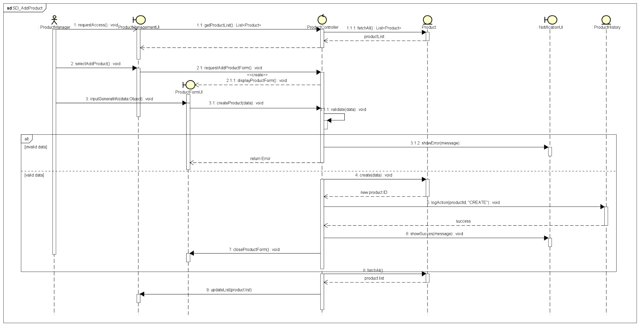
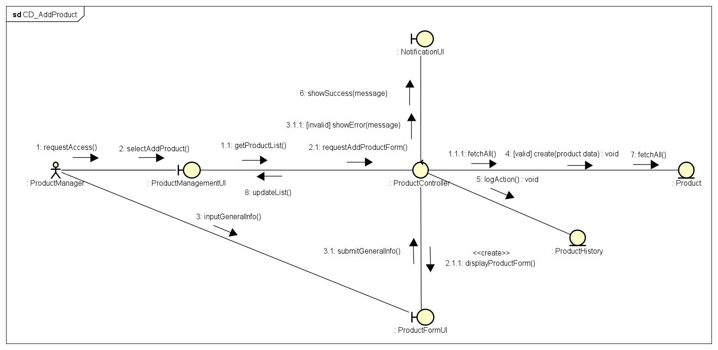

3.2.1.2 Update Product
Description: This diagram shows the step-by-step process when a Product Manager updates the details of an existing product.
Pre-condition: The user has successfully logged in as a Product Manager and selected a valid product to edit.
Main Flow:
- Receiving the request: The interface (Boundary - ProductFormUI) receives the new edits (which could be typing in standard text fields or uploading a new image) and sends them to the main controller (ProductController).
- Loading current info: The controller (ProductController) retrieves the product's current information from the system (Entity - Product) to compare and apply the changes.
- Saving data: The controller tells the system (Entity - Product) to process and save the updates.
- Audit logging: The update action is securely recorded in the history log (Entity - ProductLog).
- Feedback: The system sends a success signal back to the interface (Boundary) so the user knows the update worked.
Business Rules:
- Just like adding new items, there is no daily limit on how many products you can update.
- Any changes to the selling price must stay within an allowed range (30% to 150% of the original price). This strict rule is in place to prevent price dumping (selling too cheap) or price gouging (pricing too high), as outlined in the system specifications.

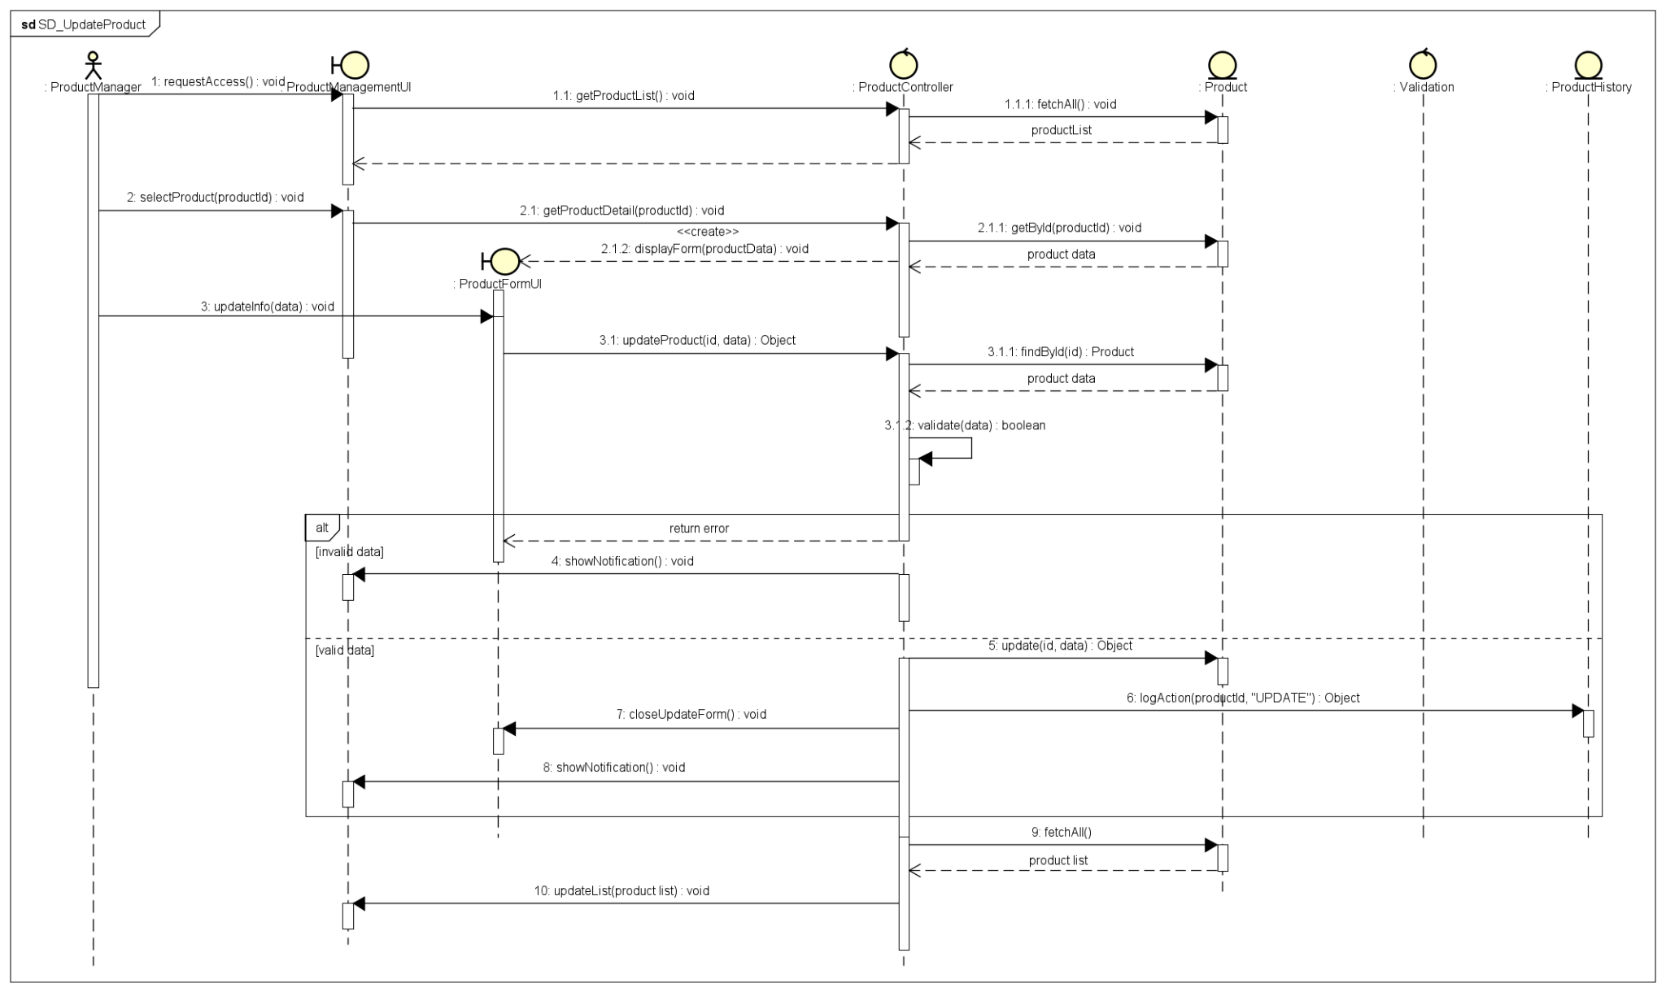
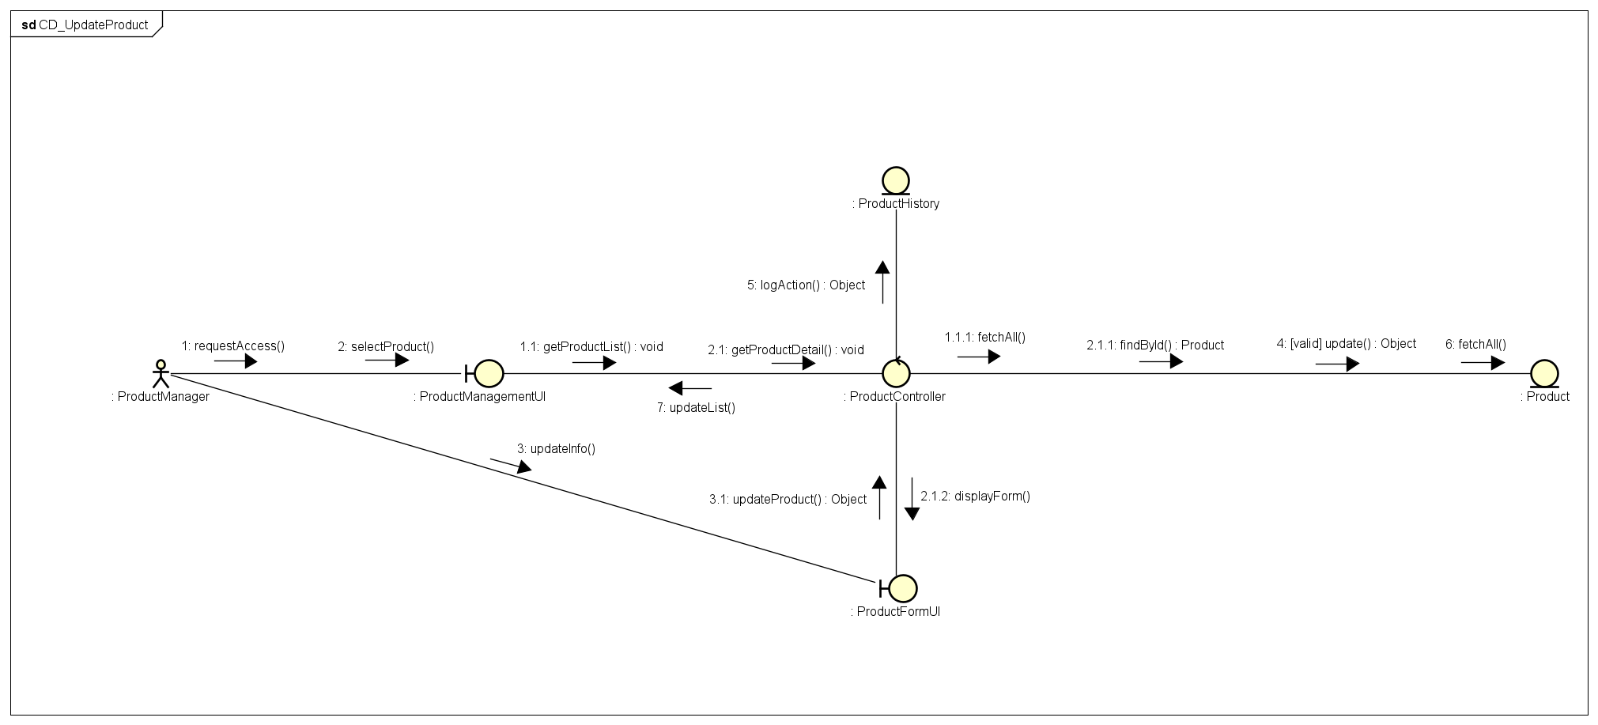

3.2.1.3 Adjust Quantity
Description: The "Adjust Quantity" flow is kept in a separate area on the detail screen. It is designed to help with inventory checks, such as adding new stock when it arrives or removing items that are damaged.
Pre-condition: The Product Manager is currently viewing a product's details (on the ProductDetailUI screen).
Main Flow:
- Receiving the request: The interface (Boundary - ProductDetailUI) opens a pop-up box (Modal) asking the user to type in the new quantity and provide a reason for the change.
- Updating data: The system reuses the standard update process (ProductController), but it focuses specifically on changing only the quantity field of the product (Entity - Product).
- Specific audit logging: This adjustment is securely recorded in the history log (Entity - ProductLog). It strictly requires the "Reason for change" to be included in the log (for example: "Damaged goods").
- Feedback: The system confirms the success, and the screen automatically updates to show the new quantity.
Business Rules:
- Any manual adjustments to the inventory require a clear, transparent reason (such as a system error, damaged goods, or adding new stock), as strictly required by the Problem Statement.
- The system will not process the update if the user leaves the reason field blank.

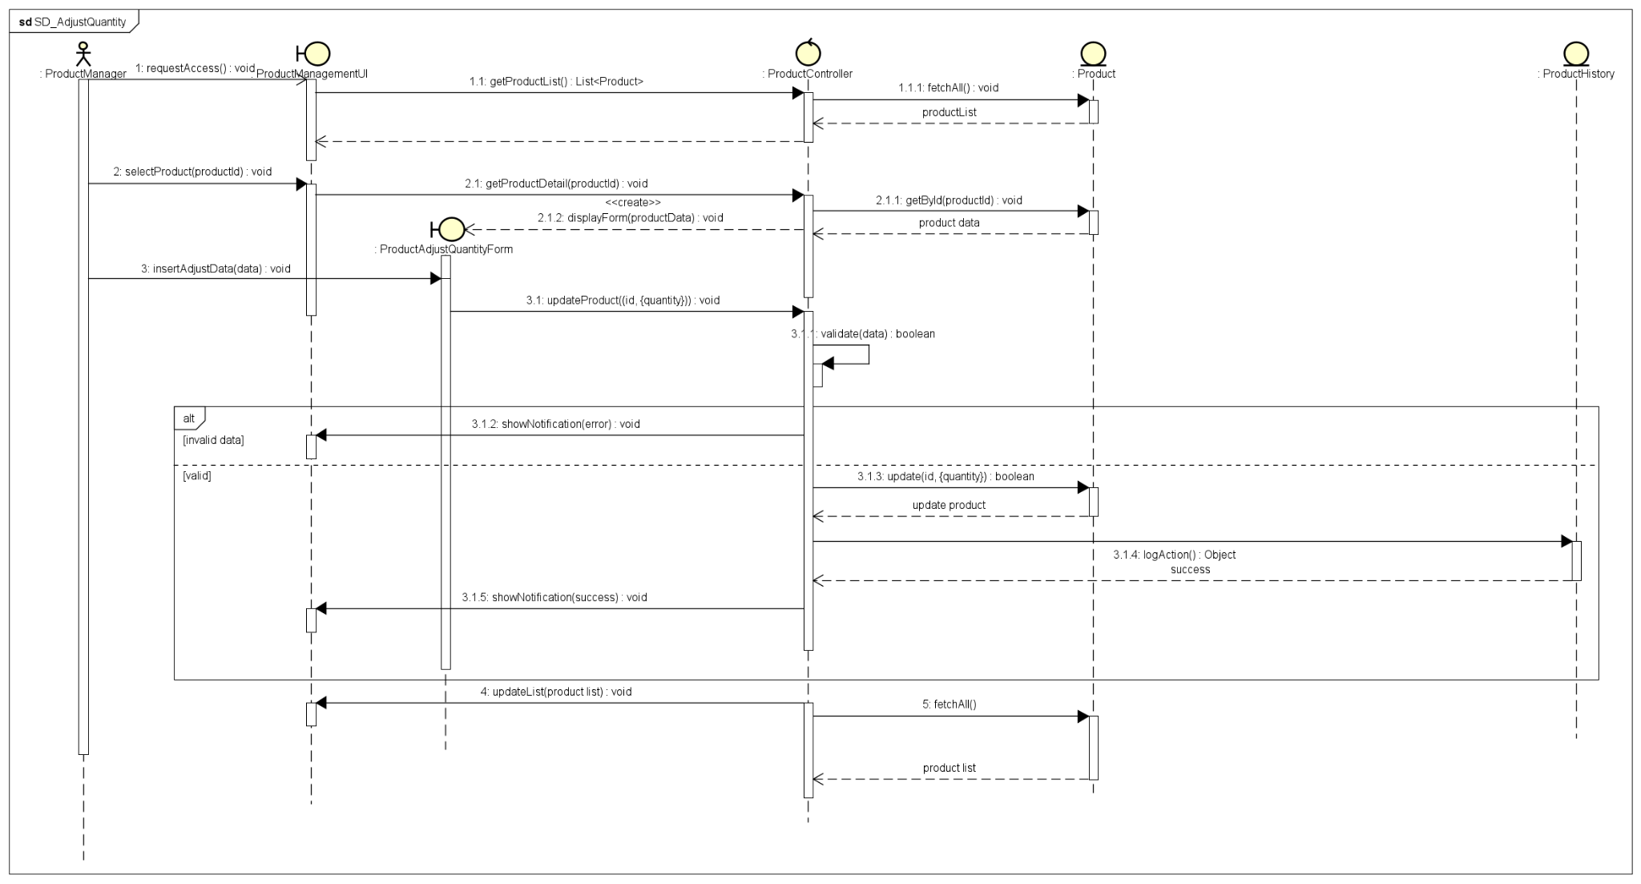
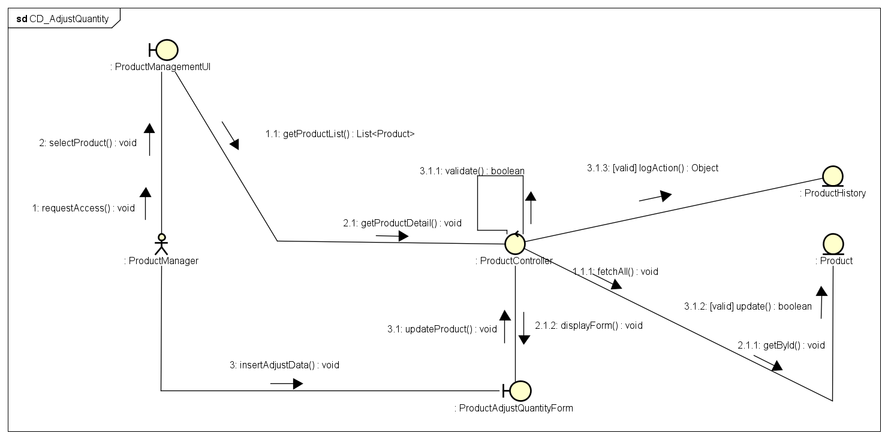

3.2.1.4 Delete Product
Description: The "Delete Product" flow is a complex process that is strictly guided by the system's security and data protection rules.
Pre-condition: The Product Manager is currently looking at the product list (ProductListUI) and selects the delete action (they can delete just one item or multiple items—up to 10 products at a time).
Main Flow:
- Receiving the request: The interface (Boundary - ProductListUI) sends a delete command to the main controller (ProductController).
- Checking the daily limit (Quota): The controller checks with the daily limit tracker (Entity - DailyQuota) to make sure the Manager hasn't exceeded their allowed number of deletions for the day. If they are over the limit, the request is instantly rejected.
- Checking data connections: The controller checks if the product is completely out of stock (Stock = 0) and looks to see if it is tied to any past customer orders (Entity - Product).
- Executing the delete: Depending on what the system finds, the product will either be completely erased from the system (Hard Delete) or its status will simply change to "Deactivated" (Soft Delete) if it is still connected to past data.
- Audit logging: The controller tells the history log (Entity - ProductLog) to record a "DELETE" event.
- Updating the quota: The Manager's daily deletion count goes up in the DailyQuota tracker.
- Feedback: The system sends the result back to the interface so the product list on the screen can update.
Business Rules:
- Security Rule (Daily Quota): A Manager cannot delete more than 20 products per day to prevent any intentional damage or accidental mass deletions. Can only select a maximum of 10 products to delete at the exact same time.
- Data Integrity Rule (Soft vs. Hard Delete): A product can only be permanently erased from the database (Hard Delete) if there are exactly 0 items in stock AND it has never been part of an order. Otherwise, its status will just change to "Deactivated" (Soft Delete). This means it won't show up for sale anymore, but its information is safely kept for accounting and history checks.
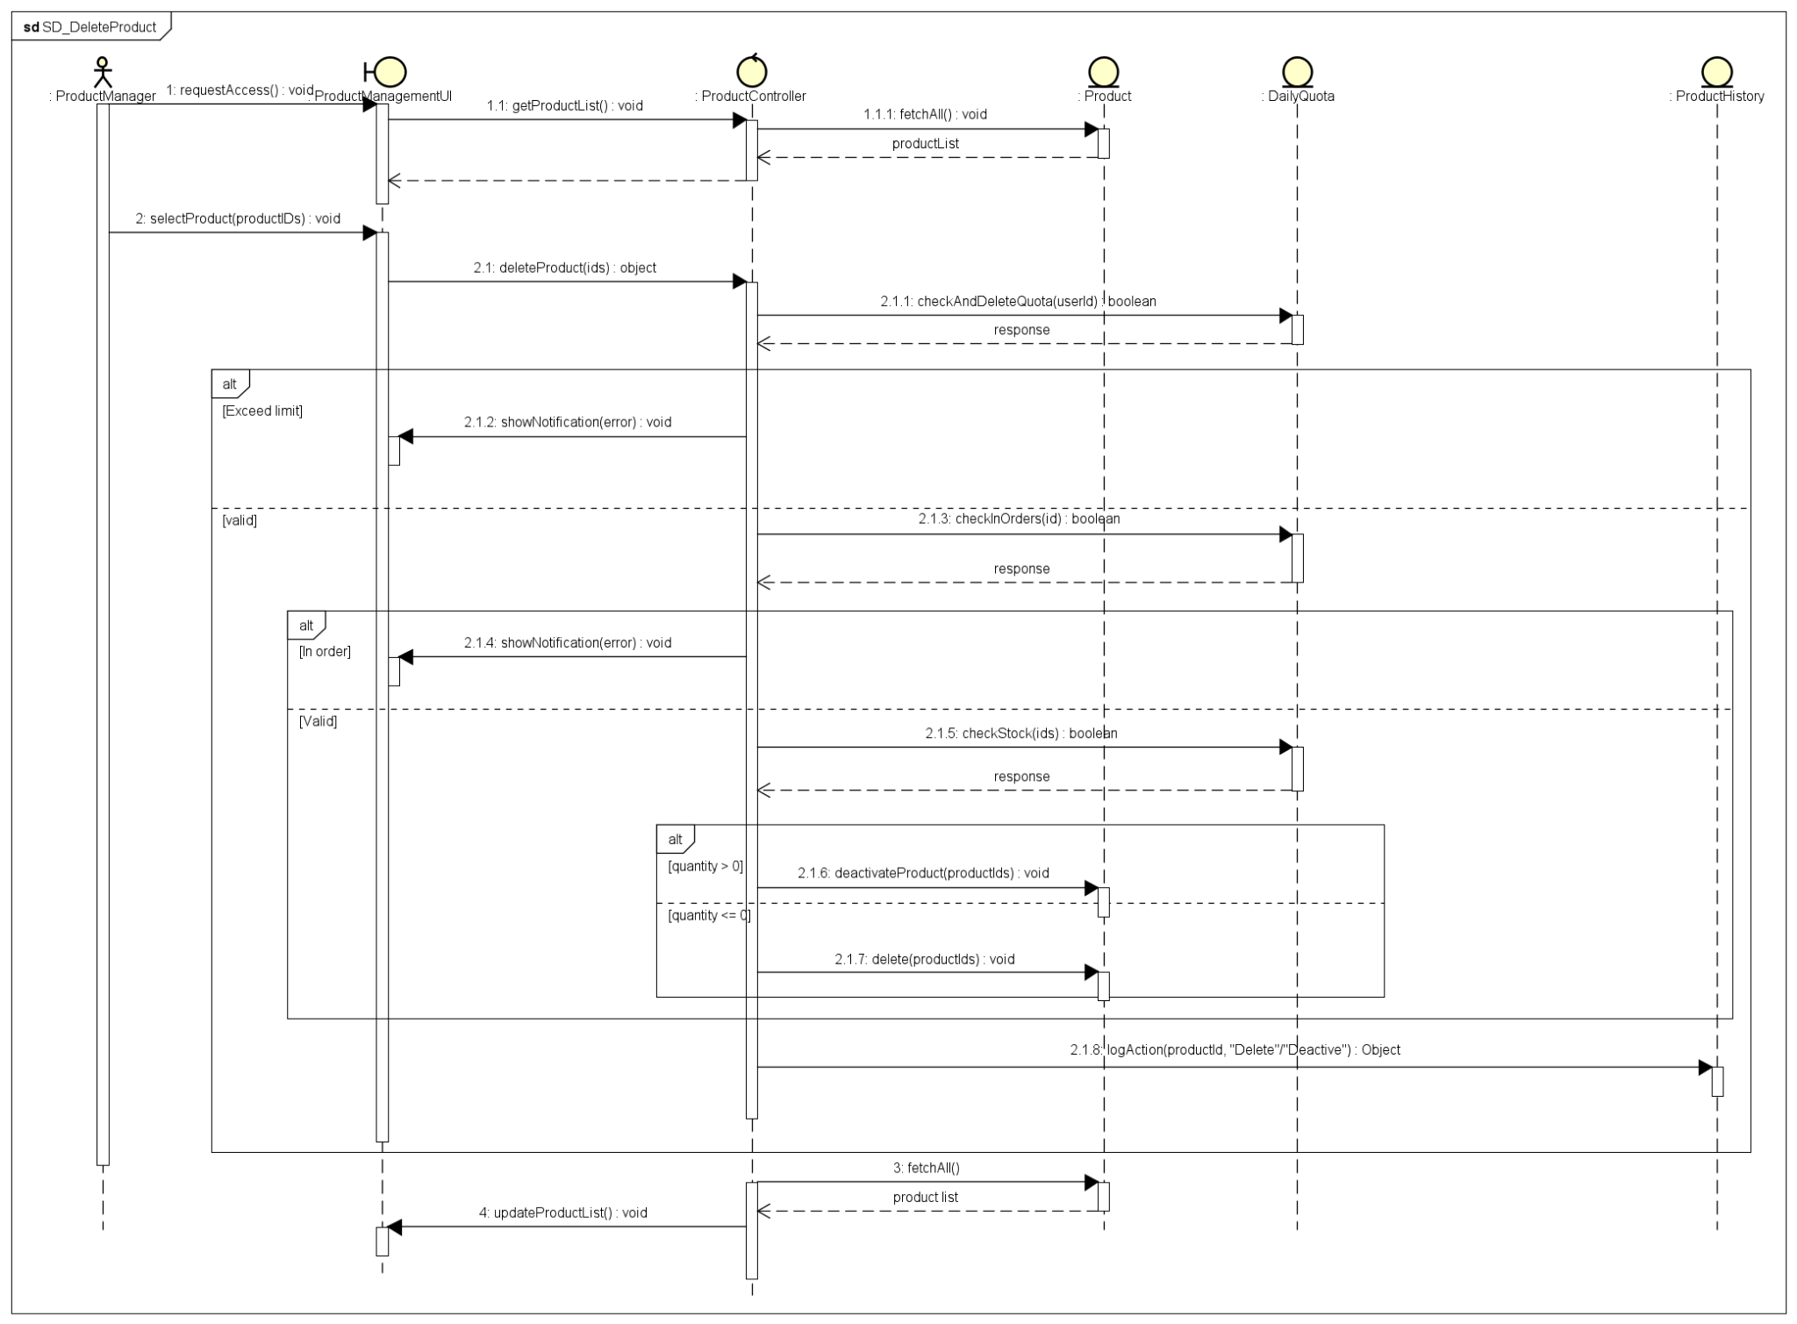
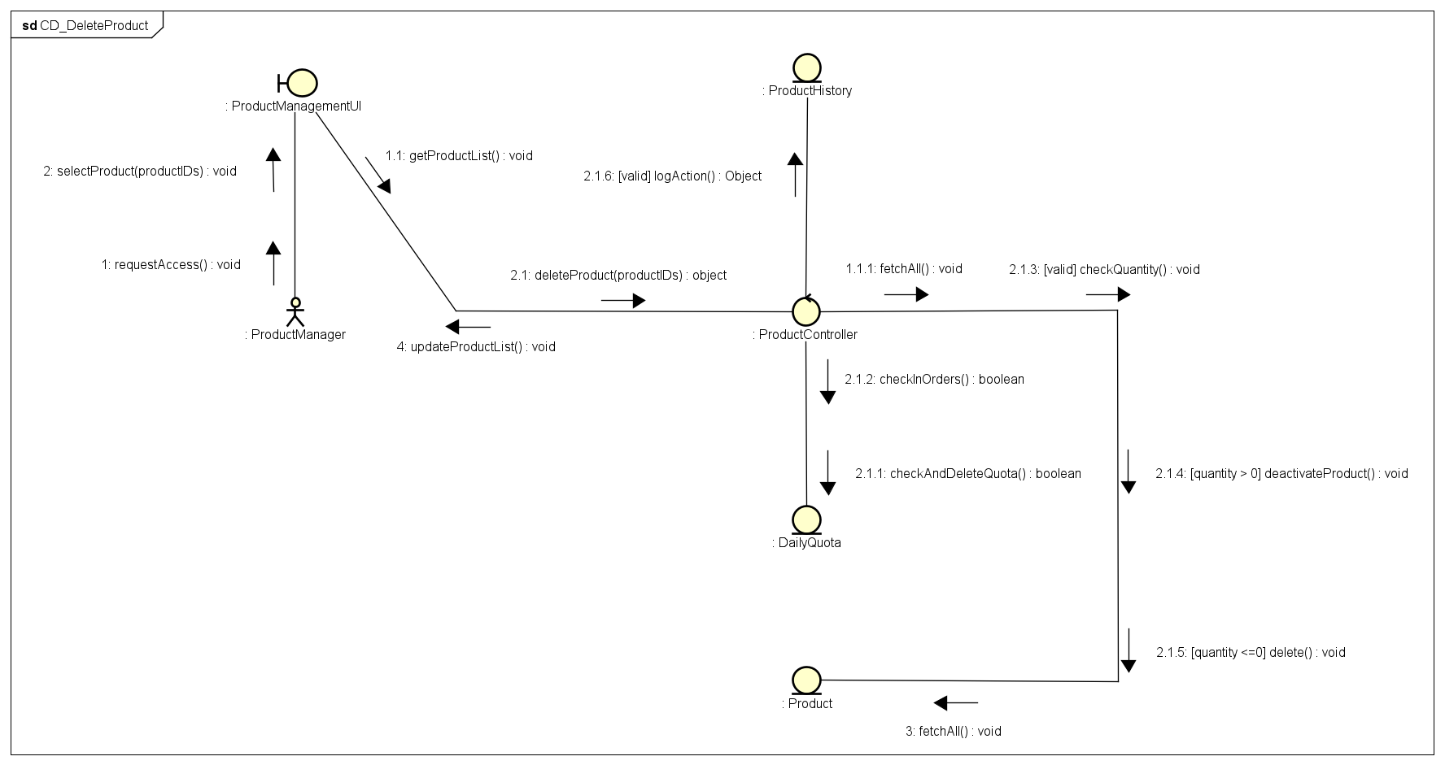

3.2.2 Pay order by PayPal

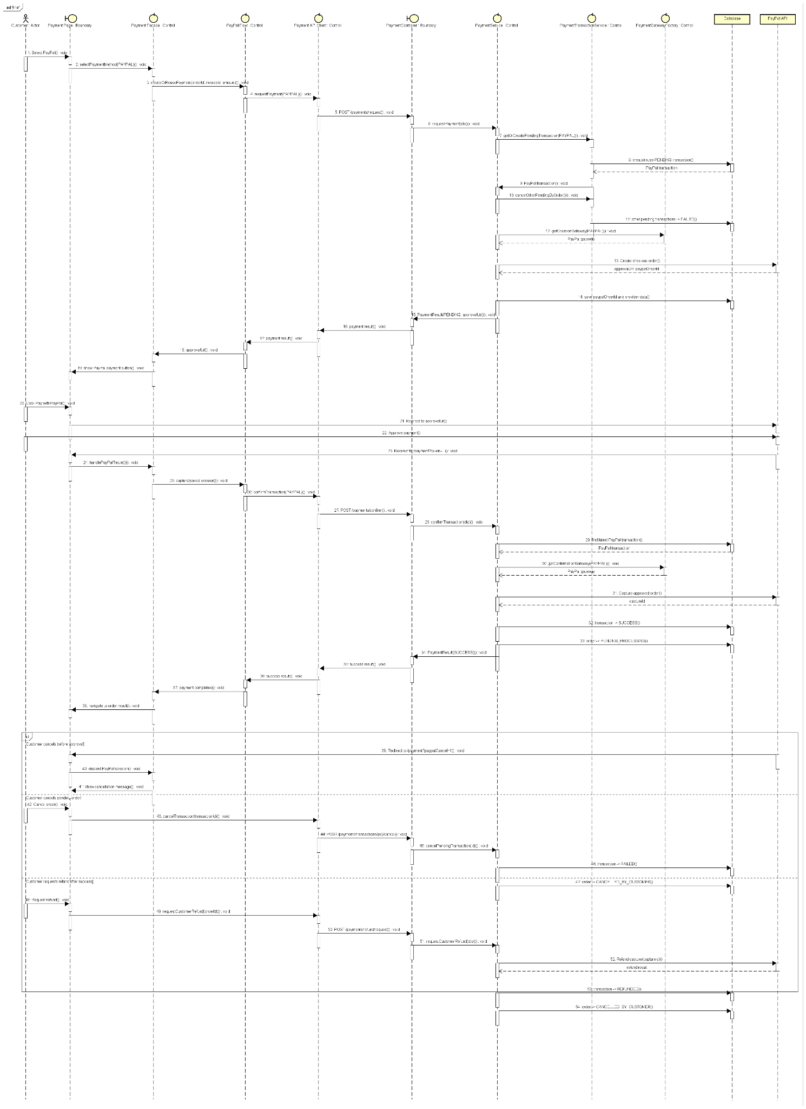

Description
This use case describes the PayPal payment flow for an online order. The customer selects PayPal as the payment method, is redirected to PayPal to approve the payment, and then returns to the system. The system confirms and captures the PayPal payment, updates the payment transaction status, and moves the order to processing. The flow also covers customer cancellation and refund requests.
Preconditions
- The customer has created an order and reached the payment step.
- The order contains a valid invoice and payable amount.
- PayPal is available as a supported payment method.
- The system is configured with valid PayPal API credentials.
- The order has no completed payment transaction yet.
- The customer has access to a valid PayPal account or PayPal-supported payment source.
Main Flow
- The customer selects PayPal as the payment method.
- The payment page sends the selected payment method to the payment facade.
- The system creates or reuses a pending PayPal payment transaction for the order and invoice.
- The system sends a payment creation request to the PayPal API.
- The payment service checks whether there is an existing pending PayPal transaction.
- If a reusable pending transaction exists, the system reuses it; otherwise, it creates a new pending transaction.
- The system cancels other pending payment transactions for the same order.
- The system creates a PayPal gateway instance.
- The PayPal gateway creates a checkout order through the PayPal API.
- PayPal returns an approval URL and PayPal order ID.
- The system saves the PayPal order ID and provider data.
- The payment result is returned to the payment page with status PENDING and the approval URL.
- The payment page displays the PayPal payment button.
- The customer clicks the PayPal payment button.
- The customer is redirected to PayPal.
- The customer approves the payment on PayPal.
- PayPal redirects the customer back to the system with a payment token.
- The system handles the PayPal return and captures the saved session information.
- The system sends a confirmation request for the PayPal transaction.
- The payment service finds the latest PayPal transaction for the order.
- The system confirms the payment with the PayPal gateway.
- The PayPal gateway captures the approved PayPal order through the PayPal API.
- PayPal returns a successful capture result.
- The system updates the transaction status to SUCCESS.
- The system updates the order status to PENDING_PROCESSING.
- The system returns a successful payment result.
- The customer is navigated to the order result page.
Business Rules
- Only one active pending payment transaction should exist for an order at a time.
- When PayPal is selected, other pending transactions for the same order must be marked as failed or cancelled.
- A pending PayPal transaction may be reused if it is still valid and belongs to the same order.
- The payment amount must match the invoice amount of the order.
- The system must store the PayPal order ID and provider response data for later confirmation.
- The order must not be moved to processing until the PayPal payment is successfully captured.
- A PayPal payment is considered successful only after PayPal returns a successful capture result.
- If the customer cancels before approving the payment, the system discards the PayPal session and shows a cancellation message.
- If the customer cancels while the transaction is still pending, the pending transaction must be cancelled and the order status becomes CANCELLED_BY_CUSTOMER.
- If the customer requests a refund after a successful payment, the system must request a refund from PayPal before marking the transaction as REFUNDED.
- After a successful refund, the order status becomes CANCELLED_BY_CUSTOMER.
- Failed, cancelled, or refunded transactions must not be reused for later payment attempts.

3.2.3 Pay order by VietQR
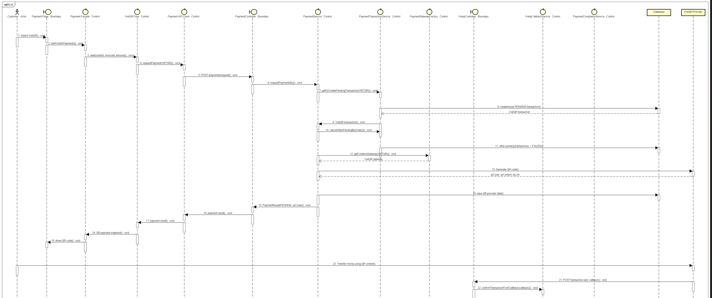
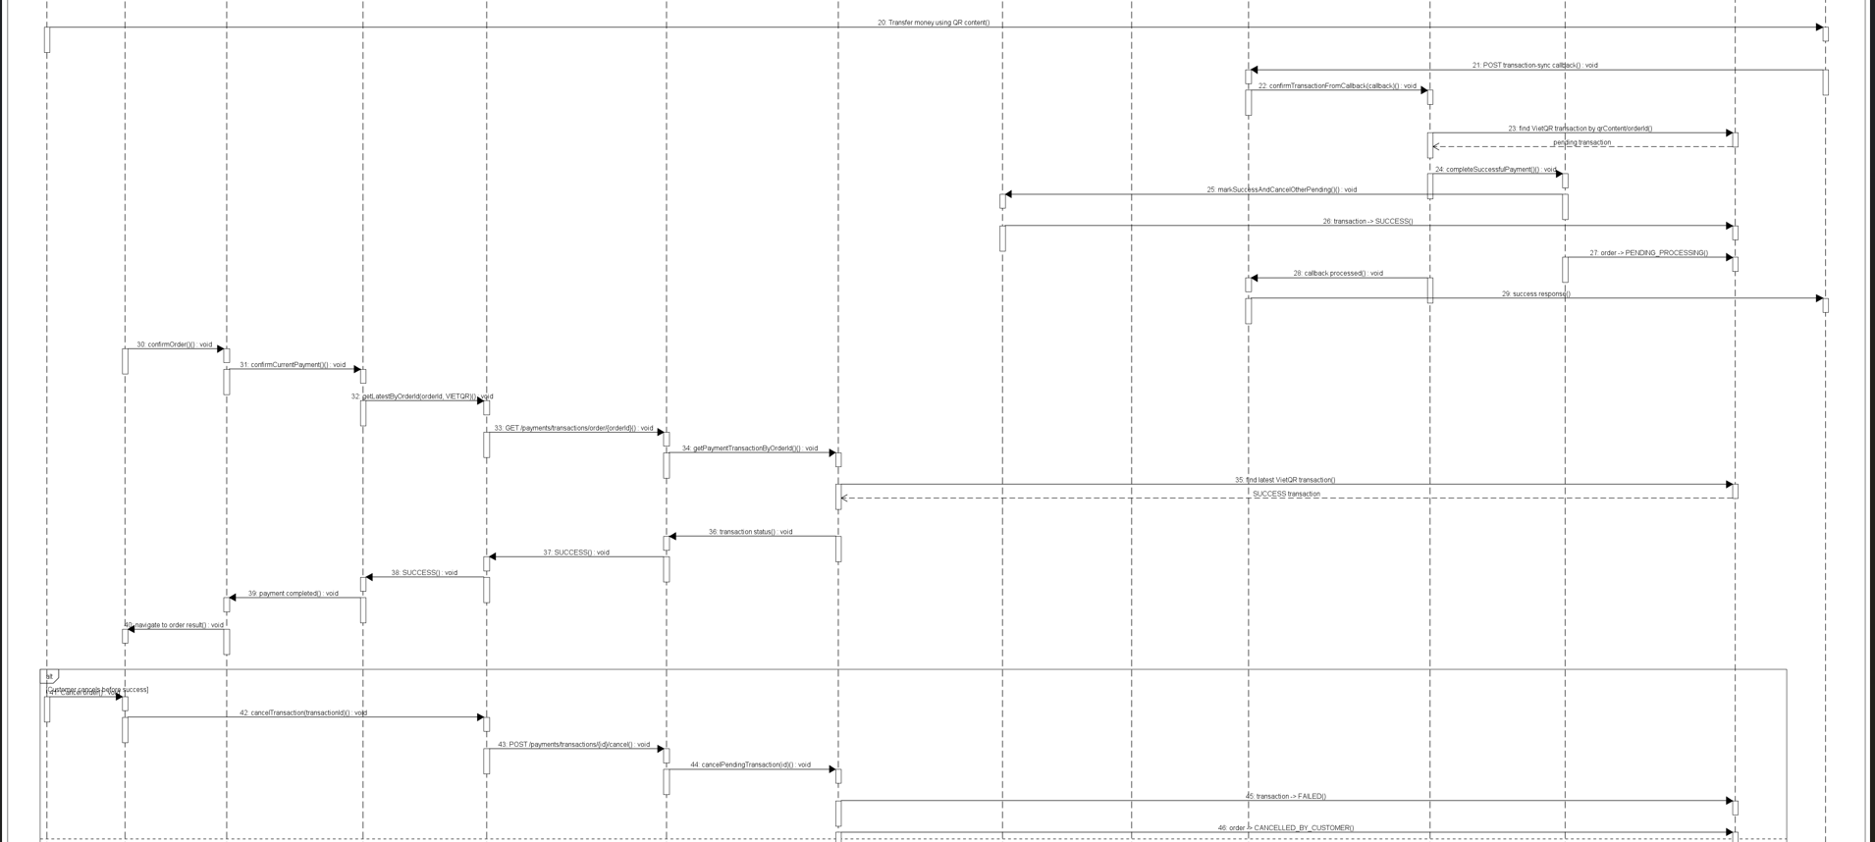
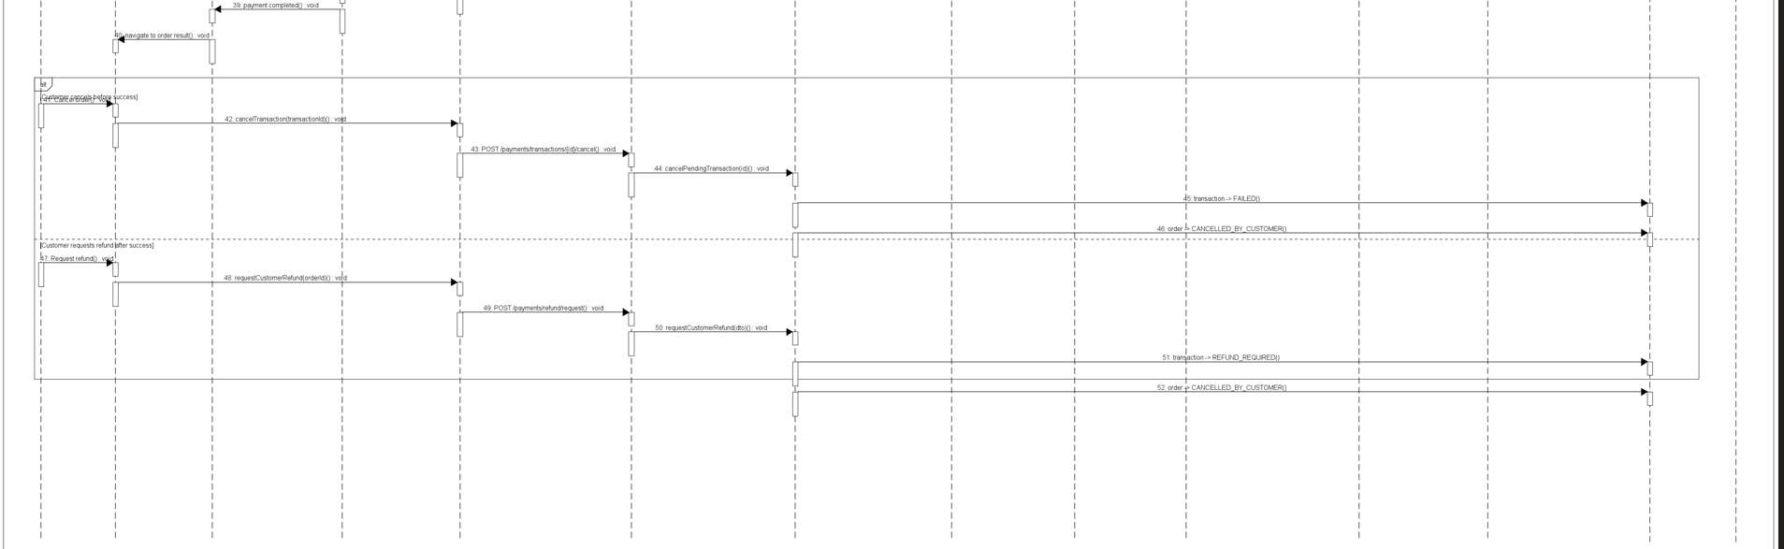
Description
This use case describes the VietQR payment flow for an online order. The customer selects VietQR as the payment method, the system creates or reuses a pending payment transaction, requests a QR code from the VietQR provider, and displays the QR code to the customer. The customer transfers money using the QR content. VietQR then sends a transaction callback to the system. The system verifies the callback, updates the payment transaction status, and moves the order to processing. The flow also covers customer cancellation while the payment is still pending.
Preconditions
- The customer has created an order and reached the payment step.
- The order contains a valid invoice and payable amount.
- VietQR is available as a supported payment method.
- The system is configured with valid VietQR API credentials.
- The system is configured with VietQR bank account and QR generation settings.
- The order has no completed payment transaction yet.
- The customer has access to a banking application that supports QR transfer.
Main Flow
- The customer selects VietQR as the payment method.
- The payment page sends the selected payment method to the payment facade.
- The system starts a fresh VietQR payment flow for the current order.
- The payment page sends a payment creation request to the backend.
- The payment service validates the order, invoice, and payable amount.
- The payment service checks whether there is an existing pending VietQR transaction.
- If a reusable pending transaction exists, the system reuses it; otherwise, it creates a new pending transaction.
- The system cancels other pending payment transactions for the same order.
- The system creates or selects the VietQR payment gateway.
- The VietQR gateway builds the QR payment request.
- The system requests an access token from the VietQR provider.
- VietQR returns an access token.
- The system sends a QR generation request to the VietQR provider.
- VietQR returns QR data, including QR code, QR content, and QR link if available.
- The system saves the QR provider data into the payment transaction.
- The payment result is returned to the payment page with status PENDING and the QR code.
- The payment page displays the VietQR QR code to the customer.
- The customer transfers money using the QR content.
- VietQR sends a transaction callback to the system.
- The system validates the callback authentication.
- The callback service finds the matching VietQR payment transaction by QR content.
- The system checks for duplicate callbacks.
- The system validates the transaction amount and transaction type.
- The system marks the payment transaction as SUCCESS.
- The system cancels other pending transactions for the same order.
- The system updates the order status to PENDING_PROCESSING.
- The system returns an HTTP 200 callback acknowledgement to VietQR.
- The frontend polls the latest payment transaction status.
- The system returns the successful VietQR transaction status.
- The payment page marks the payment as completed.
- The customer is navigated to the order result page.
Business Rules
- Only one active pending payment transaction should exist for an order at a time.
- When VietQR is selected, other pending transactions for the same order must be marked as failed or cancelled.
- A pending VietQR transaction may be reused if it is still valid and belongs to the same order.
- The payment amount must match the invoice amount of the order.
- The system must store the generated QR code, QR content, QR link, and provider data for later matching.
- A VietQR payment is not considered successful immediately after QR generation.
- A VietQR payment is considered successful only after the system receives and validates a VietQR transaction callback.
- The callback transaction amount must match the payment transaction amount.
- Duplicate callbacks must not create duplicate successful transactions.
- The order must not be moved to processing until the VietQR callback is successfully processed.
- If the customer cancels while the VietQR transaction is still pending, the pending transaction must be marked as failed and the order status becomes CANCELLED_BY_CUSTOMER.
- If the VietQR transaction has already succeeded, cancellation from the payment page must not be allowed.
- Expired or failed VietQR transactions must not be reused for later payment attempts.
- The system must return a callback acknowledgement to VietQR after processing the callback.

3.2.4 Place order
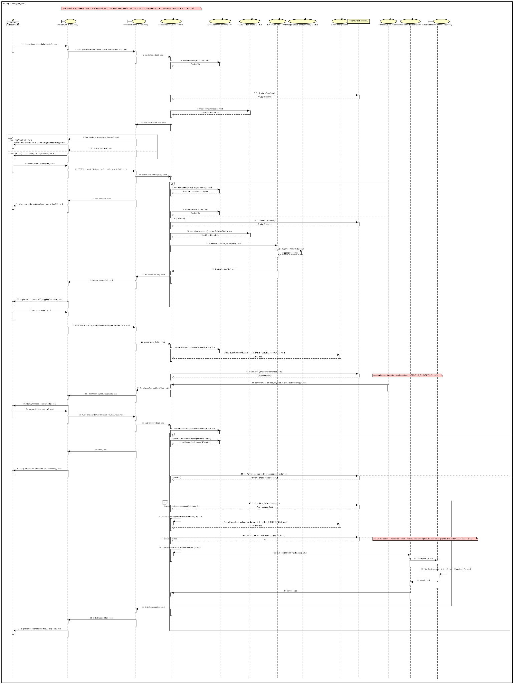

Description
The Place Order use case describes how a Customer purchases the media products currently in the cart without needing to log in. Its main purpose is to help the Customer check whether the selected items are available, provide delivery information, review the invoice, choose a payment method, and complete the payment.
During the process, the Customer can move through each step, go back to edit previous information, or cancel the order at any time. After the payment is successful, the system records the order and payment transaction, updates the order status, sends the invoice to the Customer, and displays the final order summary.
Preconditions
- The Customer has at least one item in the cart.
- Each cart item references an existing product and a positive integer quantity.
- The AIMS software is running and reachable (the payment gateway — VietQR/PayPal Sandbox — is configured for the payment step).
Main Flow
- The Customer requests to place an order for the items in the cart.
- The system normalizes the cart items (merges duplicates by product) and checks product availability for every item.
- The system displays the delivery-information form together with the current order/cart information.
- The Customer enters and submits the delivery information (receiver name, phone, province, address, optional shipping instructions, email).
- The system validates the delivery information.
- The system calculates (or recalculates) the shipping fee and displays the invoice preview: line items, subtotal before VAT, subtotal incl. VAT, delivery fee, and total amount.
- The Customer asks to pay the order.
- The system temporarily saves the order and invoice with status PENDING_PAYMENT and displays the invoice information.
- The system calls the Pay Order use case (default payment method = QR code) and displays the QR code / payment link.
- After the Customer completes the payment, the system validates the payment result (transaction id + method) and ensures the transaction has not already been processed.
- The system records the successfully paid order and the payment transaction, decrements product stock, and moves the order to PENDING_PROCESSING — all within a single atomic transaction.
- The system sends the invoice and payment-transaction information to the Customer's e-mail.
- The system displays the general order information (customer name, phone, province, address, total amount) and transaction information (transaction id, content, datetime).
Postcondition: A new order is created in the PENDING_PROCESSING state and its information is e-mailed to the Customer; if the payment is not successful, nothing is persisted.
Business Rules
- All product prices exclude a 10% VAT. subtotalAfterVat = subtotalBeforeVat × 1.10.
- An order may proceed only if, for every item, available stock ≥ requested quantity. A product whose status is DEACTIVATED/DELETED/INACTIVE/UNAVAILABLE counts as 0 available. If any item is insufficient, the system notifies the Customer with the available quantity of each affected product.
- Delivery information validation: Receiver name required, letters only; Phone required, exactly 10 digits, may contain a single separator type (., space, or -) inside the number; Province required (from the provided list); Address required, non-empty; Shipping instructions optional, max 200 characters; Email required to create the order.
- Shipping fee depends on total item weight and delivery location and is not taxed: Ha Noi / Ho Chi Minh City is 22,000 VND for the first 3 kg; elsewhere in Vietnam is 30,000 VND for the first 0.5 kg; plus 2,500 VND for every additional 0.5 kg block (rounded up).
- If the items subtotal (before VAT) > 100,000 VND, the order qualifies for a free-shipping discount of up to 25,000 VND per order (finalShippingFee = max(0, rawFee − discount)). Total amount = subtotal include VAT + final delivery fee.
- The default payment method is QR code (VietQR); the Customer may switch to PayPal. Other gateways may be added in the future.
- Cart items are normalized before processing: productId and quantity must be positive integers; items with the same productId are merged by summing quantities.
- Order lifecycle: an order is first persisted as PENDING_PAYMENT when payment is requested, then transitions to PENDING_PROCESSING after a successful payment.
- After a successful payment the system displays the order + transaction summary and records both the paid order and the payment transaction. If payment fails, the use case is notified that payment was not successful and resumes at the delivery-validation step.
- Payment confirmation requires a non-empty transaction id and payment method; otherwise it is rejected as "payment not successful". The confirmation is idempotent - a transaction that was already processed returns the existing order instead of creating a duplicate.
- Stock decrement on confirmation is atomic and oversell-safe: stock is only reduced when the order actually transitions to PENDING_PROCESSING, so duplicate/concurrent payment callbacks never decrement stock twice.
- On success, the system e-mails the invoice and payment-transaction information to the Customer (notification is delivered through pluggable channels - e-mail today; SMS/Zalo/Push may be added without changing the order flow).

3.2.5 View Product Detail
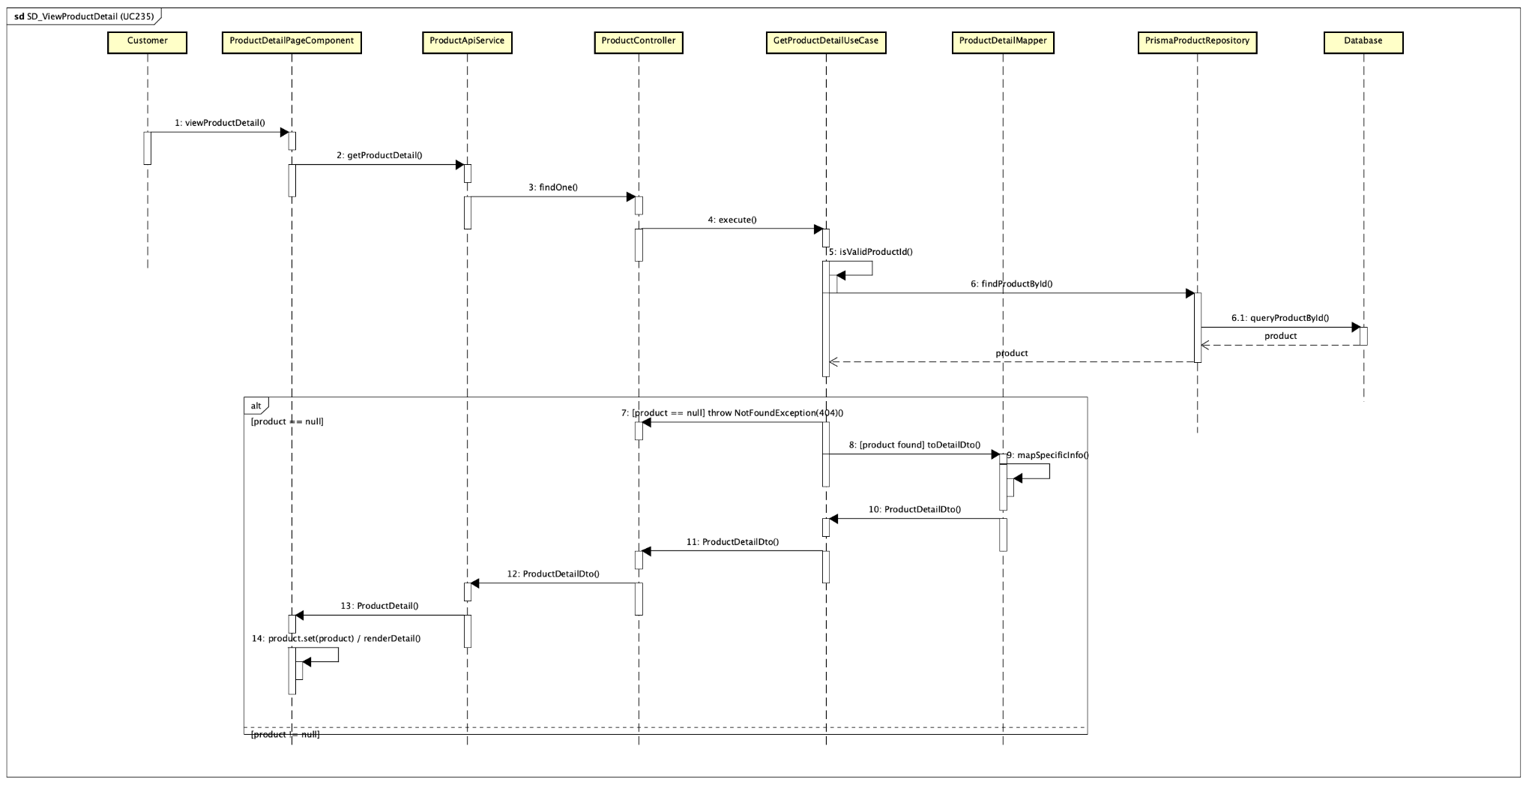
Description
The View Product Detail use case (UC235) lets a Customer open a product's detail page from the catalog to view its full information: the common fields (barcode, title, current price, original value, description, image, weight, dimensions, stock quantity and availability status) and the type-specific information for a Book, Newspaper, CD or DVD. From this screen the Customer may also choose a quantity and add the product to the shopping cart. Viewing a product detail is public and does not require login. The sequence diagram above shows the realization of this flow across the frontend (Angular) and backend (NestJS) classes.

Preconditions
1. The system is running and the product catalog (home / product list) has been loaded.
2. The Customer has selected a product from the catalog, so a product id is available in the route (/products/:id).
3. Viewing a product detail is publicly accessible — no authentication is required.

Main flow
1. The Customer selects a product from the catalog.
2. ProductDetailPageComponent reads the route parameter :id (ngOnInit) and calls ProductApiService.getProductDetail(id).
3. ProductApiService sends HTTP GET /products/:id; ProductController.findOne(id) delegates to GetProductDetailUseCase.execute(id).
4. GetProductDetailUseCase validates the id, then loads the product via ProductQueryRepository.findProductById(id) (implemented by PrismaProductRepository).
5. ProductDetailMapper.toDetailDto(product) maps the common fields and dispatches mapSpecificInfo() by product type (Strategy) to build the type-specific section, producing a ProductDetailDto.
6. The ProductDetailDto is returned as a JSON response; ProductApiService.normalizeProductDetail() converts it into the ProductDetail model.
7. ProductDetailPageComponent sets the product signal; ProductDetailComponent renders the common fields and ProductSpecificInfoComponent renders the type-specific section.
8. The Customer may adjust the quantity and add the product to the cart when it is available and in stock.

Alternative flow
1. Invalid product id (not matching ^[1-9]\d*$) → GetProductDetailUseCase throws BadRequestException (HTTP 400).
2. Product not found → NotFoundException (HTTP 404); ProductDetailPageComponent shows the 'product not found' state.
3. Backend unreachable or other error → the page shows an error message ('Cannot load product detail from backend.').
4. Product status is OUT_OF_STOCK / DEACTIVATED / UNAVAILABLE → add-tocart is disabled with a notice.

Business rules
1. Viewing a product detail is public; login is not required.
2. A product id must be a positive integer (regex ^[1-9]\d*$); otherwise the request is rejected.
3. The information displayed depends on the product type — Book, Newspaper, CD and DVD each show their own specific fields.
4. A product is purchasable only when its status is available and stockQuantity > 0; status OUT_OF_STOCK, DEACTIVATED or UNAVAILABLE makes it nonpurchasable.
5. The add-to-cart quantity must be between 1 and the available stock quantity.
6. The availability status is derived from stock: when quantity = 0 the product is shown as OUT_OF_STOCK.

3.3 Analysis Class Diagrams

3.3.1 CUD Product

3.3.1.1. Add Product
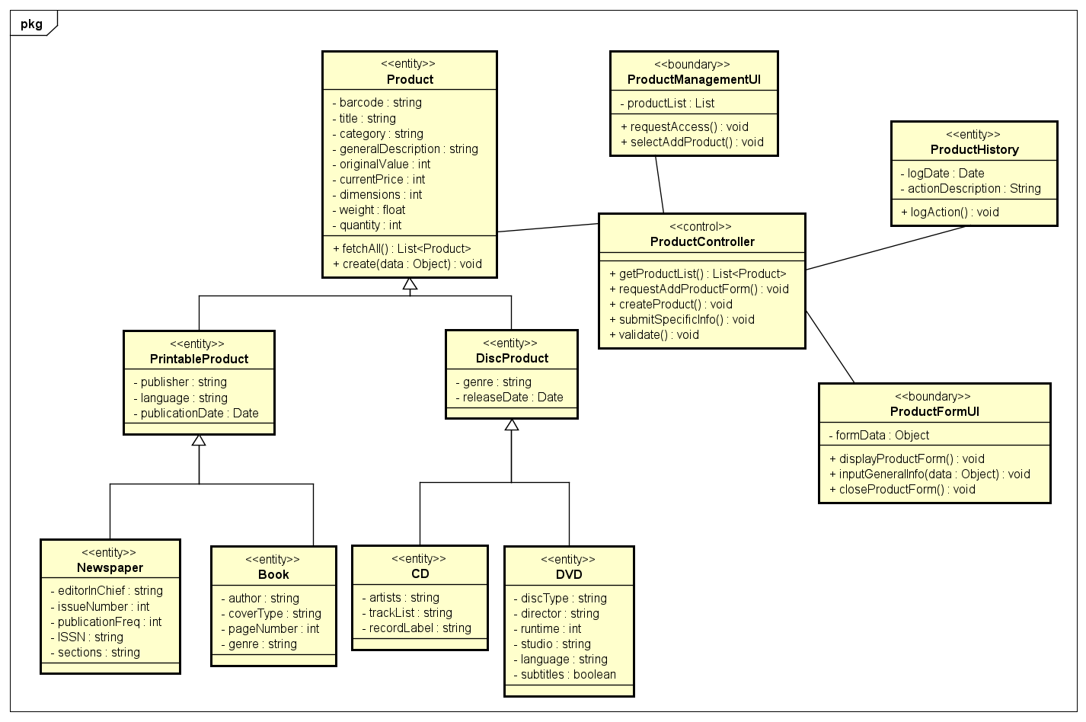

3.3.1.2. Update Product
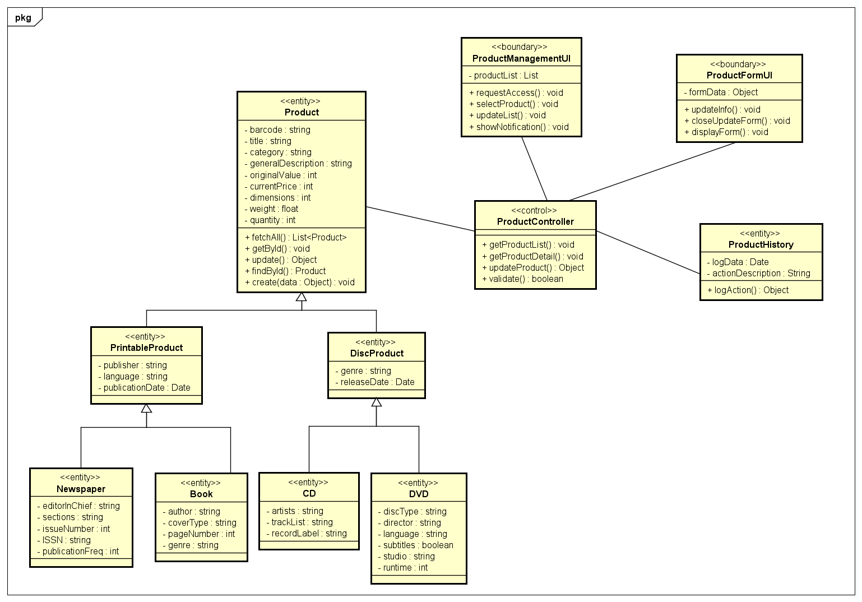

3.3.1.2. Adjust Quantity
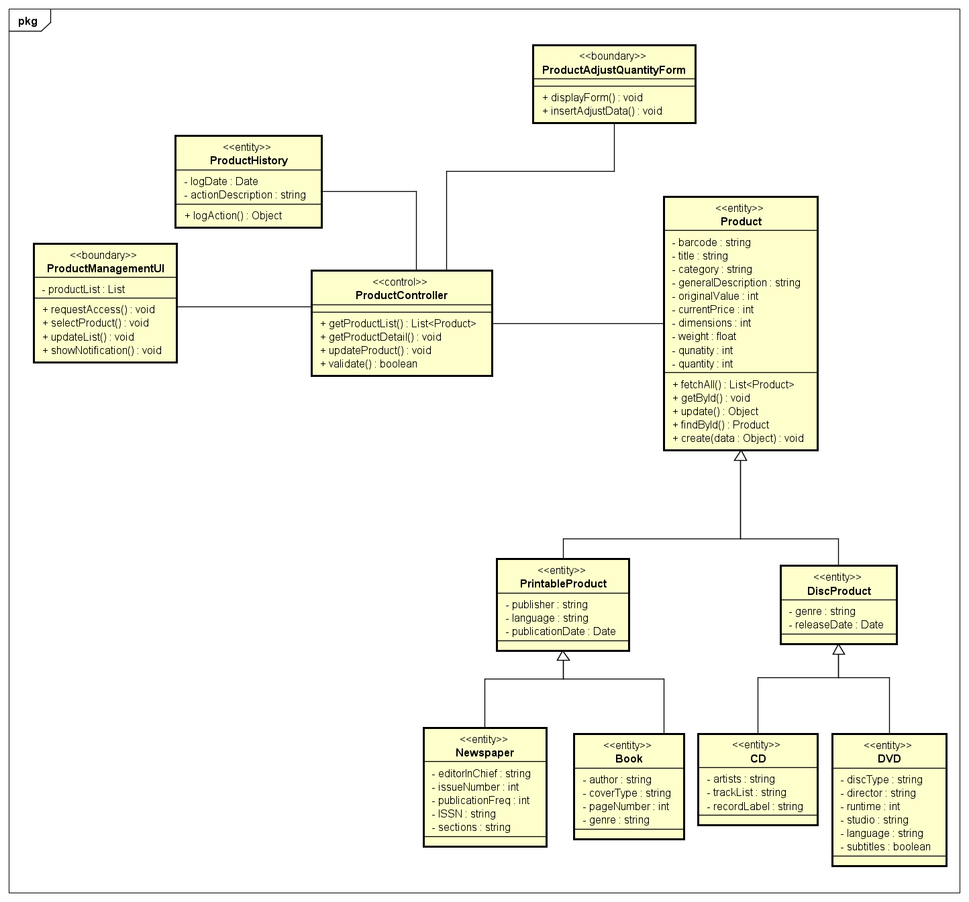

3.3.1.2. Delete Product
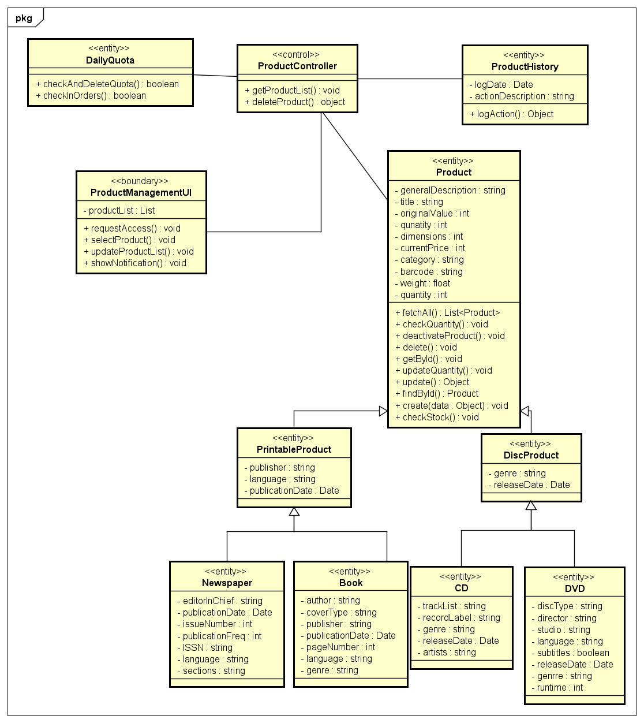

3.3.2 Pay order by VietQR

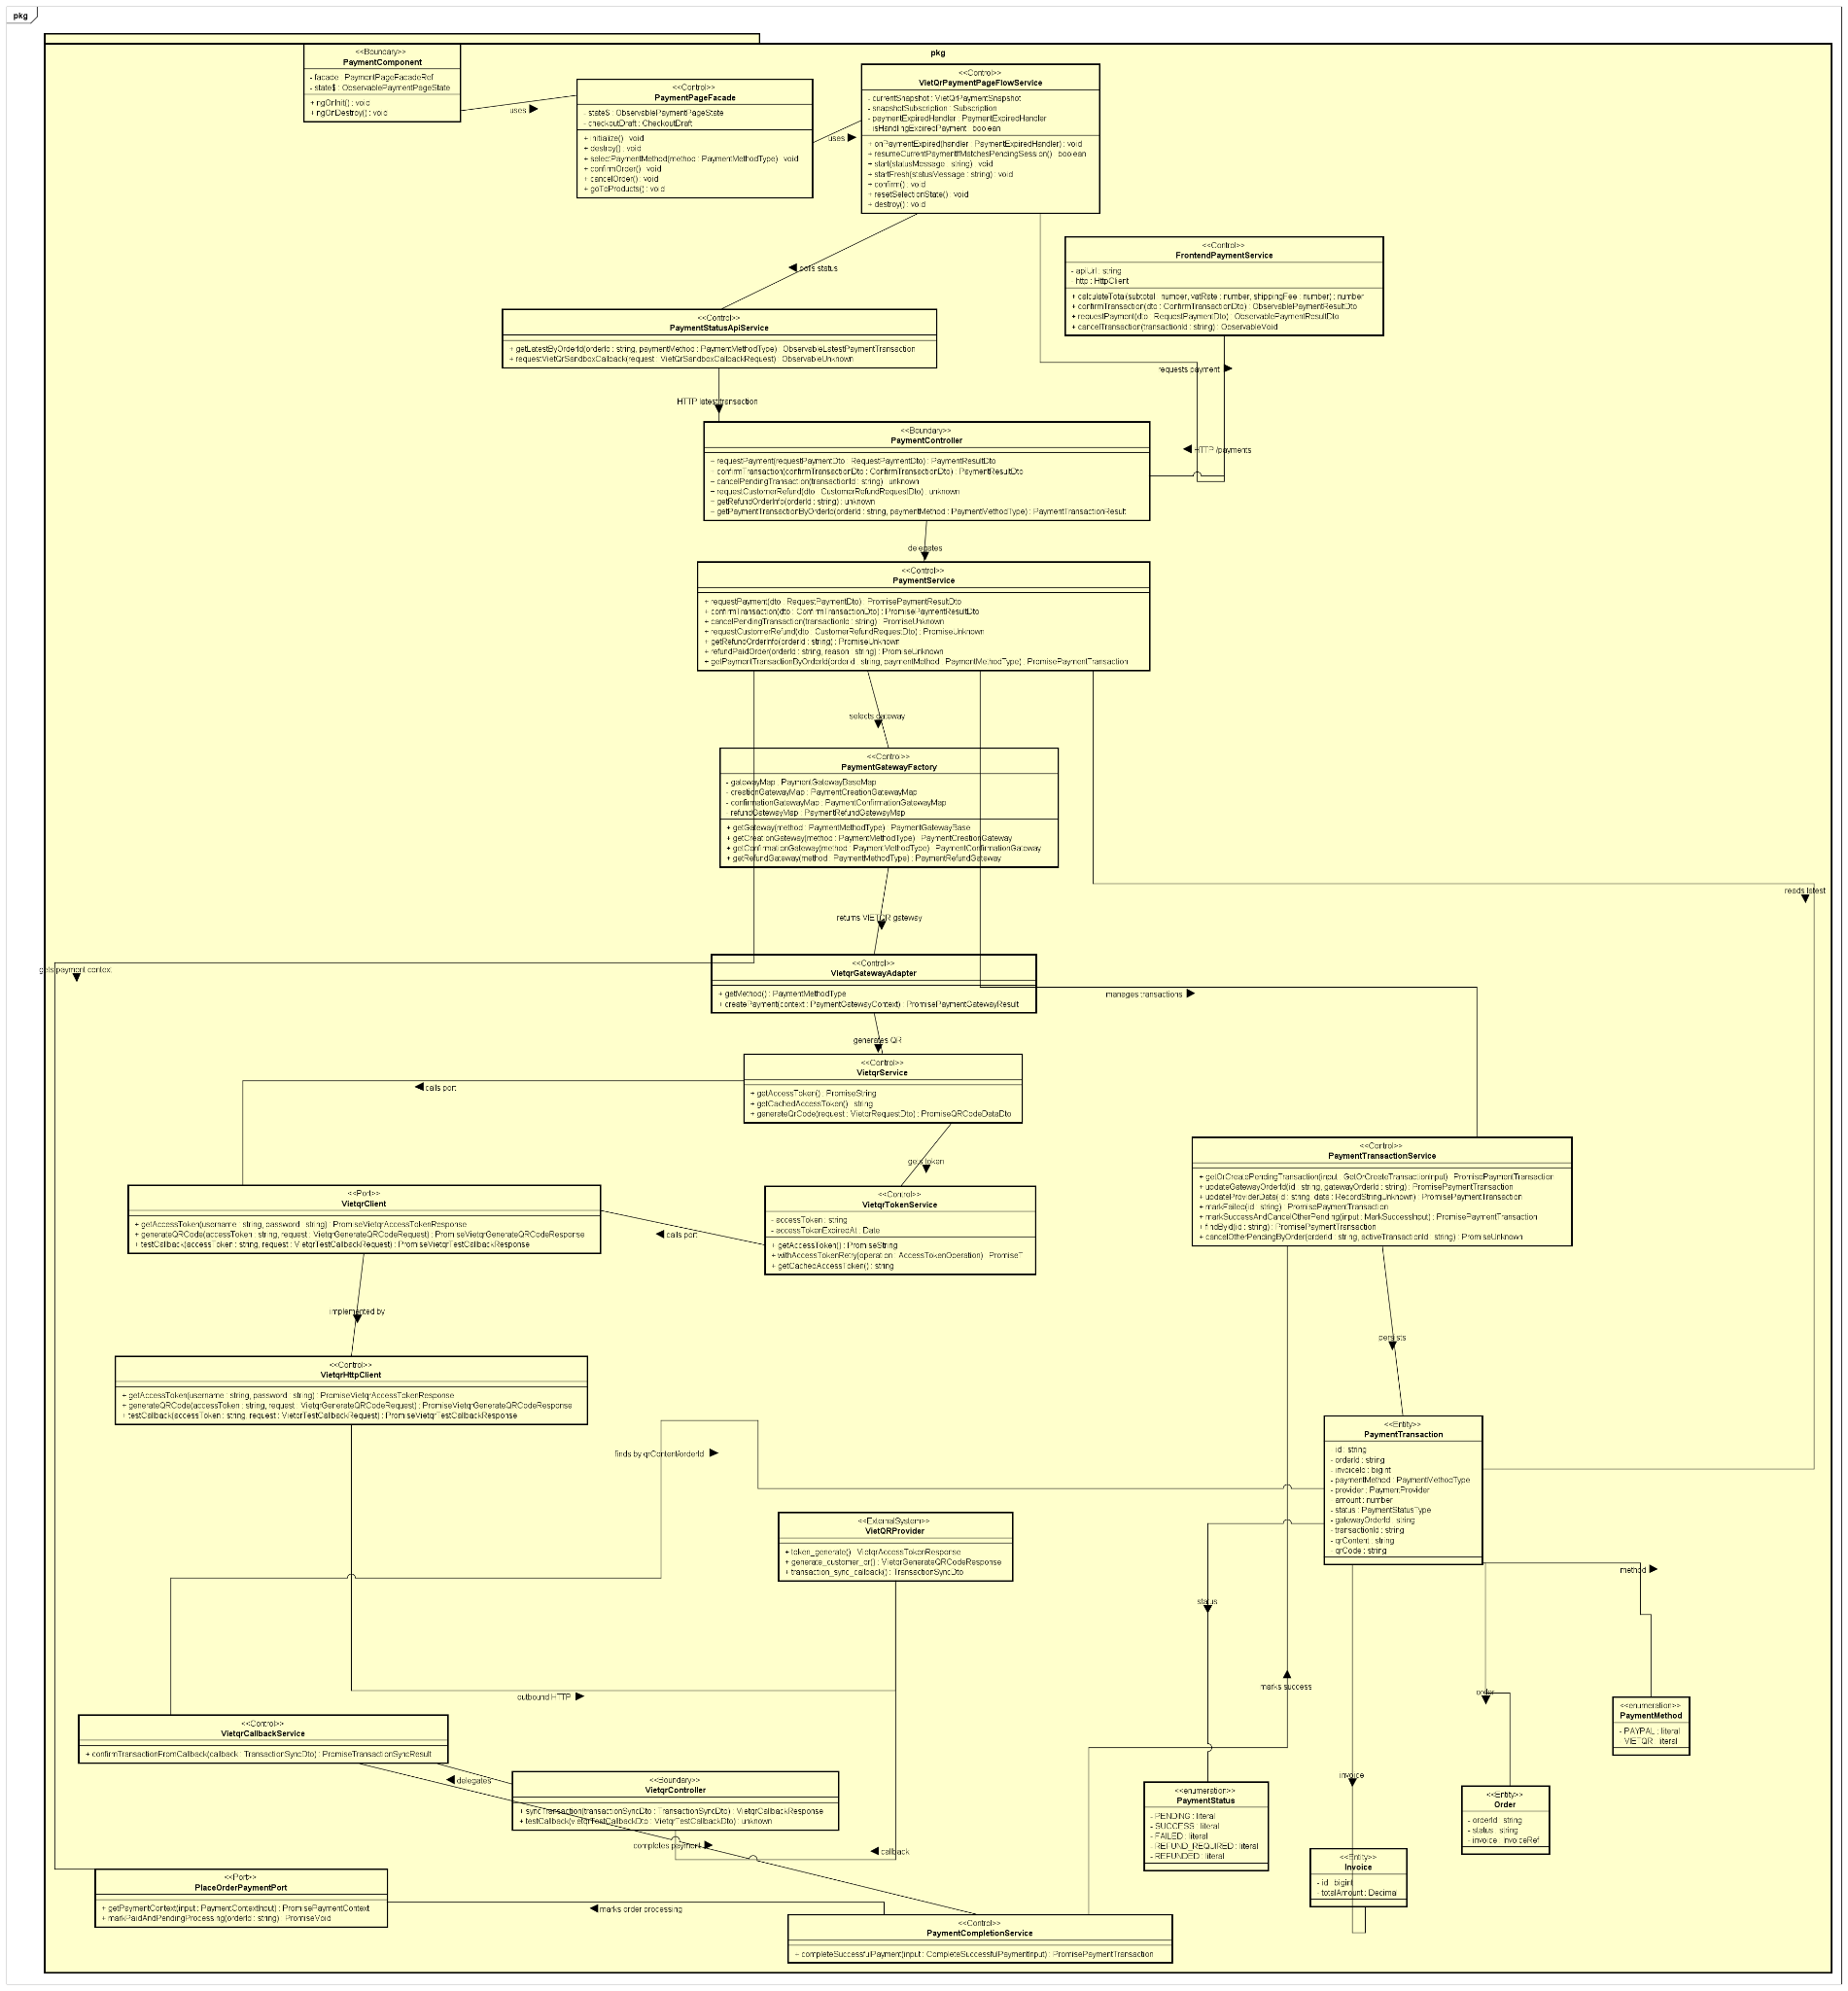

3.3.2 Pay order by PayPal
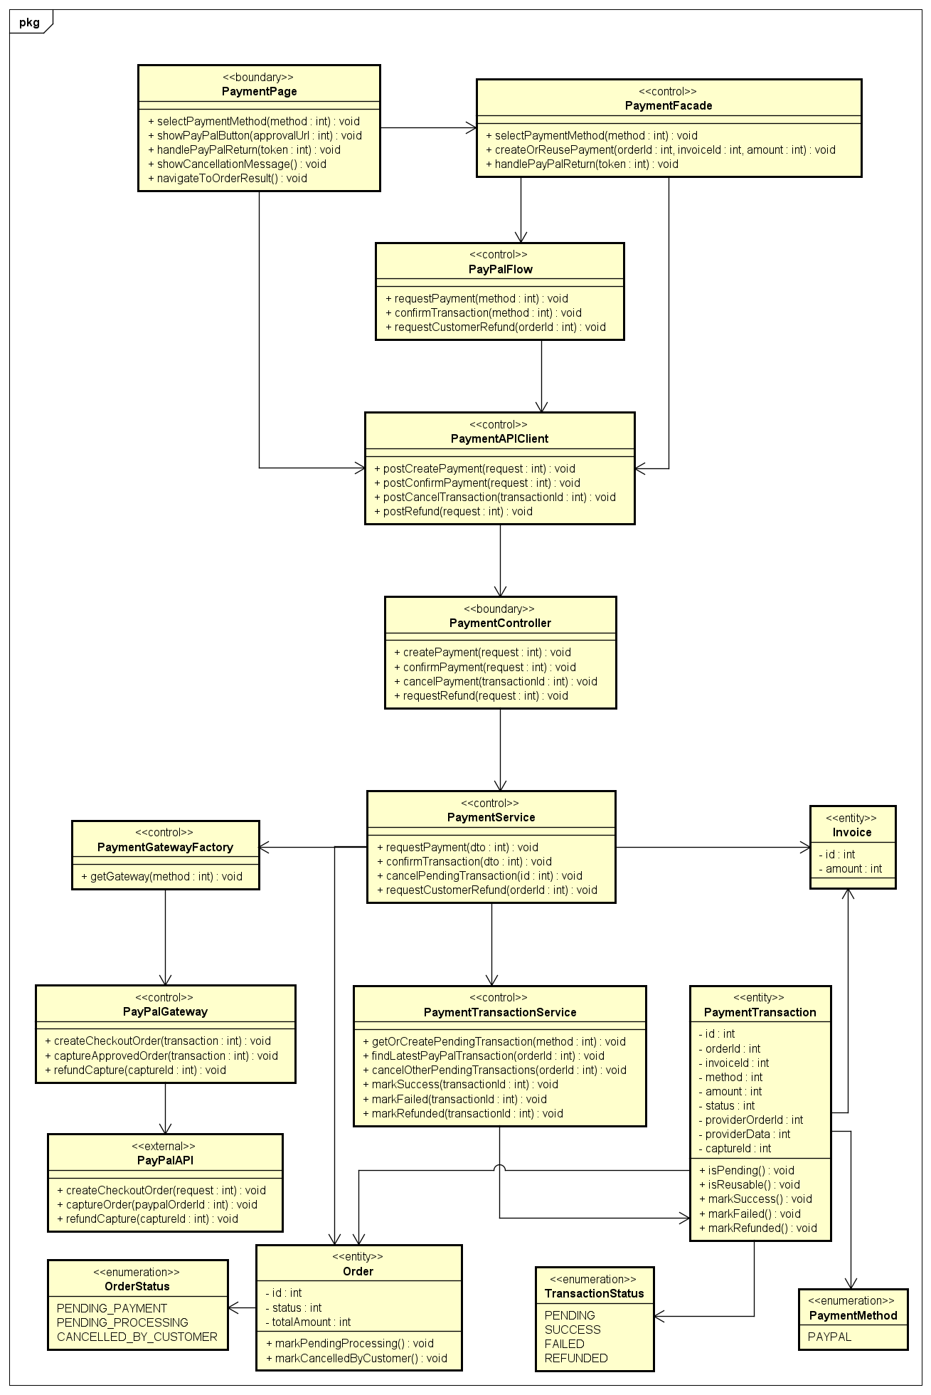

3.3.3 Place order
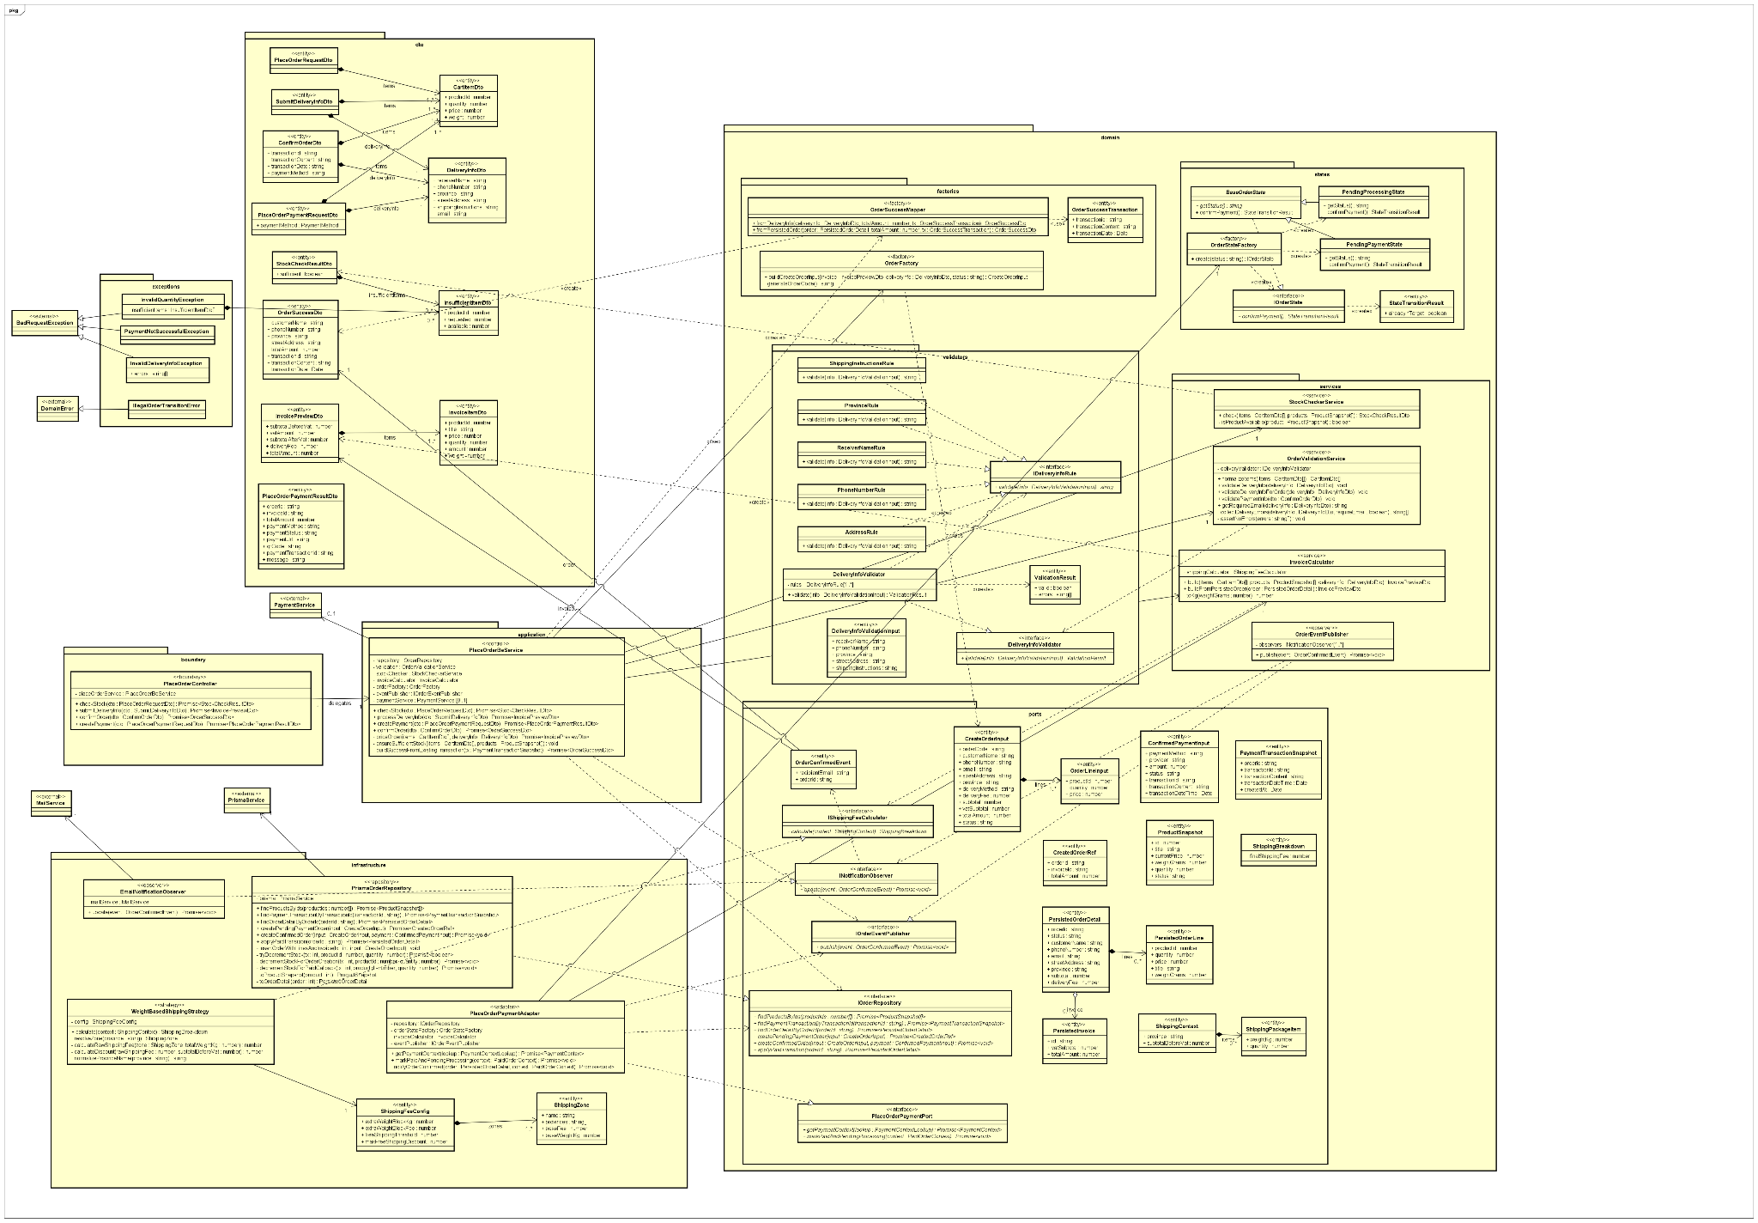

3.3.4 View Product Detail
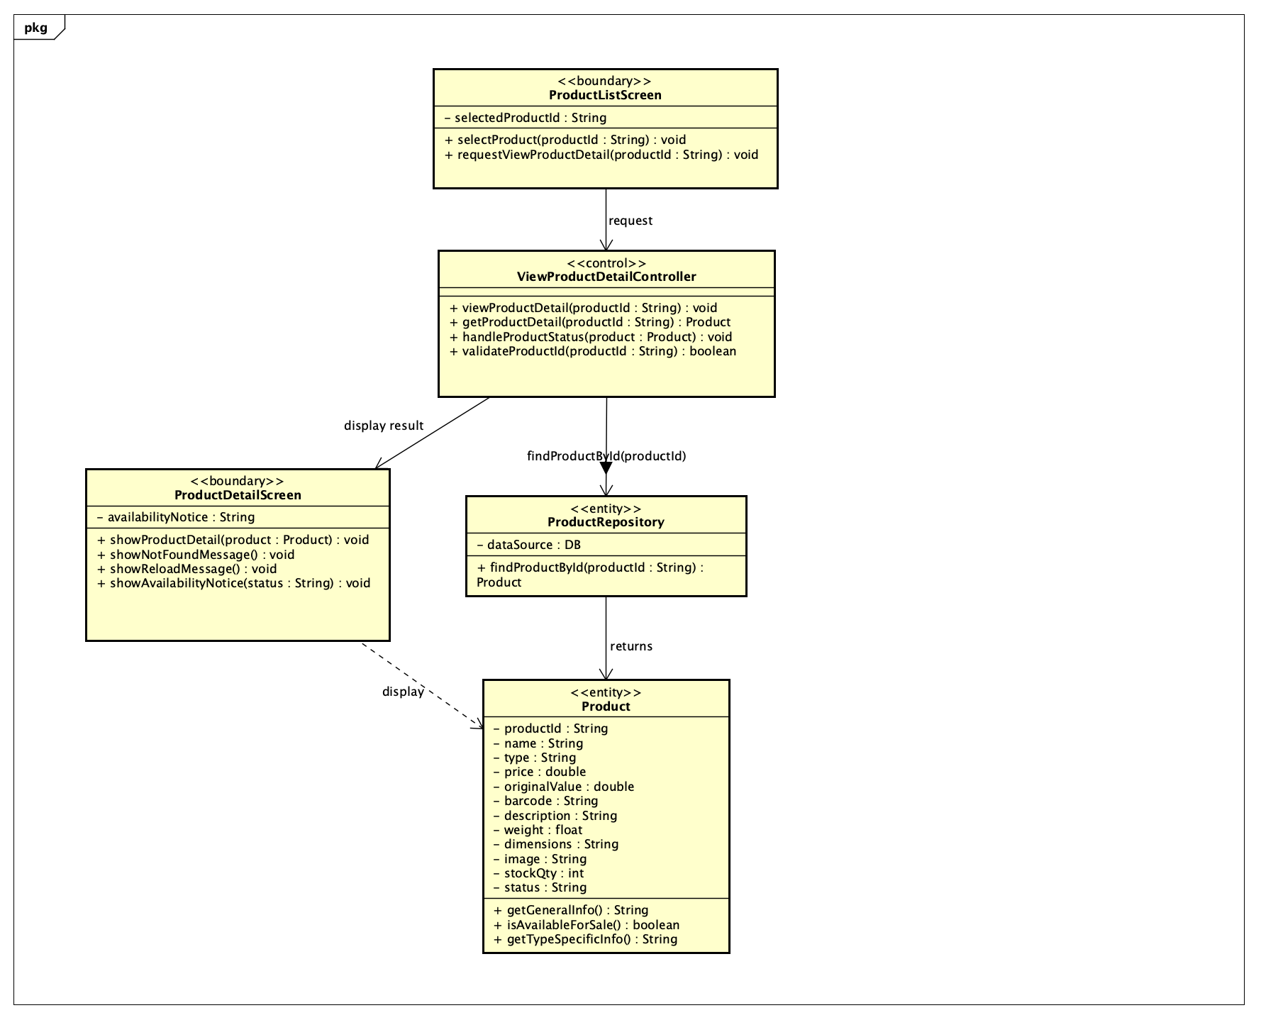

3.4 Unified Analysis Class Diagram
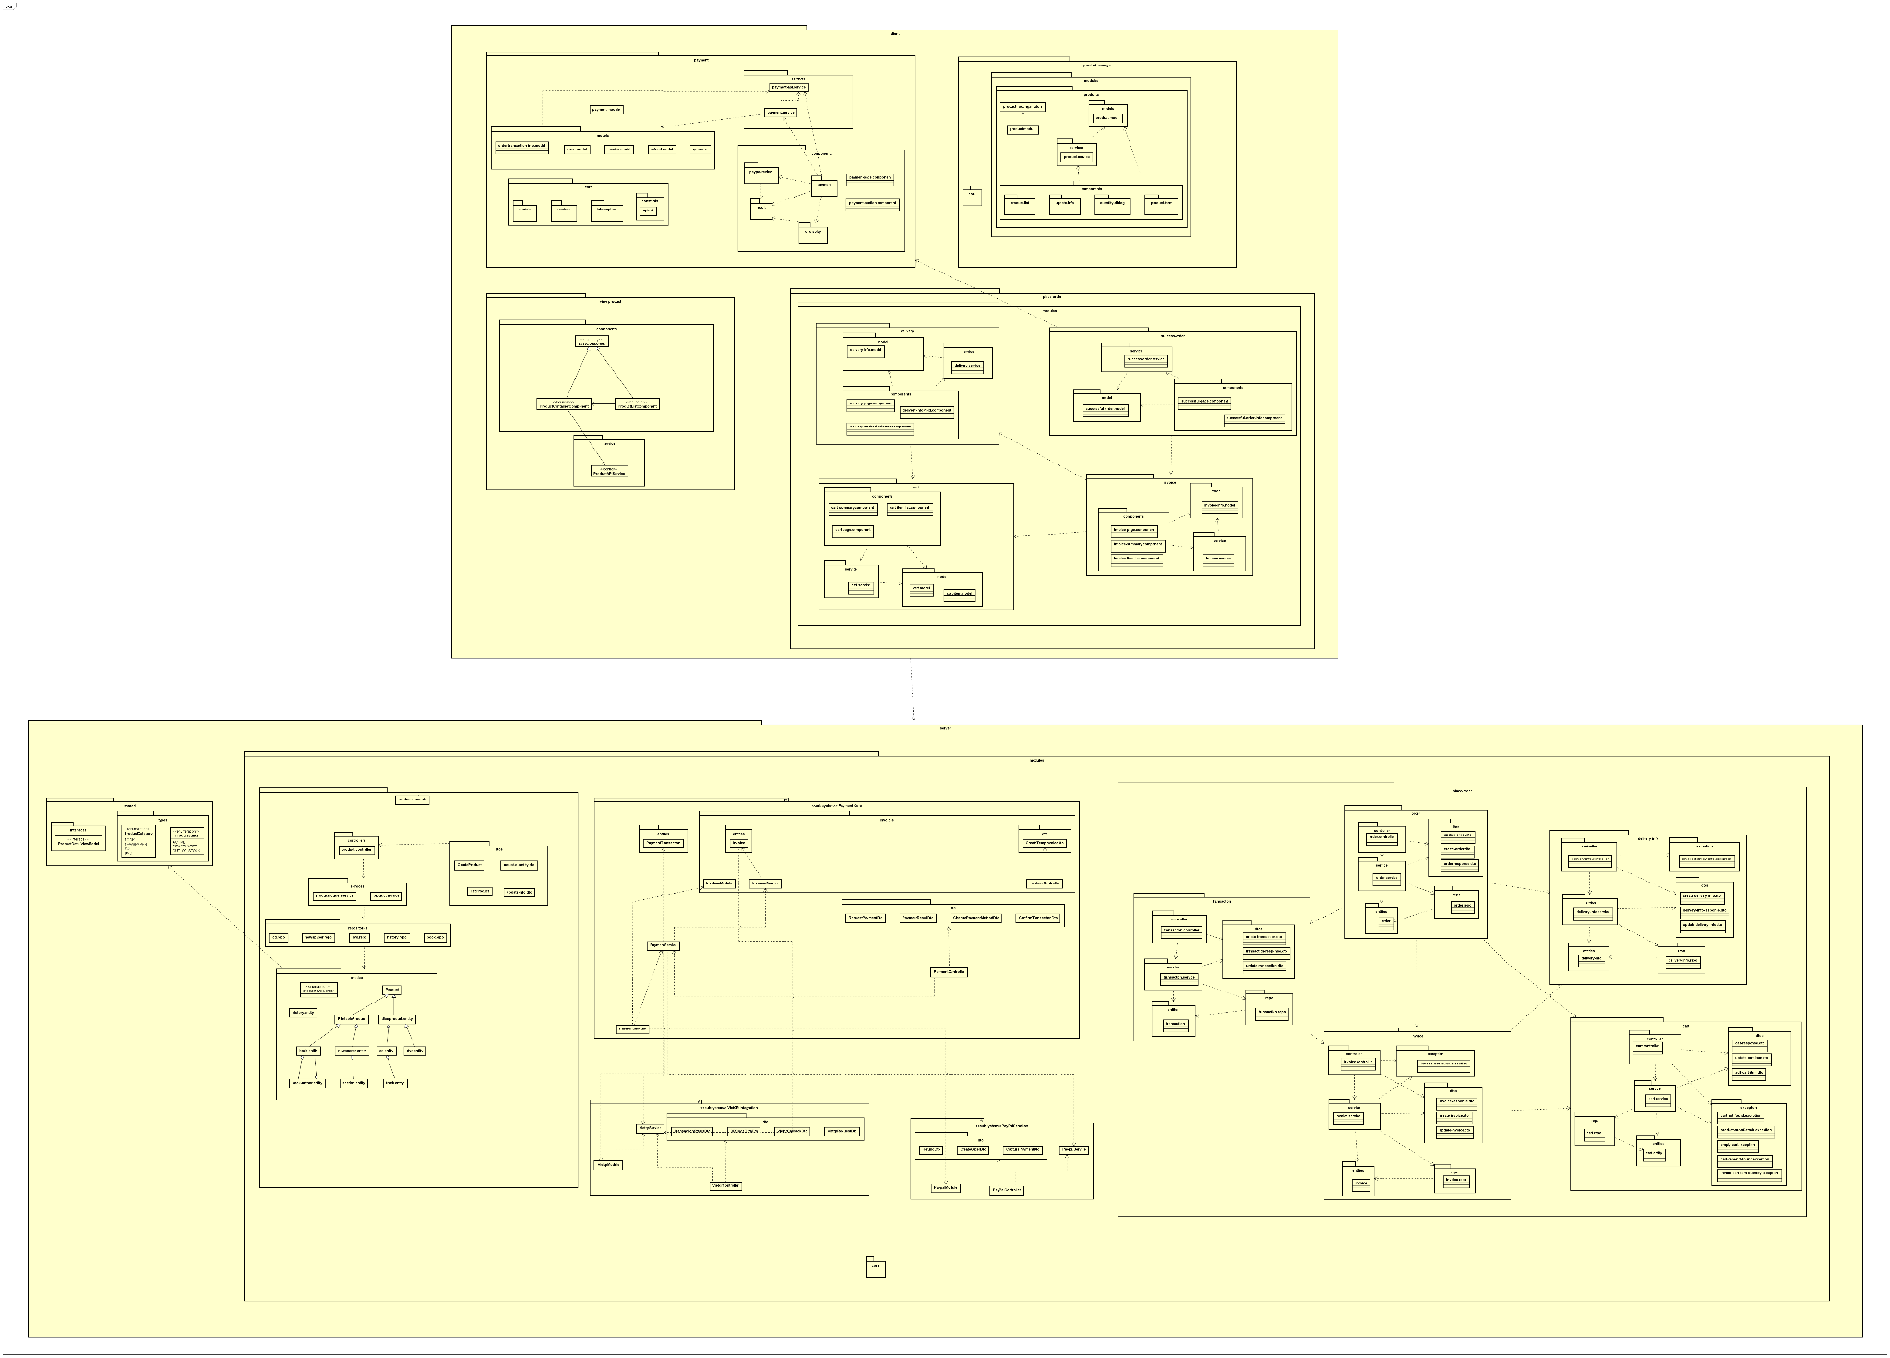

3.5 Security Software Architecture
The system uses a layered security architecture to protect user accounts, business data, transactions, and administrative operations. Security controls are applied across the client application, backend services, database, and external integrations.

3.5.1 Authentication
The system requires users to authenticate before accessing protected features. Users log in with valid account credentials, and the authentication component verifies the submitted information against stored account records. Passwords are never stored in plain text; they are securely hashed before being saved.
After successful authentication, the system issues a secure session or authentication token. This token is used to identify the user in later requests and must be protected from unauthorized access. Unauthenticated users are only allowed to access public features, such as browsing publicly available product information.

3.5.2. Authorization
The system applies authorization rules after authentication to ensure that users can only perform actions permitted by their role and ownership of resources. Customers can access and manage only their own profile, cart, orders, payments, and related information. Staff or administrative users can access management functions according to their assigned roles.
Authorization checks are enforced on the backend for all protected operations, including account management, product management, order processing, payment handling, delivery updates, cancellations, refunds, and administrative configuration. The system also validates the state of business objects before allowing an action. For example, an order can only be cancelled, paid, processed, shipped, or refunded when it is in a valid status for that operation.

3.5.3. Encryption
The system protects sensitive data during transmission and storage. All communication between the client, backend services, database, and external services uses secure communication protocols such as HTTPS/TLS to prevent interception and tampering.
Sensitive information such as passwords, authentication tokens, personal user data, payment references, API keys, and database credentials must be protected. Passwords are stored using secure hashing. System secrets and external service credentials are stored in server-side configuration or a secure secrets manager, not in client-side code.
The system does not store unnecessary sensitive financial information. Payment and external service credentials are handled by trusted providers where applicable. Any sensitive data stored in the database should be minimized and protected according to its risk level.

3.5.4. Logging and Auditing
The system records important security and business events for monitoring, troubleshooting, and auditing. Logged events may include login attempts, failed authentication attempts, account changes, product updates, order creation, order status changes, payment events, cancellation requests, refund requests, delivery updates, and administrative actions.
Audit logs should include useful trace information such as user ID, action type, affected resource ID, timestamp, result status, and relevant business reference IDs. Logs must not expose sensitive information such as passwords, authentication tokens, API secrets, full payment credentials, or confidential personal data. Sensitive values should be masked or excluded.
The logging and auditing design helps detect abnormal behavior, investigate incidents, trace business operations, support dispute resolution, and maintain accountability for user and administrative actions.

4. Detailed Design

4.1 User Interface Design

4.1.1 Screen Configuration Standardization

4.1.1.1 Visual Foundation

4.1.1.1.1 Color Palette
The AIMS platform utilizes a clean, professional color system prioritizing clarity and structure.
Role | Color Hex | Usage
Primary Action | #0078D7 (Blue) | Primary buttons, active states, focus  highlights.
High Energy | #FF5722 (Orange) | Critical CTAs (e.g., Add to Cart, Buy Now),  alerts.
Background | #F5F5F5 (Light Gray) | Neutral foundation for all screens.
Surface | #FFFFFF (White) | Cards, modals, containers, and content  areas.
Text Primary | #222222 (Dark Gray) | Main body text and headings.
Text Secondary | #666666 (Medium Gray) | Secondary text, labels, metadata

4.1.1.1.2 Typography System
Font Families: Manrope / Inter
- Headline 1: 24px Bold (Main page titles)
- Headline 2: 20px Semi-bold (Section headers)
- Headline 3: 18px Bold (Card titles, sub-sections)
- Headline 4: 16px Bold (Small headers, button text)
- Paragraph: 14px Regular (Body text, input labels)
- Caption: 12px Regular (Helper text, metadata)

4.1.1.1.3 Spatial System & Geometry
- Base Grid: 8px system. All margins, padding, and layout alignments must follow this scale:
  - XS: 4px | S: 8px | M: 16px | L: 24px | XL: 32px | XXL: 64px
- Corner Radius: 4px standard across buttons, input fields, and cards.
- Border Weights: * Standard containers/inputs: 1px
  - Active/Focus states: 2px

4.1.1.2. Component Specifications

4.1.1.2.1 Buttons
- Primary: Filled #0078D7, 4px radius, centered text.
- Secondary: Outlined #0078D7, 1px border, transparent background.
- High Energy: Filled #FF5722 (Strictly for conversion actions).
- Interaction States:
  - Hover: Darken base color by 10%.
  - Active (Click): Scale down to 98%.
  - Disabled: 50% opacity, converted to grayscale.

4.1.1.2.2 Form Inputs
- Default State: 1px border #E0E0E0, 4px radius, 14px text.
- Validation States:
  - Error Styling: 1px solid #F44336 (Red) border.
  - Error Message: Displayed immediately below the field in #F44336 using 12px Caption typography.

4.1.1.3. Layout & Structure

4.1.1.3.1 Role-Based Architectural Shells
- Customer Interface: * Top Navigation (Logo, Search Bar, Cart/User Profile) -> Main -> Content -> Footer.
- Admin/PM Interface: * Left Sidebar (Navigation) + Top Header (Page Title, User Profile) + Main Content Area.
- Alignment Rule: Page titles must always be centered at the top of the main content area.

4.1.1.3.2 Modals & Secondary Screens
- Placement: Help screens, manuals, or detailed views must appear as centered popups.
- Overlay: A dark overlay with 80% opacity must cover the main screen, disabling all background interactions.
- Close Action: A prominent "X" close button must be standardized in the top-right corner of the modal.

4.1.1.4. Interaction & Flow Standards

4.1.1.4.1 Application Flow & Navigation
- Boot Sequence: Opening Screen → Splash Screen → Homepage.
- Back Navigation: Every internal or nested screen must feature a clear "Back" button returning the user to the exact previous state.

4.1.1.4.2 Keyboard & Focus Accessibility
- Tab Order: Forms and interactive elements must support sequential keyboard navigation (Tab / Shift+Tab) flowing naturally top-to-bottom, left-to-right.
- Standard OS Shortcuts: Do not implement custom keyboard shortcuts; rely on standard browser/OS behaviors.
- Escape Key: Must trigger the 'Close' action for any active modal or secondary screen.

4.1.1.5. Data & Logic Guidelines

4.1.1.5.1 Input Validation Protocol
All form submissions must pass a strict two-step validation sequence before processing:
- Presence Check: Verify the required field is not empty.
- Format/Logic Check: Verify the data conforms to the expected type, pattern, or range (e.g., valid email regex, positive numeric values for price).

4.1.1.5.2 Data Formatting
- Currency: Formatted as [Amount] VND (e.g., 100,000 VND).
- Numbers: Use comma separators for thousands (e.g., 1,250,000).
- Dates: Strict DD/MM/YYYY format.

4.1.1.6. Layout & Structure (The Screen Shells)
Our system doesn't use a one-size-fits-all interface. Depending on who the user is, the
structural shell is fine-tuned to optimize the workspace and user flow.

4.1.1.6.1. Admin & PM Layout (The Workspace)
This environment is built for deep focus on data and management tools.
- Left Sidebar: Contains the main functional menus (Dashboard, Media Store, Settings, etc.). It stays pinned to the left so users can quickly switch between different modules.
- Top Header: Features the global search bar and account details (Profile/Notifications) tucked on the right. The Screen Title is positioned directly below this header, centered perfectly over the content area.
- Main Content Area: A spacious, clean white (#FFFFFF) canvas taking up the center stage. This is where all the heavy lifting happens—tables, input forms, and management lists.

4.1.2 Screen Transition Diagrams
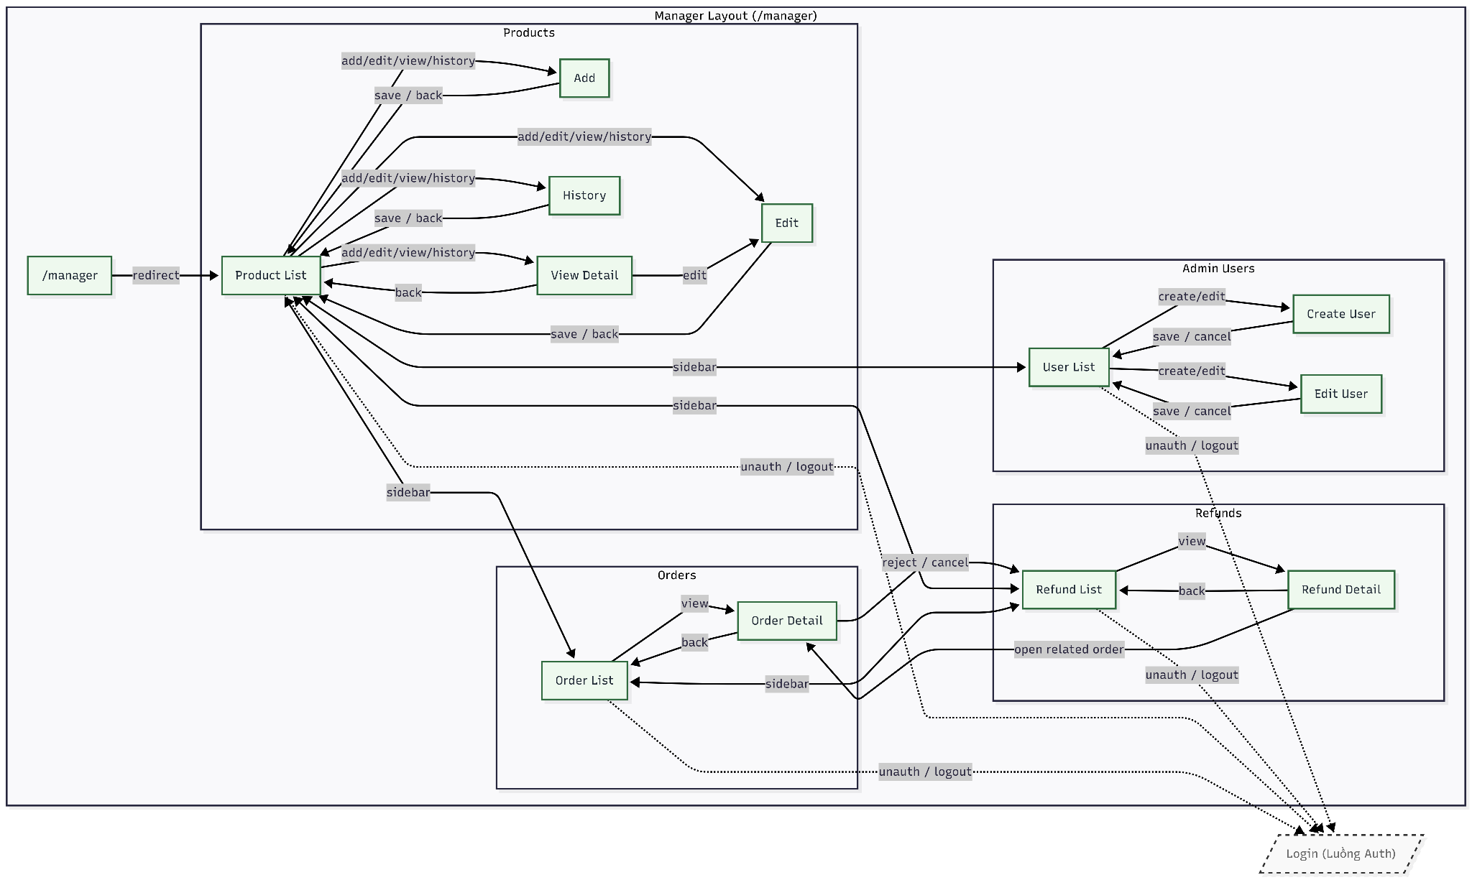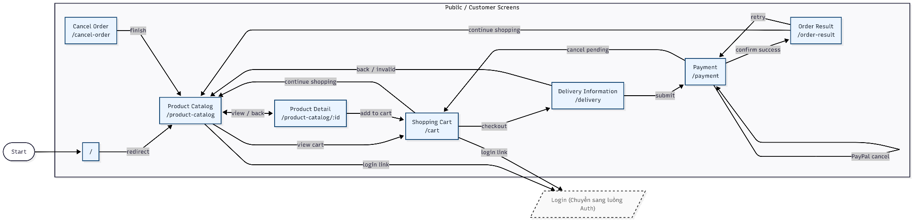
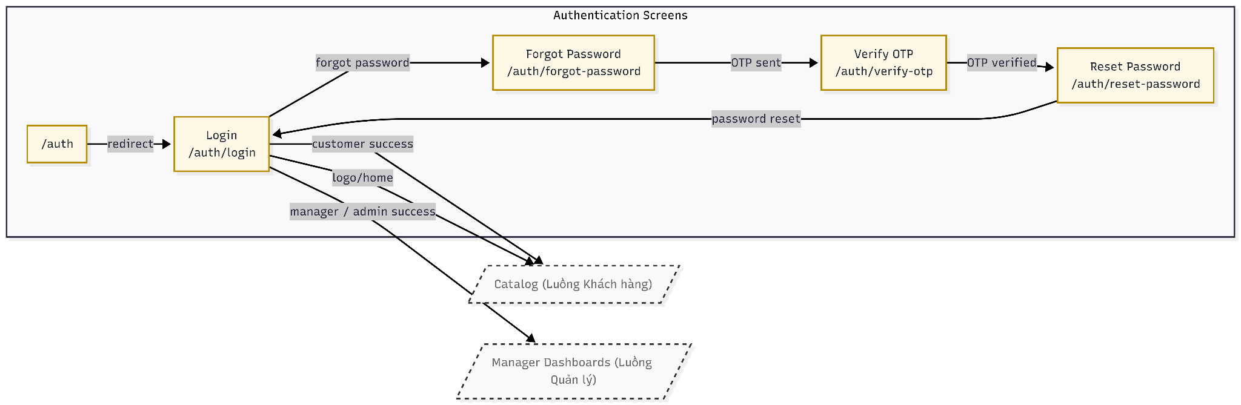

4.1.3 Screen Specifications

AIMS Software | Date of creation | Approved by | Reviewed by | Person in charge
Screen specification: Browse Media Screen | 20/4/2026 | HiếuBT | TúNHT | NghĩaTT

 | Control | Operation | Function
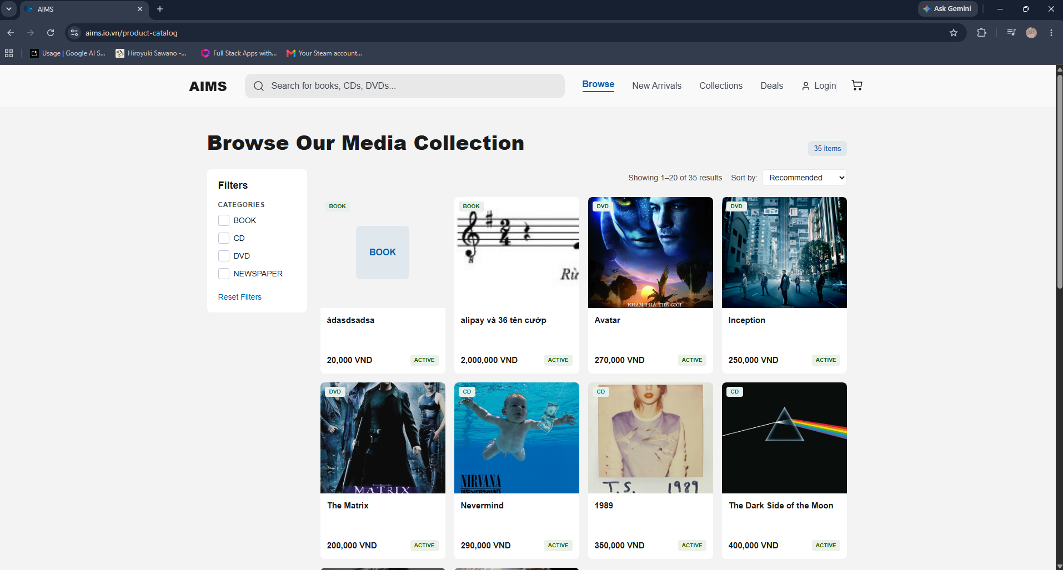 | Search Bar | Input / Press Enter | Search for specific books, CDs, DVDs, or Vinyl across the database
 | Navigation Links | Click | Navigate to Browse, New Arrivals, Collections, or Deals pages
 | Cart Icon | Click | Navigate to the View Cart screen
 | Category Checkboxes | Check / Uncheck | Filter the displayed media list by selected categories
 | Price Range Slider | Drag / Input | Update the minimum and maximum price range to filter products
 | Reset Filters Button | Click | Clear all applied category and price filters to default state
 | Sort Dropdown | Select | Sort items by predefined criteria (e.g., Recommended, Price, Title)
 | Product Card | Click | Navigate to the detailed information screen for that specific media item
 | Pagination Links | Click | Display the requested page of media results

Item | Length | Type | Color | Remarks
Search placeholder | 100 characters | Text | Gray | Left-justified
Category labels | 50 characters | Text | Black | Left-justified
Price input fields | 10 digits | Numeral / Text | Black | Right-justified, allows numeric input and suffix
Results count text | 50 characters | Text | Gray | Left-justified
Product Badge | 20 characters | Text | Blue | Uppercase, positioned top-left inside the product image area
Product Title | 100 characters | Text | Black | Left-justified, Bold
Product Description | 200 characters | Text | Gray | Left-justified, truncated with ellipsis if exceeding line limits
Product Price | 20 digits | Numeral / Text | Black | Left-justified, Bold
Pagination numbers | 5 digits | Numeral | Black / White | Center-justified, active page highlighted with a blue background

AIMS Software | Date of creation | Approved by | Reviewed by | Person in charge
Screen specification: Product Detail Screen | 20/04/2026 | HiếuBT | KhanhNT | NghĩaTT

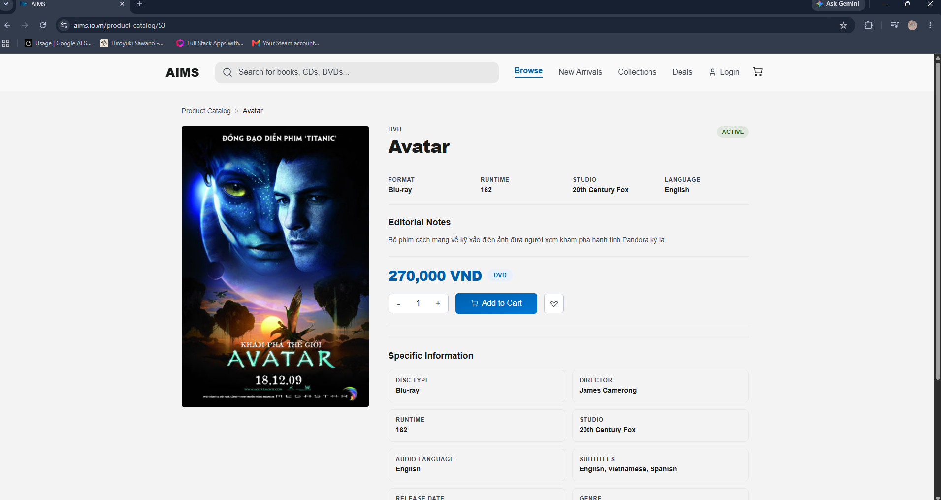 | Control | Operation | Function
 | Search bar | Input | Search for books, CDs, DVDs and other products
 | Browse tab | Click | Navigate to Browse page
 | New Arrivals tab | Click | Navigate to New Arrivals page
 | Collections tab | Click | Navigate to Collections page
 | Deals tab | Click | Navigate to Deals page
 | Cart icon | Click | Navigate to shopping cart screen
 | Breadcrumb navigation | Click | Navigate to previous category levels
 | Product image area | Initial | Display product image
 | Artist / Brand area | Initial | Display artist or brand name
 | Product title area | Initial | Display product title
 | Product subtitle area | Initial | Display product subtitle or edition
 | Price area | Initial | Display product selling price
 | Format tag | Initial | Display product format
 | Decrease quantity button | Click | Decrease selected quantity
 | Quantity field | Input | Display or edit selected quantity
 | Increase quantity button | Click | Increase selected quantity
 | Add to Cart button | Click | Add selected quantity of product to cart
 | Wishlist button | Click | Add product to wishlist or favorites
 | Format information area | Initial | Display product format information
 | Runtime information area | Initial | Display runtime information
 | Tracks information area | Initial | Display number of tracks
 | Label information area | Initial | Display label information
 | Editorial Notes area | Initial | Display editorial notes or product description
 | Privacy Policy link | Click | Navigate to Privacy Policy page
 | Terms of Service link | Click | Navigate to Terms of Service page
 | Licensing link | Click | Navigate to Licensing page
 | Contact link | Click | Navigate to Contact page

Item | Length | Type | Color | Remarks
Search bar | 100 characters | Text | Gray | Input field, left-justified
Browse tab | 20 characters | Link / Tab | Blue | Clickable
New Arrivals tab | 20 characters | Link / Tab | Black | Clickable
Collections tab | 20 characters | Link / Tab | Black | Clickable
Deals tab | 20 characters | Link / Tab | Black | Clickable
Cart icon | 1 icon | Button | Black / Orange badge | Clickable
Breadcrumb navigation | 100 characters | Link / Text | Gray / Black | Clickable
Product image | 1 image | Image | Original image color | Display only
Artist / Brand | 50 characters | Text | Gray | Uppercase, left-justified
Product title | 150 characters | Text | Black | Bold, left-justified
Product subtitle | 100 characters | Text | Black | Left-justified
Price | 20 characters | Currency | Blue | Bold, left-justified
Format tag | 20 characters | Label | Gray | Display only
Decrease quantity button | 2 characters | Button | Black / White background | Clickable
Quantity field | 5 digits | Numerical | Black | Center-justified
Increase quantity button | 2 characters | Button | Black / White background | Clickable
Add to Cart button | 20 characters | Button | White text / Blue background | Clickable
Wishlist button | 1 icon | Button | Black / White background | Clickable
Format information | 30 characters | Text | Black | Left-justified
Runtime information | 20 characters | Text | Black | Left-justified
Tracks information | 10 digits | Numerical | Black | Left-justified
Label information | 50 characters | Text | Black | Left-justified
Editorial Notes | 1000 characters | Text | Gray / Black | Multi-line, left-justified
Privacy Policy link | 30 characters | Link | Gray | Clickable
Terms of Service link | 30 characters | Link | Gray | Clickable
Licensing link | 20 characters | Link | Gray | Clickable
Contact link | 20 characters | Link | Gray | Clickable

AIMS Software | Date of creation | Approved by | Reviewed by | Person in charge
Screen specification: Cart Screen | 20/4/2026 | TúNHT | HiếuBT | KhanhNT

 | Control | Operation | Function
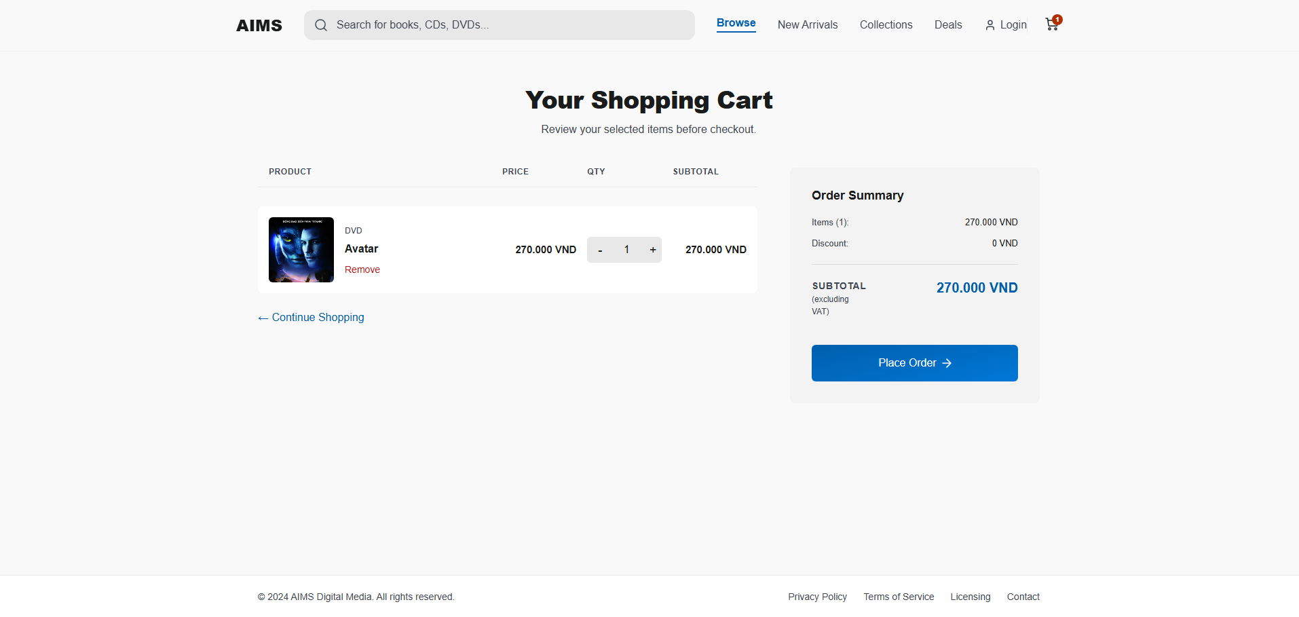 | Search Bar | Input / Press Enter | Search for specific media items across the database
 | Navigation Links | Click | Navigate to Browse, New Arrivals, Collections, or Deals pages
 | Cart Icon | Click | Reload or stay on the current View Cart screen
 | Remove Button | Click | Remove the corresponding media item from the shopping cart
 | Quantity Input Box | Input | Adjust the desired quantity of the specific item
 | Place Order Button | Click | Proceed to the Checkout/Delivery Information screen
 | Continue Shopping Link | Click | Navigate back to the previous product browsing screen or homepage

Item | Length | Type | Color | Remarks
Page Title | 50 characters | Text | Black | Center-justified, Bold ("Your Shopping Cart")
Table Headers | 20 characters | Text | Gray | Left/Center-justified, Uppercase (PRODUCT, PRICE, QTY, SUBTOTAL)
Product Image | N/A | Image | N/A | Left-aligned within the product row
Product Category | 50 characters | Text | Gray | Left-justified, small text (e.g., "Vector Graphic")
Product Title | 100 characters | Text | Black | Left-justified, Bold
Unit Price | 20 digits | Numeral / Text | Gray | Left-justified, formatted with comma separators
Quantity Box | 3 digits | Numeral | Black | Center-justified text within a light gray background box
Item Subtotal | 20 digits | Numeral / Text | Black | Left-justified, Bold
Order Summary Title | 50 characters | Text | Black | Left-justified, Bold ("Order Summary")
Summary Labels | 50 characters | Text | Gray | Left-justified (e.g., "Items (3):", "Discount:")
Summary Values | 20 digits | Numeral / Text | Black | Right-justified
Total Subtotal Label | 50 characters | Text | Gray | Left-justified, includes "(excluding VAT)" subtext
Total Subtotal Value | 20 digits | Numeral / Text | Blue | Right-justified, Bold, larger font

AIMS Software | Date of creation | Approved by | Reviewed by | Person in charge
Screen specification: Shipping & Delivery Screen | 20/4/2026 | HiếuBT | TúNHT | BìnhNT

 | Control | Operation | Function
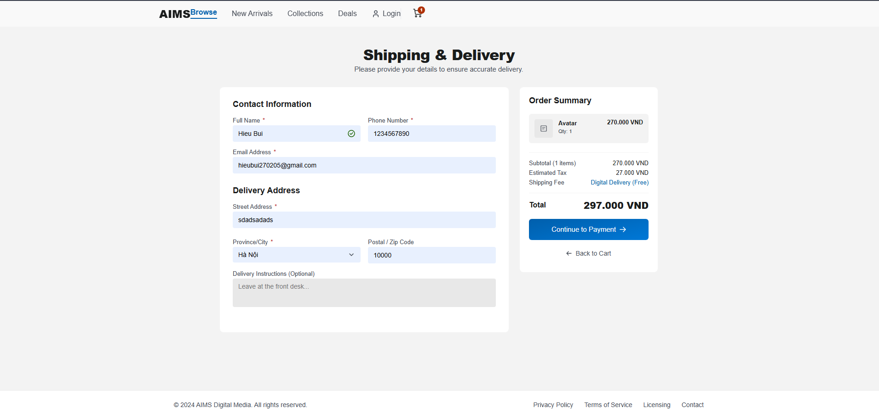 | Search Bar | Input / Press Enter | Search for specific media items across the database
 | Navigation Links | Click | Navigate to Browse, New Arrivals, Collections, or Deals pages
 | Cart Icon | Click | Navigate to the View Cart screen
 | Full Name Input | Input | Enter the recipient's full name for the order
 | Phone Number Input | Input | Enter the recipient's contact phone number
 | Email Address Input | Input | Enter an email address to receive order confirmation and updates
 | Street Address Input | Input | Enter the detailed delivery street address
 | Province/City Dropdown | Select | Choose the specific province, state, or city for delivery
 | Postal/Zip Code Input | Input | Enter the postal code corresponding to the delivery address
 | Delivery Instructions | Input | Enter optional notes or instructions for the delivery personnel
 | Continue to Payment Button | Click | Validate all required form fields and navigate to the payment processing screen
 | Back to Cart Link | Click | Return to the Shopping Cart screen to review or modify items

Item | Length | Type | Color | Remarks
Page Title | 50 characters | Text | Black | Center-justified, Bold ("Shipping & Delivery")
Section Headings | 50 characters | Text | Black | Left-justified, Bold (e.g., "Contact Information", "Delivery Address")
Input Labels | 50 characters | Text | Gray | Left-justified, positioned above input fields
Valid Input Field | N/A | UI Element | Green/Gray | Input field displays a green checkmark icon when data format is validated
Invalid Input Field | N/A | UI Element | Red | Input field background turns light red, displays a red error icon when data is invalid
Error Message | 100 characters | Text | Red | Left-justified, appears directly below the invalid input field (e.g., "Please enter a valid email address.")
Dropdown Menu | N/A | UI Element | Light Gray | Displays a chevron icon, opens a list of selectable regions
Summary Product Title | 100 characters | Text | Black | Left-justified, small font
Summary Subtext | 50 characters | Text | Gray | Left-justified, small font (e.g., "Digital License")
Summary Item Price | 20 digits | Numeral / Text | Black | Right-justified, formatted with comma separators
Cost Breakdown Labels | 50 characters | Text | Gray | Left-justified (e.g., "Subtotal (2 items)", "Estimated Tax")
Total Price Value | 20 digits | Numeral / Text | Black | Right-justified, Bold, larger font

AIMS Software | Date of creation | Approved by | Reviewed by | Person in charge
Screen specification: Payment Screen | 20/4/2026 | KhanhNT | TúNHT | HiếuBT

 | Control | Operation | Function
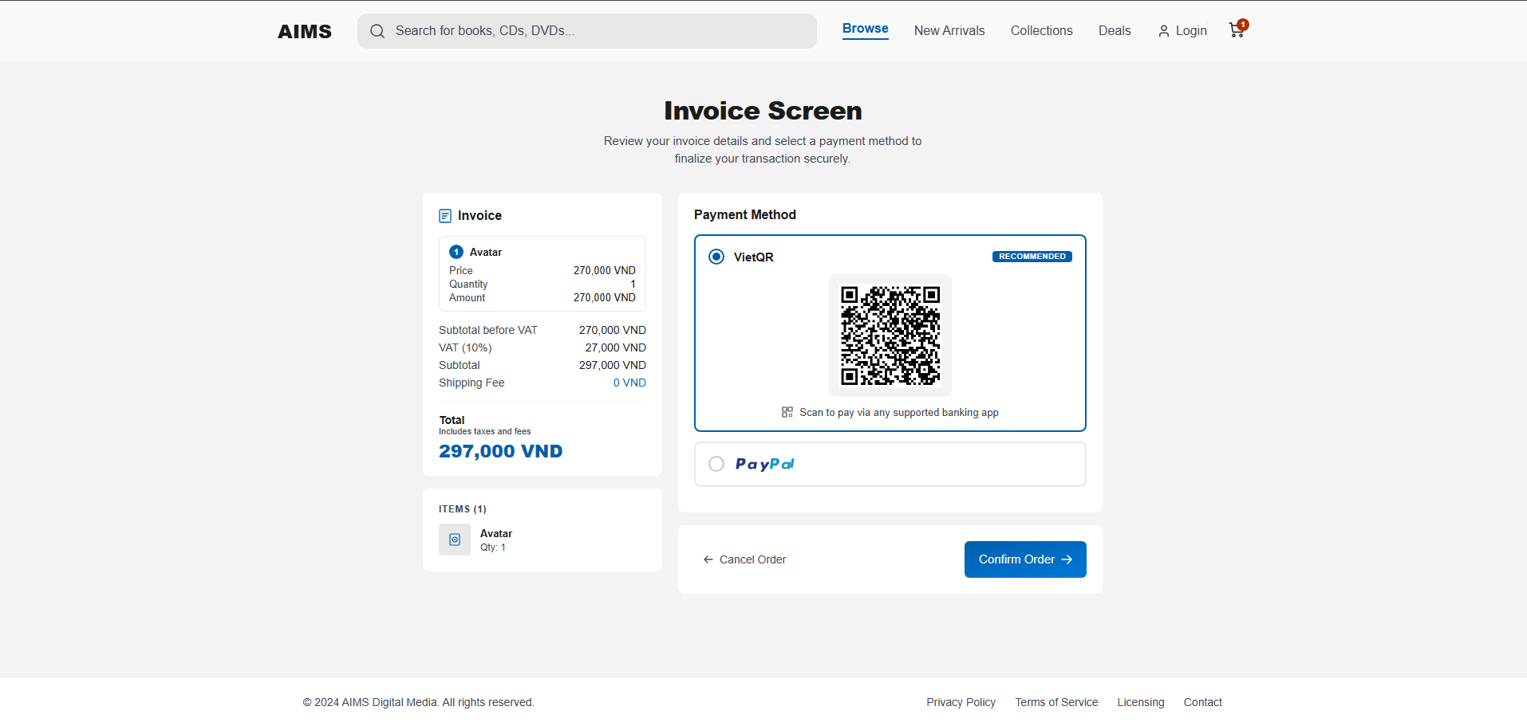  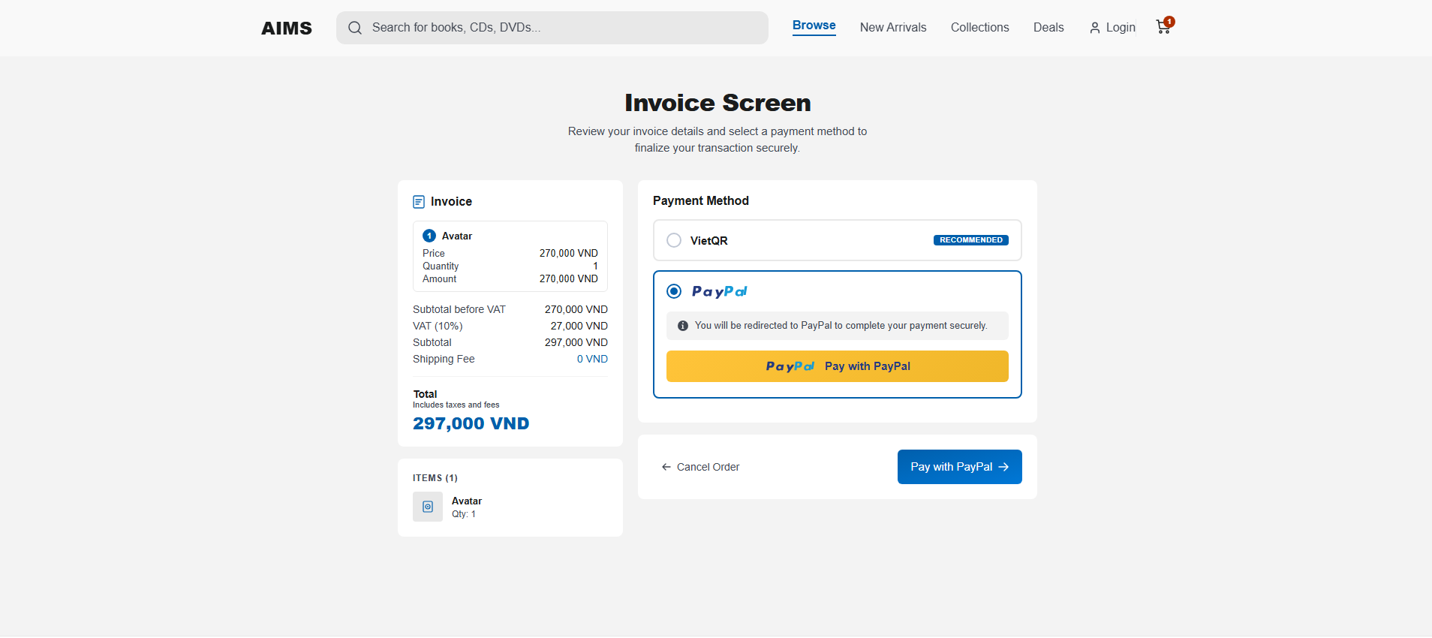 | Search Bar | Input / Press Enter | Search for specific media items across the database
 | Navigation Links | Click | Navigate to Browse, New Arrivals, Collections, or Deals pages
 | Cart Icon | Click | Navigate back to the View Cart screen
 | Method Radio Buttons | Select | Switch between available payment options (e.g., VietQR, PayPal)
 | Cancel Order Link | Click | Abort the current transaction and return to the previous screen or homepage
 | Confirm Payment Button | Click | Submit the selected payment details and finalize the transaction

Item | Length | Type | Color | Remarks
Page Title | 50 characters | Text | Black | Center-justified, Bold ("Complete Your Purchase")
Page Subtitle | 150 characters | Text | Gray | Center-justified
Section Titles | 50 characters | Text | Black | Left-justified, Bold, with leading icons (e.g., "Invoice Summary", "Payment Method")
Invoice Labels | 50 characters | Text | Gray | Left-justified (e.g., "Subtotal", "VAT (10%)")
Invoice Values | 20 digits | Numeral / Text | Black | Right-justified, formatted with comma separators and "VND"
Total Amount Label | 50 characters | Text | Black | Left-justified, Bold, includes subtext "Includes taxes and fees"
Total Amount Value | 20 digits | Numeral / Text | Blue | Right-justified, Bold, larger font
Product Item Details | 100 characters | Text | Black / Gray | Left-justified beside thumbnail (Title in black, Quantity in gray)
Selected Payment Box | N/A | UI Element | White / Blue | Background container with a solid blue highlight border
Recommended Badge | 20 characters | Text | Blue | Uppercase text with light blue background
QR Code Image | N/A | Image | N/A | Center-aligned within the VietQR payment box
Payment Instructions | 100 characters | Text | Gray | Center-justified below the QR code
Confirm Button | N/A | UI Element | Blue | Solid blue background with white text and a right-arrow icon

AIMS Software | Date of creation | Approved by | Reviewed by | Person in charge
Screen specification: Order Confirmation Screen | 20/4/2026 | BìnhNT | NghĩaTT | TúNHT

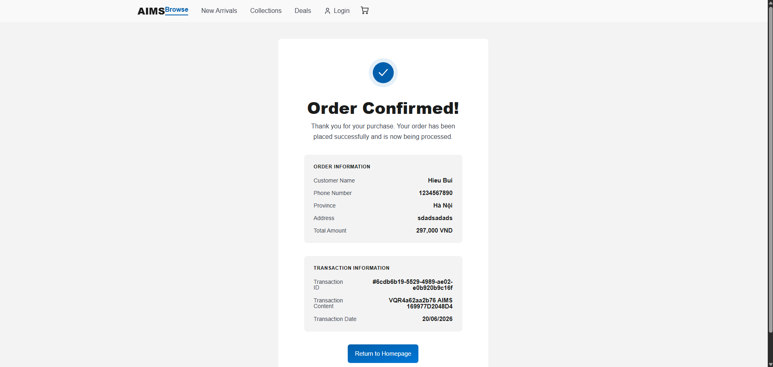 | Control | Operation | Function
 | Search Bar | Input / Press Enter | Search for specific media items across the database
 | Navigation Links | Click | Navigate to Browse, New Arrivals, Collections, or Deals pages
 | Cart Icon | Click | Navigate to the View Cart screen
 | Return to Homepage Button | Click | Navigate back to the main default homepage of the application

Item | Length | Type | Color | Remarks
Success Icon | N/A | Image/Icon | Blue / White | Center-justified, circular checkmark symbol
Page Title | 50 characters | Text | Black | Center-justified, Bold, large font ("Order Confirmed!")
Confirmation Message | 200 characters | Text | Gray | Center-justified paragraph
Order Details Container | N/A | UI Element | Light Gray | Background box for transaction information
Order Details Header | 50 characters | Text | Black | Left-justified, Bold, Uppercase ("ORDER DETAILS")
Detail Labels | 50 characters | Text | Gray | Left-justified (e.g., "Transaction ID", "Order Date")
Detail Values | 50 characters | Text | Black | Right-justified, Bold (e.g., "#AIMS-123456")

AIMS Software | Date of creation | Approved by | Reviewed by | Person in charge
Screen specification: Product Management Screen | 20/4/2026 | KhanhNT | NghĩaTT | BìnhNT

 | Control | Operation | Function
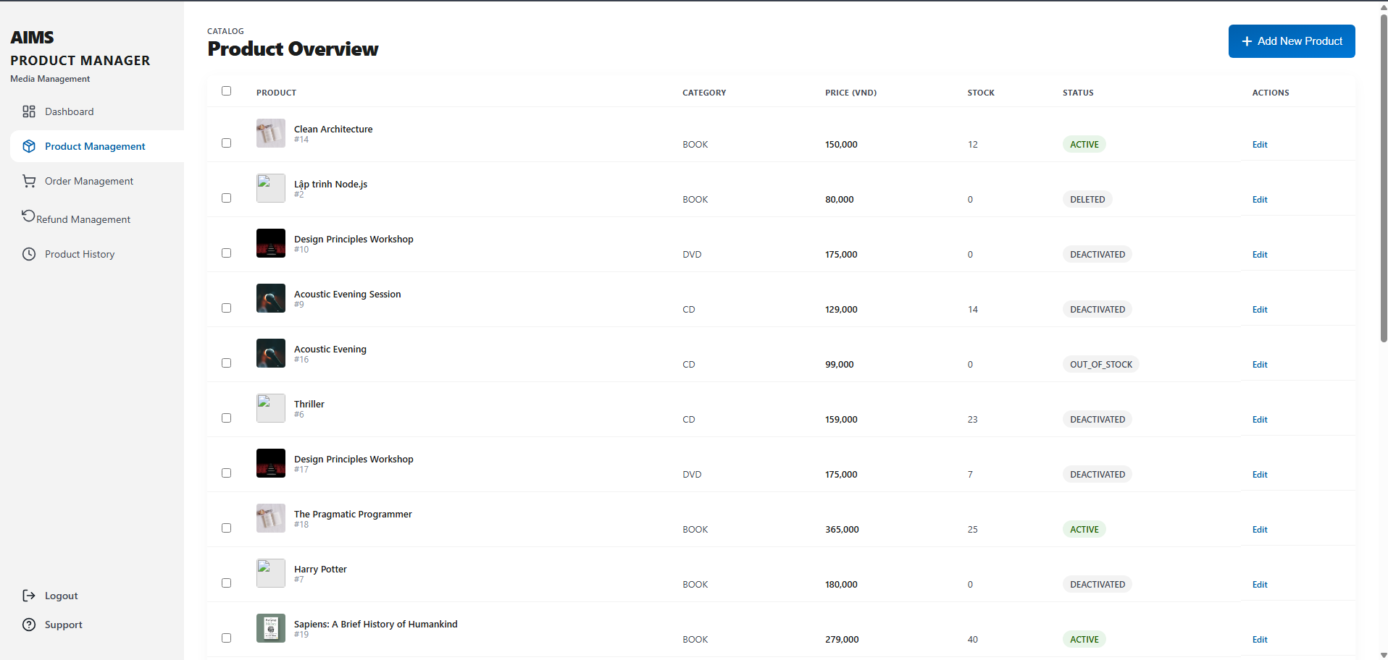 | Sidebar Navigation Links | Click | Navigate to different manager modules (Dashboard, Product Management, Order Management, Product History)
 | Global Search Bar (Top) | Input / Press Enter | Perform a global search across the entire manager portal
 | Notification / Settings / Profile Icons | Click | Open respective menus for alerts, system configurations, or user account settings
 | Local Search Bar | Input / Press Enter | Filter the product inventory table by specific keywords or IDs
 | Filter Button | Click | Open additional filtering options (e.g., by category, status, or stock level)
 | Add Product Button | Click | Navigate to the screen or modal to create a new product entry
 | Header Checkbox | Check / Uncheck | Select or deselect all product rows currently displayed on the page
 | Row Checkbox | Check / Uncheck | Select or deselect an individual product for bulk actions
 | Delete Selected Button | Click | Remove the currently selected products from the inventory (activates when items are selected)
 | Pagination Buttons | Click | Navigate through different pages of the product inventory list

Item | Length | Type | Color | Remarks
Sidebar Active State | N/A | UI Element | Blue | Active menu item is highlighted with blue text and a left border indicator
Breadcrumb Label | 50 characters | Text | Gray | Left-justified, Uppercase ("INVENTORY")
Page Title | 50 characters | Text | Black | Left-justified, Bold, Large font ("Product Management")
Table Headers | 20 characters | Text | Gray | Left/Center-justified, Uppercase
Product Image/Icon | N/A | Image | N/A | Left-aligned thumbnail within the product row
Product Title | 100 characters | Text | Black | Left-justified, Bold
Product ID | 20 characters | Text | Gray | Left-justified, positioned below the title (e.g., "ID: #P-84729")
Category Text | 50 characters | Text | Gray | Left-justified
Price Value | 20 digits | Numeral | Black | Right/Center-justified, formatted with comma separators
Stock Value | 20 characters | Numeral/Text | Black/Gray | Center-justified, displays quantity and type (e.g., "∞ Digital")
Status Badge (Active) | 20 characters | UI Element | Blue | Light blue background with dark blue text
Status Badge (Draft/Inactive) | 20 characters | UI Element | Gray | Light gray background with dark gray text
Pagination Summary | 50 characters | Text | Gray | Left-justified (e.g., "Showing 1 to 4 of 24 results")

AIMS Software | Date of creation | Approved by | Reviewed by | Person in charge
Screen specification: User Management Screen | 20/4/2026 | NghĩaTT | HiếuBT | TúNHT

 | Control | Operation | Function
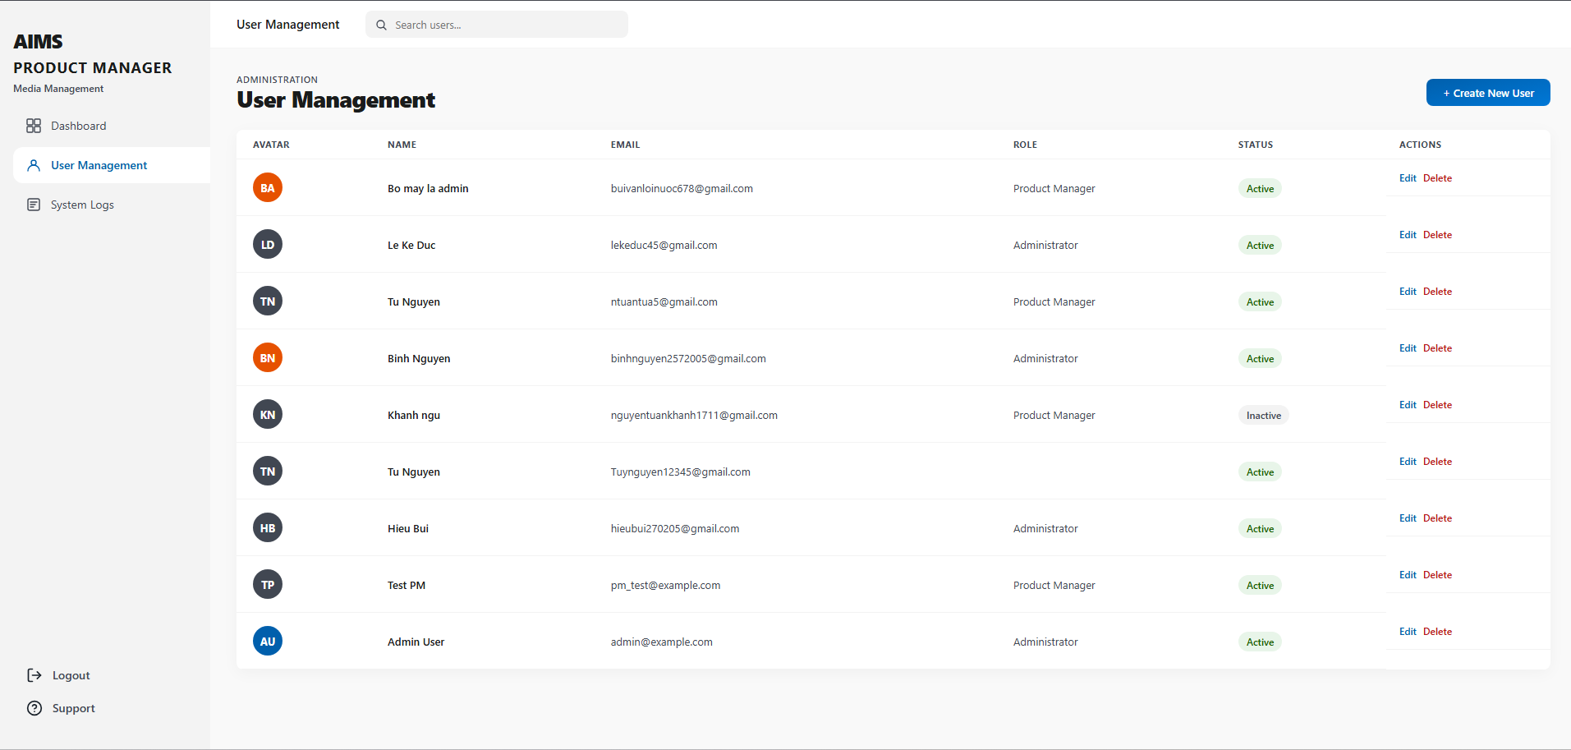 | Sidebar Navigation Links | Click | Navigate to different administrator modules (Dashboard, User Management, Role Management, System Logs)
 | Global Search Bar (Top) | Input / Press Enter | Perform a global search across the entire administrator portal
 | Notification / Settings / Profile Icons | Click | Open respective menus for alerts, system configurations, or user profile settings
 | Create New User Button | Click | Open a modal or navigate to a dedicated screen to register a new user account
 | Local Search Bar | Input / Press Enter | Search the specific user table by typing a name or email address
 | Filter Button | Click | Open advanced filtering options (e.g., by role, status, or date added)
 | Export Button | Click | Download the current user list data (typically as a CSV or Excel file)
 | Quick Edit Icon (Actions) | Click | Open the specific user's profile or a modal to quickly edit their details or roles
 | More Options Icon (Kebab) | Click | Open a dropdown menu with additional row-specific actions (e.g., Block User, Delete User, Reset Password)
 | Pagination Buttons | Click | Navigate through different pages of the user table
 | View Security Report Link | Click | Navigate to the detailed System Logs or Security module

Item | Length | Type | Color | Remarks
Page Title | 50 characters | Text | Black | Left-justified, Bold, Large font ("User Management")
Page Subtitle | 100 characters | Text | Gray | Left-justified, below the page title
Table Headers | 20 characters | Text | Gray | Left/Center-justified, Uppercase
User Avatar (Initials) | 3 characters | UI Element | Varies | Circular background with white initials
User Name | 50 characters | Text | Black | Left-justified, Bold
User Email | 100 characters | Text | Gray | Left-justified, smaller font below the user name
Role Badge (Admin) | 20 characters | UI Element | Blue | Light blue background with dark blue text
Role Badge (Standard) | 20 characters | UI Element | Gray | Light gray background with dark gray text (e.g., Editor, Viewer)
Status Badge (Active) | 20 characters | UI Element | Green | Light green background with a green dot and text
Status Badge (Blocked) | 20 characters | UI Element | Red | Light red background with a red dot and text
Last Login String | 50 characters | Text | Gray | Left-justified (e.g., "Today, 09:41 AM")
Widget Titles | 50 characters | Text | Black | Bold (e.g., "Recent Security Activity", "System Secure")
Security Activity Item | 100 characters | Text | Black | Left-justified text with a colored indicator dot
Security Subtext/Time | 50 characters | Text | Gray | Small text indicating IP address, action details, or timestamp

AIMS Software | Date of creation | Approved by | Reviewed by | Person in charge
Screen specification: Add Product Screen | 20/04/2026 | KhanhNT | BìnhNT | NghĩaTT

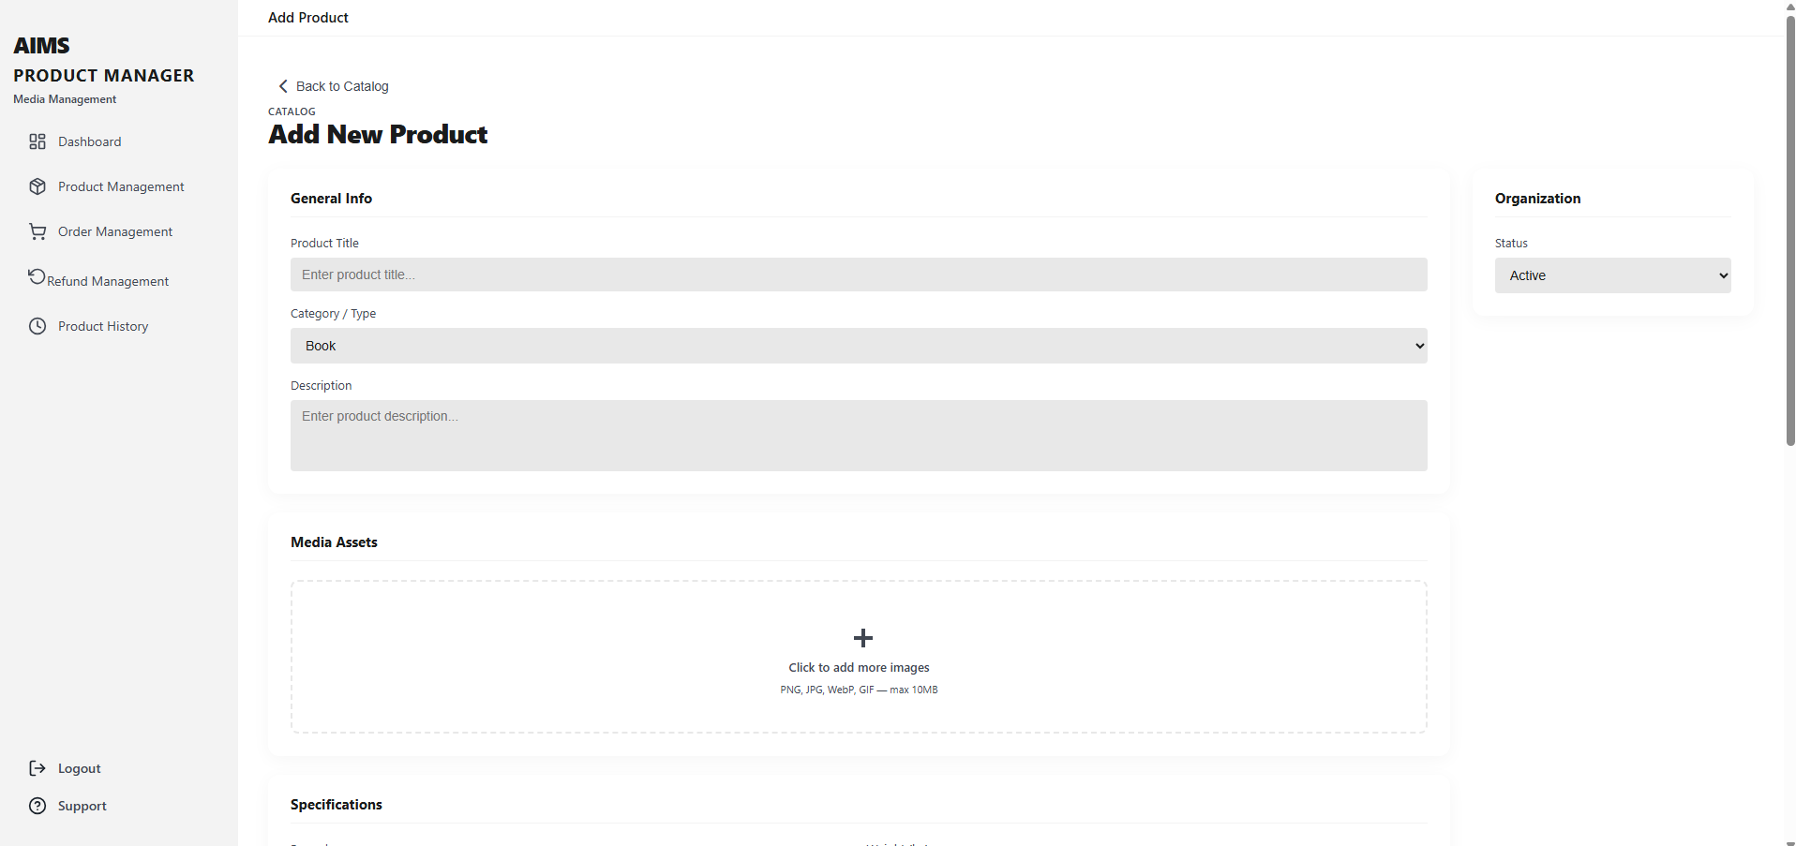  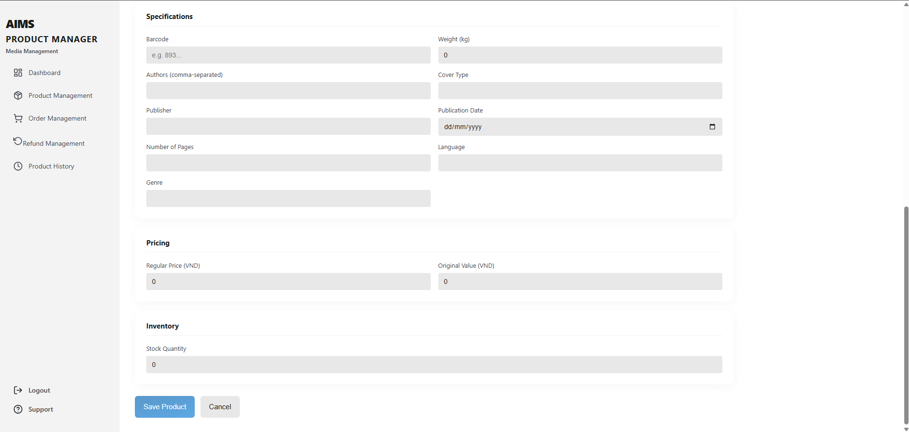 | Control | Operation | Function
 | Back to Catalog link | Click | Return to the Product Catalog screen without saving the current form
 | Product Title field | Input | Enter the product title
 | Category dropdown | Select | Choose the product category
 | Status dropdown | Select | Choose the current availability status of the product
 | Description textarea | Input | Enter a textual description of the product
 | Barcode (UPC/EAN) field | Input | Enter the unique barcode / numeric identifier of the product
 | Original Price (excl. VAT) field | Input | Enter the original price before VAT
 | Current Price (excl. VAT) field | Input | Enter the current selling price before VAT
 | Current Price validation message | Display | Show validation error when current price is not between 30% and 150% of the original price
 | Publisher field | Input | Enter publisher information for book products
 | Publication Date field | Input / Pick date | Enter or select the publication date
 | Language field | Input | Enter the language of the book
 | Dimensions field | Input | Enter physical dimensions in H x W x L format
 | Weight field | Input | Enter product weight in kilograms
 | Stock Quantity field | Input | Enter available inventory quantity
 | Cancel button | Click | Cancel product creation and return to previous/catalog screen
 | Save Product button | Click | Validate all required fields and save the new product
 | Required-field indicator (*) | Display | Mark mandatory fields that must be completed before saving

Item | Length | Type | Color | Remarks
Product Title | 255 characters | Text | Gray | Required, left-justified
Category | 50 characters | Dropdown list | Gray | Required, selectable value
Status | 20 characters | Dropdown list | Gray | Required, selectable value
Description | 1000 characters | Textarea | Gray | Optional, multi-line, left-justified
Barcode (UPC/EAN) | 13 digits | Numerical / Text numeric | Gray | Required, unique identifier
Original Price (excl. VAT) | 10 digits + 2 decimals | Decimal / Currency | Gray | Required, right-justified
Current Price (excl. VAT) | 10 digits + 2 decimals | Decimal / Currency | Gray / Red on error | Required, right-justified, validated against Original Price
Publisher | 255 characters | Text | Gray | Optional, left-justified
Publication Date | 10 characters | Date | Gray | Optional, format mm/dd/yyyy
Language | 50 characters | Text | Gray | Optional, left-justified
Dimensions (H x W x L) | 50 characters | Text | Gray | Optional, format text
Weight (kg) | 6 digits + 2 decimals | Decimal | Gray | Optional, non-negative
Stock Quantity | 10 digits | Integer | Gray | Required, default value = 0, right-justified

AIMS Software | Date of creation | Approved by | Reviewed by | Person in charge
Screen specification: Delete Product Screen | 20/04/2026 | TúNHT | HiếuBT | BìnhNT

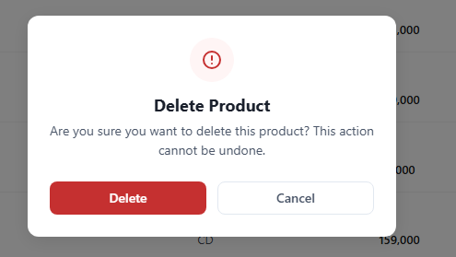 | Control | Operation | Function
 | Warning icon area | Initial | Display warning status for delete action
 | Dialog title | Initial | Display the title “Delete Product”
 | Confirmation message area | Initial | Display the confirmation message for deleting the selected product
 | Cancel button | Click | Close the dialog and cancel the delete action
 | Delete button | Click | Delete the selected product from the system

Item | Length | Type | Color | Remarks
Dialog title | 50 characters | Text | Black | Center-left justified
Confirmation message | 200 characters | Text | Gray | Left-justified
Warning icon | 1 icon | Icon | Red | Display only
Cancel button | 10 characters | Button | Blue text / White background | Clickable
Delete button | 10 characters | Button | White text / Red background | Clickable

AIMS Software | Date of creation | Approved by | Reviewed by | Person in charge
Screen specification: Product Detail Screen | 20/04/2026 | HiếuBT | BìnhNT | TúNHT

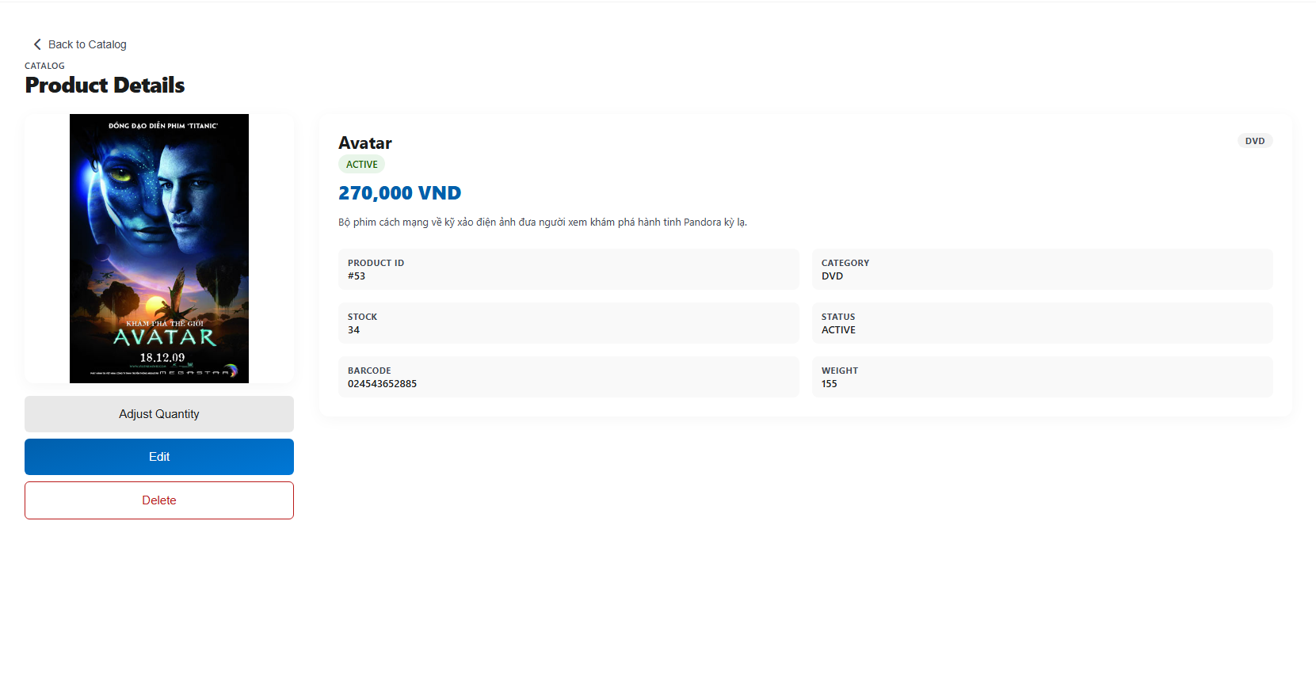 | Control | Operation | Function
 | Back to Catalog link | Click | Return to Product Catalog screen
 | Product image area | Initial | Display product cover image
 | SKU area | Initial | Display product SKU
 | Format area | Initial | Display product format
 | Category tags area | Initial | Display product categories / labels
 | Product title area | Initial | Display product title
 | Author area | Initial | Display author name
 | Description area | Initial | Display product description
 | Edit icon button | Click | Navigate to Edit Product screen
 | Publisher area | Initial | Display publisher information
 | Publication date area | Initial | Display publication date
 | Pages area | Initial | Display number of pages
 | Language area | Initial | Display product language
 | ISBN-10 area | Initial | Display ISBN-10 code
 | ISBN-13 area | Initial | Display ISBN-13 code
 | Dimensions area | Initial | Display product dimensions
 | Weight area | Initial | Display product weight
 | In Stock area | Initial | Display current stock quantity
 | Reorder Point area | Initial | Display reorder point quantity
 | Adjust Quantity button | Click | Open quantity adjustment function
 | Current Price area | Initial | Display current selling price
 | Original Price area | Initial | Display original price

Item | Length | Type | Color | Remarks
Back to Catalog link | 20 characters | Link | Blue | Clickable
Product image | 1 image | Image | Original image color | Display only
SKU | 20 characters | Text | Black | Left-justified
Format | 20 characters | Text | Black | Left-justified
Category tags | 30 characters each | Label | Gray / Orange | Display only
Product title | 150 characters | Text | Black | Bold, left-justified
Author | 100 characters | Text | Gray | Left-justified
Description | 1000 characters | Text | Gray | Multi-line, left-justified
Edit icon button | 1 icon | Button | Black | Clickable
Publisher | 100 characters | Text | Black | Left-justified
Publication date | 30 characters | Date/Text | Black | Left-justified
Pages | 10 digits | Numerical | Black | Left-justified
Language | 30 characters | Text | Black | Left-justified
ISBN-10 | 10 characters | Text/Numerical | Black | Left-justified
ISBN-13 | 13 characters | Text/Numerical | Black | Left-justified
Dimensions | 30 characters | Text | Black | Left-justified
Weight | 20 characters | Text | Black | Left-justified
In Stock | 10 digits | Numerical | Black | Left-justified
Reorder Point | 10 digits | Numerical | Black | Left-justified
Adjust Quantity button | 20 characters | Button | White text / Blue background | Clickable
Current Price | 20 characters | Currency | Blue | Bold, left-justified
Original Price | 20 characters | Currency | Gray | Strikethrough, left-justified

AIMS Software | Date of creation | Approved by | Reviewed by | Person in charge
Screen specification: Stock Adjustment Dialog | 20/04/2026 | TúNHT | NghĩaTT | BìnhNT

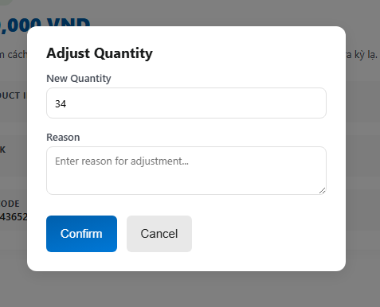 | Control | Operation | Function
 | Dialog title | Initial | Display the title “Stock Adjustment”
 | Product name area | Initial | Display the selected product name
 | Close icon button | Click | Close the dialog without saving changes
 | Adjustment Quantity field | Input | Enter quantity to increase or decrease stock
 | Quantity instruction text | Initial | Display guidance that negative values deduct stock
 | Reason for Adjustment field | Input | Enter the reason for inventory adjustment
 | Cancel button | Click | Close the dialog and cancel the stock adjustment
 | Confirm button | Click | Confirm and save the stock adjustment

Item | Length | Type | Color | Remarks
Dialog title | 50 characters | Text | Black | Bold, left-justified
Product name | 100 characters | Text | Gray | Left-justified
Close icon button | 1 icon | Button | Gray | Clickable
Adjustment Quantity | 10 digits | Numerical | Gray | Input field, accepts positive and negative values
Quantity instruction text | 100 characters | Text | Gray | Display only, left-justified
Reason for Adjustment | 500 characters | Textarea | Gray | Multi-line, left-justified
Cancel button | 10 characters | Button | Blue text / White background | Clickable
Confirm button | 10 characters | Button | White text / Blue background | Clickable

AIMS Software | Date of creation | Approved by | Reviewed by | Person in charge
Screen specification: Edit Product Screen | 20/04/2026 | KhanhNT | BìnhNT | NghĩaTT

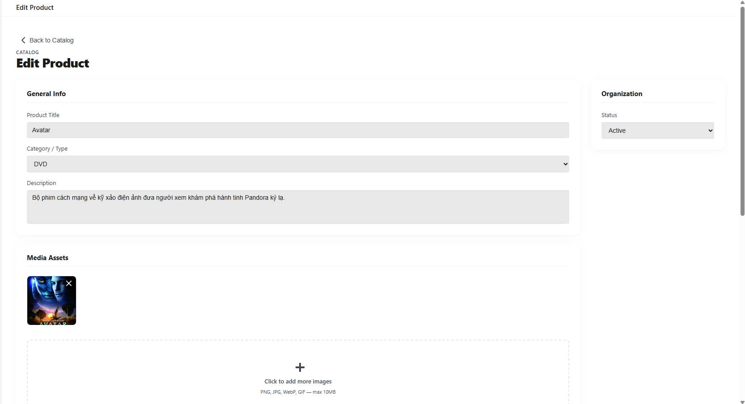  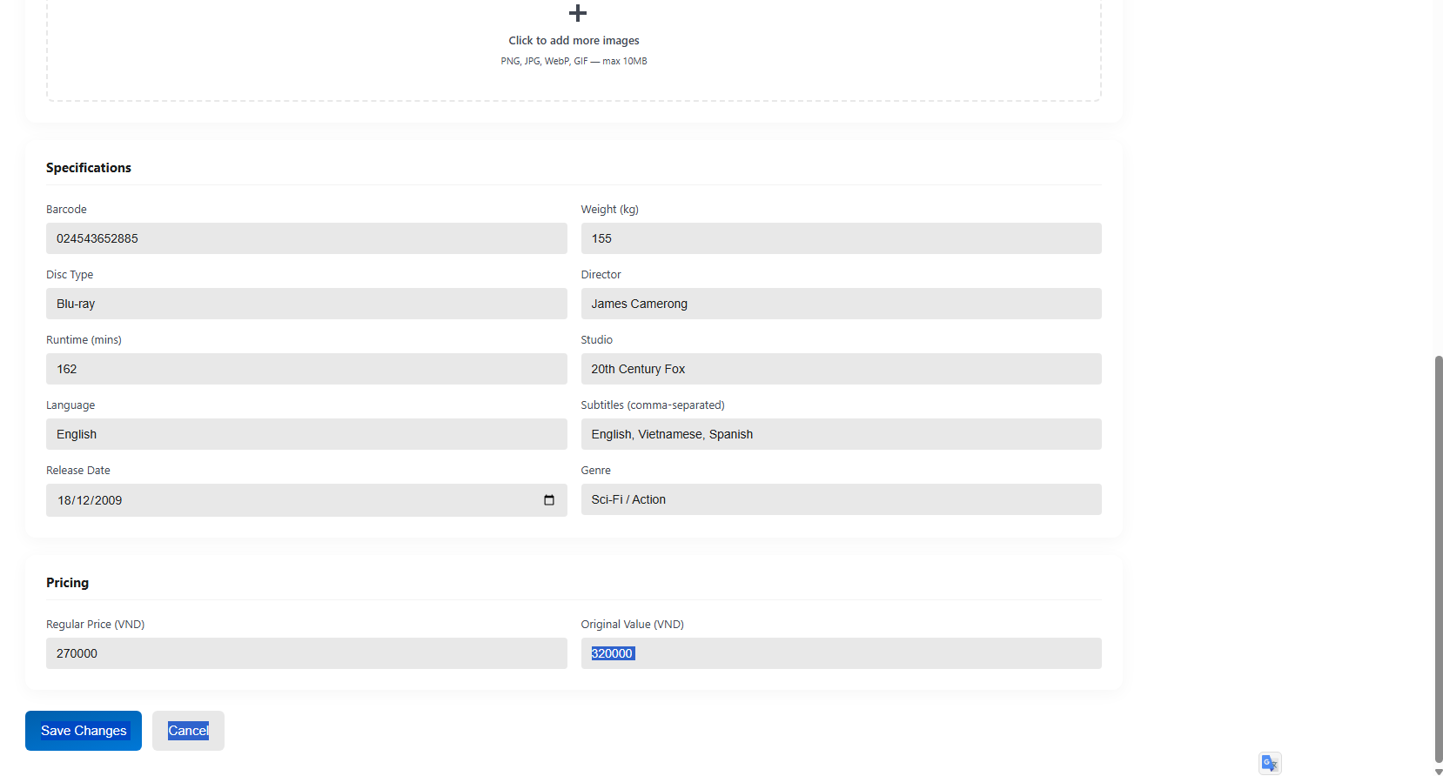 | Control | Operation | Function
 | Back to Catalog link | Click | Return to Product Catalog screen
 | Cancel button | Click | Cancel editing and discard changes
 | Save Changes button | Click | Save updated product information
 | Title field | Input | Edit product title
 | Description field | Input | Edit product description
 | Add Media link | Click | Add new media asset
 | Primary image area | Initial | Display current primary media asset
 | Add Image area | Click | Upload or add product image
 | Current Price field | Input | Edit current selling price
 | Compare at Price field | Input | Edit original / compare price
 | Category dropdown | Select | Select product category
 | Status dropdown | Select | Select product status
 | Tags field | Input | Edit product tags
 | ISBN field | Input | Edit product ISBN
 | Publisher field | Input | Edit publisher information
 | Author field | Input | Edit author name
 | Format dropdown | Select | Select product format
 | SKU field | Input | Edit product SKU
 | Available Quantity field | Input | Edit available product quantity

Item | Length | Type | Color | Remarks
Back to Catalog link | 20 characters | Link | Blue | Clickable
Cancel button | 15 characters | Button | Blue text / White background | Clickable
Save Changes button | 20 characters | Button | White text / Blue background | Clickable
Title | 150 characters | Text | Gray | Left-justified
Description | 2000 characters | Textarea | Gray | Multi-line, left-justified
Add Media link | 15 characters | Link | Blue | Clickable
Primary image | 1 image | Image | Original image color | Display only
Add Image area | 1 area | Upload control | Gray | Clickable
Current Price ($) | 10 digits + 2 decimals | Currency | Gray | Right-justified
Compare at Price ($) | 10 digits + 2 decimals | Currency | Gray | Right-justified
Category | 50 characters | Dropdown | Gray | Selectable value
Status | 20 characters | Dropdown | Gray | Selectable value
Tags | 255 characters | Text | Gray | Separate tags with commas
ISBN | 20 characters | Text / Numerical | Gray | Left-justified
Publisher | 100 characters | Text | Gray | Left-justified
Author | 100 characters | Text | Gray | Left-justified
Format | 30 characters | Dropdown | Gray | Selectable value
SKU | 50 characters | Text | Gray | Left-justified
Available Quantity | 10 digits | Numerical | Gray | Right-justified

AIMS Software | Date of creation | Approved by | Reviewed by | Person in charge
Screen specification: Order Approval Screen | 20/04/2026 | TúNHT | NghĩaTT | KhanhNT

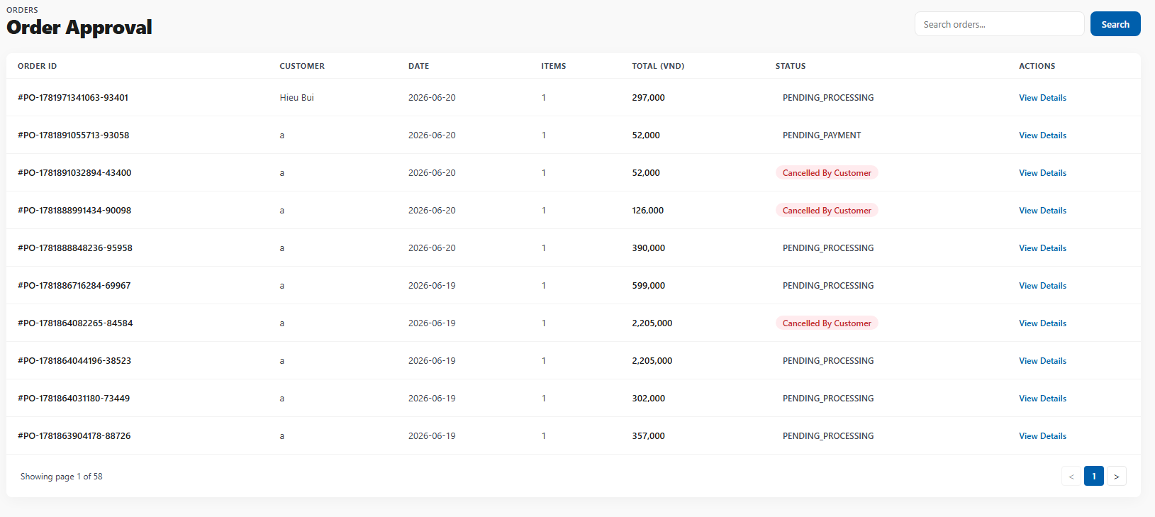 | Control | Operation | Function
 | Search field | Input | Search orders by ID or customer name
 | Order ID column | Initial | Display order ID
 | Customer Name column | Initial | Display customer name
 | Date column | Initial | Display order date
 | Total Amount column | Initial | Display total order amount
 | Approve button | Click | Approve the selected order
 | Reject button | Click | Reject the selected order
 | Current page button | Click | Display the selected page of orders
 | Previous page button | Click | Navigate to previous page
 | Next page button | Click | Navigate to next page
 | Pagination area | Initial | Display page navigation and current page status
 | Showing results text | Initial | Display current visible order range and total number of orders

Item | Length | Type | Color | Remarks
Search field | 100 characters | Text | Gray | Input field, left-justified
Order ID | 20 characters | Text | Blue | Clickable / left-justified
Customer Name | 100 characters | Text | Black | Left-justified
Date | 10 characters | Date | Black | Format dd/mm/yyyy
Total Amount (VND) | 15 digits | Currency | Black | Right-justified
Approve button | 10 characters | Button | White text / Blue background | Clickable
Reject button | 10 characters | Button | White text / Orange background | Clickable
Current page button | 5 characters | Button | White text / Blue background | Clickable
Other page button | 5 characters | Button | Black text / White background | Clickable
Previous page button | 2 characters | Icon/Button | Gray | Clickable
Next page button | 2 characters | Icon/Button | Black | Clickable
Showing results text | 30 characters | Text | Gray | Display only, left-justified

AIMS Software | Date of creation | Approved by | Reviewed by | Person in charge
Screen specification: Order Detail Screen | 20/04/2026 | NghĩaTT | KhanhNT | BìnhNT

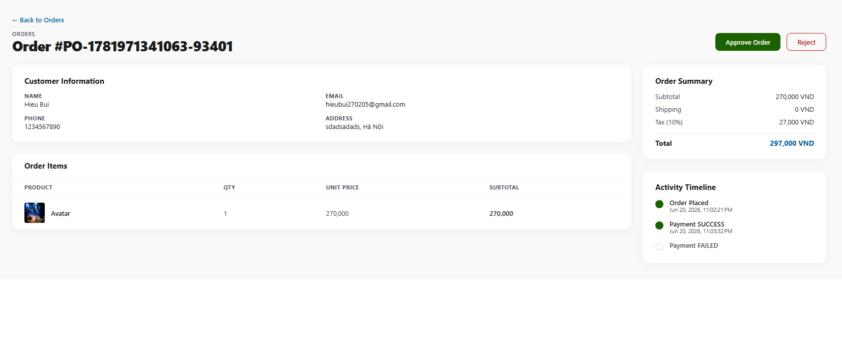 | Control | Operation | Function
 | Breadcrumb link | Click | Return to Order Approval screen
 | Reject button | Click | Reject the current order
 | Approve button | Click | Approve the current order
 | Customer Information area | Initial | Display customer information
 | Company / Name field | Initial | Display company or customer name
 | Email field | Initial | Display customer email
 | Phone field | Initial | Display customer phone number
 | Shipping Address field | Initial | Display shipping address
 | Order Status area | Initial | Display order status information
 | Date Placed field | Initial | Display date and time the order was placed
 | Payment Method field | Initial | Display selected payment method
 | Current Status field | Initial | Display current order status
 | Order Items table | Initial | Display ordered product items
 | Product column | Initial | Display ordered product information
 | Category column | Initial | Display product category
 | Price column | Initial | Display item unit price
 | Qty column | Initial | Display ordered quantity
 | Subtotal column | Initial | Display item subtotal
 | Activity Timeline area | Initial | Display order activity history
 | Order Summary area | Initial | Display order financial summary
 | Subtotal summary field | Initial | Display subtotal amount
 | VAT summary field | Initial | Display VAT amount
 | Shipping Fee summary field | Initial | Display shipping fee
 | Total Amount summary field | Initial | Display total order amount

Item | Length | Type | Color | Remarks
Breadcrumb link | 40 characters | Link | Gray / Black | Clickable
Reject button | 10 characters | Button | Orange text / White background | Clickable
Approve button | 10 characters | Button | White text / Blue background | Clickable
Company / Name | 100 characters | Text | Black | Left-justified
Email | 100 characters | Text | Black | Left-justified
Phone | 20 characters | Text | Black | Left-justified
Shipping Address | 255 characters | Text | Black | Multi-line, left-justified
Date Placed | 20 characters | Date/Time | Black | Format dd/mm/yyyy hh:mm
Payment Method | 30 characters | Text | Black | Left-justified
Current Status | 30 characters | Label | Yellow / Black | Display only
Product information | 150 characters | Text | Black | Includes product name and format
Category | 50 characters | Text | Gray | Left-justified
Price (VND) | 15 digits | Currency | Black | Right-justified
Qty | 10 digits | Numerical | Black | Center or right-justified
Item Subtotal (VND) | 15 digits | Currency | Black | Right-justified
Activity Timeline entry | 150 characters | Text | Gray / Black | Multi-line, display only
Subtotal amount | 15 digits | Currency | Black | Right-justified
VAT amount | 15 digits | Currency | Black | Right-justified
Shipping Fee | 15 digits | Currency | Black | Right-justified
Total Amount | 15 digits | Currency | Blue | Bold, right-justified

4.2 Data Modeling

4.2.1 Conceptual Data Modeling
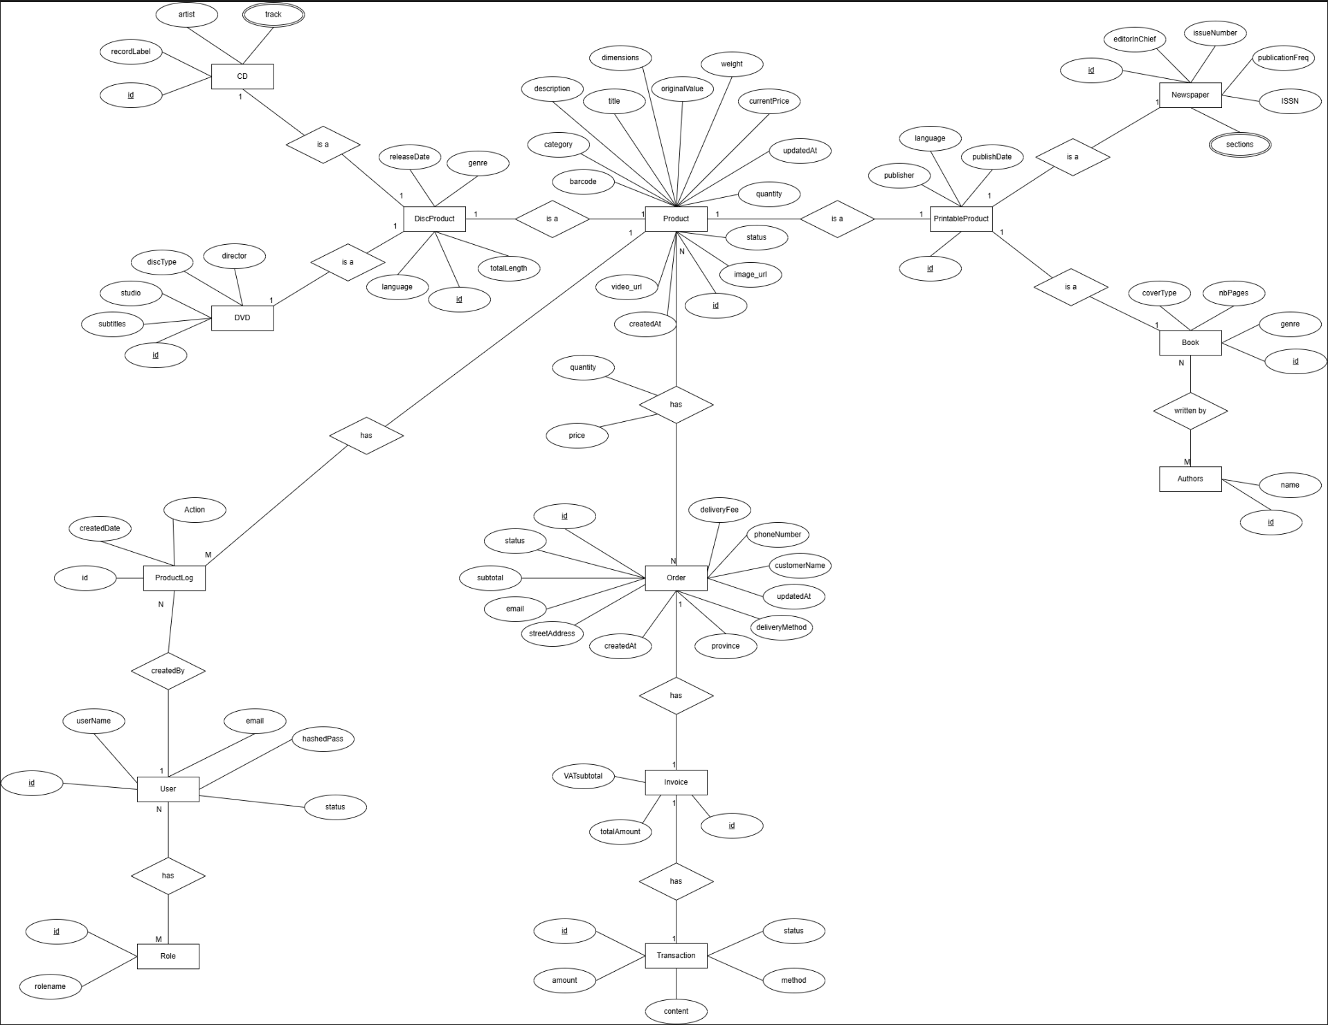
Product catalog (generalization hierarchy)
Entity | Role | Key attributes
Product (superclass) | The common abstraction for every media item sold by AIMS | id (PK), barcode (unique), category, title, description, dimensions, weight, originalValue, currentPrice (both exclude 10% VAT), quantity (stock on hand), status, image_url, video_url, createdAt, updatedAt
DiscProduct (sub-class of Product) | Common attributes of optical-disc media | id, releaseDate, genre, language, totalLength
CD (sub-class of DiscProduct) | Music disc | id, artist, recordLabel, track
DVD (sub-class of DiscProduct) | Video disc | id, discType, director, studio, subtitles
PrintableProduct (sub-class of Product) | Common attributes of printed media | id, publisher, language, publishDate
Book (sub-class of PrintableProduct) | Book | id, coverType, nbPages, genre
Newspaper (sub-class of PrintableProduct) | Newspaper / periodical | id, editorInChief, issueNumber, publicationFreq, ISSN, sections
Author | A book's author | id, name
Sales / order processing
Entity | Role | Key attributes
Order | A customer's placed order with its delivery info | id (PK, plus a unique business orderId), customerName, phoneNumber, email, streetAddress, province, deliveryMethod, deliveryFee, subtotal, status, createdAt, updatedAt
OrderProduct (associative entity / line item) | One product line inside an order | quantity, price (price snapshot captured at purchase time)
Invoice | The priced bill produced for an order | id, vatSubtotal, totalAmount
Transaction (PaymentTransaction) | The payment record for the invoice | id, amount, status, method, content (the implementation also stores provider, gateway IDs, QR data, and timestamps)
Security and audit
Entity | Role | Key attributes
User | An administrator or product manager account | id, userName, email (unique), hashedPass, status
Role | A privilege role | id, roleName
UserRole (associative entity) | Resolves the User <-> Role many-to-many | (userId, roleId)
BookAuthor (associative entity) | Resolves the Book <-> Author many-to-many | (bookId, authorId)
ProductLog | Audit entry for a product add / edit / delete | id, action, createdDate
Relationships:
Relationship | Type / Cardinality | Meaning
CD / DVD is-a DiscProduct; Book / Newspaper is-a PrintableProduct; DiscProduct / PrintableProduct is-a Product | Generalization (1:1 subtype links), total & disjoint | Every Product is exactly one leaf type (CD, DVD, Book, or Newspaper). Subtypes share the parent's primary key and inherit its attributes, so common product data is stored once.
Order has Product | N : M (realised by OrderProduct) | An order contains many products and a product appears in many orders; the line stores quantity and the purchase-time price.
Order has Invoice | 1 : 1 | Each order produces exactly one invoice carrying the VAT subtotal and total amount.
Invoice has Transaction | 1 : 1 (in the ERD) | The invoice is settled by a payment transaction.
Book written-by Author | N : M (realised by BookAuthor) | A book may have several authors; an author writes many books.
User has Role | N : M (realised by UserRole) | A user can hold multiple roles (e.g. administrator and product manager); a role is shared by many users (principle of least privilege).
Product has ProductLog | 1 : N | Every change to a product is recorded as a log entry, so the full add/edit/delete history can be queried.
ProductLog created-by User | N : 1 | Each log entry is attributed to the user who performed the action.

4.2.2 Database Design

4.2.2.1 Database Management System
The AIMS application utilizes PostgreSQL as its primary Database Management System. The decision to select PostgreSQL was driven by its strong reputation as a highly reliable, open-source relational database system. Because AIMS is an e-commerce platform handling financial transactions, order processing, and real-time inventory management, the strict ACID (Atomicity, Consistency, Isolation, Durability) compliance provided by PostgreSQL is essential to guarantee absolute data integrity.

PostgreSQL excels in managing complex relationships and concurrent operations, which directly supports the system's strict requirement to serve up to 1,000 simultaneous customers without performance degradation. Furthermore, the database integrates seamlessly with Prisma ORM, which is used throughout the NestJS backend to provide type-safe database queries and automated schema migrations. This combination enforces a highly structured relational data model that efficiently links users, physical media products, and order histories while maintaining strict foreign key constraints.

4.2.2.2 Database Diagram

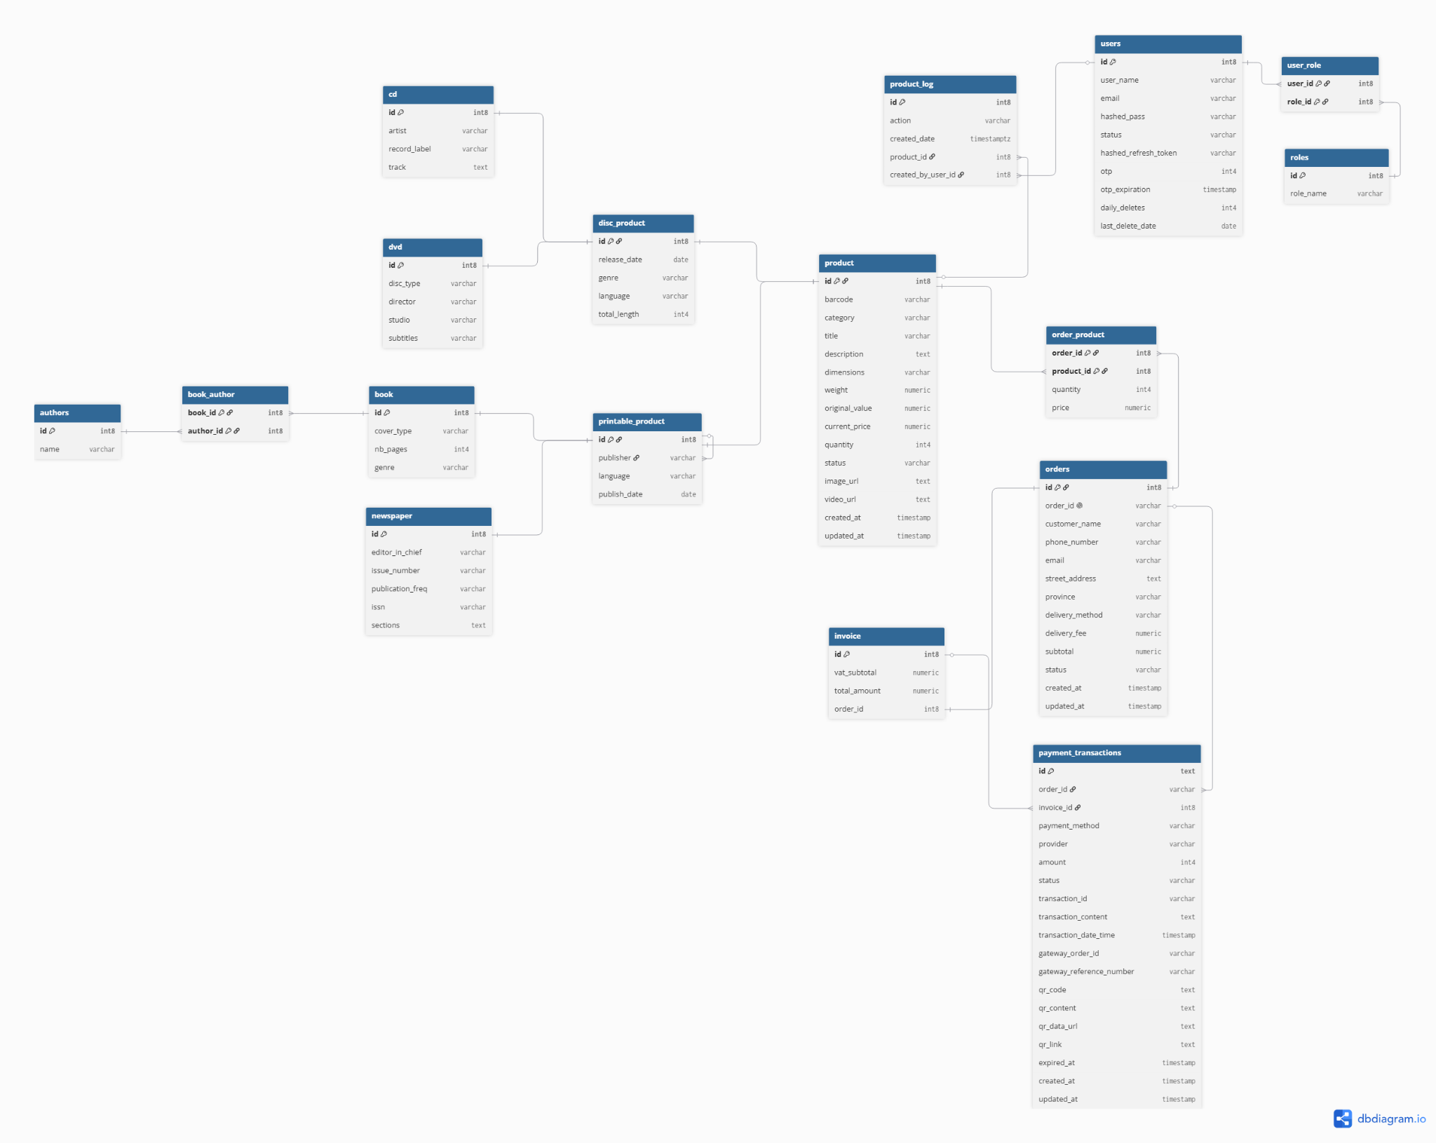

4.2.2.3 Database Detail Design
CD
# | PK | FK | Column  Name | Data type | Mandatory | Description
1. | x |  | id | BIGSERIAL | Yes | ID, same as ID of DiscProduct of which type is CD
2. |  |  | artist | VARCHAR(100) | Yes | Name of the artist or performer
3. |  |  | recordLabel | VARCHAR(100) | Yes | Record label of the CD
4. |  |  | track | TEXT | Yes | List of tracks in the CD

DVD
# | PK | FK | Column  Name | Data type | Mandatory | Description
1. | x |  | id | BIGSERIAL | Yes | ID, same as ID of DiscProduct of which type is DVD
2. |  |  | discType | VARCHAR(45) | Yes | Disc type of the DVD
3. |  |  | director | VARCHAR(100) | Yes | Director of the DVD
4. |  |  | studio | VARCHAR(100) | Yes | Production studio or manufacturer
5. |  |  | subtitles | VARCHAR(255) | Yes | Available subtitles of the DVD

DiscProduct
# | PK | FK | Column  Name | Data type | Mandatory | Description
1. | x |  | id | BIGSERIAL | Yes | ID, same as ID of Product of which type is DiscProduct
2. |  |  | releaseDate | DATE | Yes | Release date of the disc product
3. |  |  | genre | VARCHAR(100) | Yes | Genre of the disc product
4. |  |  | language | VARCHAR(45) | Yes | Language of the disc product
5. |  |  | totalLength | INTEGER | Yes | Total length of the disc product in minutes

Invoice
# | PK | FK | Column  Name | Data type | Mandatory | Description
1. | x |  | id | BIGSERIAL | Yes | ID, auto increment
2. |  |  | VATsubtotal | NUMERIC(12,2) | Yes | VAT subtotal of the invoice
3. |  |  | totalAmount | NUMERIC(12,2) | Yes | Final total amount of the invoice
4. |  | x | orderId | BIGINT | Yes | Order ID associated with this invoice

Transaction
# | PK | FK | Column  Name | Data type | Mandatory | Description
1. | x |  | id | TEXT | Yes | Payment transaction id
2. |  | x | order_id | VARCHAR | Yes | Order ID associated with this payment transaction
3. |  | x | invoice_id | INT8 | Yes | InvoiceID associated with this payment transation
4. |  |  | payment_method | VARCHAR | Yes | Payment method, e.g., credit card, VietQR
5. |  |  | Provider | VARCHAR | Yes | Payment provider name
6. |  |  | amount | INT4 | Yes | Payment amount
7. |  |  | status | VARCHAR | Yes | Payment transaction status, e.g, pending, success,failed,expired
8. |  |  | transaction_id | VARCHAR | Yes | Transaction ID returned from the payment provider or bank transaction
9. |  |  | transaction_content | TEXT | Yes | Transaction content or payment note
10. |  |  | transaction_date_time | TIMESTAMP | Yes | Date and time when the transaction is completed or recorded
11. |  |  | gateway_order_id | VARCHAR | No | Order ID created by the external payment gateway
12. |  |  | gateway_reference_number | VARCHAR | No | Reference number returned by the payment gateway
13. |  |  | qr_code | TEXT | No | QR code data returned from VietQR provider
14. |  |  | qr_content | TEXT | No | Payment content embedded in the QR code
15. |  |  | qr_data_url | TEXT | No | QR code image in data URL format
16. |  |  | qr_link | TEXT | No | QR code link returned by provider
17. |  |  | expired_at | TIMESTAMP | No | Expiration time of the pending payment transaction
18. |  |  | created_at | TIMESTAMP | Yes | Timestamp when the payment was created
19. |  |  | updated_at | TIMESTAMP | Yes | Timestamp when the payment transaction was last updated

User
# | PK | FK | Column  Name | Data type | Mandatory | Description
1. | x |  | id | BIGSERIAL | Yes | ID, auto increment
2. |  |  | userName | VARCHAR(100) | Yes | Username used for authentication
3. |  |  | email | VARCHAR(255) | Yes | User email address
4. |  |  | hashedPass | VARCHAR(255) | Yes | Hashed password of the user
5. |  |  | status | VARCHAR(30) | Yes | User account status, e.g., active, inactive, blocked
6. |  |  | hashed_refresh_token | VARCHAR(255) | Yes | Token to active silent refresh
7. |  |  | otp | INTEGER | NO | One time password when create account or change pass
8. |  |  | otp_expiration | DATE | No | Expire date of otp code
9. |  |  | daily_deletes | INTEGER | No | Quota deleted each day
10. |  |  | last_delete_date | DATE | No | Date final delete product

Role
# | PK | FK | Column  Name | Data type | Mandatory | Description
1. | x |  | id | BIGSERIAL | Yes | ID, auto increment
2. |  |  | roleName | VARCHAR(100) | Yes | Name of the role assigned to users
UserRole
# | PK | FK | Column  Name | Data type | Mandatory | Description
1. | x | x | userId | BIGINT | Yes | User ID, foreign key referencing "User"(id)
2. | x | x | roleId | BIGINT | Yes | Role ID, foreign key referencing Role(id)

Product
# | PK | FK | Column Name | Data type | Mandatory | Description
1 | x |  | id | BIGSERIAL | Yes | Product ID, auto increment
2 |  |  | barcode | VARCHAR(50) | Yes | Product barcode
3 |  |  | category | VARCHAR(50) | Yes | Product category
4 |  |  | title | VARCHAR(150) | Yes | Product title
5 |  |  | description | TEXT | Yes | Product description
6 |  |  | dimensions | VARCHAR(100) | No | Product dimensions
7 |  |  | weight | NUMERIC(10,2) | Yes | Product weight
8 |  |  | originalValue | NUMERIC(12,2) | Yes | Original value of product
9 |  |  | currentPrice | NUMERIC(12,2) | Yes | Current selling price
10 |  |  | quantity | INTEGER | Yes | Number of products in stock
11 |  |  | status | VARCHAR(30) | Yes | Product status
12 |  |  | image_url | TEXT | Yes | Product image URL
13 |  |  | video_url | TEXT | Yes | Product video URL
14 |  |  | createdAt | TIMESTAMP | Yes | Created date
15 |  |  | updatedAt | TIMESTAMP | No | Updated date

Printable Product
# | PK | FK | Column Name | Data type | Mandatory | Description
1 | x |  | id | BIGSERIAL | Yes | ID
2 |  |  | publisher | VARCHAR(150) | Yes | Publisher name
3 |  |  | language | VARCHAR(50) | Yes | Publication language
4 |  |  | publishDate | DATE | Yes | Publication date
Book
# | PK | FK | Column Name | Data type | Mandatory | Description
1 | x |  | id | BIGSERIAL | Yes | ID
2 |  |  | coverType | VARCHAR(50) | Yes | Book cover type
3 |  |  | nbPages | INTEGER | Yes | Number of pages
4 |  |  | genre | VARCHAR(100) | Yes | Book genre

Newspaper
# | PK | FK | Column Name | Data type | Mandatory | Description
1 | x |  | id | BIGSERIAL | Yes | ID
2 |  |  | editorInChief | VARCHAR(100) | Yes | Editor-in-chief name
3 |  |  | issueNumber | VARCHAR(50) | Yes | Newspaper issue number
4 |  |  | publicationFreq | VARCHAR(50) | Yes | Publication frequency
5 |  |  | ISSN | VARCHAR(20) | Yes | International Standard Serial Number
6 |  |  | sections | TEXT | Yes | Newspaper sections

Authors
# | PK | FK | Column Name | Data type | Mandatory | Description
1 | x |  | id | BIGSERIAL | Yes | Author ID, auto increment
2 |  |  | name | VARCHAR(100) | Yes | Author name

Book_Author
# | PK | FK | Column Name | Data type | Mandatory | Description
1 | x | x | bookId | BIGINT | Yes | ID of book
2 | x | x | authorId | BIGINT | Yes | ID of author

Orders
# | PK | FK | Column Name | Data type | Mandatory | Description
1 | x |  | id | BIGSERIAL | Yes | Order ID, auto increment
2 |  |  | orderId | VARCHAR(50) | Yes | Order code
3 |  |  | customerName | VARCHAR(100) | Yes | Customer name
4 |  |  | phoneNumber | VARCHAR(20) | Yes | Customer phone number
5 |  |  | email | VARCHAR(150) | Yes | Customer email
6 |  |  | streetAddress | TEXT | Yes | Customer street address
7 |  |  | province | VARCHAR(100) | Yes | Customer province
8 |  |  | deliveryMethod | VARCHAR(50) | Yes | Delivery method
9 |  |  | deliveryFee | NUMERIC(12,2) | Yes | Delivery fee
10 |  |  | subtotal | NUMERIC(12,2) | Yes | Order subtotal
11 |  |  | status | VARCHAR(30) | Yes | Order status
12 |  |  | createdAt | TIMESTAMP | Yes | Created date
13 |  |  | updatedAt | TIMESTAMP | No | Updated date

Order_product
# | PK | FK | Column Name | Data type | Mandatory | Description
1 | x | x | orderId | BIGINT | Yes | ID of order
2 | x | x | productId | BIGINT | Yes | ID of product
3 |  |  | quantity | INTEGER | Yes | Quantity of product in order
4 |  |  | price | NUMERIC(12,2) | Yes | Product price at order time

ProductLog
# | PK | FK | Column  Name | Data type | Mandatory | Description
1. | x |  | id | BIGSERIAL | Yes | ID, auto increment
2. |  |  | action | VARCHAR(100) | Yes | Action performed on the product, e.g., create, update, delete
3. |  |  | createdDate | TIMESTAMP WITH TIME ZONE | Yes | Date and time when the log record is created
4. |  | x | productId | BIGINT | Yes | Product ID associated with this log
5. |  | x | createdByUserId | BIGINT | Yes | User ID of the person who created this log

4.3 Non-Database Management System Files
Our AIMS application does not utilize any non-DBMS files for storing business logic, transactional records, or application data. All core system data, including user accounts, product details, shopping carts, and order histories, are structured and stored exclusively within the PostgreSQL Relational Database Management System. Furthermore, media assets such as product images are processed directly from memory buffers and uploaded to the external Cloudinary service, entirely bypassing the local file system.

4.4 Class Design

4.4.1 General Class Diagram


4.4.2 Class Diagrams

4.4.2.1 Class Diagram for Package Payment + Subsystem Vietqr
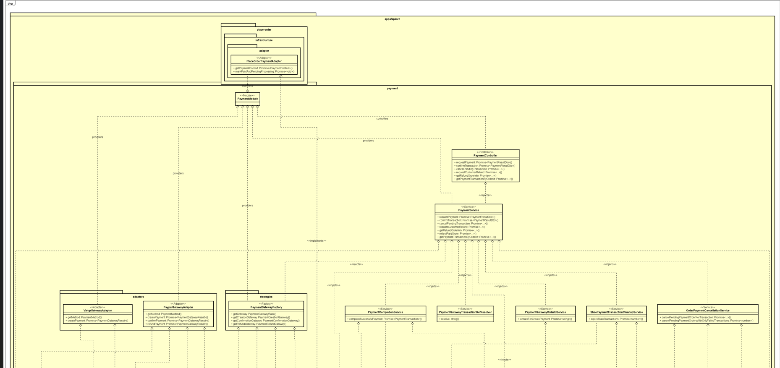
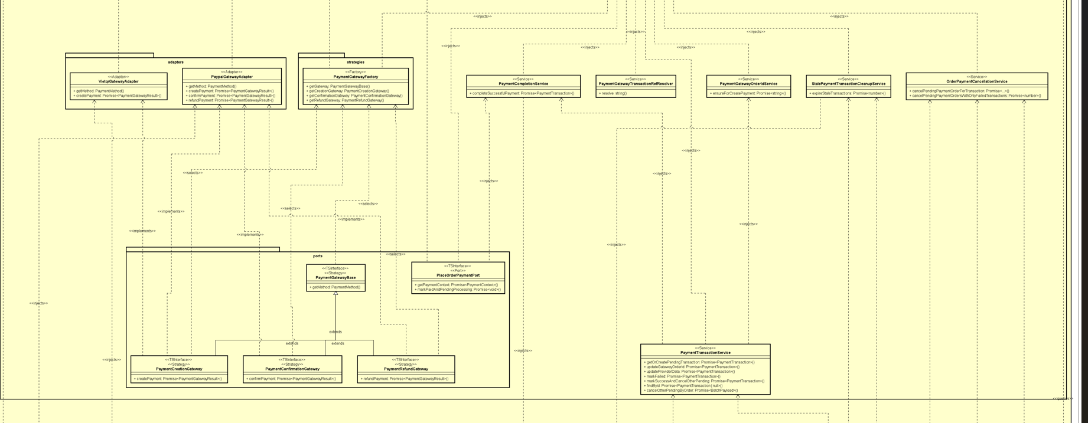
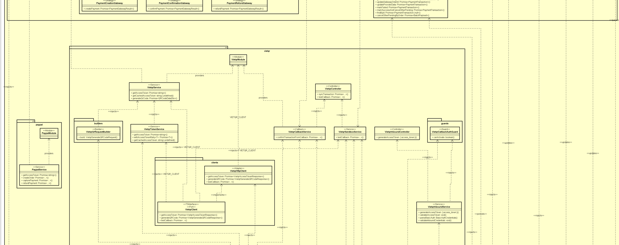
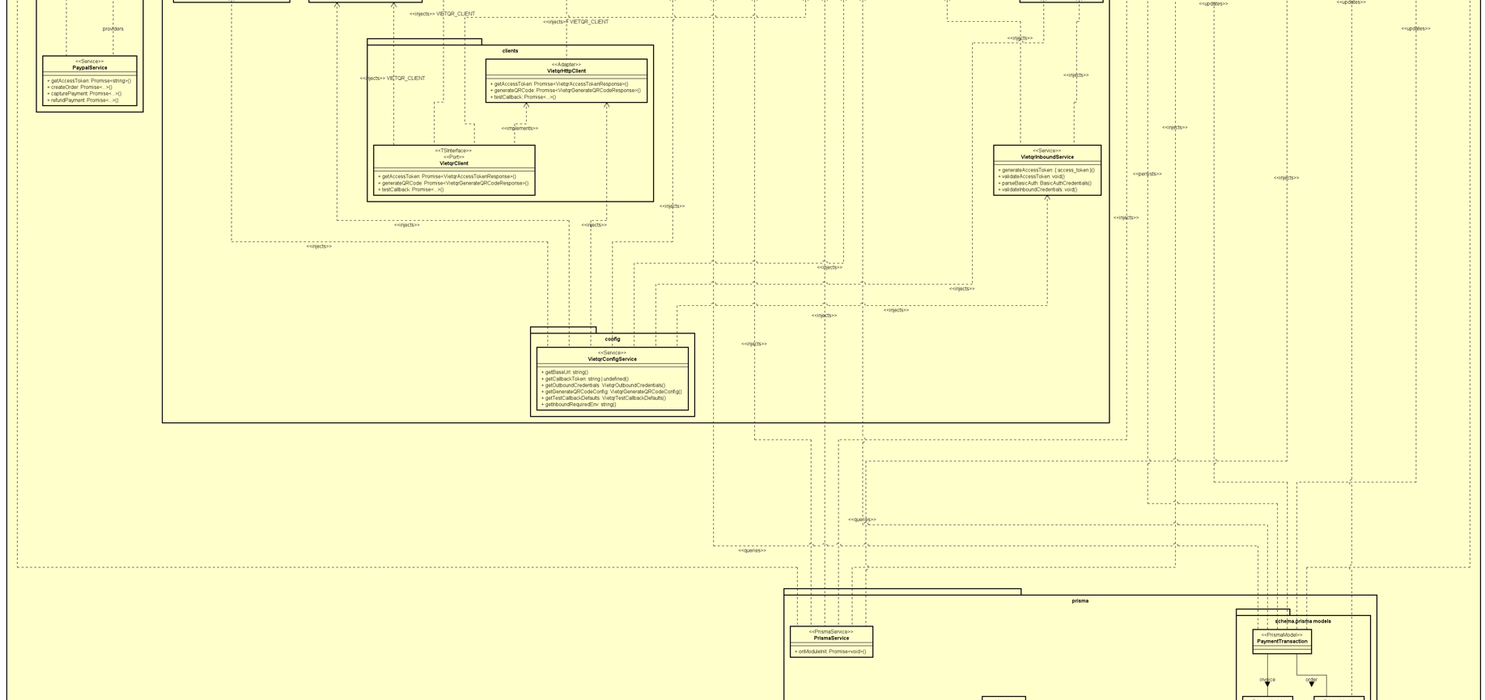
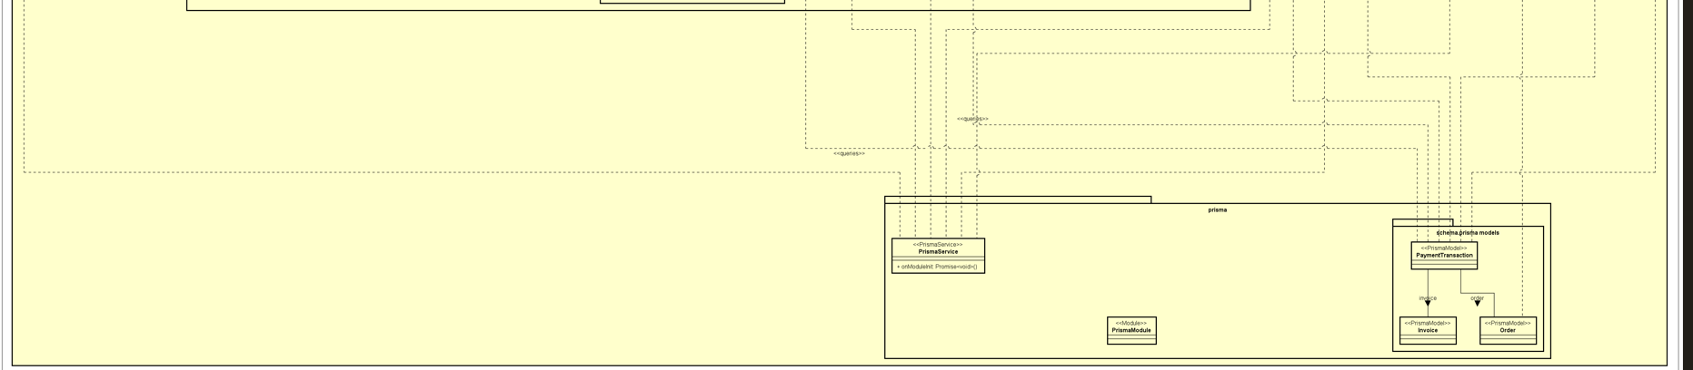

4.4.2.2 Class Diagram for Package Payment + Subsystem Paypal
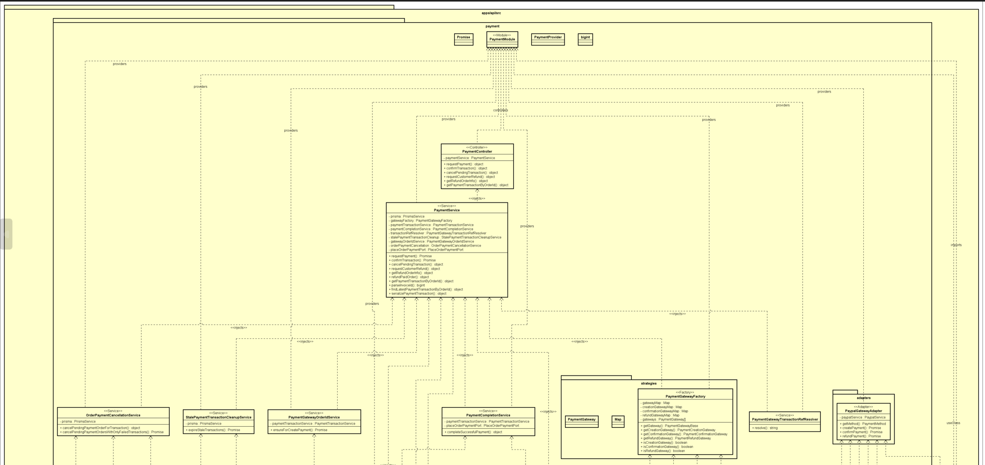
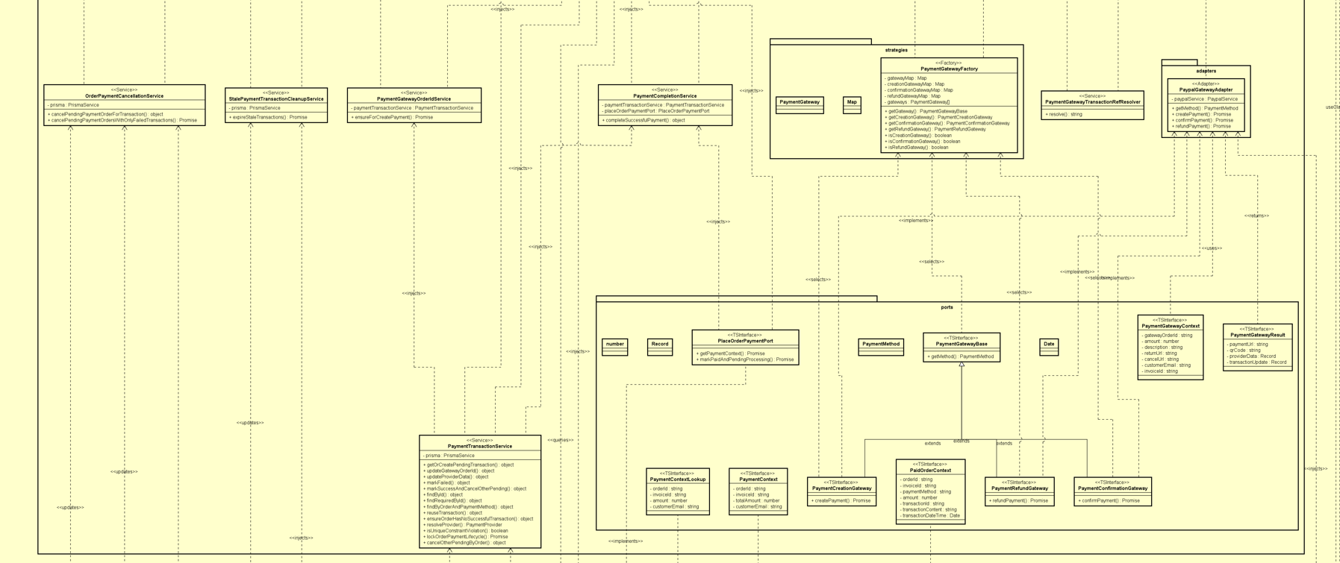
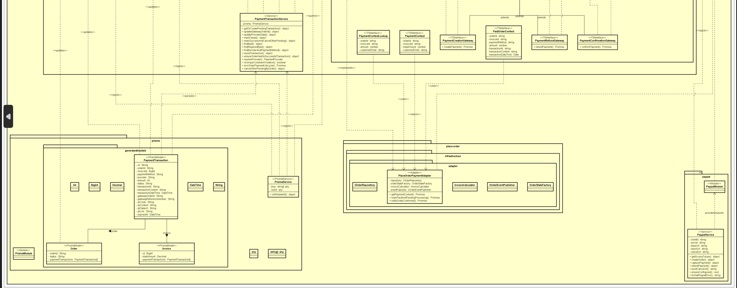

4.4.2.3 Class Diagram for Package Place Order
Package DTO:
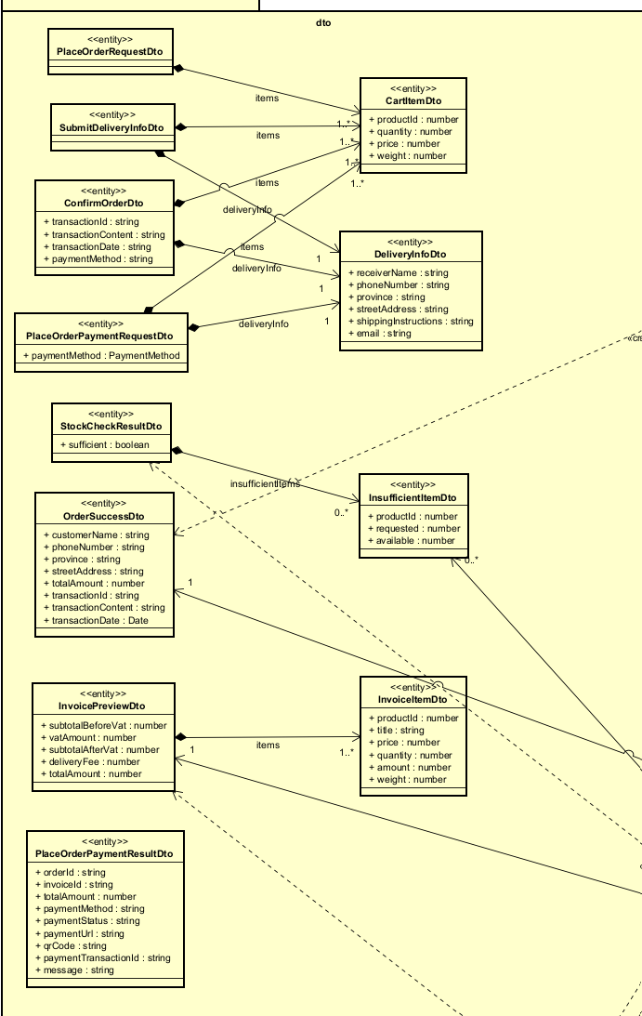
Package Application:
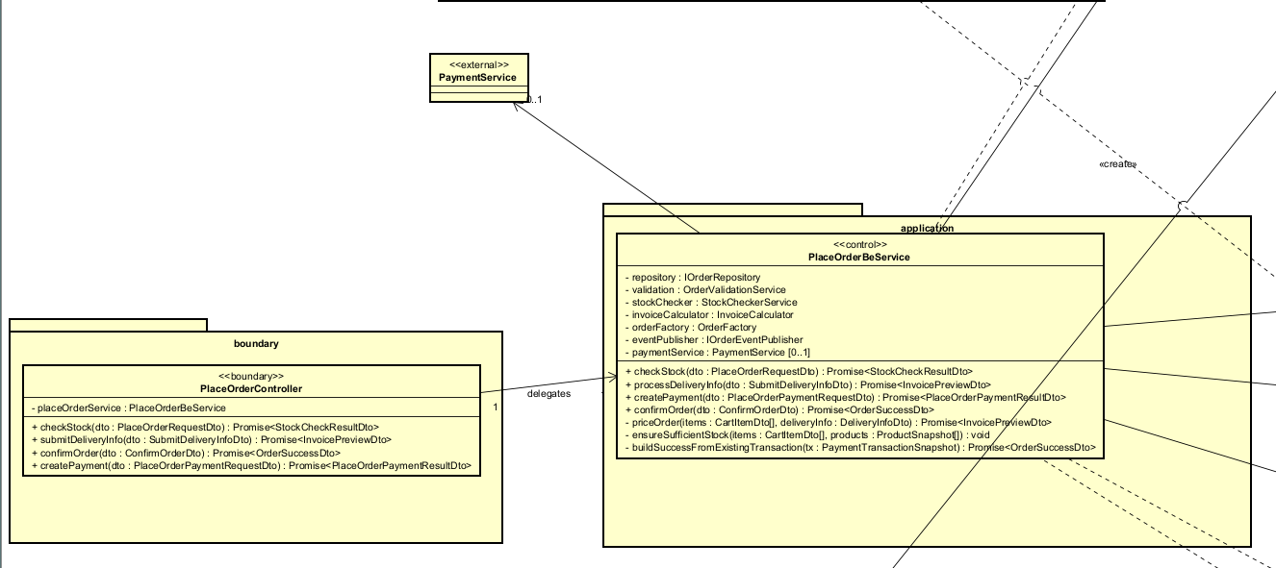
Package Infrastructure:
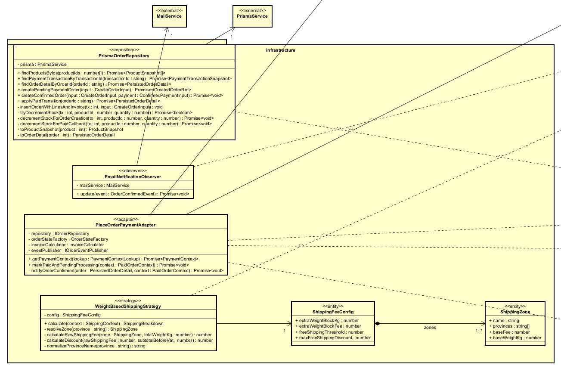
Package Exception:
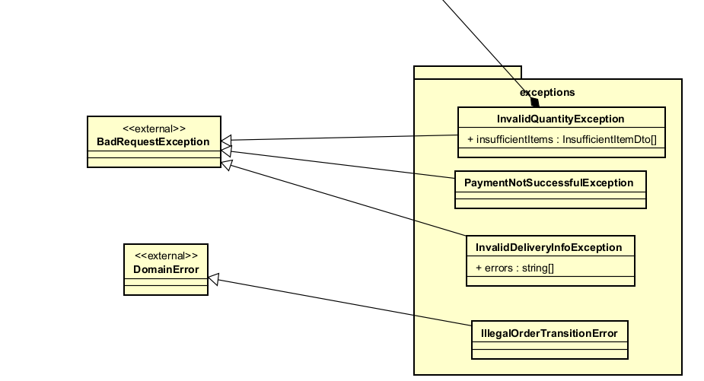
Package Domain/Factories:
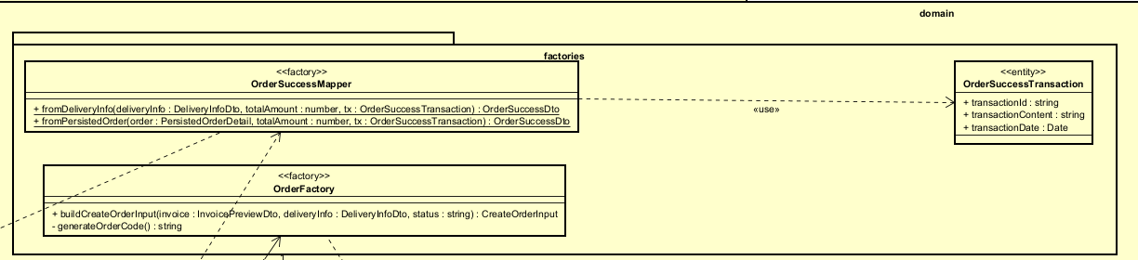
Package Domain/States:
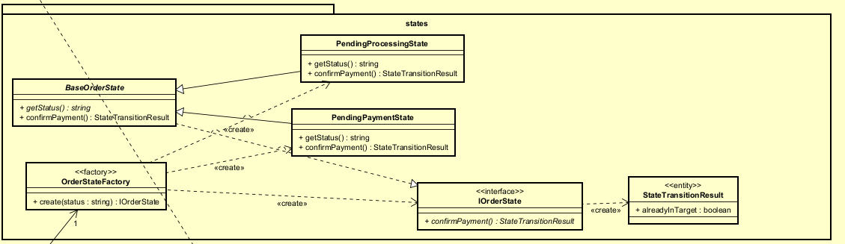
Package Domain/Validators:
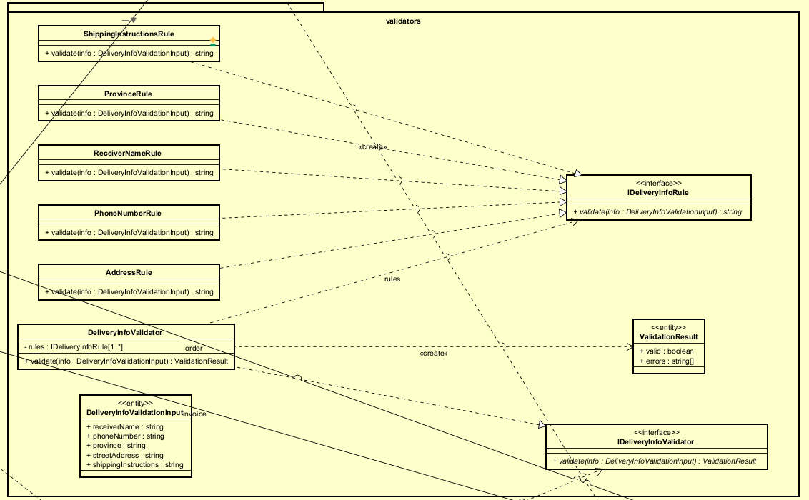
Package Domain/Services:
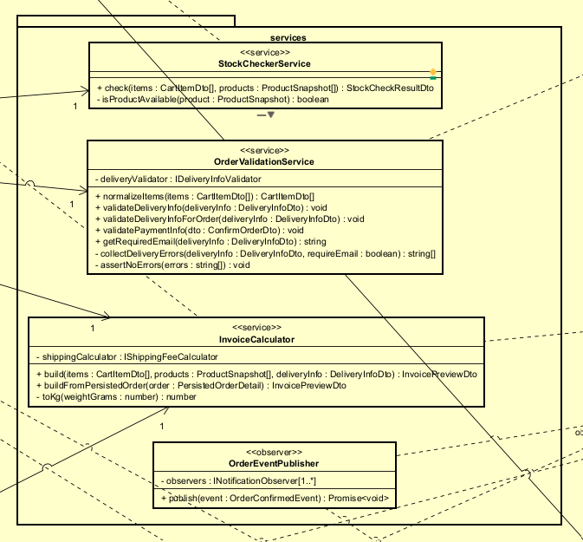
Package Domain/Ports:
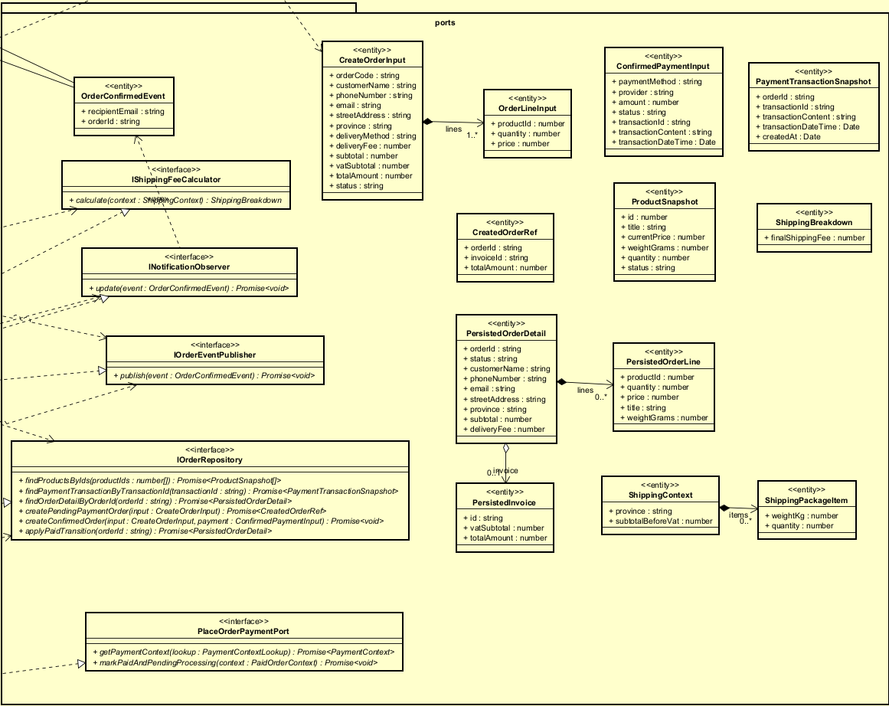

4.4.2.4 Class Diagram for View Product Detail
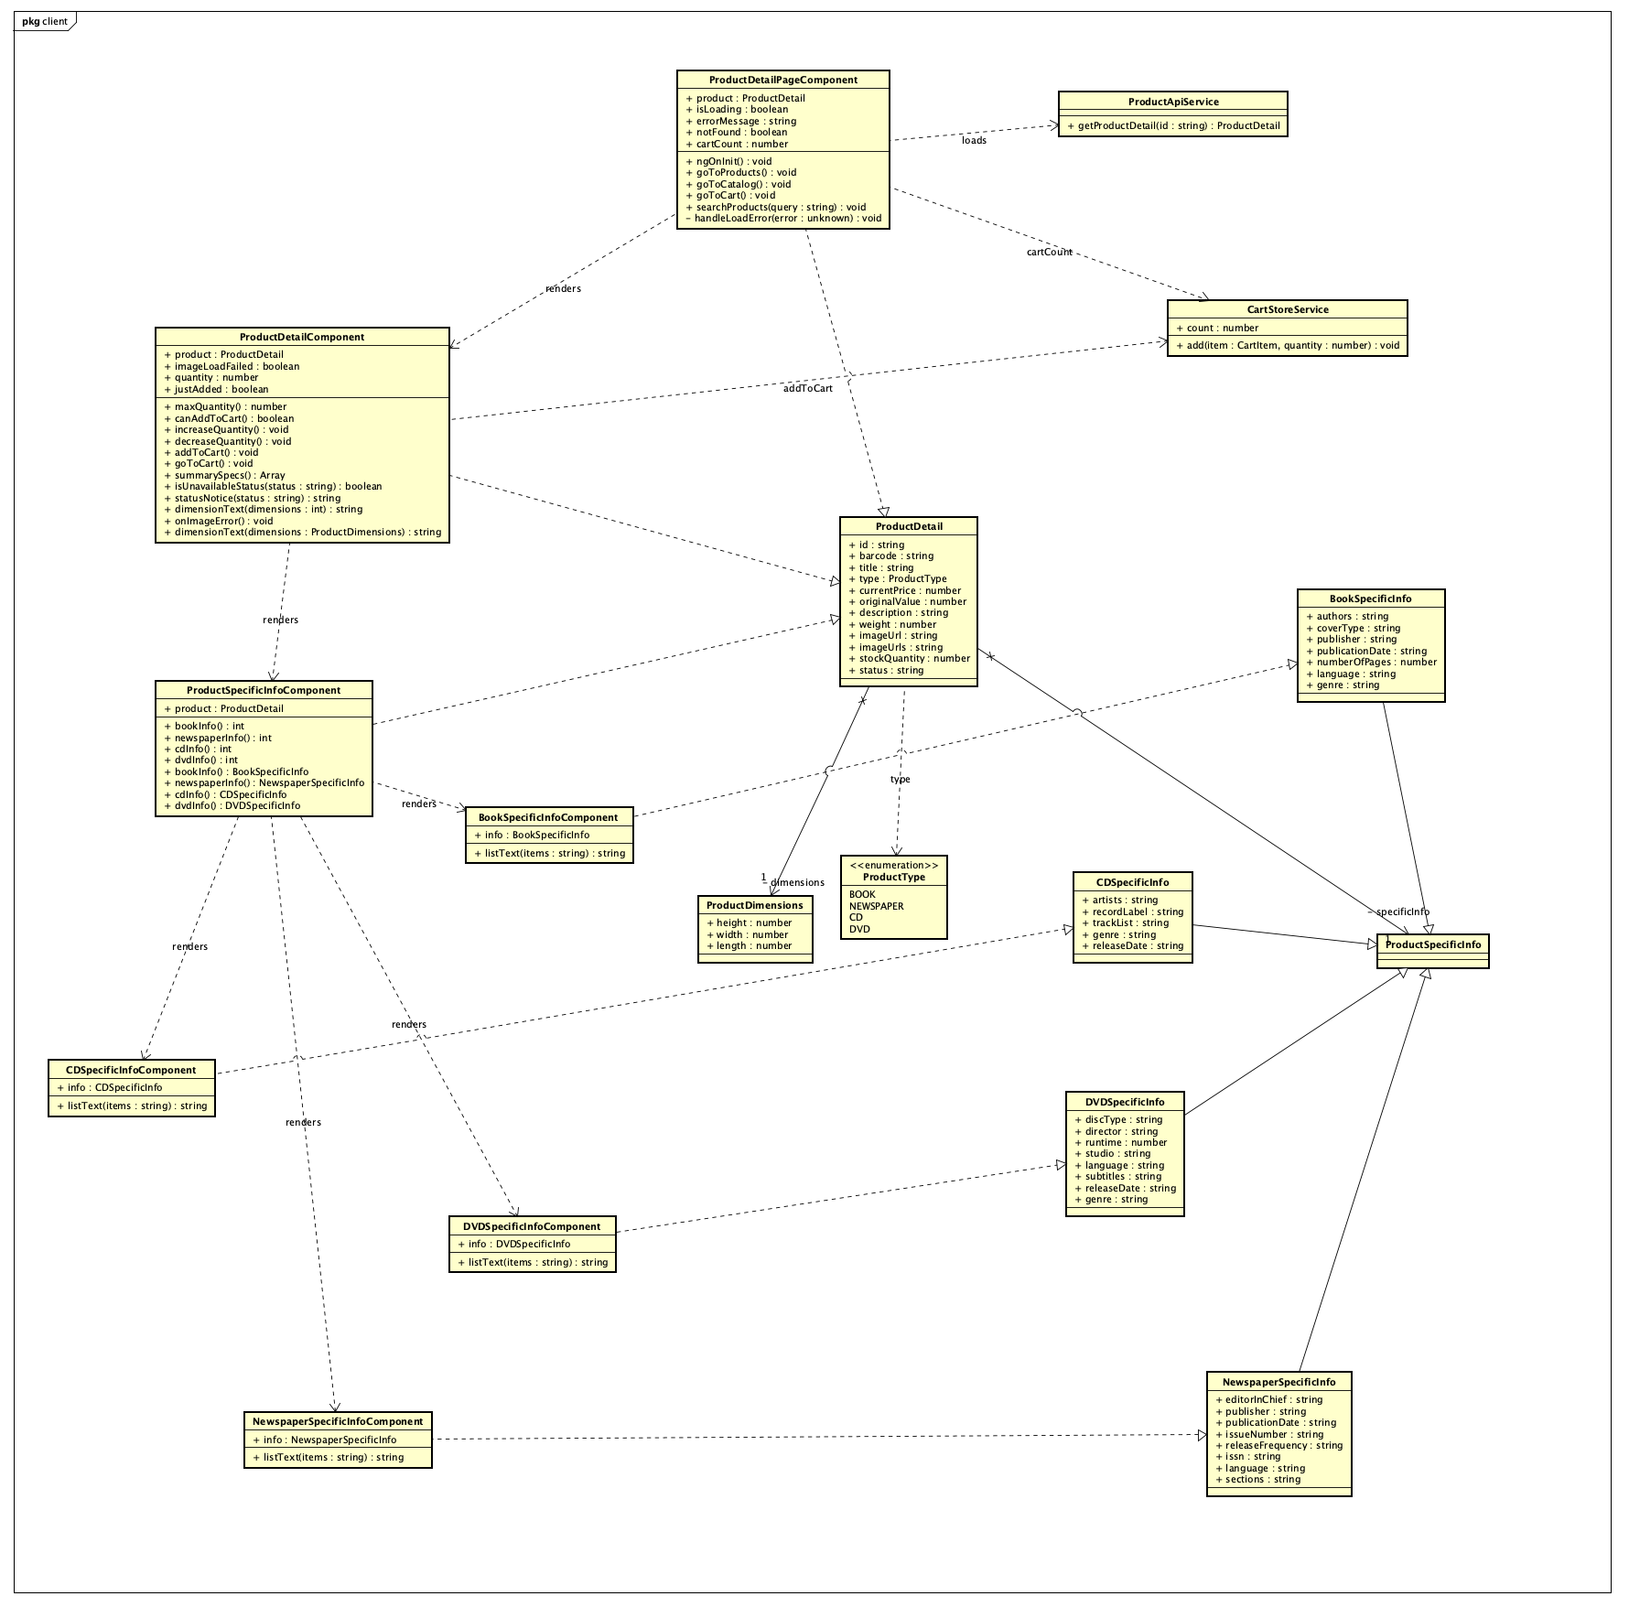
Figure: Frontend class diagram – View Product Detail (UC235)
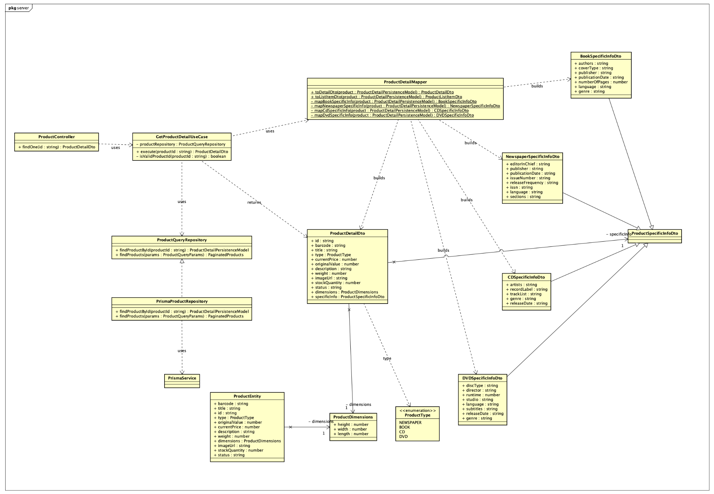
Figure: Backend class diagram – View Product Detail (UC235)
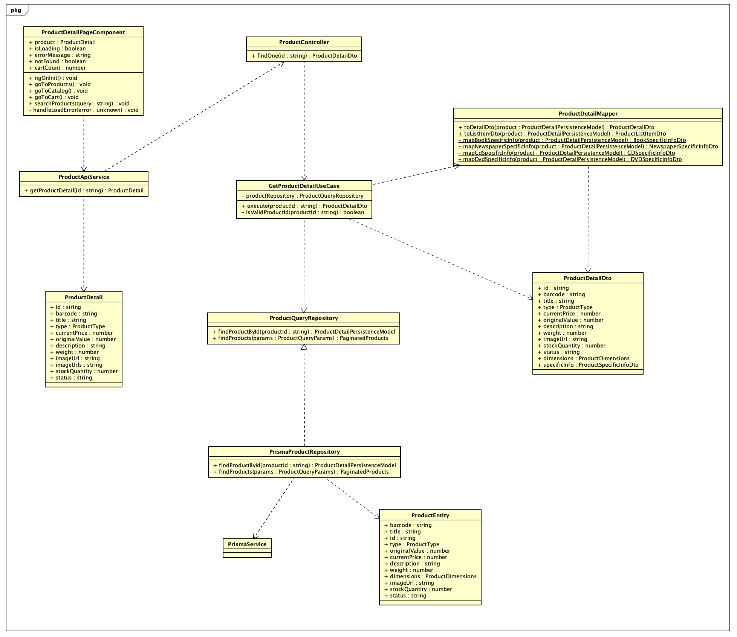
Figure: Backend–Frontend connection – View Product Detail (UC235)

4.4.2.5 CUD Product
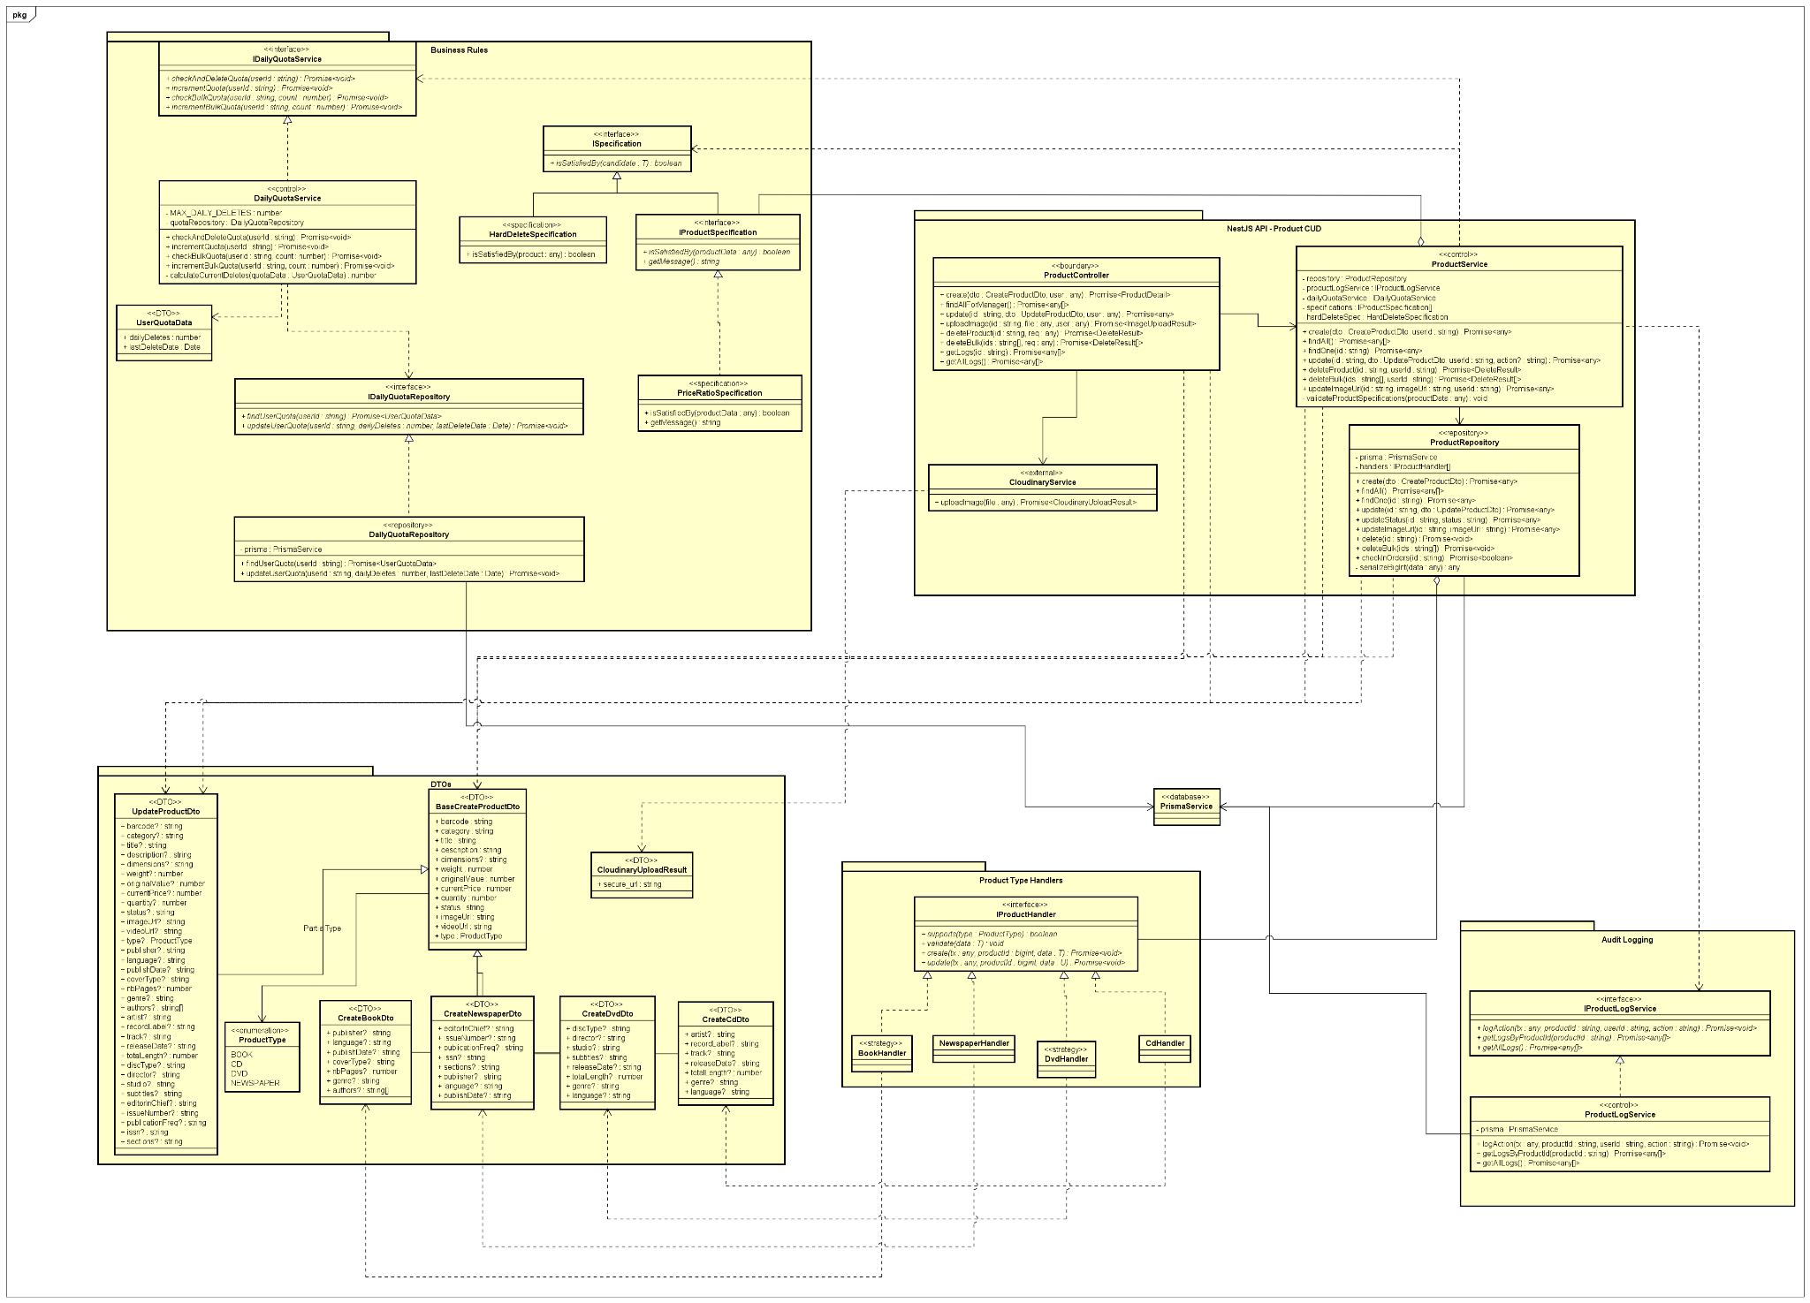
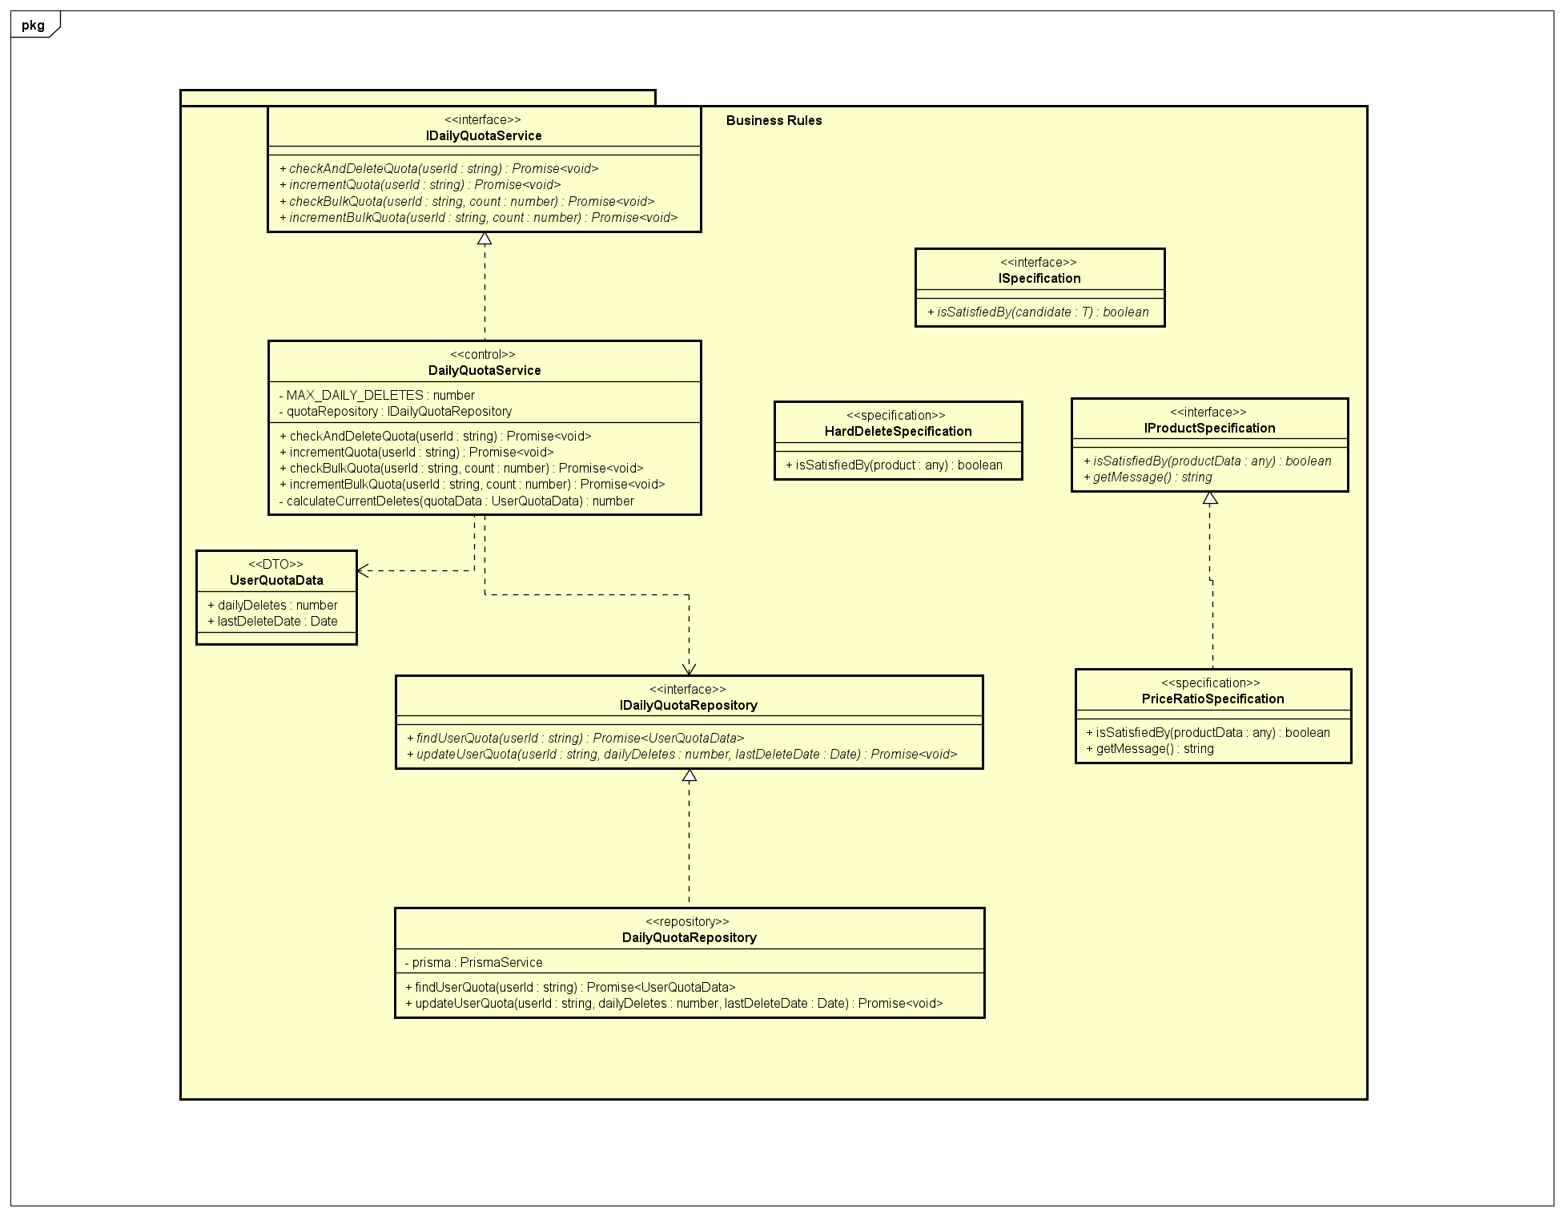
Package business rule
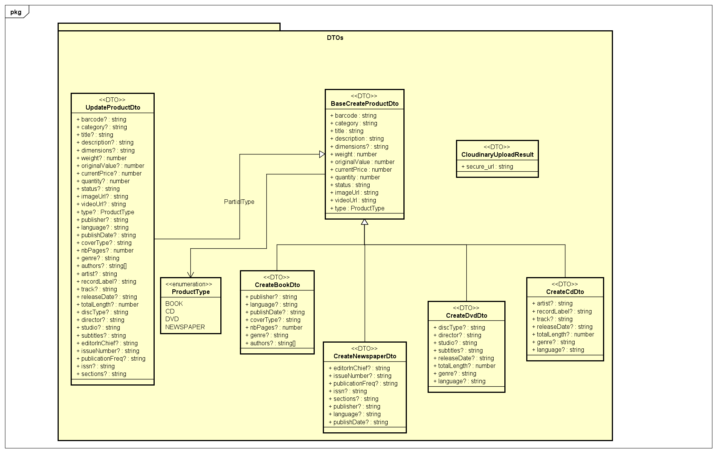
DTO package
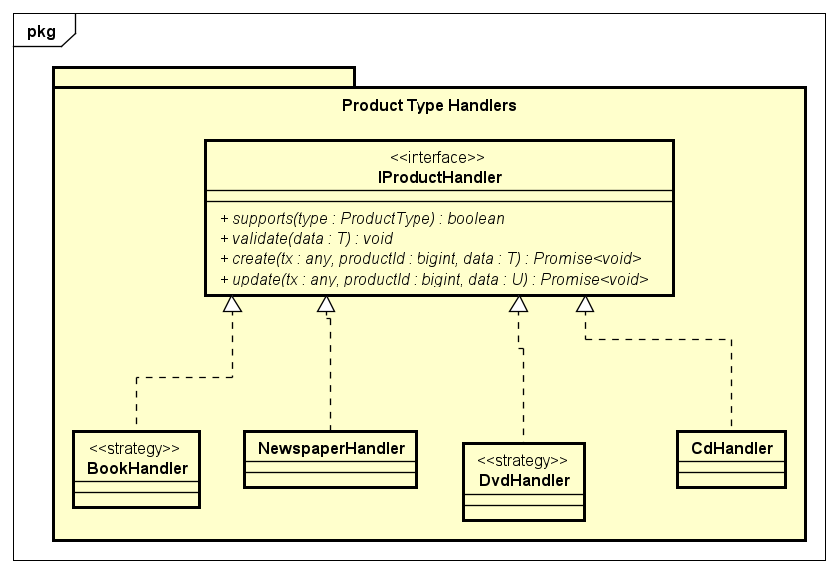
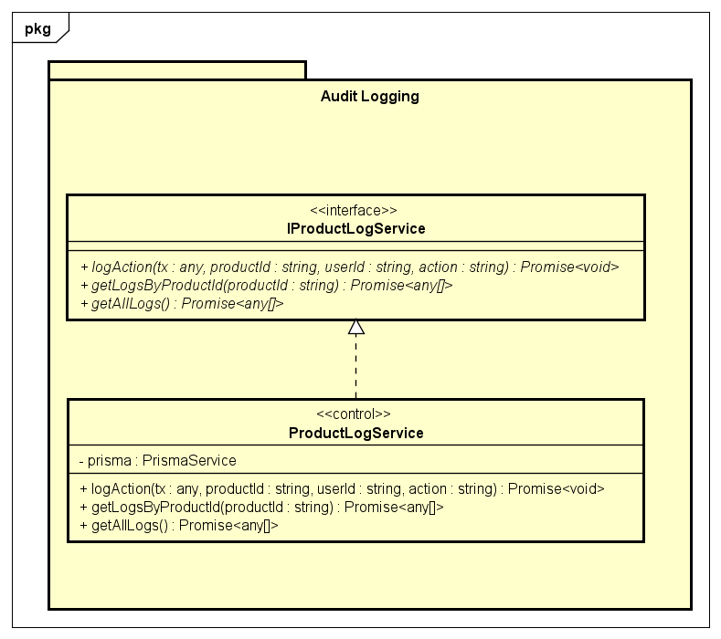
ProductLog package
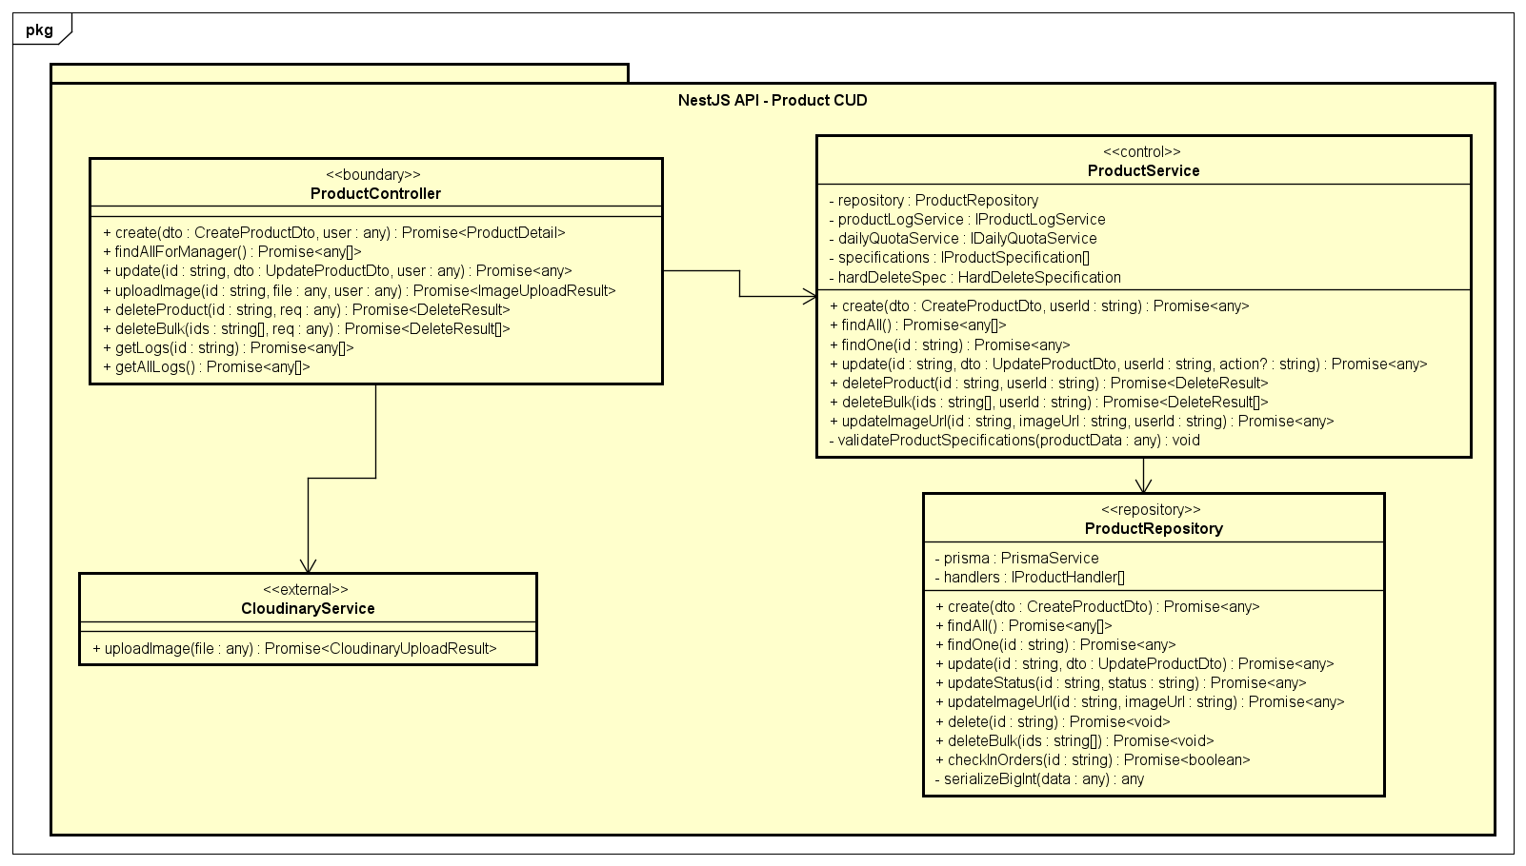
Core package CUD product

4.4.3 Class Design

4.4.3.1 Class PaymentService
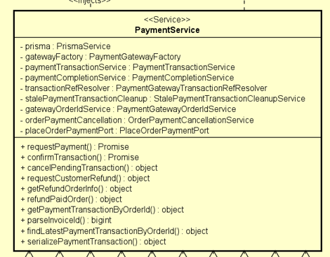
Table 2. Attribute design
# | Name | Data type | Default value | Description
1 | prisma | PrismaService | Injected by NestJS | Provides database access.
2 | gatewayFactory | PaymentGatewayFactory | Injected by NestJS | Selects the correct payment gateway by payment method.
3 | paymentTransactionService | PaymentTransactionService | Injected by NestJS | Manages payment transaction lifecycle rules.
4 | paymentCompletionService | PaymentCompletionService | Injected by NestJS | Completes successful payments and updates order status.
5 | transactionRefResolver | PaymentGatewayTransactionRefResolver | Injected by NestJS | Resolves the transaction reference used by the gateway.
6 | stalePaymentTransactionCleanup | StalePaymentTransactionCleanupService | Injected by NestJS | Expires stale pending payment transactions.
7 | gatewayOrderIdService | PaymentGatewayOrderIdService | Injected by NestJS | Ensures gateway order ID before payment creation.
8 | orderPaymentCancellation | OrderPaymentCancellationService | Injected by NestJS | Cancels pending payment orders.
9 | placeOrderPaymentPort | PlaceOrderPaymentPort | Injected by NestJS | Connects payment flow with place-order domain.
Table 3. Operation design
# | Name | Return type | Description
1 | requestPayment(dto) | Promise<PaymentResultDto> | Creates a payment request for VietQR or PayPal.
2 | confirmTransaction(dto) | Promise<PaymentResultDto> | Manually confirms a payment transaction. PayPal uses this flow; VietQR is confirmed by callback only.
3 | cancelPendingTransaction(transactionId) | Promise<any> | Cancels a pending payment transaction and related order state.
4 | requestCustomerRefund(dto) | Promise<any> | Handles customer refund request and cancels the order if allowed.
5 | getRefundOrderInfo(orderId) | Promise<any> | Returns order and payment information for refund display.
6 | refundPaidOrder(orderId, reason) | Promise<any> | Performs refund logic through the payment gateway if supported.
7 | getPaymentTransactionByOrderId(orderId, paymentMethod?) | Promise<any> | Returns the latest payment transaction for an order.
Parameter:
- dto: Request DTO containing payment, confirmation, or refund data.
- transactionId: Internal payment transaction ID.
- orderId: Public order ID.
- reason: Refund reason.
- paymentMethod: Optional payment method filter.
Exception:
- BadRequestException if amount mismatches, invoice ID is invalid, confirmation is unsupported, or order cannot be cancelled.
- NotFoundException if order or payment transaction is not found.
Method:
- requestPayment() validates order payment context, creates/reuses a pending transaction, selects gateway, creates payment, and stores provider data.
- confirmTransaction() finds latest transaction, rejects VietQR manual confirmation, calls gateway confirmation, then marks payment as successful.
- refundPaidOrder() tries automatic refund through gateway; if unsupported, marks refund as required.

4.4.3.2 Class PaymentController
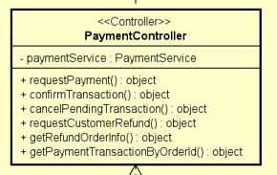
Table 2. Attribute design
# | Name | Data type | Default value | Description
1 | paymentService | PaymentService | Injected by NestJS | Handles payment business logic.
Table 3. Operation design
# | Name | Return type | Description
1 | requestPayment() | Promise<PaymentResultDto> | Endpoint for creating a payment request.
2 | confirmTransaction() | Promise<PaymentResultDto> | Endpoint for confirming a transaction.
3 | cancelPendingTransaction() | Promise<any> | Endpoint for cancelling a pending payment transaction.
4 | requestCustomerRefund() | Promise<any> | Endpoint for requesting customer refund.
5 | getRefundOrderInfo() | Promise<any> | Endpoint for fetching refund-related order information.
6 | getPaymentTransactionByOrderId() | Promise<any> | Endpoint for fetching latest payment transaction by order.
Parameter:
- requestPaymentDto: Payment request data.
- confirmTransactionDto: Payment confirmation data.
- transactionId: Internal transaction ID.
- dto: Refund request data.
- orderId: Public order ID.
- paymentMethod: Optional payment method query.
Exception:
- Exceptions are delegated from PaymentService.
Method:
- This class only exposes REST endpoints and delegates business logic to PaymentService.

4.4.3.3 Class PaymentTransactionService
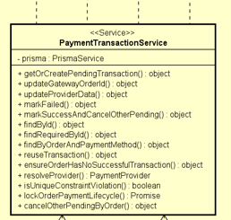
Table 2. Attribute design
# | Name | Data type | Default value | Description
1 | prisma | PrismaService | Injected by NestJS | Provides database access for payment transactions.
Table 3. Operation design
# | Name | Return type | Description
1 | getOrCreatePendingTransaction(input) | Promise<any> | Creates a new pending transaction or reuses an existing one.
2 | updateGatewayOrderId(id, gatewayOrderId) | Promise<any> | Updates gateway order ID for a transaction.
3 | updateProviderData(id, data) | Promise<any> | Updates provider-specific transaction fields.
4 | markFailed(id) | Promise<any> | Marks a transaction as failed.
5 | markSuccessAndCancelOtherPending(input) | Promise<any> | Marks one transaction successful and fails other pending transactions of the same order.
6 | findById(id) | Promise<any> | Finds a transaction by ID.
7 | cancelOtherPendingByOrder(orderId, activeTransactionId) | Promise<any> | Marks other pending transactions of the order as failed.
Parameter:
- input: Transaction creation or success-marking data.
- id: Payment transaction ID.
- gatewayOrderId: Gateway-specific order ID.
- data: Provider update data.
- orderId: Public order ID.
- activeTransactionId: Transaction that should remain active.
Exception:
- BadRequestException if the order already has a successful payment.
- NotFoundException if the transaction is not found.
- Other database exceptions may be thrown by Prisma.
Method:
- The service centralizes transaction lifecycle rules across VietQR and PayPal.
- When one transaction succeeds, other pending transactions of the same order are marked as failed.

4.4.3.4 Class PaymentGatewayFactory
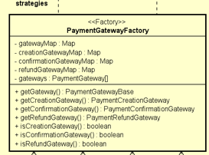
Table 2. Attribute design
# | Name | Data type | Default value | Description
1 | gateways | PaymentGateway[] | Injected by NestJS | List of available payment gateway adapters.
2 | gatewayMap | Map<PaymentMethod, PaymentGatewayBase> | Initialized in constructor | Stores all gateways by payment method.
3 | creationGatewayMap | Map<PaymentMethod, PaymentCreationGateway> | Initialized in constructor | Stores gateways that support payment creation.
4 | confirmationGatewayMap | Map<PaymentMethod, PaymentConfirmationGateway> | Initialized in constructor | Stores gateways that support manual confirmation.
5 | refundGatewayMap | Map<PaymentMethod, PaymentRefundGateway> | Initialized in constructor | Stores gateways that support refund.
Table 3. Operation design
# | Name | Return type | Description
1 | getGateway(method) | PaymentGatewayBase | Returns the gateway for the selected method.
2 | getCreationGateway(method) | PaymentCreationGateway | Returns a gateway that supports payment creation.
3 | getConfirmationGateway(method) | PaymentConfirmationGateway | Returns a gateway that supports manual confirmation.
4 | getRefundGateway(method) | PaymentRefundGateway | Returns a gateway that supports automatic refund.
Parameter:
- method: Selected payment method.
Exception:
- BadRequestException if the payment method is unsupported or does not support the requested operation.
Method:
- The constructor groups gateway adapters by supported capability.
- Public methods retrieve the required gateway type for the payment flow.

4.4.3.5 Class PaymentCompletionService
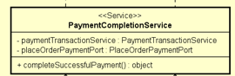
Table 2. Attribute design
# | Name | Data type | Default value | Description
1 | paymentTransactionService | PaymentTransactionService | Injected by NestJS | Updates payment transaction status.
2 | placeOrderPaymentPort | PlaceOrderPaymentPort | Injected by NestJS | Updates the related order after payment success.
Table 3. Operation design
# | Name | Return type | Description
1 | completeSuccessfulPayment(input) | Promise<any> | Marks transaction as successful and marks the order as paid.
Parameter:
- input.transactionId: Internal payment transaction ID.
- input.data: Provider transaction data.
- input.fallbackProviderTransactionId: Fallback external transaction ID.
Exception:
- May throw exceptions from PaymentTransactionService or PlaceOrderPaymentPort.
Method:
- Marks the transaction as SUCCESS.
- Cancels other pending transactions of the same order.
- Marks the order as paid and pending processing.

4.4.3.6 Class VietqrGatewayAdapter
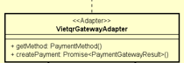
Table 2. Attribute design
# | Name | Data type | Default value | Description
1 | vietqrService | VietqrService | Injected by NestJS | Service used to generate VietQR payment QR codes.
Table 3. Operation design
# | Name | Return type | Description
1 | getMethod() | PaymentMethod | Returns VIETQR.
2 | createPayment(context) | Promise<PaymentGatewayResult> | Generates a VietQR payment QR code and provider data.
Parameter:
- context.gatewayOrderId: Gateway order ID used in QR content.
- context.invoiceId: Invoice ID.
- context.amount: Payment amount.
- context.customerEmail: Customer email, if needed by gateway context.
Exception:
- Exceptions from VietqrService.generateQrCode() are propagated.
Method:
- Builds normalized QR content from AIMS {gatewayOrderId}.
- Calls VietqrService.generateQrCode().
- Returns QR code, QR link, QR content, expiry time, and transaction update data.

4.4.3.7 Class VietqrService
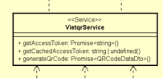
Table 2. Attribute design
# | Name | Data type | Default value | Description
1 | vietqrClient | VietqrClient | Injected by NestJS | Client used to call VietQR HTTP APIs.
2 | tokenService | VietqrTokenService | Injected by NestJS | Manages VietQR access token retrieval and retry.
3 | qrRequestBuilder | VietqrQrRequestBuilder | Injected by NestJS | Builds VietQR QR generation request payload.
Table 3. Operation design
# | Name | Return type | Description
1 | getAccessToken() | Promise<string> | Returns a VietQR access token.
2 | getCachedAccessToken() | string | undefined | Returns the currently cached token, if any.
3 | generateQrCode(request) | Promise<QRCodeDataDto> | Generates a VietQR QR code for a payment request.
Parameter:
- request: Contains order ID, invoice ID, amount, description, return URL, and cancel URL.
Exception:
- BadRequestException if amount is invalid.
- UnauthorizedException if VietQR authentication fails.
- BadGatewayException if QR generation fails.
Method:
- Validates amount.
- Builds the VietQR request payload.
- Calls VietQR API with access-token retry support.
- Maps VietQR response to QRCodeDataDto.

4.4.3.8 Class VietqrTokenService
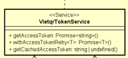
Table 2. Attribute design
# | Name | Data type | Default value | Description
1 | accessToken | string | undefined | undefined | Cached VietQR access token.
2 | accessTokenExpiredAt | Date | undefined | undefined | Expiration time of the cached token.
3 | vietqrClient | VietqrClient | Injected by NestJS | Client used to request tokens from VietQR.
4 | configService | VietqrConfigService | Injected by NestJS | Provides VietQR credentials and configuration.
Table 3. Operation design
# | Name | Return type | Description
1 | getAccessToken() | Promise<string> | Returns cached token or requests a new one.
2 | withAccessTokenRetry(operation) | Promise<T> | Executes an operation with token retry if authentication fails.
3 | getCachedAccessToken() | string | undefined | Returns the cached token.
Parameter:
- operation: Function that receives an access token and performs a VietQR API operation.
Exception:
- UnauthorizedException if token retrieval fails.
Method:
- Reuses cached token if still valid.
- Clears token and retries once when the VietQR API returns authentication errors.

4.4.3.9 Class VietqrCallbackService
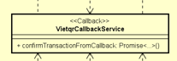
Table 2. Attribute design
# | Name | Data type | Default value | Description
1 | prisma | PrismaService | Injected by NestJS | Used to find and update payment transactions.
2 | configService | VietqrConfigService | Injected by NestJS | Provides expected VietQR transaction type.
3 | responseMapper | VietqrCallbackResponseMapper | Injected by NestJS | Maps callback data to response DTO.
4 | paymentCompletionService | PaymentCompletionService | Injected by NestJS | Completes successful payment after valid callback.
Table 3. Operation design
# | Name | Return type | Description
1 | confirmTransactionFromCallback(callback) | Promise<{ status, refTransactionId, duplicate }> | Confirms a VietQR payment from bank callback data.
Parameter:
- callback: VietQR transaction sync data including transaction ID, amount, content, reference number, transaction type, and transaction time.
Exception:
- BadRequestException if transaction type or amount does not match.
- NotFoundException if no matching payment transaction is found.
Method:
- Validates transaction type.
- Checks duplicate callback by transaction ID or reference number.
- Finds matching VietQR transaction by order ID or QR content.
- Completes payment using PaymentCompletionService.

4.4.3.10 Class VietqrController
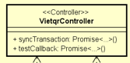
Table 2. Attribute design
# | Name | Data type | Default value | Description
1 | vietqrCallbackService | VietqrCallbackService | Injected by NestJS | Handles VietQR callback confirmation.
2 | responseMapper | VietqrCallbackResponseMapper | Injected by NestJS | Builds VietQR callback response format.
3 | sandboxService | VietqrSandboxService | Injected by NestJS | Supports VietQR test callback flow.
Table 3. Operation design
# | Name | Return type | Description
1 | syncTransaction(transactionSyncDto) | Promise<any> | Receives VietQR bank callback and confirms payment.
2 | testCallback(vietqrTestCallbackDto) | Promise<any> | Sends test callback request to VietQR sandbox.
Parameter:
- transactionSyncDto: VietQR bank callback payload.
- vietqrTestCallbackDto: Sandbox callback test payload.
Exception:
- Exceptions are caught in syncTransaction() and mapped to VietQR error response.
- testCallback() propagates exceptions from VietqrSandboxService.
Method:
- syncTransaction() is protected by VietqrCallbackAuthGuard.
- It delegates confirmation to VietqrCallbackService and returns success/error response using mapper.

4.4.3.11 Class VietqrHttpClient
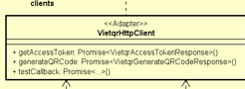
Table 2. Attribute design
# | Name | Data type | Default value | Description
1 | configService | VietqrConfigService | Injected by NestJS | Provides VietQR base URL and configuration.
Table 3. Operation design
# | Name | Return type | Description
1 | getAccessToken(username, password) | Promise<VietqrAccessTokenResponse> | Requests VietQR access token using Basic Authentication.
2 | generateQRCode(accessToken, request) | Promise<VietqrGenerateQRCodeResponse> | Calls VietQR QR generation API.
3 | testCallback(accessToken, request) | Promise<{ status?: string; message?: string }> | Calls VietQR sandbox test callback API.
Parameter:
- username: VietQR username.
- password: VietQR password.
- accessToken: Bearer token for VietQR API.
- request: VietQR API request body.
Exception:
- Axios errors may be thrown when VietQR API requests fail.
Method:
- This class is a low-level HTTP client and does not contain business logic.

4.4.3.12 Class VietqrConfigService
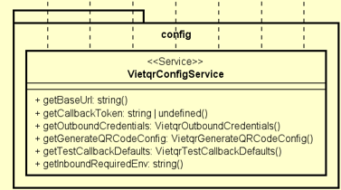
Table 2. Attribute design
# | Name | Data type | Default value | Description
1 | None | - | - | This service reads configuration from environment variables and does not store mutable state.
Table 3. Operation design
# | Name | Return type | Description
1 | get(key) | string | undefined | Reads an environment variable.
2 | getBaseUrl() | string | Returns VietQR base URL.
3 | getReturnUrl() | string | undefined | Returns VietQR return URL.
4 | getCallbackToken() | string | undefined | Returns static callback token.
5 | getOutboundCredentials() | VietqrOutboundCredentials | Returns VietQR username and password.
6 | getGenerateQRCodeConfig() | VietqrGenerateQRCodeConfig | Returns validated QR generation config.
7 | getTestCallbackDefaults() | VietqrTestCallbackDefaults | Returns default sandbox callback fields.
8 | getTransType() | string | Returns expected transaction type.
9 | getInboundRequiredEnv(key) | string | Returns required inbound config value.
Parameter:
- key: Environment variable name.
Exception:
- UnauthorizedException if outbound credentials are missing.
- BadRequestException if payment configuration is missing or invalid.
- InternalServerErrorException if required inbound config is missing.
Method:
- Reads environment variables.
- Validates bank code, bank account, user bank name, QR type, and transaction type.

4.4.3.13 Class VietqrQrRequestBuilder
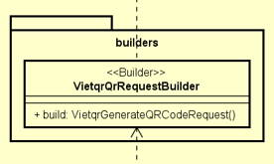
Table 2. Attribute design
# | Name | Data type | Default value | Description
1 | configService | VietqrConfigService | Injected by NestJS | Provides QR generation configuration.
Table 3. Operation design
# | Name | Return type | Description
1 | build(request) | VietqrGenerateQRCodeRequest | Builds the request payload required by VietQR QR generation API.
Parameter:
- request: Payment QR request containing amount, order ID, description, and return URL.
Exception:
- May throw configuration-related exceptions from VietqrConfigService.
Method:
- Normalizes QR content.
- Combines payment request data with VietQR environment configuration.

4.4.3.14 Class VietqrInboundService
Table 2. Attribute design
# | Name | Data type | Default value | Description
1 | configService | VietqrConfigService | Injected by NestJS | Provides inbound authentication configuration.
Table 3. Operation design
# | Name | Return type | Description
1 | generateAccessToken(authorization?) | { access_token, token_type, expires_in } | Generates a signed inbound callback token after Basic Authentication.
2 | validateAccessToken(token) | void | Validates callback bearer token signature, subject, and expiration.
3 | parseBasicAuth(header?) | BasicAuthCredentials | Parses Basic Authentication header.
4 | validateInboundCredentials(username, password) | void | Validates inbound username and password.
Parameter:
- authorization: Basic Authentication header.
- token: Bearer token sent by callback client.
- username: Inbound username.
- password: Inbound password.
Exception:
- UnauthorizedException if authentication header, credentials, token signature, subject, or expiration is invalid.
- InternalServerErrorException if token expiration configuration is invalid.
Method:
- Uses HMAC SHA-256 to sign and verify inbound access tokens.

4.4.3.15 Class VietqrSandboxService
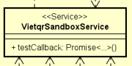
Table 2. Attribute design
# | Name | Data type | Default value | Description
1 | vietqrClient | VietqrClient | Injected by NestJS | Sends test callback requests to VietQR sandbox.
2 | configService | VietqrConfigService | Injected by NestJS | Provides default sandbox values.
3 | prisma | PrismaService | Injected by NestJS | Checks existing pending VietQR transaction.
4 | stalePaymentTransactionCleanup | StalePaymentTransactionCleanupService | Injected by NestJS | Expires stale pending transactions before testing.
5 | tokenService | VietqrTokenService | Injected by NestJS | Provides VietQR access token with retry.
Table 3. Operation design
# | Name | Return type | Description
1 | testCallback(dto) | Promise<any> | Sends a simulated VietQR callback request for testing.
Parameter:
- dto: Contains test callback amount, content, order ID, bank account, bank code, and transaction type.
Exception:
- BadRequestException if no matching pending VietQR payment exists.
- UnauthorizedException if VietQR authentication fails.
- BadGatewayException if sandbox callback request fails.
Method:
- Ensures a matching VietQR transaction is still pending.
- Builds callback request using DTO values and default configuration.
- Calls VietQR sandbox callback API.

4.4.3.16 Class VietQrPaymentFlowService
Table 2. Attribute design
# | Name | Data type | Default value | Description
1 | paymentService | PaymentService | Injected by Angular | Calls backend payment APIs.
2 | paymentStatusApi | PaymentStatusApiService | Injected by Angular | Reads latest transaction status from backend.
Table 3. Operation design
# | Name | Return type | Description
1 | createPayment(input) | Observable<VietQrPaymentSnapshot> | Creates a VietQR payment and maps result to page snapshot.
2 | reuseExistingPayment(context) | Observable<VietQrPaymentSnapshot> | Reuses an existing VietQR transaction if still available.
3 | pollStatus(orderId) | Observable<PaymentTransactionStatus> | Polls payment transaction status.
4 | isSuccessfulStatus(status) | boolean | Checks whether transaction status is successful.
Parameter:
- input: Order and payment data required to request VietQR payment.
- context: Existing order/payment context.
- orderId: Public order ID.
- status: Payment transaction status object.
Exception:
- Errors are returned through the Observable error channel.
Method:
- Uses backend payment APIs to create QR payment and check whether callback has marked the transaction successful.

4.4.3.17 Class VietQrPaymentPageFlowService
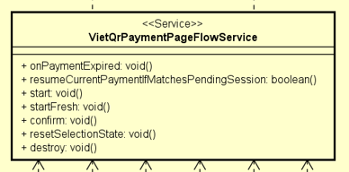
Table 2. Attribute design
# | Name | Data type | Default value | Description
1 | paymentFlow | VietQrPaymentFlowService | Injected by Angular | Handles VietQR creation and status polling.
2 | pendingPaymentSession | PendingPaymentSessionService | Injected by Angular | Provides pending payment session data.
3 | stateStore | PaymentPageStateStore | Injected by Angular | Stores payment page UI state.
Table 3. Operation design
# | Name | Return type | Description
1 | start(hasCheckoutDraft) | void | Starts VietQR payment creation flow.
2 | confirm() | void | Checks whether VietQR payment has been completed.
Parameter:
- hasCheckoutDraft: Indicates whether checkout draft data exists.
Exception:
- Does not throw directly; errors are reflected in payment page state.
Method:
- Creates VietQR payment when session is ready.
- Updates QR code, loading state, status message, and error message in the state store.
- Confirms payment by polling backend transaction status.

4.4.3.18 Class VietQrPaymentViewComponent

Table 2. Attribute design
# | Name | Data type | Default value | Description
1 | qrCode | string | '' | Raw QR code data.
2 | qrImageSrc | string | '' | QR image source displayed to the customer.
3 | qrContent | string | '' | Payment transfer content shown to the customer.
Table 3. Operation design
# | Name | Return type | Description
1 | None | - | This component renders the VietQR payment UI.
Parameter:
- No method parameters.
Exception:
- No direct exceptions.
Method:
- Displays QR image and payment content for bank transfer.

4.4.3.19 Class PaymentPageFacade
Table 2. Attribute design
# | Name | Data type | Default value | Description
1 | route | ActivatedRoute | Injected by Angular | Reads query parameters such as PayPal token or cancellation flag.
2 | router | Router | Injected by Angular | Navigates between payment and result pages.
3 | stateStore | PaymentPageStateStore | Injected by Angular | Central UI state store for payment page.
4 | vietQrPageFlow | VietQrPaymentPageFlowService | Injected by Angular | Handles VietQR page flow.
5 | paypalPageFlow | PaypalPaymentPageFlowService | Injected by Angular | Handles PayPal page flow.
Table 3. Operation design
# | Name | Return type | Description
1 | initialize() | void | Initializes payment page and handles query parameters.
2 | confirmPayment() | void | Delegates confirmation to the selected payment method flow.
3 | selectPaymentMethod(method) | void | Changes selected payment method and starts the corresponding flow.
4 | cancelPayment() | void | Cancels or exits the payment flow.
Parameter:
- method: Selected payment method.
Exception:
- Does not throw directly; errors are handled by child flows and state store.
Method:
- Acts as the frontend coordinator between UI components and payment method-specific flows.

4.4.3.20 Class PaypalService
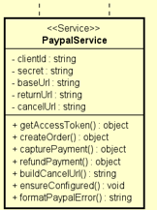
Table 2. Attribute design
# | Name | Data type | Default value | Description
1 | clientId | string | undefined | process.env.PAYPAL_CLIENT_ID | The PayPal client ID used for API authentication.
2 | secret | string | undefined | process.env.PAYPAL_SECRET | The PayPal secret key used with the client ID to request an access token.
3 | baseUrl | string | undefined | process.env.PAYPAL_BASE_URL | The base URL of the PayPal API.
4 | returnUrl | string | PAYPAL_RETURN_URL or http://localhost:4200/payment | The URL PayPal redirects to after the customer approves the payment.
5 | cancelUrl | string | PAYPAL_CANCEL_URL or http://localhost:4200/payment | The URL PayPal redirects to when the customer cancels the payment.
Table 3. Operation design
# | Name | Return type | Description
1 | getAccessToken() | Promise<string> | Requests an OAuth access token from PayPal.
2 | createOrder(amount) | Promise<any> | Creates a PayPal checkout order with the given USD amount.
3 | capturePayment(orderId) | Promise<any> | Captures an approved PayPal order.
4 | refundPayment(captureId) | Promise<any> | Refunds a successful PayPal capture.
5 | buildCancelUrl() | string | Builds the cancellation redirect URL with paypalCancel=1.
6 | ensureConfigured() | void | Validates that required PayPal environment variables are configured.
7 | formatPaypalError(err) | string | Extracts a readable error message from a PayPal or Axios error response.
Parameter:
- amount: No default value. The payment amount in USD. It must be greater than 0.
- orderId: No default value. The PayPal order ID to be captured.
- captureId: No default value. The PayPal capture ID to be refunded.
- err: No default value. The error object returned by PayPal or Axios.
Exception:
- UnauthorizedException if PayPal credentials are missing or the access token request fails.
- BadRequestException if the amount is invalid, order creation fails, capture fails, or refund fails.
Method:
- createOrder(amount) first calls getAccessToken(), then sends POST /v2/checkout/orders to PayPal with intent = CAPTURE.
- capturePayment(orderId) sends POST /v2/checkout/orders/{orderId}/capture.
- refundPayment(captureId) sends POST /v2/payments/captures/{captureId}/refund.

4.4.3.21 Class PaypalGatewayAdapter
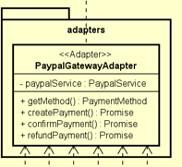
Table 2. Attribute design
# | Name | Data type | Default value | Description
1 | paypalService | PaypalService | Injected by NestJS | The service responsible for communicating with the PayPal API.
Table 3. Operation design
# | Name | Return type | Description
1 | getMethod() | PaymentMethod | Returns the supported payment method, which is PAYPAL.
2 | createPayment(context) | Promise<PaymentGatewayResult> | Creates a PayPal order and returns the approval URL to the client.
3 | confirmPayment(transactionRef) | Promise<PaymentGatewayResult> | Captures the PayPal payment using the PayPal order ID.
4 | refundPayment(transactionRef) | Promise<PaymentGatewayResult> | Refunds the PayPal payment using the PayPal capture ID.
Parameter:
- context: No default value. Contains payment information such as amount, order ID, and invoice ID.
- transactionRef: No default value. For confirmation, this is the PayPal order ID. For refund, this is the PayPal capture ID.
Exception:
- BadRequestException if the PayPal order response does not contain an order ID or approval link.
- Exceptions from PaypalService are propagated if the PayPal API request fails.
Method:
- createPayment(context) converts the amount to USD, calls paypalService.createOrder(), finds the approval link, and returns paymentUrl, providerData, and gatewayOrderId.
- confirmPayment(transactionRef) calls PayPal capture and extracts the captureId from the response for future refund operations.

4.4.3.22 Class PaymentGatewayTransactionRefResolver
Table 2. Attribute design
# | Name | Data type | Default value | Description
1 | None | - | - | This class does not maintain internal state. It only resolves the transaction reference used by the payment gateway.
Table 3. Operation design
# | Name | Return type | Description
1 | resolve(transaction) | string | Resolves the transaction reference used when calling the payment gateway. For PayPal, it must return the real PayPal order ID.
Parameter:
- transaction.id: No default value. The internal transaction ID.
- transaction.paymentMethod: No default value. The payment method of the transaction.
- transaction.gatewayOrderId: No default value. The gateway order ID stored in the transaction.
Exception:
- BadRequestException if a PayPal transaction does not have gatewayOrderId.
- BadRequestException if the PayPal gatewayOrderId is still a local temporary ID instead of a real PayPal order ID.
Method:
- If the payment method is not PayPal, return gatewayOrderId or transaction.id.
- If the payment method is PayPal, validate that gatewayOrderId exists and is not the local temporary gateway order ID, then return it.

4.4.3.23 Class PaymentGatewayOrderIdService
Table 2. Attribute design
# | Name | Data type | Default value | Description
1 | paymentTransactionService | PaymentTransactionService | Injected by NestJS | The service used to update transaction data in the database.
Table 3. Operation design
# | Name | Return type | Description
1 | ensureForCreatePayment(paymentMethod, transaction) | Promise<string> | Ensures that the transaction has a proper gateway order ID before creating a payment.
Parameter:
- paymentMethod: No default value. The selected payment method, such as PAYPAL or VIETQR.
- transaction: No default value. Contains id and gatewayOrderId.
Exception:
- May throw an exception if paymentTransactionService.updateGatewayOrderId() fails.
Method:
- For VietQR, it creates a local gateway order ID and stores it in the database.
- For PayPal, it returns the existing gatewayOrderId or a temporary local ID. The real PayPal order ID is updated later after PayPal creates the order successfully.

4.4.3.24 Class PaypalPaymentFlowService
Table 2. Attribute design
# | Name | Data type | Default value | Description
1 | paymentService | PaymentService | Injected by Angular | The service used to call backend payment APIs.
2 | paymentSessionStorage | PaymentSessionStorageService | Injected by Angular | The service used to save, load, and clear the PayPal session on the client side.
Table 3. Operation design
# | Name | Return type | Description
1 | createOrReusePayment(pendingPaymentSession) | Observable<PlaceOrderPaymentResult> | Creates or reuses a PayPal payment for the current order.
2 | capture(paymentSession) | Observable<PaymentResultDto> | Confirms the PayPal payment after the customer approves it.
3 | saveSession(orderId, invoiceId) | void | Saves the PayPal session to client-side storage.
4 | loadSession() | PaypalPaymentSession | null | Loads the saved PayPal session.
5 | clearSession() | void | Clears the saved PayPal session.
Parameter:
- pendingPaymentSession: No default value. Contains orderId, invoiceId, totalAmount, and customerEmail.
- paymentSession: No default value. Contains orderId and invoiceId.
- orderId: No default value. The order ID.
- invoiceId: No default value. The invoice ID.
Exception:
- This class does not throw exceptions directly. API errors are returned through the Observable error channel.
Method:
- createOrReusePayment() calls requestPayment() with paymentMethod = PAYPAL.
- capture() calls confirmTransaction() with transaction content PayPal capture.

4.4.3.25 Class PaypalPaymentPageFlowService
Table 2. Attribute design
# | Name | Data type | Default value | Description
1 | paypalPaymentSession | PaypalPaymentSession | null | null | The current PayPal payment session on the payment page.
2 | paymentExpiredHandler | () => void | undefined | Callback function used when the PayPal payment expires.
3 | isHandlingExpiredPayment | boolean | false | Prevents duplicated handling of an expired PayPal payment.
Table 3. Operation design
# | Name | Return type | Description
1 | onPaymentExpired(handler) | void | Registers a callback for expired PayPal payments.
2 | start(hasCheckoutDraft) | void | Starts the PayPal payment creation flow.
3 | handleReturn() | void | Handles the browser redirect from PayPal back to the application.
4 | discardApprovalSession() | void | Clears the current PayPal approval session.
5 | confirm() | void | Captures payment, navigates to result page, or redirects to PayPal depending on the current state.
Parameter:
- handler: No default value. Callback executed when the PayPal payment expires.
- hasCheckoutDraft: No default value. Indicates whether a checkout draft exists.
Exception:
- This class does not throw exceptions directly. Errors are handled by updating the page state through stateStore.patch().
Method:
- start() sets the page to loading state, ensures a pending payment session exists, then calls PaypalPaymentFlowService.createOrReusePayment().
- handleReturn() loads the saved PayPal session, marks the payment as approved, and starts capture.
- confirm() captures the payment if it is approved, navigates to /order-result if it is already confirmed, or redirects the user to the PayPal approval URL.

4.4.3.26 Class PaypalPaymentViewComponent
Table 2. Attribute design
# | Name | Data type | Default value | Description
1 | paypalRedirectUrl | string | ''" | The PayPal approval URL used to redirect the customer.
2 | paypalApproved | boolean | false | Indicates whether the customer has approved the payment on PayPal.
3 | paypalConfirmed | boolean | false | Indicates whether the system has captured and confirmed the payment successfully.
4 | isLoading | boolean | false | Indicates whether the PayPal checkout or confirmation process is loading.
Table 3. Operation design
# | Name | Return type | Description
1 | None | - | This component does not contain business operations. It only receives input values and renders the PayPal payment UI.
Method:
- If the payment is not approved or confirmed, the component displays a message telling the customer they will be redirected to PayPal.
- If paypalRedirectUrl exists, it displays the Pay with PayPal button.
- If paypalApproved is true, it displays the payment finalization state.
- If paypalConfirmed is true, it displays the successful payment state.

4.4.3.27 Class “PlaceOrderController”
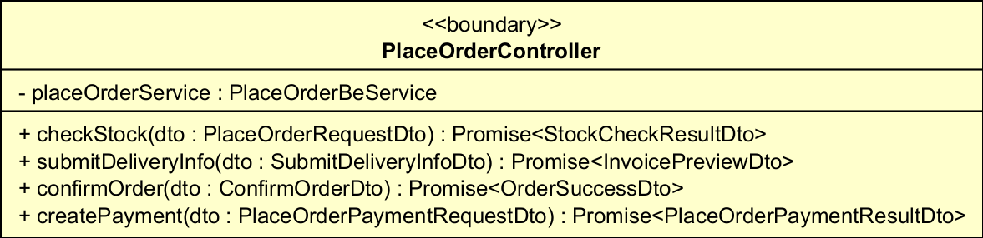
Table. Attribute design of PlaceOrderController
# | Name | Data type | Default value | Description
1 | placeOrderService | PlaceOrderBeService | (injected) | Application facade the controller delegates every request to.
Table. Operation design of PlaceOrderController
# | Name | Return type | Description (purpose)
1 | checkStock | Promise<StockCheckResultDto> | REST POST /place-order/check-stock – checks cart availability.
2 | submitDeliveryInfo | Promise<InvoicePreviewDto> | POST /place-order/delivery-info – validates delivery info and returns priced invoice.
3 | confirmOrder | Promise<OrderSuccessDto> | POST /place-order/confirm – confirms a paid order.
4 | createPayment | Promise<PlaceOrderPaymentResultDto> | POST /place-order/payment – creates a pending order and requests payment.
Parameter:
- checkStock(placeOrderRequestDto: PlaceOrderRequestDto) – cart items to verify.
- submitDeliveryInfo(submitDeliveryInfoDto: SubmitDeliveryInfoDto) – items + delivery info.
- confirmOrder(confirmOrderDto: ConfirmOrderDto) – items + delivery + payment transaction.
- createPayment(placeOrderPaymentRequestDto: PlaceOrderPaymentRequestDto) – items + delivery + payment method.
Method
Thin REST adapter. Each handler simply forwards the validated DTO to PlaceOrderBeService and returns its result; it contains no business logic.

4.4.3.28 Class “PlaceOrderBeService”
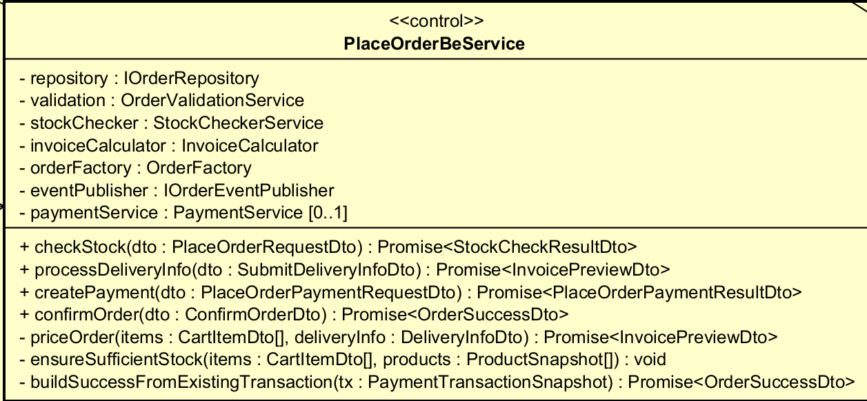
Table. Attribute design of PlaceOrderBeService
# | Name | Data type | Default value | Description
1 | repository | IOrderRepository | (injected) | Persistence port (PrismaOrderRepository).
2 | validation | OrderValidationService | (injected) | Validates cart items and delivery/payment info.
3 | stockChecker | StockCheckerService | (injected) | Computes stock sufficiency.
4 | invoiceCalculator | InvoiceCalculator | (injected) | Builds priced invoice (VAT + shipping).
5 | orderFactory | OrderFactory | (injected) | Assembles the order-create input.
6 | eventPublisher | IOrderEventPublisher | (injected) | Publishes the order-confirmed event (email).
7 | paymentService | PaymentService | undefined | Optional payment gateway (VietQR/PayPal).
Table. Operation design of PlaceOrderBeService
# | Name | Return type | Description (purpose)
1 | checkStock | Promise<StockCheckResultDto> | Normalize items, load products, run stock check.
2 | processDeliveryInfo | Promise<InvoicePreviewDto> | Validate delivery info, then price the invoice.
3 | createPayment | Promise<PlaceOrderPaymentResultDto> | Price order, persist PENDING_PAYMENT order, request payment.
4 | confirmOrder | Promise<OrderSuccessDto> | Validate, idempotency check, persist confirmed order, email customer.
5 | priceOrder | Promise<InvoicePreviewDto> | [private] Shared pipeline: normalize → load products → ensure stock → build invoice.
6 | ensureSufficientStock | void | [private] Throw if any item is short of stock.
7 | buildSuccessFromExistingTransaction | Promise<OrderSuccessDto> | [private] Idempotency: map an already-stored transaction to a success DTO.
Parameter:
- priceOrder(items: CartItemDto[], deliveryInfo: DeliveryInfoDto)
- ensureSufficientStock(items, products: ProductSnapshot[])
Exception:
- BadRequestException – if paymentService is not configured (createPayment).
- InvalidQuantityException – if requested quantity exceeds available stock.
- InvalidDeliveryInfoException – if delivery info is invalid.
- PaymentNotSuccessfulException – if payment info is missing on confirm.
Method
Pure orchestrator (Facade). It only coordinates collaborators – no DB access, no VAT/shipping math, no email logic of its own. priceOrder() is reused by processDeliveryInfo / createPayment / confirmOrder (DRY).

4.4.3.29 Class “OrderFactory”
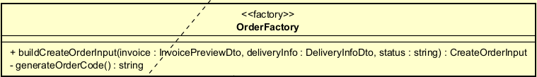
Table. Attribute design of OrderFactory
# | Name | Data type | Default value | Description
- | (none) |  |  | This class declares no attributes.
Table. Operation design of OrderFactory
# | Name | Return type | Description (purpose)
1 | buildCreateOrderInput | CreateOrderInput | Assemble the persistence input for a new order from a priced invoice + delivery info.
2 | generateOrderCode | string | [private] Produce a unique order code (PO-{timestamp}-{random}).
Parameter:
- buildCreateOrderInput(invoice: InvoicePreviewDto, deliveryInfo: DeliveryInfoDto, status: string)
Method
Trims user-entered fields, sets STANDARD delivery method, copies invoice totals, and maps invoice items to order lines. Removes order-building code that used to be duplicated in createPayment() and confirmOrder().

4.4.3.30 Class “OrderSuccessMapper”
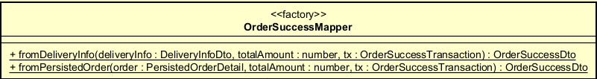
Table. Attribute design of OrderSuccessMapper
# | Name | Data type | Default value | Description
- | (none) |  |  | This class declares no attributes.
Table. Operation design of OrderSuccessMapper
# | Name | Return type | Description (purpose)
1 | fromDeliveryInfo | OrderSuccessDto | [static] Build the success DTO from raw form input (trims user fields).
2 | fromPersistedOrder | OrderSuccessDto | [static] Build the success DTO from an already-stored order.
Parameter:
- fromDeliveryInfo(deliveryInfo: DeliveryInfoDto, totalAmount: number, transaction: OrderSuccessTransaction)
- fromPersistedOrder(order: PersistedOrderDetail, totalAmount: number, transaction: OrderSuccessTransaction)
Method
Single source of truth for assembling OrderSuccessDto. Two entry points because the customer fields come from two sources (raw form vs. stored order).

4.4.3.31 Class “InvoiceCalculator”
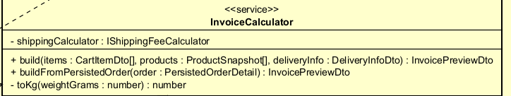
Table. Attribute design of InvoiceCalculator
# | Name | Data type | Default value | Description
1 | shippingCalculator | IShippingFeeCalculator | (injected) | Strategy used to compute the delivery fee.
Table. Operation design of InvoiceCalculator
# | Name | Return type | Description (purpose)
1 | build | InvoicePreviewDto | Compute line amounts, VAT, shipping fee and total for a fresh order.
2 | buildFromPersistedOrder | InvoicePreviewDto | Rebuild the invoice preview from a stored order (for the confirmation email / idempotent flow).
3 | toKg | number | [private] Convert grams to kilograms (guards against invalid weight).
Parameter:
- build(items: CartItemDto[], products: ProductSnapshot[], deliveryInfo: DeliveryInfoDto)
- buildFromPersistedOrder(order: PersistedOrderDetail)
- toKg(weightGrams: number)
Method
subtotalBeforeVat = sum(price*qty); vatAmount = subtotal * VAT_RATE (0.1); delegates shipping to the IShippingFeeCalculator strategy; totalAmount = subtotalAfterVat + deliveryFee.

4.4.3.32 Class “StockCheckerService”
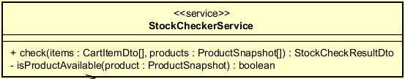
Table. Attribute design of StockCheckerService
# | Name | Data type | Default value | Description
- | (none) |  |  | This class declares no attributes.
Table. Operation design of StockCheckerService
# | Name | Return type | Description (purpose)
1 | check | StockCheckResultDto | For each item, compute availability and collect items that lack stock.
2 | isProductAvailable | boolean | [private] False when the product status is in the UNAVAILABLE set.
Parameter:
- check(items: CartItemDto[], products: ProductSnapshot[])
- isProductAvailable(product: ProductSnapshot)
Method
A product missing from the catalog or with an unavailable status (DEACTIVATED/DELETED/INACTIVE/UNAVAILABLE) counts as 0 available. Returns sufficient=true only when no item is short.

4.4.3.33 Class “OrderValidationService”
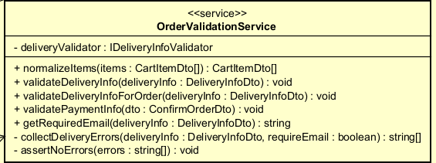
Table. Attribute design of OrderValidationService
# | Name | Data type | Default value | Description
1 | deliveryValidator | IDeliveryInfoValidator | (injected) | Rule-based delivery-info validator (behind a DIP token).
Table. Operation design of OrderValidationService
# | Name | Return type | Description (purpose)
1 | normalizeItems | CartItemDto[] | Validate and merge cart items by productId.
2 | validateDeliveryInfo | void | Validate delivery info WITHOUT requiring email.
3 | validateDeliveryInfoForOrder | void | Validate delivery info AND require a non-empty email.
4 | validatePaymentInfo | void | Require a non-empty transactionId and paymentMethod.
5 | getRequiredEmail | string | Return the trimmed email or throw if missing.
6 | collectDeliveryErrors | string[] | [private] Run the validator and optionally add the email-required error.
7 | assertNoErrors | void | [private] Throw InvalidDeliveryInfoException when there are errors.
Parameter:
- normalizeItems(items: CartItemDto[])
- validateDeliveryInfo(deliveryInfo: DeliveryInfoDto)
- validatePaymentInfo(dto: ConfirmOrderDto)
Exception:
- BadRequestException – empty items / non-positive productId or quantity (normalizeItems).
- InvalidDeliveryInfoException – delivery info invalid or email missing.
- PaymentNotSuccessfulException – transactionId or paymentMethod missing.
Method
normalizeItems sums quantities of duplicate productIds. Delivery validation is delegated to IDeliveryInfoValidator; email requirement is enforced only for order-creating flows.

4.4.3.34 Class “OrderEventPublisher”
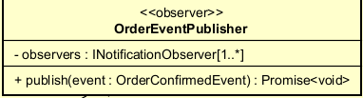
Table. Attribute design of OrderEventPublisher
# | Name | Data type | Default value | Description
1 | observers | INotificationObserver[] | (injected) | Registered notification channels.
Table. Operation design of OrderEventPublisher
# | Name | Return type | Description (purpose)
1 | publish | Promise<void> | Notify every observer about an order-confirmed event.
Parameter:
- publish(event: OrderConfirmedEvent)
Method
Calls observer.update() for all observers in parallel and isolates failures (a failing observer is logged and does not break the others). Adding a channel (SMS/Zalo/Push) = register a new observer (OCP).

4.4.3.35 Class “BaseOrderState”
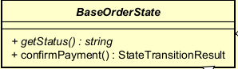
Table. Attribute design of BaseOrderState
# | Name | Data type | Default value | Description
- | (none) |  |  | This class declares no attributes.
Table. Operation design of BaseOrderState
# | Name | Return type | Description (purpose)
1 | getStatus | string | [abstract] The status string this state represents.
2 | confirmPayment | StateTransitionResult | Default behaviour: illegal – throws IllegalOrderTransitionError.
Exception:
- IllegalOrderTransitionError – confirming payment from a non-payable state.
Method
Template for concrete order states; subclasses override confirmPayment() to allow the transition.

4.4.3.36 Class “PendingPaymentState”
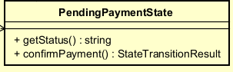
Table. Operation design of PendingPaymentState
# | Name | Return type | Description (purpose)
1 | getStatus | string | Returns PENDING_PAYMENT.
2 | confirmPayment | StateTransitionResult | Returns { alreadyInTarget: false } – transition to PENDING_PROCESSING is allowed.
State
Order created and awaiting payment.

4.4.3.37 Class "PendingProcessingState"
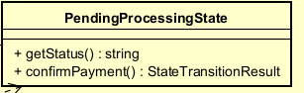
Table. Attribute design of PendingProcessingState
# | Name | Data type | Default value | Description
- | (none) |  |  | This class declares no attributes.

Table. Operation design of PendingProcessingState
# | Name | Return type | Description (purpose)
1 | getStatus | string | Returns PENDING_PROCESSING.
2 | confirmPayment | StateTransitionResult | Returns { alreadyInTarget: true } - already paid, the transition is a no-op (idempotent).

State
Order already paid, awaiting product-manager processing.

4.4.3.38 Class "OrderStateFactory"
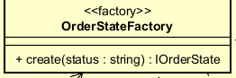
Table. Attribute design of OrderStateFactory
# | Name | Data type | Default value | Description
- | (none) |  |  | This class declares no attributes.

Table. Operation design of OrderStateFactory
# | Name | Return type | Description (purpose)
1 | create | IOrderState | Map a status string to the matching state object.

Parameter:
· create(status: string)
Exception:
· IllegalOrderTransitionError - unknown / non-payable status.
Method
switch(status): PENDING_PAYMENT -> PendingPaymentState; PENDING_PROCESSING -> PendingProcessingState; otherwise throw.

4.4.3.39 Class "DeliveryInfoValidator"
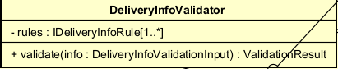
Table. Attribute design of DeliveryInfoValidator
# | Name | Data type | Default value | Description
1 | rules | IDeliveryInfoRule[] | DEFAULT_DELIVERY_INFO_RULES | Ordered set of validation rules.

Table. Operation design of DeliveryInfoValidator
# | Name | Return type | Description (purpose)
1 | validate | ValidationResult | Run every rule and collect the non-null error messages.

Parameter:
· validate(info: DeliveryInfoValidationInput)
Method
Aggregates a collection of IDeliveryInfoRule. Order of rules = order errors are reported. Returns { valid, errors }.

4.4.3.40 Class "ReceiverNameRule"
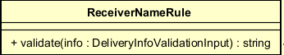
Table. Attribute design of ReceiverNameRule
# | Name | Data type | Default value | Description
- | (none) |  |  | This class declares no attributes.

Table. Operation design of ReceiverNameRule
# | Name | Return type | Description (purpose)
1 | validate | string | null | Receiver name is required and must contain letters only.

Parameter:
· validate(info: DeliveryInfoValidationInput)
Method
Returns an error message when the name is blank or contains non-letter characters, otherwise null.

4.4.3.41 Class "PhoneNumberRule"
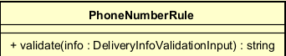
Table. Attribute design of PhoneNumberRule
# | Name | Data type | Default value | Description
- | (none) |  |  | This class declares no attributes.

Table. Operation design of PhoneNumberRule
# | Name | Return type | Description (purpose)
1 | validate | string | null | Phone is required: exactly 10 digits, a single separator type (".", space or "-") allowed.

Parameter:
· validate(info: DeliveryInfoValidationInput)
Method
Rejects more than one separator type; strips separators and checks for exactly 10 digits.

4.4.3.42 Class "ProvinceRule"
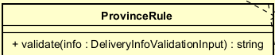
Table. Attribute design of ProvinceRule
# | Name | Data type | Default value | Description
- | (none) |  |  | This class declares no attributes.

Table. Operation design of ProvinceRule
# | Name | Return type | Description (purpose)
1 | validate | string | null | Province is required (must not be blank).

Parameter:
· validate(info: DeliveryInfoValidationInput)
Method
Returns the "Province is required." message when blank, otherwise null.

4.4.3.43 Class "AddressRule"
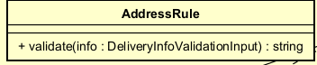
Table. Attribute design of AddressRule
# | Name | Data type | Default value | Description
- | (none) |  |  | This class declares no attributes.

Table. Operation design of AddressRule
# | Name | Return type | Description (purpose)
1 | validate | string | null | Street address is required (must not be blank).

Parameter:
· validate(info: DeliveryInfoValidationInput)
Method
Returns the "Delivery address is required." message when blank, otherwise null.

4.4.3.44 Class "ShippingInstructionsRule"
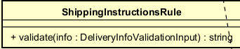
Table. Attribute design of ShippingInstructionsRule
# | Name | Data type | Default value | Description
- | (none) |  |  | This class declares no attributes.

Table. Operation design of ShippingInstructionsRule
# | Name | Return type | Description (purpose)
1 | validate | string | null | Optional; if present must not exceed 200 characters.

Parameter:
· validate(info: DeliveryInfoValidationInput)
Method
Null when absent; otherwise rejects values longer than 200 characters.

4.4.3.45 Class "PrismaOrderRepository"
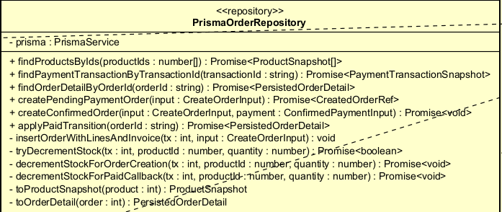
Table. Attribute design of PrismaOrderRepository
# | Name | Data type | Default value | Description
1 | prisma | PrismaService | (injected) | Prisma client wrapper - the only DB access point.

Table. Operation design of PrismaOrderRepository
# | Name | Return type | Description (purpose)
1 | findProductsByIds | Promise<ProductSnapshot[]> | Load products and normalise to ProductSnapshot.
2 | findPaymentTransactionByTransactionId | Promise<PaymentTransactionSnapshot | null> | Look up an existing payment transaction (idempotency).
3 | findOrderDetailByOrderId | Promise<PersistedOrderDetail | null> | Load full order detail (lines + invoice).
4 | createPendingPaymentOrder | Promise<CreatedOrderRef> | Insert a PENDING_PAYMENT order (no stock decrement).
5 | createConfirmedOrder | Promise<void> | Insert an already-paid order, decrement stock and record the payment - atomically.
6 | applyPaidTransition | Promise<PersistedOrderDetail> | Move PENDING_PAYMENT -> PENDING_PROCESSING and decrement stock atomically.
7 | insertOrderWithLinesAndInvoice | { orderId, invoiceId } | [private] Insert order + lines + invoice within a transaction.
8 | tryDecrementStock | Promise<boolean> | [private] Atomic conditional decrement (guards against overselling).
9 | decrementStockForOrderCreation | Promise<void> | [private] Decrement during order create; shortage -> InvalidQuantityException.
10 | decrementStockForPaidCallback | Promise<void> | [private] Decrement during paid callback; shortage -> BadRequestException.
11 | toProductSnapshot | ProductSnapshot | [private] Map a Prisma product row to a normalised snapshot.
12 | toOrderDetail | PersistedOrderDetail | [private] Map a Prisma order row (+relations) to a normalised read-model.

Parameter:
· findProductsByIds(productIds: number[])
· createConfirmedOrder(input: CreateOrderInput, payment: ConfirmedPaymentInput)
· applyPaidTransition(orderId: string)
Exception:
· InvalidQuantityException - insufficient stock during order creation (customer-facing).
· BadRequestException - insufficient stock during paid callback, or missing order context.
Method
The only class allowed to touch Prisma. Normalises Decimal/BigInt to plain number/string. applyPaidTransition uses updateMany guarded by status to atomically claim the PENDING_PAYMENT -> PENDING_PROCESSING transition, so duplicate/concurrent payment callbacks never decrement stock twice (idempotent under races).

4.4.3.46 Class "WeightBasedShippingStrategy"
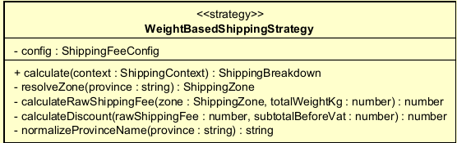
Table. Attribute design of WeightBasedShippingStrategy
# | Name | Data type | Default value | Description
1 | config | ShippingFeeConfig | DEFAULT_SHIPPING_FEE_CONFIG | Injected pricing data (zones, fees, thresholds).

Table. Operation design of WeightBasedShippingStrategy
# | Name | Return type | Description (purpose)
1 | calculate | ShippingBreakdown | Compute the final shipping fee for a package.
2 | resolveZone | ShippingZone | [private] Match the province to a pricing zone (else default zone).
3 | calculateRawShippingFee | number | [private] Base fee + extra 0.5kg blocks beyond the base weight.
4 | calculateDiscount | number | [private] Free-ship discount when subtotal exceeds the threshold.
5 | normalizeProvinceName | string | [private] Lowercase, strip diacritics/dots for province matching.

Parameter:
· calculate(context: ShippingContext)
Method
Ha Noi/HCM: 22,000 VND for first 3kg. Elsewhere: 30,000 VND for first 0.5kg. +2,500 VND per extra 0.5kg block (ceil). If items subtotal > 100,000 VND, discount up to 25,000 VND. finalShippingFee = max(0, rawFee - discount).

4.4.3.47 Class "EmailNotificationObserver"
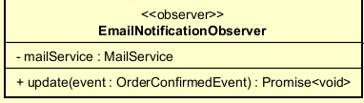
Table. Attribute design of EmailNotificationObserver
# | Name | Data type | Default value | Description
1 | mailService | MailService | (injected) | Mail transport used to send the confirmation email.

Table. Operation design of EmailNotificationObserver
# | Name | Return type | Description (purpose)
1 | update | Promise<void> | On an order-confirmed event, render and send the confirmation email.

Parameter:
· update(event: OrderConfirmedEvent)
Method
Skips when no recipient email. Builds a cancel-order link from CLIENT_URL + orderId, renders the order-confirmation template, and sends it via MailService.

4.4.3.48 Class "PlaceOrderPaymentAdapter"
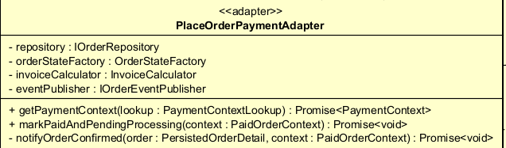
Table. Attribute design of PlaceOrderPaymentAdapter
# | Name | Data type | Default value | Description
1 | repository | IOrderRepository | (injected) | Order persistence port.
2 | orderStateFactory | OrderStateFactory | (injected) | Resolves the order state for the transition.
3 | invoiceCalculator | InvoiceCalculator | (injected) | Rebuilds the invoice for the email.
4 | eventPublisher | IOrderEventPublisher | (injected) | Publishes the order-confirmed event.

Table. Operation design of PlaceOrderPaymentAdapter
# | Name | Return type | Description (purpose)
1 | getPaymentContext | Promise<PaymentContext> | Return order payment context for the PaymentService.
2 | markPaidAndPendingProcessing | Promise<void> | On successful payment: verify amount/invoice, apply the state transition, decrement stock, notify.
3 | notifyOrderConfirmed | Promise<void> | [private] Build success DTO + invoice and publish the order-confirmed event.

Parameter:
· getPaymentContext(lookup: PaymentContextLookup)
· markPaidAndPendingProcessing(context: PaidOrderContext)
Exception:
· NotFoundException - order/invoice not found.
· BadRequestException - invoice does not belong to order, or amount mismatch.
Method
Server-side payment callback path. Uses the State pattern (OrderStateFactory.create(status).confirmPayment()) to decide if the transition is legal or a no-op before applying applyPaidTransition().

4.4.3.49 Class "InvalidQuantityException"
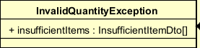
Table. Attribute design of InvalidQuantityException
# | Name | Data type | Default value | Description
1 | insufficientItems | InsufficientItemDto[] | - | Items whose requested quantity exceeds the available stock.

Table. Operation design of InvalidQuantityException
# | Name | Return type | Description (purpose)
- | (none) |  | Data class - no operations.

Method
Thrown when stock is insufficient. Carries the per-product shortage so the client can show available quantities.

4.4.3.50 Class "InvalidDeliveryInfoException"
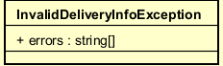
Table. Attribute design of InvalidDeliveryInfoException
# | Name | Data type | Default value | Description
1 | errors | string[] | - | List of human-readable delivery-info validation messages.

Table. Operation design of InvalidDeliveryInfoException
# | Name | Return type | Description (purpose)
- | (none) |  | Data class - no operations.

Method
Thrown when one or more delivery-info rules fail.

4.4.3.51 Class "PaymentNotSuccessfulException"
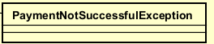
Table. Attribute design of PaymentNotSuccessfulException
# | Name | Data type | Default value | Description
- | (none) |  |  | This class declares no attributes.

Table. Operation design of PaymentNotSuccessfulException
# | Name | Return type | Description (purpose)
1 | constructor | - | Wraps a message into a BadRequestException.

Method
Thrown when the order payment is missing/unsuccessful (e.g., no transaction id or payment method on confirm).

4.4.3.52 Class "IllegalOrderTransitionError"
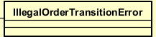
Table. Attribute design of IllegalOrderTransitionError
# | Name | Data type | Default value | Description
- | (none) |  |  | This class declares no attributes.

Table. Operation design of IllegalOrderTransitionError
# | Name | Return type | Description (purpose)
1 | constructor | - | Pure domain error (no HTTP/framework dependency).

Method
Raised when an order is asked to perform a status transition that is not allowed from its current state.

4.4.3.53 Class "CartItemDto"
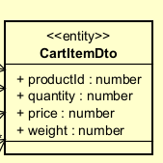
Table. Attribute design of CartItemDto
# | Name | Data type | Default value | Description
1 | productId | number | - | Product identifier (positive integer).
2 | quantity | number | - | Requested quantity (positive integer).
3 | price | number | undefined | [ISP] Unused by the server (price always taken from DB).
4 | weight | number | undefined | [ISP] Unused by the server (weight always taken from DB).

Table. Operation design of CartItemDto
# | Name | Return type | Description (purpose)
- | (none) |  | Data class - no operations.

Method
Data Transfer Object - no operations.

4.4.3.54 Class "DeliveryInfoDto"
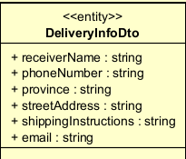
Table. Attribute design of DeliveryInfoDto
# | Name | Data type | Default value | Description
1 | receiverName | string | - | Recipient name (letters only).
2 | phoneNumber | string | - | Recipient phone (10 digits).
3 | province | string | - | Province/city.
4 | streetAddress | string | - | Detailed street address.
5 | shippingInstructions | string | undefined | Optional, up to 200 chars.
6 | email | string | - | Customer email (required for order creation).

Table. Operation design of DeliveryInfoDto
# | Name | Return type | Description (purpose)
- | (none) |  | Data class - no operations.

Method
Data Transfer Object - no operations.

4.4.3.55 Class "SubmitDeliveryInfoDto"
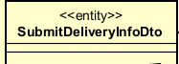
Table. Attribute design of SubmitDeliveryInfoDto
# | Name | Data type | Default value | Description
1 | items | CartItemDto[] | - | Cart items.
2 | deliveryInfo | DeliveryInfoDto | - | Delivery information.

Table. Operation design of SubmitDeliveryInfoDto
# | Name | Return type | Description (purpose)
- | (none) |  | Data class - no operations.

Method
Data Transfer Object - no operations.

4.4.3.56 Class "PlaceOrderRequestDto"
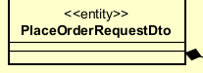
Table. Attribute design of PlaceOrderRequestDto
# | Name | Data type | Default value | Description
1 | items | CartItemDto[] | - | Cart items to check stock for.

Table. Operation design of PlaceOrderRequestDto
# | Name | Return type | Description (purpose)
- | (none) |  | Data class - no operations.

Method
Data Transfer Object - no operations.

4.4.3.57 Class "PlaceOrderPaymentRequestDto"
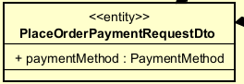
Table. Attribute design of PlaceOrderPaymentRequestDto
# | Name | Data type | Default value | Description
1 | items | CartItemDto[] | - | Cart items.
2 | deliveryInfo | DeliveryInfoDto | - | Delivery information.
3 | paymentMethod | PaymentMethod | PaymentMethod.VIETQR | Chosen payment method (default QR).

Table. Operation design of PlaceOrderPaymentRequestDto
# | Name | Return type | Description (purpose)
- | (none) |  | Data class - no operations.

Method
Data Transfer Object - no operations.

4.4.3.58 Class "ConfirmOrderDto"
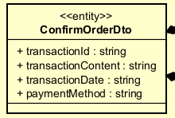
Table. Attribute design of ConfirmOrderDto
# | Name | Data type | Default value | Description
1 | items | CartItemDto[] | - | Cart items.
2 | deliveryInfo | DeliveryInfoDto | - | Delivery information.
3 | transactionId | string | - | Payment transaction id.
4 | transactionContent | string | undefined | Optional transaction content.
5 | transactionDate | string | undefined | Optional ISO transaction date.
6 | paymentMethod | string | - | Payment method used.

Table. Operation design of ConfirmOrderDto
# | Name | Return type | Description (purpose)
- | (none) |  | Data class - no operations.

Method
Data Transfer Object - no operations.

4.4.3.59 Class "InvoiceItemDto"
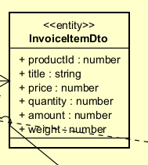
Table. Attribute design of InvoiceItemDto
# | Name | Data type | Default value | Description
1 | productId | number | - | Product id.
2 | title | string | undefined | Product title.
3 | price | number | - | Unit price.
4 | quantity | number | - | Quantity.
5 | amount | number | - | price * quantity.
6 | weight | number | undefined | Unit weight (kg).

Table. Operation design of InvoiceItemDto
# | Name | Return type | Description (purpose)
- | (none) |  | Data class - no operations.

Method
Data Transfer Object - no operations.

4.4.3.60 Class "InvoicePreviewDto"
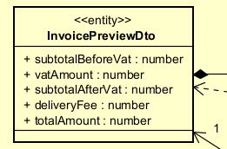
Table. Attribute design of InvoicePreviewDto
# | Name | Data type | Default value | Description
1 | items | InvoiceItemDto[] | - | Priced line items.
2 | subtotalBeforeVat | number | - | Items subtotal before VAT.
3 | vatAmount | number | - | VAT amount.
4 | subtotalAfterVat | number | - | Subtotal including VAT.
5 | deliveryFee | number | - | Final delivery fee.
6 | totalAmount | number | - | Subtotal incl. VAT + delivery fee.

Table. Operation design of InvoicePreviewDto
# | Name | Return type | Description (purpose)
- | (none) |  | Data class - no operations.

Method
Data Transfer Object - no operations.

4.4.3.61 Class "OrderSuccessDto"
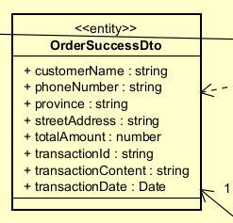
Table. Attribute design of OrderSuccessDto
# | Name | Data type | Default value | Description
1 | customerName | string | - | Customer name.
2 | phoneNumber | string | - | Customer phone.
3 | province | string | - | Province.
4 | streetAddress | string | - | Street address.
5 | totalAmount | number | - | Total paid.
6 | transactionId | string | - | Transaction id.
7 | transactionContent | string | - | Transaction content.
8 | transactionDate | Date | - | Transaction date.

Table. Operation design of OrderSuccessDto
# | Name | Return type | Description (purpose)
- | (none) |  | Data class - no operations.

Method
Data Transfer Object - no operations.

4.4.3.62 Class "InsufficientItemDto"
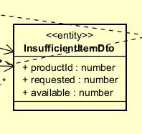
Table. Attribute design of InsufficientItemDto
# | Name | Data type | Default value | Description
1 | productId | number | - | Product id that is short.
2 | requested | number | - | Requested quantity.
3 | available | number | - | Available quantity.

Table. Operation design of InsufficientItemDto
# | Name | Return type | Description (purpose)
- | (none) |  | Data class - no operations.

Method
Data Transfer Object - no operations.

4.4.3.63 Class "StockCheckResultDto"
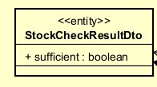
Table. Attribute design of StockCheckResultDto
# | Name | Data type | Default value | Description
1 | sufficient | boolean | - | True if every item has enough stock.
2 | insufficientItems | InsufficientItemDto[] | - | Items lacking stock.

Table. Operation design of StockCheckResultDto
# | Name | Return type | Description (purpose)
- | (none) |  | Data class - no operations.

Method
Data Transfer Object - no operations.

4.4.3.64 Class ProductController
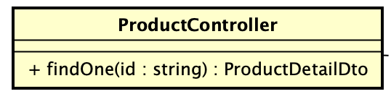
REST controller (NestJS) that exposes the product read API. For UC235 it exposes GET /products/:id and delegates to GetProductDetailUseCase. Kept thin: no Prisma queries, DTO mapping or UI logic.
Table 2. Attribute design
# | Name | Data type | Default value | Description
1 | productService | ProductService | - | Product command operations (not used by UC235).
2 | getProductsListUseCase | GetProductsListUseCase | - | Catalog listing use case.
3 | getProductDetailUseCase | GetProductDetailUseCase | - | Main dependency for UC235: retrieves a product detail.
4 | getProductLogsUseCase | GetProductLogsUseCase | - | Product log query (manager).
5 | cloudinaryService | CloudinaryService | - | Image upload (manager).
Table 3. Operation design
# | Name | Return type | Description (purpose)
1 | findOne(id: string) | Promise<ProductDetailDto> | Handles GET /products/:id; delegates to getProductDetailUseCase.execute(id) and returns the product detail.
2 | findAll(...) | Promise<...> | Handles GET /products catalog listing (filtering, sorting, pagination).
Parameter: id – product identifier taken from the URL path (@Param('id')).

4.4.3.65 Class GetProductDetailUseCase
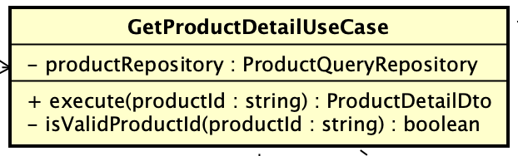
Application use case that orchestrates the business flow for retrieving one product detail: validate id → fetch via repository → map to DTO. Depends on the ProductQueryRepository abstraction (DIP).
Table 2. Attribute design
# | Name | Data type | Default value | Description
1 | productRepository | ProductQueryRepository | - | Injected read-side repository abstraction (token PRODUCT_QUERY_REPOSITORY).
Table 3. Operation design
# | Name | Return type | Description (purpose)
1 | execute(productId: string) | Promise<ProductDetailDto> | Validates the id, loads the product, and returns the mapped ProductDetailDto.
2 | isValidProductId(productId: string) | boolean | Private. Returns true if the id matches ^[1-9]\d*$.
Exception: BadRequestException if the product id is invalid.
Exception: NotFoundException if no product with the given id exists.

4.4.3.66 Class ProductQueryRepository
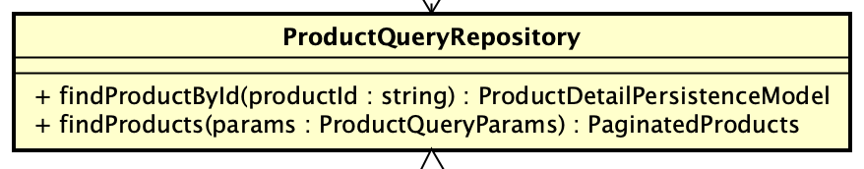
Domain abstraction that exposes only read operations needed for product viewing; PrismaProductRepository is the Prisma-based implementation. Command operations (create/update/delete) are intentionally kept in separate abstractions (ISP).
Table 2. Attribute design
# | Name | Data type | Default value | Description
1 | (no fields – interface) | - | - | Implementation holds the Prisma client / data source.
Table 3. Operation design
# | Name | Return type | Description (purpose)
1 | findProductById(productId: string) | Promise<ProductDetailPersistenceModel | null> | Returns the persistence record for the id, or null when not found (used by UC235).
2 | findProducts(params?: ProductQueryParams) | Promise<PaginatedProducts> | Returns a filtered/sorted/paginated catalog page.

4.4.3.67 Class ProductDetailMapper
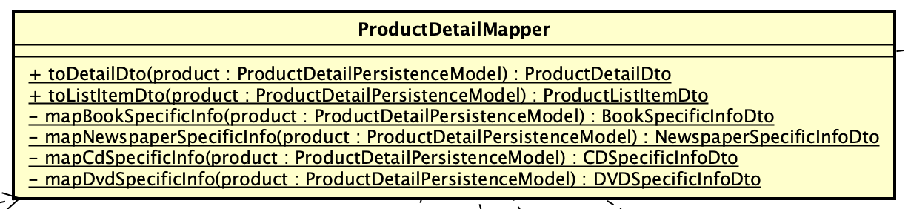
Static mapper that transforms a persistence record into response DTOs. Type-specific mapping is dispatched by a Strategy map (Record<ProductType, mapperFn>) so each product type is handled by its own method.
Table 3. Operation design
# | Name | Return type | Description (purpose)
1 | toDetailDto(product) | ProductDetailDto | Maps common product fields and attaches the type-specific specificInfo section.
2 | toListItemDto(product) | ProductListItemDto | Maps a record into a lightweight catalog list item.
3 | mapSpecificInfo(type, product) | ProductSpecificInfoDto | Strategy dispatch: selects the mapper for the product type.
4 | mapBookSpecificInfo / mapNewspaperSpecificInfo / mapCdSpecificInfo / mapDvdSpecificInfo | *SpecificInfoDto | Build the type-specific section for each product type.
Helpers: normalizeType, normalizeStatus, parseDimensions, toNumber, toStringValue, toDateString, toStringList (private conversion utilities).

4.4.3.68 Class ProductDetailDto
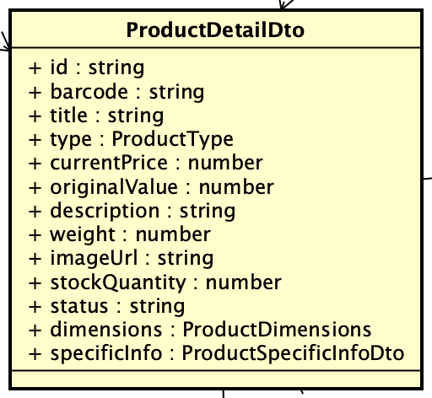
Response contract returned to the frontend for the product detail screen. Common fields are stable; the specificInfo section is extended per product type (OCP).
Table 2. Attribute design
# | Name | Data type | Default value | Description
1 | id | string | - | Product identifier.
2 | barcode | string | - | Product barcode.
3 | title | string | - | Product title.
4 | type | ProductTypeValue | - | BOOK | NEWSPAPER | CD | DVD.
5 | currentPrice | number | - | Current selling price.
6 | originalValue | number | - | Original value of the product.
7 | description | string | - | Product description.
8 | weight | number | - | Weight (for shipping calculation).
9 | dimensions | ProductDimensions | - | height x width x length.
10 | imageUrl | string? | undefined | Optional product image URL.
11 | stockQuantity | number | - | Available stock quantity.
12 | status | string | - | Availability status (e.g. AVAILABLE, OUT_OF_STOCK).
13 | specificInfo | ProductSpecificInfoDto | - | Type-specific section (Book/Newspaper/CD/DVD).

4.4.3.69 Class ProductEntity
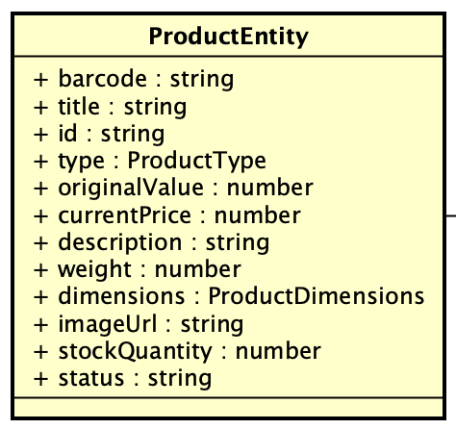
Domain entity holding the common product fields used by read use cases. Type-specific fields are kept out of this common contract and live in the specificInfo DTOs.
Table 2. Attribute design
# | Name | Data type | Default value | Description
1 | id | string | - | Identifier.
2 | barcode | string | - | Barcode.
3 | title | string | - | Title.
4 | type | ProductTypeValue | - | Product type.
5 | currentPrice | number | - | Current price.
6 | originalValue | number | - | Original value.
7 | description | string | - | Description.
8 | weight | number | - | Weight.
9 | dimensions | ProductDimensions | - | Dimensions.
10 | imageUrl | string? | undefined | Optional image.
11 | stockQuantity | number | - | Stock.
12 | status | string | - | Status.
Table 3. Operation design
# | Name | Return type | Description (purpose)
1 | constructor(partial: Partial<ProductEntity>) | ProductEntity | Builds an entity from a partial object (Object.assign).

4.4.3.70 Class ProductDetailPageComponent
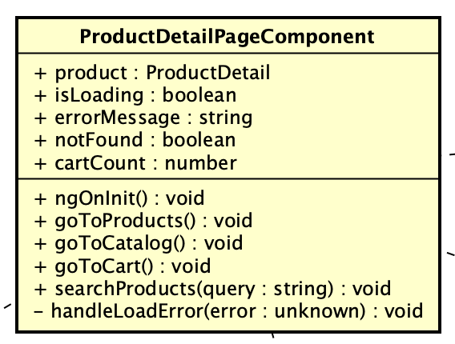
Angular page (smart) component for the product detail screen. Coordinates route-parameter reading, loading state and error handling, and delegates rendering to child components.
Table 2. Attribute design
# | Name | Data type | Default value | Description
1 | product | Signal<ProductDetail | null> | null | Loaded product detail.
2 | isLoading | Signal<boolean> | true | Loading flag.
3 | errorMessage | Signal<string> | '' | Error message for non-404 failures.
4 | notFound | Signal<boolean> | false | True when the product id returns 404.
5 | route | ActivatedRoute | - | Reads the :id route parameter.
6 | productApi | ProductApiService | - | Fetches the product detail.
7 | cartCount | Signal<number> | - | Cart item count for the header.
Table 3. Operation design
# | Name | Return type | Description (purpose)
1 | ngOnInit() | void | Subscribes to route params, fetches the product via productApi.getProductDetail(id), updates state.
2 | handleLoadError(error) | void | Private. Sets notFound on HTTP 404, otherwise sets an error message.
3 | goToProducts() / goToCatalog() | void | Navigate back to the catalog.
4 | goToCart() | void | Navigate to the cart.
5 | searchProducts(query: string) | void | Navigate to the catalog with a search query.

4.4.3.71 Class ProductDetailComponent
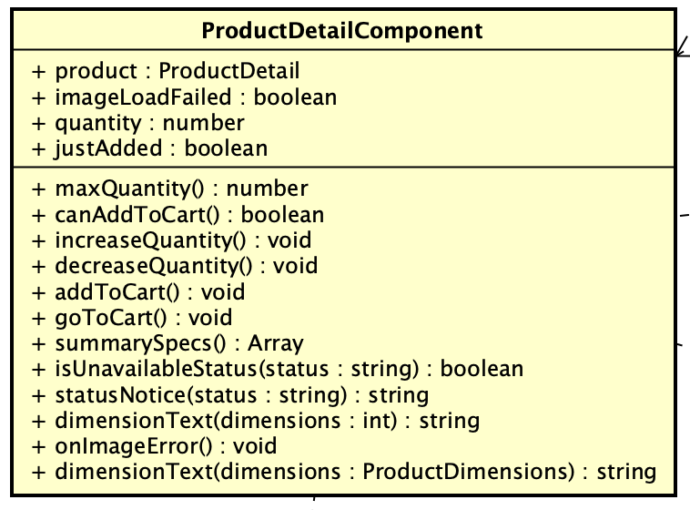
Presentational component that renders the common product detail fields and owns the local add-to-cart quantity selector. Cart persistence is delegated to CartStoreService; type-specific fields are delegated to ProductSpecificInfoComponent.
Table 2. Attribute design
# | Name | Data type | Default value | Description
1 | product | ProductDetail (@Input, required) | - | Product to display.
2 | quantity | Signal<number> | 1 | Selected add-to-cart quantity.
3 | justAdded | Signal<boolean> | false | Shows the 'added to cart' notice.
4 | imageLoadFailed | boolean | false | True when the product image fails to load.
5 | cartStore | CartStoreService | - | Cart state (add item).
Table 3. Operation design
# | Name | Return type | Description (purpose)
1 | maxQuantity | number (getter) | Maximum selectable quantity from stock.
2 | canAddToCart | boolean (getter) | True when the product is available and in stock.
3 | increaseQuantity() / decreaseQuantity() | void | Adjust the selected quantity within bounds.
4 | addToCart() | void | Adds the product to the cart via CartStoreService.
5 | summarySpecs() | Array<{label,value}> | Returns the short type-specific spec summary.
6 | isUnavailableStatus(status) / statusNotice(status) | boolean / string | Availability checks and user-facing notice.
7 | dimensionText(dimensions) | string | Formats dimensions as h x w x l.
8 | onImageError() | void | Marks the image as failed to load.

4.4.3.72 Class ProductSpecificInfoComponent
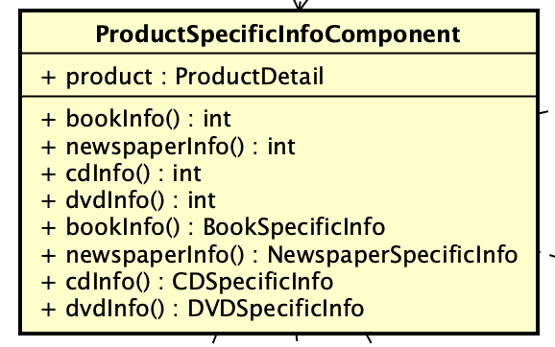
Small dispatcher (presentational) component that renders the correct type-specific information by delegating to Book/Newspaper/CD/DVD specific-info components.
Table 2. Attribute design
# | Name | Data type | Default value | Description
1 | product | ProductDetail (@Input, required) | - | Product whose specificInfo is rendered.
Table 3. Operation design
# | Name | Return type | Description (purpose)
1 | bookInfo / newspaperInfo / cdInfo / dvdInfo | *SpecificInfo (getters) | Cast specificInfo to the matching type and pass it to the corresponding child component.

4.4.3.73 Class ProductApiService
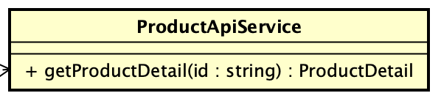
Angular service that centralizes the product read HTTP calls so components do not duplicate API URLs.
Table 2. Attribute design
# | Name | Data type | Default value | Description
1 | apiUrl | string | `${AIMS_API_BASE_URL}/products` | Base products endpoint.
2 | http | HttpClient | - | Angular HTTP client.
Table 3. Operation design
# | Name | Return type | Description (purpose)
1 | getProductDetail(productId: string) | Observable<ProductDetail> | Calls GET /products/:id and normalizes the response into the ProductDetail model (used by UC235).
2 | getProducts() | Observable<ProductListItem[]> | Loads the product list.
3 | getProductsPaged(query) | Observable<ProductPage> | Loads a paginated/filtered/sorted catalog page.
4 | normalizeProductDetail(response) | ProductDetail | Private. Maps the raw API payload into the typed ProductDetail model.

4.4.3.74 Class "PlaceOrderPaymentResultDto"
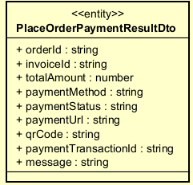
Table. Attribute design of PlaceOrderPaymentResultDto
# | Name | Data type | Default value | Description
1 | orderId | string | - | Created order id.
2 | invoiceId | string | - | Invoice id.
3 | totalAmount | number | - | Amount to pay.
4 | paymentMethod | string | - | Payment method.
5 | paymentStatus | string | - | Payment status.
6 | paymentUrl | string | - | Redirect/payment URL.
7 | qrCode | string | - | QR code payload.
8 | paymentTransactionId | string | - | Gateway transaction id.
9 | message | string | - | Result message.

Table. Operation design of PlaceOrderPaymentResultDto
# | Name | Return type | Description (purpose)
- | (none) |  | Data class - no operations.

Method
Data Transfer Object - no operations.

4.4.3.75 Class "ProductController"

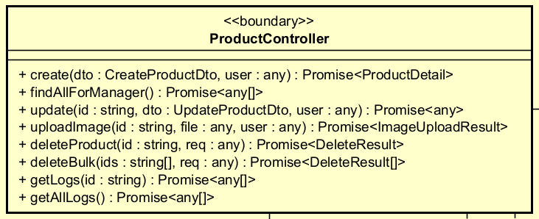

Table 1. Attributes of ProductController
# | Name | Data type | Default value | Description
1 | productService | ProductService |  | Service handling CUD operations for products
2 | getProductsListUseCase | GetProductsListUseCase |  | Use case for querying the product list
3 | getProductDetailUseCase | GetProductDetailUseCase |  | Use case for querying product detail
4 | getProductLogsUseCase | GetProductLogsUseCase |  | Use case for querying logs of a single product
5 | getAllProductLogsUseCase | GetAllProductLogsUseCase |  | Use case for querying all product logs
6 | cloudinaryService | CloudinaryService |  | Service for uploading images to Cloudinary
Table 2. Operations of ProductController
# | Name | Return type | Description
1 | create(dto, user) | Promise<any> | Creates a new product. Requires role Product Manager.
2 | findAll(...) | Promise<any> | Queries the product list with filter/sort/pagination (public).
3 | findAllForManager() | Promise<any[]> | Retrieves all products without filtering, for Product Managers.
4 | findOne(id) | Promise<any> | Queries a single product by ID (public).
5 | update(id, dto, user) | Promise<any> | Updates product information. Requires role Product Manager.
6 | uploadImage(id, file, user) | Promise<{imageUrl}> | Uploads a product image to Cloudinary and updates the URL in the DB.
7 | deleteProduct(id, req) | Promise<DeleteResult> | Soft-deletes or hard-deletes a product based on business conditions.
8 | deleteBulk(ids, req) | Promise<DeleteResult[]> | Deletes multiple products at once. Maximum 10 products.
9 | getLogs(id) | Promise<any[]> | Retrieves the operation history of a single product.
10 | getAllLogs() | Promise<any[]> | Retrieves the full product operation history.
Method:
create(dto, user)
- Parameters:
  - dto: CreateProductDto — Product creation data (required)
  - user: any — Current user info extracted from JWT token
- Exception: Throws 403 Forbidden if the user does not have the Product Manager role
- Flow: Receive DTO → Call productService.create(dto, user.userId) → Return the created product
uploadImage(id, file, user)
- Parameters:
  - id: string — ID of the product
  - file: any — Image file from multipart/form-data
  - user: any — Current user
- Exception: Throws BadRequestException if file is null/undefined
- Flow: Validate file → Upload to Cloudinary → Get secure_url → Call productService.updateImageUrl() → Return { imageUrl }
deleteBulk(ids, req)
- Parameters:
  - ids: string[] — Array of product IDs to delete (max 10)
  - req: any — Request object containing user info
- Exception: BadRequestException if ids is empty or exceeds 10 items

4.4.3.76 Class "ProductService"

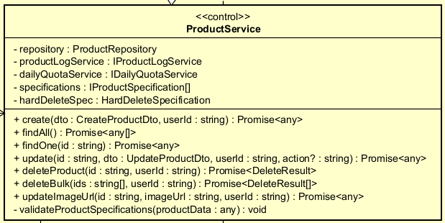

Table 1. Attributes
# | Name | Data type | Default value | Description
1 | repository | ProductRepository | — | Repository executing DB operations for Product
2 | productLogService | IProductLogService | — | Service for writing audit logs, injected via token
3 | dailyQuotaService | IDailyQuotaService | — | Service for enforcing daily deletion quotas
4 | specifications | IProductSpecification[] | [] | List of business rule specifications
5 | hardDeleteSpec | ISpecification<any> | — | Specification determining if a product may be hard-deleted
Table 2. Operations
# | Name | Return type | Description
1 | create(dto, userId) | Promise<any> | Validates specifications → creates product → logs CREATE
2 | findAll() | Promise<any[]> | Retrieves all products from the repository
3 | findOne(id) | Promise<any> | Finds a product by ID; throws an error if not found
4 | update(id, dto, userId, action?) | Promise<any> | Validates specifications → updates product → logs UPDATE
5 | deleteProduct(id, userId) | Promise<{status}> | Checks quota → hard/soft delete → logs action → increments quota
6 | deleteBulk(ids, userId) | Promise<DeleteResult[]> | Checks bulk quota → deletes each item → increments bulk quota
7 | updateImageUrl(id, imageUrl, userId) | Promise<any> | Updates the image URL and logs UPDATE_IMAGE
8 | validateProductSpecifications(productData) | void | Iterates all specifications; throws an error if any is violated

4.4.3.77 Class "ProductRepository"

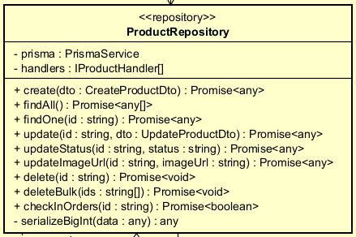
Table 1. Attributes
# | Name | Data type | Default value | Description
1 | prisma | PrismaService | — | ORM client for executing DB queries
2 | handlers | IProductHandler[] | — | List of handlers for each product type
Table 2. Operations
# | Name | Return type | Description
1 | create(dto) | Promise<bigint> | Creates the base product record and delegates to the matching handler within a transaction
2 | findAll() | Promise<any> | Retrieves all products with nested includes
3 | findOne(id) | `Promise | null>`
4 | update(id, dto) | Promise<any> | Updates the base product and delegates to the matching handler within a transaction
5 | updateStatus(id, status) | Promise<any> | Updates the status field of a product
6 | updateImageUrl(id, imageUrl) | Promise<any> | Updates the imageUrl field of a product
7 | delete(id) | Promise<void> | Deletes a product after checking for order constraints
8 | deleteBulk(ids) | Promise<void> | Deletes multiple products within a single transaction
9 | checkInOrders(id) | Promise<boolean> | Checks whether a product exists in any orders
10 | serializeBigInt(data) | any | Converts BigInt values to strings for JSON serialization

4.4.3.78 Class "CloudinaryService"
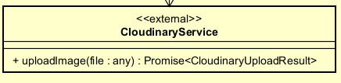
Table 2. Operation
# | Name | Return type | Description
1 | uploadImage(file) | Promise<CloudinaryUploadResult> | Uploads an image file to Cloudinary and returns the result containing secure_url

4.4.3.79 Class "BaseCreateProductDto"

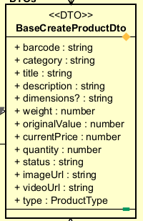
Table 1. Attributes
# | Name | Data type | Default value | Description
1 | barcode | string | — | Product barcode; required
2 | category | string | — | Product category; required
3 | title | string | — | Product name; required
4 | description | string | — | Product description; required
5 | dimensions? | string | — | Product dimensions (HxWxL); optional
6 | weight | number | — | Weight in kg; ≥ 0; required
7 | originalValue | number | — | Original product value; ≥ 0; required
8 | currentPrice | number | — | Current selling price; ≥ 0; required
9 | quantity | number | — | Stock quantity; ≥ 0; required
10 | status | string | — | Product status (ACTIVE/INACTIVE); required
11 | imageUrl | string | — | Product image URL; required
12 | videoUrl | string | — | Product video URL; required
13 | type | ProductType | — | Product type (BOOK/CD/DVD/NEWSPAPER); required

4.4.3.80 Class "CreateBookDto"

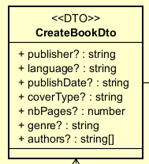

Table 1. Attributes
# | Name | Data type | Default value | Description
1 | publisher? | string | — | Publisher name
2 | language? | string | — | Language of the book
3 | publishDate? | string (ISO date) | — | Publication date
4 | coverType? | string | — | Cover type (hardcover/paperback)
5 | nbPages? | number | — | Number of pages
6 | genre? | string | — | Book genre
7 | authors? | string[] | — | List of author names

4.4.3.81 Class "CreateCdDto"

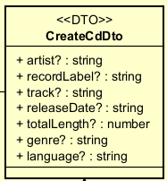
Table 1. Attributes
# | Name | Data type | Default value | Description
1 | artist? | string | — | Artist name
2 | recordLabel? | string | — | Record label
3 | track? | string | — | Track listing
4 | releaseDate? | string (ISO date) | — | Release date
5 | totalLength? | number | — | Total duration in seconds
6 | genre? | string | — | Music genre
7 | language? | string | — | Language

4.4.3.82 Class "CreateDvdBookDto"

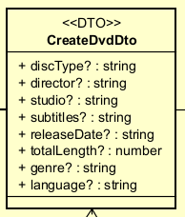
Table 1. Attributes
# | Name | Data type | Default value | Description
1 | discType? | string | — | Disc type (Blu-ray/DVD)
2 | director? | string | — | Director name
3 | studio? | string | — | Production studio
4 | subtitles? | string | — | Available subtitles
5 | releaseDate? | string (ISO date) | — | Release date
6 | totalLength? | number | — | Film runtime in minutes
7 | genre? | string | — | Film genre
8 | language? | string | — | Language

4.4.3.83 Class "CreateNewspaperDto"

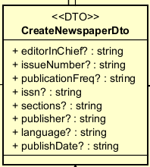
Table 1. Attributes
# | Name | Data type | Default value | Description
1 | editorInChief? | string | — | Editor-in-chief name
2 | issueNumber? | string | — | Issue number
3 | publicationFreq? | string | — | Publication frequency
4 | issn? | string | — | ISSN code
5 | sections? | string | — | Sections included in the newspaper
6 | publisher? | string | — | Publisher name
7 | language? | string | — | Language
8 | publishDate? | string (ISO date) | — | Publication date

4.4.3.84 Class "CloudinaryUploadResult"

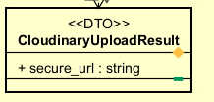
Table 1. Attributes
# | Name | Data type | Default value | Description
1 | secure_url | string | — | HTTPS URL of the uploaded image on Cloudinary

4.4.3.85 Interface "IProductHandler<T, U>"

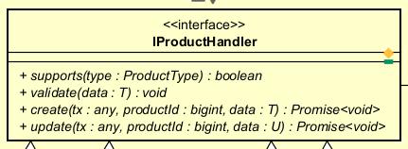
Table 1. Operations
# | Name | Return type | Description
1 | supports(type) | boolean | Returns whether this handler is responsible for the given product type
2 | validate(data) | void | Validates type-specific data before persistence
3 | create(tx, productId, data) | Promise<void> | Creates type-specific DB records within a Prisma transaction
4 | update(tx, productId, data) | Promise<void> | Updates type-specific DB records within a Prisma transaction
Parameter Details:
supports(type: ProductType): boolean
- type: The product type to check
create(tx: any, productId: bigint, data: T): Promise<void>
- tx: Prisma transaction client
- productId: ID of the base Product record just created
- data: T: Type-specific DTO (e.g., CreateBookDto, CreateCdDto)
update(tx: any, productId: bigint, data: U): Promise<void>
- tx: Prisma transaction client
- productId: ID of the Product to update
- data: U: Type-specific update DTO (currently typed as any)

4.4.3.86 Interface "ISpecification<T>"

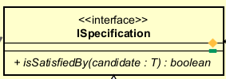
Table 1. Operations
# | Name | Return type | Description
1 | isSatisfiedBy(candidate) | boolean | Checks whether candidate satisfies the specification

4.4.3.87 Interface "IProductSpecification"

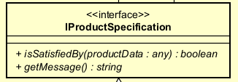
Table 1. Operations
# | Name | Return type | Description
1 | isSatisfiedBy(candidate) | boolean | Inherited from ISpecification
2 | getMessage() | string | Returns the error message when the specification is not satisfied

4.4.3.88 Class "HardDeleteSpecification"

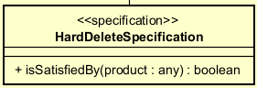
Table 1. Operations
# | Name | Return type | Description
1 | isSatisfiedBy(product) | boolean | Returns true if product.quantity === 0
Method Details:
isSatisfiedBy(product)
- Parameters:
product: any — The product object to evaluate (must contain the quantity field)
- Logic: return product.quantity === 0
- Business Rule: If quantity > 0, the product is DEACTIVATED instead of DELETED

4.4.3.89 Class "PriceRatioSpecification"

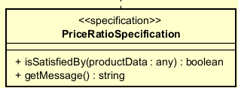
Table 1. Operations
# | Name | Return type | Description
1 | isSatisfiedBy(productData) | boolean | Checks that currentPrice is within [30%, 150%] of originalValue
2 | getMessage() | string | Returns a validation error message
Method Details:
isSatisfiedBy(productData)
- Parameters:
  - productData: any — Must contain currentPrice and originalValue
- Logic:
currentPrice = Number(productData.currentPrice)
originalValue = Number(productData.originalValue)
IF either is NaN return true (skip; let DTO validation handle it)
IF originalValue === 0 return currentPrice === 0
ELSE return 0.3 * originalValue ≤ currentPrice ≤ 1.5 * originalValue
- Business Rule : The selling price must be between 30% and 150% of the original value. If the original value is 0, the selling price must also be 0.
getMessage()
- Return: "The current price must be between 30% and 150% of the original value. (Or must be 0 if the original value is 0)."

4.4.3.90 Interface "IDailyQuotaService"

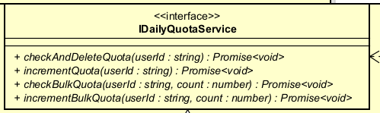
Table 1. Operations
# | Name | Return type | Description
1 | checkAndDeleteQuota(userId) | Promise<void> | Checks remaining quota for a single deletion. Throws HTTP 429 if the limit is reached.
2 | incrementQuota(userId) | Promise<void> | Increments the user's deletion counter by 1
3 | checkBulkQuota(userId, count) | Promise<void> | Checks remaining quota for a bulk deletion of count items. Throws HTTP 429 if insufficient.
4 | incrementBulkQuota(userId, count) | Promise<void> | Increments the user's deletion counter by count

4.4.3.91 Class "DailyQuotaService"

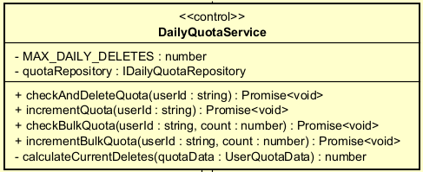
Table 1. Attributes
# | Name | Data type | Default value | Description
1 | MAX_DAILY_DELETES | number (static const) | 20 | Maximum number of deletions allowed per user per day
2 | quotaRepository | IDailyQuotaRepository | — | Repository for reading and writing quota data

Table 2. Operations
# | Name | Return type | Description
1 | checkAndDeleteQuota(userId) | Promise<void> | Fetches current quota and enforces the daily limit
2 | incrementQuota(userId) | Promise<void> | Persists dailyDeletes + 1 to the DB
3 | checkBulkQuota(userId, count) | Promise<void> | Checks that currentDeletes + count ≤ MAX
4 | incrementBulkQuota(userId, count) | Promise<void> | Persists dailyDeletes + count to the DB
5 | calculateCurrentDeletes(quotaData) | number | Returns 0 if lastDeleteDate is not today (UTC); resets the counter for a new day
Method Details:
calculateCurrentDeletes(quotaData)
- Parameters:
quotaData: UserQuotaData — Quota data retrieved from DB
- Logic:
IF isTodayUTC(quotaData.lastDeleteDate) → return quotaData.dailyDeletes
ELSE return 0 (new day — reset counter)
checkAndDeleteQuota(userId)
- Parameters: userId: string
- Exception:
BadRequestException if the user does not exist
HttpException (429) if currentDeletes >= MAX_DAILY_DELETES

4.4.3.92 Class "UserQuotaData"

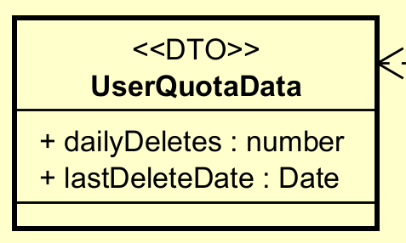
Table 1. Attributes
# | Name | Data type | Default value | Description
1 | dailyDeletes | number | — | Number of products deleted by the user today
2 | lastDeleteDate | Date \ | null | —

4.4.3.93 Interface " IDailyQuotaRepository"

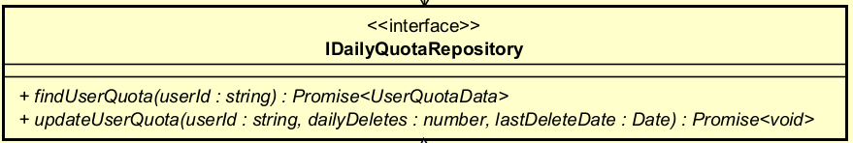
Table 1. Operations
# | Name | Return type | Description
1 | findUserQuota(userId) | `Promise | null>`
2 | updateUserQuota(userId, dailyDeletes, lastDeleteDate) | Promise<void> | Overwrites the user's dailyDeletes and lastDeleteDate
Parameter Details for updateUserQuota:
- userId: string — Target user ID
- dailyDeletes: number — New deletion count to persist
- lastDeleteDate: Date — UTC midnight of today

4.4.3.94 Class "DailyQuotaRepository"

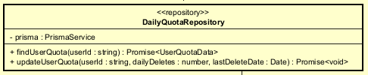
Table 1. Attributes
# | Name | Data type | Default value | Description
1 | prisma | PrismaService | — | Prisma ORM client

Table 2. Operations
# | Name | Return type | Description
1 | findUserQuota(userId) | `Promise | null>`
2 | updateUserQuota(userId, dailyDeletes, lastDeleteDate) | Promise<void> | Updates the User table with the new quota values

4.4.3.95 Interface " IProductLogService"

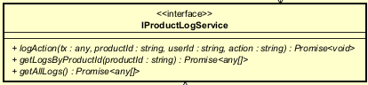
Table 1. Operations
# | Name | Return type | Description
1 | logAction(tx, productId, userId, action) | Promise<void> | Records an audit log entry for the given action
2 | getLogsByProductId(productId) | Promise<any[]> | Retrieves all log entries for a specific product
3 | getAllLogs() | Promise<any[]> | Retrieves all product audit log entries in the system
Parameter Details for logAction:
- tx: Prisma TransactionClient (optional) — used when logging must occur within an existing transaction
- productId: string — ID of the target product
- userId: string — ID of the user performing the action
- action: string — Action name: 'CREATE', 'UPDATE', 'DELETE', 'DEACTIVATE', 'UPDATE_IMAGE'

4.4.3.96 Class "ProductLogService"

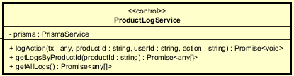
Table 1. Attributes
# | Name | Data type | Default value | Description
1 | prisma | PrismaService | — | Prisma ORM client

Table 2. Operations
# | Name | Return type | Description
1 | logAction(tx, productId, userId, action) | Promise<void> | Creates a ProductLog record in the DB
2 | getLogsByProductId(productId) | Promise<any[]> | Queries logs by productId; includes the createdBy user object
3 | getAllLogs() | Promise<any[]> | Queries all logs; includes product and user info; ordered by createdDate DESC

Method Details:
logAction(tx, productId, userId, action)
- Parameters:
tx: Prisma transaction client or undefined (falls back to this.prisma)
productId: string, userId: string, action: string
- Special Logic: If userId is falsy/empty → skip silently; no log is written (prevents errors when no authenticated user is present)
- Exception: Throws a Prisma error if productId or userId do not exist in the DB
getLogsByProductId(productId)
- Parameters: productId: string
- Return: Array of log objects including createdBy: { id, userName, email }, ordered by createdDate DESC
- Note: BigInt fields are converted to strings via JSON.parse(JSON.stringify(..., BigInt → string))
getAllLogs()
- Return: Array of all log objects including product: { id, title, barcode } and createdBy: { id, userName, email }, ordered by createdDate DESC
- Note: Same BigInt serialization as getLogsByProductId

5.Design Considerations
<Describe issues which need to be addressed or resolved before attempting to devise a complete design solution. Remember that, you have to refactor your source code to strictly follow the final design>

5.1 Goals and Guidelines

5.1.1 Design goals
- High Performance: The system prioritizes swift responses to user requests, aiming for interactions within 2 seconds under normal load and 5 seconds during peak traffic. This is crucial for a smooth e-commerce experience and user satisfaction, as slow responses can lead to abandonment.
- Scalability: AIMS is designed to support up to 1,000 concurrent users seamlessly. This goal is vital for accommodating future growth and ensuring system stability as the user base expands. Achieved through modular architecture, efficient resource management, and load balancing
- Reliability and Availability: The system is engineered to remain operational for at least 300 hours continuously and recover within 1 hour following any downtime. This minimizes service interruptions and maintains user trust, particularly important for an e-commerce platform where transactions are frequent.
- Security: Strong security practices are integrated throughout the design, including encrypted data storage, secure user authentication (e.g., JWT), role-based access control, and input validation. This is paramount to protect sensitive user data, payment information, and maintain compliance.
- User-Friendliness (Intuitive UI/UX): The user interface is designed to be simple, intuitive, and accessible for non-technical users. This focus ensures a positive user experience, reduces the learning curve, and encourages engagement with the platform.
- Maintainability: The system is designed with clear separation of concerns (e.g., Client-Server architecture) and adherence to design principles (e.g., SOLID) to simplify future updates, bug fixes, and feature additions, reducing long-term development costs and efforts.
- Extensibility: The architecture is modular to support the addition of new product types, payment methods, and external integrations without significant overhauls. This ensures the system can adapt to evolving business needs and technological Advancements.

5.1.2 Guidelines
- Maintainability: The system should be organized into clear modules so that each feature, such as product management, ordering, payment, authentication, and administration, can be developed and maintained independently. This reduces complexity and makes future updates easier.
- Separation of Concerns: The frontend, backend, database access, and external service integrations should have clearly separated responsibilities. This helps developers understand the system structure and reduces the risk of unintended side effects when modifying a feature.
- Consistency: Coding style, API structure, naming conventions, and user interface behavior should remain consistent across the whole application. This improves readability, simplifies collaboration, and makes the system easier to extend.
- Usability: The application should provide simple and predictable workflows for users, especially when browsing products, managing the cart, entering delivery information, placing orders, and completing payments. Clear feedback should be provided after each important action.
- Reliability: Order placement and payment processing must be handled carefully to prevent duplicated orders, incorrect payment status, or inconsistent transaction data. The system should prioritize correctness in all business-critical operations.
- Security: The system should validate user input, protect sensitive data, enforce authentication and authorization, and store secret configuration values securely. This helps prevent common security risks and protects user information.
- Scalability: The design should allow new features, payment methods, product types, and management functions to be added with minimal changes to existing modules.
- Responsiveness: The frontend should support different screen sizes and provide a stable user experience on both desktop and mobile devices.
- Error Handling: The system should handle errors gracefully and provide meaningful feedback to users while keeping technical details available for debugging by developers.
- Testing and Quality Assurance: Important business functions, especially product browsing, order placement, payment, authentication, and administration, should be tested to reduce regression risks and improve system stability.

5.2 Architectural Strategies

5.2.1 Monorepo and Technology Stack
The whole system lives in a single Nx monorepo containing three projects: apps/api (backend), apps/client (frontend), and apps/api-e2e (end-to-end tests). The backend is built with NestJS 11 on TypeScript, the frontend with Angular 21, and the build pipeline uses Webpack + SWC with shared ESLint/Prettier config. Reasoning: a monorepo lets the two apps share types, tooling, and CI while Nx’s task caching keeps builds fast; the trade-off (a larger repository) is acceptable for a single coordinated team.

5.2.2 Layered + Hexagonal (Ports & Adapters) Architecture
The backend’s core principle is Dependency Inversion: business modules (e.g. place-order, payment) are split into domain/ (entities, services, ports = interfaces, states, factories, validators), application/ (use-case orchestration / Facade), and infrastructure/ (adapters, repositories). High-level logic depends only on port interfaces wired through NestJS DI tokens (ORDER_REPOSITORY, SHIPPING_FEE_CALCULATOR, PLACE_ORDER_PAYMENT_PORT, …), never on concrete frameworks. Reasoning / trade-off: this is what gives the system loose coupling, high cohesion, testability, and OCP extensibility; the cost is more indirection (more small classes), which we judged worthwhile for maintainability.

5.2.3 RESTful API and DTO-based Contracts
Communication between the Angular client and the NestJS backend is via a stateless RESTful API. Each NestJS controller exposes resource endpoints (e.g. POST /place-order/check-stock, /delivery-info, /payment, /confirm) and accepts/returns DTOs validated declaratively with class-validator + class-transformer. Reasoning: DTOs decouple the public API contract from internal domain/persistence models and centralise input validation at the boundary.

5.2.4 Frontend – Angular Single-Page Application
The UI (apps/client) is an Angular 21 component-based SPA (standalone components, SCSS styling). It holds no business logic — it renders state and calls the REST API. Reasoning: a component model maximises reuse and a clear input/output (request/response) interaction model with the backend.

5.2.5 Persistence and Data Management
Data is stored in PostgreSQL, accessed through Prisma 7 using the driver-adapter pattern (@prisma/adapter-pg over a pg connection Pool). A single PrismaService wraps the generated client, and the Repository pattern ensures only repository adapters touch Prisma — the domain receives normalised read-models (plain number/string), so Prisma Decimal/BigInt types never leak inward. Multi-row writes (order + lines + invoice + stock + payment transaction) run inside a single $transaction for atomicity. Reasoning / trade-off: the driver-adapter + repository indirection keeps the domain database-agnostic and swappable, at the price of an extra mapping layer.

5.2.6 Security and Authentication
Authentication is stateless JWT via Passport (@nestjs/jwt, passport-jwt, jwt.strategy.ts); passwords are hashed with bcrypt; an OTP service supports sensitive flows. Cookies are parsed via cookie-parser, and secrets/keys are kept out of code in environment variables. Reasoning: JWT enables scalable, server-side-stateless sessions consistent with the REST design.

5.2.7 Payment Gateway Integration (pluggable)
Payments are integrated through an abstraction layer: a payment-gateway.port.ts (IPaymentGateway) with a payment-gateway.factory.ts that selects the concrete gateway — VietQR (QR generated with qrcode, default method) or PayPal (REST via axios) — implemented as separate vietqr/ and paypal/ adapter modules. The place-order and payment modules integrate only through ports (PlaceOrderPaymentPort), avoiding a circular module dependency. Reasoning: this is a Strategy/Adapter design so a new gateway is a new adapter, not a change to existing code (the problem statement’s “other gateways may be supported in the future”).

5.2.8 Notifications and Communication
Order notifications use the Observer pattern: a confirmed order publishes an event to registered observers. Today an EmailNotificationObserver sends the invoice via the mail module (nodemailer / Resend, HTML templates); SMS/Zalo/Push can be added as new observers without touching the order flow. Reasoning: decouples “an order was paid” from “how the customer is notified” (OCP).

5.2.9 Error Detection and Recovery
Errors are separated by layer: pure domain errors (DomainError, IllegalOrderTransitionError) carry no HTTP/framework dependency, while application/infrastructure raise NestJS HTTP exceptions (InvalidQuantityException, InvalidDeliveryInfoException, PaymentNotSuccessfulException). Recovery mechanisms include idempotent payment confirmation (look up an existing transaction before creating an order), a State-pattern guard on illegal transitions, and a stale-payment-transaction cleanup service that releases orphaned PENDING_PAYMENT orders. Reasoning: keeps the domain testable and makes the payment flow resilient to retries/abandonment.

5.2.10 Concurrency and Synchronization
The system is stateless at the service layer (no shared mutable in-memory state) and pushes concurrency control to atomic PostgreSQL operations. The PENDING_PAYMENT → PENDING_PROCESSING transition is claimed exactly once with a status-guarded updateMany, and stock is decremented with a conditional update (quantity >= requested) so concurrent orders and duplicate payment callbacks can never oversell or double-decrement. Reasoning / trade-off: relying on the database for synchronisation keeps services horizontally scalable (matching the “1,000 concurrent customers” requirement) instead of using in-process locks.

5.2.11 File and Asset Management
Product images are uploaded with Multer and stored in Cloudinary (external object storage) rather than in the database or app server. Reasoning: offloads large binary storage/CDN delivery to a specialised service and keeps the relational DB lean.

5.2.12 Configuration and Environment Management
All environment-specific values — DATABASE_URL/DIRECT_URL, CLIENT_URL, payment-gateway keys, mail keys — are externalised via @nestjs/config + dotenv, never hard-coded. Pricing data (e.g. DEFAULT_SHIPPING_FEE_CONFIG) is also injected, not embedded. Reasoning: supports clean deployment across dev/staging/production and per-environment overrides.

5.2.13 Testing and Quality Assurance
Quality is enforced with Jest unit tests (apps/api/jest.config) and a separate e2e project (apps/api-e2e), using @nestjs/testing for DI-based mocking. Reasoning: the Ports & Adapters design lets domain logic be tested with in-memory fakes (e.g. new OrderFactory()) without a real database or HTTP server.

5.2.14 Extensibility and Future Plans (OCP)
The architecture is designed for the AIMS “may be supported in the future” requirements: a new shipping rule, notification channel, payment gateway, or product type is added by implementing the relevant port and changing one DI binding — existing code is untouched. Reasoning: this Open–Closed extensibility was the primary design goal that justified the Hexagonal layering chosen in 5.2.2.

5.3 Design and Program Evaluation

5.3.1 Cohesion & SRP
Explain in detail for each class in the table.
Table 4. Cohesion & SRP of AIMS
# | Class Name | PIC | Cohesion | SRP | Solution
1 | PaymentPage | TuNHT, BinhNT | Functional cohesion. It only acts as the payment page boundary: receives user actions, displays payment state, and delegates workflow actions to PaymentPageFacade. | Yes. It does not call backend business logic, database code, or provider APIs directly. | No change needed. Keep UI display and event forwarding only.
2 | PaymentPageFacade | TuNHT, BinhNT | Sequential/functional cohesion. It coordinates the payment page workflow: initialize page, select payment method, confirm order, cancel order, and route to result/cart pages. | Yes. It coordinates client-side flow but does not create gateway payments or mutate backend state directly. | If more payment methods are added, keep using separate flow services instead of adding provider-specific logic here.
3 | PaymentServiceClient | TuNHT, BinhNT | Functional cohesion. It is an Angular HTTP client for payment endpoints such as requestPayment, confirmTransaction, and cancelTransaction. | Yes. It only serializes DTOs and calls REST endpoints; it contains no business rules. | requestCustomerRefund() may stay here because refund is part of the payment API boundary.
4 | PaymentController | TuNHT, BinhNT | Functional cohesion. All methods expose payment endpoints: request, confirm, cancel, refund, and transaction lookup. | Yes. It only receives HTTP requests and delegates to PaymentService. It does not query Prisma or call gateway providers directly. | If refund grows into a larger domain, split RefundController; otherwise no change needed.
5 | PaymentService | TuNHT, BinhNT | Sequential cohesion. It coordinates ordered steps in the payment lifecycle: validate amount, create/reuse transaction, cancel other pending transactions, select gateway, update provider data, confirm, cancel, and refund. | Mostly yes. It is an application service, so orchestration is its accepted responsibility. The risk is that it can become too large. | The design already extracts transaction mutation, completion, gateway selection, and reference resolution to separate classes. If refund logic grows, create a dedicated RefundService.
6 | PaymentTransactionService | TuNHT, BinhNT | Functional cohesion. It only handles payment transaction state changes: create/reuse pending, cancel other pending transactions, mark failed, and mark success. | Yes. It does not know provider APIs or UI details. | No change needed.
7 | PaymentGatewayFactory | TuNHT, BinhNT | Functional cohesion. It only resolves payment gateways by method and capability: creation, confirmation, and refund. | Yes. It does not execute payments; it only returns the proper adapter. | No change needed. This is the main OCP extension point.
8 | PaymentCompletionService | TuNHT, BinhNT | Functional cohesion. It only completes a successful payment: marks the transaction successful, cancels other pending transactions, and marks the order as pending processing. | Yes. It separates post-success completion from PaymentService. | No change needed.
9 | PaymentGatewayTransactionRefResolver | TuNHT, BinhNT | Functional cohesion. It only resolves the transaction reference that should be sent to the gateway. | Yes. It validates and returns a reference; it does not perform capture/refund. | No change needed.
10 | PaymentSessionStorageService | TuNHT, BinhNT | Functional cohesion. It only stores, loads, and clears client-side payment session data. | Yes. It does not call the API or apply business rules. | No change needed.
11 | PaypalPaymentPageFlowService | TuNHT | Functional cohesion. Manages only the PayPal page-level flow: start checkout, handle return, capture payment, show errors. | Yes. Does not know PayPal HTTP endpoints or DB schema. | No change needed. Extract a presenter if UI-state handling grows.
12 | PaypalPaymentFlowService | TuNHT | Functional cohesion. Groups PayPal client operations: create, capture, save/load/clear session. | Yes. Bridges page flow, API client, and session storage only. | No change needed.
13 | PaypalGatewayAdapter | TuNHT | Functional cohesion. Adapts PayPal provider operations to the generic payment gateway interfaces. | Yes. Does not handle Angular HTTP requests or mutate Prisma records directly. | No change needed.
14 | PaypalService | TuNHT | Functional cohesion. Communicates solely with the PayPal HTTP API: auth, create, capture, refund. | Yes. Does not know AIMS order state, payment transactions, or UI sessions. | Split into separate auth/order/refund clients if the API scope grows.
15 | VietQrPaymentPageFlowService | BinhNT | Sequential/functional cohesion. It manages the VietQR page flow: create/resume QR payment, update QR image, confirm current payment, handle expired/failed status, and complete successful payment. | Mostly yes. It coordinates UI state and VietQR page-level workflow, but it also contains QR image update and error handling logic. | Extract QR image update or UI error-message handling into smaller helpers if the page flow keeps growing
16 | VietQrPaymentFlowService | BinhNT | Functional cohesion. It owns VietQR client-side payment operations: request payment, store snapshot, poll latest transaction status, resume/clear snapshot, and trigger sandbox callback | Mostly yes. It focuses on VietQR flow logic, but polling and sandbox callback triggering are both handled here. | Move sandbox callback triggering into a dedicated VietQrSandboxCallbackFlowService if confirmation logic becomes more complex
17 | PaymentStatusApiService | BinhNT | Functional cohesion. It wraps payment status endpoints used by the client, including latest transaction lookup and VietQR sandbox callback request | Mostly yes. It only performs HTTP calls, but it mixes general payment status lookup with VietQR-specific sandbox callback API | Split latest transaction lookup and VietQR sandbox callback API into separate services if more status or sandbox endpoints are added
18 | QrImageService | BinhNT | Functional cohesion. It only converts VietQR QR source data into an image URL for display. | Yes. It does not know payment state, order state, or backend APIs. | No change needed.
19 | VietqrGatewayAdapter | BinhNT | Functional cohesion. It adapts VietQR QR creation to the generic payment gateway interface | Yes. It builds VietQR payment output from VietqrService and does not mutate Prisma records directly. | No change needed. This is a clean adapter between generic payment flow and VietQR.
20 | VietqrController | BinhNT | Functional cohesion. It exposes VietQR sandbox-related endpoints: transaction sync callback and test callback | Mostly yes. It delegates business logic, but it groups callback sync and sandbox test callback in the same controller. | If sandbox endpoints expand, create a VietqrSandboxController and keep this controller focused on callback sync
21 | VietqrService | BinhNT | Functional cohesion. It handles VietQR QR generation: validates amount, builds VietQR request, gets token, calls the VietQR client, and maps QR response data. | Mostly yes. It is focused on QR generation, but it also maps provider response into internal QR data. | Extract response mapping into a VietqrQrResponseMapper if VietQR response handling becomes more detailed.
22 | VietqrSandboxService | BinhNT | Sequential cohesion. It validates that a pending VietQR transaction exists, fills sandbox callback defaults, gets an access token, and requests the VietQR test callback. | Mostly yes. It is focused on sandbox callback simulation, but includes pending transaction validation. | Extract pending VietQR transaction validation into a helper/service if other sandbox actions reuse the same validation.
23 | VietqrCallbackService | BinhNT | Sequential cohesion. It processes VietQR callback steps: validate transaction type, detect duplicates, find matching VietQR transaction, check amount, and complete successful payment | Mostly yes. Callback processing is its responsibility, but duplicate lookup and transaction matching make the service relatively dense. | Extract duplicate-callback lookup and transaction matching into small resolver methods/classes if callback rules grow.
24 | VietqrInboundController | BinhNT | Functional cohesion. It exposes only the VietQR inbound token generation endpoint | Yes. It only receives the Authorization header and delegates token generation to VietqrInboundService | No change needed.
25 | VietqrInboundService | BinhNT | Functional cohesion. It handles VietQR inbound authentication: parse Basic Auth, validate credentials, generate callback token, and validate callback bearer token. | Mostly yes. It stays inside inbound auth, but token signing, token validation, and Basic Auth parsing are all in one class. | Extract token signing/verification into a small token service if more inbound auth logic is added.
26 | VietqrTokenService | BinhNT | Functional cohesion. It manages VietQR outbound access tokens: fetch, cache, refresh, clear, and retry after auth failure. | Yes. It does not generate QR codes or process callbacks directly | No change needed.
27 | VietqrHttpClient | BinhNT | Functional cohesion. It communicates only with VietQR HTTP endpoints: token generation, QR generation, and sandbox test callback | Yes for current sandbox size. It contains provider HTTP details only, with no AIMS business rules. | Keep as is. Split into smaller clients only if the VietQR API surface becomes much larger
28 | VietqrQrRequestBuilder | BinhNT | Functional cohesion. It only builds VietQR QR generation requests from payment input and VietQR config. | Yes. It does not call HTTP APIs or update payment state. | No change needed.
29 | VietqrCallbackAuthGuard | BinhNT | Functional cohesion. It only validates VietQR callback bearer-token authentication before allowing callback sync. | Yes. It does not process payment data or call provider APIs. | No change needed.
30 | VietqrCallbackResponseMapper | BinhNT | Functional cohesion. It only maps VietQR callback results/errors into response DTOs. | Yes. It has no business workflow or persistence responsibility. | No change needed.
31 | VietqrConfigService | BinhNT | Functional cohesion. It centralizes VietQR sandbox configuration: base URL, credentials, QR config, callback defaults, and inbound auth env values. | Mostly yes. It is a configuration boundary, but it contains several groups of VietQR config. | No change needed.
32 | PlaceOrderController | KhanhNT | Functional – every handler only exposes an endpoint and delegates to the service | Yes – one reason to change: the HTTP boundary of place-order | None
33 | PlaceOrderBeService | KhanhNT | Functional/Communicational – all methods coordinate one ordering workflow and share the same collaborators | Yes – it only orchestrates; no DB access / VAT math / e-mail of its own | None
34 | OrderValidationService | KhanhNT | Communicational (near Logical) – groups three different kinds of validation | No – more than one reason to change: cart rules vs. payment rules | Extract normalizeItems → CartItemValidator and validatePaymentInfo → PaymentInfoValidator; delivery validation is already delegated to DeliveryInfoValidator
35 | StockCheckerService | KhanhNT | Functional | Yes – one reason: stock-checking rules | None
36 | InvoiceCalculator | KhanhNT | Functional | Yes – one reason: invoice/VAT pricing (shipping is delegated) | None
37 | ProductController | NghiaTT | Functional: only routes HTTP requests for the product API | Yes: single responsibility = expose product read endpoints. | No change needed (keep thin).
38 | GetProductDetailUseCase | NghiaTT | Functional: orchestrates the single flow of retrieving a product detail. | Yes: one business operation. | None.
39 | ProductDetailMapper | NghiaTT | Functional/ Communicati onal: all methods transform one record into DTOs. | Yes: only persistence → DTO mapping. | None.
40 | PrismaProductRepository | NghiaTT | Functional: implements product read queries. | Yes: read-side persistence only. | Keep command ops in a separate repository (done).
41 | ProductDetailPageComponent | NghiaTT | Functional (mostly): reads route id, manages load state, renders. | Partial: also handles error + navigation. | Delegate rendering to child components (done).
42 | ProductDetailComponent | NghiaTT | Communicati onal: renders detail fields and owns add-to-cart quantity. | Partial: display + add-to-cart. | Cart state delegated to CartStoreServ ice.
43 | ProductApiService | NghiaTT | Functional: centralizes product read HTTP calls. | Yes. | None.
44 | ProductController | HieuBT | Functional cohesion. All methods serve one purpose: expose HTTP endpoints for the product CUD API and delegate to the service layer. No business logic, no Prisma calls, no gateway interaction exists here. | Yes. Its single reason to change is when the product HTTP API surface changes (new endpoints, route structure, or auth guards). It does not encode rules about deletion limits, price ratios, or DB schema. | No change needed. Keep the controller thin: receive request → delegate → return response. If the product surface grows significantly (e.g., a dedicated inventory API), split into ProductCudController and ProductQueryController.
45 | ProductService | HieuBT | Sequential cohesion. Methods execute ordered steps through the product lifecycle: validate business specifications → persist via repository → record audit log → enforce/increment deletion quota. The output of one step feeds the next. | Mostly yes. As an application-layer orchestrator, coordinating multiple domain services is its accepted responsibility. The risk is that it can become too large if more lifecycle events are added. | The design already extracts quota enforcement, audit logging, and business rule validation into separate injected services. If the deletion flow grows more complex (e.g., order-aware rollback logic), extract a dedicated ProductDeletionService.
46 | ProductRepository | HieuBT | Functional cohesion. All methods perform a single concern: read or write the Product aggregate to the database via Prisma. Type-specific persistence is delegated to IProductHandler, keeping this class focused on base-product CRUD only. | Mostly yes. Its single reason to change is when the base product DB schema changes. The serializeBigInt utility method is a minor SRP deviation — it is a serialization concern, not a persistence concern. The checkInOrders method crosses domain boundaries (it queries the Order domain). | Extract serializeBigInt into a shared BigIntSerializer utility. Consider moving checkInOrders to an OrderRepository or a cross-domain query service to respect domain boundaries.
47 | BookHandler | HieuBT | Functional cohesion. All logic in this class pertains exclusively to persisting Book-specific product data: creating PrintableProduct, Book, and Author/BookAuthor records, and updating them in isolation. | Yes. Its single reason to change is when the Book product's DB schema or Author upsert rules change. It does not know about CD, DVD, or Newspaper structure. | No change needed. If Author management grows complex (e.g., deduplication rules, author profiles), extract an AuthorRepository to isolate that logic from the handler.
48 | CdHandler | HieuBT | Functional cohesion. All logic pertains exclusively to DiscProduct and CD record persistence. | Yes. Single reason to change: CD-specific DB schema changes. | No change needed.
49 | DvdHandler | HieuBT | Functional cohesion. All logic pertains exclusively to DiscProduct and DVD record persistence. | Yes. Single reason to change: DVD-specific DB schema changes. | No change needed.
50 | NewspaperHandler | HieuBT | Functional cohesion. All logic pertains exclusively to PrintableProduct and Newspaper record persistence. | Yes. Single reason to change: Newspaper-specific DB schema changes. | No change needed.
51 | BaseCreateProductDto | HieuBT | Communicational cohesion. All fields operate on the same data structure: the common attributes of any product being created. Fields are grouped because they all describe the same entity. | Yes. Single reason to change: when the set of common product fields changes (e.g., adding a sku field that all product types share). | No change needed. This is the correct base for type-specific DTOs to extend.
52 | CreateBookDto / CreateCdDto / CreateDvdDto / CreateNewspaperDto | HieuBT | Communicational cohesion. Each DTO groups only the fields that belong to its specific product type. | Yes. Each DTO has one reason to change: when its specific product type's attributes change. They do not contain fields from other product types. | No change needed. This is the correct result of splitting the old God DTO.
53 | UpdateProductDto | HieuBT | Logical cohesion. Fields from all four product types (Book, CD, DVD, Newspaper) are grouped together into a single class for no reason other than they all serve "update" operations. This is a God DTO. | No. It has four reasons to change: one for each product type. Adding a new field to the Book domain forces a change to this class, even though CD, DVD, and Newspaper are unaffected. This is a known technical debt. | Refactor needed. Split into UpdateBookDto, UpdateCdDto, UpdateDvdDto, and UpdateNewspaperDto following the same structure as the Create DTOs. The ProductService and ProductRepository should accept a union type or use the Strategy Pattern to delegate to the correct handler with the right DTO.
54 | HardDeleteSpecification | HieuBT | Functional cohesion. The entire class exists to evaluate one business rule: can this product be hard-deleted? The single method isSatisfiedBy checks quantity === 0. | Yes. Single reason to change: when the hard-delete eligibility rule changes (e.g., "quantity must be 0 AND no pending returns"). | No change needed. The Specification Pattern correctly isolates this rule.
55 | PriceRatioSpecification | HieuBT | Functional cohesion. The entire class exists to evaluate one business rule: is the current price within the allowed ratio of the original value (30%–150%)? | Yes. Single reason to change: when the AIMS price ratio policy changes. | No change needed.
56 | DailyQuotaService | HieuBT | Functional cohesion. All methods relate to a single concern: enforcing daily deletion quotas. Methods checkAndDeleteQuota, checkBulkQuota, incrementQuota, and incrementBulkQuota all operate on the same quota state. The private calculateCurrentDeletes is a pure helper for the same concern. | Yes. Single reason to change: when the quota business rules change (e.g., limit changes from 20 to 30, or a weekly quota is introduced). It does not know about Prisma, HTTP, or product domain details. | No change needed. This class was already refactored from a version that mixed business logic with direct Prisma access (see SOLID section below).
57 | DailyQuotaRepository | HieuBT | Functional cohesion. All methods perform a single concern: read and write user quota fields (dailyDeletes, lastDeleteDate) in the database. It queries only the fields it needs, not the full User record. | Yes. Single reason to change: when the storage mechanism for quota data changes (e.g., migrating from PostgreSQL to Redis). | No change needed. This is a clean data access layer with no business logic.
58 | UserQuotaData | HieuBT | Communicational cohesion. Both fields (dailyDeletes, lastDeleteDate) operate together to represent a user's quota state. They are inseparable in the context of quota calculation. | Yes. Single reason to change: when the data structure needed for quota calculation changes. It intentionally exposes only quota fields, not the entire User entity (ISP compliance). | No change needed.
59 | ProductLogService | HieuBT | Functional cohesion. All methods relate to a single concern: audit logging of product operations. logAction writes a log; getLogsByProductId and getAllLogs read logs. | Mostly yes. Its primary responsibility is audit logging. However, mixing write (logAction) and read (getLogsByProductId, getAllLogs) operations means it has two reasons to change: when the log write format changes, and when the log query shape changes. | If the audit log querying requirements grow significantly (e.g., filtering, aggregation, export), extract a ProductLogQueryService for read operations and keep ProductLogService for write-only.
60 | IProductHandler\<T,U\> | HieuBT | Functional cohesion. The interface defines exactly the operations needed to handle one product type's full lifecycle: check support, validate, create, and update. | Yes. Single reason to change: when the contract for what a product type handler must support changes (e.g., adding a delete method to the contract). | No change needed. Generic parameters T and U ensure type-safe DTO binding per implementation.
61 | IProductLogService / IDailyQuotaService / IDailyQuotaRepository / ISpecification / IProductSpecification | HieuBT | Functional cohesion. Each interface defines a single focused contract: log product events, manage quotas, access quota data, check a specification, and check a specification with a message, respectively. | Yes. Each interface has one reason to change: when its specific contract evolves. They are deliberately narrow to support DIP and ISP compliance. | No change needed. These are the abstraction layer that allows the application core to be independent of infrastructure and concrete implementations.
62 | WeightBasedShippingStrategy | KhanhNT | Functional – calculate + helpers (resolveZone, calculateRawShippingFee, calculateDiscount) all compute the shipping fee | Yes – one reason: the shipping-fee algorithm | None
63 | OrderFactory | KhanhNT | Functional – buildCreateOrderInput, generateOrderCode both assemble the order-create input | Yes – one reason: how CreateOrderInput is assembled | None
64 | OrderSuccessMapper | KhanhNT | Functional – fromDeliveryInfo, fromPersistedOrder both build OrderSuccessDto | Yes – one reason: the result-DTO shape | None
65 | OrderEventPublisher | KhanhNT | Functional – publish only broadcasts the event to observers | Yes – one reason: the event-publishing mechanism | None
66 | EmailNotificationObserver | KhanhNT | Functional – update only renders & sends the confirmation e-mail | Yes – one reason: the e-mail channel | None
67 | OrderStateFactory | KhanhNT | Functional – create only maps a status to its state object | Yes – one reason: the set of valid states | None
68 | BaseOrderState / PendingPaymentState / PendingProcessingState | KhanhNT | Functional – each class encapsulates the confirmPayment behaviour of exactly one state | Yes – each class = exactly one state | None
69 | DeliveryInfoValidator | KhanhNT | Functional – the validator runs a set of rules; each rule (ReceiverNameRule, PhoneNumberRule, …) validates exactly one field | Yes – each rule = one field; the validator = one job: run the rules | None
70 | PrismaOrderRepository | KhanhNT | Functional – every method serves "order persistence" behind the IOrderRepository port (find*, create*, applyPaidTransition, stock decrement) | Yes – one reason: the persistence schema / Prisma | None
71 | PlaceOrderPaymentAdapter | KhanhNT | Functional – getPaymentContext, markPaidAndPendingProcessing, notifyOrderConfirmed all bridge place-order ↔ payment | Yes – one reason: the payment-port contract | None

5.3.2 Coupling & Other SOLID
Explain in detail for each problem in the table. Each problem, you may provide a class diagram before and after the improvement.
Table 5. Coupling & other SOLID of AIMS
# | Problem | PIC | Location | Solution
1 | Control coupling risk through paymentMethod. A weaker design would put if method == ... logic throughout the service layer. | TuNHT, BinhNT | PaymentService, gateway selection. | Gateway selection is centralized in PaymentGatewayFactory. Provider-specific behavior is moved into adapters. This reduces control coupling and improves OCP.
2 | Stamp coupling risk if full persistence objects are passed into gateways. Gateways should not receive full Prisma models. | TuNHT, BinhNT | PaymentService to gateway adapters. | The current design passes focused DTOs such as PaymentGatewayContext and transaction references. This is data coupling, which is acceptable.
3 | External coupling with PayPal API. | TuNHT | PaypalService | Unavoidable but isolated inside PaypalService. Other AIMS classes do not know the endpoints or payload details.
4 | Content coupling risk if PayPal HTTP logic is placed in PaymentService. | TuNHT | PaymentService / PaypalGatewayAdapter | Solved by PaypalGatewayAdapter. PaymentService communicates strictly through generic gateway interfaces.
5 | Temporal coupling caused by browser redirect. | TuNHT | PaypalPaymentPageFlowService | Session persistence is isolated. Missing/expired sessions are handled as explicit error paths.
6 | Stamp coupling risk with PayPal provider data. | TuNHT | PaypalGatewayAdapter, PaypalService | Converted to Data coupling: Only primitive data (amount, PayPal order id, capture id) is passed instead of full entity objects.
7 | OCP risk when PayPal refund behavior differs from other providers. | TuNHT | Refund flow | PayPal implements Payment RefundGateway; providers without automatic refund omit it and fall back to manual handling.
8 | External coupling with VietQR sandbox API. AIMS must call VietQR sandbox endpoints for token generation, QR generation, and test callback. | BinhNT | VietqrHttpClient, VietqrService, VietqrSandboxService | This external coupling is isolated inside VietqrHttpClient. Other classes do not know VietQR URLs, headers, or raw HTTP payload details. VietqrService and VietqrSandboxService communicate through VietqrClient and DTOs only.
9 | Content coupling risk if VietQR request payload construction is placed directly in PaymentService or VietqrGatewayAdapter. | BinhNT | VietqrGatewayAdapter, VietqrService, VietqrQrRequestBuilde | VietQR payload construction is extracted to VietqrQrRequestBuilder. PaymentService only sends generic payment data, while VietqrGatewayAdapter converts it to VietQR payment intent. This improves SRP and reduces content coupling.
10 | Temporal coupling in VietQR sandbox payment flow. The client must create QR payment, poll transaction status, trigger sandbox callback, then check status again. | BinhNT | VietQrPaymentFlowService, VietQrPaymentPageFlowService | The ordered workflow is centralized in VietQrPaymentFlowService and VietQrPaymentPageFlowService instead of being spread across components. Snapshot storage and polling make the sequence explicit and easier to recover after refresh.
11 | coupling risk through VietQR transaction status. UI behavior changes based on PENDING, SUCCESS, FAILED, and REFUND_REQUIRED. | BinhNT | VietQrPaymentPageFlowService, VietQrPaymentFlowService | Status-based behavior is kept inside VietQR flow services. The payment component does not contain large conditional logic for every transaction status. This keeps the UI boundary thinner and improves SRP.
12 | Stamp coupling risk if full PaymentTransaction records are passed to VietQR callback response logic. | BinhNT | VietqrCallbackService, VietqrCallbackResponseMapper | The callback flow uses TransactionSyncDto and TransactionStatusDto instead of exposing full Prisma entities. VietqrCallbackResponseMapper maps only the fields needed by the callback response.
13 | Content coupling risk if VietQR callback processing directly updates all order/payment fields. | BinhNT | VietqrCallbackService, PaymentCompletionService | VietqrCallbackService only validates and matches the callback, then delegates successful completion to PaymentCompletionService. This keeps callback-specific logic separate from general payment completion logic.
14 | Data coupling with environment configuration. VietQR sandbox depends on many config values such as bank account, bank code, credentials, callback defaults, and token secret | BinhNT | VietqrConfigService | Configuration access is centralized in VietqrConfigService. Other VietQR classes request named config groups instead of reading process.env directly everywhere. If config grows, split it into outbound QR, inbound auth, and sandbox callback config groups.
15 | Authentication coupling between VietQR callback guard and inbound token validation. | BinhNT | VietqrCallbackAuthGuard, VietqrInboundService | VietqrCallbackAuthGuard only extracts the bearer token and delegates validation to VietqrInboundService. This avoids duplicating token validation rules in the controller or callback service.
16 | OCP risk when adding more sandbox provider actions. Adding new VietQR sandbox operations directly into PaymentStatusApiService can make the service too broad. | BinhNT | PaymentStatusApiService | Current design is acceptable for the existing sandbox flow. If more sandbox actions are added, split VietQR sandbox callback calls into a dedicated VietQrSandboxApiService while keeping PaymentStatusApiService for transaction lookup only
17 | ISP risk because PaymentStatusApiService exposes both general payment status lookup and VietQR-specific sandbox callback request. | BinhNT | PaymentStatusApiService | The current interface is still small, but clients that only need status lookup can technically access VietQR sandbox callback too. A cleaner design would separate PaymentTransactionStatusApi and VietQrSandboxCallbackApi if the client API grows.
18 | DIP risk if services depend directly on concrete VietQR HTTP implementation. | BinhNT | VietqrService, VietqrSandboxService, VietqrHttpClient | The code uses the VietqrClient interface/token instead of directly depending on VietqrHttpClient. This follows DIP and makes the sandbox client replaceable in tests.
19 | Control coupling risk in gateway behavior if PaymentService manually checks VietQR-specific QR behavior. | BinhNT | PaymentService, VietqrGatewayAdapter | VietQR-specific QR creation is handled inside VietqrGatewayAdapter. PaymentService uses generic gateway interfaces, so adding or changing VietQR behavior does not require spreading VietQR conditions through PaymentService.
20 | Temporal coupling with token caching and retry. VietQR calls must use a valid access token and retry after auth failure. | BinhNT | VietqrTokenService, VietqrService, VietqrSandboxService | Token lifecycle is isolated in VietqrTokenService. VietqrService and VietqrSandboxService call withAccessTokenRetry(), so they do not need to duplicate token refresh logic
21 | Control coupling (resolved → improved) | NghiaTT | ProductDetailMapper previously selected type-specific mapping with if/else on product type | Refactored to a Strategy map Record → data coupling + OCP.
22 | DIP | NghiaTT | GetProductDetailUseC ase ↔ persistence. | Depends on the ProductQueryRepository abstraction (tokeninjected), not on Prisma directly.
23 | ISP | NghiaTT | ProductQueryRepository. | Exposes only read ops (findProducts, findProductById); command ops kept in separate abstractions.
24 | OCP | NghiaTT | Adding a new product type. | Add a new specificInfo mapper + child component; existing dispatch logic is not modified.
25 | Data coupling (good) | NghiaTT | controller → use case → repository → mapper. | Layers pass simple ids/DTOs, no shared global state.
26 | Control coupling & OCP risk if product type specific logic (Book, CD, DVD) is hard-coded using if/switch throughout the service layer. | HieuBT | ProductService, ProductRepository | Product type handling is centralized using the Strategy Pattern via IProductHandler. The repository dynamically selects the handler. This reduces control coupling and improves OCP.
27 | Content coupling & DIP risk if business logic accesses the database directly. Previously, DailyQuotaService contained raw Prisma queries, mixing rules with data access. | HieuBT | DailyQuotaService | Extracted DB access to IDailyQuotaRepository and injected it. DailyQuotaService now depends on abstractions (DIP) and passes focused DTOs (Data Coupling).
28 | DIP risk & Content coupling if services depend directly on concrete rule classes. ProductService previously injected the concrete HardDeleteSpecification class. | HieuBT | ProductService, HardDeleteSpecification | Injected the specification via the HARD_DELETE_SPECIFICATION DI token typed as ISpecification<any>. The service now depends on an abstraction.
29 | Common coupling & SRP risk due to a God DTO. UpdateProductDto groups fields from all four product types, forcing handlers to see irrelevant fields. | HieuBT | UpdateProductDto, Handlers | Pending Refactor: Split the God DTO into UpdateBookDto, UpdateCdDto, etc., to achieve Data Coupling and satisfy ISP/SRP for handlers.
30 | Content coupling at infrastructure boundary. Handlers depend directly on the Prisma transaction internals and exact nested schema. | HieuBT | BookHandler, CdHandler, DvdHandler, NewspaperHandler | Accepted trade-off. Handlers operate specifically at the infrastructure boundary to bridge DTOs and the ORM. This prevents over-engineering.
31 | Cross-domain coupling. Product persistence layer directly queries the Order domain to check if a product can be deleted. | HieuBT | ProductRepository.checkInOrders() | Pending Refactor: Move the order checking logic to an OrderRepository or a dedicated cross-domain query service to respect domain boundaries.
32 | External coupling with image hosting API. ProductController needs to upload images but should not know the HTTP/API details. | HieuBT | ProductController, CloudinaryService | Isolated in CloudinaryService. The controller only passes the file object and receives a URL result (Data coupling), ensuring SRP.
33 | OCP & SRP risk for product validation rules. Business rules (e.g., price ratio) might change frequently, risking bloated validation methods. | HieuBT | ProductService.validateProductSpecifications() | Implemented Specification Pattern. ProductService injects IProductSpecification[] and loops through them. Adding rules requires no changes to the service.
34 | ISP risk if quota tracking exposes the entire User entity to the business layer. | HieuBT | IDailyQuotaRepository, DailyQuotaService | Created UserQuotaData DTO containing only dailyDeletes and lastDeleteDate, ensuring the business logic only receives what it needs.
35 | ISP violation | KhanhNT | CartItemDto — consumed by PlaceOrderController, OrderValidationService.normalizeItems, StockCheckerService.check. Fields price and weight are never read by the serve | Remove price and weight; keep only productId + quantity (the cart’s real intent). If a future use case (e.g., a client-side price preview) needs them, define a separate DTO instead of widening the shared one.
36 | Stamp coupling | KhanhNT | CartItemDto is a composite object passed to OrderValidationService.normalizeItems(items) and StockCheckerService.check(items, …), but only productId/quantity are used → unused fields ride along. | Pass only the elementary fields actually required, or trim CartItemDto.. This drops the coupling to Data coupling.
37 | SRP violation | KhanhNT | OrderValidationService — validates three different inputs: cart items (normalizeItems), delivery info (validateDeliveryInfo*), and payment info (validatePaymentInfo). More than one reason to change. | Split into CartItemValidator (normalizeItems) and PaymentInfoValidator (validatePaymentInfo); keep delivery validation delegated to DeliveryInfoValidator
38 | DIP | KhanhNT | PlaceOrderBeService (high-level Facade) → injects the concrete PaymentService from the payment module, not an abstraction. | Define a payment port interface (e.g. IPaymentGateway with requestPayment(...)) and inject it via a DI token, so the facade depends on the abstraction (consistent with how IOrderRepository/IShippingFeeCalculator are already done).
39 | Control coupling | KhanhNT | OrderValidationService.collectDeliveryErrors(deliveryInfo, requireEmail: boolean) — a boolean flag selects behaviour (whether to add the “email required” error). | Remove the flag: split into two private helpers (collectDeliveryErrorsBasic / …ForOrder), or compose the email rule into the rule list. Eliminates the flag parameter.

5.4 Design Patterns

5.4.1 Payment

5.4.1.1 Strategy Pattern
Why it is used
Different payment methods have different algorithms for payment creation, confirmation, and refund.
- PayPal creates a checkout order, redirects the customer, then captures the approved order.
- VietQR generates a QR code and is confirmed by callback.
- Some methods support automatic refund, while others require manual refund.
If all of these behaviors were implemented directly inside PaymentService with many if/else or switch(paymentMethod) branches, PaymentService would become tightly coupled to every provider and violate OCP when a new payment method is added.
Concrete strategies implement the capabilities they support:
- PaypalGatewayAdapter: create, confirm/capture, refund
- VietqrGatewayAdapter: create QR payment; confirmation is handled by callback
PaymentService uses the selected strategy without knowing provider details.
Benefit
Adding a new method such as Momo or ZaloPay mainly requires adding a new gateway adapter. The generic payment lifecycle remains stable.

5.4.1.2 Factory Pattern
Why it is used
The system must select the correct gateway at runtime based on payment method and required operation: create, confirm, or refund.
Benefit
Gateway selection is centralized. This reduces control coupling and supports OCP because new providers can be registered without rewriting payment orchestration logic.

5.4.1.3 Adapter Pattern
Why it is used
External providers expose different APIs and data formats. The generic payment module should not depend directly on PayPal or VietQR request/response structures.
Benefit
Provider-specific details are isolated. If PayPal or VietQR changes its API, only the adapter/provider service needs to change, not PaymentService or PaymentController.

5.4.2 View Product Detail

5.4.2.1 Strategy Pattern
Problem
The product detail must show different fields for Book, Newspaper, CD and DVD. A naive design uses a long if/else (or switch) on the product type in the mapper and in the UI – this creates control coupling and violates OCP because every new product type forces edits to existing code.
Solution
Each product type is handled by its own strategy. On the backend, ProductDetailMapper.mapSpecificInfo uses a Strategy map Record ProductSpecificInfoDto> that selects the matching mapBookSpecificInfo / mapNewspaperSpecificInfo / mapCdSpecificInfo / mapDvdSpecificInfo. On the frontend, ProductSpecificInfoComponent dispatches to a dedicated Book/Newspaper/CD/DVD specific-info component.
Benefit
Adding a new product type means adding one new strategy (mapper + component) without modifying the existing dispatch – satisfying OCP and reducing coupling to data coupling.

5.4.2.2 Repository Pattern
The application layer depends on the ProductQueryRepository abstraction (read operations only) instead of Prisma directly. PrismaProductRepository is the concrete implementation injected via a DI token. This isolates persistence, supports DIP, and lets the data source be replaced without touching the use case.

5.4.1.3 DTO+Mapper Pattern
Persistence records are never exposed to the controller or the frontend. ProductDetailMapper converts them into a stable ProductDetailDto read contract, decoupling the API/UI from the database shape.

5.4.3 CUD Product

5.4.3.1 Strategy Pattern
Why it is used: Different product types have different database structures and logic for creation and updating.
- Book creates a PrintableProduct and Book record, and must handle complex Author upsert and linking logic.
- CD creates a DiscProduct and CD record with tracklist details.
- Newspaper creates a PrintableProduct and Newspaper record.
If all of these behaviors were implemented directly inside ProductRepository with many if/else or switch(productType) branches, ProductRepository would become tightly coupled to every specific product type and violate OCP when a new product type is added.
Concrete strategies implement the persistence capabilities they support:
- BookHandler: create, update for Book database records.
- CdHandler, DvdHandler, NewspaperHandler: create, update for their respective records.
ProductRepository dynamically selects and uses the correct strategy at runtime based on the ProductType enum, without knowing type-specific schema details.
Benefit: Adding a new product type such as Vinyl or EBook mainly requires adding a new IProductHandler adapter. The generic product creation and update lifecycle in ProductRepository remains stable and untouched.

5.4.3.2 Specification Pattern
Why it is used: The system has complex and evolving business rules that must be evaluated before creating, updating, or deleting a product.
- Deletion rule: A product can only be hard-deleted if its stock quantity is 0; otherwise, it must be soft-deleted (deactivated).
- Pricing rule: A product's selling price must remain within 30% to 150% of its original value.
If all of these business validations were written directly inside ProductService as procedural if/else checks, the service would become a bloated God Object, tightly coupling application orchestration with volatile business rules.
Concrete specifications implement the evaluation logic:
- HardDeleteSpecification: checks if quantity === 0.
- PriceRatioSpecification: calculates and checks if currentPrice is valid against originalValue.
ProductService relies on injected specifications without knowing their internal logic (e.g., iterating through an array of validations or checking the hard-delete rule).
Benefit: Business rules are isolated and decentralized. If AIMS changes its pricing policy or adds a new validation rule (e.g., weight limits or barcode formats), developers only need to create a new Specification class and register it. ProductService orchestration logic remains completely unchanged, significantly improving OCP and SRP.

5.4.4 Place Order

5.4.4.1 Strategy - shipping-fee calculation
Intent: Define a family of interchangeable algorithms, encapsulate each one, and make them selectable at runtime.
Motivation (problem): The delivery fee depends on weight, zone, and free-ship rules, and the problem statement explicitly says new rules may be supported in the future (e.g., volumetric weight). If the fee formula were hard-coded inside the invoice logic, every rule change would force us to edit the ordering code — violating OCP and mixing two responsibilities.
Solution:
- Strategy interface: IShippingFeeCalculator with calculate(context: ShippingContext): ShippingBreakdown.
- Concrete strategy: WeightBasedShippingStrategy (22,000 VND first 3 kg for Hanoi/HCM, 30,000 VND first 0.5 kg elsewhere, +2,500 VND per extra 0.5 kg, free-ship discount).
- Context: InvoiceCalculator, which holds the strategy and only calls calculate(...) - it never knows the formula.
Implementation: The concrete strategy is bound to the SHIPPING_FEE_CALCULATOR token in PlaceOrderDomainModule via useClass. The pricing data (zones/fees) is injected separately through ShippingFeeConfig. To switch to a volumetric-weight strategy we add a new class implementing IShippingFeeCalculator and change one useClass line.
Pros: New shipping algorithm = new class, no edit to existing code (OCP).

5.4.4.2 Observer — order-confirmation notifications
Intent: Define a one-to-many dependency so that when one object (the subject) changes state, all dependents (observers) are notified automatically, while the subject stays decoupled from them.
Motivation (problem): When an order is successfully paid, the customer must receive the invoice by e-mail; the statement adds that SMS or push notifications may also be supported in the future. Calling the mail service directly from the ordering flow would hard-wire “order paid” to one specific channel and force edits whenever a channel is added.
Solution:
- Subject interface: IOrderEventPublisher with publish(event: OrderConfirmedEvent).
- Concrete subject: OrderEventPublisher, holding a list of INotificationObserver.
- Observer interface: INotificationObserver with update(event: OrderConfirmedEvent).
- Concrete observer: EmailNotificationObserver (renders the template and calls MailService).
- Event (DTO): OrderConfirmedEvent (recipient, order, invoice).
Implementation: Observers are registered through the NOTIFICATION_OBSERVERS provider; publish() iterates them in parallel and isolates failures (one failing channel is logged and does not break the others). Adding SMS = implement INotificationObserver and append it to the provider list.
Pros: The publisher knows nothing about concrete channels (loose coupling); new channels obey OCP; no fixed notification order is assumed.

5.4.4.3 State - order payment lifecycle
Intent: Allow an object to alter its behaviour when its internal state changes; the object appears to change its class, replacing if/else/switch over a status field.
Motivation (problem): A paid-callback may arrive once, twice, or out of order. Deciding “is it legal to mark this order paid?” with conditionals on a status string (PENDING_PAYMENT, PENDING_PROCESSING, …) becomes tightly coupled and error-prone as states grow.
Solution:
- State interface: IOrderState with confirmPayment(): StateTransitionResult.
- Abstract base: BaseOrderState — default confirmPayment() throws IllegalOrderTransitionError.
- Concrete states: PendingPaymentState (transition allowed → { alreadyInTarget: false }) and PendingProcessingState (already paid → { alreadyInTarget: true }, an idempotent no-op).
Implementation: In PlaceOrderPaymentAdapter.markPaidAndPendingProcessing(), the code does orderStateFactory.create(order.status).confirmPayment(). Each state encapsulates its own rule, so a duplicate payment callback safely becomes a no-op instead of decrementing stock twice.
Pros: No conditional logic on status; polymorphic, robust, and trivially extensible (add a state class); prevents inconsistent transitions.

5.4.4.4 Factory (Simple Factory)
Intent: Encapsulate the logic that decides which object to create / how to assemble it, hiding construction details from the caller.
Motivation: Mapping a status string to the right IOrderState should live in one place, not be duplicated; building the persistence input for an order (trim fields, map lines, generate code) used to be copy-pasted across createPayment() and confirmOrder().
Solution:

- OrderStateFactory.create(status) → returns the correct IOrderState (the clearest Simple Factory; throws for unknown states).
- OrderFactory.buildCreateOrderInput(invoice, deliveryInfo, status) → assembles CreateOrderInput and privately generates the order code.
- OrderSuccessMapper → static factory that builds OrderSuccessDto from either raw form input or a persisted order.
Implementation: Each factory exposes a single build/create method and keeps the construction rules (generateOrderCode, field trimming, line mapping) private.
Pros: Removes duplicated construction code (DRY); centralises creation rules; callers depend only on the produced abstraction (e.g., IOrderState), not on concrete classes.

5.4.4.5 Adapter - integrating with payment and persistence
Intent: Convert the interface of a class into another interface that clients expect, so that otherwise-incompatible classes can work together.
Motivation: Two boundaries must be bridged without coupling: (1) the Payment module needs order data through its own contract, and (2) the domain must talk to Prisma without depending on Prisma’s Decimal/BigInt types.
Solution:
- PlaceOrderPaymentAdapter implements PlaceOrderPaymentPort (the interface the Payment module expects). It adapts the place-order domain (repository, state, invoice, publisher) to that contract via getPaymentContext() / markPaidAndPendingProcessing().
- PrismaOrderRepository implements IOrderRepository — it wraps PrismaService (the adaptee) and normalises DB types into plain read-models (ProductSnapshot, PersistedOrderDetail, …). This is simultaneously the Repository pattern.
Implementation: Both adapters are bound behind DI tokens (PLACE_ORDER_PAYMENT_PORT, ORDER_REPOSITORY), so neither side sees the other’s concrete class.
Pros: Payment and place-order evolve independently; the persistence technology can be swapped by writing a new adapter; the domain stays free of framework/DB types (DIP).

5.4.4.6 Facade
Intent: Provide a unified, simplified interface to a set of interfaces in a subsystem.

Motivation: Placing an order involves validation, stock checking, invoice/VAT/shipping calculation, persistence, payment, and notification. The REST controller should not orchestrate all of these collaborators directly.
Solution: PlaceOrderBeService is the facade: the controller calls four high-level operations (checkStock, processDeliveryInfo, createPayment, confirmOrder), and the façade coordinates OrderValidationService, StockCheckerService, InvoiceCalculator, OrderFactory, IOrderRepository, and IOrderEventPublisher. It contains no DB access, VAT/shipping math, or e-mail logic of its own.
Pros: The controller depends on one simple interface; the workflow lives in one cohesive place; subsystem changes don’t ripple to the boundary (low coupling, high cohesion).

