1. Visual Foundation

1.1 Color Palette
The AIMS platform utilizes a clean, professional color system prioritizing clarity and structure.
Role | Color Hex | Usage
Primary Action | #0078D7 (Blue)   | Primary buttons, active states, focus highlights.
High Energy | #FF5722 (Orange)   | Critical CTAs (e.g., Add to Cart, Buy Now), alerts.
Background | #F5F5F5 (Light Gray)   | Neutral foundation for all screens.
Surface | #FFFFFF (White)   | Cards, modals, containers, and content areas.
Text Primary | #222222 (Dark Gray)   | Main body text and headings.
Text Secondary | #666666 (Medium Gray)   | Secondary text, labels, metadata.

1.2 Typography System
Font Families: Manrope / Inter

- Headline 1: 24px Bold (Main page titles)
- Headline 2: 20px Semi-bold (Section headers)
- Headline 3: 18px Bold (Card titles, sub-sections)
- Headline 4: 16px Bold (Small headers, button text)
- Paragraph: 14px Regular (Body text, input labels)
- Caption: 12px Regular (Helper text, metadata)

1.3 Spatial System & Geometry
- Base Grid: 8px system. All margins, padding, and layout alignments must follow this scale:
  - XS: 4px | S: 8px | M: 16px | L: 24px | XL: 32px | XXL: 64px
- Corner Radius: 4px standard across buttons, input fields, and cards.
- Border Weights: * Standard containers/inputs: 1px
  - Active/Focus states: 2px

2. Component Specifications

2.1 Buttons
- Primary: Filled #0078D7, 4px radius, centered text.
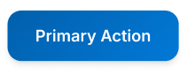
- Secondary: Outlined #0078D7, 1px border, transparent background.
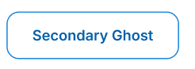

- High Energy: Filled #FF5722 (Strictly for conversion actions).
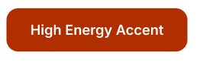
- Interaction States:
  - Hover: Darken base color by 10%.
  - Active (Click): Scale down to 98%.
  - Disabled: 50% opacity, converted to grayscale.

2.2 Form Inputs
- Default State: 1px border #E0E0E0, 4px radius, 14px text.
- Validation States:
  - Error Styling: 1px solid #F44336 (Red) border.
  - Error Message: Displayed immediately below the field in #F44336 using 12px Caption typography.

3. Layout & Structure

3.1 Role-Based Architectural Shells
- Customer Interface: * Top Navigation (Logo, Search Bar, Cart/User Profile) → Main Content → Footer.
- Admin/PM Interface: * Left Sidebar (Navigation) + Top Header (Page Title, User Profile) + Main Content Area.
- Alignment Rule: Page titles must always be centered at the top of the main content area.

3.2 Modals & Secondary Screens
- Placement: Help screens, manuals, or detailed views must appear as centered popups.
- Overlay: A dark overlay with 80% opacity must cover the main screen, disabling all background interactions.
- Close Action: A prominent "X" close button must be standardized in the top-right corner of the modal.

4. Interaction & Flow Standards

4.1 Application Flow & Navigation
- Boot Sequence: Opening Screen → Splash Screen → Homepage.
- Back Navigation: Every internal or nested screen must feature a clear "Back" button returning the user to the exact previous state.

4.2 Keyboard & Focus Accessibility
- Tab Order: Forms and interactive elements must support sequential keyboard navigation (Tab / Shift+Tab) flowing naturally top-to-bottom, left-to-right.
- Standard OS Shortcuts: Do not implement custom keyboard shortcuts; rely on standard browser/OS behaviors.
- Escape Key: Must trigger the 'Close' action for any active modal or secondary screen.

5. Data & Logic Guidelines

5.1 Input Validation Protocol
All form submissions must pass a strict two-step validation sequence before processing:
- Presence Check: Verify the required field is not empty.
- Format/Logic Check: Verify the data conforms to the expected type, pattern, or range (e.g., valid email regex, positive numeric values for price).

5.2 Data Formatting
- Currency: Formatted as [Amount] VND (e.g., 100,000 VND).
- Numbers: Use comma separators for thousands (e.g., 1,250,000).
- Dates: Strict DD/MM/YYYY format.

6. Layout & Structure (The Screen Shells)
Our system doesn't use a one-size-fits-all interface. Depending on who the user is, the structural shell is fine-tuned to optimize the workspace and user flow.

6.1. Admin & PM Layout (The Workspace) This environment is built for deep focus on data and management tools.

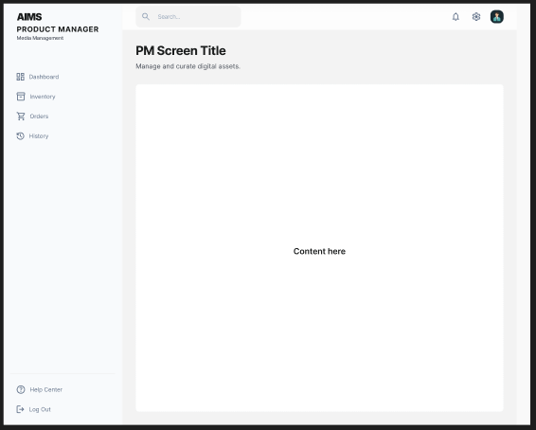
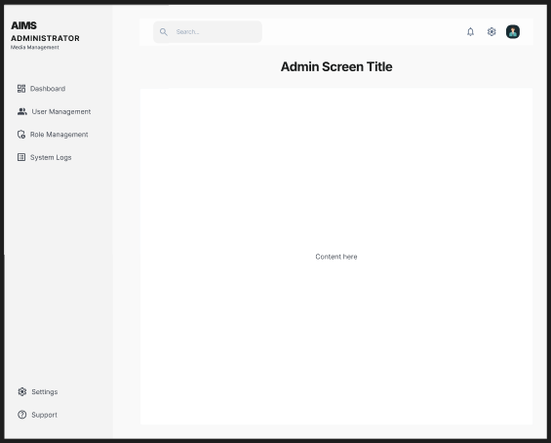
- Left Sidebar: Contains the main functional menus (Dashboard, Media Store, Settings, etc.). It stays pinned to the left so users can quickly switch between different modules.
- Top Header: Features the global search bar and account details (Profile/Notifications) tucked on the right. The Screen Title is positioned directly below this header, centered perfectly over the content area.
- Main Content Area: A spacious, clean white (#FFFFFF) canvas taking up the center stage. This is where all the heavy lifting happens—tables, input forms, and management lists.

6.2. Customer Layout (The Shopping Experience)

This interface prioritizes product discovery and smooth navigation.
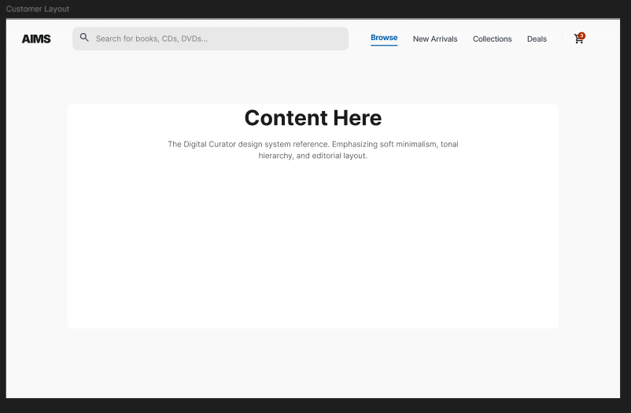
- Top Navigation: Runs horizontally across the very top. It houses the Logo, a prominent central search bar, and key shortcuts (Categories, Cart, Profile) on the right side.
- Main Content Area: Takes up the remaining space on the right. This area is dedicated to showcasing the Product Grid, item details, and promotional banners.

