|  |
| --- |
| vietnam national university – ho chi minh city international university |
| WEB PROJECT REPORT |
| Web application development |
|  |
| **Chung Minh Nhat – ITITIU170?? Nguyen Tran Chi Hieu – ITITIU170?? Nguyen Xuan Tung – ITITIU17008** |
| **16-Jun-20** |

|  |
| --- |
| A report submitted to the instructor of the Web Application Development course in fulfillment of the course project, Spring 2020 semester. |

# Introduction

## Motivation

It is a concern for every family and every person about their own health. Nowadays, it is not such an easy thing to get access to doctors and medical needs. Often it is the case that hospitals are situated far from one’s home, and they are often full, and queuing to meet with the doctor often takes a long time.

The purpose of our project is to design an interactive webpage for doctors and patients alike. We aim to provide an E-commerce platform for doctors and patients to interact, make appointments, etc., and to be able purchase medicines and medical equipments. Such a platform can greatly increase communication efficiency of patients and doctors, reducing time consumed on medical needs.

## Problems Statement

## Scope

# Literature Review

## Similar Applications/Systems

The umedpro system by the University Medical Center HCMC allows for easy appointment booking of doctors. However it is limited to appointment and scheduling only.

The medicare system is an e-commerce application focusing on medical products. However it lacks the interactive features of the umedpro system. It also does not allow access to experts for guidance on the medical matter.

## Platform and Tools Review

# System Design

## System Requirement Specification

## System Design Specification

# System Implementation

## Use case diagram

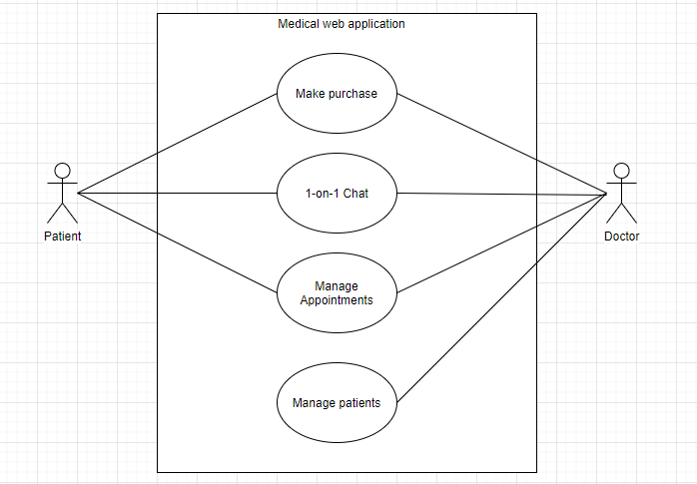

There are two actors: doctors and patients. A brief description of each use case is as follow:

- Manage patients (summary goal UC): Doctors can manage their patients’ information, such as medicine prescribed, time and date, appointments, etc.

- Make purchase: Doctors and patients are allowed to purchase medicine and medical equipments on the website.

- 1-on-1 chat: Doctors and patients can chat with each other through message forms. They can also send pending messages when either party is offline.

- Manage appointments: Patients can make appointments to doctors. Doctors can manage their own schedule, manage patient appointment timetable, etc.

Our database consists of several tables. The design is shown below

[printed_db_v2.pdf]

The database model was designed on Microsoft MySQL Workbench on a MySQL database server. The database was generated using MySQL Workbench’s forward engineering.

# Conclusion and Discussion

## List of accomplished work

## Strength and Weakness

## Future Work

# References