BÁO CÁO THỰC HÀNH LAB 1  
LẬP TRÌNH HƯỚNG ĐỐI TƯỢNG

# The Very First Java Programs

## *2.2.1* Write, compile the first Java application:

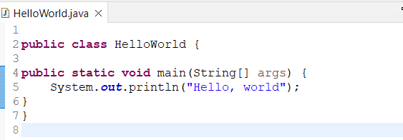

*Kết quả*

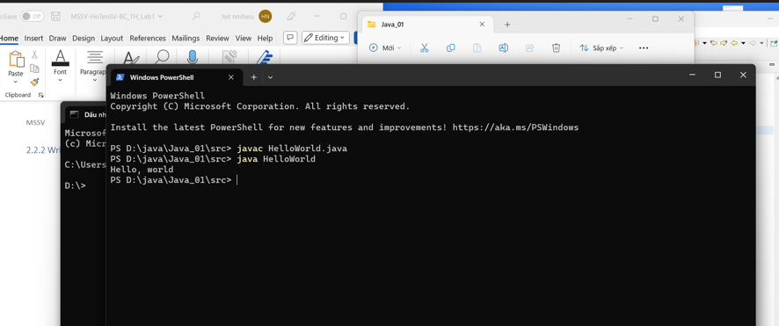

## 2.2.2 Write, compile the first dialog Java program

### Screen Shot 2019-02-12 at 12

## 2.2.3 Write, compile the first input dialog Java application

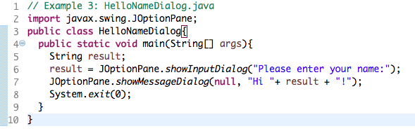

## 2.2.4 Write, compile, and run the following example:

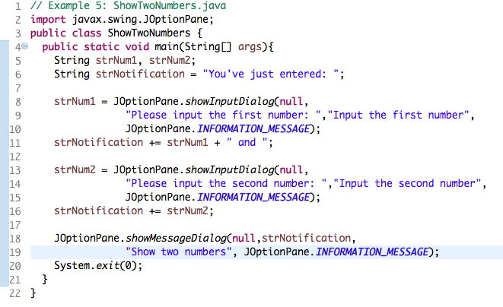

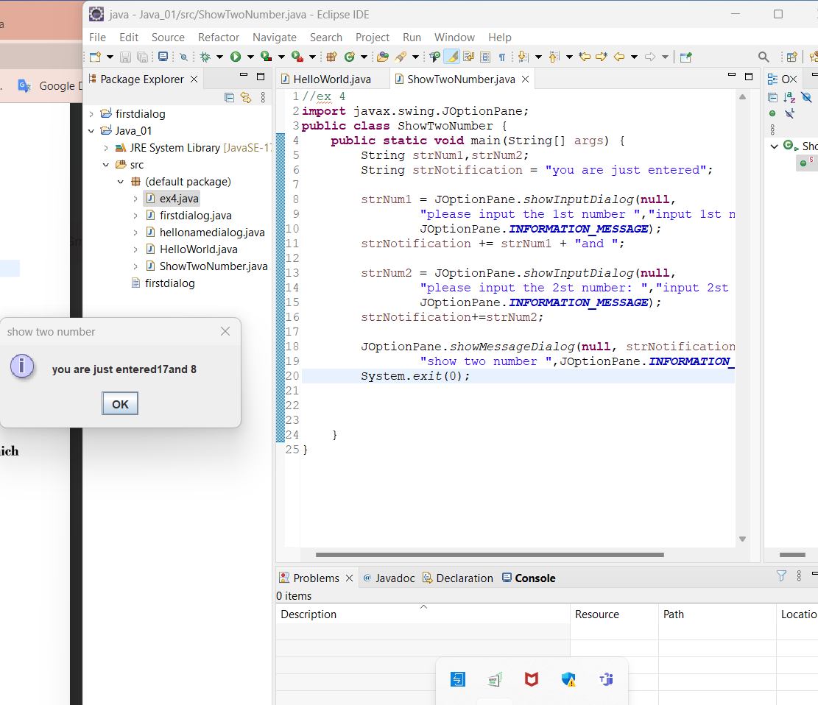

## 2.2.5 Write a program to calculate sum, difference, product, and quotient of 2 double numbers which are entered by users.

**Notes**

* To convert from String to double, you can use

**double num1 = Double.parseDouble(strNum1)**

* Check the divisor of the division

2.2.6

Part a:

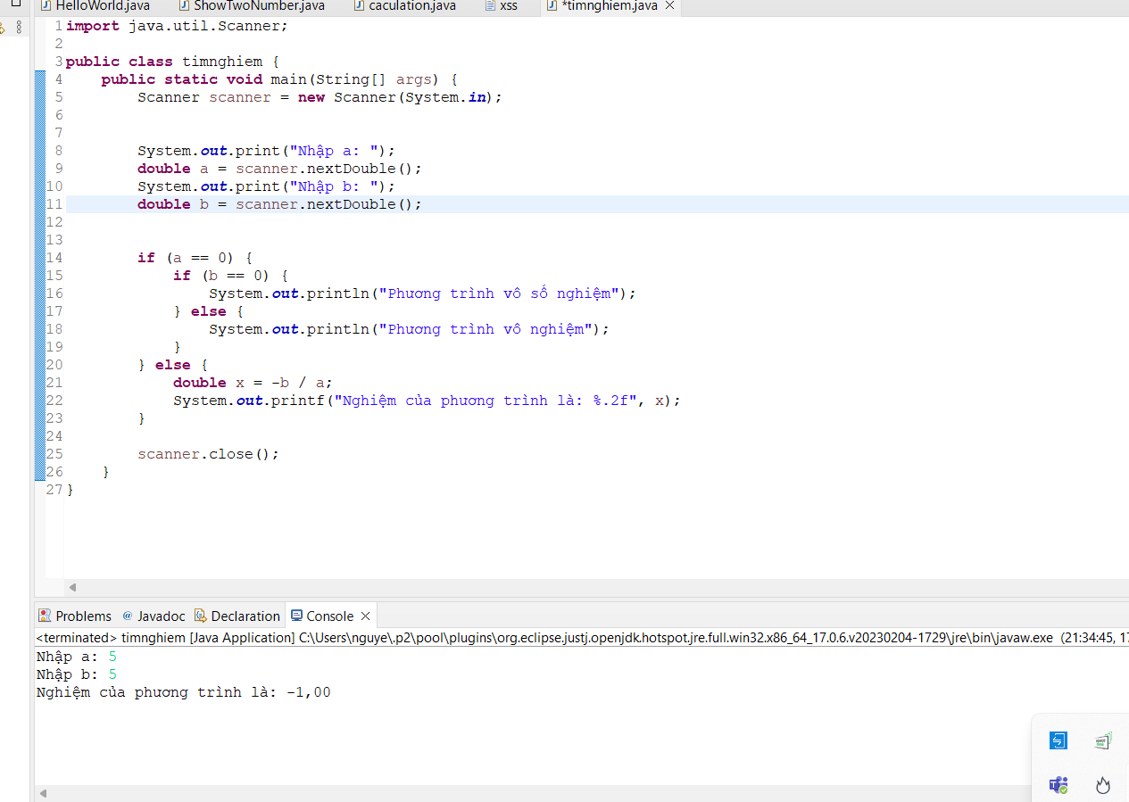

6.1

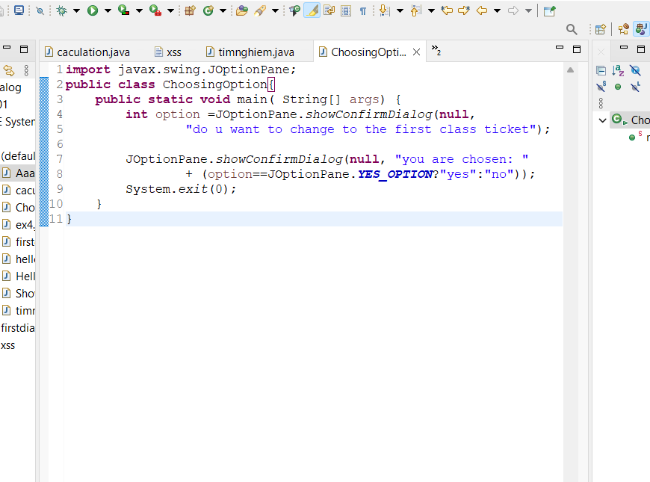

6.2

*6.3:* *Write a program to display a triangle with a height of n stars (*), n is entered by users*

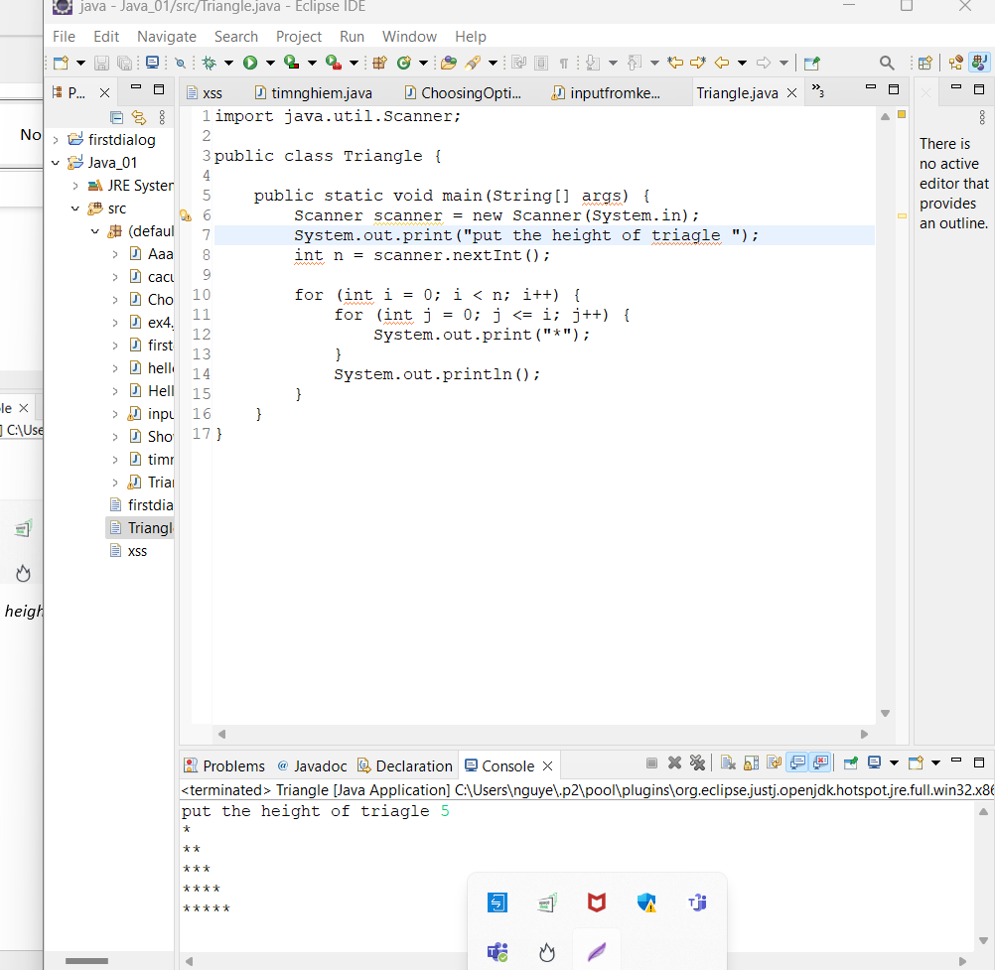

*6.4 number of day of month*

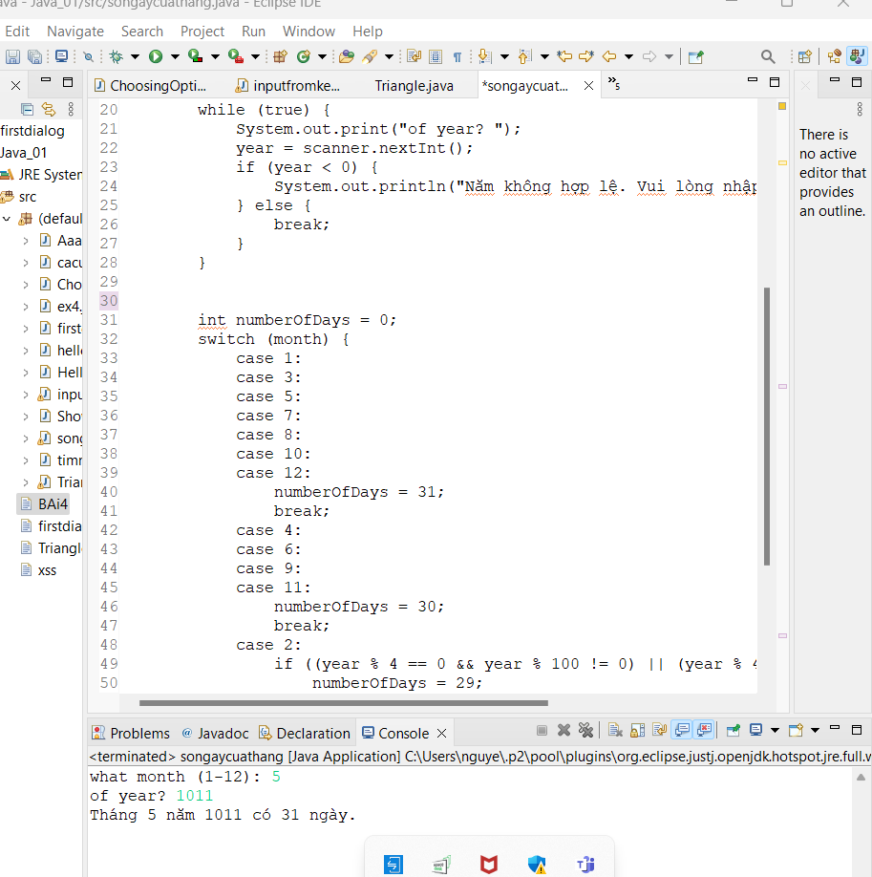

*6.5*

*6.6*