**LINUX EXERCISE (LAB 09)**

Exercise 1. Use the Buildroot tool to build a complete Linux system image for an embedded computer, then boot it on that embedded computer (using the QEMU virtualization tool).

Clone buildroot directory:

Configure buildroot:

Build the system:

Install QEMU: sudo apt install qemu-system-x86

Boot the system: qemu-system-x86_64 -M pc -kernel output/images/bzImage -drive file=output/images/rootfs.ext2,if=virtio,format=raw -append "root=/dev/vda console=ttyS0" -nographic -net nic,model=virtio -net user

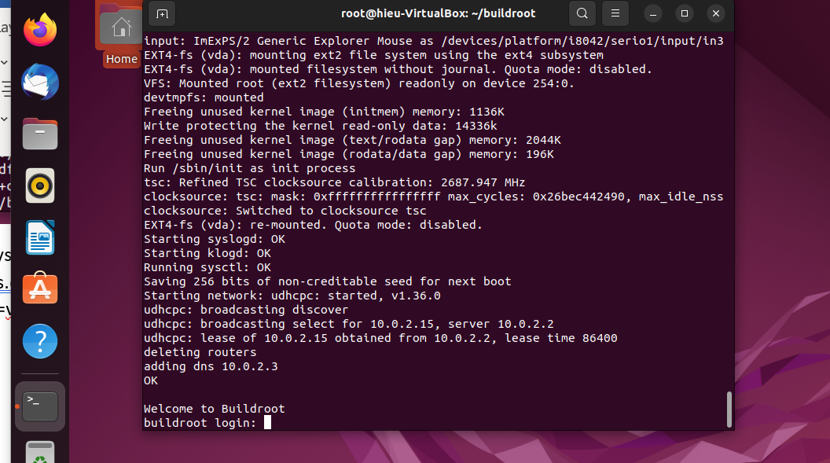

Exercise 2 (Optional). Try adding a new application, either created by the student or a third party, to the Buildroot system.