

**Capstone Project Report**

**Report 4 – HRM Software Design Document**

– Hanoi, April 2021–

**Table of Contents**

I. Project Report 3

1. Status Report 3

2. Team Involvements 3

3. Issues/Suggestions 3

II. Software Design Document 4

1. Overall Description 4

1.1 Assumptions 4

1.2 Design Constraints 4

1.3 [Technology Suggestion] 5

2. System Architecture Design 5

2.1 Overall Architecture 5

2.2 System Architecture 5

2.3 Package Diagram 5

3. System Detailed Design 6

3.1 <Feature Name1> 6

4. Class Specifications 7

4.1 XYZ Class 7

4.2 ABC Class 7

4.3 … 8

5. Data & Database Design 8

5.1 Database Design 8

5.2 Data File Design 8

# I. Project Report

## 1. Status Report

|  |  |  |  |
| --- | --- | --- | --- |
| **#** | **Work Item** | **Status** | **Notes (Work Item in Details)** |
| 1 | Database and System Design | Completed |  |
| 2 | Write API List and it’s details | Completed |  |
| 3 | Draw Sequence Diagram, Class Diagram, Database Diagram | Completed |  |

## 2. Team Involvements

|  |  |  |  |
| --- | --- | --- | --- |
| **#** | **Task** | **Member** | **Notes (Task Details, etc.)** |
| 1 | Creat and design DataBase and frontEnd | ThangND |  |
| 2 | Creat and design DataBase and Write BackEnd | HieuDT |  |
| 3 | Draw Diagram and Software Design Document | Tund |  |
| 4 | Data & Database Design Document | DatBEDE |  |

## 3. Issues/Suggestions

|  |  |  |  |
| --- | --- | --- | --- |
| **#** | **Issue** | **Status** | **Notes (Solution, Suggestion, etc.)** |
| 1 |  | Pending |  |
| 2 |  | In Progress |  |
| 3 |  | Completed |  |

# II. Software Design Document

## 1. Overall Description

### 1.1 Assumptions

This system is designed basing on these following assumptions:

* Windows 10
* Google Chrome
* NetBeans 8.2
* SQL Server 2014
* …

### 1.2 Design Constraints

This system should be complied with following items:

- User use web browser (Internet Explorer, Mozilla Firefox, Google Chrome,…) to interact with system.

- System must available 24/7.

- Every process in this system must be less than 10s.

- HTTP protocol is the communication protocol between services.

- An user must logged in to system successfully before they can use any function*.*

## 2. System Architecture Design

### 2.1 Overall Architecture

This system use RESTFul Web Service architecture as its system architecture. All the components will be as the following:

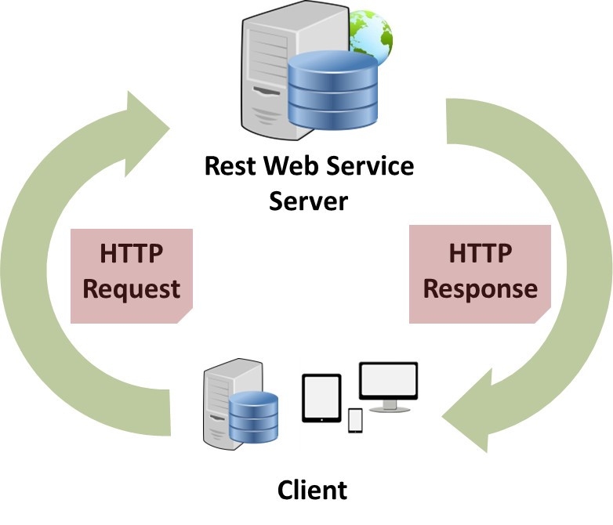

- REST Service (Web Service): a service to handle data managing from a client service.7

- Browser/Application: uses as a client service from end-users. They take data response form REST Service

and present it to users.

- The Client Service will manipulate with data through http request to server.

### 2.2 System Architecture

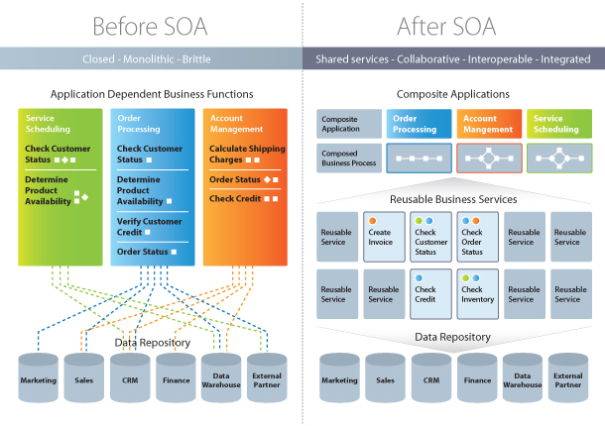

Specifically, we will use Java RESTFUL Web Service for this project.

### 2.3 Package Diagram

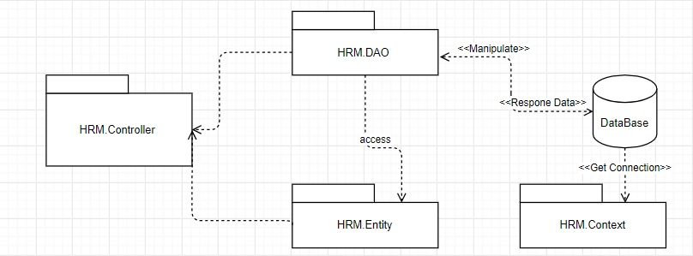

***Code Packages***

|  |  |  |
| --- | --- | --- |
| **No** | **Package** | **Description** |
| 01 | HRM.Controller | Get request from another service and directioning to supporting function |
| 02 | HRM.DAO | Interact with database |
| 03 | HRM.Entity | Object pattern for dao package to access and make their function |
| 04 | HRM.Context | Manipulate connection between this service and the database |

**Client Service Package Diagram**

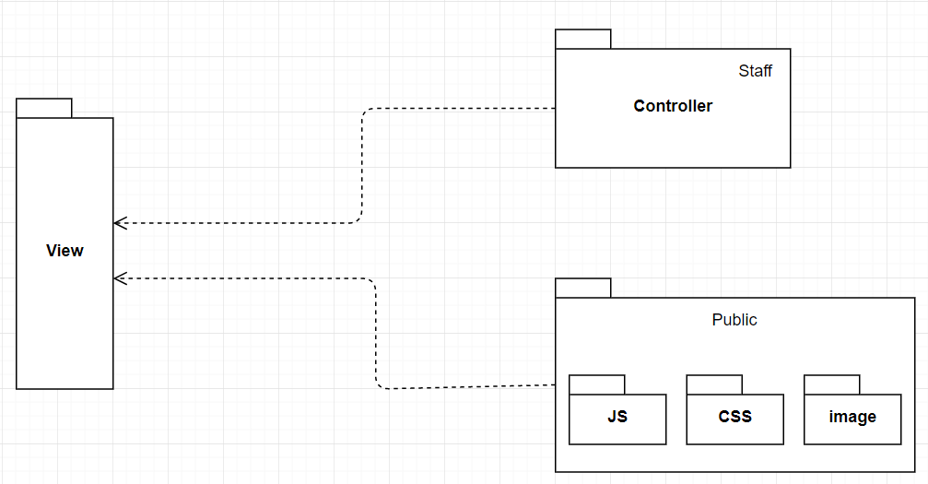



## 3. System Detailed Design

### 3.1 Back-End Server

#### a. Class Diagram

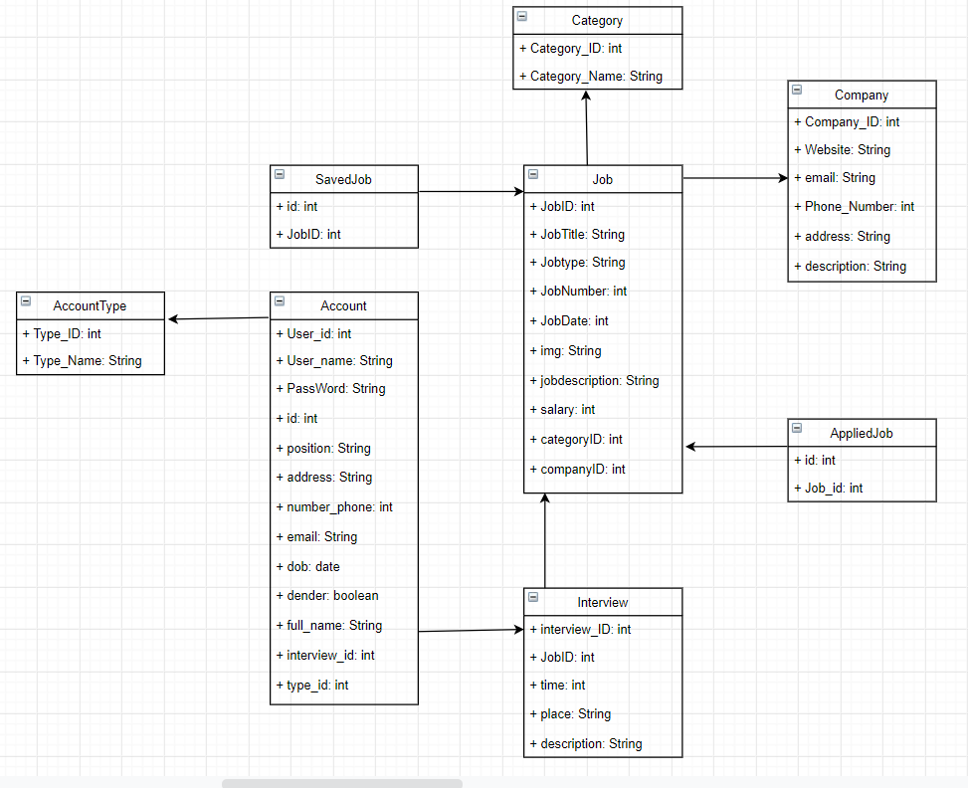

#### b. Sequence Diagram(s)

Login

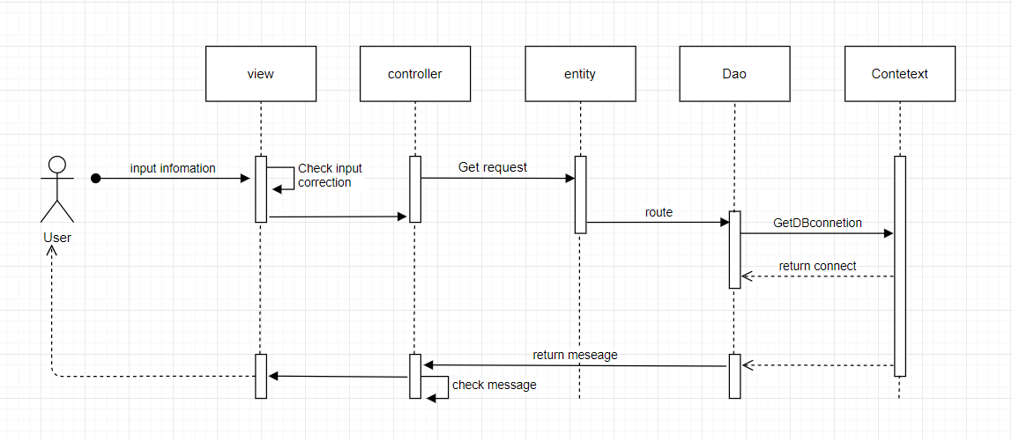

Logout

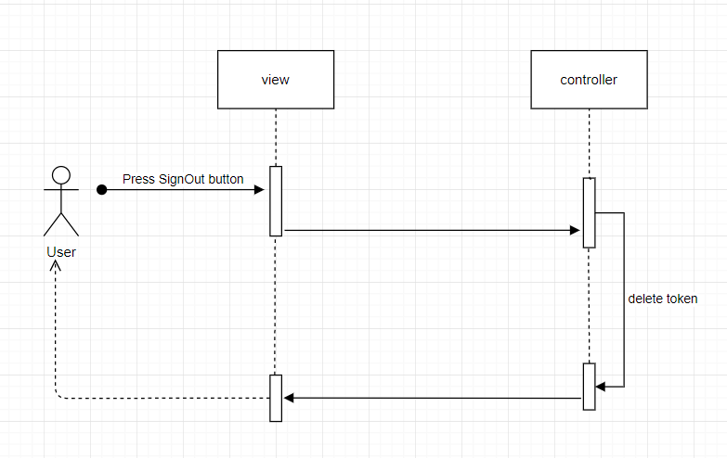

Creat new job

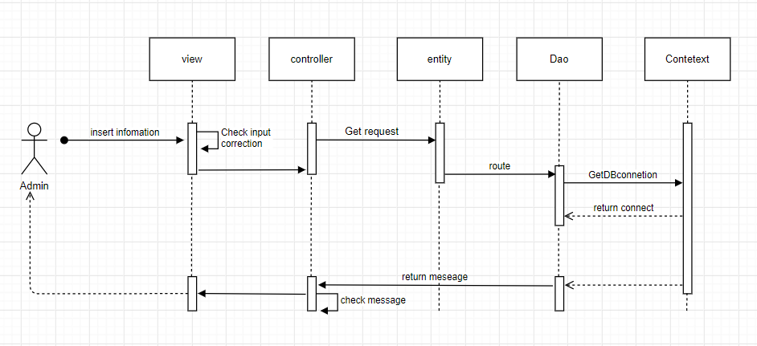

Search

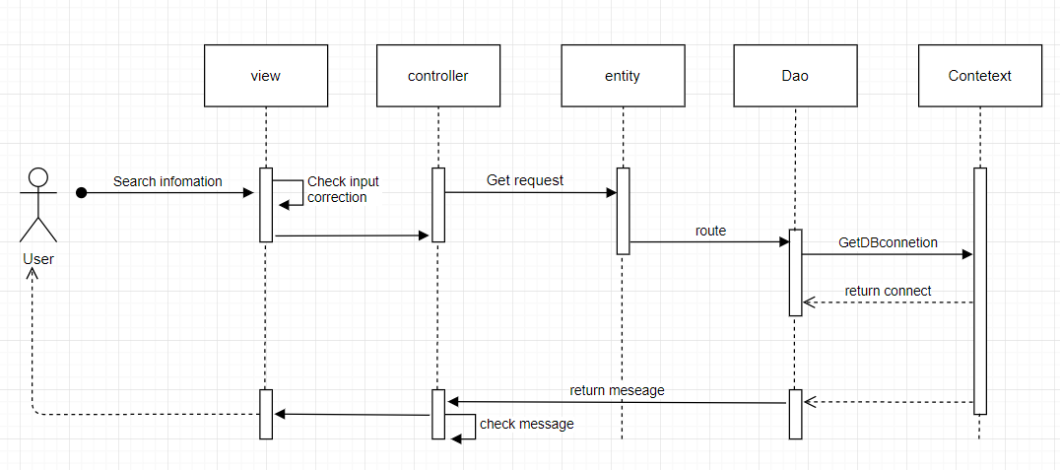

Edit

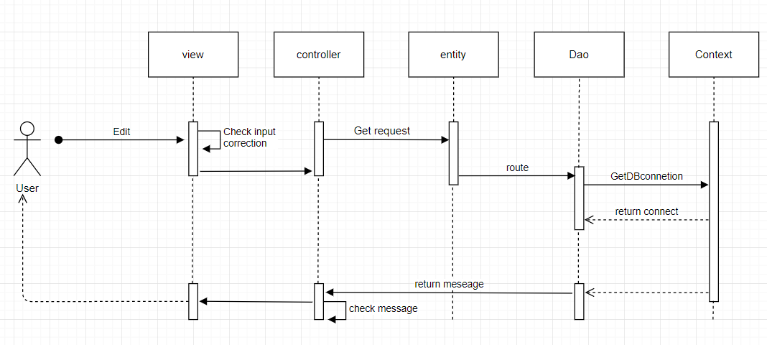

Delete

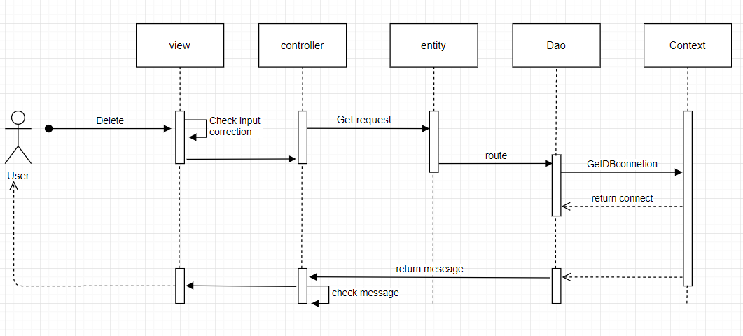

**4. Class Specification**

**4.1 REST Service**

|  |  |  |
| --- | --- | --- |
| **No** | **Method** | **Description** |
| 1 | GET | Take a get data request from Client Service |
| 2 | POST | Take a insert data request from Client Service |
| 3 | PUT | Take a update data request from Client Service |
| 4 | DELETE | Take a delete data request from Client Service |

**4.1.1 API List**

- Base URL: http://localhost:8080/Recruitment_SWE/

a. Account API

|  |  |  |  |  |
| --- | --- | --- | --- | --- |
| **No** | **Method** | **URL** | **XML String Send** | **Description** |
| 1 | Post | /login | No | Check login with username, password and login field |

b. User API

|  |  |  |  |  |
| --- | --- | --- | --- | --- |
| **No** | **Method** | **URL** | **XML String Send** | **Description** |
|  | GET | /jobs | No | Get list of all jobs |
|  | GET | /about | No | Get information of the recruitment website |
|  | GET | /blog | No | See the personal diaries of some company members |
|  | PUT | /profile | No | Edit a user profile registration, reset password |
|  | GET | /contact | No | Get contact, address information of the recruitment website |
|  | POST | /contact | No | Submit a request to the recruitment website |
|  | GET | /jobdetail?id={id} | No | Get information about work |

d. Job API

|  |  |  |  |  |
| --- | --- | --- | --- | --- |
| **No** | **Method** | **URL** | **XML String Send** | **Description** |
| 1 | GET | /search?search=&search=Search | No | Get all jobs |
| 2 | POST | /search?search=recruitment&search=Search | No | Search jobs by recruitment |
| 3 | POST | /jobdetail?id={id} | No | Get information of a job by id |

e. Contact API

|  |  |  |  |  |
| --- | --- | --- | --- | --- |
| **No** | **Method** | **URL** | **XML String Send** | **Description** |
| 1 | POST | /contact | No | Submit a request to the recruitment website |
| 2 | GET | /contact | No | Get company address via Google Map |

**4.1.1.1 Login**

- URL: /login

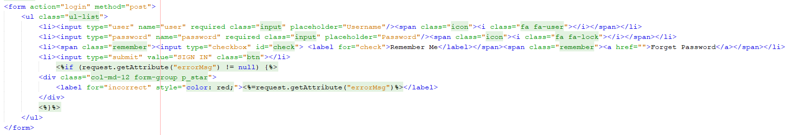

* LoginFiled: we supported 2 login field: user, admin, for more information about these two

**4.1.1.2 Get all jobs**

- URL: /job

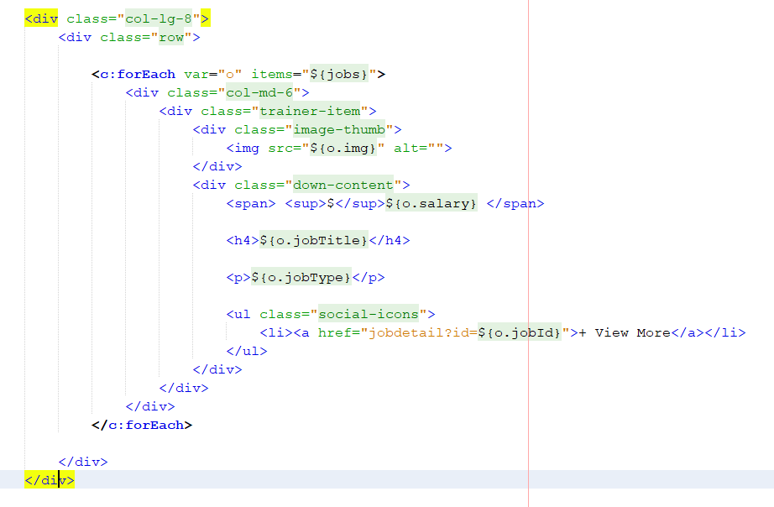

* Response from Server:

+ The server will response the list of jobs from database. Each page will have maximum of 4 job in one page

**4.1.1.2 Get information from a jobs( jobdetail)**

- URL: /jobdetail?id={id}

+ {id}: it’s id from a job by int type

+ The sever will response the job information in database if there is a job with exact id . Otherwise it’s will return nothing.

## 5. Data & Database Design

### 5.1 Database Design

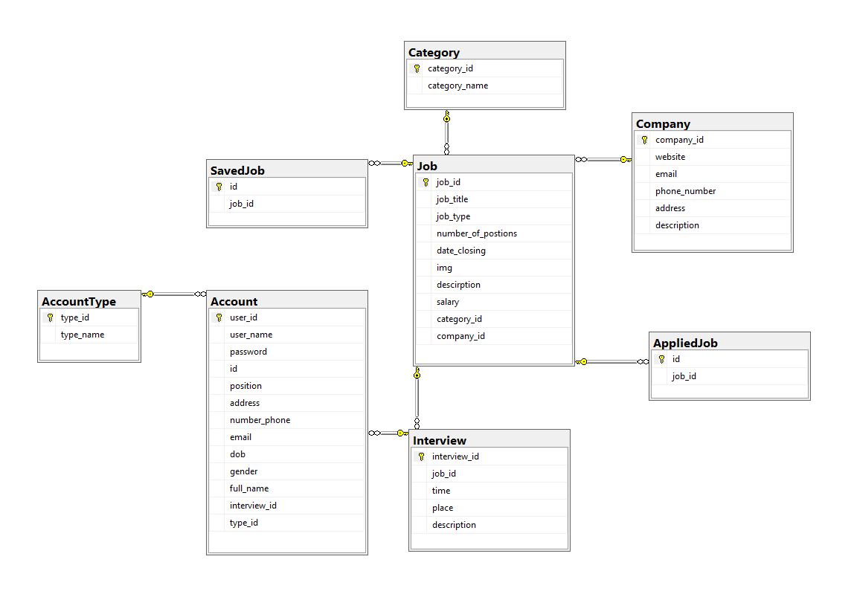

**5.1.2 Category**

|  |  |  |  |  |  |  |  |
| --- | --- | --- | --- | --- | --- | --- | --- |
| **#** | **Field name** | **Type** | **Size** | **Unique** | **Not null** | **PK/FK** | **Notes** |
| 1 | category_id | Int |  | No | Yes | PK |  |
| 2 | category_name | Nvarchar | 30 | No | Yes |  |  |

**5.1.3 Account**

|  |  |  |  |  |  |  |  |
| --- | --- | --- | --- | --- | --- | --- | --- |
| **#** | **Field name** | **Type** | **Size** | **Unique** | **Not null** | **PK/FK** | **Notes** |
| 1 | User_id | Int |  | Yes | Yes | PK |  |
| 2 | User_name | Nvarchar | 50 | No | Yes |  |  |
| 3 | Password | Nvarchar | 50 | No | Yes |  |  |
| 4 | Id | Int |  | No | Yes |  |  |
| 5 | Position | Nvarchar | 50 | No | No |  |  |
| 6 | Address | Nvarchar | 50 | No | No |  |  |
| 7 | Number_phone | Int |  | No | No |  |  |
| 8 | Email | Nvarchar | 50 | No | No |  |  |
| 9 | Dob | Date |  | No | No |  |  |
| 10 | Gender | Bit |  | No | No |  |  |
| 11 | Full_name | Nvarchar | 50 | No | No |  |  |
| 12 | Interview_id | Int |  | No | Yes |  |  |
| 13 | Type_id | Int |  | No | No |  |  |

**5.1.4 AccountType**

|  |  |  |  |  |  |  |  |
| --- | --- | --- | --- | --- | --- | --- | --- |
| **#** | **Field name** | **Type** | **Size** | **Unique** | **Not null** | **PK/FK** | **Notes** |
| 1 | Type_id | Int |  | No | Yes | PK |  |
| 2 | Type_name | Nvarchar | 50 | No | No |  |  |

**5.1.5 Interview**

|  |  |  |  |  |  |  |  |
| --- | --- | --- | --- | --- | --- | --- | --- |
| **#** | **Field name** | **Type** | **Size** | **Unique** | **Not null** | **PK/FK** | **Notes** |
| 1 | Interview_id | Int |  | No | Yes | PK |  |
| 2 | Job_id | Int |  | No | Yes |  |  |
| 3 | Time | Date |  | No | No |  |  |
| 4 | Place | Nvarchar | 50 | No | No |  |  |
| 5 | Description | Nvarchar | 50 | No | No |  |  |

**5.1.6 Job**

|  |  |  |  |  |  |  |  |
| --- | --- | --- | --- | --- | --- | --- | --- |
| **#** | **Field name** | **Type** | **Size** | **Unique** | **Not null** | **PK/FK** | **Notes** |
| 1 | Job_id | Int |  | No | Yes | PK |  |
| 2 | Job_title | Nvarchar | 50 | No | No |  |  |
| 3 | Job_type | Nvarchar | 50 | No | No |  |  |
| 4 | Number_of_postions | Int |  | No | No |  |  |
| 5 | Date_closing | Date |  | No | No |  |  |
| 6 | Img | Nvarchar | 150 | No | No |  |  |
| 7 | Description | Nvarchar | 1000 | No | No |  |  |
| 8 | Salary | Int |  | No | No |  |  |
| 9 | Category_id | Int |  | No | No |  |  |
| 10 | Category_id | Int |  | No | No |  |  |

**5.1.7 SavedJob**

|  |  |  |  |  |  |  |  |
| --- | --- | --- | --- | --- | --- | --- | --- |
| **#** | **Field name** | **Type** | **Size** | **Unique** | **Not null** | **PK/FK** | **Notes** |
| 1 | Id | Int |  | No | Yes | PK |  |
| 2 | Job_id | Int |  | No | No |  |  |

**5.1.8 Company**

|  |  |  |  |  |  |  |  |
| --- | --- | --- | --- | --- | --- | --- | --- |
| **#** | **Field name** | **Type** | **Size** | **Unique** | **Not null** | **PK/FK** | **Notes** |
| 1 | Company_id | Int |  | No | Yes | PK |  |
| 2 | Website | Nvarchar | 100 | No | No |  |  |
| 3 | Email | Nvarchar | 100 | No | No |  |  |
| 4 | Phone_number | Nvarchar | 100 | No | No |  |  |
| 5 | Address | Nvarchar | 300 | No | No |  |  |
| 6 | Description | Nvarchar | 1000 | No | No |  |  |

**5.1.8 AppliedJob**

|  |  |  |  |  |  |  |  |
| --- | --- | --- | --- | --- | --- | --- | --- |
| **#** | **Field name** | **Type** | **Size** | **Unique** | **Not null** | **PK/FK** | **Notes** |
| 1 | Id | Int |  | No | Yes | PK |  |
| 2 | Job_id | Int |  | No | No |  |  |