
SOFTWARE TECHNICAL SPECIFICATION

Facial Recognition Attendance System with Emotion Recognition and Liveness Detection
Author: Truong Ngoc Gia Hieu
Student ID (Vietnam): SWS01217
Student ID (Swinburne): 105565520
Supervisor / Lecturer: Mr. Hoang Anh Minh
Institution: Swinburne University of Technology Vietnam
Date: 22 October 2026
Version 1.0.0
REVISION HISTORY
DATE | VERSION | DESCRIPTION | AUTHOR
22 Oct 2026 | 1.0.0 | Initial release: complete technical specification for the facial recognition attendance system with emotion recognition and liveness detection. | Truong Ngoc Gia Hieu
TABLE OF CONTENTS
INTRODUCTION 3
PURPOSE 3
INTENDED AUDIENCE AND PERTINENT SECTIONS 3
PROJECT SCOPE 3
DOCUMENT CONVENTIONS 3
REFERENCES 3
DESCRIPTION 4
PRODUCT PERSPECTIVE 4
FEATURES 5
USER OVERVIEW 5
OPERATING ENVIRONMENT 5
CONTRAINTS: IMPLEMENTATION / DESIGN 5
DOCUMENTATION 6
ASSUMPTIONS / DEPENDENCIES 6
SYSTEM FEATURES 6
SYSTEM FEATURE 1: EMPLOYEE ENROLLMENT 6
SYSTEM FEATURE 2: LIVE FACE RECOGNITION AND TRACKING 7
SYSTEM FEATURE 3: LIVENESS DETECTION (ANTI-SPOOFING) 7
SYSTEM FEATURE 4: EXPRESSION RECOGNITION 7
SYSTEM FEATURE 5: ATTENDANCE DECISION AND LOGGING 7
SYSTEM FEATURE 6: MODEL TRAINING AND EVALUATION (OFFLINE) 8
REQUIREMENTS OF EXTERNAL INTERFACE 8
USER INTERFACES 8
HARDWARE INTERFACES 8
SOFTWARE INTERFACES 8
COMMUNICATION INTERFACES 9
ADDITIONAL NONFUNCTIONAL REQUIREMENTS 9
PERFORMANCE 9
SAFETY 9
SECURITY 9
SOFTWARE QUALITY 10
APPENDICES 10
APPENDIX A: GLOSSARY OF TERMS 10
APPENDIX B: ANALYSIS DOCUMENTATION 10
APPENDIX C: ISSUES 11

INTRODUCTION

PURPOSE
This Software Technical Specification describes the design and requirements of the Facial Recognition Attendance System with Emotion Recognition and Liveness Detection (referred to as “FRAS”). FRAS identifies people from a live webcam stream, confirms that the face belongs to a live person rather than a photo or video, shows the person’s facial expression, and records attendance automatically.
The desired outcome is a working, well-evaluated prototype that records attendance accurately (target EER ≤ 5%), resists simple spoofing attacks, responds within 2 seconds, and costs nothing to build or run.

INTENDED AUDIENCE AND PERTINENT SECTIONS
READER | MOST RELEVANT SECTIONS
Developer (project author) | Description, System Features, External Interface Requirements, Appendix B
Supervisor / assessor (Mr. Hoang Anh Minh) | Introduction, Description, System Features, Non-functional Requirements, Appendix C
Testers / evaluators | System Features (functional requirements), Performance, Software Quality
Administrators / HR (prospective users) | User Overview, User Interfaces, Security, Communication Interfaces (API)
Future maintainers | Product Perspective, Software Interfaces, Document Conventions, Appendix A

PROJECT SCOPE
FRAS covers webcam capture, face detection and tracking, face recognition, liveness detection, expression recognition, employee enrollment, attendance decision and logging, an API to a SQL database, a live user interface, and model training and evaluation. Hardware purchases, production deployment, mobile apps and live HR-system integration are out of scope (see the Project Charter).
Objectives and goals: (1) real-time recognition with L2-normalised embeddings and FAISS search; (2) multi-frame liveness verification; (3) display-only expression recognition; (4) reliable attendance logging without duplicates; (5) evaluation with AUC/EER; (6) delivery at zero cost within 12 weeks (26 Oct 2026 – 17 Jan 2027).
Relation to organisational goals: the project supports the Swinburne Vietnam learning outcomes of applying AI techniques to a real problem and shows that secure biometric attendance can be built with free tools, which matches a goal of low-cost, accessible technology.

DOCUMENT CONVENTIONS
- Requirements carry unique IDs: FR-x.y for functional requirements of System Feature x, and NFR-xx for non-functional requirements.
- “Shall” marks a mandatory requirement; “should” marks a desirable one.
- Priority levels are High, Medium and Low. Symbols τ (recognition threshold) and θ (liveness threshold) are defined in Appendix A.
- Section titles follow the Smartsheet technical-specification template so readers can find content in a familiar place. Figures are numbered Figure 1, Figure 2, and so on.

REFERENCES
- Project Proposal and Agile Project Charter, Truong Ngoc Gia Hieu, 22 Oct 2026.
- Deng, J. et al. “ArcFace: Additive Angular Margin Loss for Deep Face Recognition,” CVPR 2019.
- Schroff, F., Kalenichenko, D., Philbin, J. “FaceNet: A Unified Embedding for Face Recognition and Clustering,” CVPR 2015.
- Tan, M., Le, Q. “EfficientNet: Rethinking Model Scaling for Convolutional Neural Networks,” ICML 2019.
- Sandler, M. et al. “MobileNetV2: Inverted Residuals and Linear Bottlenecks,” CVPR 2018.
- Wojke, N., Bewley, A., Paulus, D. “Simple Online and Realtime Tracking with a Deep Association Metric (DeepSORT),” ICIP 2017.
- Johnson, J., Douze, M., Jégou, H. “Billion-scale similarity search with GPUs (FAISS),” 2017.
- Huang, G. et al. “Labeled Faces in the Wild (LFW),” University of Massachusetts Amherst, 2007.
- Goodfellow, I. et al. “Challenges in Representation Learning: FER-2013,” 2013.

DESCRIPTION

PRODUCT PERSPECTIVE
FRAS is a new, self-contained system. It replaces manual or card-based attendance with contactless face-based attendance. It is organised in four layers (Figure 1). Each layer talks only to its neighbours, which keeps the code modular and testable.
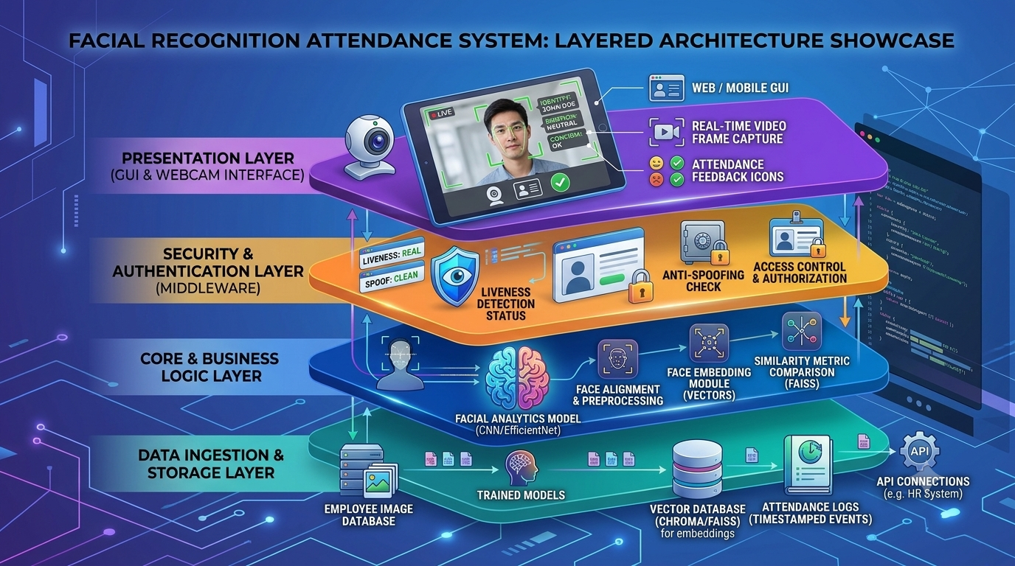
Figure 1. Layered architecture of FRAS.
LAYER | RESPONSIBILITY
Presentation (GUI & webcam interface) | Real-time video frame capture, live view with bounding box, identity, liveness status, expression label, attendance feedback icons and retry guidance.
Security & Authentication (middleware) | Liveness detection status, anti-spoofing check, access control and authorization; validates liveness before any attendance is accepted.
Core & Business Logic | Face alignment and preprocessing; facial analytics CNN (EfficientNet/MobileNet); face embedding module (L2-normalised vectors); similarity search (FAISS); attendance decision logic.
Data Ingestion & Storage | Employee image database, trained models, vector database (FAISS/Chroma) for embeddings, timestamped attendance logs in SQL, and API connections (e.g., HR system).

At run time FRAS uses a multi-threaded pipeline (Figure 2). Webcam frames enter a thread-safe queue. Faces are detected, aligned and tracked (DeepSORT/SORT with a tracking-feedback loop). Three CNN threads then run in parallel on the GPU when available: face recognition, liveness and expression. The authentication service validates liveness, the FAISS index returns the nearest employee, and the attendance decision logic records attendance only when cosine similarity > τ and liveness = True. Employee enrollment and model training/evaluation are separate flows.
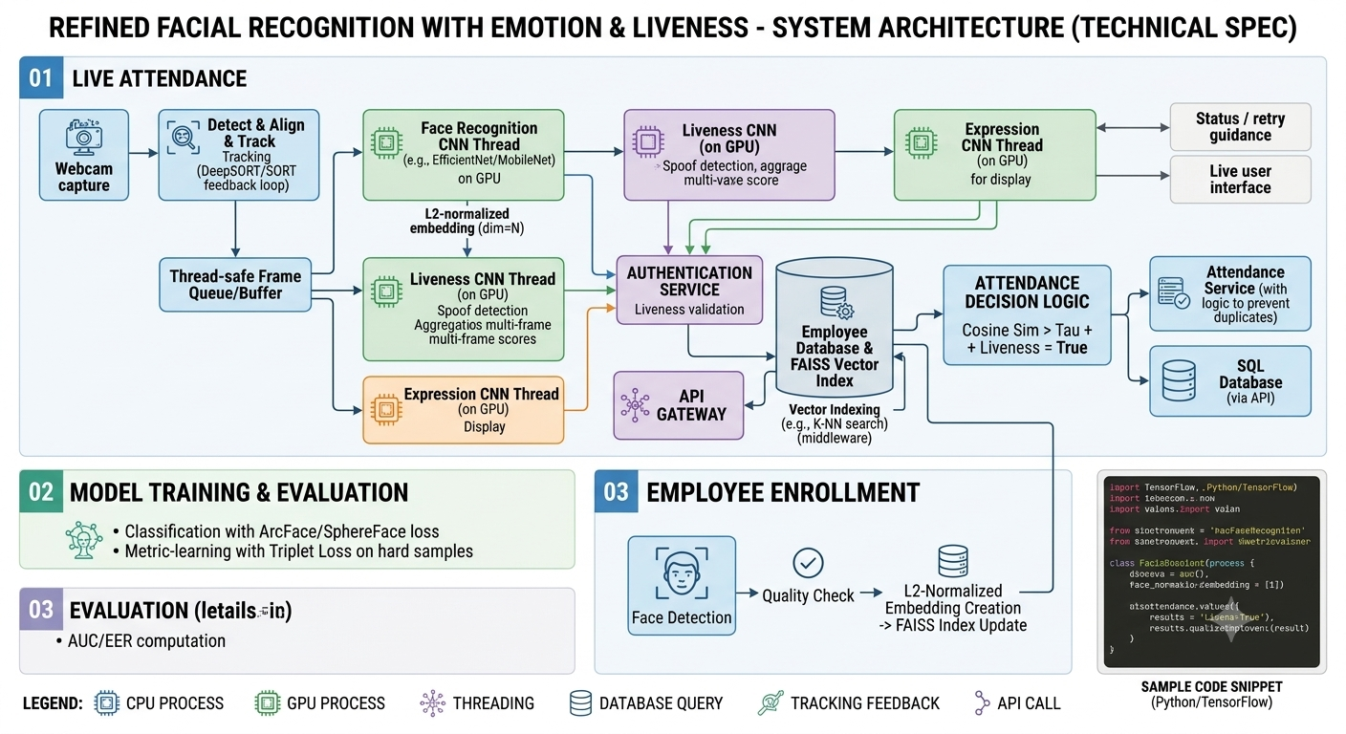
Figure 2. System architecture: live attendance, model training and evaluation, and employee enrollment.

FEATURES
- Employee enrollment with face-quality check and L2-normalised embedding creation.
- Live recognition and tracking of faces from a webcam using a CNN and FAISS cosine search.
- Liveness detection (anti-spoofing) with multi-frame score aggregation.
- Expression recognition displayed live to the user (display only).
- Attendance decision and logging with duplicate prevention, SQL storage and an API gateway.
- Model training and evaluation with ArcFace/SphereFace loss, triplet loss on hard samples, and AUC/EER reporting.

USER OVERVIEW
USER GROUP | CHARACTERISTICS
Employee (end user) | Non-technical; stands in front of the webcam for a few seconds; needs clear, immediate feedback (success, retry guidance).
Administrator / HR | Basic computer skills; enrolls and removes employees, reviews and exports attendance records, adjusts settings.
Developer / integrator | Technical; trains models, tunes thresholds, maintains the system and uses the API.
Supervisor / assessor | Reviews the design, the evaluation results (AUC/EER) and the live demonstration.

OPERATING ENVIRONMENT
- Hardware: laptop or PC with a quad-core CPU and at least 8 GB RAM; built-in or USB webcam (720p, 30 fps); an NVIDIA GPU is optional (recommended for ≥ 15 FPS). Training uses Google Colab or Kaggle free GPUs.
- Operating system: Windows 10/11 or Ubuntu 22.04 LTS.
- Software: Python 3.10+, PyTorch or TensorFlow, OpenCV, FAISS (CPU), a DeepSORT/SORT implementation, FastAPI, SQLite (PostgreSQL optional), and a modern web browser or a Python GUI toolkit for the user interface.
- Network: none required for the prototype (all components run on one machine); the REST API can be exposed on a local network.

CONTRAINTS: IMPLEMENTATION / DESIGN
- Zero budget: only free and open-source software, free compute tiers and public datasets may be used.
- Time and staffing: one developer and 12 weeks (26 Oct 2026 – 17 Jan 2027).
- Free GPU limits: session time and quota limits on Colab/Kaggle restrict model size and training length.
- Real-time on commodity hardware: models must be light enough (MobileNet/EfficientNet-class) to run without special hardware.
- Data: only public datasets and consented test images; some anti-spoofing datasets require a licence or access request.
- Privacy: biometric data is sensitive; only embeddings are stored after enrollment, and no data is sent to third-party clouds.
- Single camera: a single RGB webcam without depth or infrared sensors, so liveness relies on the RGB image only.

DOCUMENTATION
DOCUMENT | CONTENT | DELIVERY
Project Proposal, Project Charter, Technical Specification | Planning and design documents | Word (.docx) / PDF
README and user guide | Installation, enrollment and daily-use instructions | Markdown in GitHub repository
API documentation | REST endpoints, request/response examples | Auto-generated OpenAPI (FastAPI) page
Evaluation report | Datasets, metrics, ROC/AUC/EER, results and discussion | Word / PDF, with notebooks
Final report and demo | Summary of results and live demonstration | Report and presentation

ASSUMPTIONS / DEPENDENCIES
- Free GPU resources (Google Colab/Kaggle) remain available at a usable quota during Weeks 4–6.
- Public datasets (LFW, CelebA, FER-2013 and a public anti-spoofing set) can be downloaded and used for academic purposes.
- Pre-trained backbones (EfficientNet/MobileNet) are available under permissive licences and can be fine-tuned.
- The deployment machine has a working webcam and reasonable, front-facing lighting.
- Test subjects give consent for their face images to be used in testing.
- The sponsor will accept a mock HR API in place of a real HR system.

SYSTEM FEATURES

SYSTEM FEATURE 1: EMPLOYEE ENROLLMENT
DESCRIPTION AND PRIORITY | Priority: High. An administrator registers a new employee by capturing face images. The system checks image quality, creates an L2-normalised embedding and adds it to the FAISS index and the employee database.
STIMULUS / RESPONSE SEQUENCES | - Stimulus: the administrator enters the employee ID and name and starts the capture.  - Response: the system detects the face and checks quality; if poor (blurry, dark, small, extreme pose) it shows guidance and asks for a retry.  - Response: on success it creates the embedding, updates the FAISS index and shows a confirmation.
FUNCTIONAL REQUIREMENTS | - FR-1.1: The system shall detect exactly one face per enrollment image.  - FR-1.2: The system shall reject images that fail the quality check (size, blur, brightness, pose).  - FR-1.3: The system shall capture at least 3 images per employee and store their embeddings.  - FR-1.4: The system shall create L2-normalised embeddings of dimension N and add them to the FAISS index.  - FR-1.5: The system shall reject duplicate employee IDs and warn when the face matches an existing employee.  - FR-1.6: The system should allow an employee record to be updated or deleted.

SYSTEM FEATURE 2: LIVE FACE RECOGNITION AND TRACKING
DESCRIPTION AND PRIORITY | Priority: High. The system reads webcam frames, detects, aligns and tracks faces, computes embeddings and finds the closest enrolled employee.
STIMULUS / RESPONSE SEQUENCES | - Stimulus: a person appears in front of the webcam.  - Response: a bounding box and track ID appear; the face is embedded and searched in FAISS; the name or “Unknown” is shown.
FUNCTIONAL REQUIREMENTS | - FR-2.1: The system shall capture frames into a thread-safe queue/buffer.  - FR-2.2: The system shall detect and align faces and track them with DeepSORT/SORT, using a feedback loop to stabilise tracks.  - FR-2.3: The face recognition CNN shall run in its own thread and output an L2-normalised embedding.  - FR-2.4: The system shall search the FAISS index (K-NN) and compute cosine similarity to the best match.  - FR-2.5: The system shall label a face “Unknown” when similarity ≤ τ.

SYSTEM FEATURE 3: LIVENESS DETECTION (ANTI-SPOOFING)
DESCRIPTION AND PRIORITY | Priority: High. A liveness CNN decides whether the face is a live person or a spoof (printed photo, phone/monitor replay). Scores are aggregated over several frames for robustness.
STIMULUS / RESPONSE SEQUENCES | - Stimulus: a tracked face is available.  - Response: the liveness status “REAL” or “SPOOF” is shown; for SPOOF, no attendance is recorded and retry guidance is displayed.
FUNCTIONAL REQUIREMENTS | - FR-3.1: The liveness CNN shall run in its own thread and produce a per-frame spoof score.  - FR-3.2: The system shall aggregate scores over the last K frames and declare “live” when the aggregated score ≥ θ.  - FR-3.3: The authentication service shall validate the liveness result before attendance is accepted.  - FR-3.4: The system shall detect at least printed-photo and screen-replay attacks.

SYSTEM FEATURE 4: EXPRESSION RECOGNITION
DESCRIPTION AND PRIORITY | Priority: Medium. An expression CNN classifies the facial expression and shows it as live feedback. It is for display only.
STIMULUS / RESPONSE SEQUENCES | - Stimulus: a tracked face is available.  - Response: the expression label (angry, disgust, fear, happy, neutral, sad, surprise) is shown next to the face.
FUNCTIONAL REQUIREMENTS | - FR-4.1: The expression CNN shall run in its own thread and classify 7 expressions.  - FR-4.2: The expression result shall not influence the attendance decision.  - FR-4.3: The expression display should be switchable on or off in settings.

SYSTEM FEATURE 5: ATTENDANCE DECISION AND LOGGING
DESCRIPTION AND PRIORITY | Priority: High. The decision logic combines recognition and liveness, prevents duplicates and records attendance through the API into an SQL database.
STIMULUS / RESPONSE SEQUENCES | - Stimulus: recognition and liveness results arrive for a tracked face.  - Response: if cosine similarity > τ AND liveness = True, attendance is recorded and a success icon is shown; otherwise a failure icon and retry guidance are shown.
FUNCTIONAL REQUIREMENTS | - FR-5.1: The system shall record attendance only when cosine similarity > τ and liveness = True.  - FR-5.2: The attendance service shall ignore repeat detections of the same employee within a configurable window (default 5 minutes) to prevent duplicates.  - FR-5.3: Each record shall contain employee ID, timestamp, similarity score and liveness score.  - FR-5.4: Records shall be stored in the SQL database through the API gateway.  - FR-5.5: An administrator shall be able to view and export records (CSV) by date and employee.

SYSTEM FEATURE 6: MODEL TRAINING AND EVALUATION (OFFLINE)
DESCRIPTION AND PRIORITY | Priority: High. The models are trained and evaluated offline and then loaded by the live system.
STIMULUS / RESPONSE SEQUENCES | - Stimulus: the developer runs the training or evaluation notebook/script.  - Response: trained weights, ROC curves, AUC/EER values and threshold recommendations are produced.
FUNCTIONAL REQUIREMENTS | - FR-6.1: The face model shall be trained by classification with ArcFace/SphereFace loss, then refined with metric learning (triplet loss on hard samples).  - FR-6.2: A liveness classifier and an expression classifier shall be trained on public datasets.  - FR-6.3: The evaluation script shall compute AUC and EER on a held-out set and report TAR at fixed FAR.  - FR-6.4: The threshold τ shall be chosen from the evaluation results (at EER or a target FAR); θ likewise.  - FR-6.5: Experiments shall be reproducible (fixed seeds, saved configuration).

REQUIREMENTS OF EXTERNAL INTERFACE

USER INTERFACES
The live screen shows the video with a bounding box and track ID, the identity (or “Unknown”), the liveness status (REAL/SPOOF), the expression label, an attendance feedback icon (success/failure), and a status/retry message. A separate administrator view offers enrollment, employee management, attendance records and CSV export.
- Feedback shall appear within 1 second of a decision and use both icons and text (not colour alone).
- The interface is a browser-based GUI served by FastAPI or a Python desktop GUI; the final choice is recorded in Appendix C.
- Messages are in English with clear retry guidance (e.g., “Move closer”, “Improve lighting”, “Look at the camera”).

HARDWARE INTERFACES
- The webcam is accessed through OpenCV VideoCapture (USB Video Class / built-in camera) at 720p and about 30 fps.
- The optional NVIDIA GPU is used through CUDA via PyTorch/TensorFlow; the system falls back to CPU if no GPU is present.

SOFTWARE INTERFACES
COMPONENT | TECHNOLOGY (VERSION) | PURPOSE / DATA
Deep-learning framework | PyTorch 2.x or TensorFlow 2.x | Face, liveness and expression CNNs; input face crops, output embeddings and scores
Computer vision | OpenCV 4.x | Capture, detection support, alignment, drawing overlays
Tracking | DeepSORT / SORT | Associates detections across frames into track IDs
Vector index | FAISS 1.7+ (or Chroma) | Stores embeddings and returns nearest neighbours (cosine/inner product)
API gateway / service | FastAPI + Uvicorn | REST API for enrollment, attendance and reports
Database | SQLite (development); PostgreSQL optional | Employee table and timestamped attendance log
Evaluation | scikit-learn, NumPy, Matplotlib | ROC, AUC, EER, TAR@FAR

COMMUNICATION INTERFACES
- Internal: frames and results pass between threads through thread-safe in-process queues.
- External: REST over HTTP with JSON payloads. Endpoints: POST /api/enroll, POST /api/attendance, GET /api/attendance?date=, GET /api/employees, DELETE /api/employees/{id}.
- Security: the prototype binds to localhost; any network use shall use HTTPS/TLS and token-based authentication (API key or JWT).
- Data rates: attendance events are small (< 1 KB each) and infrequent, so bandwidth is negligible. No video leaves the machine.

ADDITIONAL NONFUNCTIONAL REQUIREMENTS

PERFORMANCE
ID | REQUIREMENT | TARGET | RATIONALE
NFR-01 | End-to-end latency from a face appearing to an attendance decision | ≤ 2 s | Keeps queues short at a door or desk
NFR-02 | Live pipeline frame rate | ≥ 15 FPS with GPU; ≥ 10 FPS CPU-only | Smooth tracking and multi-frame liveness
NFR-03 | FAISS search time | ≤ 50 ms for 1,000 employees | Search must not dominate latency
NFR-04 | Face verification EER; TAR at FAR = 1% | EER ≤ 5%; TAR ≥ 95% | Accurate, few false accepts
NFR-05 | Liveness APCER and BPCER | ≤ 10% each | Block spoofs without rejecting real users
NFR-06 | Expression accuracy (FER-2013 test) | ≥ 65% | Reasonable for display-only use
NFR-07 | Capacity | Up to 1,000 enrolled employees | Typical small-to-medium organisation

SAFETY
- FRAS is not safety-critical and has no physical actuators. It uses a standard webcam and presents no physical hazard.
- Fail-safe behaviour: on camera loss, model error or low confidence, the system records no attendance and shows a message, rather than recording a wrong one. An administrator can add a manual record with an audit entry.
- External policies: biometric data is sensitive personal data. The design follows Vietnamese personal-data protection rules (e.g., Decree 13/2023/ND-CP) and general privacy principles (consent, purpose limitation, minimisation, retention limits); compliance is to be confirmed (Appendix C).

SECURITY
- Only embeddings are stored after enrollment; raw enrollment images are deleted or kept only with consent (NFR-08).
- Embedding index and database files are protected by file-system permissions and, where supported, encryption at rest (NFR-09).
- Role-based access control: employees can only be recognised; administrators manage records and settings (NFR-10).
- API calls require authentication; network use requires HTTPS/TLS (NFR-11).
- The liveness check is mandatory for attendance, which defends against photo and replay attacks (NFR-12).
- Every enrollment, deletion and manual change is written to an audit log (NFR-13).
- Data stays on the local machine; no biometric data is sent to third-party cloud services (NFR-14).

SOFTWARE QUALITY
ATTRIBUTE | QUANTITATIVE, VERIFIABLE REQUIREMENT
Reliability | Runs continuously for 8 hours in a test session without crashing; the system restarts and reloads the FAISS index in under 30 s.
Maintainability | Modular code following the four layers; PEP 8 compliant; unit tests cover at least 70% of the decision and attendance logic.
Usability | An employee completes attendance in one attempt in at least 90% of trials under normal lighting.
Portability | Runs on both Windows 10/11 and Ubuntu 22.04 with a documented, reproducible setup (requirements file).
Testability | One command reproduces the evaluation (AUC/EER) from saved models and a fixed random seed.
Scalability | Supports 1,000 employees without architectural change; index type can be switched to an approximate one.

APPENDICES

APPENDIX A: GLOSSARY OF TERMS
TERM | DEFINITION
AUC | Area Under the ROC Curve; overall measure of verification quality (higher is better).
EER | Equal Error Rate; the point where false accept and false reject rates are equal (lower is better).
FAR / FRR / TAR | False Accept Rate / False Reject Rate / True Accept Rate.
APCER / BPCER | Attack Presentation / Bona fide Presentation Classification Error Rate (liveness errors).
ArcFace / SphereFace | Angular-margin classification losses that produce discriminative face embeddings.
Triplet loss | Metric-learning loss that pulls same-person embeddings together and pushes different people apart; hard-sample mining selects difficult triplets.
Embedding | A fixed-length numeric vector (dimension N) representing a face; L2-normalised to unit length.
Cosine similarity | Similarity of two embeddings; equals their dot product when both are L2-normalised.
τ (tau) | Recognition threshold: attendance requires cosine similarity > τ.
θ (theta) | Liveness threshold applied to the aggregated liveness score.
FAISS | Facebook AI Similarity Search; library for fast nearest-neighbour search over vectors.
DeepSORT / SORT | Multi-object tracking algorithms that keep a stable ID for each face across frames.
Liveness / anti-spoofing | Checks that distinguish a live face from a photo, video or mask.
CNN | Convolutional Neural Network.
FRAS | Facial Recognition Attendance System (this project).

APPENDIX B: ANALYSIS DOCUMENTATION
FILE / DOCUMENT | DESCRIPTION
Layers.png (Figure 1) | Layered architecture of FRAS: Presentation, Security & Authentication, Core & Business Logic, Data Ingestion & Storage.
Technical_Specification.png (Figure 2) | System architecture with the live attendance threading pipeline, model training and evaluation, and employee enrollment.
Project_Proposal.docx | One-page project proposal.
Project_Charter.docx | Agile project charter with scope, milestones and success metrics.
logo-removebg-preview.png | Swinburne University of Technology Vietnam logo used on the documents.

APPENDIX C: ISSUES
ID | DESCRIPTION | PARTY RESPONSIBLE
1 | Choose the final GUI: browser-based (FastAPI) or Python desktop. | Truong Ngoc Gia Hieu
2 | Choose the backbone (EfficientNet vs MobileNet) after a speed/accuracy benchmark. | Truong Ngoc Gia Hieu
3 | Confirm access to a public anti-spoofing dataset (some require a licence or request). | Truong Ngoc Gia Hieu / Mr. Hoang Anh Minh
4 | Set τ and θ from the evaluation results (values TBD). | Truong Ngoc Gia Hieu
5 | Decide between FAISS and Chroma as the vector store. | Truong Ngoc Gia Hieu
6 | Confirm compliance with personal-data rules and the consent procedure for test subjects. | Truong Ngoc Gia Hieu / Mr. Hoang Anh Minh
7 | Decide whether the HR-system API is mocked or integrated with a real system. | Mr. Hoang Anh Minh / Truong Ngoc Gia Hieu
8 | Confirm semester dates and the final submission/demo date. | Mr. Hoang Anh Minh
9 | Monitor free GPU quota; prepare a fallback to lighter models. | Truong Ngoc Gia Hieu

