

Swinburne University of Technology
Lab01
REPORT
Applied Machine Learning - COS30082
Student Name: Truong Ngoc Gia Hieu
Student ID (VietNam): SWS01217
StudentID (Australia): 105565520

Table of Contents
Part A: Local Installation 4
Part B: Colab Running 5

Part A: Local Installation
According to the guidance of the Lab01 (Getting Started) of Week01, I download the Anaconda Distribution version from the website https://www.anaconda.com/ . After completing the installation on my local computer, the Anaconda Navigator Dashboard was displayed.
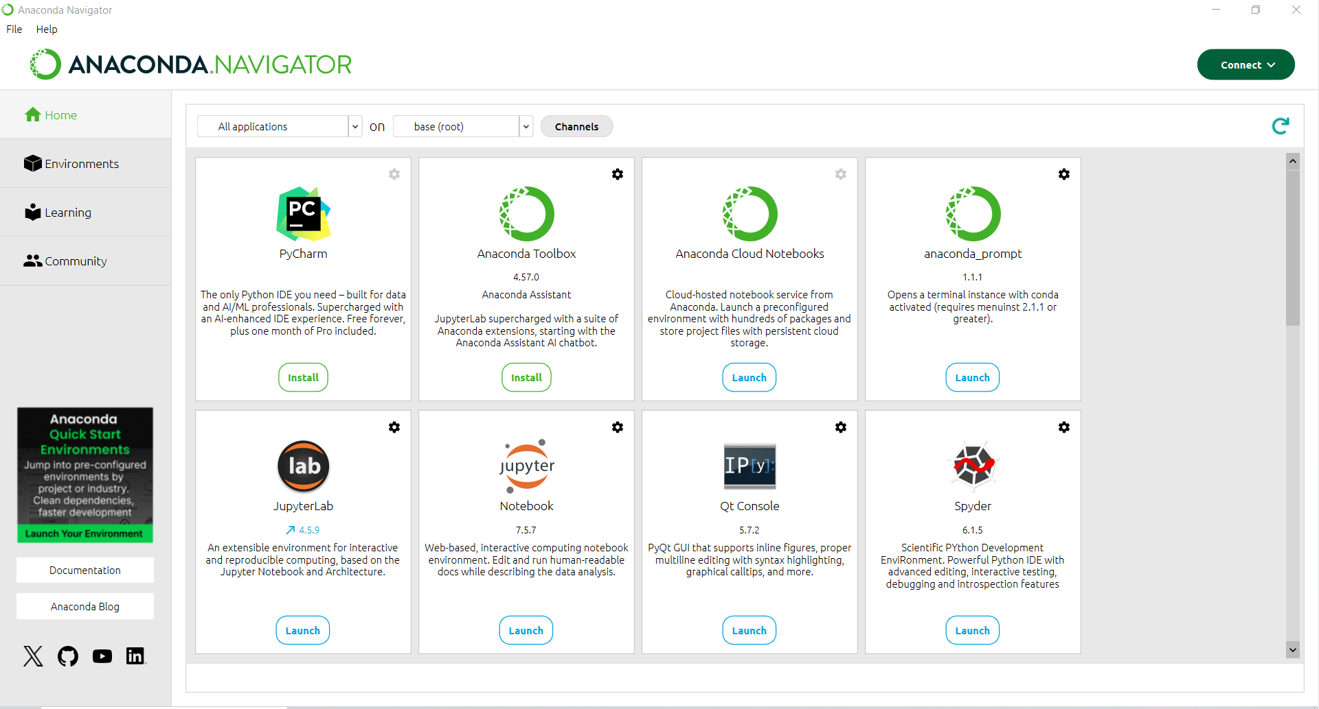
Figure 1: Anaconda Dashboard
Regarding of Jupyter Notebook, choosing Launch button on Jupyter Notebook.
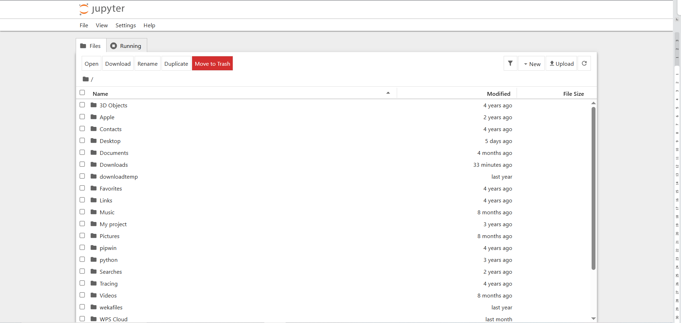
Figure 2: Jupyter Notebook Dashboard

Part B: Colab Running
Regarding of using resources, my Google Colab utilizes the CPU.
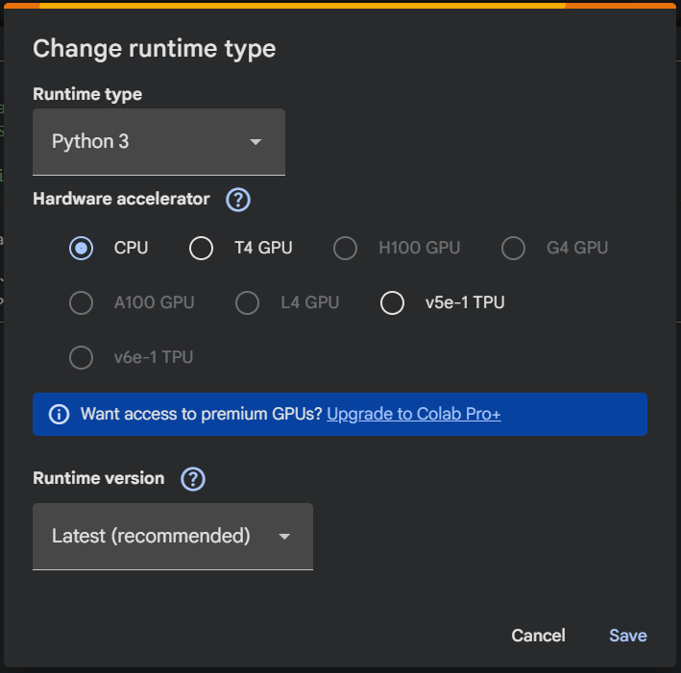

Figure 3: Configuring hardware accelerator in Google Colab.
In the guidance document, the instructions recommend each student should generate a .csv file that contains following data:
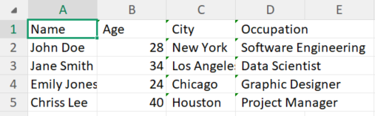
Figure 4: Data preview from file Citizen.csv
Next, I created file named Lab01.ipynb which I can download whole file .ipynb after finishing all tasks in the first laboratory.

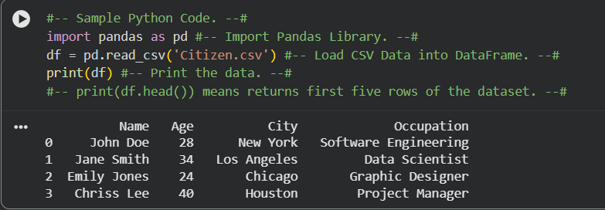
Figure 5: Python code and data return from Citizen.csv
Firstly, based on my search, the Pandas library primarily used for data manipulation, cleaning, exploration, and analysis. Therefore:
- The first line import pandas as pd is for importing Pandas library.
- The second line is for assigning data has been read from file Citizen.csv to variable named df.
- Last line used for prinitng all data (NOTE: .head() in Pythong is print automatically for first 5 rows from the dataset so if I want to print more, I have to put number of rows that I want to see such as df.head(10))
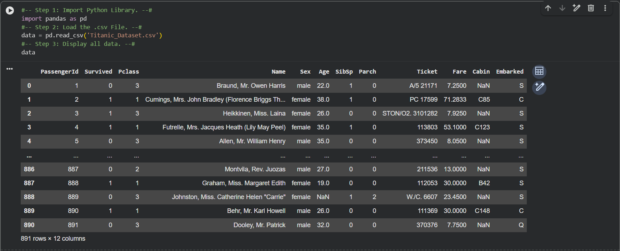
Secondly, I download fle named Titanic_Data.csv from Kaggle website: https://www.kaggle.com/competitions/titanic/data?select=train.csv
Figure 6: Titanic dataset preview loaded in Python
After that, I use .head() function to display first five rows in the dataset and .info() is used to showcase information about the dataset, including the column names and the data types of each column (labels).

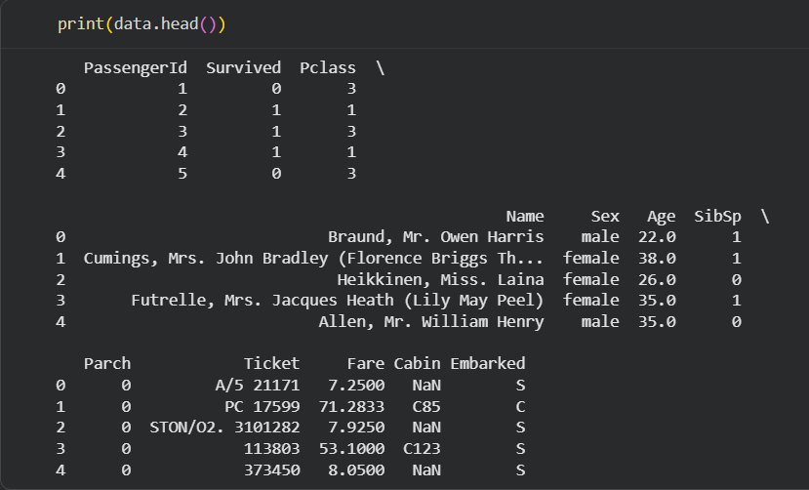
Figure 7: Titanic dataset preview using .head() function
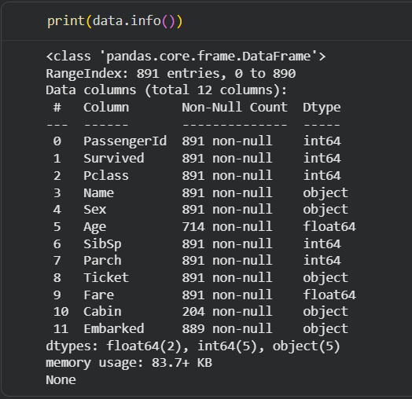

Figure 8: Titanic dataset info and data types preview

It is clear that in Figure 7, the .describe() used for generating descriptive statistics summarizing the central tendency, dispersion, and shape of a dataset's numerical columns:
- count: Number of non-missing values.
- mean: Average value
- std: Standard deviation
- min/max: Minimum/Maximum values
- 50%: Median
As Figure 8 illustrated, the dataset includes following columns (labels) named by using .info():
- PassengerId
- Survived (0 means No and 1 means Yes)
- Pclass (Ticket class: 1 - 1st class, 2 - 2nd class, and 3 - 3rd class)
- Name of Passenger
- Sex (Gender)
- Age
- SibSp (stands for Number of Siblings/Spouses Aboard => 1 means traveling with 1 family member, either a spouse, brother, or sister, and 0 means traveling alone).
- Parch (stands for Number of Parents/Children Aboard: 1 means traveling with one parent or child, while 0 means traveling with neither parents nor children).
- Ticket (Ticket Number)
- Fare (indicates the amount of money the passenger paid for their ticket in British Pounds, which often correlates with their passenger class).
- Cabin (Cabin Number)
- Embarked (stands for Port of Embarkation: indicates the port where the passenger boarded the Titanic, C = Cherbourgh, Q = Queenstown, and S = Southampton)
Finally, for visualizng the graph, I decide to visualize relationship between Passenger Class (Pclass) and Survived by using Matplotlib library.

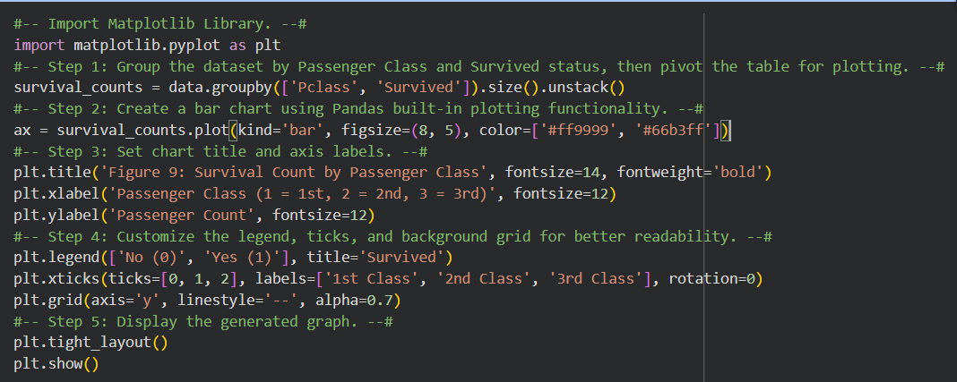
Figure 9: Survival Count by Passgener Class
It is clear from the Figure 9 that:
- import matplotlib.pyplot as plt: Import Matplotlib Library.
- survival_counts = data.groupby([‘Pclass’, ‘Survived’]).size().unstack() (Pclass => Survived)
- Groups and sorts the data: It gathers passengers by their Ticket Class (Pclass), and then subdivides each class by their Survival status (Survived).
- Counts the head count: It counts how many people fall into each of those specific sub-groups.
- Reshapes the table: It transforms that long, vertical list into a clean 2-dimensional table (like an Excel sheet) so that the computer can easily read it and draw side-by-side bar charts.
- ax = survival_counts.plot(kind='bar', figsize=(8, 5), color=['#ff9999', '#66b3ff']) .
- survival_counts.plot(...): Tells Pandas to generate a chart directly from the grouped table.
- kind='bar': Specifies that the chart type should be a vertical bar graph.
- figsize=(8, 5): Sets the dimensions of the figure canvas to 8 inches wide by 5 inches high.
- color=['#ff9999', '#66b3ff']: Assigns custom hex color codes to the bars (soft red for non-survivors and soft blue for survivors).
- Set title fot the figure, label for x-axis and y-axis through next three lines in Step 3.
- Set customize the legend, ticks, and background grid for better readability in Step 4.
- Disply graph in step 5

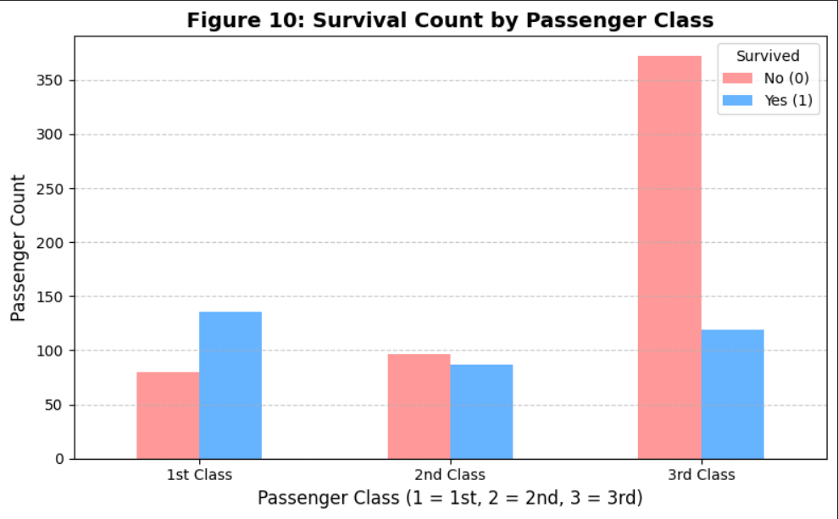
Figure 10: Survival Count by Passenger Class
It is represent that the percentage of survival in the 1st class had the higest ratio among three groups while the 3rd class recorded the most significant number of non-survivors. In contrast, the 2nd class showed a relatively balanced proportion, where the number of survivors and non-survivors was nearly equal.

