Lab Task 2
Write a MapReduce Program for Finding the Shifted Word Counts
COS20028 – Big data Architecture and Applications
Semester 2

Name: Truong Ngoc Gia Hieu
Student ID (Vietnam): SWS01217
Student ID (Australia): 105565520
Date: May 28th, 2026

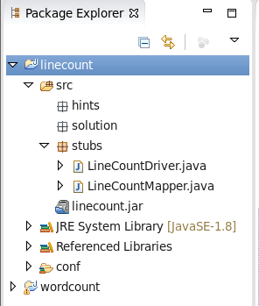
Project Folder Structure Screenshot

Figure 1: Folder Structure

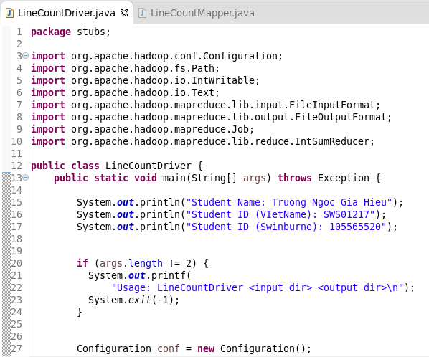
Driver Code

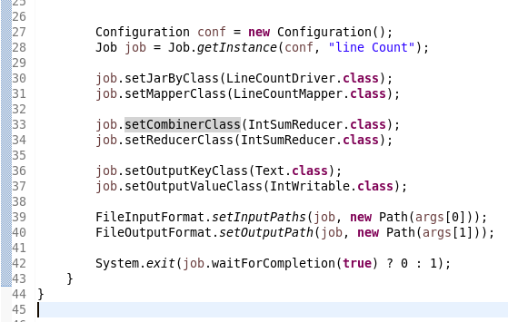
Figure 2: File LineCountDriver.java (Part I)
Figure 3: File LineCountDriver.java (Part II)

Mapper Code
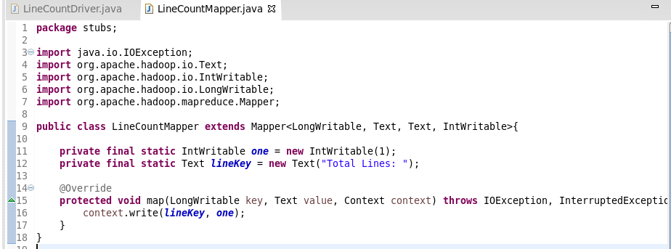

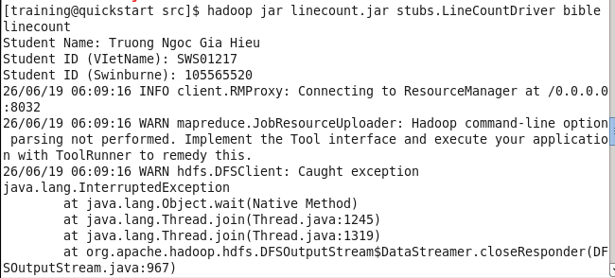
Execution Result

Commands for Retrieving and Displaying Results

Screenshot of the First Page Result Content
