Lab Task 1
Write a MapReduce Program for Finding the Shifted Word Counts
COS20028 – Big data Architecture and Applications
Semester 2

Name: Truong Ngoc Gia Hieu
Student ID (Vietnam): SWS01217
Student ID (Australia): 105565520
Date: May 28th, 2026

Project Folder Structure Screenshot
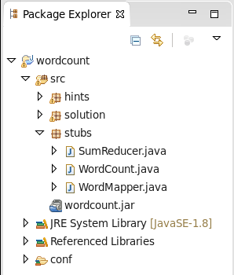

Figure 1: Structure of folder WordCount

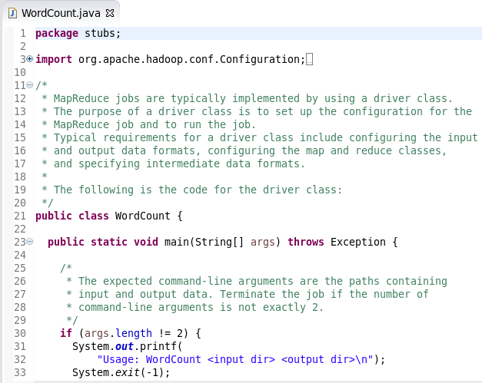
Driver Code

Figure 2: File WordCount.java (Part I)
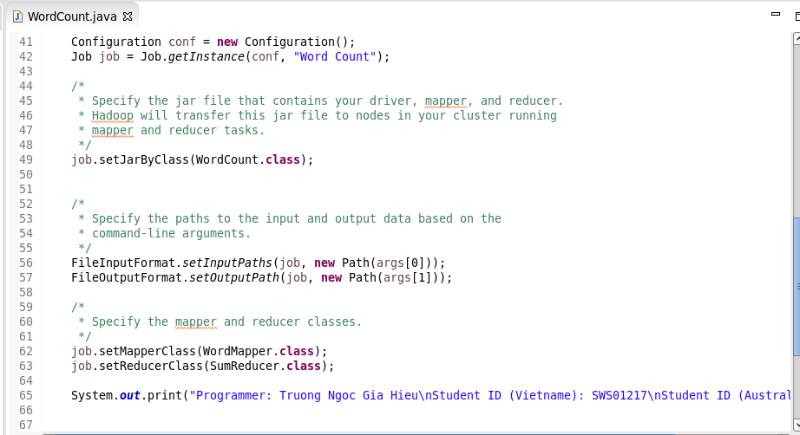
Figure 3: File WordCount.java (Part II)

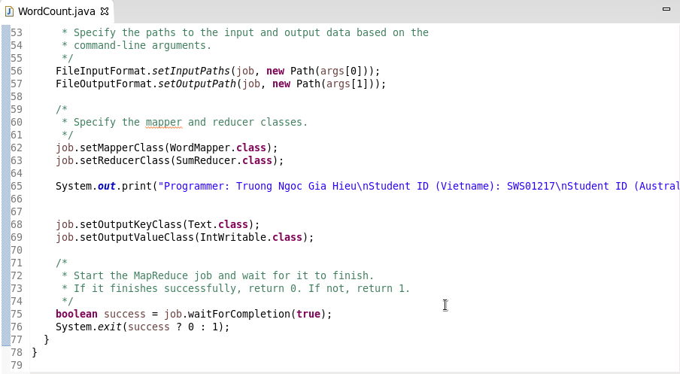
Figure 4: File WordCount.java (Part III)

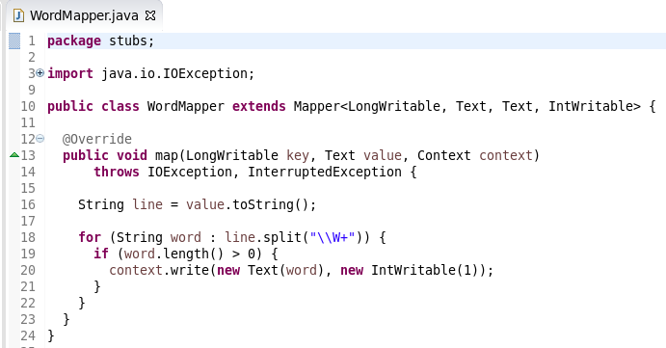
Mapper Code

Figure 5: File WordMapper.java

Reducer Code
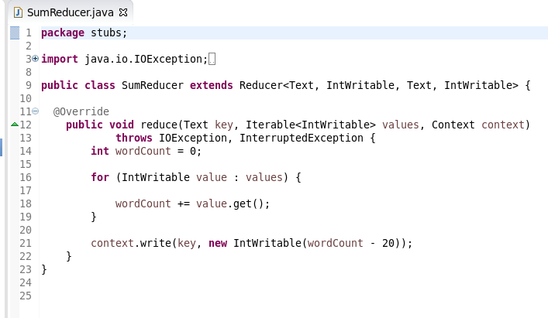
Figure 6: File SumReducer.java

Execution Result
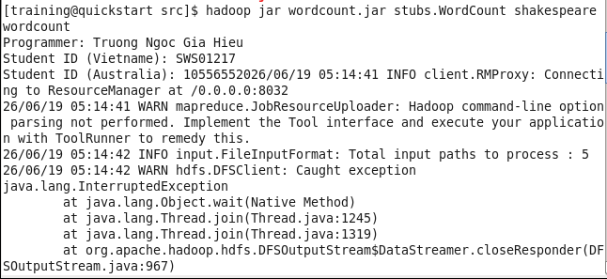

Figure 7: Execution Result

Commands for Retrieving and Displaying Results

Figure 8: Comands for Retrieving and Displaying Ressults

Screenshot of the First Page Result Content
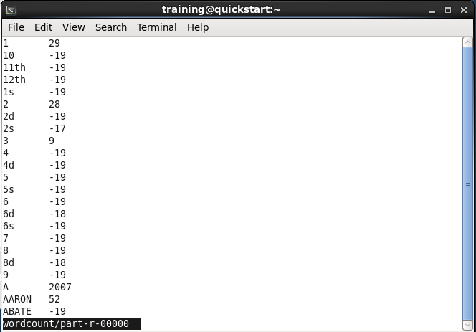
Figure 9: Result

