
Swinburne University of Technology Hawthorn Campus
Department of Computing Technologies

COS20028 Big Data Architecture and Application
Assignment 2 - Semester 2, 2025

Assessment Title: Big Data Analytics.

Assessment Outcome: 20%
Due Date: AEST 23:59 on 24/10/2025.
Assessable Item:
- One (1) piece of a report for answers to the given questions.
- One (1) document of the code collections for your assignment.

Background

You are given a dataset “loyalty_data.txt” containing loyalty program member information. The source file is located on the path “~/training_materials/analyst/exercises/data_mgmt”. Each row is pipe-delimited (|) and includes:
- Customer ID
- First Name
- Last Name
- Email
- Membership Tier (SILVER, GOLD, PLATINUM)
- Phone Numbers
- Transactions (comma-separated)
- Account Summary (comma-separated values: points earned, total spend, purchases, lifetime value)

Assignment Task

Use only Apache Pig to solve the given tasks. Your codes must be used to find answers to the questions. Some questions may require multiple steps of code to find answers. Follow the question sequence to build your code. If the answer is found based on the outcome from previous questions, you can provide the code based on the current system state. There is no need to post all the code from the beginning unless the answer cannot be found based on previous process results. You should store the results in the HDFS in the statements you made.
1. | Load the source data and find how many tuples are included in this dataset. | [10 marks]
2. | Calculate how many customers belong to each membership tier (SILVER, GOLD, PLATINUM). | [10 marks]
3. | Split the account_summary field into meaningful columns: points, spend, purchases, and lifetime_value. | [10 marks]
4. | Find the top 5 customers with the highest lifetime value. | [10 marks]
5. | Calculate the average total_spend for each membership tier. | [15 marks]
6. | Find customers who have more than one phone number recorded. | [15 marks]
7. | Sum the total points earned by customers in each membership tier. | [15 marks]
8. | Count how many customers use each email domain (e.g., gmail.com, example.com). | [15 marks]

Please use the template to prepare your submission.

Question Answering

Student Name: Truong Ngoc Gia Hieu

Student ID (Vietnam): SWS01217

StudentID (Australia): 105565520

Before answering following questions, I would like to demonstrate the setup stage.

Firstly, I would like to view dataset named ‘loyalty_data.txt’ in the directory ‘home/training/training_materials/analyst/exercises/data_mgmt/loyalty_data.txt’.

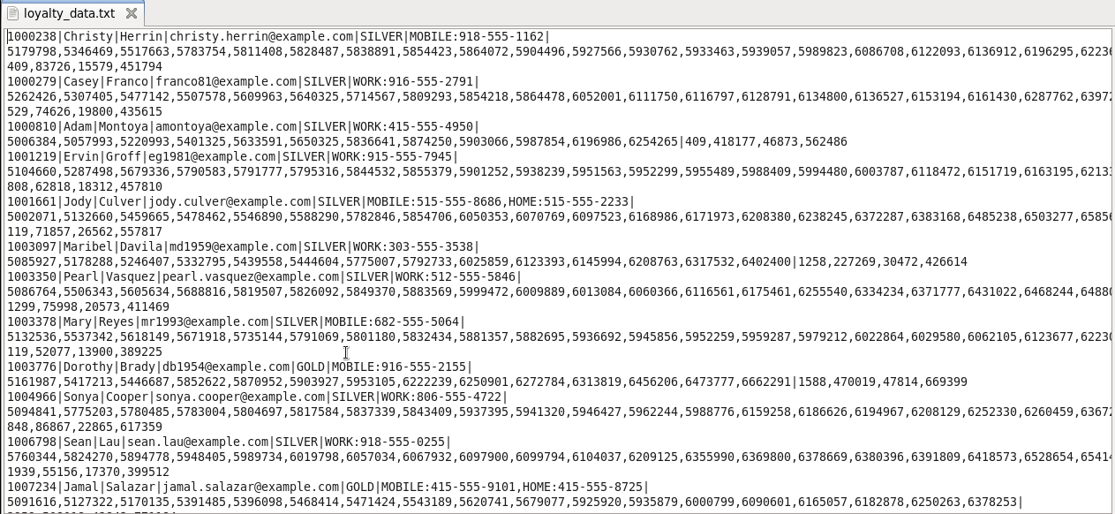
Figure 1: Contents of the loyalty_data.txt file

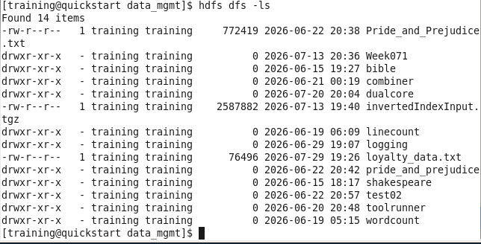
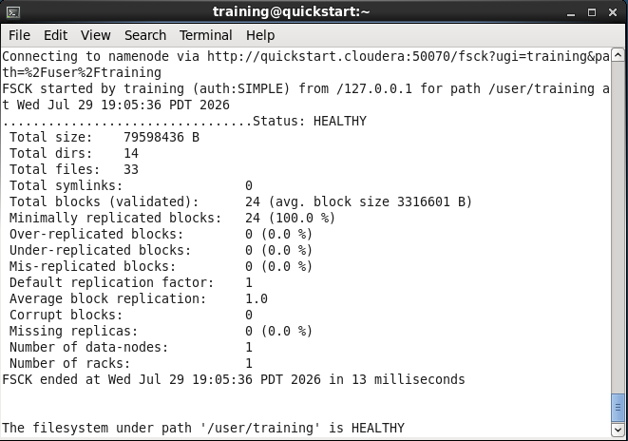
Secondly, I check the HDFS system status is healthy or not by using command ‘hdfs fsck/user/training/’.
Next, after ensuring the HDFS status is healthy, I have to upload the text file from the local virtual machine to the HDFS system with command ‘hdfs dfs -put loyalty_data.txt .’ Then, I check whether the provided file has alredy exists in HDFS by following command ‘hdfs dfs -ls’
Figure 3: Checking uploaded files in the HDFS system.
Figure 2: Verifying HDFS cluster health status

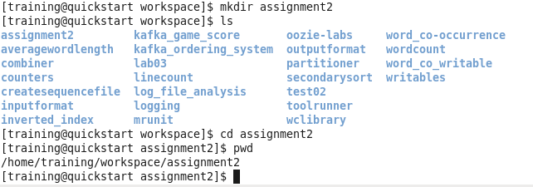
Then, I created a folder named Assignment2 to store the .pig files for executing the following tasks.
Figure 4: assignment2 folder creation

Load the source data and find how many tuples are included in this dataset. List the code you used in Apache Pig for loading the data and finding the answer.

=> Ans

- The count of tuples in the given dataset is 311.

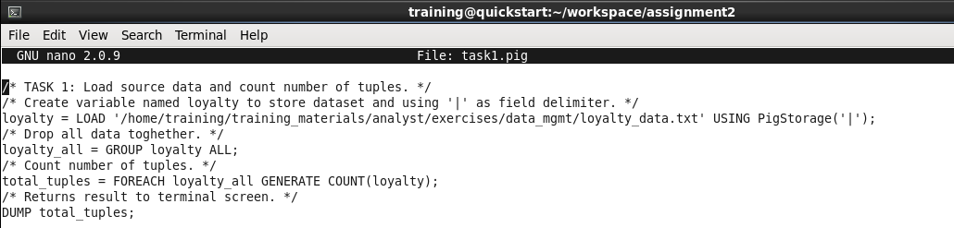
- List the statements of loading data and find the count of tuples below:
Figure 5: File task1.pig

Calculate how many customers belong to each membership tier (SILVER, GOLD, PLATINUM).

=> Ans:

- SILVER: 256, GOLD: 52 , PLATINUM: 3.

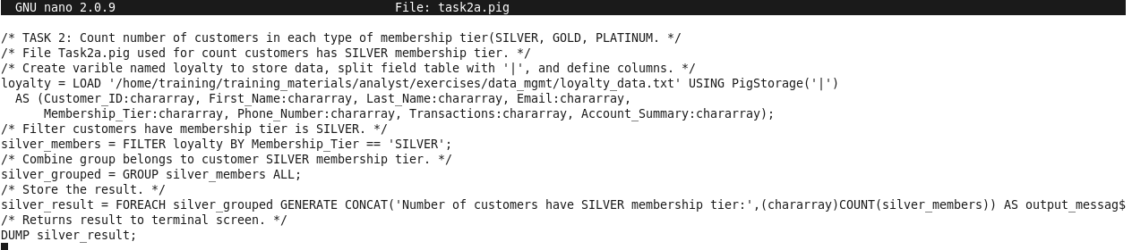
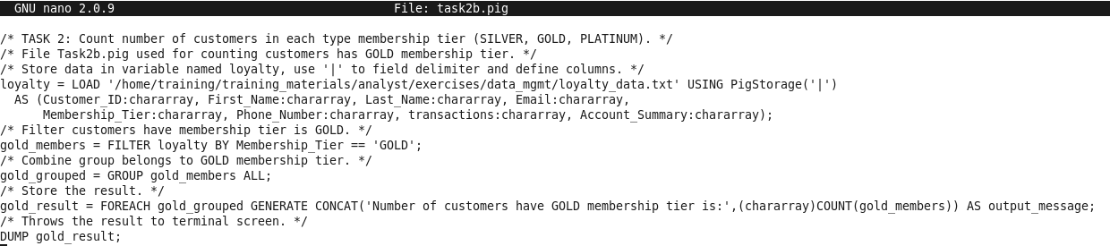
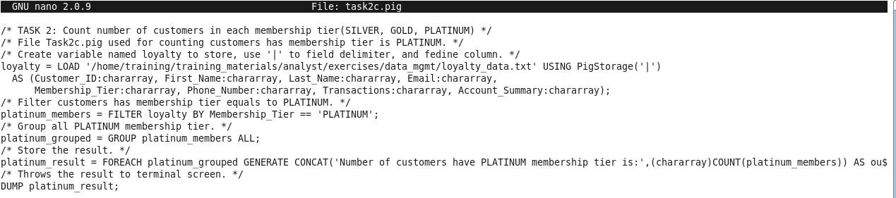
- List the statements for finding the answer to this question below:
(In this question, I decide to create three files named task2a.pig, task2b.pig, task2c.pig for couting customers have membership tier SILVER, GOLD, and PLATINUM respecively).
Figure 6: File task2a.pig
Figure 8: File task2c.pig
Figure 7: File task2b.pig

Split the account_summary field into meaningful columns: points, spend, purchases, and lifetime_value. Store the result in “A2_2025_Q3”.

=> Ans: In the third question, I suggest load dataset first, create new dataset named A2_2025_Q3 with field account_summary split into four seperated fields including points, spend, purchases, and lifetime_value

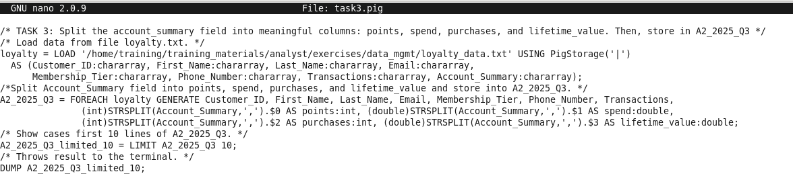
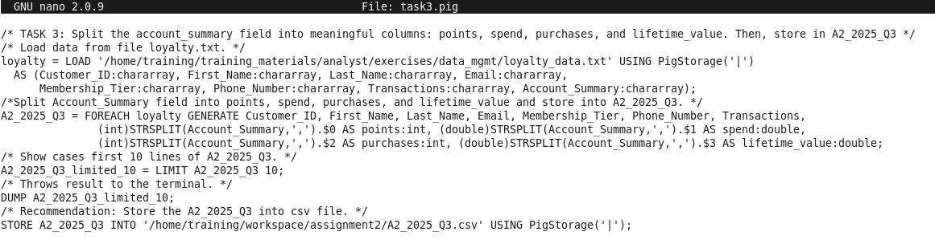
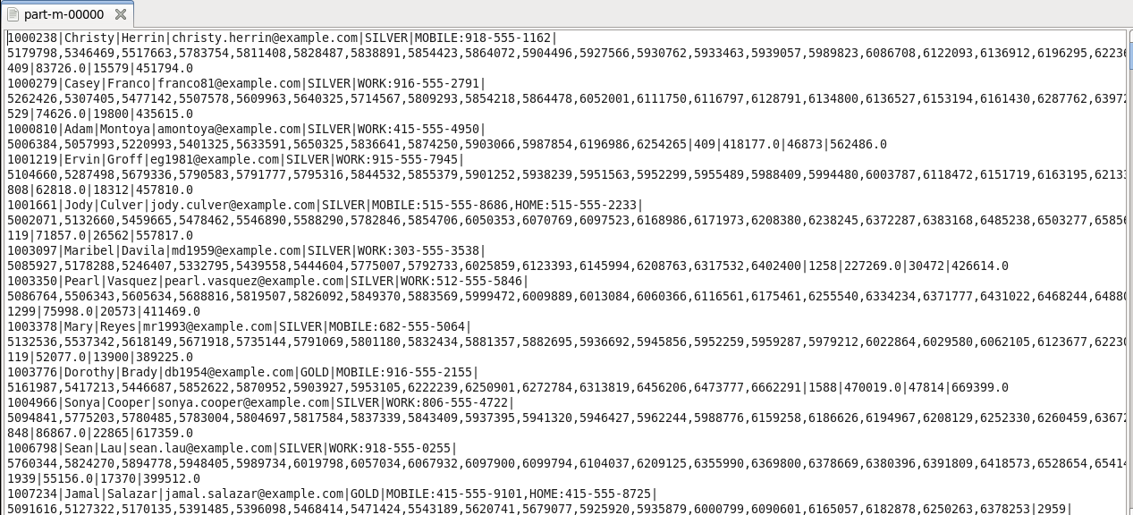
- List the statements for finding the answer to this question below:
Then, I decided to store data into folder named A2_2025_Q3 in following directory ‘home/training/workspace/assignment2/A2_2025_Q3’ with file named part-m-00000.
Figure 9: File task3.pig
Figure 11: Updated code in file task3.pig
Figure 11: Updated code in file task3.pig
Figure 10: Content in file part-m-00000
Figure 10: Content in file part-m-00000

Find the top 5 customers with the highest lifetime value. Store the result in “A2_2025_Q4”. Answer the question below.
=> In the fourth question, I create a new file named task4.pig with command nano task4.pig and store the result in the directory: /home/training/workspace/assignment2/A2_2025_Q4.

The output contains 3 PLATINUM and 2 SILVER (membership tier) records.

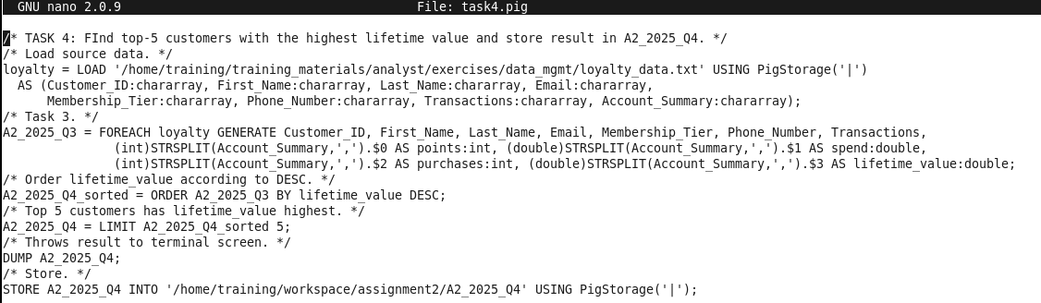
List the statements for finding the answer to this question below:
Figure 12: File task4.pig

Calculate the average total_spend for each membership tier. Store the result in “A2_2025_Q5”. Answer the questions below.

[Ans]

Description: I decide to split three seperated files for calculating total and average spend of each membership tier for GOLD, SILVER, PLATINUM.

The total spend of each membership tier is:

SILVER: 4.4217219E7 (44,217,219)

(Total spend of SILVER: 44,217,219 and Average spend of SILVER: 172723.51171875)

GOLD: 2.3150155E7 (23,150,155)
(Total spend of GOLD: 44,217,219 and Average spend of GOLD: 445195.28846153844)

PLATINUM: 1369025.0

(Total spend of PLATINUM: 1369025.0 and Average spend of PLATINUM: 456341.666666667)

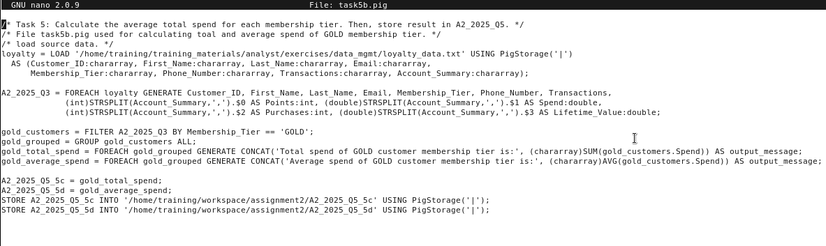
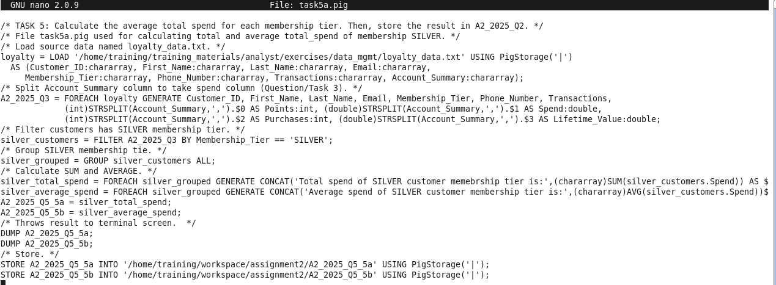
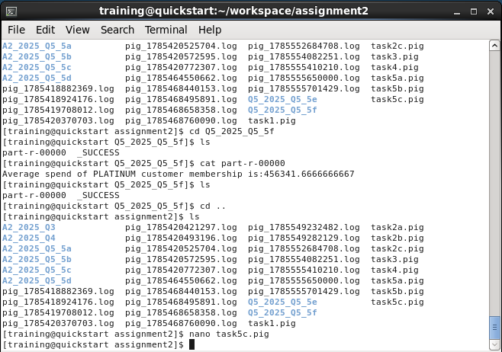
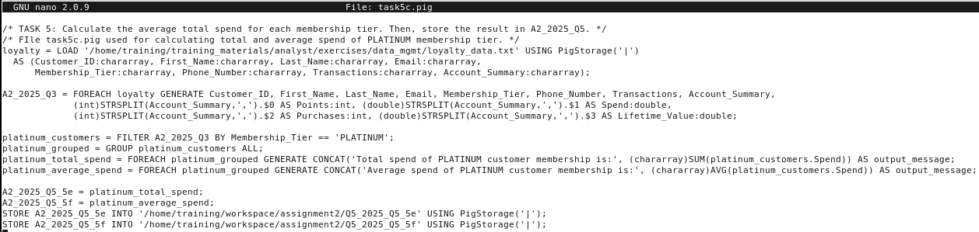
List the statements for finding the answer to this question below:
Figure 13: Code in file task5a.pig
Figure 14: Code in file task5b.pig
Figure 15: Code in file task5c.pig
Figure 16: Files in filder assignment2

Find customers who have more than one phone number recorded. Store the result in “A2_2025_Q6”.

[Ans]

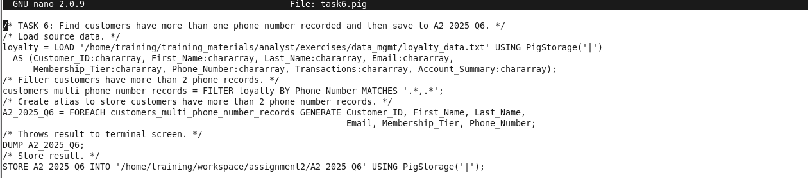
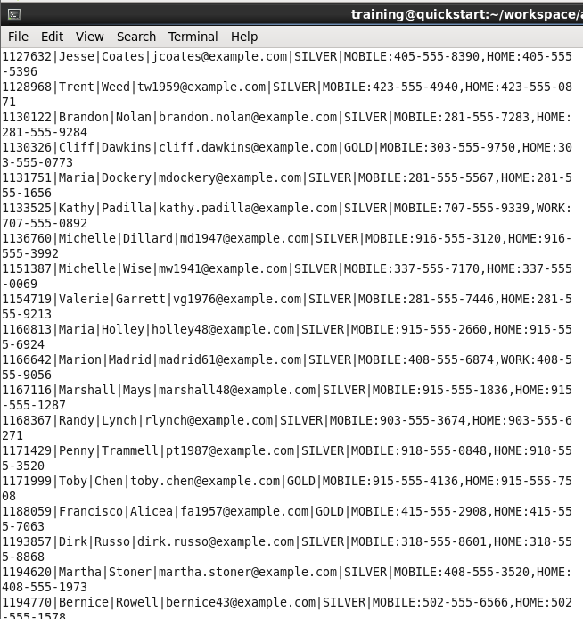
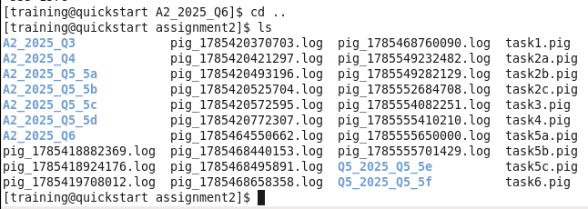
List the statements for finding the answer to this question below:
Figure 17: Code in file task6.pig
Figure 18: Result in file part-m-00000
After viewing result, customers who have more than 2 phone number records acutally is including mobile and work/home phone numbers
Figure 19: Current inside folder assignment2

Sum the total points earned by customers in each membership tier. Store the result in "A2_2025_Q7". Answer the questions below.

[Ans] => Similarly to question 5, I split the question into three parts named task7a.pig, task7b.pig, task7c.pig with count total points for GOLD, SILVER, PLATINUM respectively.

The sum of total points earned by each membership tier is:

GOLD: 76026

SILVER: 346458

PLATINUM: 4737

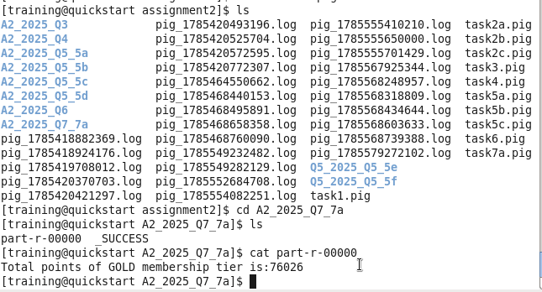
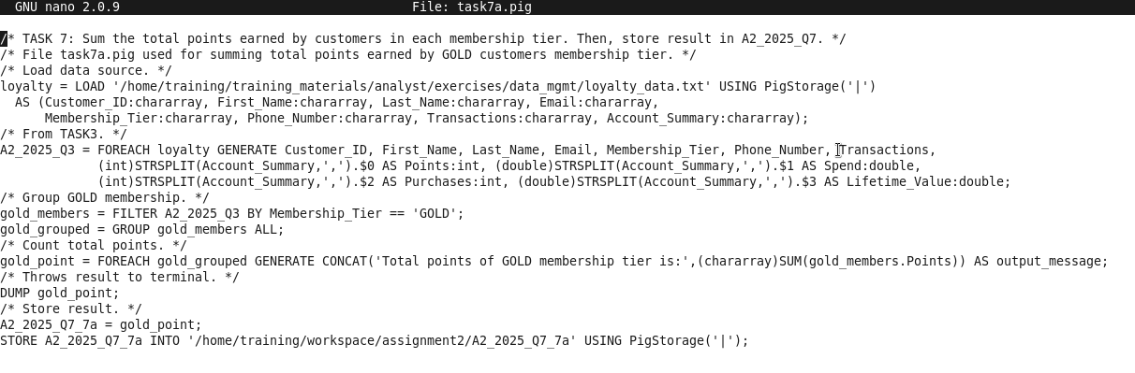
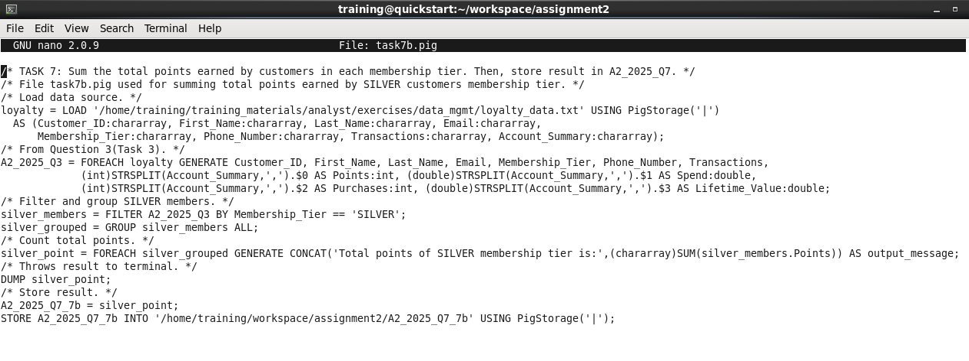
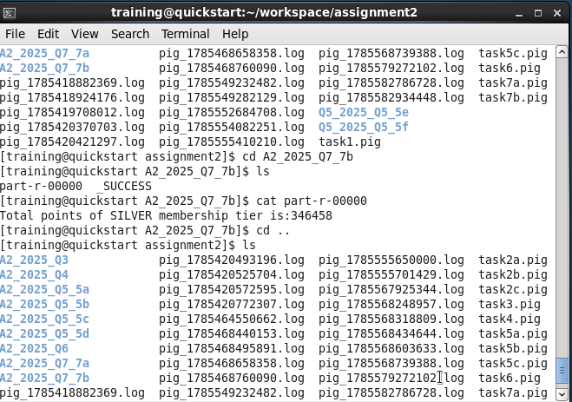
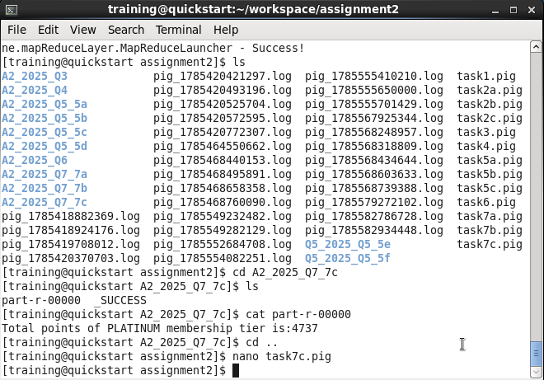
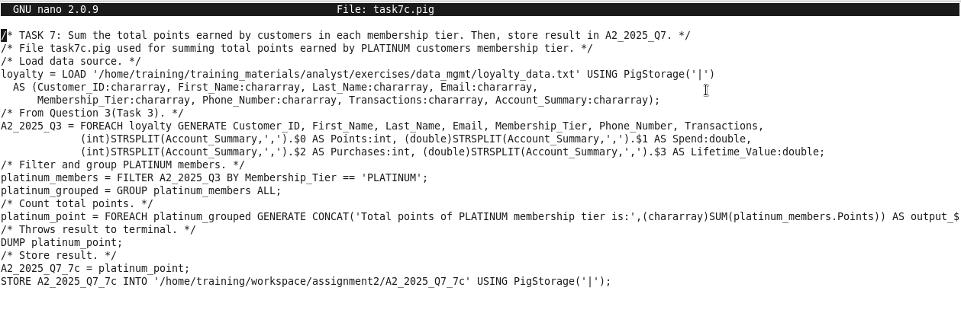
List the statements for finding the answer to this question below:
Figure 20: Code in file task7a.pig
Figure 21: Content in file part-r-00000 in folder A2_2025_Q7_7a
Figure 23: Content in file part-r-00000 in folder A2_2025_Q7_7b
Figure 22: Code in file task7b.pig
Figure 25: Content in file part-r-00000 in folder A2_2025_Q7_7c
Figure 24: Code in file task7c.pig

Count how many customers use each email domain (e.g., gmail.com, example.com). Store the result in "A2_2025_Q8". Answer the question below.

[Ans]

List the email domains and the corresponding counts in the following table. Add new rows as needed.
Domain | Count
example.com | 311

List the statements for finding the answer to this question below:

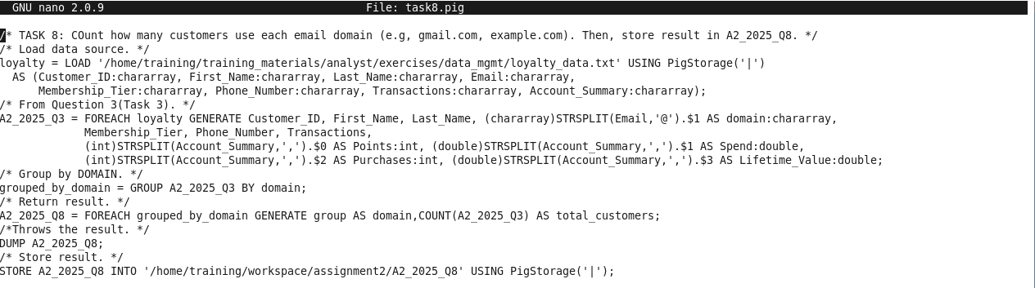
Figure 24: Code in file task8.pig

Commands used for execution during the assignment2:

- hdfs fsck /user/training: uses for checking HDFS status health.

- pwd: used for checking current directory.

- ls: used for showcasing files and sub-folders in the directory.

- cd workspace: used for moving to folder named workspace.

- cd assignment2: used for moving to folder named assignment2.

- nano task1.pig: used for creating file named task1.pig to code and view.

- pig -x local task1.pig: used for running file task1.pig.

- nano task2a.pig: used for creating file named task2a.pig to code and view.

- pig -x local task2a.pig: used for running file task2a.pig.

- nano task2b.pig: used for creating file named task2b.pig to code and view.

- pig -x local task2b.pig: used for running file task2b.pig.

- nano task2c.pig: used for creating file named task2c.pig to code and view.

- pig -x local task2c.pig: used for running file task2c.pig.

- nano task3.pig: used for creating file named task3.pig to code and view.

- pig -x local task3.pig: used for running file task3.pig.

- cd A2_2025_Q3: used for moving to folder named A2_2025_Q3;

- ls: used for showing what files inside the folder A2_2025_Q3.

- cat part-m-00000: used for showing result in file part-m-00000.

- cd..: used for returning back to folder assignment2.

- nano task4.pig: used for creating file named task4.pig to code and view.

- pig -x local task4.pig: used for running file task4.pig.

- cd A2_2025_Q4: used for moving to folder named A2_2025_Q4.

- ls: used for showing what files inside the folder A2_2025_Q4.

- cat part-r-00000: used for showing result in file part-r-00000.

- cd..: used for returning back to folder assignment2.

- nano task5a.pig: used for creating file named task5a.pig to code and view.

- pig -x local task5a.pig: used for running file task5a.pig.

- cd A2_2025_Q5_5a: used for moving to folder named A2_2025_Q5_5a.

- ls: used for showing what files inside the folder A2_2025_Q5_5a.

- cat part-r-00000: used for showing result in file part-r-00000.

- cd..: used for returning back to folder assignment2.

- nano task5b.pig: used for creating file named task5b.pig to code and view.

- pig -x local task5b.pig: used for running file task5b.pig.

- cd A2_2025_Q5_5b: used for moving to folder named A2_2025_Q5_5b.

- ls: used for showing what files inside the folder A2_2025_Q5_5b.

- cat part-r-00000: used for showing result in file part-r-00000.

- cd..: used for returning back to folder assignment2.

- nano task5c.pig: used for creating file named task5c.pig to code and view.

- pig -x local task5c.pig: used for running file task5c.pig.

- cd A2_2025_Q5_5c: used for moving to folder named A2_2025_Q5_5c.

- ls: used for showing what files inside the folder A2_2025_Q5_5c.

- cat part-r-00000: used for showing result in file part-r-00000.

- cd..: used for returning back to folder assignment2.

- nano task5d.pig: used for creating file named task5d.pig to code and view.

- pig -x local task5d.pig: used for running file task5d.pig.

- cd A2_2025_Q5_5d: used for moving to folder named A2_2025_Q5_5d.

- ls: used for showing what files inside the folder A2_2025_Q5_5d.

- cat part-r-00000: used for showing result in file part-r-00000.

- cd..: used for returning back to folder assignment2.

- nano task5e.pig: used for creating file named task5e.pig to code and view.

- pig -x local task5e.pig: used for running file task5e.pig.

- cd A2_2025_Q5_5e: used for moving to folder named A2_2025_Q5_5e.

- ls: used for showing what files inside the folder A2_2025_Q5_5e.

- cat part-r-00000: used for showing result in file part-r-00000.

- cd..: used for returning back to folder assignment2.

- nano task5f.pig: used for creating file named task5f.pig to code and view.

- pig -x local task5f.pig: used for running file task5f.pig.

- cd A2_2025_Q5_5f: used for moving to folder named A2_2025_Q5_5f.

- ls: used for showing what files inside the folder A2_2025_Q5_5f.

- cat part-r-00000: used for showing result in file part-r-00000.

- cd..: used for returning back to folder assignment2.

- nano task6.pig: used for creating file named task6.pig to code and view.

- pig -x local task6.pig: used for running file task6.pig.

- cd A2_2025_Q6: used for moving to folder named A2_2025_Q6.

- ls: used for showing what files inside the folder A2_2025_Q6.

- cat part-r-00000: used for showing result in file part-r-00000.

- cd..: used for returning back to folder assignment2.

- nano task7a.pig: used for creating file named task7a.pig to code and view.

- pig -x local task7a.pig: used for running file task7a.pig.

- cd A2_2025_Q7_7a: used for moving to folder named A2_2025_Q7_7a.

- ls: used for showing what files inside the folder A2_2025_Q7_7a.

- cat part-r-00000: used for showing result in file part-r-00000.

- cd..: used for returning back to folder assignment2.

- nano task7b.pig: used for creating file named task7b.pig to code and view.

- pig -x local task7b.pig: used for running file task7b.pig.

- cd A2_2025_Q7_7b: used for moving to folder named A2_2025_Q7_7b.

- ls: used for showing what files inside the folder A2_2025_Q7_7b.

- cat part-r-00000: used for showing result in file part-r-00000.

- cd..: used for returning back to folder assignment2.

- nano task7c.pig: used for creating file named task7c.pig to code and view.

- pig -x local task7b.pig: used for running file task7c.pig.

- cd A2_2025_Q7_7b: used for moving to folder named A2_2025_Q7_7b.

- ls: used for showing what files inside the folder A2_2025_Q7_7b.

- cat part-r-00000: used for showing result in file part-r-00000.

- cd..: used for returning back to folder assignment2.

- nano task8.pig: used for creating file named task8.pig to code and view.

- pig -x local task7b.pig: used for running file task7c.pig.

- cd A2_2025_Q8: used for moving to folder named A2_2025_Q8.

- ls: used for showing what files inside the folder A2_2025_Q8.

- cat part-r-00000: used for showing result in file part-r-00000.

- cd..: used for returning back to folder assignment2..

