Lab Task 4
Write a MapReduce Program for Finding the Shifted Word Counts
COS20028 – Big data Architecture and Applications
Semester 2

Name: Truong Ngoc Gia Hieu
Student ID (Vietnam): SWS01217
Student ID (Australia): 105565520
Date: 07/14/2026

Project Folder Structure Screenshot

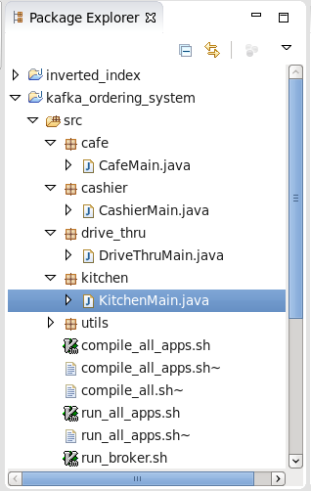

Cashier.java Code
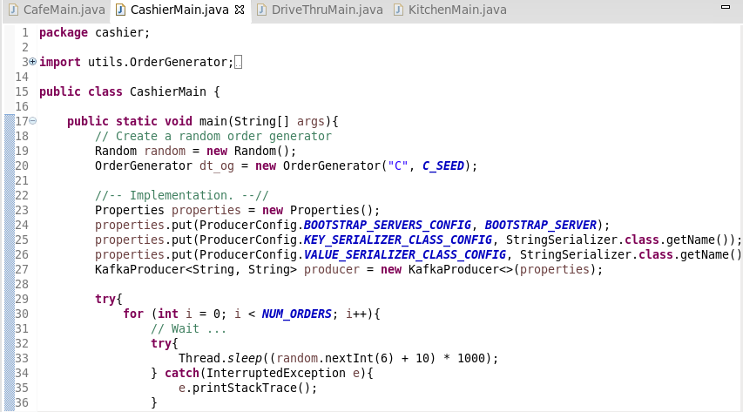

Cafe.java Code
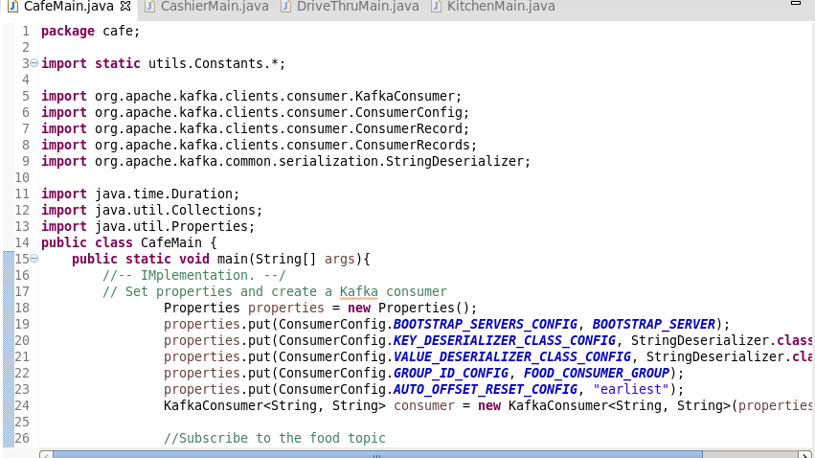

Screenshot of the Final Result Content
