Lab Task 5
Analysing Ad campaign data with Pig
COS20028 – Big data Architecture and Applications
Semester 2

Name: Truong Ngoc Gia Hieu
Student ID (Vietnam): SWS01217
Student ID (Australia): 105565530
Date: July 20th, 2026

Screenshot of the First Page Result Content

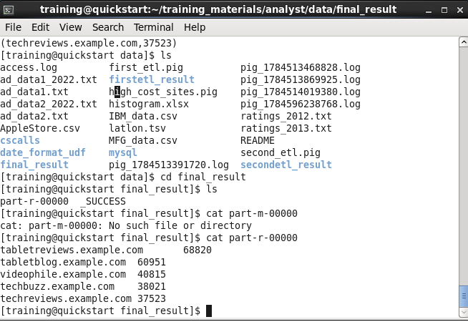

The Code for Processing the First AD:
(The “first_etl.pig” content)
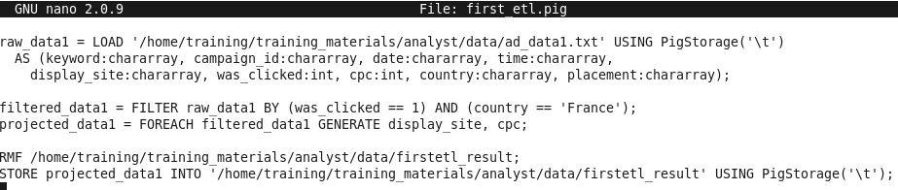

The Code for Processing the Second AD:
(The “second_etl.pig” content)
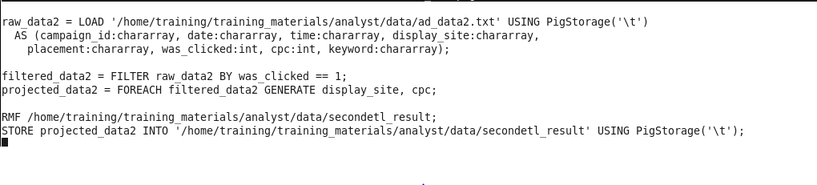

The Code for Merging Multiple Sources and Finding Answers:
(The “high_cost_sites.pig” content)
