Lab Task 6
Analysing Ad campaign data with Pig
COS20028 – Big data Architecture and Applications
Semester 2

Name: Truong Ngoc Gia Hieu
Student ID (VietNam): SWS01217
StudentID (Australia): 105565520
Date: July 24th, 2026

The Code for the first question:
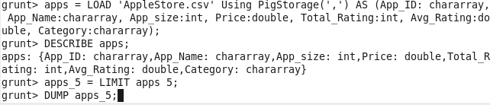

Screenshot of the First Page Result Content
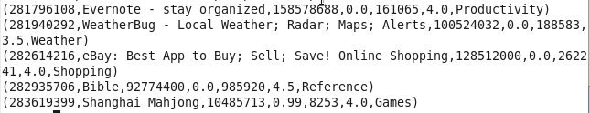

The Code for the second question:
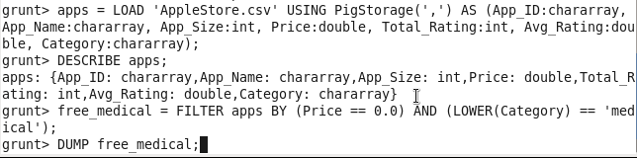

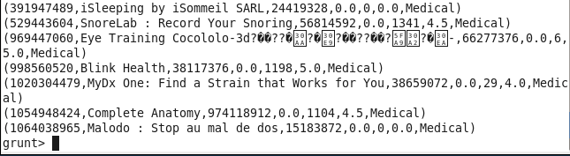
Screenshot of the Second Page Result Content

The Code for the third question:

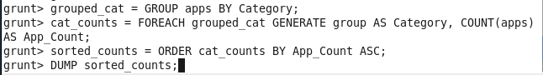

Screenshot of the First Page Result Content

