

Task 2 – Pass Submission

Student Number: Truong Ngoc Gia Hieu
Student Name (VietNam/Australia): SWS01217/ 105565520

Task Pass2a
In the first task of the Pass section, students are required to open file named studentlist.csv by Notepad editor.
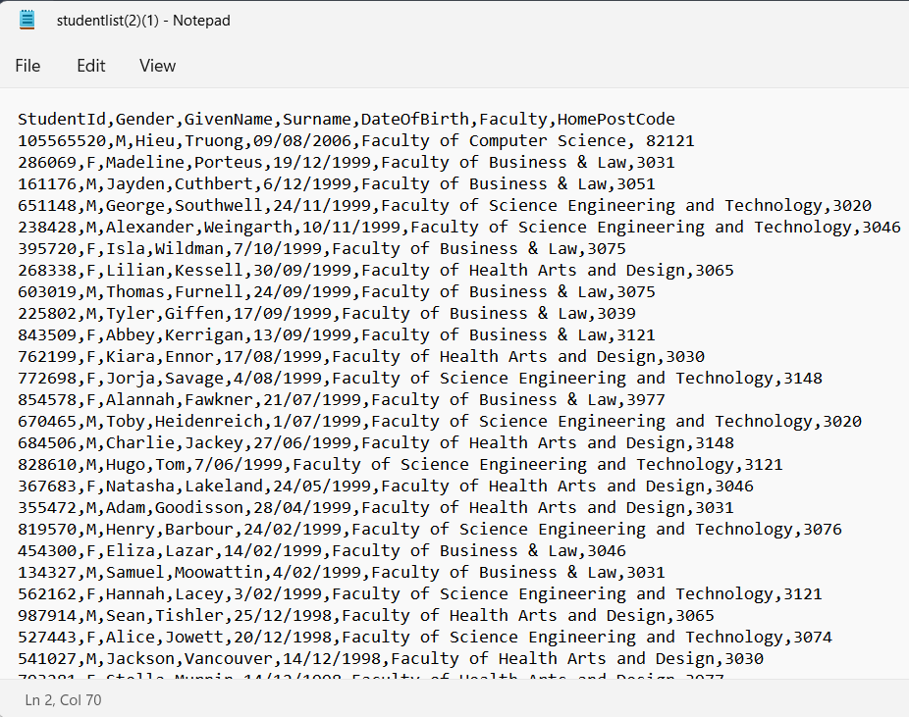
Figure 1: Editing studentlist.csv in Notepad
Next, select Delimited, choose Comma (Tick First Row Contains Field Names), and set table name is Student5520 in order too import file studentlist.csv into .accdb file

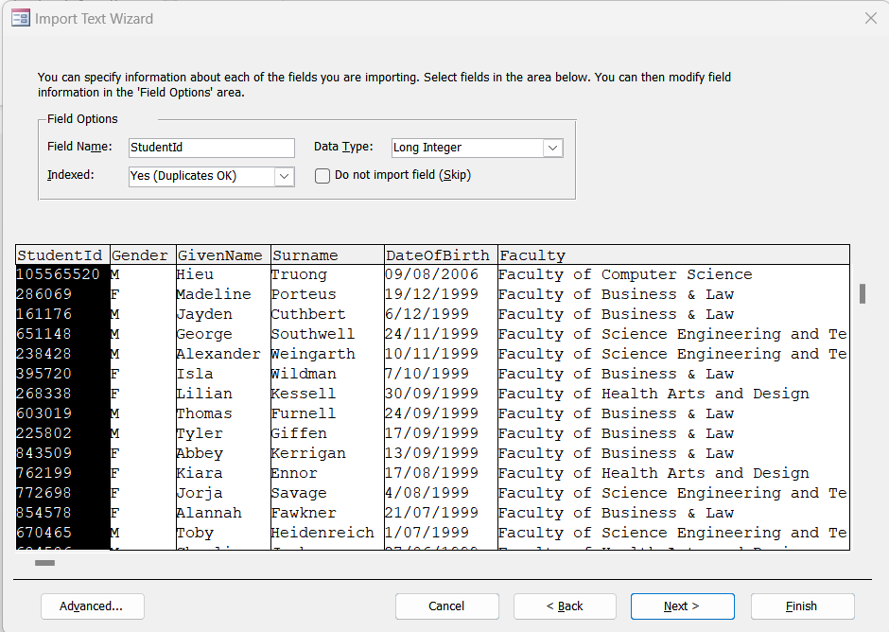
Figure 2: Field Options Process in Import Text Wizard
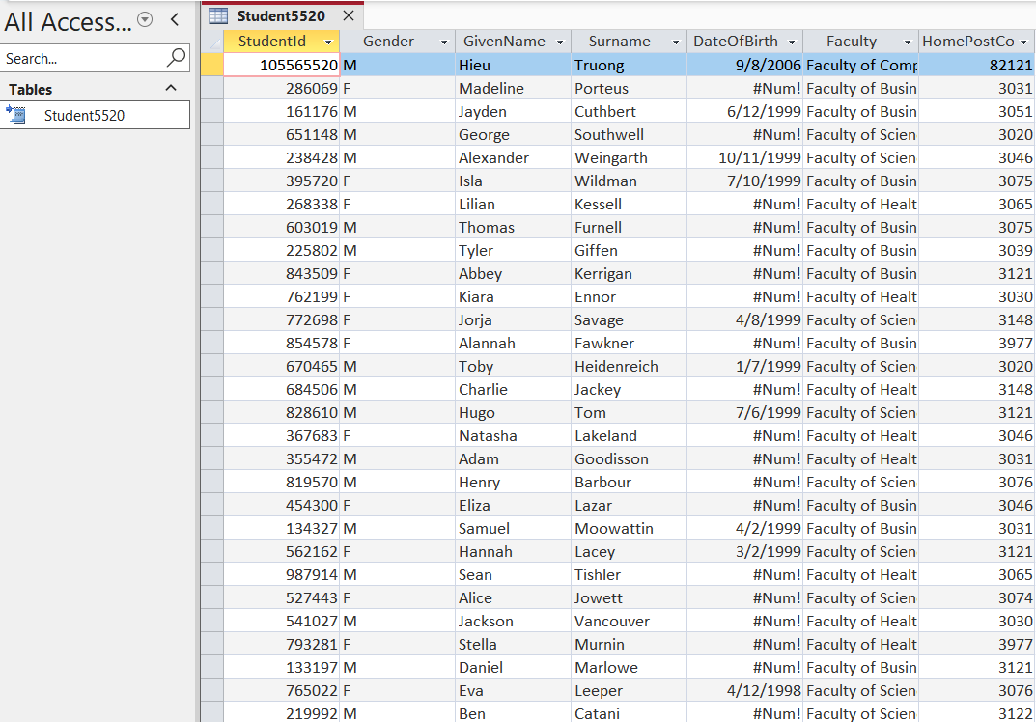
Figure 3: Datasheet View of Student5520 Table

Task Pass2b
- In my opinion, double-clicking typically opens a .csv file in Microsoft Excel because Windows operating system the .csv file extension with Excel by default. Furthermore, when Excel is installed, it registers itself with Windows as the default program for handling Comma-Separated Values (.csv) files because tabular spreadsheet software is commonly used to view and edit this type of structured data.
- For permanently change the default program for .csv files to Notepad:
- Right click on any .csv files
- Select Open with and then click on Choose another app (or More apps).
- Scroll down and select Notepad from the list of available applications.
- Check the box that says "Always use this app to open .csv files".
- Click OK. From then on, double-clicking any .csv file will automatically open it in Notepad instead of Excel.

Task Pass2c
In the third task, students must switch to Design View, add the field name FeesPaid, and set its data type to Currency.
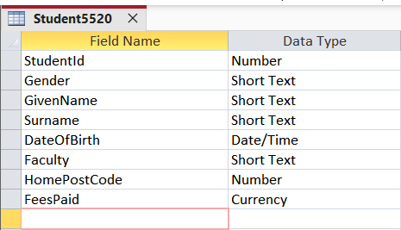
Figure 4: Table Design View with FeesPaid Field
Next, open the datasheet view of the Student5520 table and sort the data in descending order by StudentId (displaying the top 10 rows with the largest student numbers at the top).

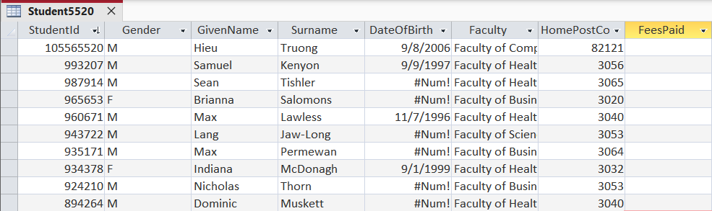
Figure 5: Top 10 Rows of Student5520 in Descending Student ID Sequence
Subsequently, students are required to generate a copy table name STUCOPY5520
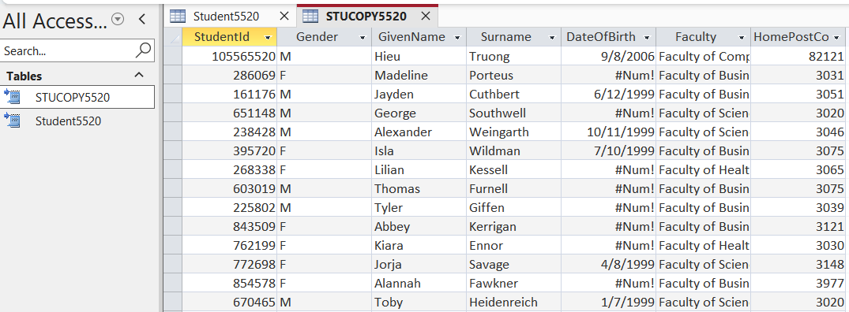
Figure 6: Navigation Pane Showing Both Student5520 and STUCOPY5520 Tables.

Task Pass2d
Before generating the query, the requirement instructs students to close Student5520 table and then create query named T2PD_Update_5520. Then, in the Query Design tab, click on the Update to specify the update rule, and set based on following instructions:
- Field: FeesPaid, Table: Student5520, Update To: 4000.
- Field: Gender, Table: Student5520, Criteria: “M”.
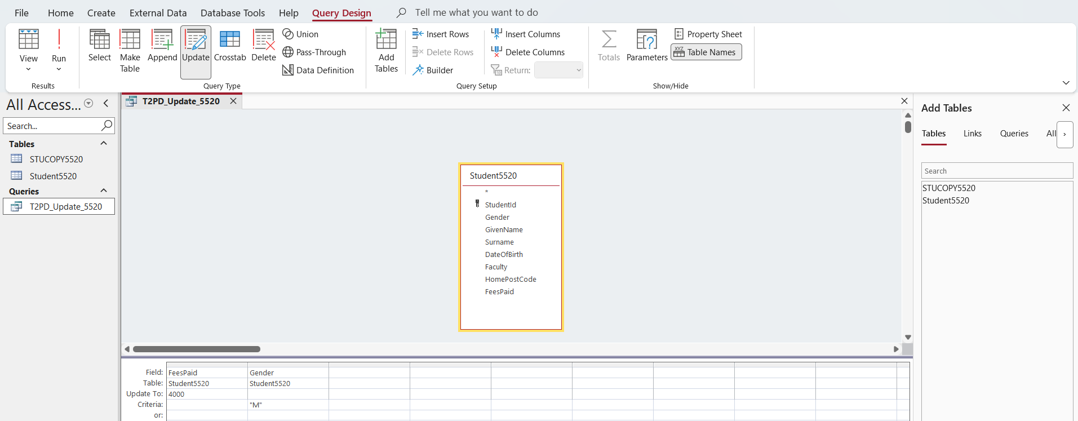
Figure 7: Query Design (Query Configuration) for T2PD_Update_5520
After successful configuration, reopen the Student5520 table, sort the StudentId in descending order, and verify that the updated FeesPaid values are correctly displayed for all male students.
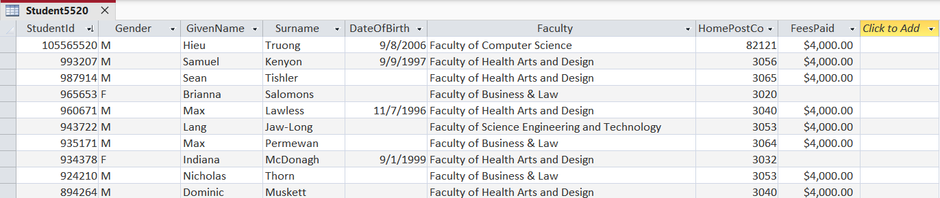
Figure 8: Updated Top 10 Rows of Student5520 in Descending Student ID Sequence

Task Pass2e
Subsequently, the requirement guide student to close the student table first, choose Query Design in the Create ribbon, select Delete in the Query Type, and configure these following:
- Field: Surname,
- Table: Student5520.
- Delete: Where.
- Criteria: Like “M*”
After configuring above requirements, save query named T2PE_Delete_5520.
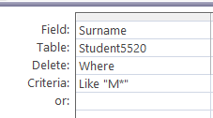

Figure 9: Query Design for T2PE_Delete_5520
After setting configure successfully, click on Run button. After that, choose table Student5520 table on Datasheet View and sort StudentID Descending.
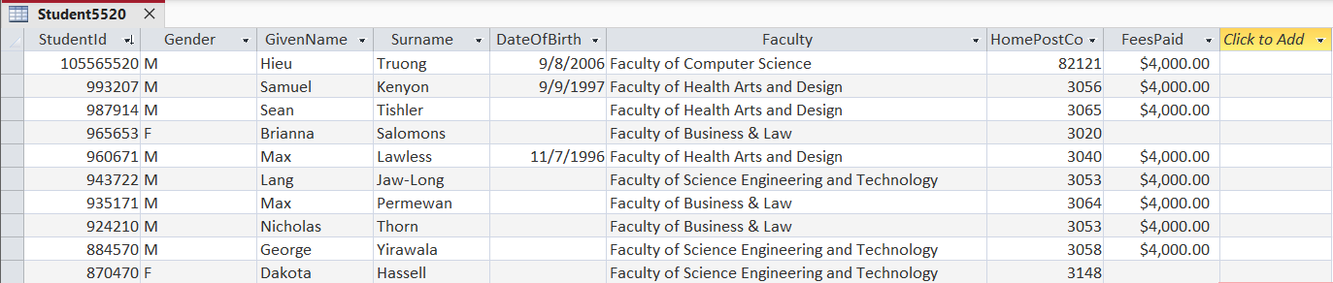
Figure 10: Updated Top 10 Rows of Student5520 After Deleting Students with Surname Starting with 'M'
In detail, when comparing the Student5520 table to the STUCOPY5520 backup table, 11 records with a surname starting with 'M' have been successfully deleted.

Task Pass2f
Similarly to Task Pass2e, close the student table first, create a new query design named T2PF_Param_5520, and configure it according to the following instructions:
- Field: StudentId, Table: Student5520
- Field: GivenName, Table: Student5520
- Field: SurName, Table: Student5520
- Field: Gender, Table: Student5520
- Field: HomePostCode, Table: Student5520, Criteria: [Enter Postcode: ]
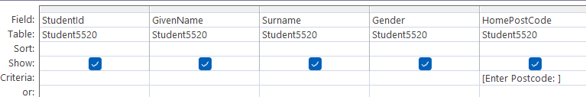
Figure 11: Query Design Grid for Parameter Query T2PF_Param_5520
After configuring the above settings, click the Run button to display the Enter Parameter Value dialog box that prompts the user to enter a postcode.
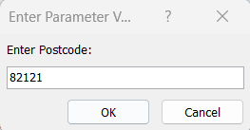

Figure 12: Enter Parameter Value Dialog Box Prompting for Postcode Input
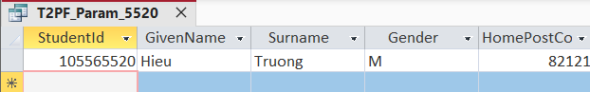
Figure 13: Query Result for T2PF_Param_5520 Using Postcode 82121
Next, testing the query with another postcode (3056) yields the following result:
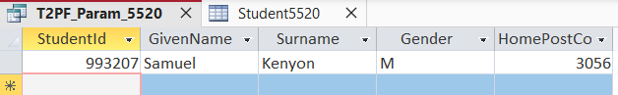
Figure 14: Query Result for T2PF_Param_5520 Using Postcode 3056

Task Pass2g
In Task Pass2g, the requirement instructs students to get familiar with Microsoft Power BI. First and foremost, double-click on the Microsoft Power BI icon to initiate the program, choose Get Data from other sources, select Database options, select Connect, click on moviedatabaseDAD, choose Open, and finally right-mouse click on Import all six tables from the moviedatabaseDAD.accdb file obtained in Task 01.
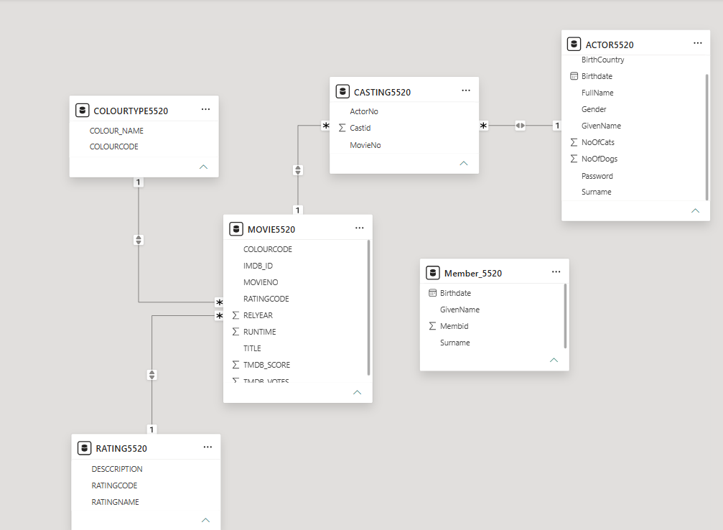
Figure 15: Power BI Model View Showing Table Relationships and Cross-Filter Settings

Task Pass2h
Regarding the requirement of Task Pass2h, I changed to Report View, clicked the Table icon on the Visualizations pane, and added the four following fields: TITLE, RELYEAR, RUNTIME, and RATINGCODE. Then, under the Build visual tab below the Visualizations, choose Don't Summarize for each field.
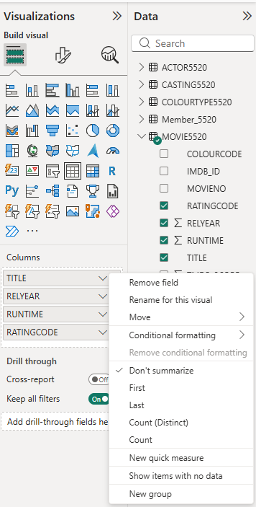
Figure 16: Configuring Table Fields
In terms of sorting RELYEAR in ascending order, I clicked on the RELYEAR column header in the table until the upward-pointing arrow appears.

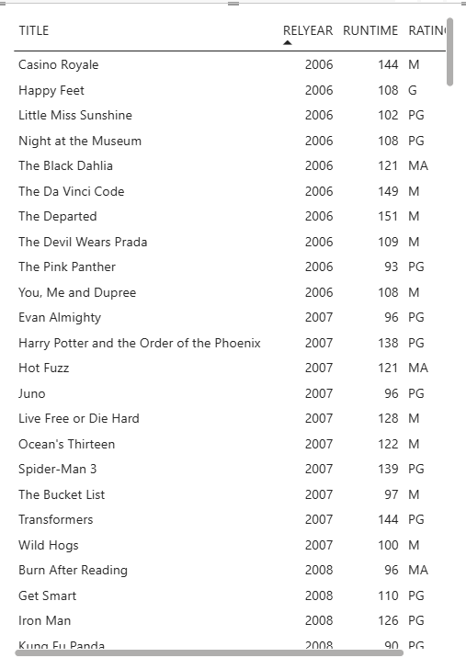

Figure 17: Table visual displaying the filtered and sorted movie data.
Regarding of adding a heading to the visualization that includes my Student ID and title, I clicked Format your visual under the Visualizations pane, turned on the Title, and enter Text named 105565520 - Movie Data (Released from 2006 Onward) with font is Times New Roman, font size: 15, Text Color: Brown, and Horizontal Alignment is Center

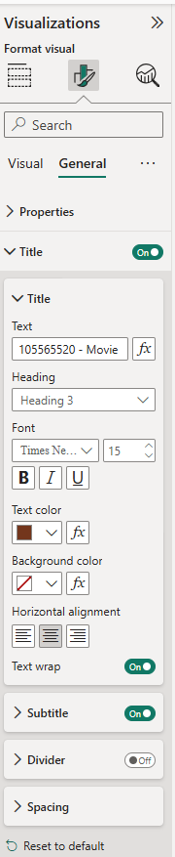
Figure 18: Configuring visual title formatting

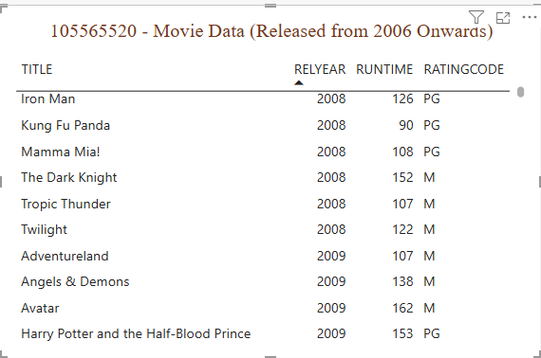
Figure 19: Filtered and sorted movie table visual with custom title

Task Pass2i
In this section, task Pass2i asks students to create a Donut chart with following settings:
- The donut chart must display the count of Movies by RatingCode
- Add a heading to the visualization that includes your student ID and the title of the visualization
- Format Title Font size and colour to your liking.
- The data labels must show both the Rating Code and the Count of movies.

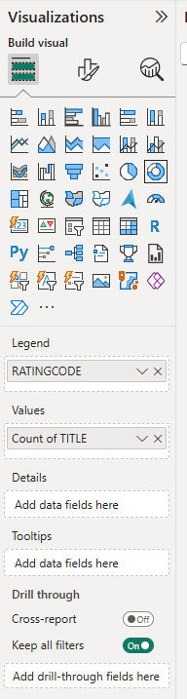

Figure 20: Configuring Donut Chart Fields and Values

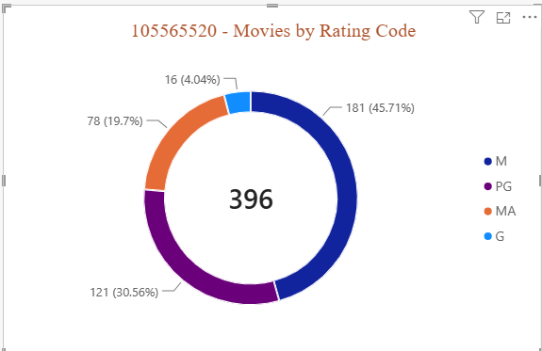
Figure 21: Donut chart displaying movies by rating code with custom title
According to Figure 21, the donut chart illustrates the distribution of movies categorized by their rating codes (M, PG, MA, and G). Firstly, the M (Mature) rating accounts for the highest proportion with 181 movies (45.71%), followed by PG (Parental Guidance) with 121 movies (30.56%). While the MA (Mature Accompanied) and G (General) ratings, 78 movies (19.7%) and 16 movies (4.04%), respectively, bringing the total number of movies analyzed to 396.

Task Pass2j
For Task Pass2j, I put TITLE from the MOVIE5520 table into Rows, Gender from the ACTOR5520 table into Columns, and ActorNo from the ACTOR5520 table into Values for generating the Matrix visualization. After that, I set the title to 105565520 - Actor Count by Movie and Gender with a font size of 15, an orange color, and center alignment.

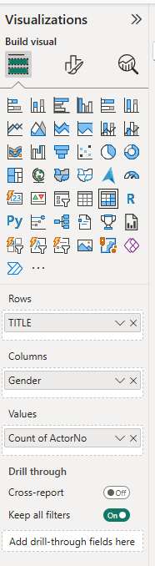
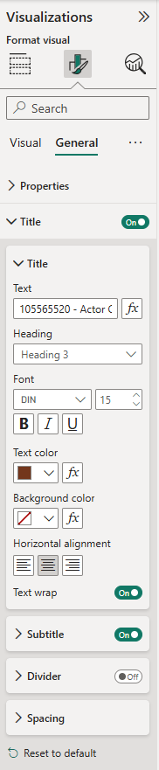
Figure 22: Visualizations Pane Settings (Build visual and Format visual tabs)

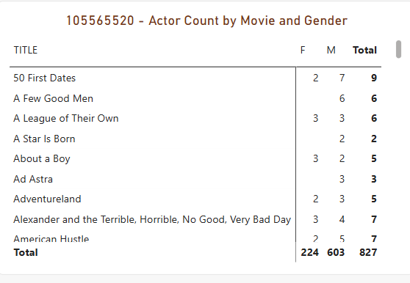
Figure 23: Matrix Visualization of Actor Count by Movie and Gender

Task Pass2k
In the Pass2k part, the task requires students to generate a Map visualization with the following settings:
- It must display the count of actors by birth country.
- Add a heading to the visualization that includes your student ID and the title of the visualization
However, I had to go to File, choose Options and settings, click on Options, select Security, and tick on Use Map and Filled Map visuals. In Build Visual part, choose BirthCountry from ACTOR5520 table for Location field, FullName from ACTOR5520 table for Legend field. In General part of the Format Visual, I set Title is 105565520 - Actor Count by Birth Country, Font size is 15 and Center Alignment.
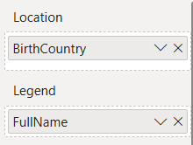
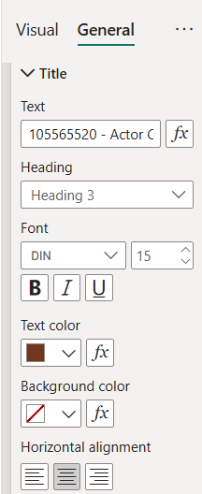
Step 29: Setting Configuration
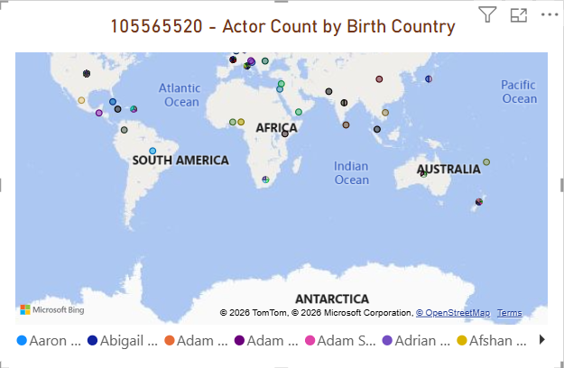
Figure 30: Map visualization showing the count of actors by birth country.

Task Pass2l
In this section, I generated a Clustered Bar Chart with following configuration:
- Y-axis: BirthCountry
- X-axis: Count of ActorNo
- Title: 105565520 - Actor Count by Birth Country
- Font Size: 15
- Alignment: Center
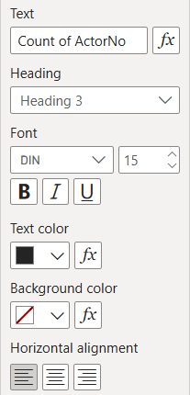
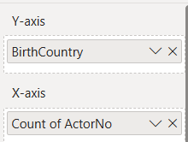
Figure 31: Visualization Pane for task Pass2l

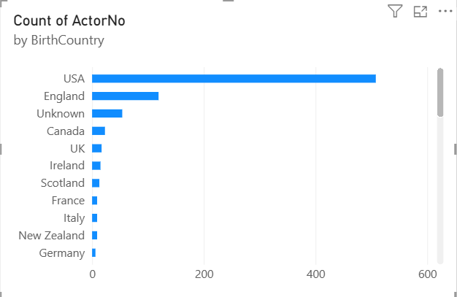
Figure 32: Clustered bar chart showing the count of actors by birth country.

Task Pass2m
In the final task of Pass part, I created new table named FavoriteSong5520, changed to Design View mode to fill in the three following fields including Field Name, Data Type, and Description (Optional).
- Field Name: SongID (Primary key), Data Type: AutoNumber, Description: Unique identifier for each song.
- Field Name: SongTitle, Data Type: Short Text, Description: Title of the favorite song.
- Field Name: Artist, Data Type: Short Text, Description: Name of the artist/band.
- Field Name: ReleaseDate, Data Type: Date/Time, Description: Date when the song was released.
- Field Name: StreamsMillion, Data Type: Number, Description: Total streams In million.
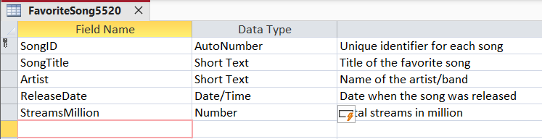
Figure 33: Table Design View of FavoriteSong5520
Then, I entered 10 records for the FavoriteSong5520 Table.
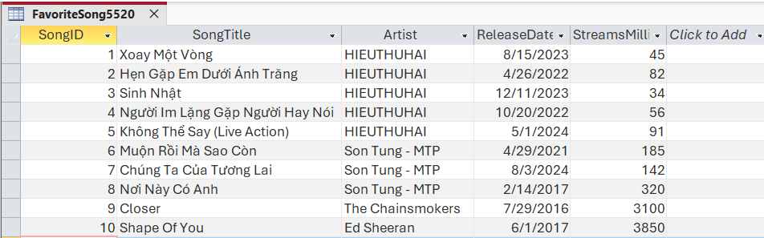
Figure 34: Date View of FavoriteSong5520 with 10 records
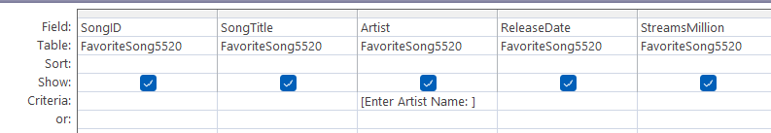
Next, in the tab Query, choose Query Design, add FavoriteSong5520 Table, drop down all columns in the table to Design Grid and enter [Enter Artist Name: ] in the criteria for the column Artist and saved query named FavoriteSongQuery5520.
Figure 35: Query Design grid with parameter criteria
Subsequently, I entered value HIEUTHUHAI for the [Enter Artist Name: ], the following figure showcase the result.
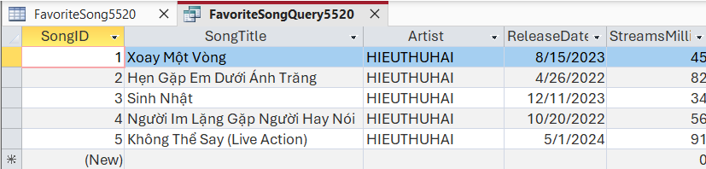
Figure 36: Data View of the executed parameter query

Conclusion
After Successfully completed all Pass tasks from 2a to 2m, I have learn how to import and modify data, perform action queries, build parameter, select queries, integrate Access databases with Power BI to configure bidirectional cross-filtering relationships, generate various data visualizations (Table, Donut chart, Matrix, and Map), and design a custom Access table with associated records and queries.

