

Task 1 – Credit Submission

Student Number: Truong Ngoc Gia Hieu
Student Name (VietNam/Australia): SWS01217/ 105565520

Task Credit1a
First and foremost, students are required to download the database file customer(1)-1.accdb from the ZIP file named CUSTOMERDB [ACCDB, 1.4MB] available on Canvas and rename the CUSTOMER table by appending the last four digits of their student number, resulting in the table name CUSTOMER5520.
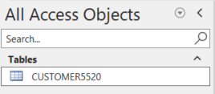

Figure 1: Renamed CUSTOMER Table with Student ID Suffix (5520)
Next, I selected the Create tab and chose Query Design to create a query named T1CA_5520. The query includes the following columns: Customer ID, Surname, Gender, Loyalty Points, Rating Code, and State, which match the assignment requirements.
- The State must be Tasmania
- The Loyalty Points must be greater than or equal to 7500
- The Gender must be M
- The Rating code must be 1 or 3

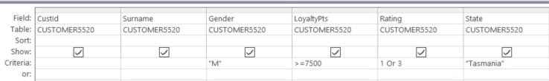
Figure 2: Query Design Grid for T1CA_5520

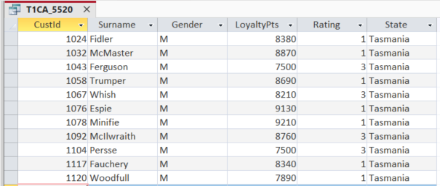
Figure 3: Query results for T1CA_5520

Task Credit1b
In Credit Task 1b, the task is slightly more challenging because it requires students to create a query with two separate sets of criteria connected by the OR operator. In addition, the query must display the required customer information while filtering records that satisfy either of the specified conditions. Therefore, the Query Design Grid includes Customer ID, Surname, Sales This Year, Sales Last Year, Loyalty Points, Rating Code, and State, together with the criteria provided in the assignment description with following matching criteria:
- Sales this year must be greater than or equal to 560
- The Rating code must be 1
- The state must be Tasmania
- The loyalty points must be in the range 3000 to 5999
OR
- Sales last year must be less than 75
- The Rating code must be 2
- The state must be Victoria
- The loyalty points must be in the range 7500 to 8999
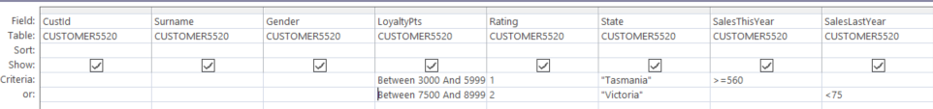
Figure 4: Query Design Grid for T1CB_5520 Showing Multiple Criteria with OR Conditions

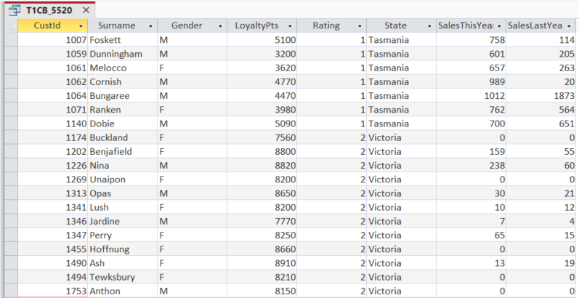
Figure 5: Query Results for T1CB_5520 Showing Customers Matching Alternative Criteria

Task Credit1c
In the third task, the lab requires students to generate query named T1CC_5520 contains following attributes Customer ID, given name, surname, date of birth and postcode. However, the condition of DateOfBirth requires within years 31st Dec 1999 to 31st Dec 2001
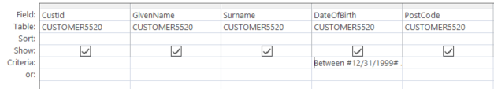

Figure 6: Query Design Grid for T1CC_5520 Showing Customers by Date of Birth Range
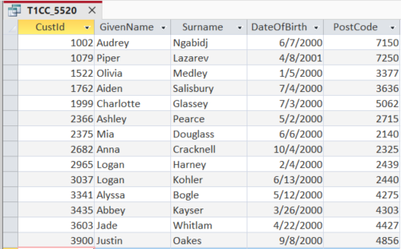
Figure 7: Query Results for T1CC_5520 (Customer Date of Birth Filter)

Task Credit1d
In the fourth task, students are required to add their own information as a new record in the CUSTOMER5520 table.
Figure 8: Newly Added Customer Record in the Customer Table.

Task Credit1e
Before setting Relationships, student has to download file ProductSales DB [ZIP, 11.5MB] on Canvas and rename all tables by adding last 4 digits of your student ID at the end of each table name.
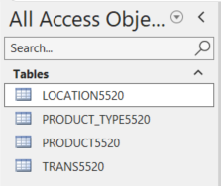

Figure 9: Renamed Product Sales Database Tables with Student ID Suffix
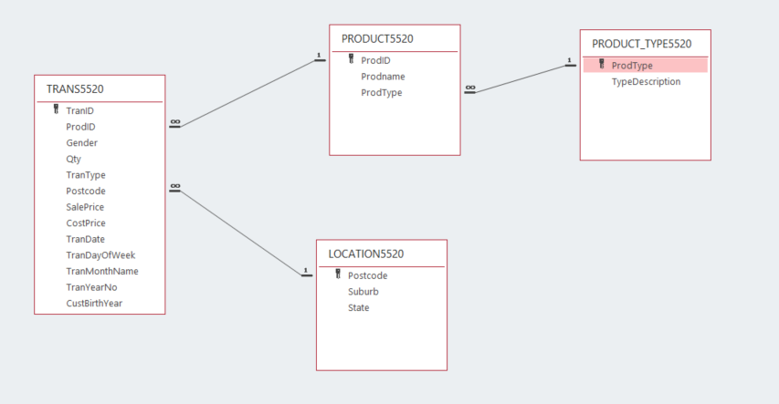
Figure 10: Table Relationships Diagram for the Product Sales Database
It is clear that TRANS5520.Postcode is linked to LOCATION5520.Postcode, TRANS5520.ProdID is linked to PRODUCT5520.ProdID, and PRODUCT5520.ProdType is linked to PRODUCT_TYPE5520.ProdType.

Task Credit1f
In Task Credit1f, the Lab asks students to create query named T1CF_4567 that displays these columns: TranID, ProdID, Prodname, TypeDescription, Qty, TranDate in Ascending TransID sequence. Additionally, Qty greater than or equal to 10 and TranDate = 01/03/2011
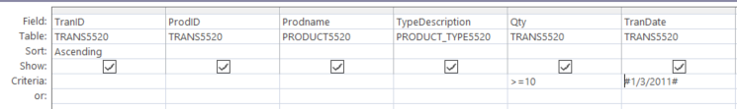
Figure 11: Query Design for T1CF_5520
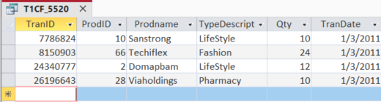

Figure 12: Query Results for T1CF_5520 (Datasheet View)

Task Credit1g
Subsequently, the taskCredítg asks student to create query named T1CG_5520 that displays these columns: TranDate, TranID, Prodname, SalePrice, Qty, Suburb, CustBirthYear:
- Ascending TransDate sequence
- Prodname is “Highway" or "Touchtrax "
- Suburb is Balwyn

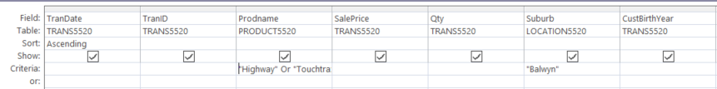
Figure 13: Query Design for T1CG_5520 (Product and Suburb Filtering)

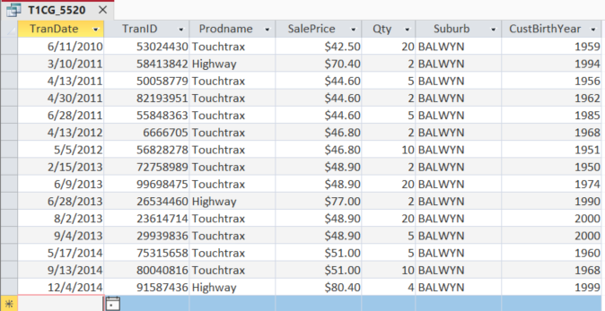
Figure 14: Query Results for T1CG_5520 (Datasheet View)

Task Credit1h
In this part, the question is divided into two smaller questions for I will answer respectively.
First, for answering how many times has Touchtrax product been sold, I decided to create new aquery name T1CH_01_5520 with following step configurations:
- Create new Query Design.
- Choose two tables: PRODUCT5520 and TRAN5520
- Add Fields to the Grid:
- Add the Prodname field (from the PRODUCT5520 table).
- Add the TranID field (from the TRANS5520 table).
- Enable Totals: On the Design tab, click the Totals ($\Sigma$) button to display the Total row in the design grid.
- Configure Criteria and Functions:
- In the Prodname column, set the Total row to Group By and enter "Touchtrax" in the Criteria row.
- In the TranID column, set the Total row to Count.
- Run the Query

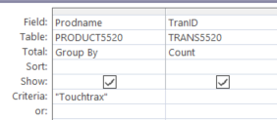
Figure 15: Query Design for Counting Touchtrax Sales
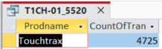
Figure 16: Query Result for Counting Touchtrax Sales (Datasheet View)
After configuring and running the query, it shows that the product Touchtrax has been sold 4,725 times.
Then, for answering question that How many different prices has this product been sold for, the following descriptions showcase how can I do it
- Create Query Design: Open Access, go to the Create tab, and click Query Design.
- Select Tables: Add the PRODUCT5520 and TRANS5520 tables to the design window.
- Add Fields to the Grid:
- Add the Prodname field (from the PRODUCT5520 table).
- Add the SalePrice field (from the TRANS5520 table).
- Enable Totals: On the Design tab, click the Totals ($\Sigma$) button to display the Total row in the design grid.
- Configure Criteria and Functions:
- In the Prodname column, set the Total row to Group By and enter "Touchtrax" in the Criteria row.
- In the SalePrice column, set the Total row to Group By to list all unique selling prices without duplication.
- Run the Query
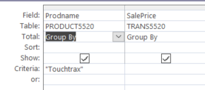
Figure 17: Query Design for Distinct Selling Prices

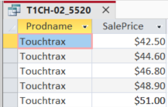
Figure 18: Query Design for Distinct Selling Prices (Datasheet View)
Based on the datasheet view, there are a total of five different prices for the product Touchtrax.
Subsequently, I create a new query named T1CH-03_5520, select tables PRODUCT5520 and TRANS5520, add fields inclduing Prodname, TranDate, SalePrice,. Then, configure column Prodname enter “Touchtrax” in Criteria and Ascending in TransDate.
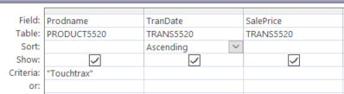
Figure 19: Query Design for price trend Analysis
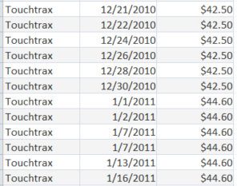
Figure 20: Query Result for Price Trend Analysis (Datasheet View)
Based on the query result, the price of the product remains stable within the same year and increases progressively across different years. In detail, the sale price of the product Touchtrax was $42.50 in 2010, then increased to $44.60 the following year, and continued to rise, reaching $51.00 by 2014.

Task Credit1i
In the Task1i, a query named T1Ci_5520 was created using the TRANS5520 table to calculate the sum of the quantity sold for each weekday, including Saturday and Sunday. In the query design, a calculated expression using weekday formatting was set to Group By, while the Qty field was configured with the Sum function to aggregate the total sales volume. Additionally, the Qty column was sorted in Ascending order to arrange the list from the lowest to the highest total quantity. The resulting datasheet view successfully displays each weekday alongside its corresponding total quantity sold, ordered sequentially as required (WeekdayName(Weekday([TranDate])).
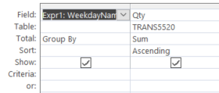

Figure 21: Query Design for T1Ci_5520 (Weekday Sales Quantity Sum)
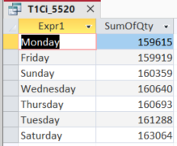
Figure 22: Query result for T1Ci_5520 (Datasheet View)

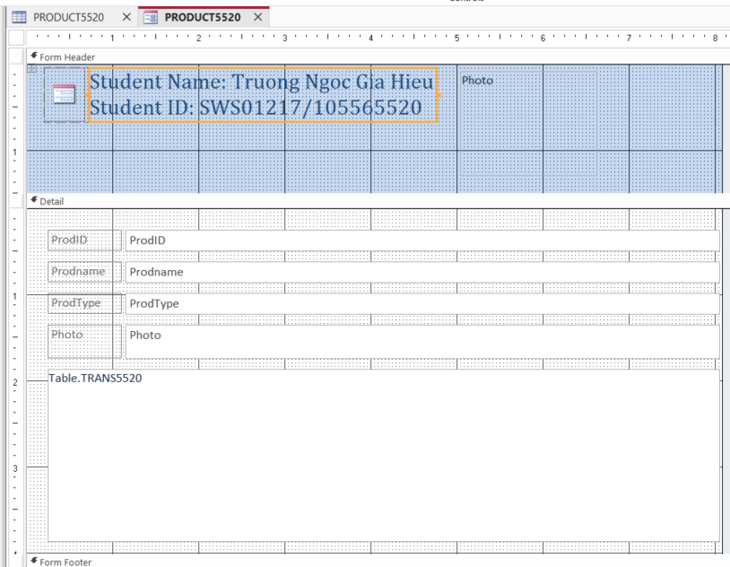
Task Credit1j
Figure 23: Form Design View for PRODUCT5520
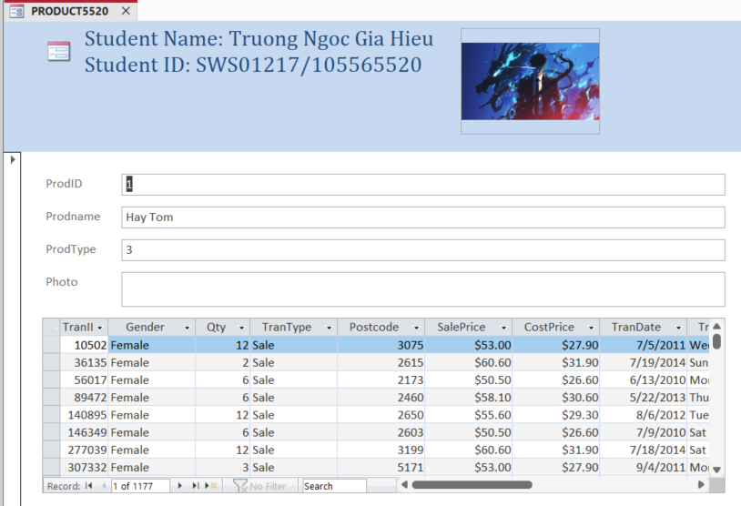
Figure 24: Form View for PRODUCT5520

CONCLUSION
Through this lab, I mastered essential database management skills in Microsoft Access, including applying standardized naming conventions (_5520), building advanced analytical queries using criteria, aggregation (Sum), and date functions (WeekdayName), and designing professional forms with customized image formatting (SizeMode) and embedded transaction subforms.

